[Training Portal]

Netcracker [Training Center]

|  |  |
| --- | --- |
| Version Number | 0.04 |
| Status | Approved |
| Document Date | 2019 |
| Owner | Netcracker |

Business Requirements

Version History

|  |  |  |  |
| --- | --- | --- | --- |
| Version | Date | Author | Description of Changes |
| 0.01 | 28/03/2019 | Nataliia Pleskanko | Initial Draft |
| 0.02 | 1/04/2019 | Nataliia Pleskanko | Reviewed |
| 0.03 | 5/04/2019 | Nataliia Pleskanko | Reviewed |
| 0.04 | 7/04/2019 | Nataliia Pleskanko | Approved |

Contents

Introduction 5

Document Purpose 5

Document Objectives 5

Intended Audience and Reading Suggestions 5

Project Priorities 6

Business Requirements 7

Requirements 8

Appendix 1 15

Appendix 2 16

Document Reference

|  |  |  |
| --- | --- | --- |
| # | Document Name | Description |
| 1 | Picture 1 | System roles. |

# Introduction

The system helps to organize training process. The system allows employees, trainers and managers to access their educational information in one place.

## Document Purpose

Business requirements help to define technical requirements of systems.

## Document Objectives

The objectives of this document are to:

* describe the high-level business requirements
* provide necessary information to enable the business stakeholders to understand and approve the requirements
* provide all necessary information for the recipients of the document to design and develop the Solution Design

## Intended Audience and Reading Suggestions

Students, curators.

## Project Priorities

Describe the priorities among the project’s requirements. The table below may be helpful in identifying the parameters around the project’s key drivers (top priority objectives), constraints to work within, and dimensions that can be balanced against each other to achieve the drivers within the known constraints.

Table 1. Project Priorities

|  |  |  |  |
| --- | --- | --- | --- |
| Dimension | Driver (state objective) | Priority | Degree of Freedom (state allowable range) |
| ER diagram, landing page, registration | release 1.0 to be available by 15/04/2019 – 19/04/2019 | M | 70-80% of mandatory priority features must be included in release 1.0 |
| Admin functionality (creation of profiles), notifications to email | release 2.0 to be available by 22/04/2019 – 26/04/2019 | M | About 60% of mandatory priority features must be included in release 2.0 |
| Trainer functionality, admin part of attendance | release 3.0 to be available by 29/04/2019 – 5/05/2019 | M | About 60% of mandatory priority features must be included in release 3.0 |
| Manager functionality | release 4.0 to be available by 6/05/2019 – 10/05/2019 | M | About 70% of mandatory priority features must be included in release 4.0 |
| Employee functionality | release 5.0 to be available by 13/05/2019 – 17/05/2019 | M | About 90% of mandatory priority features must be included in release 5.0 |
| Notification center for all users | H | About 80% of high priority features must be included in release 5.0 |
| Chats | release 6.0 to be available by 20/05/2019 – 24/05/2019 | H | About 100 % of mandatory and 90% of high priority features must be included in release 6.0 |
| Stabilization | M |

# Business Requirements

Within every project we must carefully prioritize requirements in order for the project to deliver the biggest return to the organization and to be considered successful. Failure to use a sensible criterion for prioritizing requirements is one of the reasons why projects fail.

The requirements are prioritized using the following classification:

Table 2.Requirements Priorities

|  |  |  |
| --- | --- | --- |
| Priority | Add | Description |
| Mandatory | M | A requirement is mandatory and the project would be stopped if it could not be delivered |
| High | H | There will be significant impact to the business if these highly desirable requirements are not delivered |
| Optional | O | There will be a low impact if these nice to have requirements are not delivered |

## Requirements

Business requirements describe the needs of the business. The following types of requirements must be defined fully here:

**System user roles:**

Picture 1. Roles

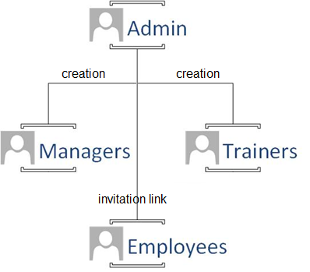

Table 3. Description of system users

|  |  |
| --- | --- |
| User role | Description |
| Admin | He operates managers and trainers. Only one admin should be in the system. |
| Managers | They monitor employee’s progress: attendance, level. |
| Trainers | They check attendance, attach materials to the lessons. |
| Employees | They attend trainings. |

**Note!** Admin shall have trainer’s functionality; manager shall have employee functionality at the same time.

**Note!** Admin creates account for managers and trainers, employees register by themselves. However, each user can view profile with **general** information of each other.

**General requirements:**

Table 4. Business Requirements [General]

| Requirements Description | Comment | Owner | Priority | Status |
| --- | --- | --- | --- | --- |
| Log in/Log out. |  |  | M |  |
| Recover password. |  |  | M |  |
| View landing page. | The landing page shall represents general information about courses and trainers. |  | M |  |
| Notification center. | The system shall inform:  Admin about new requests in Info Desk.  Managers about new feedback for his employees, about absence without reasons etc.  Trainers about new group, new attendee etc.  Employee about missed lessons, response for his request via Info Desk etc. |  | H |  |
| Chats | The system allow every user to send a message to another users. |  | H |  |

Table 5. Non-functional Requirements [General]

| Requirements Description | Comment | Owner | Priority | Status |
| --- | --- | --- | --- | --- |
| Session life is 1 hour of inactivity. |  |  | H |  |
| Life of registration temporary link is 24 hours. |  |  | H |  |
| Adaptive and responsive design. |  |  | Н |  |
| Web interface and functionality of the system should be the same on the latest version of Google Chrome/Chromium, Mozilla Firefox, Opera web browsers. |  |  | H |  |

**Admin functionality:**

Table 6. Business Requirements [Administrator]

| Requirements Description | Comment | Owner | Priority | Status |
| --- | --- | --- | --- | --- |
| Create, update and remove a manager’s account. |  |  | M |  |
| Create, update and remove a trainer’s account. |  |  | M |  |
| Manage landing page. | Add/Edit/Remove slider with general information, add/edit/remove information about trainers. |  | M |  |
| View profiles with all information about each user in the system. |  |  | M |  |
| Create a new group/course. | The system shall allow to choose teacher(s), day(s), time(s) and employees.  **Note**: Each course shall have level (for example junior, middle, senior or elementary, pre-intermediate, intermediate etc.) and course name (Java SE, Java EE, Hibernate or general English, business English, keep fit English etc.), trainer and attendee, schedule. |  | M |  |
| Schedule time for new student, for new group. | The system shall displays combination of desirable schedule of student (group) and existing training. |  | M |  |
| View attendance of each group. | The system shall allow to filter attendance by trainer(s), training level(s) and employee(s). |  | M |  |
| View dashboards:   * Training and quantity of employee * Training level and quantity of groups for each level. * Training level and trainers | The system shall display data in real time. All information should be clickable and redirects to appropriate list with details. |  | H |  |
| The system shall allow the user to choose parameters and view dashboard based on the chosen parameters. |  | O |  |
| View/Download attendance and dashboard reports. | The system shall generate xls report based on the chosen parameter(s). |  | M |  |
| Attendance settings. | The system shall allow to add\edit\delete type of absence. |  | O |  |
| Support users via Info Desk. |  |  | O |  |

**Trainer functionality:**

Table 7. Business Requirements

| Requirements Description | Comment | Owner | Priority | Status |
| --- | --- | --- | --- | --- |
| View all trainer group(s) and course(s). |  |  | M |  |
| Edit schedule for his group(s). Cancel the lesson. | The system shall notify attendee about changes. |  | H |  |
| View profile of his attendee. | The profile shall include at least name, surname, his training level, training courses, active training, email, trainer’s feedback(s), manager name and surname, manager’s email. |  | M |  |
| View profile of attendee’s manager. | The profile shall include at least name, surname, email, department information. |  | M |  |
| Leave feedback. | During course or after successfully finishing of the course, trainer shall be able to leave feedback.  The admin shall view all feedbacks, but trainers can view only his feedback. |  | H |  |
| Check attendance. | The system shall propose attendance type: present, absent without reason, absent due to business trip, absent due to sick leave, absent due to project activities and so on. |  | M |  |
| Attendance reminder. | If an employee missed lessons without reasons the system shall send a reminder to inform by an email to his manager, trainer, and admin with an indication of the reason for absence. |  | H |  |
| The system shall propose the trainer to change parameters of reminder or add new reminder. For example, to send notification each tree days until the trainer mark type of absence or if employee missed three lessons one after another. |  | O |  |
| Attach material for the lesson(s). |  |  | O |  |
| View dashboard:   * Presence of each group; * Training level etc. |  |  | H |  |

**Manager functionality:**

Table 8. Business Requirements [Employee]

| Requirements Description | Comment | Owner | Priority | Status |
| --- | --- | --- | --- | --- |
| View the list of his subordinates. |  |  | M |  |
| View profile of his subordinates. | Example of employee account is presented in appendix 1. |  | M |  |
| View attendance of his subordinates. |  |  | M |  |
| View dashboards:   * Training level; * Absence of each subordinates. | The system shall display data in real time. The information shall be clickable and redirects to the list with appropriate information. |  | H |  |

**Employee functionality:**

Table 8. Business Requirements

| Requirements Description | Comment | Owner | Priority | Status |
| --- | --- | --- | --- | --- |
| Registration | Example of employee account is presented in appendix 1. |  | M |  |
| Leave desired time for training course. |  |  | M |  |
| View dashboard based on training(s), level(s), and attendance. | The system shall display completed trainings, level progress and attendance statistics. |  | H |  |
| View, download lesson’s material. |  |  | O |  |
| Chat with his groupmates. |  |  | H |  |
| Send request to Info Desk. | The system shall allow the employee to send request with question to the admin. Then they chat until the User closes the request as answered.  See appendix 2 for more details. |  | O |  |

## Appendix 1

**Employee account example**

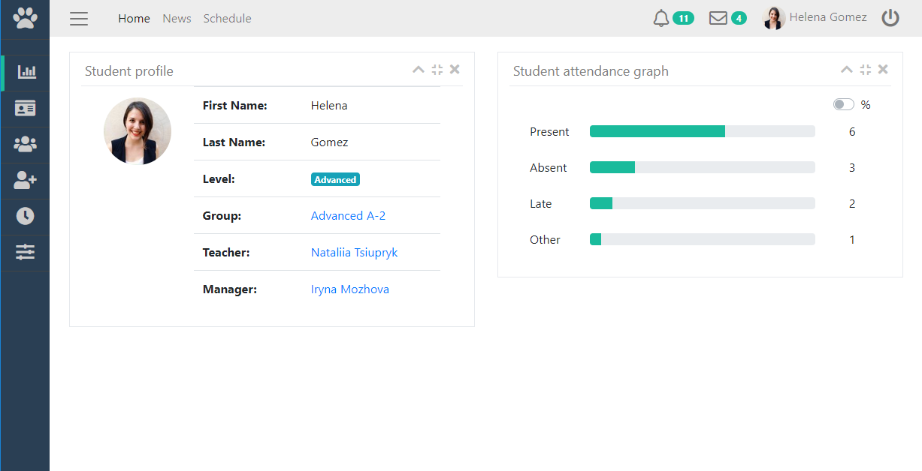

## Appendix 2

**Info Desk request lifecycle**

Draft

|  |  |
| --- | --- |
| Status | Description |
| Draft | The employee created request but the request is not submitted. |
| Open | The employee submitted the request. The system displays notification regarding new request. |
| In progress | The admin starts to answer to employee’s response. The system saves intermediate status of the answer. |
| Answered | The employee marked request as answered. The admin cannot type anything in this request. |
| Reopened | The employee reopened the request. |

Reopened

Open

Answered

In progress