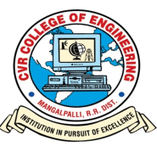
CVR COLLEGE OF ENGINEERING
(An UGC Autonomous Institute, NAAC approved with ‘A’ Grade)

DEPARTMENT OF COMPUTER SCIENCE AND ENGINEERING

Date: 21/02/2024

The CSE Department Academic Committee meeting is scheduled for 23/02/2024 at 02:00 pm in the CSE Department office. All the members are requested to attend the meeting.

AGENDA:

- Purchase of equipment for CSE Labs
- Mini Project Review-1 for B.Tech. III year students.
- Major Project Review-1 for B.Tech. IV year students.
- Review the results of B.Tech. IV year I semester.

MINUTES OF MEETING

- It was decided to purchase the latest configuration computers for setting new laboratory.
- It was decided to purchase fans, AC, Projector for setting up a new laboratory.
- It was decided to conduct the mini project review-1 for B.Tech. III year students on April 06th 2023.
- Major project Review-3 Schedule was finalized and decided to conduct on 04.03.2024.
- Reviewed the results B.Tech. IV year I semester of 2023-24 Academic year.

Head of the Department
CSE

