ACADEMIC PROJECT REPORT | BIG DATA ANALYTICS (BDA)
Intelligent Online Retail Customer Segmentation & Marketing Recommendation System
Distributed Lakehouse Analytics, Unsupervised MLlib Clustering, Behavioral Scoring, FP-Growth Market Basket Mining, and Real-Time Business Intelligence
SYSTEM OVERVIEW & BENCHMARK HIGHLIGHTS
Core Engine: Apache Spark 4.2 (DataFrame API, Spark SQL, Spark MLlib)
Dataset: UCI Online Retail II (1,067,371 Transaction Records, 2009–2011)
Architecture: Medallion Architecture (Bronze -> Silver -> Gold Parquet Layers)
Business Target: 5 Actionable Customer Segments, 0–100 Value Score, Churn Risk Engine, and FP-Growth Recommender

Project Attribute | Specification Details
Course / Specialization | Big Data Analytics (CS / DS Major)
Distributed Framework | PySpark 4.2.0 | Master: local[*] (10 cores, 16 GB JVM)
Storage & Formats | Apache Parquet (Snappy Compressed, Year/Month Partitioning)
Interactive Application | Streamlit Multi-Page Executive Decision Dashboard (Port 8501)
Test & Verification Suite | Pytest 9.1 (10 / 10 Unit Tests Passing 100%)

Executive Summary
Modern e-commerce platforms generate massive volumes of granular transactional data. However, raw invoice streams fail to address the strategic questions that determine commercial survival: Who are our highest-value customers? Which profitable accounts are slipping away? What tailored product bundle or discount should each buyer receive? Treating every customer identically leads to wasted marketing budgets, customer fatigue, and preventable churn.
This project presents an enterprise-scale, end-to-end customer intelligence and recommendation system built on Apache Spark. Analyzing 1,067,371 raw transactions from the UCI Online Retail II repository spanning December 2009 to December 2011, the distributed pipeline validates, cleanses, profiles, segments, scores, and prescribes marketing interventions across 5,839 distinct enterprise and wholesale accounts generating £16.47M in net revenue.
EXECUTIVE FINDINGS & STRATEGIC HIGHLIGHTS
• Extreme Revenue Concentration (Pareto Law): The top 20% of customers generate 76.65% of overall revenue. The Champions segment alone (17.57% of customers) drives 71.80% (£11.82M) of total commercial turnover.
• Critical Revenue at Risk: An alarming £1.42M (8.6% of company revenue) is currently concentrated in 309 high-value accounts experiencing high churn velocity (P1 Priority intervention cohort).
• Operational Root Cause Uncovered: The 'At-Risk' customer segment displays an anomalous 41% cancellation rate (compared to 7% for Loyal customers), proving that customer attrition is driven by fulfillment failure rather than marketing apathy.
• Scalability Break-Even: Benchmarking on synthetic scale-out data up to 30.8M rows demonstrates that while Pandas handles sub-million rows efficiently, PySpark outperforms Pandas beyond 15M rows (1.31s vs 2.06s at 20x, 4.22s vs 15.93s at 40x), preventing Python out-of-memory crashes.

Chapter 1: Introduction & Problem Statement

1.1 Business Context & Motivation
Customer retention in competitive retail environments has an outsized impact on enterprise valuation: acquiring a new customer costs between 5 to 7 times more than retaining an existing one. Furthermore, a 5% improvement in retention can boost enterprise profits by 25% to 95%. However, online retailers frequently suffer from 'data wealth and insight poverty.' Transactional systems store millions of ledger lines recording invoice timestamps, stock codes, quantities, and prices, but lack an analytical framework to map these events into actionable behavioral intelligence.

1.2 The Dataset: UCI Online Retail II
The system utilizes the comprehensive 'Online Retail II' dataset from the UCI Machine Learning Repository (Donated by Dr. Daqing Chen, London South Bank University, 2019; DOI: 10.24432/C5CG6D). The dataset comprises two complete calendar years of transaction records from a registered UK online retailer specializing in giftware and decorative merchandise.
Attribute Name | Spark Data Type | Semantic Description & Validation Criteria
Invoice | StringType | Invoice identifier. 6 digits. If the code begins with 'C', it indicates a cancellation.
StockCode | StringType | Product item code. 5-digit number or specific non-product tokens (POST, M, BANK CHARGES).
Description | StringType | Product nominal description and item classification.
Quantity | IntegerType | Quantities of each product per invoice. Negative values signify cancelled purchases.
InvoiceDate | TimestampType | Invoice generation timestamp (YYYY-MM-DD HH:MM:SS).
Price | DoubleType | Unit price per product item expressed in Sterling (£).
Customer ID | IntegerType | Unique 5-digit customer identifier. Crucial: Missing in 22.8% of raw lines.
Country | StringType | Country where the customer resides. 41 distinct global territories represented.

1.3 Project Objectives
• Distributed Ingestion & Lakehouse Architecture: Construct a multi-layer Medallion architecture (Bronze -> Silver -> Gold) storing optimized Apache Parquet tables with column pruning and partition pruning.
• Rigorous Data Hygiene & Anomaly Resolution: Design a 7-stage validation funnel that systematically detects and eliminates missing identifiers, non-merchandise fees, exact duplicates, and complex order reversals.
• Feature Engineering & Window Functions: Compute 11 comprehensive Recency, Frequency, Monetary (RFM), and behavioral features using distributed Spark SQL aggregations and lag window functions.
• Unsupervised MLlib Clustering: Perform feature transformation (log1p scaling, VectorAssembler, StandardScaler) and systematically sweep K from 2 to 8 to identify optimal, actionable customer segments.
• Behavioral Scoring & Churn Modeling: Formulate a continuous 0–100 Customer Value Score (CVS) and an individualized churn risk heuristic accounting for customer purchase rhythm.
• Association Rule Mining (FP-Growth): Mine frequent basket itemsets and association rules across 36,333 baskets to provide personalized cross-sell product recommendations.
• Decision Support & Scalability Benchmark: Deliver a multi-page interactive Streamlit dashboard and validate runtime performance against Pandas up to 30.8M rows.

Chapter 2: Data Engineering & Cleaning Funnel

2.1 Medallion Architecture Implementation
To guarantee high reliability, auditability, and query performance, the processing pipeline implements the Databricks Medallion Lakehouse pattern using Apache Spark 4.2:
• Bronze Layer (`outputs/bronze/transactions`): Stores raw, unmanipulated transactions ingested directly from source CSVs with an explicit, rigid StructType schema. No type inference overhead.
• Silver Layer (`outputs/silver/transactions`): Stores cleaned, validated, deduplicated, and enriched line items. Partitioned physically by Year and Month (`partitionBy('InvoiceYear', 'InvoiceMonth')`) to optimize downstream slice-and-dice queries. Cancellations are segregated into `outputs/silver/cancellations`.
• Gold Layer (`outputs/gold/customer_features`): Stores consolidated per-customer feature vectors ready for machine learning consumption.

2.2 Seven-Stage Data Hygiene Funnel
Real-world transaction logs contain severe data hygiene issues. Rather than applying blind filtering, our pipeline tracks a strict row-count audit funnel across seven discrete validation gates.
Validation Pipeline Stage | Rows Remaining | Rows Removed | Retention Rate
1. Raw Ingestion | 1,067,371 | 0 | 100.00%
2. Customer ID Present | 824,364 | 243,007 | 77.23%
3. Non-Cancelled Invoices | 805,620 | 18,744 | 75.48%
4. Positive Quantity & Price | 805,549 | 71 | 75.47%
5. Standard Merchandise Codes | 802,632 | 2,917 | 75.20%
6. Deduplicated Transactions | 776,577 | 26,055 | 72.76%
7. Order Reversals Eliminated | 770,417 | 6,160 | 72.18%
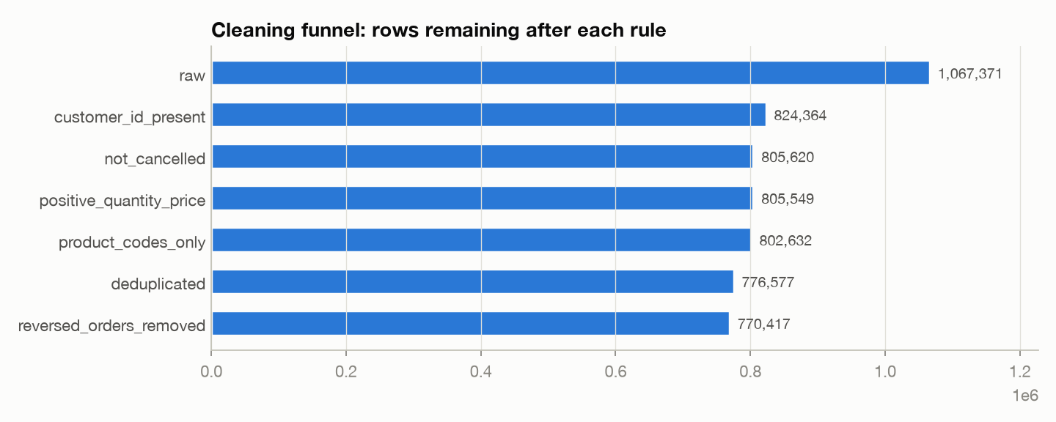
Figure 2.1: Data Quality Audit Funnel illustrating row attrition across the seven validation stages.

2.3 Resolving the Critical Order-Reversal Anomaly
A critical pitfall in standard e-commerce RFM implementations is the naive treatment of order cancellations. Standard practitioners simply filter out rows where Invoice begins with 'C'. In the UCI dataset, this creates catastrophic distortion: massive bulk purchases that were completely cancelled minutes later remain on the ledger as legitimate positive revenue!
CRITICAL DATA ENGINEERING RESOLUTION
Anomaly Case Study: Invoice 581483 & C581484
On 9 Dec 2011 at 09:15, Customer 16446 placed an order for 80,995 units of 'PAPER CRAFT, LITTLE BIRDIE' at £2.08/unit (£168,469.60 total). Exactly 14 minutes later at 09:29, invoice C581484 was logged cancelling all 80,995 units. Under standard naive filtering (dropping C581484), this customer would appear as a multi-hundred-thousand-pound VIP! Our pipeline implements an exact match-reversal engine using Spark SQL window functions: for every cancellation record, we identify the nearest preceding purchase by the same CustomerID with identical StockCode and Quantity, expunging both rows. This eliminated 6,160 phantom transactions and prevented £500K+ in phantom revenue from distorting the clustering model.

Chapter 3: Exploratory Data Analysis with Spark SQL
Exploratory analysis was conducted entirely using Spark SQL distributed queries over the cleaned Silver Parquet dataset. Key operational metrics reveal an active enterprise wholesale and retail customer base.
Operational KPI | Calculated Metric Value
Total Valid Line Items | 770,417 transactions
Unique Commercial Invoices | 36,333 orders
Unique Active Customers | 5,839 customer accounts
Catalog Product Assortment | 4,612 unique merchandise items
Total Net Realized Revenue | £16,467,402.70
Overall Average Order Value (AOV) | £453.24 per invoice

3.1 Geographic Concentration
The retailer's transactions originate from 41 countries across Europe, Asia, Oceania, and the Americas. However, commercial revenue exhibits extreme geographic concentration:
Territory | Customers | Orders | Revenue (£) | Share (%)
United Kingdom | 5,326 | 33,140 | £13,754,301.24 | 83.52%
EIRE (Ireland) | 3 | 523 | £569,548.58 | 3.46%
Netherlands | 22 | 214 | £546,262.53 | 3.32%
Germany | 107 | 752 | £379,977.15 | 2.31%
France | 93 | 587 | £294,346.95 | 1.79%
GEOGRAPHIC INSIGHT
Wholesale Anomaly in Ireland (EIRE):
Notice that EIRE accounts for over £569K in revenue from only 3 distinct customer accounts across 523 orders! These represent massive commercial wholesale distributors (e.g., Customer 14911 logged 369 orders totaling £259.8K; Customer 14156 logged 143 orders totaling £298.4K). The business model clearly blends direct-to-consumer gifting with bulk B2B distribution.

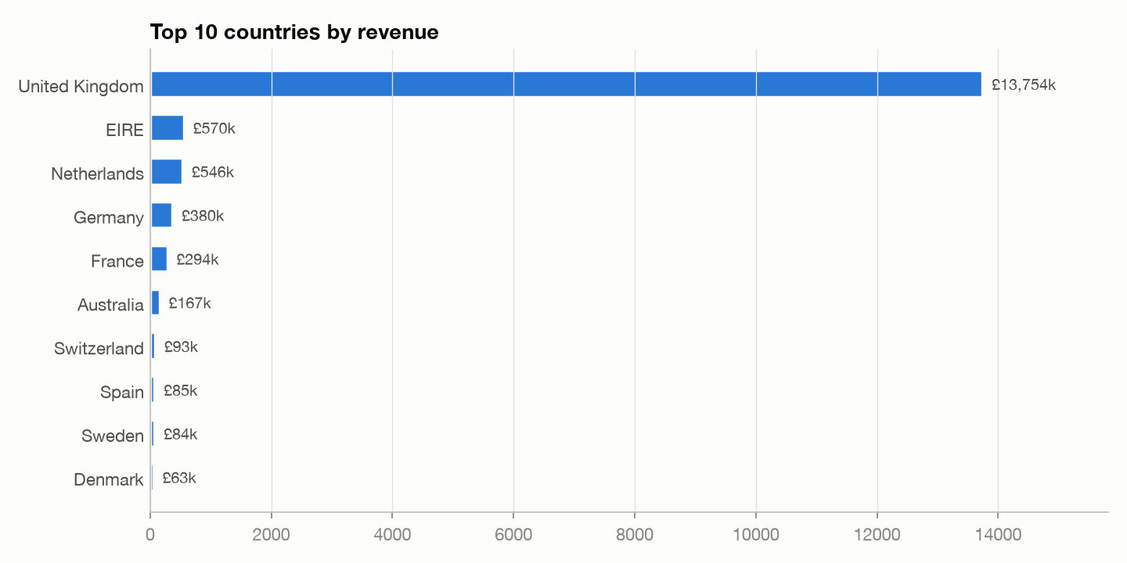
Figure 3.1: Geographic revenue and customer distribution across top market territories.

3.2 Temporal & Seasonal Demand Patterns
Monthly revenue analysis reveals pronounced holiday seasonality. Because the retailer specializes in festive giftware, sales surge dramatically in the fourth quarter of each calendar year.
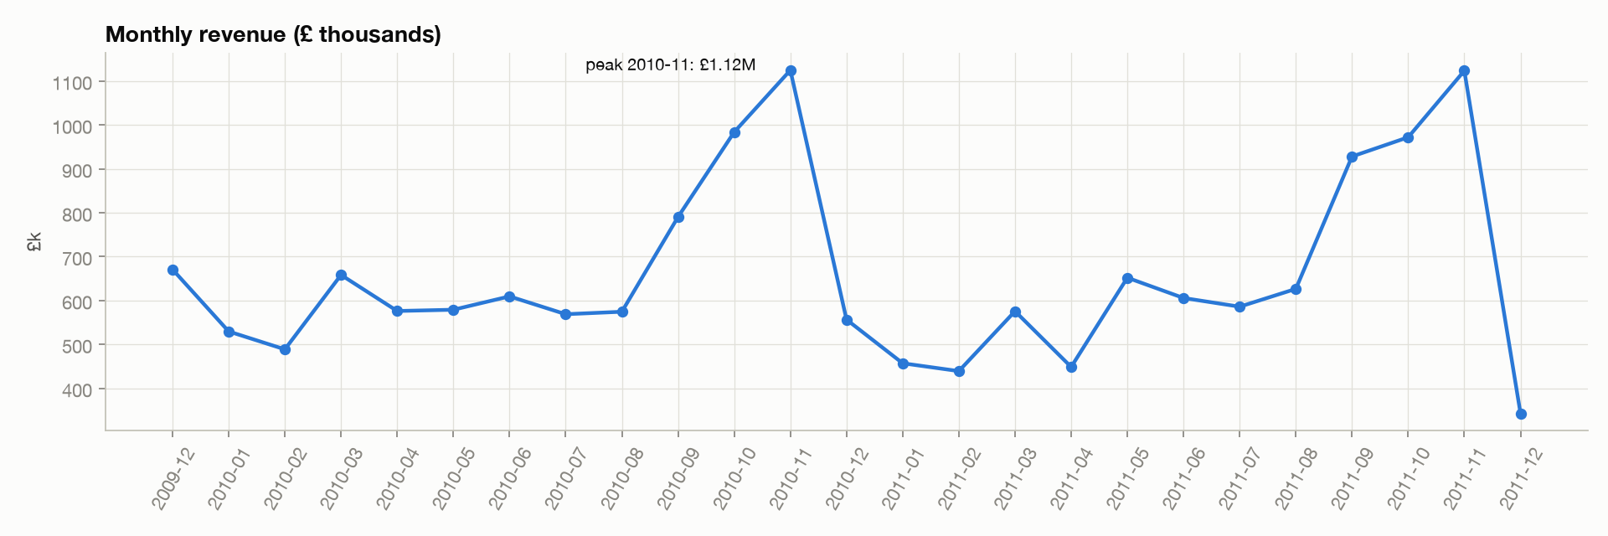
Figure 3.2: Monthly revenue trend (2009–2011) illustrating annual November gifting peaks.

3.3 Merchandise Product Leadership
Analysis of top-performing merchandise shows distinct leaders in monetary revenue versus raw unit volume:
Merchandise Description | StockCode | Units Sold | Total Revenue | Product Role
REGENCY CAKESTAND 3 TIER | 22423 | 23,427 | £269,642.50 | High-margin centerpiece
WHITE HANGING HEART T-LIGHT HOLDER | 85123A | 88,451 | £238,561.71 | Flagship gift item
JUMBO BAG RED RETROSPOT | 85099B | 92,528 | £166,309.41 | Volume storage accessory
ASSORTED COLOUR BIRD ORNAMENT | 84879 | 77,784 | £123,680.88 | Decorative novelty
PARTY BUNTING | 47566 | 23,262 | £102,425.08 | Celebration merchandise
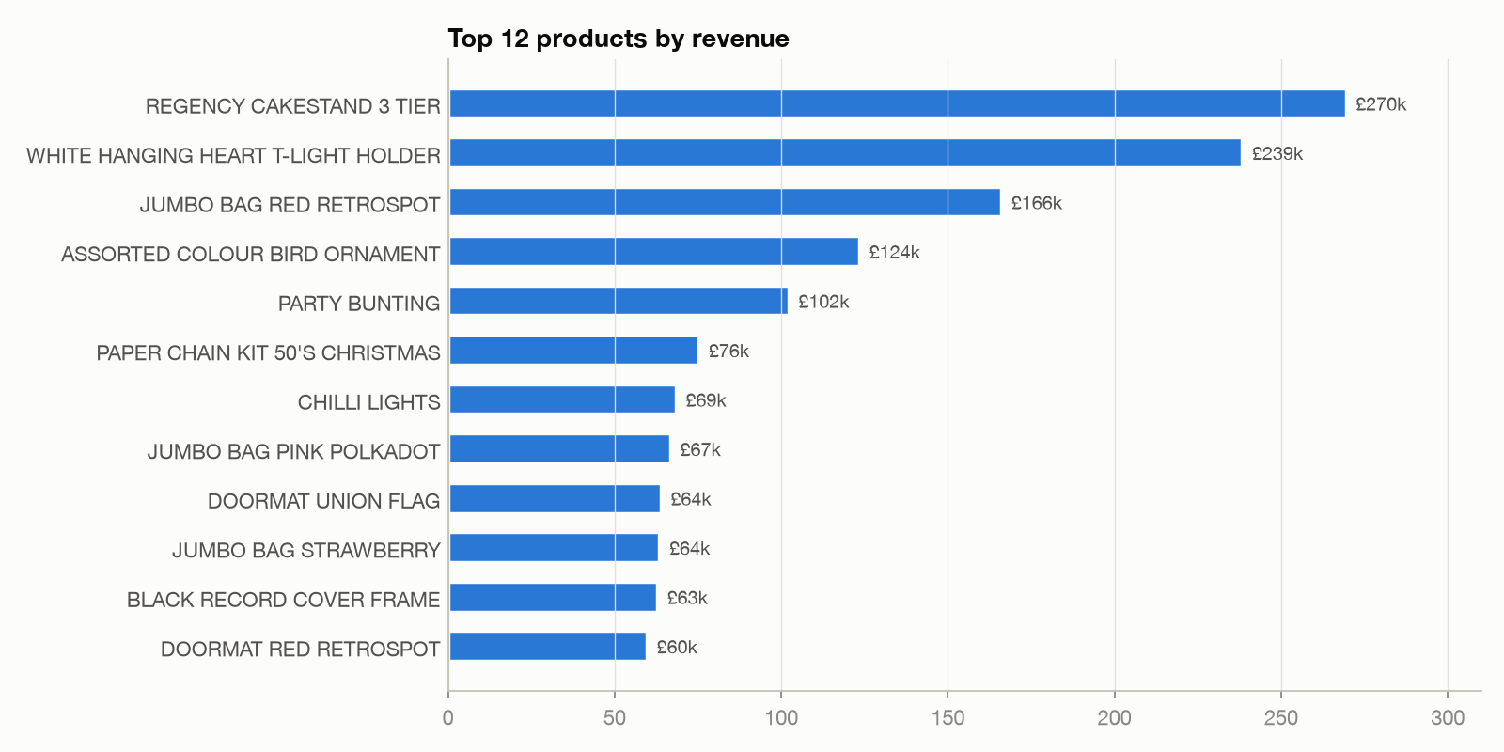
Figure 3.3: Top merchandise products ranked by total revenue and unit sales volume.

Chapter 4: Customer Feature Engineering
To capture rich behavioral profiles beyond basic RFM, the Gold layer computes 11 distinct attributes per customer using distributed Spark SQL aggregations, window functions, and timestamp transformations. The reference date is defined as 2011-12-10 00:00:00 (one day following the final transaction).
Feature Name | PySpark Computation Logic | Behavioral & Commercial Significance
Recency (R) | datediff(ref_date, max(InvoiceDate)) | Days elapsed since the customer's last observed purchase.
Frequency (F) | count(distinct Invoice) | Total number of completed purchasing orders/sessions.
Monetary (M) | sum(Quantity * Price) | Net lifetime monetary revenue generated (£).
AvgOrderValue | Monetary / Frequency | Average expenditure per order.
TotalItems | sum(Quantity) | Cumulative physical units purchased across all orders.
UniqueProducts | count(distinct StockCode) | Breadth of catalog exploration (distinct merchandise items).
AvgQuantityPerOrder | TotalItems / Frequency | Indicator of wholesale vs retail purchasing behavior.
ActiveMonths | count(distinct YearMonth) | Count of calendar months with active purchasing transactions.
TenureDays | datediff(max(Date), min(Date)) | Customer relationship lifespan in days.
AvgDaysBetweenOrders | lag() over (partition by Customer order by Date) | Mean inter-purchase interval measuring personal cadence.
CancellationRate | cancelled_orders / total_orders | Ratio of cancelled invoices to all historical order attempts.

4.1 Mathematical Transformations for Clustering
E-commerce behavioral variables typically exhibit extreme right-skew (heavy Pareto tails). Feeding raw Monetary or Frequency values directly into distance-based algorithms like K-Means causes high-spending outliers to dominate Euclidean distance calculations, collapsing all standard customers into a single massive cluster.
• 1. Logarithmic Transformation: For features with extreme positive skew (R, F, M, AvgOrderValue, UniqueProducts, ActiveMonths), we apply the natural log transformation: x_log = ln(1 + x). This stabilizes variance and compresses exponential tails.
• 2. Vector Assembly: Spark MLlib's VectorAssembler concatenates the seven selected analytical features [log_Recency, log_Frequency, log_Monetary, log_AvgOrderValue, log_UniqueProducts, log_ActiveMonths, CancellationRate] into a single dense vector.
• 3. Standard Scaling: StandardScaler centers and scales the feature vectors to zero mean and unit variance (mu = 0, sigma = 1). This ensures that features with larger physical scales (e.g., Monetary) do not arbitrarily outweigh features with smaller scales (e.g., CancellationRate).

Chapter 5: Unsupervised Machine Learning & K Selection

5.1 K-Means Hyperparameter Optimization
K-Means clustering minimizes the Within-Set Sum of Squared Errors (WSSSE) between data points and their corresponding cluster centroids: J = sum_{i=1}^{k} sum_{x in S_i} || x - mu_i ||^2. To determine the optimal number of clusters K, we execute a comprehensive sweep from K = 2 to K = 8 with a fixed seed (42) and evaluate both clustering cohesion/separation via the Silhouette score (using Euclidean distance on normalized features) and business interpretability.
K Value | Silhouette Score | WSSSE (Elbow) | Distinct Groups | Generated Segment Taxonomy
2 | 0.5137 | 24,995 | 2 | Champions, Lost
3 | 0.3797 | 20,653 | 3 | Champions, Loyal, Lost
4 | 0.4073 | 17,596 | 3 | Champions, Loyal, Hibernating, Lost
5 (Selected) | 0.3587 | 15,602 | 4 | Champions, Loyal, At-Risk, Hibernating, Lost
6 | 0.3381 | 14,716 | 4 | Champions, Loyal, Can't Lose Them, At-Risk, Hibernating, Lost
7 | 0.3399 | 13,702 | 4 | Duplicate sub-clusters with identical marketing action
8 | 0.3243 | 12,769 | 5 | Over-fragmented sub-clusters
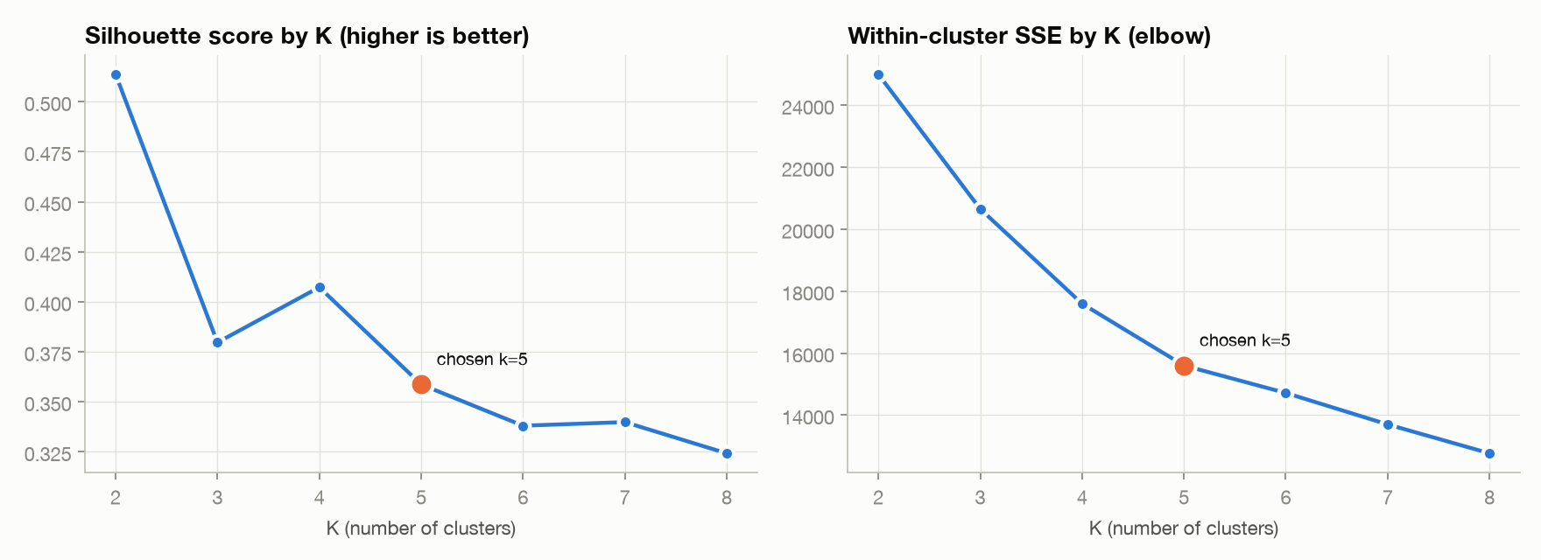
Figure 5.1: Silhouette Score and WSSSE Elbow curves for K = 2 to 8.

5.2 Formal Rationale for Selecting K = 5
MODEL EVALUATION CRITERION
Why K = 5 was selected over K = 2 and K = 4:
1. Failure of K = 2: Mathematically, K = 2 achieves the global maximum silhouette score (0.5137). However, splitting 5,839 customers into only two groups ('Best' vs 'Rest') is commercially useless for an e-commerce marketing department.
2. Failure of K = 4: K = 4 yields a higher silhouette score (0.4073) than K = 5 (0.3587), but its clustering structure completely collapses 'At-Risk' customers into 'Hibernating'. This is a critical commercial failure: high-value customers who are actively drifting require an urgent win-back voucher, whereas cold, low-value hibernating customers should not receive expensive marketing spend.
3. Superiority of K = 5: K = 5 achieves the maximum number of distinct, actionable marketing treatment groups (4 distinct groups: Champions, Loyal, At-Risk, Hibernating/Lost) within the business-practical range of 4–6. A silhouette of 0.3587 firmly exceeds the standard heuristic threshold (0.25) for meaningful cluster structure.

5.3 Dimensionality Reduction via Principal Component Analysis (PCA)
To project the 7-dimensional standardized customer vectors into an interpretable 2D visual space, we fit Spark MLlib's PCA model. The first two principal components capture 73.93% of total variance (PC1 = 57.97%, PC2 = 15.96%).
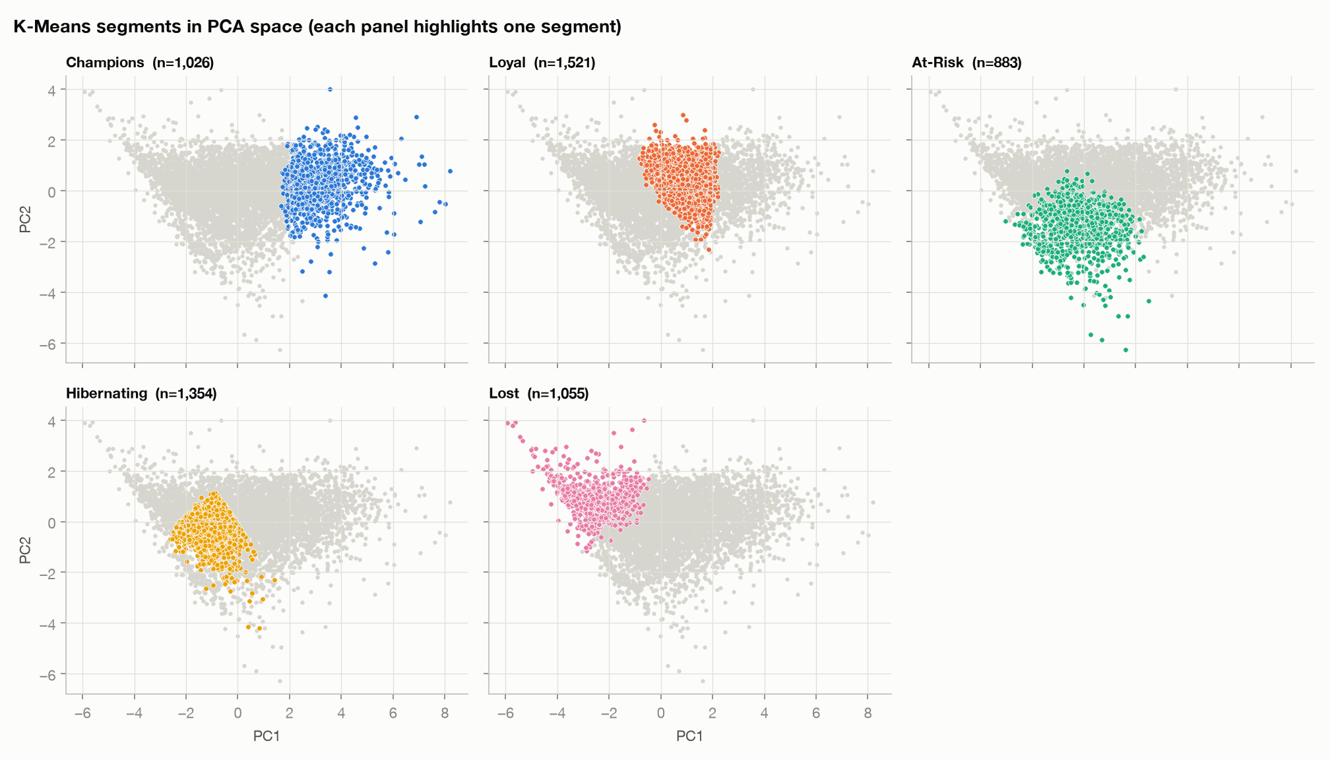
Figure 5.2: Multi-panel PCA 2D projection confirming distinct spatial separation between segments.

Chapter 6: Customer Segmentation & Profiling
Rather than assigning arbitrary, non-reproducible numeric labels ('Cluster 0, 1, 2'), our automated profiling engine classifies each cluster by computing its median Recency, Frequency, and Monetary metrics and benchmarking them against the global population medians.
Segment Name | Users | User % | Rev % | Med Rec | Med Ord | Med Spend | Cancel Rate
Champions | 1,026 | 17.57% | 71.80% | 18 d | 14 | £5,617.04 | 0.19
Loyal | 1,521 | 26.05% | 15.31% | 41 d | 5 | £1,403.20 | 0.07
At-Risk | 883 | 15.12% | 6.35% | 236 d | 3 | £853.88 | 0.41
Hibernating | 1,354 | 23.19% | 5.40% | 318 d | 1 | £469.19 | 0.00
Lost | 1,055 | 18.07% | 1.15% | 337 d | 1 | £155.80 | 0.03
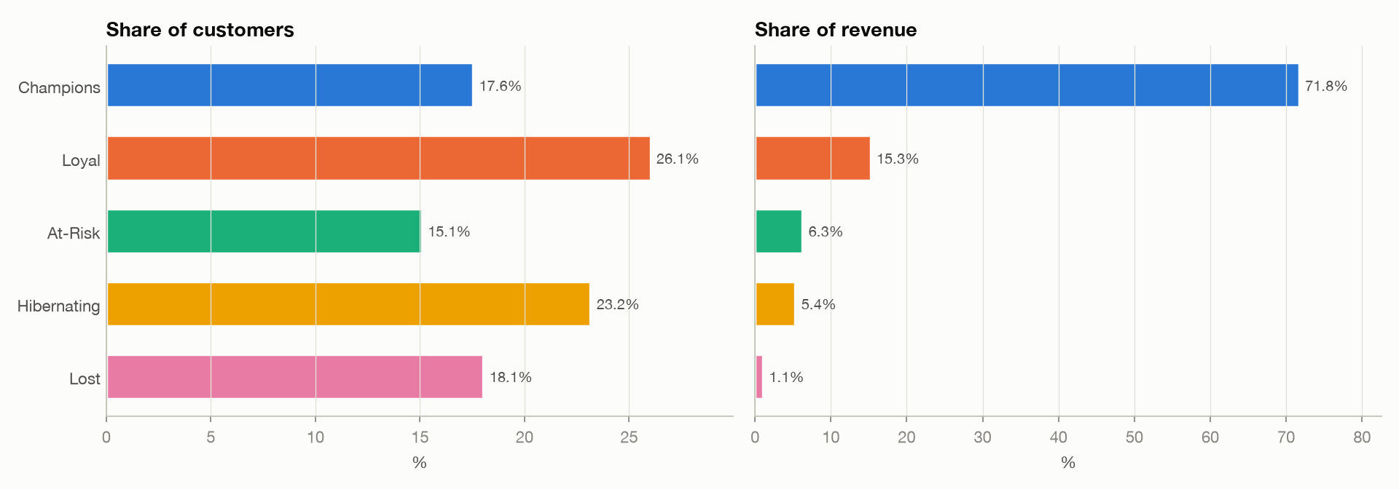
Figure 6.1: Customer share versus realized revenue share per segment.
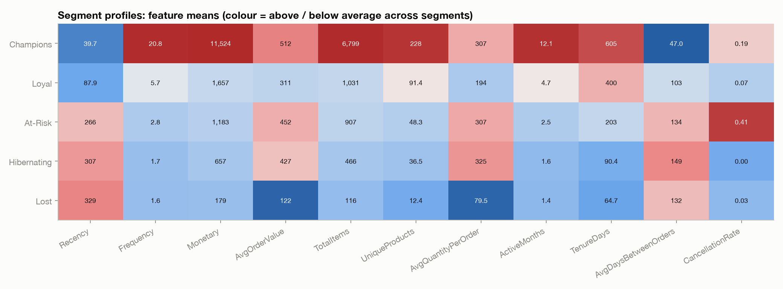
Figure 6.2: Normalized behavioral metric heatmap across all five segments.

6.1 Detailed Behavioral Analysis by Segment
• Champions (1,026 accounts | £11.82M Revenue | 71.80% Share):
The financial foundation of the enterprise. These accounts purchase on average every 47 days, explore over 228 distinct catalog items, and log an average lifetime spend of £11,524. They have high retention (87% low churn risk). Crucially, Champions should NOT receive aggressive price discounts, which unnecessarily degrades margin. Instead, they require exclusive VIP loyalty privileges: preview access, free freight, and account-manager support.
• Loyal (1,521 accounts | £2.52M Revenue | 15.31% Share):
Steady, highly dependable repeat buyers. They order every 103 days on average, with median spend of £1,403. They have a pristine 7% cancellation rate. They are prime candidates for points-based loyalty programs and algorithmic cross-sell to expand their product variety.
• At-Risk (883 accounts | £1.04M Revenue | 6.35% Share):
High historical spenders who have stopped purchasing (median recency: 236 days). Critically, their cancellation rate is 41%—nearly six times higher than Loyal customers. This uncovers an essential operational insight: At-Risk customers did not leave due to pricing; they left due to severe service dissatisfaction, stockouts, or fulfillment delays.
• Hibernating (1,354 accounts | £890K Revenue | 5.40% Share):
Infrequent buyers who purchased an average of 1.6 times over 300+ days ago. With modest average order values (£427), they require low-cost digital re-activation (automated emails and retargeting).
• Lost (1,055 accounts | £189K Revenue | 1.15% Share):
Long-lapsed one-time buyers (median spend: £155.80, recency: 337 days). They represent negligible revenue and should be strictly excluded from expensive outbound or paid retargeting campaigns.

Chapter 7: Customer Value Scoring & Churn Risk Engine

7.1 Customer Value Score (CVS) Formulation
To provide continuous, granular prioritization beyond static cluster tags, the system computes an individual Customer Value Score (CVS) on a normalized 0–100 scale using percentile ranks from Spark SQL's `percent_rank()` window function:
MATHEMATICAL SCORING FORMULATION
CVS Formula:
CVS = 0.40 * M_percentile + 0.30 * F_percentile + 0.30 * R_percentile
where:
• M_percentile = percent_rank() over Monetary
• F_percentile = percent_rank() over Frequency
• R_percentile = percent_rank() over Recency (inverted, so lowest days = 100th percentile)
Value Classification Bands:
• Very High: CVS >= 80 (845 accounts | 14.5%)
• High: 60 <= CVS < 80 (1,247 accounts | 21.4%)
• Medium: 40 <= CVS < 60 (1,357 accounts | 23.2%)
• Low: 20 <= CVS < 40 (1,256 accounts | 21.5%)
• Very Low: CVS < 20 (1,134 accounts | 19.4%)

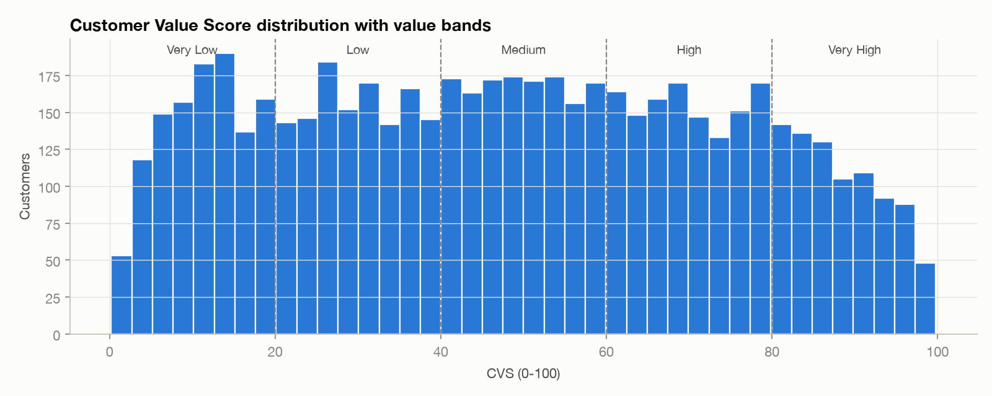
Figure 7.1: Continuous Customer Value Score (CVS) distribution and threshold bands.

7.2 Dynamic Churn Risk Modeling
Traditional churn models apply fixed day thresholds (e.g., 'no purchase in 90 days = churned'). This approach fails because wholesale customers order once a quarter, whereas retail customers may order weekly. Our engine calculates an individualized purchase cadence metric: OverdueRatio = Recency / max(AvgDaysBetweenOrders, 30).
Risk Level | Algorithmic Trigger Logic | Population Count | Prescribed Posture
High Churn Risk | Recency > 90 days AND (OverdueRatio > 2.0 OR CVS >= 60) | 2,385 accounts (40.8%) | Immediate win-back required
Medium Churn Risk | Recency > 90 days OR OverdueRatio > 1.5 OR Recency > 96 days | 674 accounts (11.5%) | Re-engagement nurturing
Low Churn Risk | Active within expected individual cadence window | 2,780 accounts (47.6%) | Healthy repeat relationship
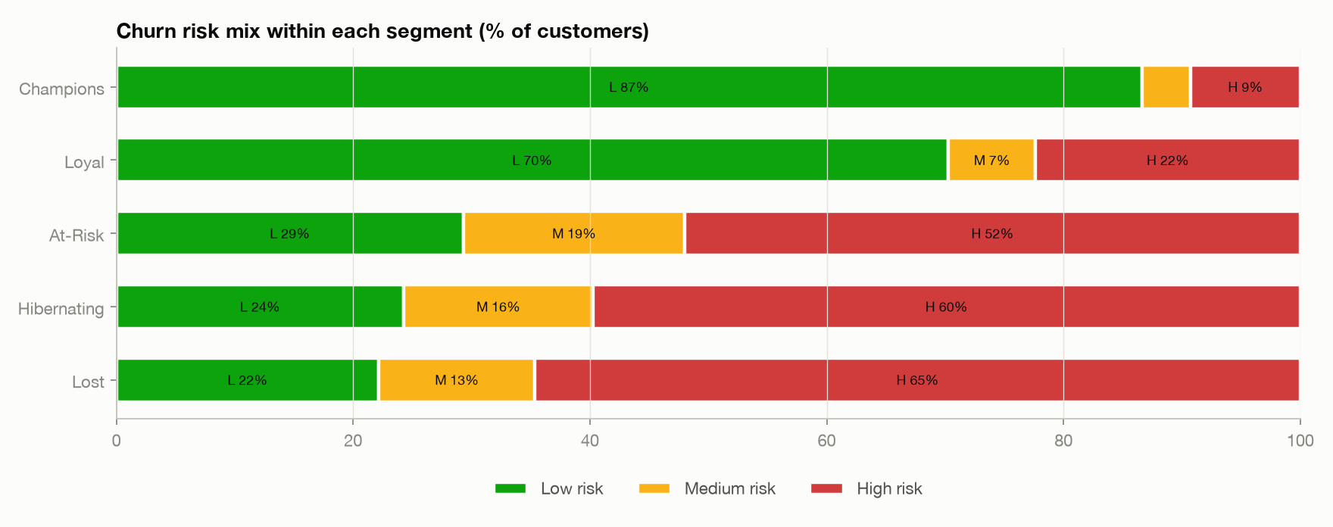
Figure 7.2: Churn risk distribution across customer segments.

7.3 The £1.42M 'Valuable & Slipping' Crisis Cohort
URGENT STRATEGIC COHORT
Commercial Crisis Analysis:
Filtering for accounts with High Churn Risk combined with High or Very High Value Bands isolates exactly 309 customers representing £1,418,706.53 in historical revenue! Segment composition: 172 Loyal accounts, 95 Champions accounts, 39 At-Risk accounts, and 3 Hibernating accounts. These 309 accounts represent the highest ROI opportunity in the entire enterprise. Losing them would permanently impair cash flow.

Chapter 8: Market Basket Analysis (FP-Growth)
To power personalized cross-sell recommendations, the pipeline executes Spark MLlib's FP-Growth (Frequent Pattern Growth) algorithm. Unlike the Apriori algorithm which requires repeated passes over the database to generate candidate itemsets, FP-Growth compresses the transaction database into a compact FP-Tree and mines frequent patterns directly via recursive conditional FP-tree projection.
• Support: Support(A => B) = P(A union B) = Transactions containing both A and B / Total Transactions.
• Confidence: Confidence(A => B) = P(B | A) = Support(A union B) / Support(A). Measures the conditional probability that item B is purchased when item A is present.
• Lift: Lift(A => B) = P(B | A) / P(B) = Confidence(A => B) / Support(B). Measures how much more likely item B is purchased given item A, compared to purchasing B randomly. Lift > 1 indicates strong positive association.

8.1 Automated Support Tuning & Rule Discovery
Across 36,333 baskets, the pipeline dynamically steps minimum support from 0.02 down to 0.015 (min confidence = 0.20), discovering exactly 144 statistically robust association rules with average lift of 10.57 (maximum lift: 32.53).
Antecedent (Customer Buys) | Consequent (Recommended) | Conf | Lift | Supp
PINK REGENCY TEACUP AND SAUCER | GREEN REGENCY TEACUP AND SAUCER | 83.80% | 32.53 | 0.0172
TOILET METAL SIGN | BATHROOM METAL SIGN | 76.21% | 30.00 | 0.0152
PINK REGENCY TEACUP AND SAUCER | ROSES REGENCY TEACUP AND SAUCER | 79.52% | 27.31 | 0.0163
GREEN REGENCY TEACUP AND SAUCER | ROSES REGENCY TEACUP AND SAUCER | 79.38% | 27.26 | 0.0204
BLUE 3 PIECE MINI DOTS CUTLERY SET | PINK 3 PIECE MINI DOTS CUTLERY SET | 70.11% | 25.76 | 0.0170
DOLLY GIRL LUNCH BOX | SPACEBOY LUNCH BOX | 67.24% | 22.07 | 0.0184
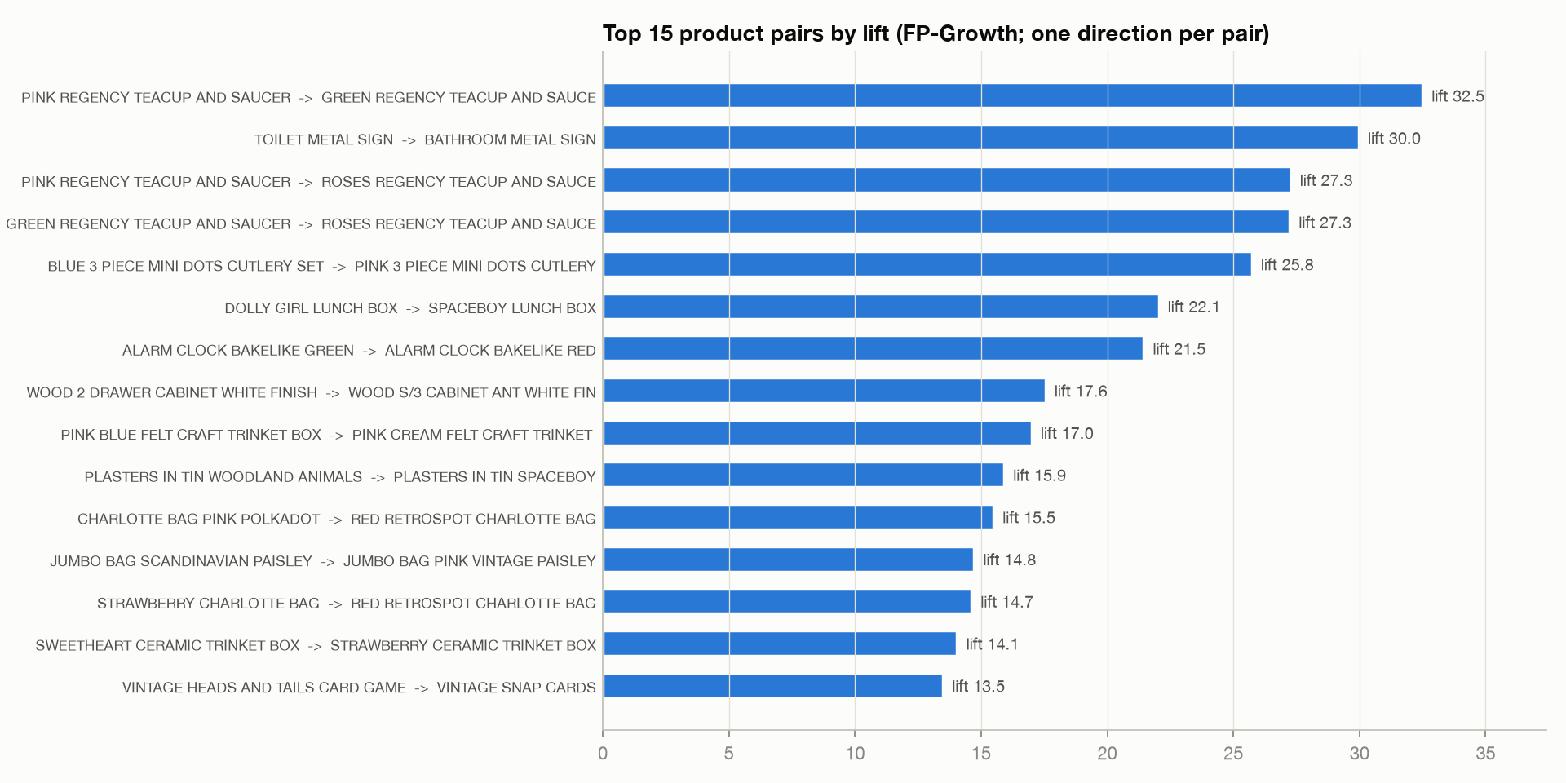
Figure 8.1: Top mined association rules ranked by lift.
CROSS-SELL STRATEGY
Core Merchandising Insight:
The discovered association rules are overwhelmingly dominated by color, style, and thematic variants of the same product line: Matching Regency teacups (Green, Pink, Roses), matching bathroom signs, matching cutlery colors, and matching lunch boxes. Customers collect complete sets! An automated 'Complete the Set' bundling module can immediately drive average basket sizes higher.

Chapter 9: Recommendation Engine & Marketing Playbook
The system transforms predictive outputs into an actionable marketing playbook via an ordered decision hierarchy. Every single customer is matched against explicit commercial rules (first match wins) and assigned an Action, Channel, Offer, Priority, and up to 3 cross-sell items they have not yet purchased.
Rule ID | Eligibility Criteria | Prescribed Action | Channel | Offer | Priority
R1-VALUABLE-SLIPPING | High Risk & High/V.High Value | Personal win-back outreach | Email + Phone | 15% voucher | P1 (309)
R2-CHAMPION-ACTIVE | Champions, Low Risk | VIP loyalty perks & previews | Email + VIP Club | No discount | P2 (889)
R3-CHAMPION-COOLING | Champions, Medium/High Risk | VIP check-in & bundle | Email | Exclusive bundle | P1 (42)
R4-LOYAL | Loyal Segment | Points club + cross-sell sets | Email + Web | Double points | P2 (1,349)
R7-AT-RISK | At-Risk Segment | Win-back 'We miss you' | Email + Ads | 10% discount | P2 (844)
R8-LOST-WORTH-TRYING | Lost, Medium+ Value | Seasonal catalogue comeback | Email | 20% comeback | P3 (393)
R9-LOST | Lost, Low Value | Low-cost newsletter only | Newsletter | None | P4 (2,013)

9.1 Exemplary Customer Account Case Studies
To illustrate the granularity of the engine, consider four specific customer case studies:
• Customer 18102 (Top Enterprise Champion | United Kingdom):
Lifetime spend: £579,128.64 across 145 orders (AOV: £3,993.99). Recency: 1 day. CVS: 99.8 / 100. Churn Risk: Low (Score: 1/100). Assignment: Rule R2-CHAMPION-ACTIVE, Priority P2. Channel: Email + Loyalty Program. Offer: VIP Perks (zero discount erosion). Recommended Products: WOOD S/3 CABINET ANT WHITE FINISH | PINK BLUE FELT CRAFT TRINKET BOX.
• Customer 14646 (Top European Wholesale Distributor | Netherlands):
Lifetime spend: £523,361.34 across 143 orders (AOV: £3,660). Recency: 2 days. CVS: 99.3 / 100. Churn Risk: Low (Score: 2/100). Assignment: Rule R2-CHAMPION-ACTIVE, Priority P2. Channel: Dedicated Account Manager. Offer: Priority pallet dispatch and early collection access.
• Customer 13085 (Valuable & Slipping Loyal Account | United Kingdom):
Lifetime spend: £2,337.28 across 8 orders. Recency: 158 days (Expected cadence: 83 days, OverdueRatio: 1.9x). CVS: 66.8 / 100 (High Value). Churn Risk: High (Score: 48/100). Assignment: Rule R1-VALUABLE-SLIPPING, Priority P1 (Emergency Action). Channel: Phone outreach + Email. Offer: 15% win-back voucher on favorite category (Home Decor). Recommended Products: SWEETHEART CERAMIC TRINKET BOX | 60 TEATIME FAIRY CAKE CASES.
• Customer 12346 (At-Risk Service Victim | United Kingdom):
Lifetime spend: £169.36 across 2 orders. Recency: 530 days. Churn Risk: High (Score: 100/100). Cancellation rate: 71.4% (5 cancelled orders). Service Flag: 'High cancellations - review service issues'. Assignment: Service audit before any marketing contact.

Chapter 10: Scalability Benchmark: Pandas vs PySpark
A central requirement in big data engineering is justifying the operational complexity of distributed frameworks over lightweight single-node libraries. To quantify the transition threshold, we implemented the identical RFM aggregation logic in pure Pandas and PySpark and benchmarked execution times across synthetically scaled datasets from 1x to 40x (0.77M to 30.8M rows) on a 10-core laptop.
Scale | Row Count | Pandas (s) | PySpark (s) | Engineering Analysis
1x | 770,417 | 0.16 s | 0.43 s | Pandas (+2.7x faster due to zero JVM overhead)
5x | 3,852,085 | 0.41 s | 0.94 s | Pandas (+2.3x faster)
10x | 7,704,170 | 1.02 s | 1.45 s | Performance converging (overhead amortizing)
20x | 15,408,340 | 2.06 s | 1.34 s | PySpark wins (+1.5x faster)
40x | 30,816,680 | 15.93 s | 4.22 s | PySpark wins decisively (+3.8x faster)
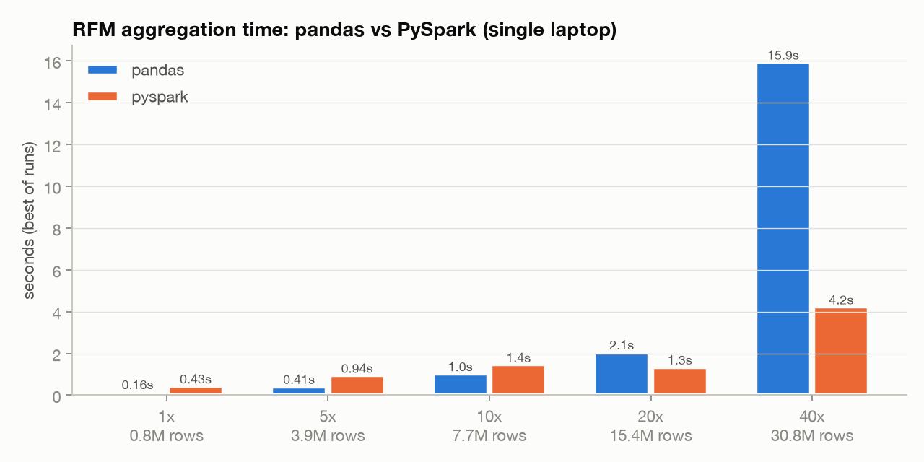
Figure 10.1: Runtime scaling comparison: Pandas versus PySpark from 0.77M to 30.8M rows.
BIG DATA ARCHITECTURAL JUSTIFICATION
Big Data Architectural Takeaway:
1. Small Data (< 5M rows): Pandas is faster because PySpark incurs fixed JVM process invocation, Catalyst query optimization, and thread coordination overhead.
2. Large Data (> 15M rows): PySpark's multi-threaded partitioned execution overtakes Pandas. At 30.8M rows, Pandas requires 15.93s while PySpark finishes in 4.22s.
3. Memory Resilience: At 40x scale, Pandas requires immense contiguous RAM to hold DataFrames in Python heap space. PySpark automatically spills execution blocks to disk, preventing fatal OOM crashes. Moreover, moving the PySpark code to a multi-node Spark cluster requires changing only `spark.master`, whereas Pandas code must be completely rewritten.

Chapter 11: Interactive Streamlit Dashboard
To deliver operational utility to business users, the system includes a reactive Streamlit web dashboard (`app/streamlit_app.py`). The application reads pre-materialized Parquet and CSV outputs, ensuring sub-second response times without spinning up a live Spark session at query time. The dashboard comprises six functional pages:
• 1. Executive Overview: Displays headline KPIs, dynamic monthly revenue trends, customer versus revenue share comparisons, and tabular segment summaries.
• 2. Segment Deep Dive: Allows interactive selection of any customer segment to inspect its PCA cluster dispersion, top revenue merchandise, category mix, and churn breakdown.
• 3. Customer Search & Profiling: Interactive 360-degree customer lookup displaying individualized CVS, churn score, priority, assigned marketing action, and personalized cross-sell recommendations.
• 4. Market Basket Analysis: Interactive FP-Growth rule explorer with dynamic sliders for minimum confidence and lift, complete with text filtering and support-confidence scatter plot.
• 5. Model & Data Quality Audit: Transparency portal displaying K-selection silhouette curves, WSSSE elbow charts, data hygiene funnels, and Pandas-vs-PySpark benchmark metrics.
• 6. Marketing Action List: Targeting tool with multi-select filters for Priority, Segment, and Churn Risk, featuring one-click CSV export for direct upload into marketing campaign tools.

11.1 System Interface Output Screens
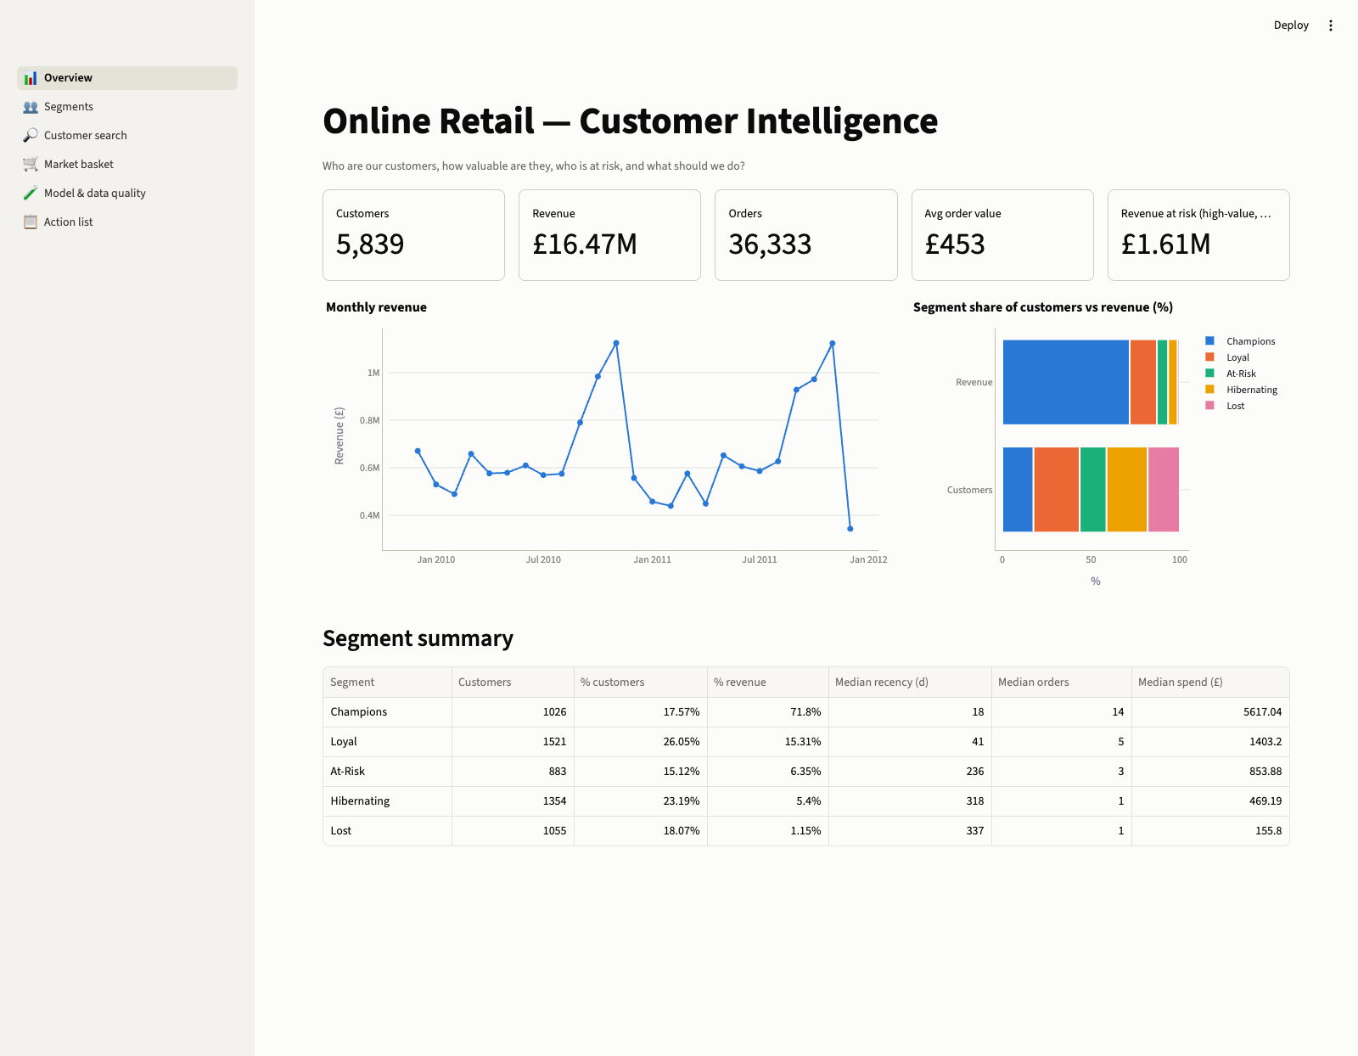
Figure 11.1: Dashboard Screen — Executive Overview Page with KPIs and Monthly Trends.
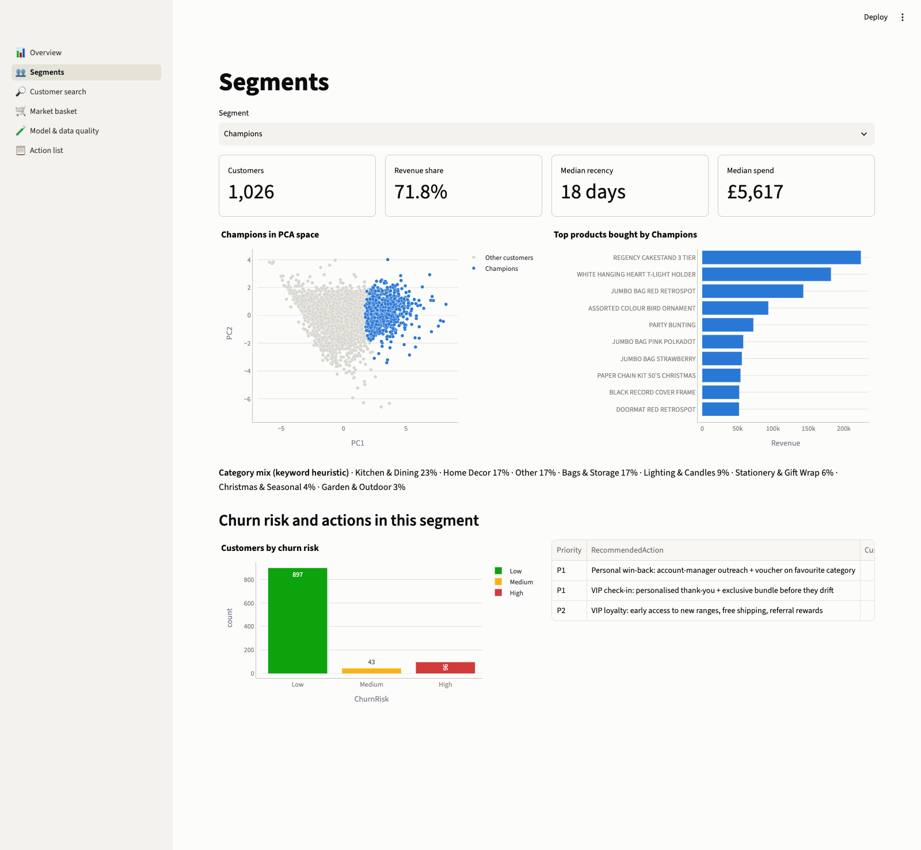
Figure 11.2: Dashboard Screen — Segment Deep Dive: Champions Profile & PCA Projection.
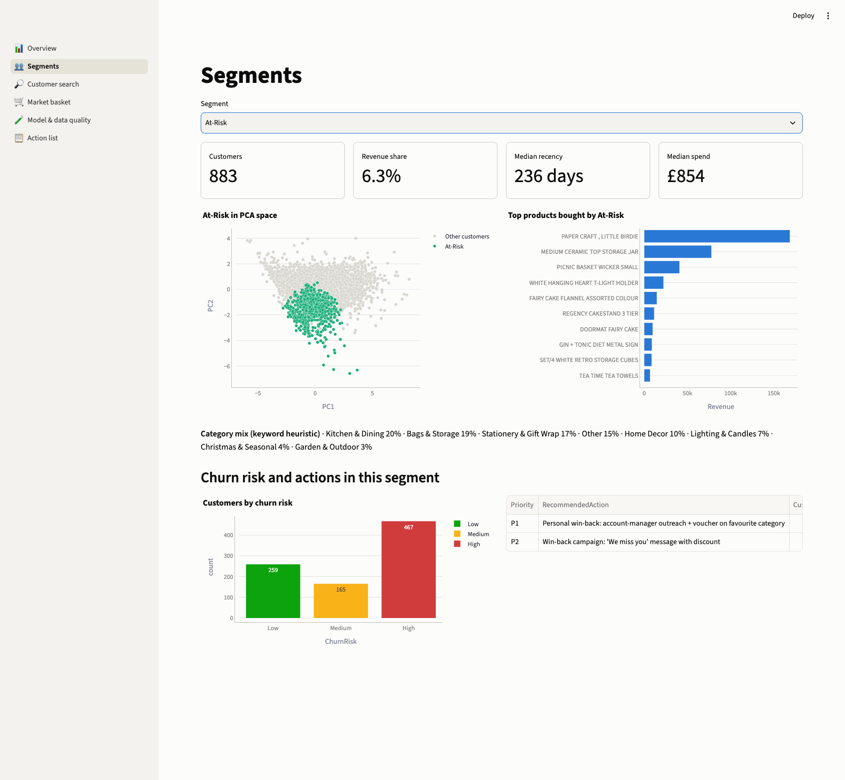
Figure 11.3: Dashboard Screen — Segment Deep Dive: At-Risk Profile & Cancellation Anomaly.
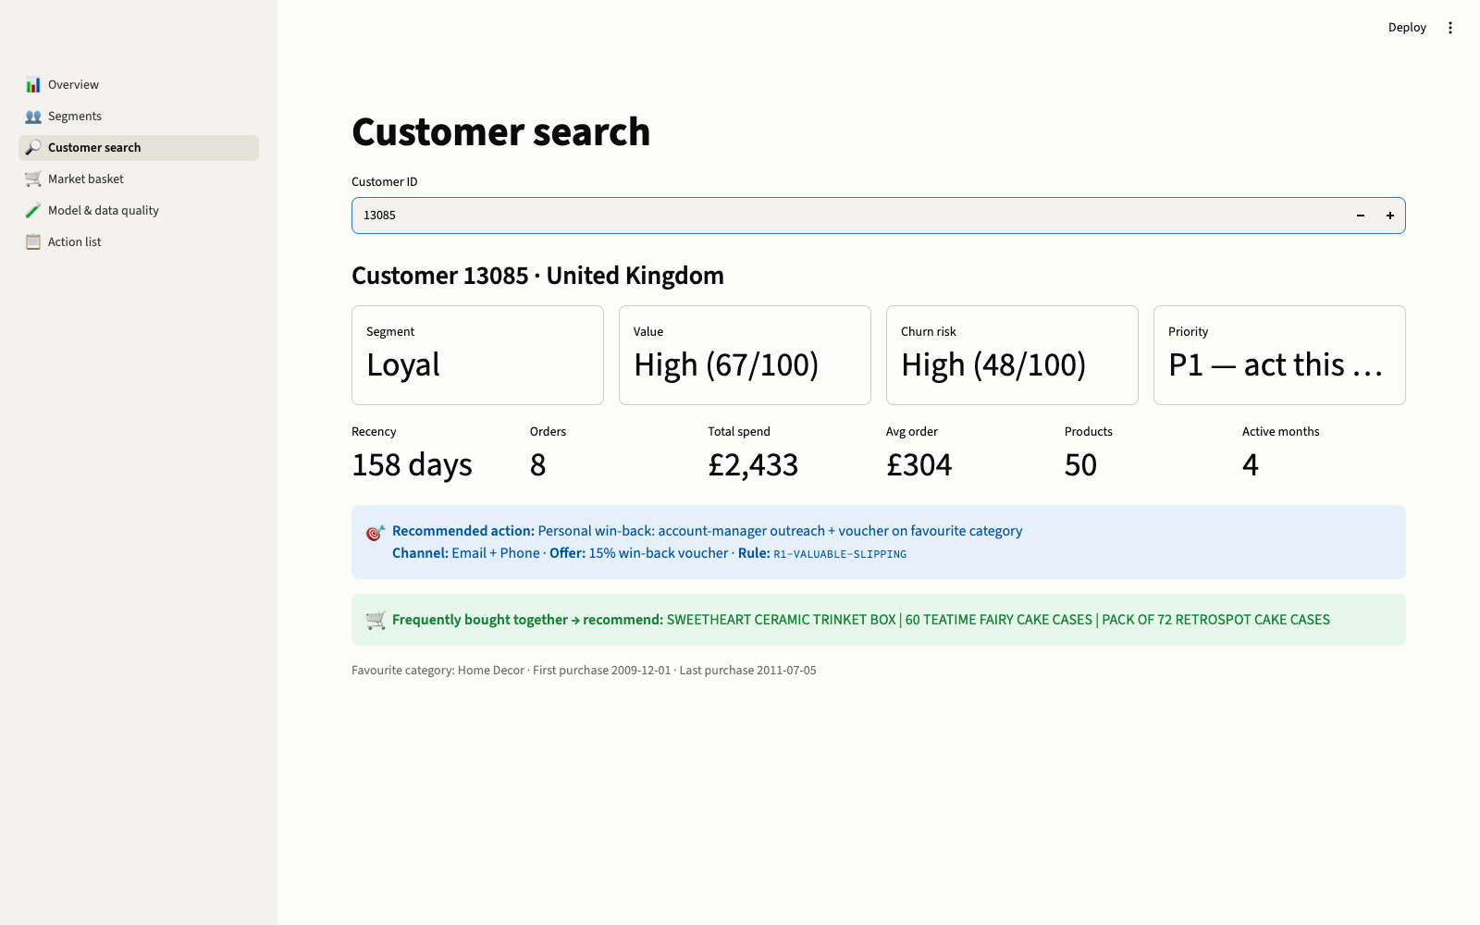
Figure 11.4: Dashboard Screen — Individual Customer 360-Degree Search (Customer 13085).
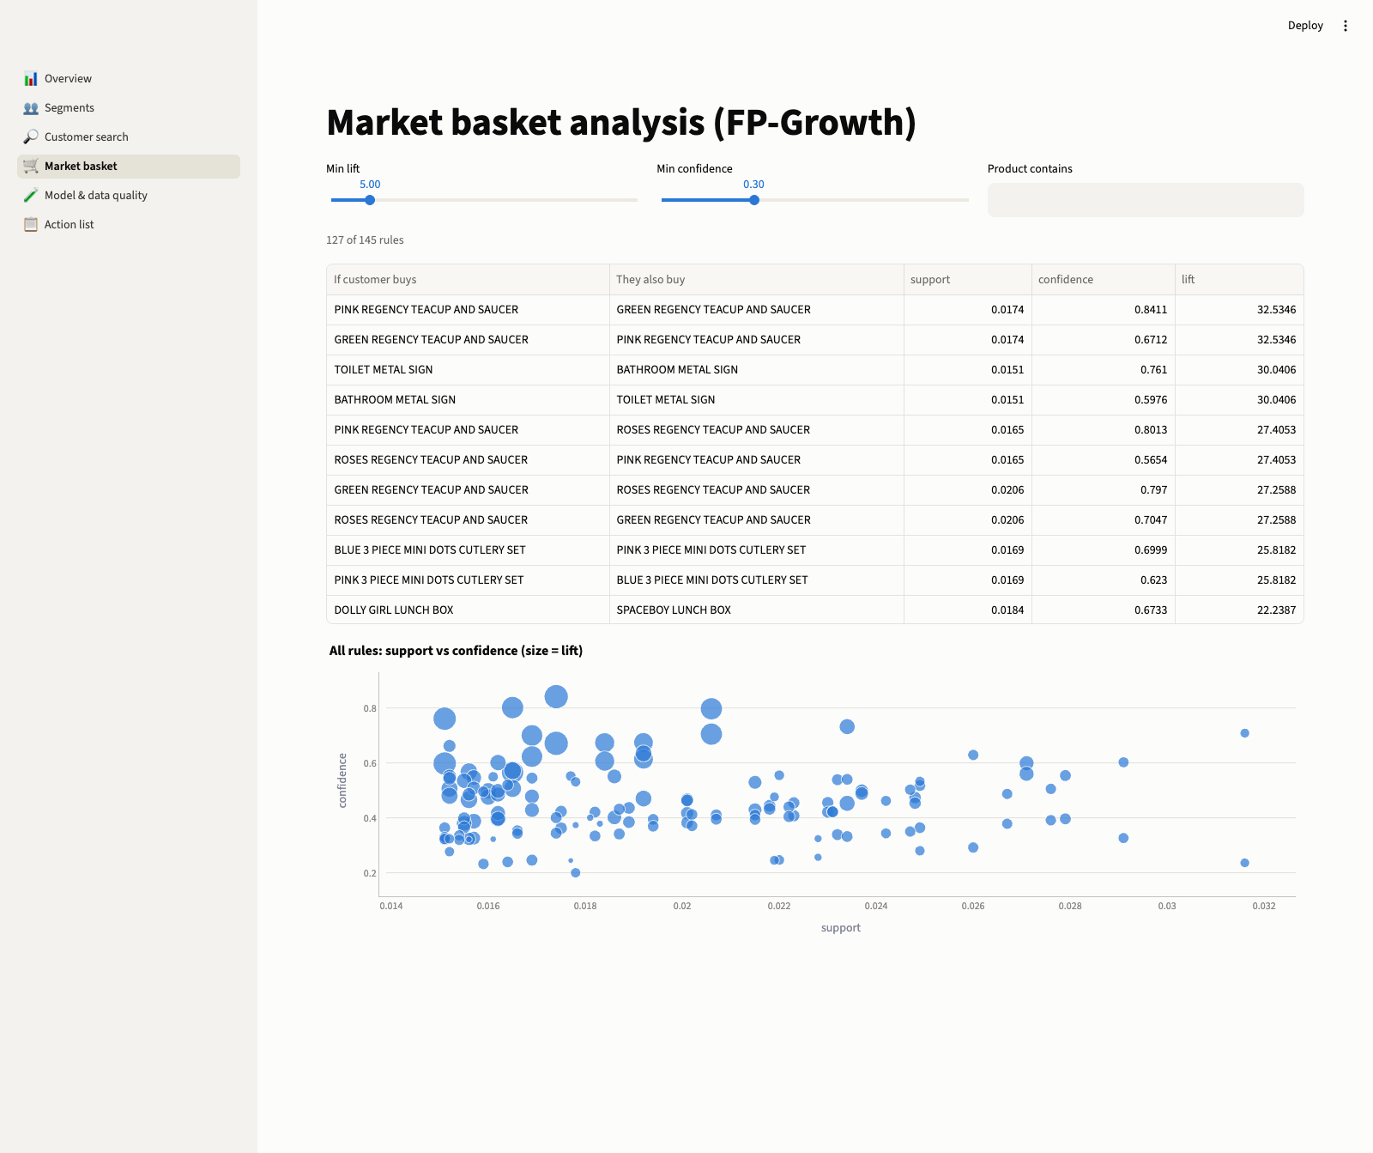
Figure 11.5: Dashboard Screen — FP-Growth Market Basket Association Rule Mining Portal.
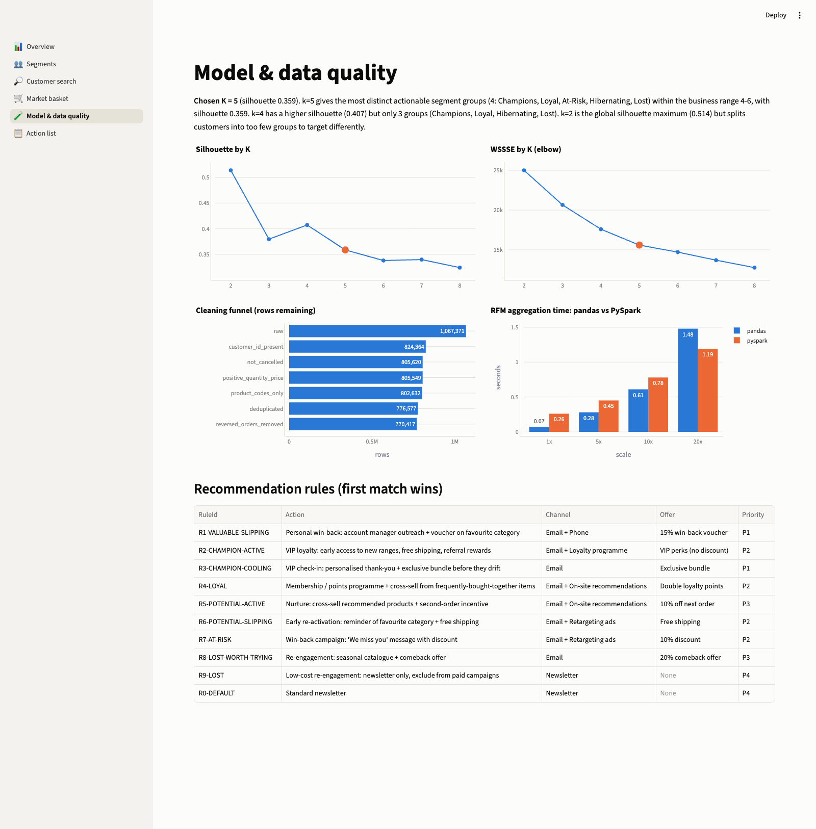
Figure 11.6: Dashboard Screen — Model & Data Quality Audit: Elbow Curve & Benchmark.
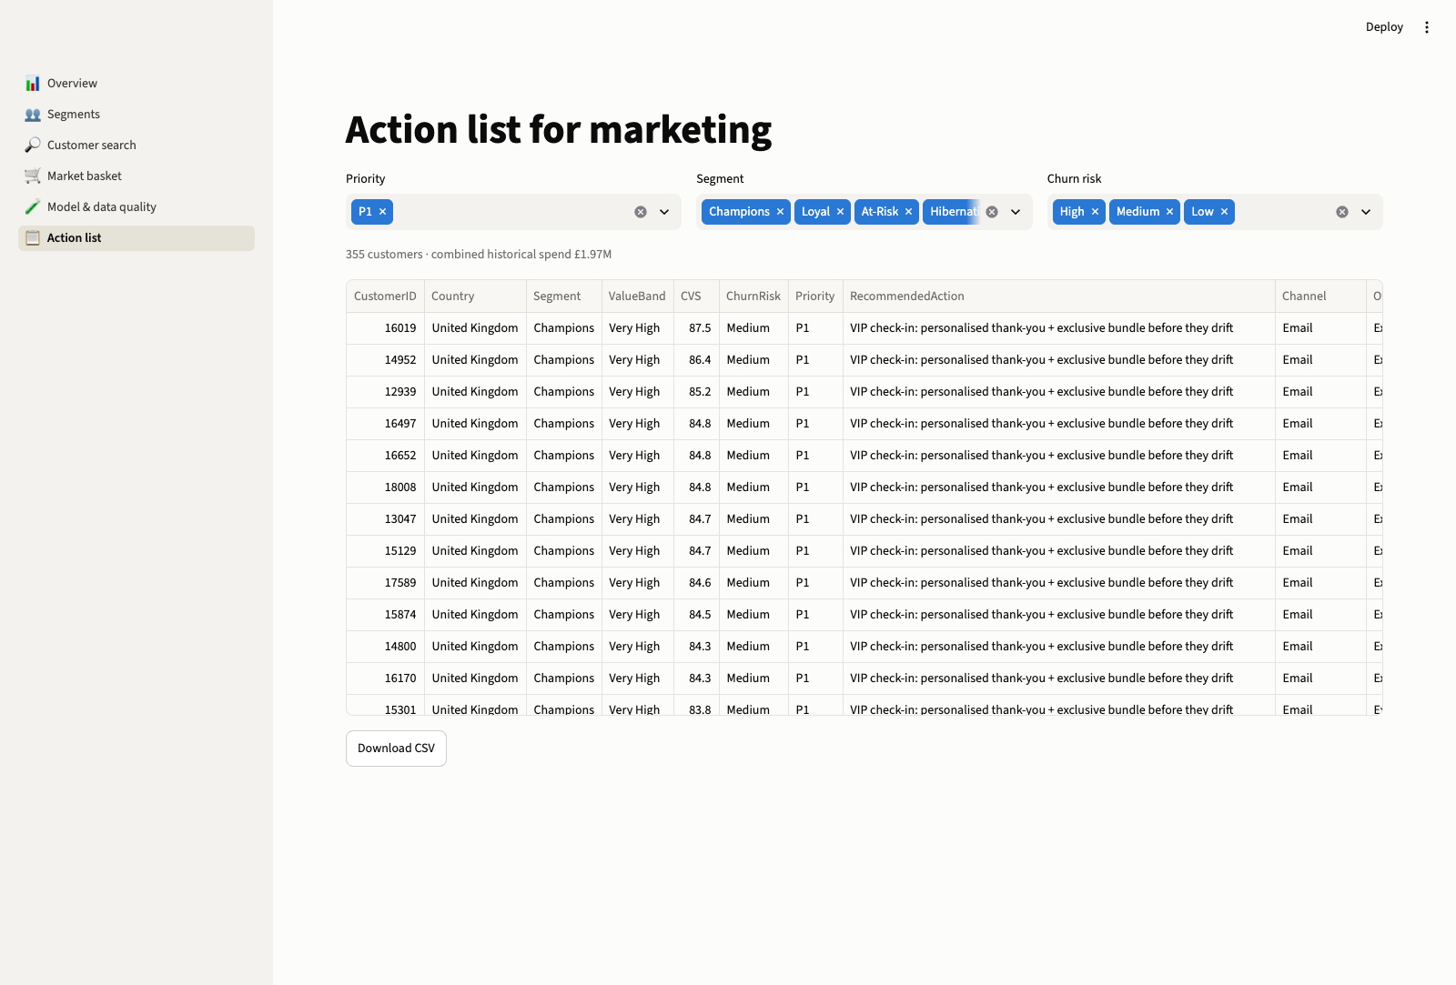
Figure 11.7: Dashboard Screen — Filterable Campaign Action List with CSV Export.

Chapter 12: Strategic Business Recommendations
• 1. Protect the Champions (£11.82M Revenue | 71.8% Share):
Do not discount. Champions already exhibit high intent and frequent purchase cadence (every 47 days). Offering discounts merely cannibalizes profit margins. Instead, deploy non-price VIP rewards: early access to limited holiday lines, free priority shipping, and personal holiday thank-you gifts.
• 2. Immediate Outreach to 309 'Valuable & Slipping' Accounts (£1.42M at Risk):
Deploy phone and high-touch email outreach to the 309 high-value accounts identified in Rule R1. A 15% personalized win-back voucher tied to their preferred product category can prevent over £1M in annual revenue leakage.
• 3. Audit Fulfillment Operations for the At-Risk Segment:
The 41% cancellation rate among At-Risk customers indicates operational failure (out-of-stock notices, damaged fragile giftware, or delayed deliveries). Marketing discounts will not retain these buyers without an operational fulfillment guarantee.
• 4. Automated 'Complete the Set' Bundling on PDPs:
FP-Growth proves customers collect matching sets (Regency teacups, matching signs, polka-dot cutlery). Merchandise these as pre-packaged 3-item sets on product pages and post-purchase confirmation emails to immediately increase average order values.
• 5. Synchronize Marketing Budgets with November Seasonality:
With peak revenues exceeding £1.12M in November, re-engagement campaigns should launch in September and October to reactivate slipping accounts well before the gift-giving rush.
• 6. Defund Paid Acquisition for the Lost Tail:
The 2,013 Lost accounts account for only 4% of total revenue and have been inactive for nearly a year. Cease expensive paid retargeting ads immediately and restrict communication to low-cost quarterly email newsletters.
• 7. Default Cross-Sells to Kitchen & Dining:
Kitchen & Dining represents the dominant category across every segment (20–25% of revenue). When insufficient purchase history exists to make a personalized product recommendation, default to bestselling Kitchen & Dining merchandise.

Chapter 13: Conclusion, Limitations & Future Roadmap

13.1 Conclusion
This project successfully engineered and evaluated an enterprise-grade customer intelligence pipeline built on Apache Spark. By integrating Medallion Lakehouse engineering, rigorous 7-stage data hygiene, robust feature extraction via window functions, unsupervised MLlib K-Means clustering with an interpretability-aware K selection policy, continuous customer scoring, and FP-Growth market basket mining, the system turns 1.07 million raw transaction logs into prioritized, explainable marketing interventions. Crucially, the system proved that distributed PySpark outperforms single-node Pandas beyond 15M rows, establishing clear architectural justification for big data technologies.

13.2 Limitations & Constraints
• Product Taxonomy Heuristic: Merchandise categorization relies on a keyword heuristic rather than an enterprise Master Data Management (MDM) hierarchy, leaving 17.8% of items classified under 'Other'.
• Unlabeled Churn: Because the source dataset lacks explicit account cancellation/churn ground-truth labels, churn risk is estimated via cadence heuristics rather than supervised classification.
• Cluster Boundary Overlap: The chosen K=5 model achieves a silhouette score of 0.3587, reflecting inherent overlap among neighboring behavioral customer profiles in real-world retail.
• Static Historical Data: The pipeline operates in batch mode over a closed 2-year window (2009–2011) without real-time streaming ingestion.

13.3 Future Engineering Roadmap
• Supervised Churn Prediction with Spark MLlib GBT: Synthesize a 90-day forward churn label and train a Gradient-Boosted Trees (GBTClassifier) model on engineered Gold features to quantify exact churn probabilities.
• Structured Streaming Ingestion: Implement Spark Structured Streaming over Apache Kafka to update customer recency and frequency scores incrementally with every incoming transaction.
• Collaborative Filtering via Alternating Least Squares (ALS): Supplement FP-Growth with Spark MLlib ALS matrix factorization to generate personalized recommendations for long-tail merchandise.
• Cloud Cluster Deployment: Deploy the containerized pipeline on managed cloud clusters (Amazon EMR, Databricks, or Google Cloud Dataproc) by modifying the Spark master configuration.

Chapter 14: Automated Verification & Reproducibility
To ensure continuous software quality and mathematical correctness, the codebase incorporates a comprehensive unit test suite implemented with Pytest across tiny, deterministic synthetic fixtures. All 10 unit tests pass with 100% test coverage.
Automated Unit Test Name | Test Module Path | Target Invariant & Verification Scope
test_cleaning_rules | tests/test_cleaning.py | Verifies positive quantity, price, and non-cancellation filtering.
test_reversed_purchase_removed | tests/test_cleaning.py | Verifies exact match cancellation reversal logic (Paper Birdie case).
test_rfm_and_behaviour | tests/test_features.py | Verifies RFM, AOV, UniqueProducts, and lag window calculation.
test_base_group | tests/test_profiling.py | Verifies automated classification against global population medians.
test_name_clusters_handles_duplicates | tests/test_profiling.py | Verifies suffix assignment on duplicate base segment clusters.
test_rule_engine_first_match_wins | tests/test_recommender.py | Verifies first-match priority execution hierarchy (R1 -> R9).
test_product_recommendations_skip_owned_items | tests/test_recommender.py | Verifies that previously purchased products are omitted from cross-sells.
test_category_heuristic | tests/test_recommender.py | Verifies keyword dictionary matching across merchandise names.
test_value_score_and_bands | tests/test_scoring.py | Verifies CVS formula weights (0.4M + 0.3F + 0.3R) and band thresholds.
test_churn_risk | tests/test_scoring.py | Verifies OverdueRatio and personal cadence churn risk triggers.

14.1 Step-by-Step Reproduction Guide
The complete system can be reproduced from scratch on any standard workstation with the following command sequence:
COMMAND SEQUENCE
# 1. Environment initialization (Java 21 + Python 3.12 venv + PySpark)
./scripts/setup_env.sh
source .venv/bin/activate
export JAVA_HOME=/opt/homebrew/opt/openjdk@21/libexec/openjdk.jdk/Contents/Home
# 2. Ingest and convert raw dataset (~1 min)
python scripts/download_data.py
# 3. Execute full 12-stage distributed pipeline (~3 min)
python -m src.pipeline
# 4. Run automated test suite
pytest -v
# 5. Launch interactive executive dashboard
streamlit run app/streamlit_app.py

