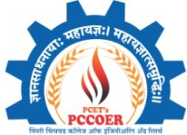 | Pimpri Chinchwad Education Trust’s  Pimpri Chinchwad College of Engineering & Research Ravet, Pune  An Autonomous Institute | NBA Accredited (4 UG Programs) | NAAC A++ Accredited | ISO 21001:2018 Certified  IQAC PCCOER | 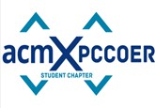
AY: 2025–26 | Report of ESP by Mr. R. Venkateswaran | Term - II

HOST CHAPTER: PCCOER ACM Student Chapter
DATE: 12th January 2026
VENUE: PCCOER Auditorium (6th floor)
NUMBER OF ATTENDEES: 248

TITLE: Eminent Speaker Program on “Evolution of AI, Agentic AI & the Future of Artificial Intelligence” by Mr. R. Venkateswaran.

SUMMARY:
The Eminent Speaker Program 2026 was successfully conducted on Monday, 12 January 2026, under the PCCOER ACM Student Chapter, featuring Mr. R. Venkateswaran, an eminent academician and industry expert with academic credentials from IIT Bombay and Washington State University. The session was held at the New Auditorium (6th Floor) and witnessed enthusiastic participation from students across engineering disciplines.
The program commenced with the formal felicitation of the speaker, followed by an insightful technical talk on “Evolution of AI, Agentic AI & the Future of Artificial Intelligence.” During the session, Mr. Venkateswaran traced the evolution of artificial intelligence from traditional rule-based systems to modern intelligent and autonomous models. He elaborated on the rapid growth of AI in the global market, highlighting trends in AI investments, adoption across industries, and the expanding role of AI in decision-making systems.
The speaker provided valuable insights into AI and Machine Learning advancements, emerging AI agents, and their real-world applications. He discussed current AI statistics, market growth patterns, and how agentic AI is shaping the future by enabling autonomous, goal-driven systems. The talk also emphasized the career opportunities and skill requirements for students aspiring to work in AI-driven domains.
An interactive discussion session followed, where students actively engaged with the speaker by asking questions related to AI evolution, industry expectations, ethical considerations, and

future career paths. The interaction helped bridge the gap between academic learning and industry trends, motivating students to explore AI and ML more deeply.
The program concluded with a vote of thanks, expressing gratitude to Mr. R. Venkateswaran for his enlightening session and valuable guidance. The Eminent Speaker Program 2026 proved to be a highly informative and inspiring experience, enriching students’ understanding of the present and future landscape of Artificial Intelligence.

EVENT POSTER AND MESSAGE:

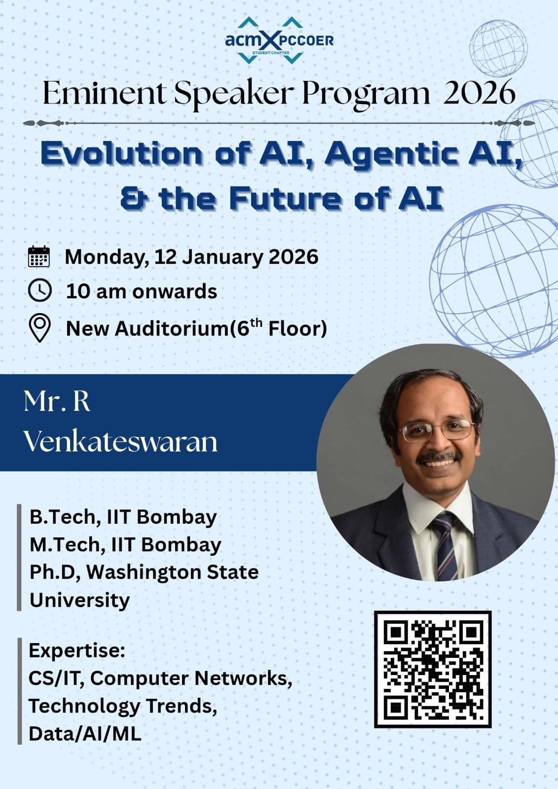
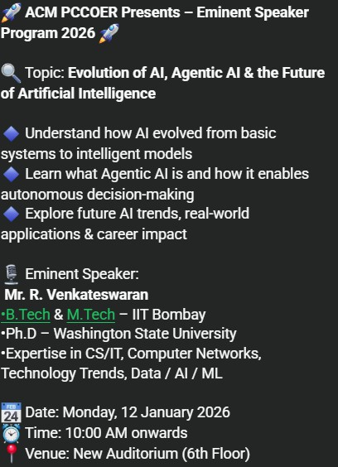

EVENT IMAGES:

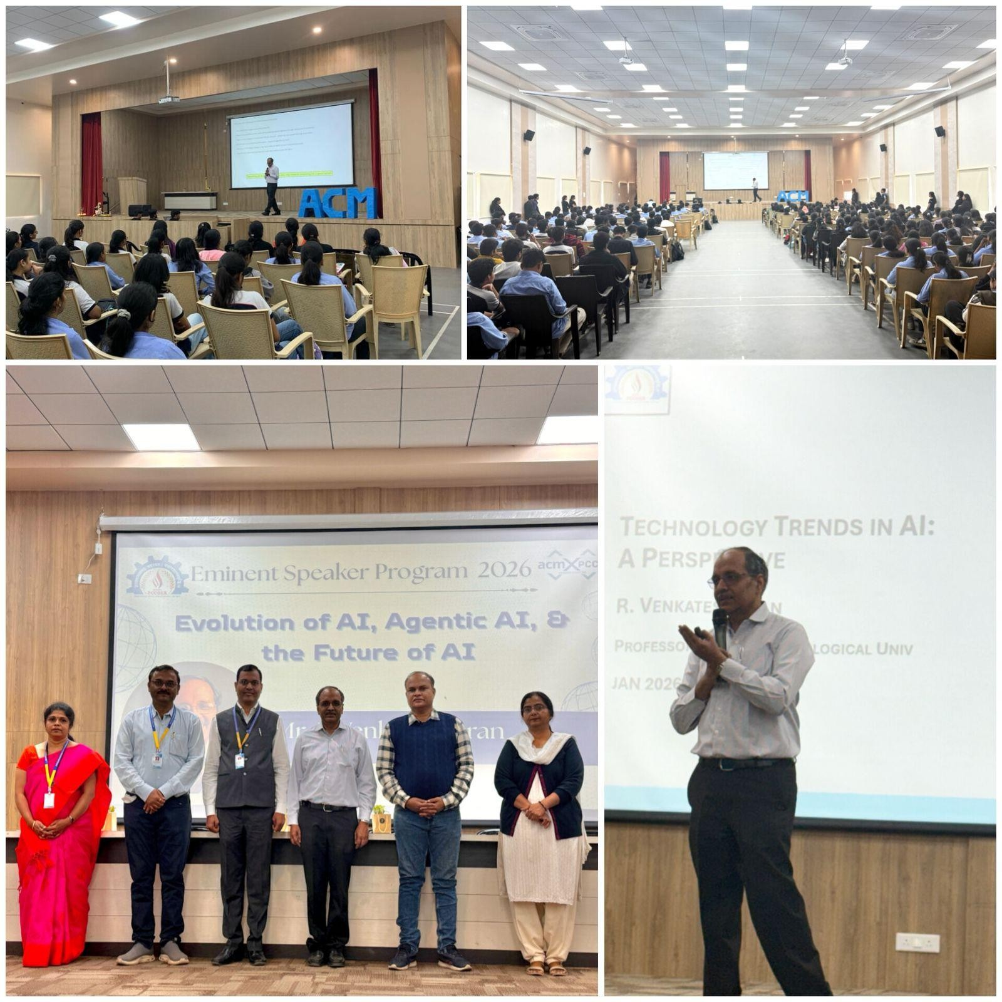

EVENT FEEDBACK:

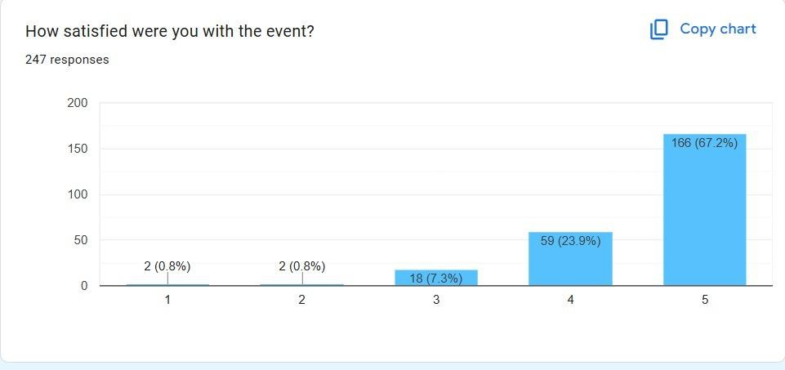
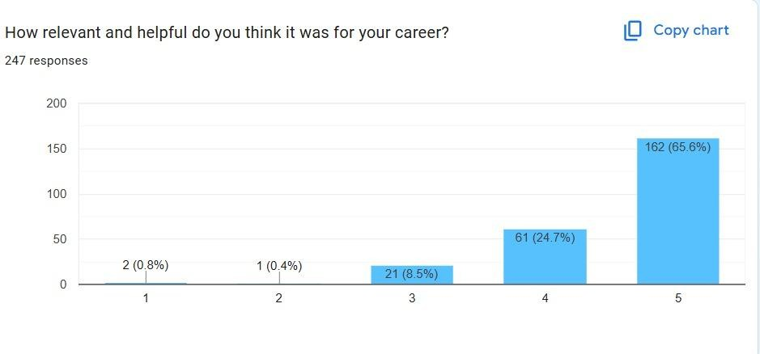

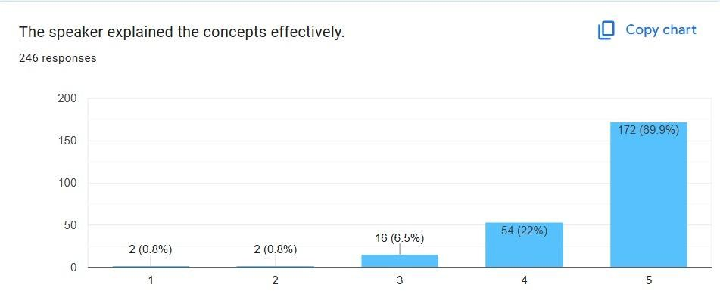

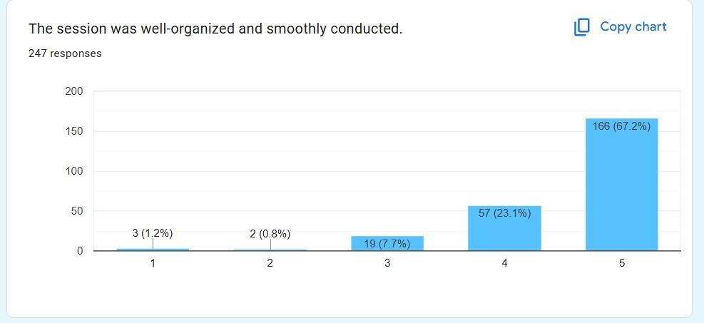

INSTITUTE FEEDBACK:
The Speaker had a good clarity, was very positive with his body language, was confident while delivering his session and had many visuals for better understanding
The speaker was very interactive with the crowd and was very wise and humble.

