**Assignment # 6**

**Course: Database Systems**

**Use Company database as given earlier**

1. Change salary of employee 130 to salary of the employee with first name ‘joe’. If ‘joe’ is not found then take average salary of all employees. If more than one employee with first name ‘joe’ is found, then take the least salary of them and set the salary of employee 130.
2. Display 5th and 10th employee information using cursor.
3. Create a function that takes Dept_id and returns name of the manager.
4. Create a procedure that takes the Dept_id and change the manager_id of the dept to employee in the dept with highest salary.
5. Create a trigger to ensure salary of the employees is not decreased.
6. Write a trigger to check whether the salary of an employee to be inserted in employee table doesn’t violate the min-max salary constraint of the corresponding job ID. If it violates the constraint raise an exception with some message.
7. List the name and salary of employees of the department 20 who are leading a project that started before December 31, 1990.
8. Write a cursor to show the job title and name of those employees who have been hired after a given date (supplied by user), and who have a manager working in a given department (supplied by user).
9. Write a trigger for the following:
10. If dept number or job type of any employee gets updated in the EMPLOYEES table then insert <EMPNO, :old.jobtype, :new.jobtype, :old.deptno, :new.deptno, change_date, user, type of change> of those employees in a newly created table EMPLOYMENT_CHANGE() with required fields. Also incorporate the date of update and user who has modified the record in the EMPLOYMENT_CHANGE table
11. If an employee record is deleted (resigns the organization), insert (empno, ename, deptno, release date) in a newly created table EXEMPLOYEE() with required fields.
12. Write a PL/SQL procedure to increase the salary of all employees who work in the department given by the procedure's parameter. Use a cursor for update.

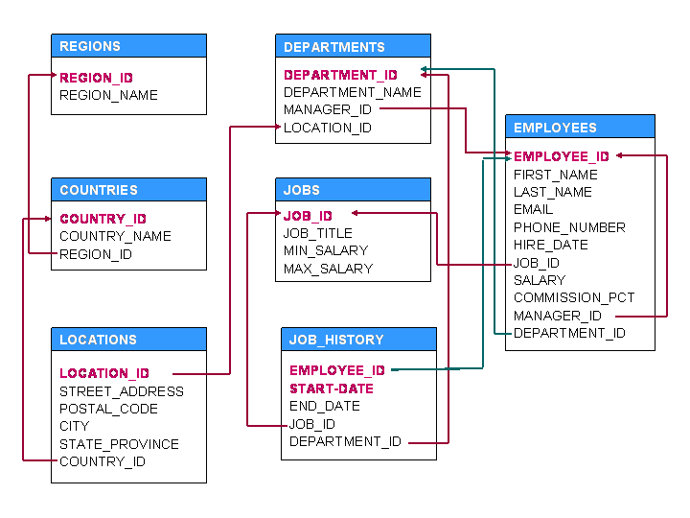

1. Given a relation graph (P,Q, cost) where P and Q attributes represent vertices associated to edges in the graph and cost represent weight.

Write SQL/PL-SQL program for the followings

(i) Find the vertices with max and min degree.

(ii) List all the path of length 2 with total cost less than 10.

1. Consider following two relations

Book_stock(**Book_id**, Title, No of Copies)

Book_Issue(tr_id, **card_no**, cholder_name, **book_id**, issue_date, due_date)

Book_Return(tr_id, **card_no**, cholder_name, **book_id**, return_date, issue_date)

Write a PL/SQL program for issuing/return of books with following conditions:

The program will take option I(issue) / R(return) along with card_no from user. Accordingly, insert records in Issue and Return relations. The field Tr_id must be populated from sequence. Date of issue/return must be populated with SYSDATE. Before issuing book, check the following constraints: A member is not allowed to issue more than 3 books. A member is not allowed to issue more than one copy of same bookid.

After issuing/return of book the no of copies must be updated. If the return date of the book is later than the due date; insert a record in a new table called Fine (card_no, amt). Assume a fixed late fine amt.