PROJECT_SIMPLE_GATES:

- OR GATE:

CODES:

or_gate.v:

`timescale 1ns / 1ps

module or_gate(

input a,
input b,
output y
);

assign y = a | b;

endmodule

tb_or_gate.v:

`timescale 1ns / 1ps

module tb_or_gate(

);

reg a,b;
wire y;

or_gate uut(a, b, y);

initial begin

a = 0; b = 0;
#10;

a = 0; b = 1;
#10;

a = 1; b = 0;
#10;

a = 1; b = 1;

$finish;

end
endmodule

OUTPUT:

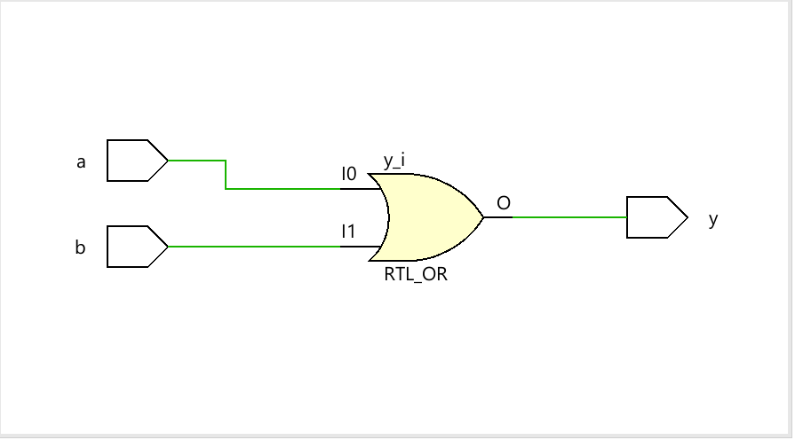

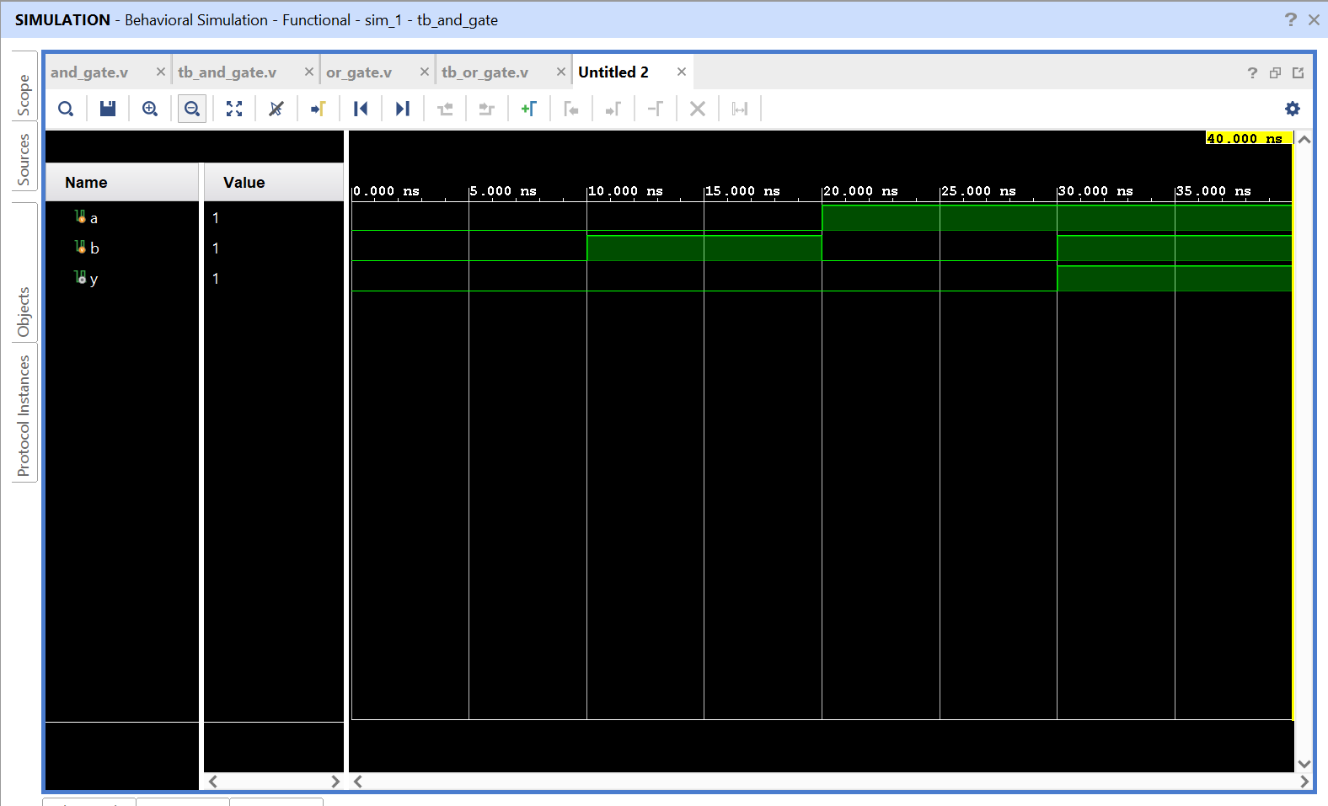

- AND GATE:

CODES:

and_gate.v:

`timescale 1ns / 1ps

module and_gate(

input a,
input b,
output y
);

assign y = a & b;

endmodule

tb_and_gate.v:

`timescale 1ns / 1ps

module tb_and_gate(

);

reg a,b;
wire y;

and_gate uut(a, b, y);

initial begin

a = 0; b = 0;
#10;

a = 0; b = 1;
#10;

a = 1; b = 0;
#10;

a = 1; b = 1;

$finish;

end
endmodule

OUTPUT:

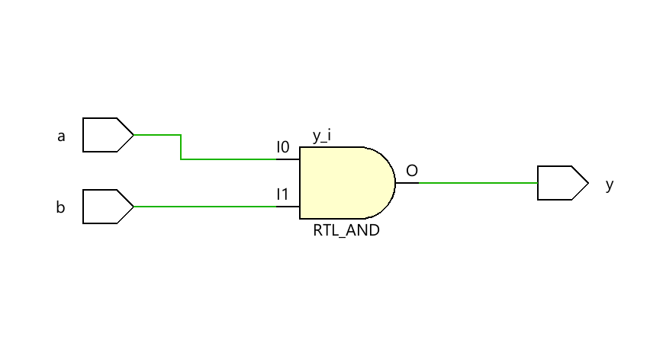

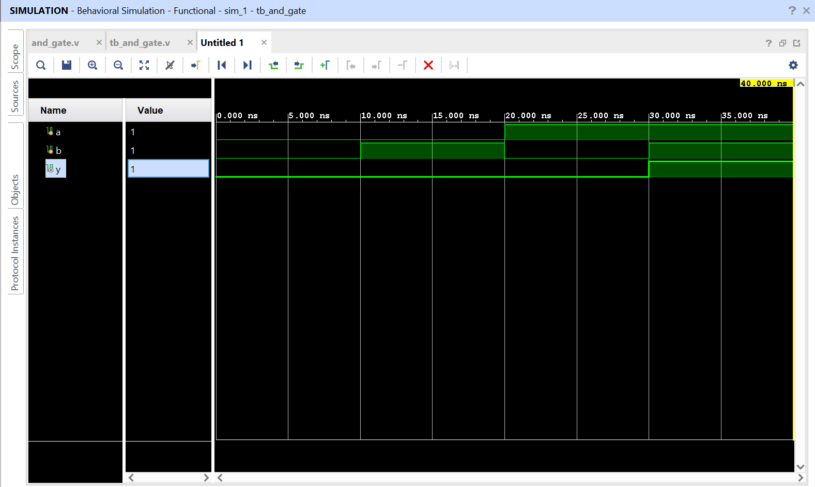

- NOT GATE:

CODES:

not_gate.v:

`timescale 1ns / 1ps

module not_gate(

input a,
output y
);

assign y = ~ a;

endmodule

tb_not_gate.v:

`timescale 1ns / 1ps

module tb_not_gate(

);

reg a;
wire y;

not_gate uut(a, y);

initial begin

a = 0;
#10;

a = 1;

$finish;

end
endmodule

OUTPUT:

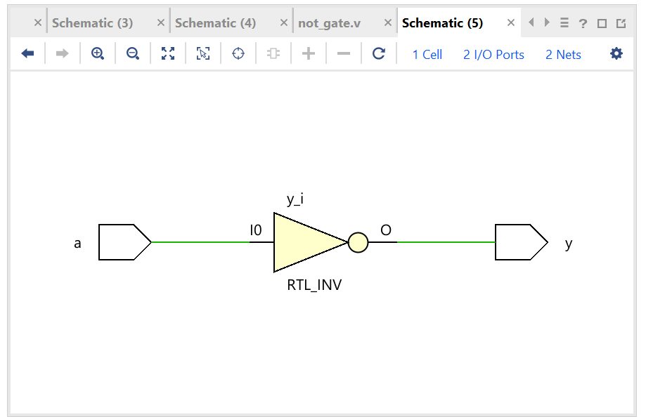

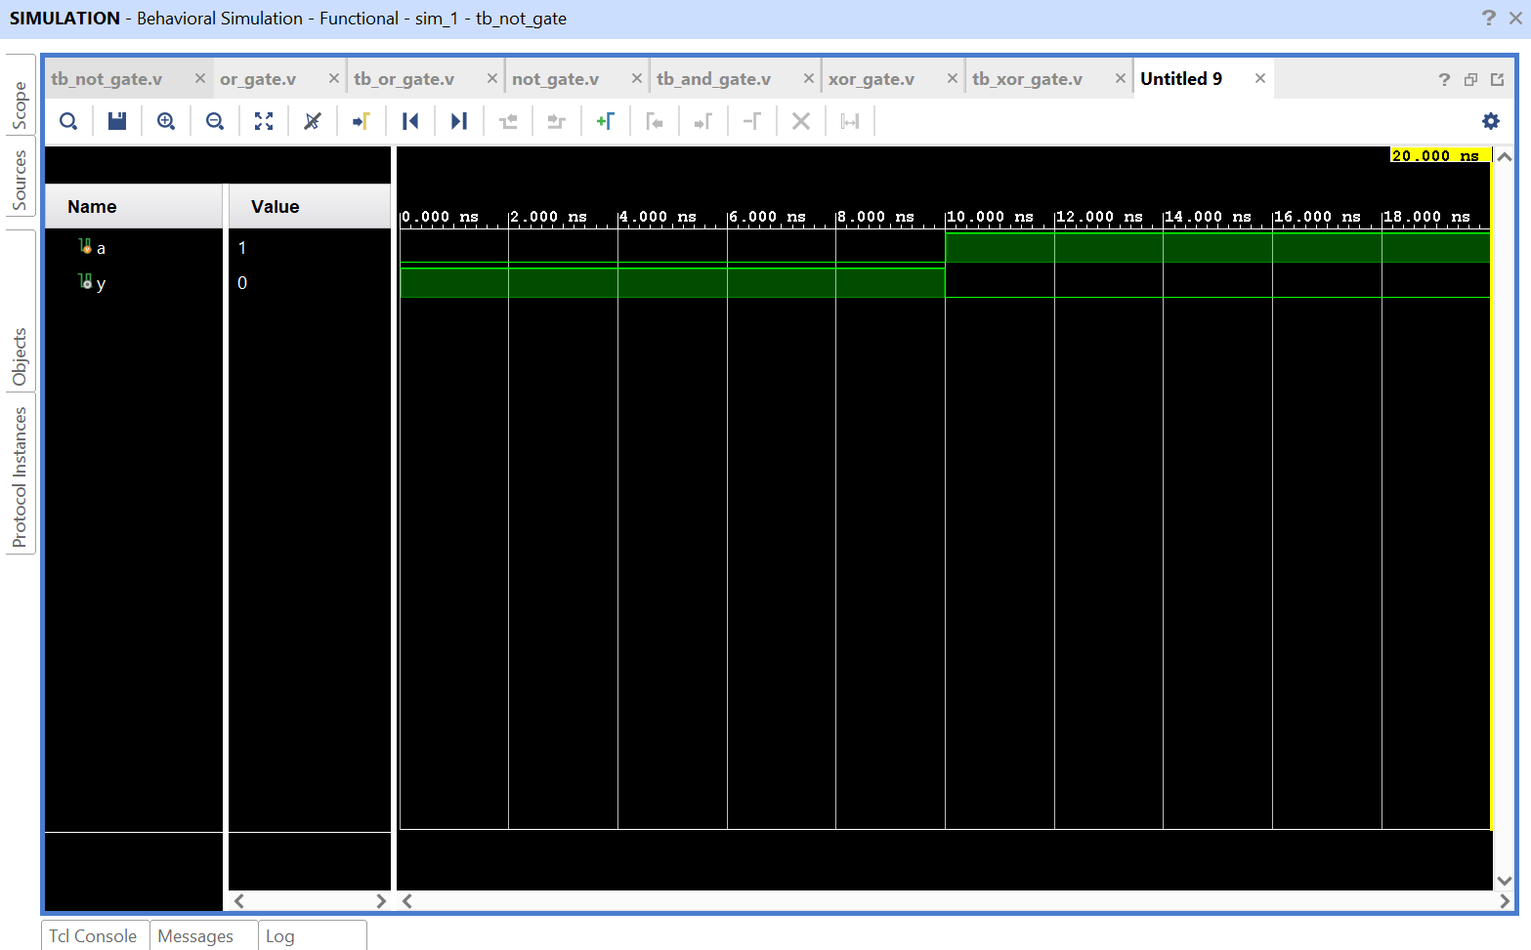

- NAND & NOR GATES:

CODES:

nand_nor.v:

`timescale 1ns / 1ps

module nand_nor_gate(

input a, b,

output x, y
);

assign x = ~(a & b);
assign y = ~(a | b);

endmodule

tb_nand_nor.v:

`timescale 1ns / 1ps

module tb_nand_nor_gate(

);

reg a, b;
wire x,y;

nand_nor_gate uut(a, b, x, y);

initial begin

a = 0; b = 0;
#10;

a = 0; b = 1;
#10;

a = 1; b = 0;
#10;

a = 1; b = 1;

$finish;

end

endmodule

OUTPUT:

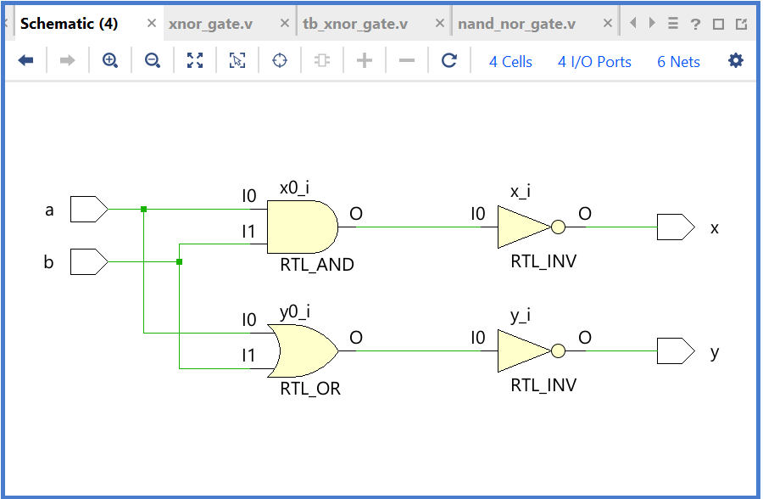

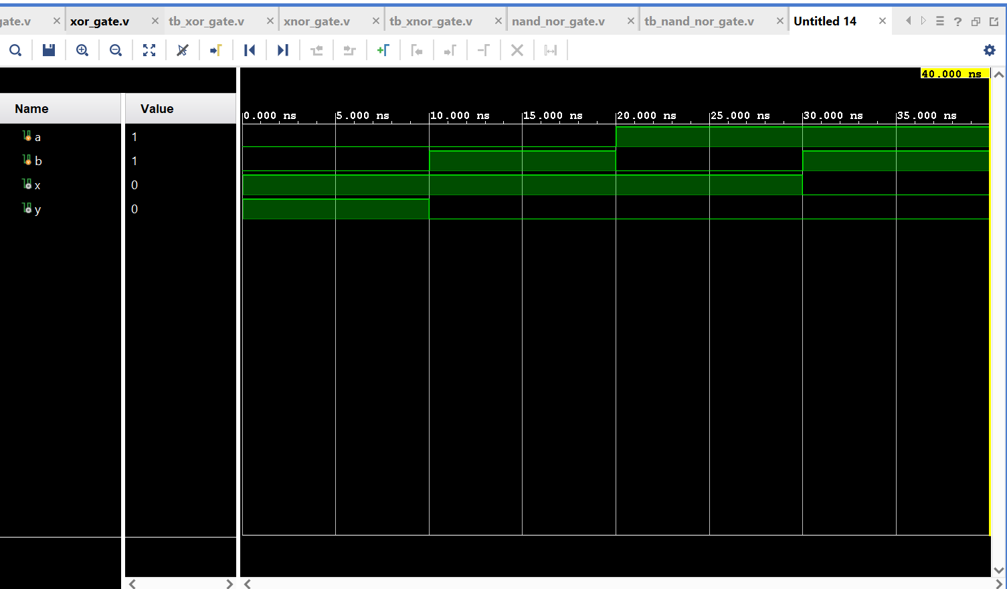

- XOR GATE:

CODES:

xor_gate.v:

`timescale 1ns / 1ps

module xor_gate(

input a,
input b,
output y
);

assign y = a ^ b;

endmodule

tb_xor_gate.v:

`timescale 1ns / 1ps

module tb_xor_gate(

);

reg a,b;
wire y;

xor_gate uut(a, b, y);

initial begin

a = 0; b = 0;
#10;

a = 0; b = 1;
#10;

a = 1; b = 0;
#10;

a = 1; b = 1;

$finish;

end
endmodule

OUTPUT:

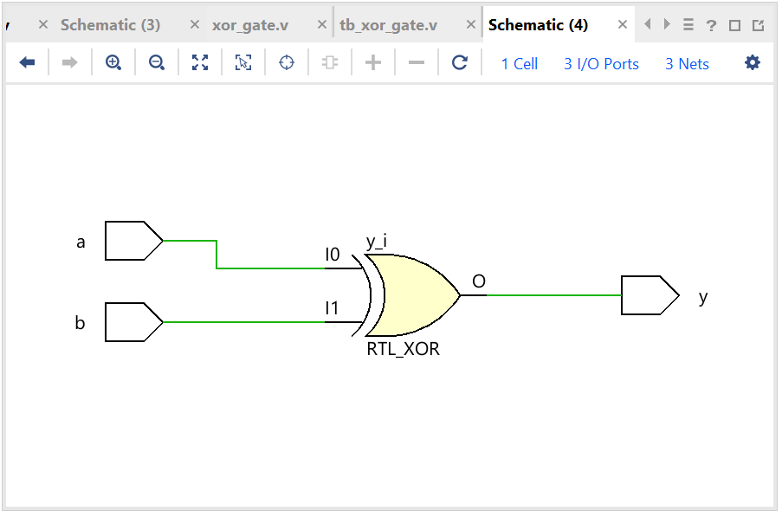

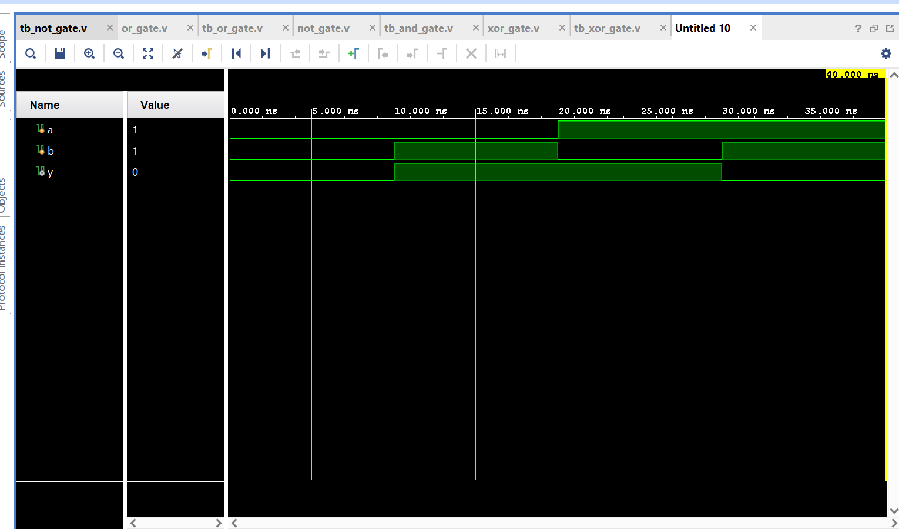

- XNOR GATE:

CODES:

xnor_gate.v:

`timescale 1ns / 1ps

module xnor_gate(

input a,
input b,

output y

);

assign y = a ~^ b;
endmodule

tb_xnor_gate.v:

`timescale 1ns / 1ps

module tb_xnor_gate(

);

reg a, b;
wire y;

xnor_gate uut(a, b, y);

initial begin

a = 0; b = 0;
#10;

a = 0; b = 1;
#10;

a = 1; b = 0;
#10;

a = 1; b = 1;

$finish;

end

endmodule
OUTPUT:

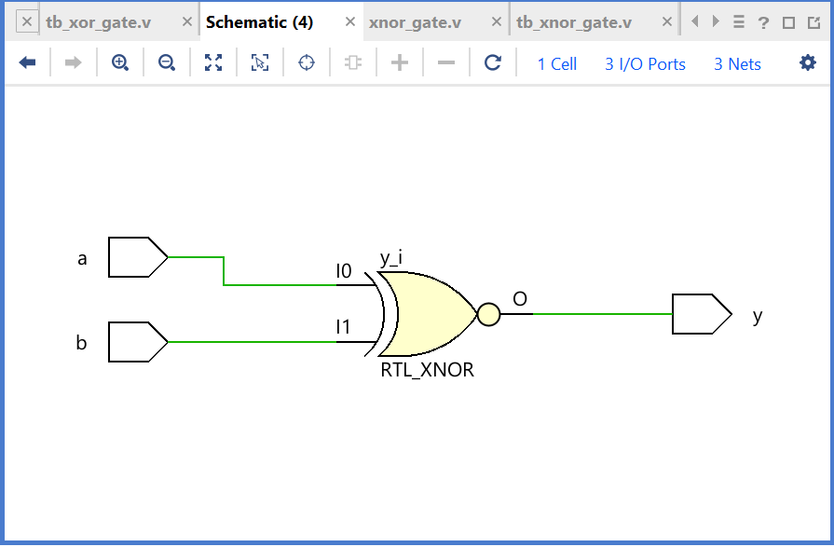

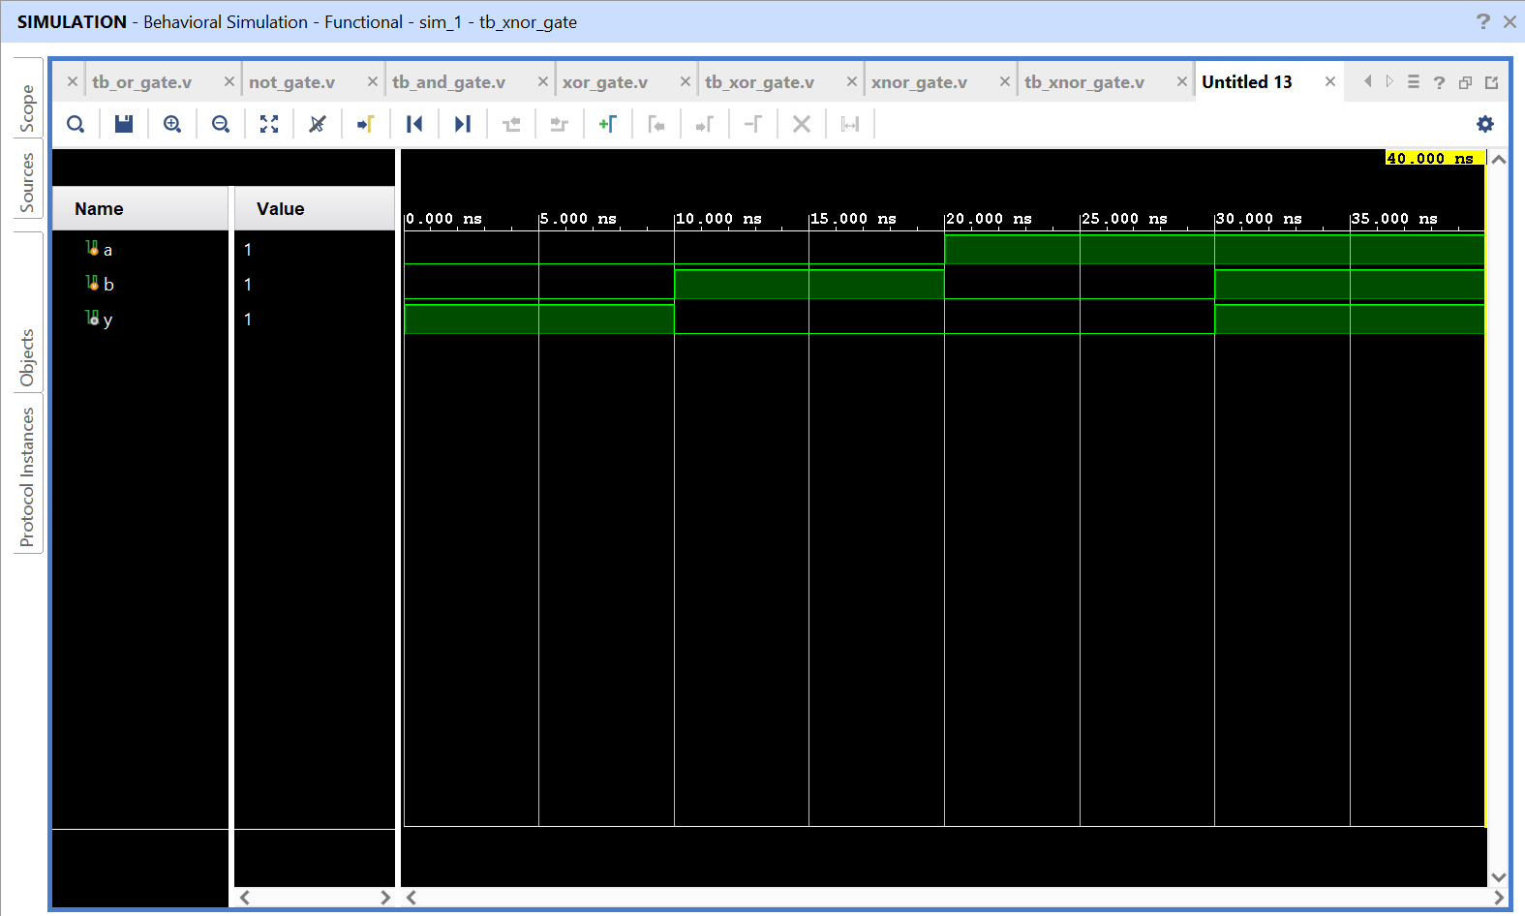
PROJECT_BOOLEAN_EXPRESSION:

- BOOLEAN 1: Y = A.(B+(~C))

boolean_1.v:

`timescale 1ns / 1ps

module boolean_1(

input a, b, c,
output y

);

assign y = a & (b | (~c));
endmodule

tb_boolean_1.v:

`timescale 1ns / 1ps

module tb_boolean_1(

);

reg a, b, c;
wire y;

boolean_1 uut (a, b, c, y);

initial begin

a = 0; b = 0; c = 0; //000
#10;

a = 0; b = 0; c = 1; //001
#10;

a = 0; b = 1; c = 0; //010
#10;

a = 0; b = 1; c = 1; //011
#10;

a = 1; b = 0; c = 0; //100
#10;

a = 1; b = 0; c = 1; //101
#10;

a = 1; b = 1; c = 0; //110
#10;

a = 1; b = 1; c = 1; // 111

$finish;

end
endmodule

OUTPUT:

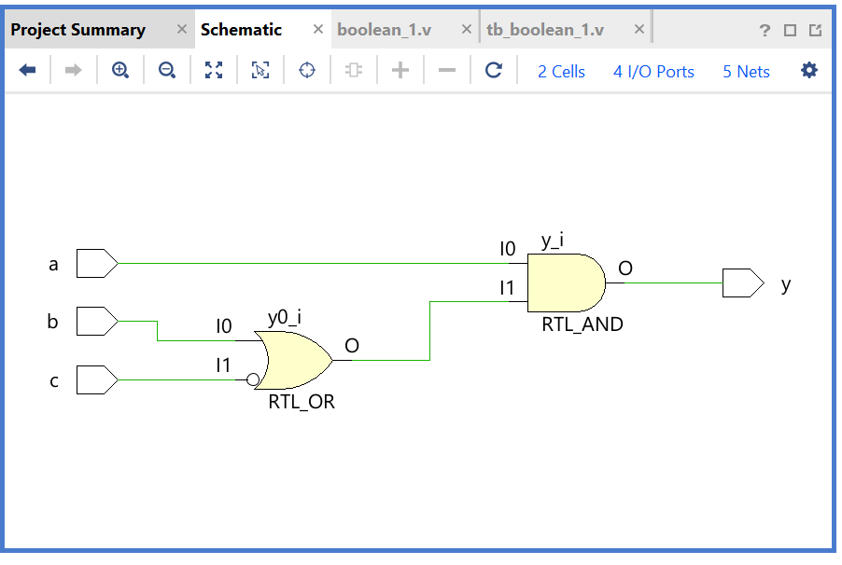
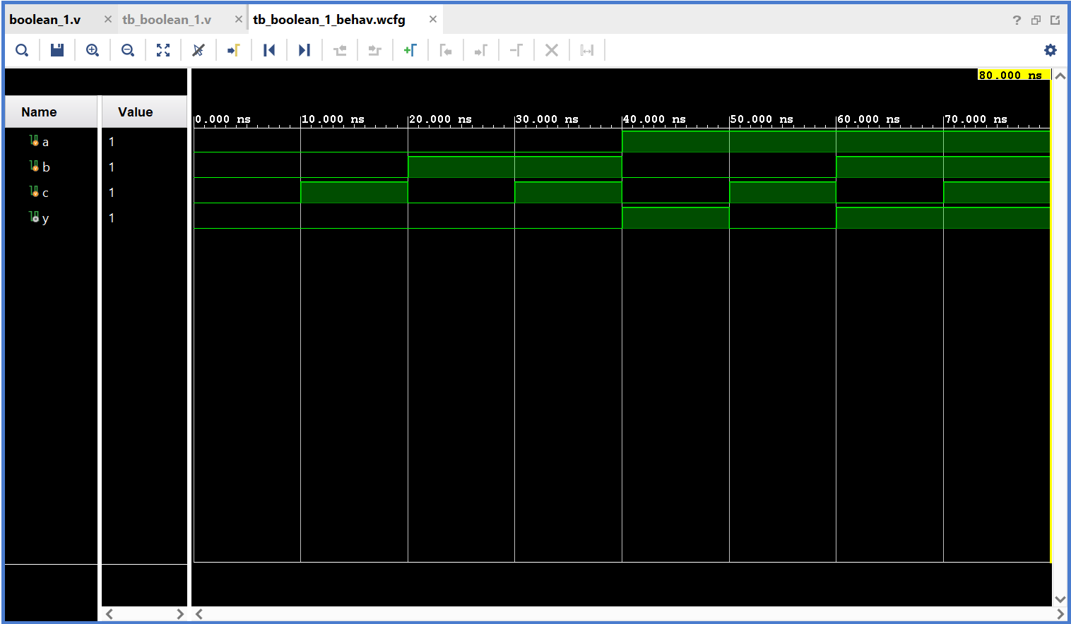

- BOOLEAN 2: Y=((~A).(B+C)) + ((A+B).(~C))

CODES:

boolean_2.v:
`timescale 1ns / 1ps

module boolean_2(

input a, b, c,
output y

);

assign y = ((~a)&(b|c))|((a|b)&(~c));
endmodule

tb_boolean_2.v:

`timescale 1ns / 1ps

module tb_boolean_2(

);

reg a, b, c;
wire y;

boolean_2 uut (a, b, c, y);

initial begin

a = 0; b = 0; c = 0; //000
#10;

a = 0; b = 0; c = 1; //001
#10;

a = 0; b = 1; c = 0; //010
#10;

a = 0; b = 1; c = 1; //011
#10;

a = 1; b = 0; c = 0; //100
#10;

a = 1; b = 0; c = 1; //101
#10;

a = 1; b = 1; c = 0; //110
#10;

a = 1; b = 1; c = 1; // 111

$finish;

end
endmodule

OUTPUT:

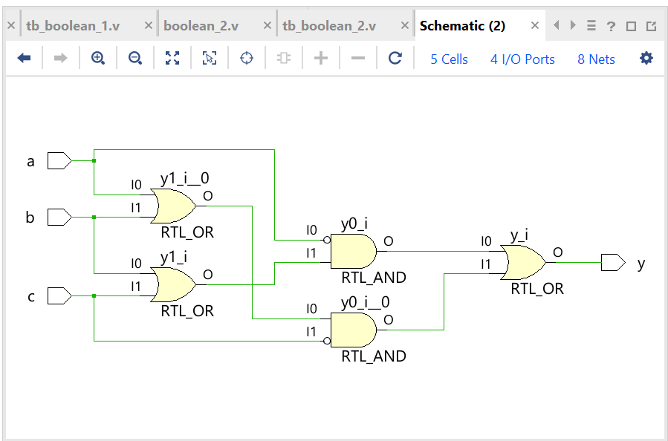

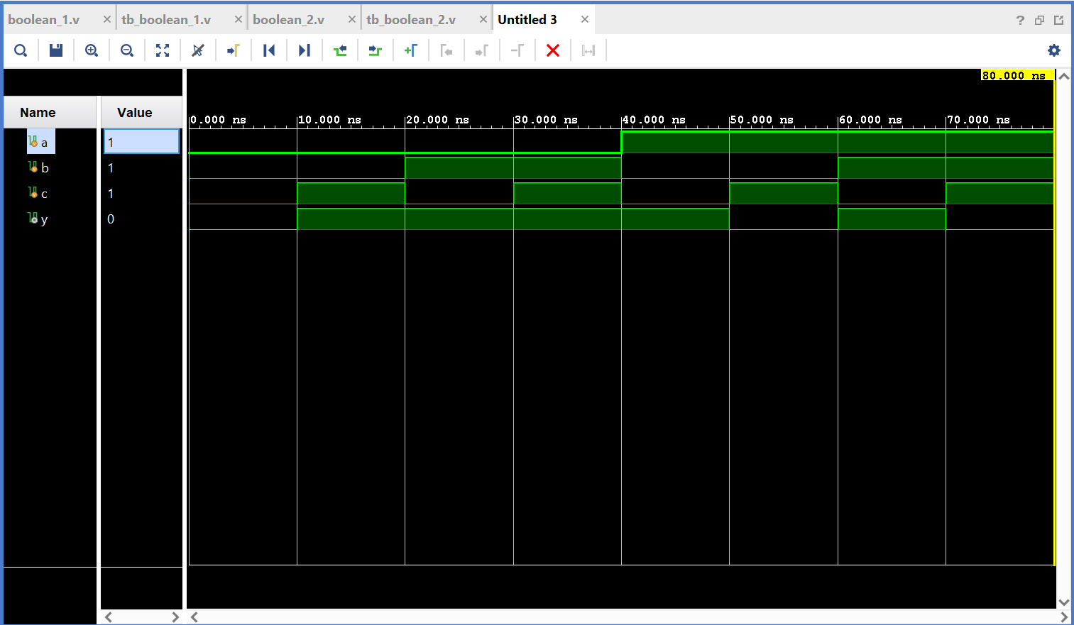

- BOOLEAN 3: Y = (A XOR B)+((A.B).(A+B))

CODES:

boolean_3.v:

`timescale 1ns / 1ps

module boolean_3(

input a, b, c,
output y

);

assign y = ((a^b)|((a&b)&(a|b)));
/* My expression has two input a and b, but I take three inputs
only just to show that it will not effect the circuit as well
as the simulation.
*/

endmodule

tb_boolean_3.v:

`timescale 1ns / 1ps

module tb_boolean_3(

);

reg a, b, c;
wire y;

boolean_3 uut (a, b, c, y);

initial begin

a = 0; b = 0; c = 0; //000
#10;

a = 0; b = 0; c = 1; //001
#10;

a = 0; b = 1; c = 0; //010
#10;

a = 0; b = 1; c = 1; //011
#10;

a = 1; b = 0; c = 0; //100
#10;

a = 1; b = 0; c = 1; //101
#10;

a = 1; b = 1; c = 0; //110
#10;

a = 1; b = 1; c = 1; // 111

$finish;

end
endmodule

OUTPUT:

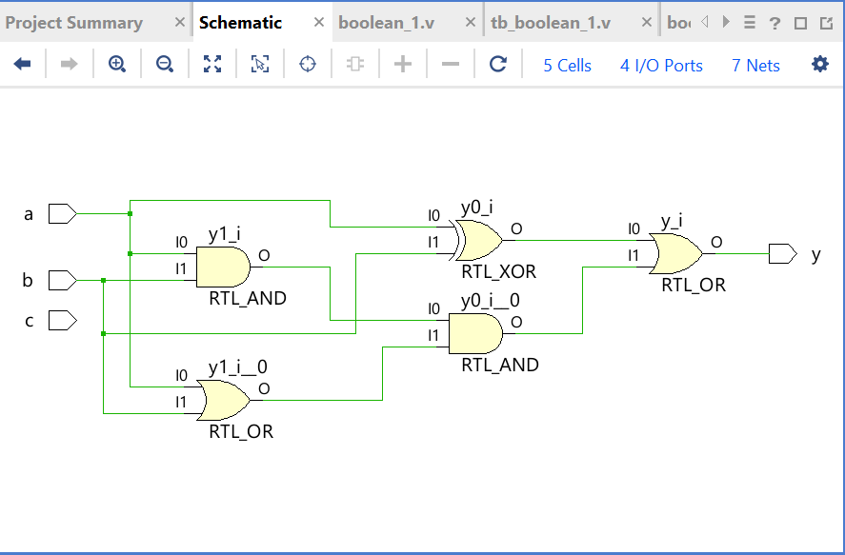
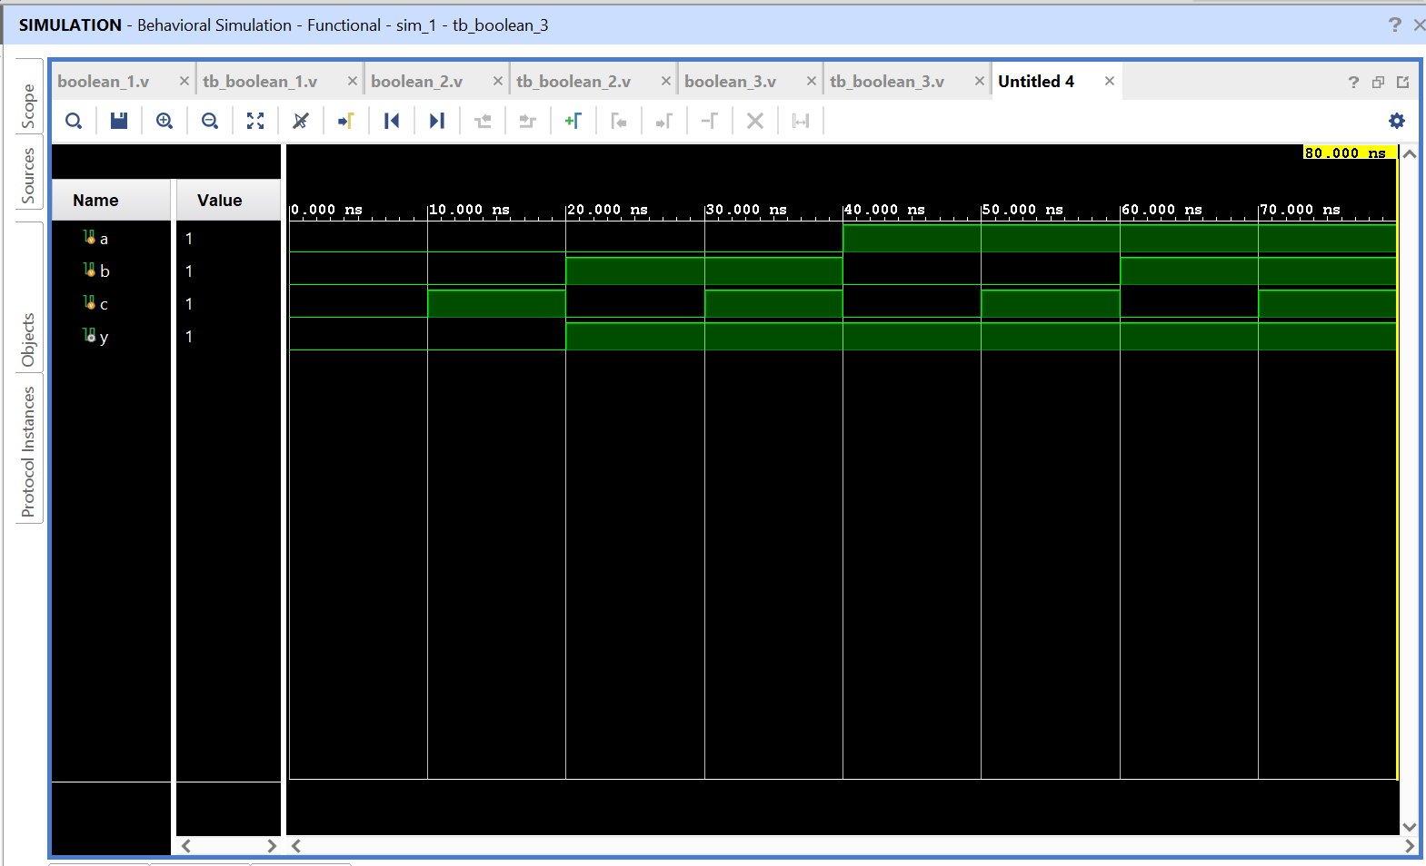

If you see the simulation, ‘c’ is treated as don`t care condition because actual Boolean expression uses ‘a’ & ‘b’ as input but in code, I take ‘a’, ‘b’ and ‘c’ as inputs to show that it will not affect the circuit diagram and simulation.
But treated ‘c’ as don`t care.

PROJECT_MUX:

- 2X1 MUX:

mux1.v:

`timescale 1ns / 1ps
module mux1(
input a,b,s0,
output y
);

assign y= (~(s0)& a) | (s0&b);

endmodule

tb_mux1.tb:

`timescale 1ns / 1ps

module tb_mux1(

);

reg a,b,s0;
wire y;
mux1 uut(a,b,s0,y);

initial begin

a=0;b=0;s0=0;
#10

a=0;b=0;s0=1;
#10

a=0;b=1;s0=0;
#10

a=0;b=1;s0=1;
#10

a=1;b=0;s0=0;
#10

a=1;b=0;s0=1;
#10

a=1;b=1;s0=0;
#10

a=1;b=1;s0=1;

$finish;
end

endmodule

OUTPUT:

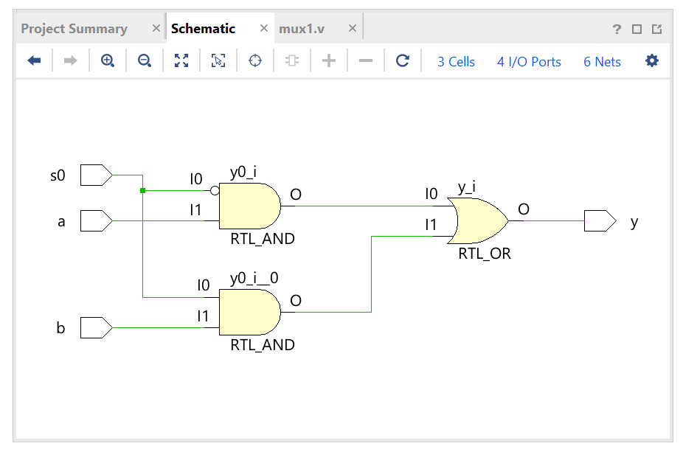
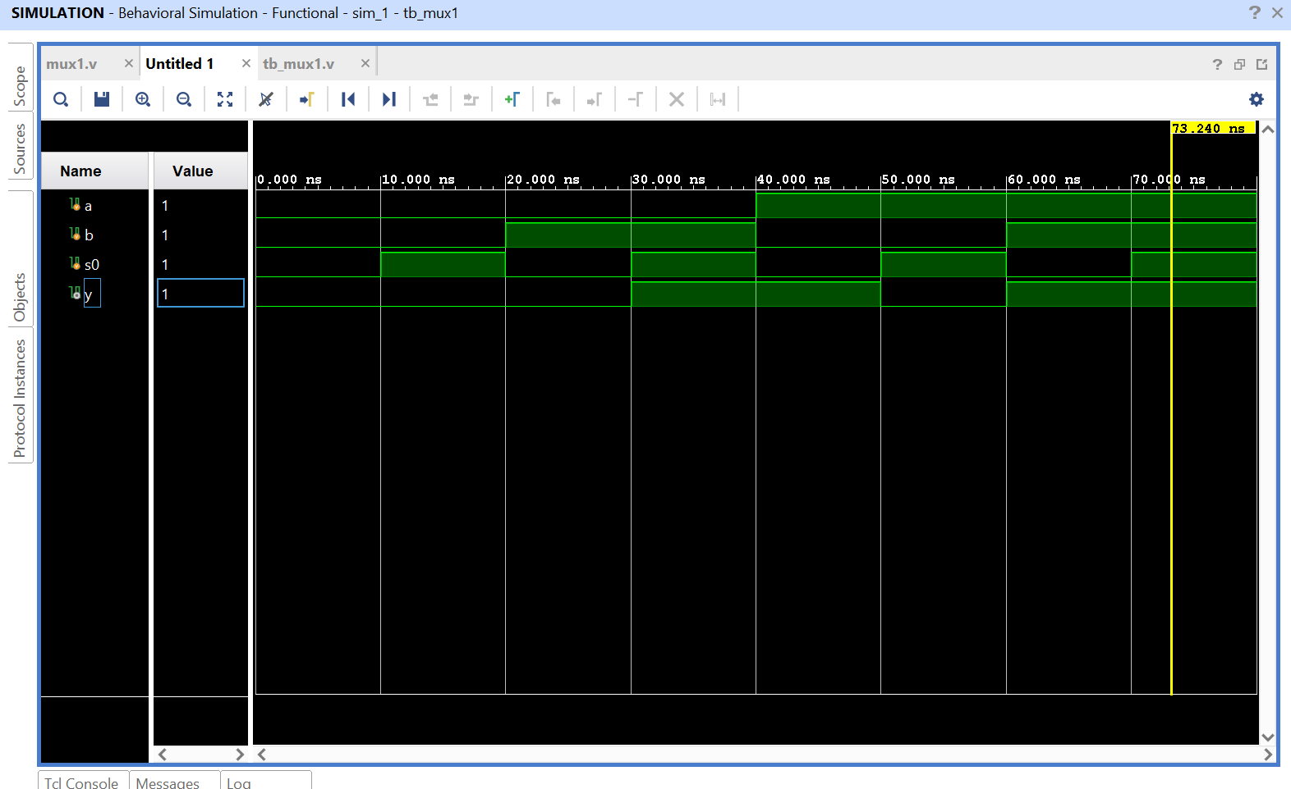

- BASIC GATES USING MUX:

CODES:

mux1_basic_gates.v:

`timescale 1ns / 1ps
module mux1_basic_gates(
input a,b,s0,
output y0, y1, y2
);

assign y0 = s0 & a;
assign y1 = ((~s0)&a)|s0;
assign y2 = ((~s0)&a)|(b&s0);

endmodule

tb_mux1_basic_gates.v:

`timescale 1ns / 1ps

module tb_mux1_basic_gates(

);

reg a,b,s0;
wire y0, y1, y2;
mux1_basic_gates uut(a,b,s0,y0, y1, y2);

initial begin

a=0;b=0;s0=0;
#10

a=0;b=0;s0=1;
#10

a=0;b=1;s0=0;
#10

a=0;b=1;s0=1;
#10

a=1;b=0;s0=0;
#10

a=1;b=0;s0=1;
#10

a=1;b=1;s0=0;
#10

a=1;b=1;s0=1;

$finish;
end

endmodule

OUTPUT:
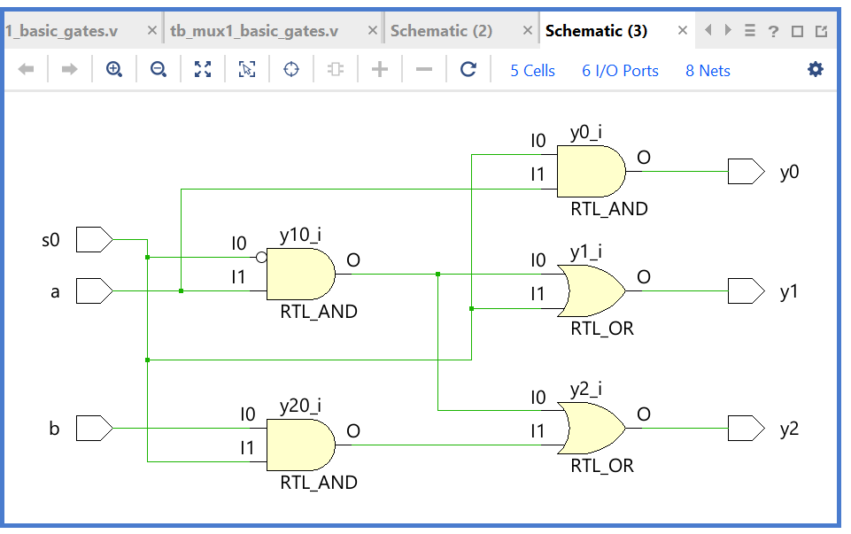
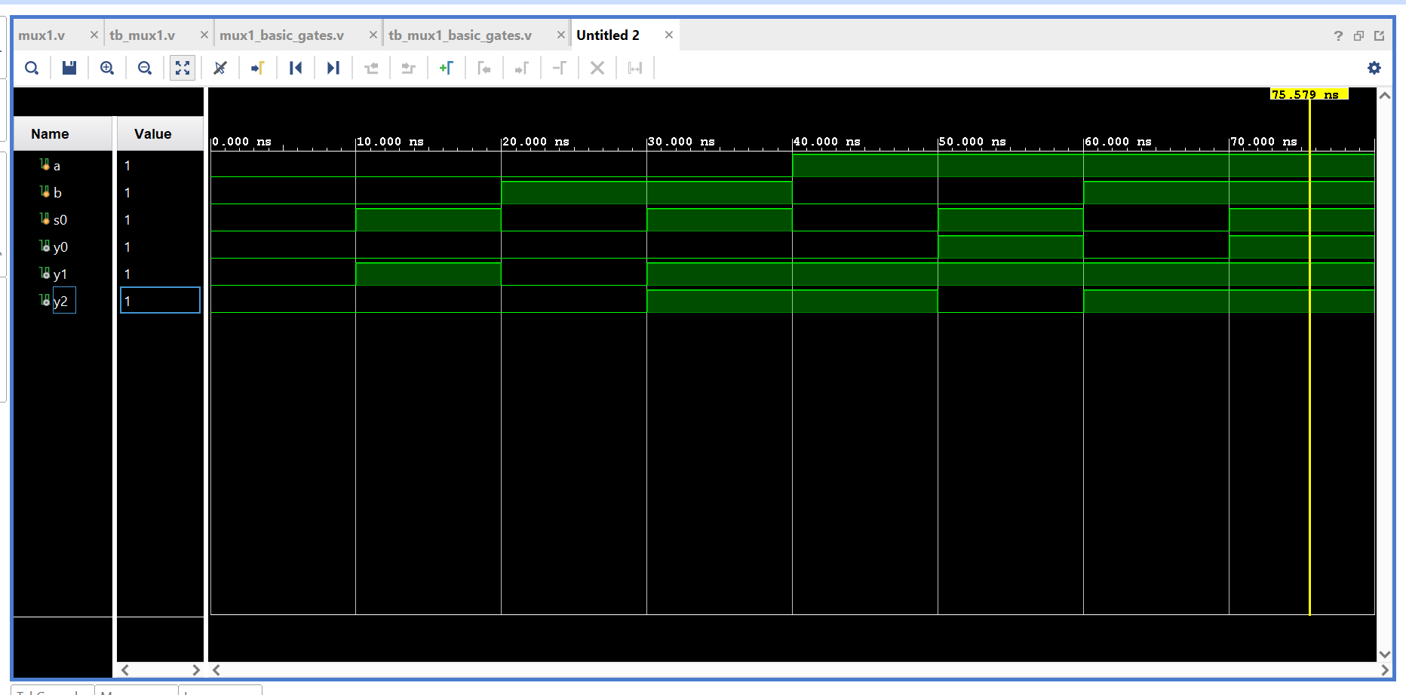
- 4x1 MUX:

CODES:

mux_4to1.v:

`timescale 1ns / 1ps

module mux_4to1(

input a, b, c, d, s0, s1,

output y

);

assign y = ((~s0)&(~s1)&a) | ((~s0)&(s1)&b)
|((s0)&(~s1)&c) | ((s0)&(s1)&d);
Endmodule

Tb_mux_4to1.v:

`timescale 1ns / 1ps

module tb_mux_4to1(

);

reg a, b, c, d, s0, s1;
wire y;

mux_4to1 uut(a, b, c, d, s0, s1, y);

initial begin

s0 = 0; s1 = 0; a = 1; b = 0; c = 0; d = 0;
#10;

s0 = 0; s1 = 1; a = 0 ; b = 1; c = 0; d = 0;
#10;

s0 = 1; s1 = 0; a = 0; b = 0; c = 1; d = 0;
#10;

s0 = 1; s1 = 1; a = 0; b = 0; c = 0; d = 1;

$finish;

end

endmodule

OUTPUT:

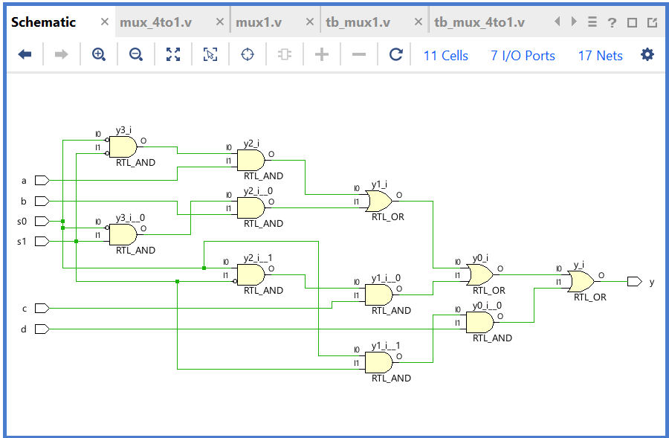

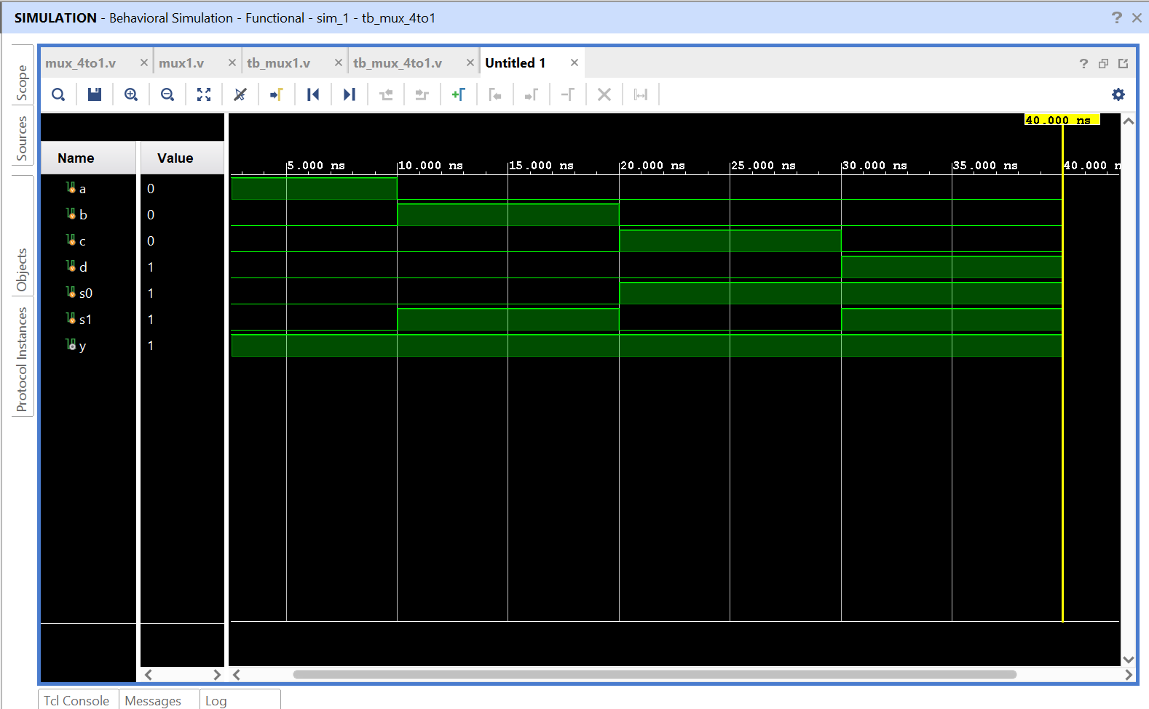

- MUX 8X1:

CODES:
mux_8to1.v:

`timescale 1ns / 1ps

module mux_8to1(

input a0, a1, a2, a3, a4, a5, a6, a7,
input s0, s1, s2,

output y

);

assign y = (~s2 & ~s1 & ~s0 & a0) | (~s2 & ~s1 & s0 & a1) |
(~s2 & s1 & ~s0 & a2) | (~s2 & s1 & s0 & a3) |
(s2 & ~s1 & ~s0 & a4) | (s2 & ~s1 & s0 & a5) |
(s2 & s1 & ~s0 & a6) | (s2 & s1 & s0 & a7);

Endmodule

tb_mux_8to1.v:

`timescale 1ns / 1ps

module tb_mux_8to1(

);

reg a0, a1, a2, a3, a4, a5, a6, a7;
reg s0, s1, s2;

wire y;

mux_8to1 uut(a0, a1, a2, a3, a4, a5, a6,a7, s0, s1, s2, y);

initial begin

s0 = 0; s1 = 0; s2 = 0; //000
a0 = 1; a1 = 0; a2 = 0; a3 = 0; a4 = 0; a5 = 0; a6 = 0; a7 = 0;
#10; // a0

s0 = 0; s1 = 0; s2 = 1; // 001
a0 = 0; a1 = 1; a2 = 0; a3 = 0; a4 = 0; a5 = 0; a6 = 0; a7 = 0;
#10; //a

s0 = 0; s1 = 1; s2 = 0; //010
a0 = 0; a1 = 0; a2 = 1; a3 = 0; a4 = 0; a5 = 0; a6 = 0; a7 = 0;
#10; // a2

s0 = 0; s1 = 1; s2 = 1;// 011
a0 = 0; a1 = 0; a2 = 0; a3 = 1; a4 = 0; a5 = 0; a6 = 0; a7 = 0;
#10; //a3

s0 = 1; s1 = 0; s2 = 0; //100
a0 = 0; a1 = 0; a2 = 0; a3 = 0; a4 = 1; a5 = 0; a6 = 0; a7 = 0;
#10; //a4

s0 = 1; s1 = 0; s2 = 1; //101
a0 = 0; a1 = 0; a2 = 0; a3 = 0; a4 = 0; a5 = 1; a6 = 0; a7 = 0;
#10; //a5

s0 = 1; s1 = 1; s2 = 0; //110
a0 = 0; a1 = 0; a2 = 0; a3 = 0; a4 = 0; a5 = 0; a6 = 1; a7 = 0;
#10; //a6

s0 = 1; s1 = 1; s2 = 1; //111
a0 = 0; a1 = 0; a2 = 0; a3 = 0; a4 = 0; a5 = 0; a6 = 0; a7 = 1;
//a7

$finish;

end
endmodule

OUTPUT:

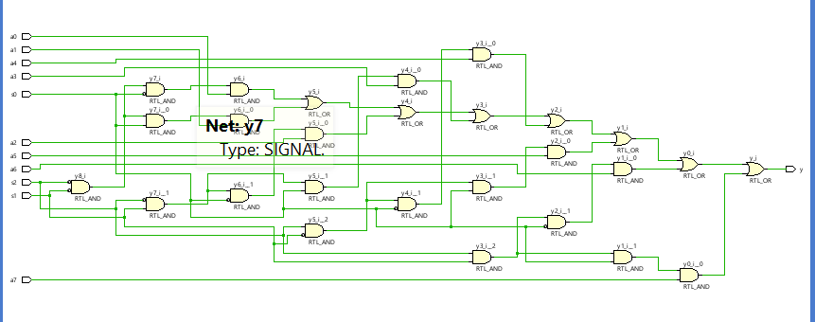
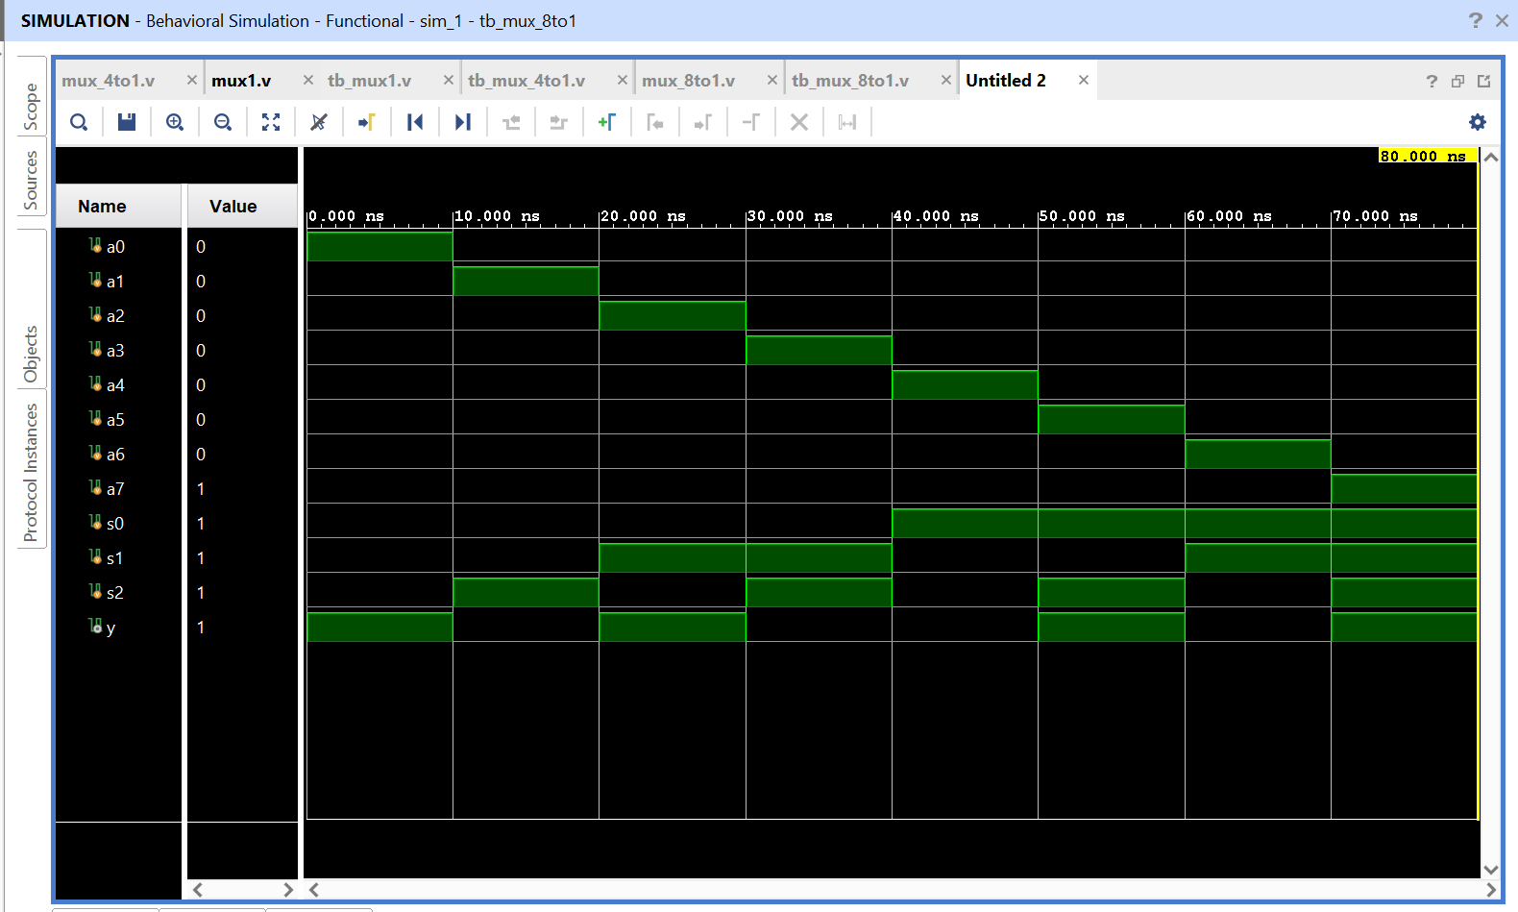

PROJECT_ENCODER_DECODER:
- ENCODER 4 TO 2:

CODES:

encoder_4to2.v:

`timescale 1ns / 1ps

module encoder_4to2(

input d0, d1, d2, d3,
output a, b

);

assign a = d2 | d3;
assign b = d1 | d3;

endmodule

tb_encoder_4to2.v:

`timescale 1ns / 1ps

module tb_encoder_4to2(

);

reg d0, d1, d2, d3;
wire a, b;

encoder_4to2 uut (d0, d1, d2, d3, a, b);

initial begin

d0 = 1; d1 = 0; d2 = 0; d3 = 0;
#10;

d0 = 0; d1 = 1; d2 = 0; d3 = 0;
#10;

d0 = 0; d1 = 0; d2 = 1; d3 = 0;
#10;

d0 = 0; d1 = 0; d2 = 0; d3 = 1;

$finish;

end

endmodule

OUTPUT:

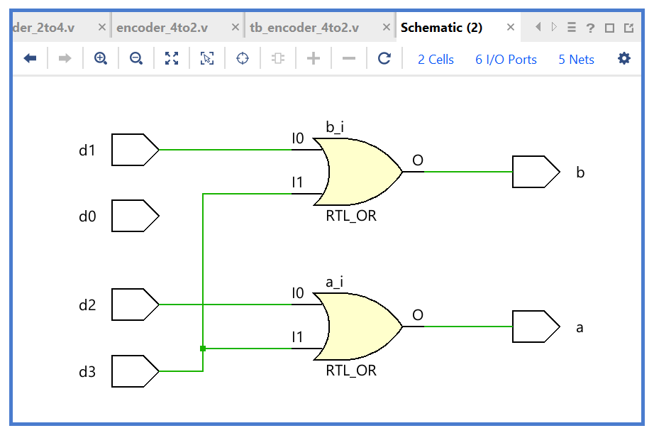
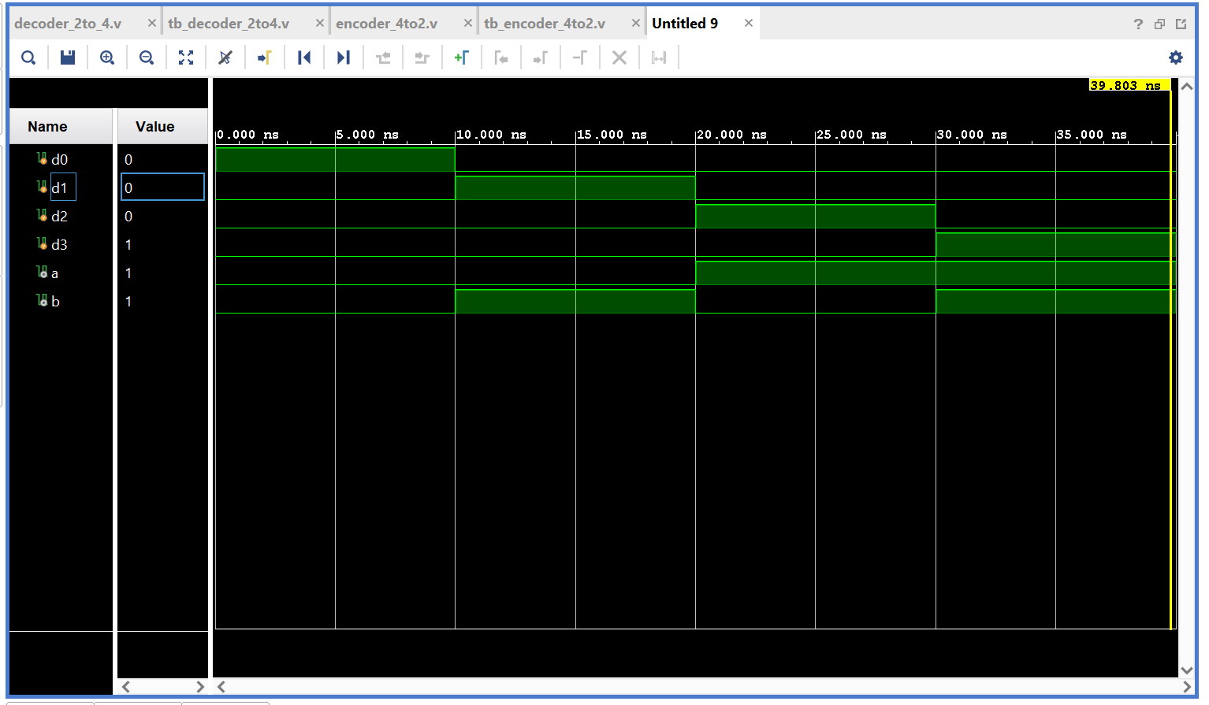

- DECODER 2 TO 4:

CODES:

decoder_2to_4.v:

`timescale 1ns / 1ps

module decoder_2to_4(

input a, b,
output d0, d1, d2, d3

);

assign d0 = (~a)&(~b);
assign d1 = (~a)&(b);
assign d2 = (a)&(~b);
assign d3 = (a)&(b);

endmodule

OUTPUT:

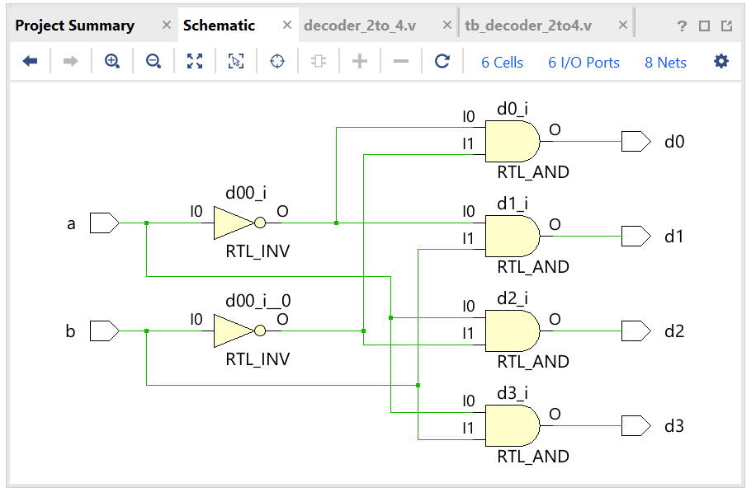
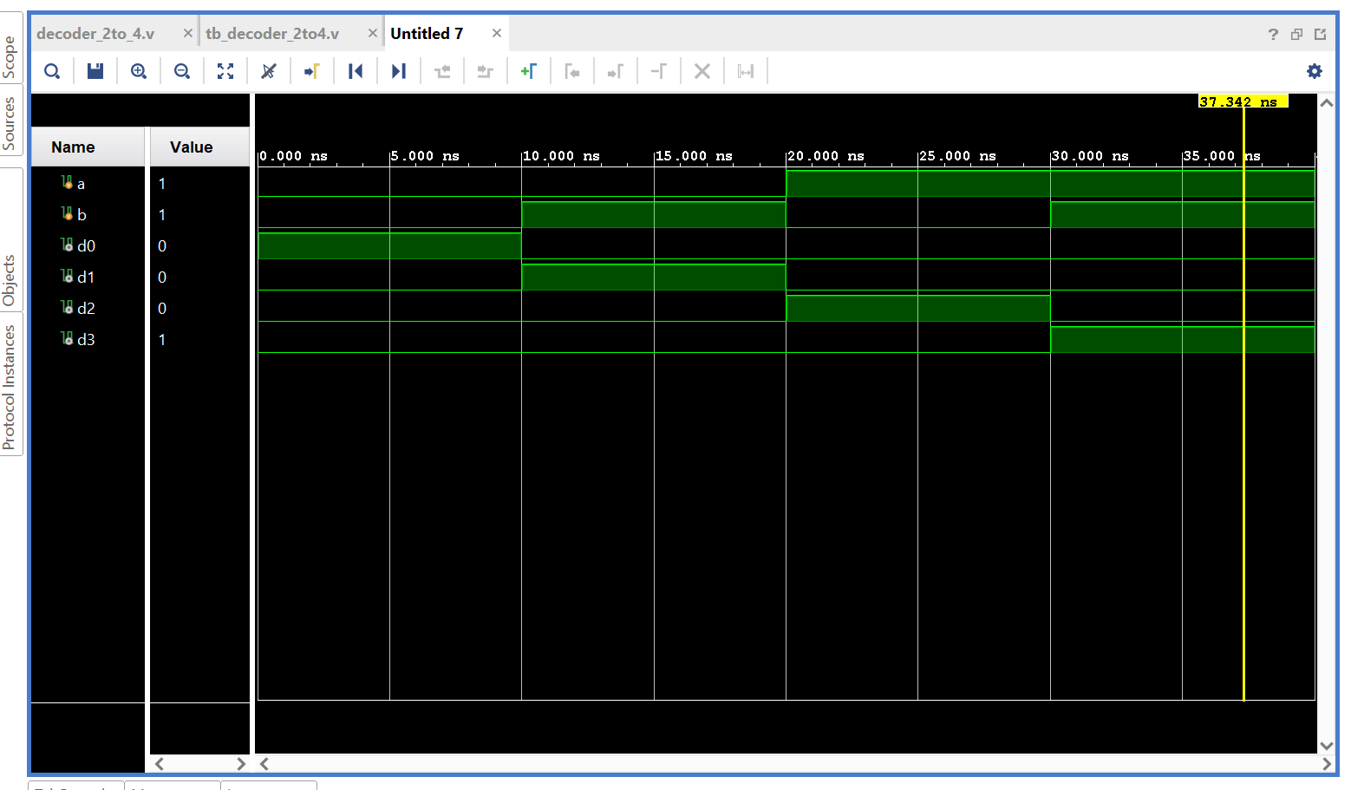
PROJECT_ARITHMETIC:
- HALF ADDER:

CODES:

half_adder.v:

`timescale 1ns / 1ps

module half_adder(

input a, b,
output s, c

);

assign s = a ^ b;
assign c = a & b;

endmodule

tb_half_adder.v:

`timescale 1ns / 1ps

module tb_half_adder(

);

reg a, b;
wire c, s;

half_adder uut(a, b, c, s);

initial begin

a = 0; b = 0;
#10;

a = 0; b = 1;
#10;

a = 1; b = 0;
#10;

a = 1; b = 1;

$finish;

end
endmodule

OUTPUT:

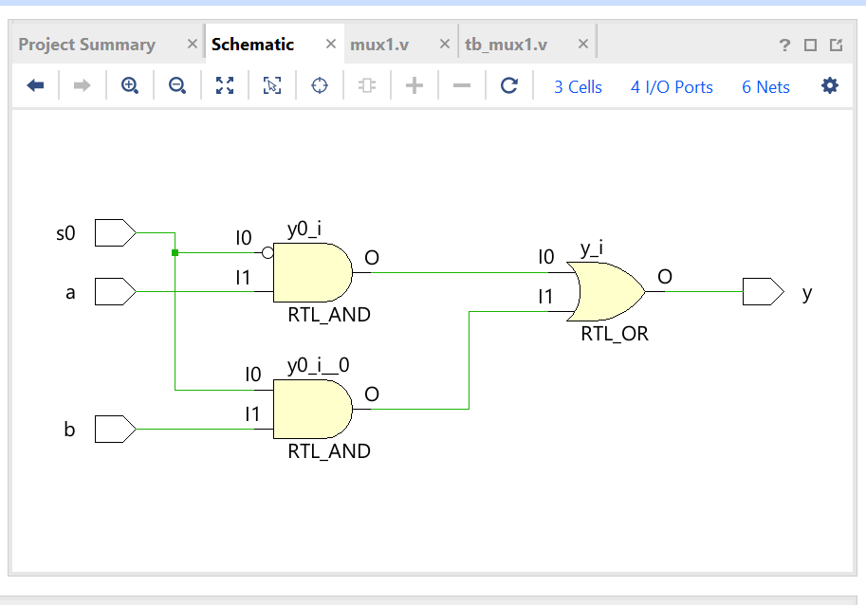
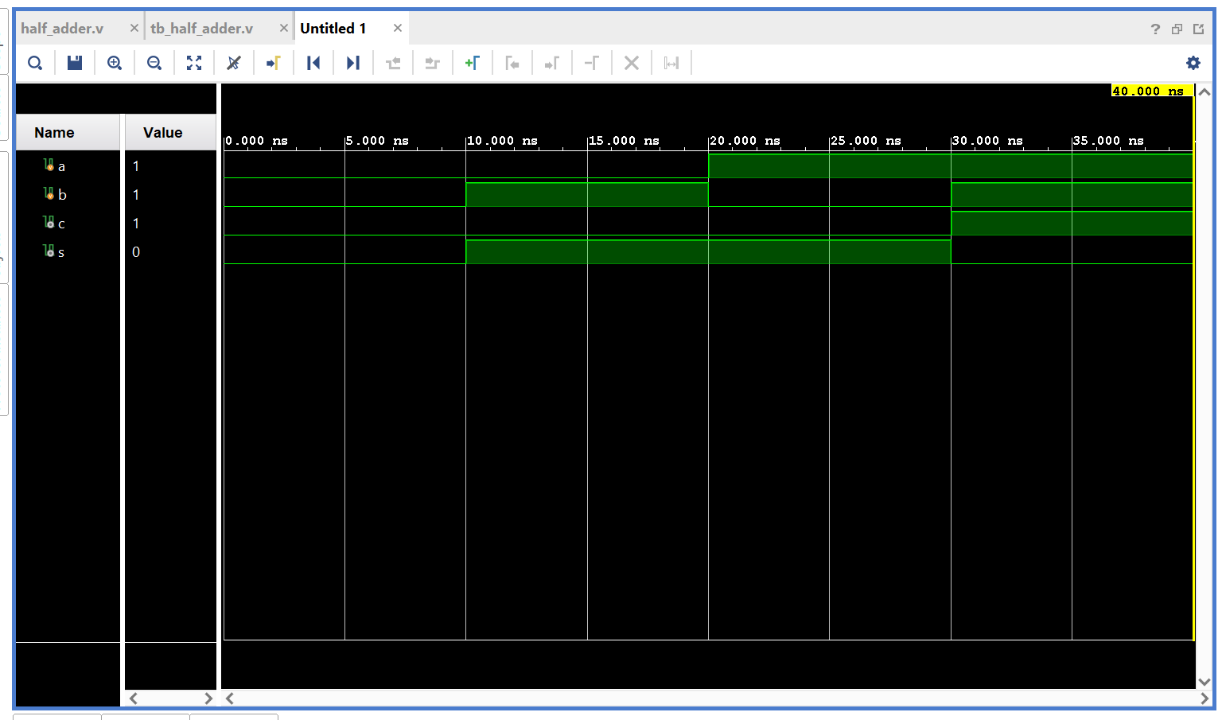

- HALF SUBTRACTOR:

CODES:

half_subtractor.v:

`timescale 1ns / 1ps

module half_subtractor(

input a, b,
output diff, borrow

);

assign diff = a^b;
assign borrow = (~a)&b;

endmodule

tb_half_subtractor:

`timescale 1ns / 1ps

module tb_half_subtractor(

);

reg a, b;
wire diff, borrow;

half_subtractor uut(a, b, diff, borrow);

initial begin

a = 0; b = 0;
#10;

a = 0; b = 1;
#10;

a = 1; b = 0;
#10;

a = 1; b = 1;

$finish;

end
endmodule

OUTPUT:

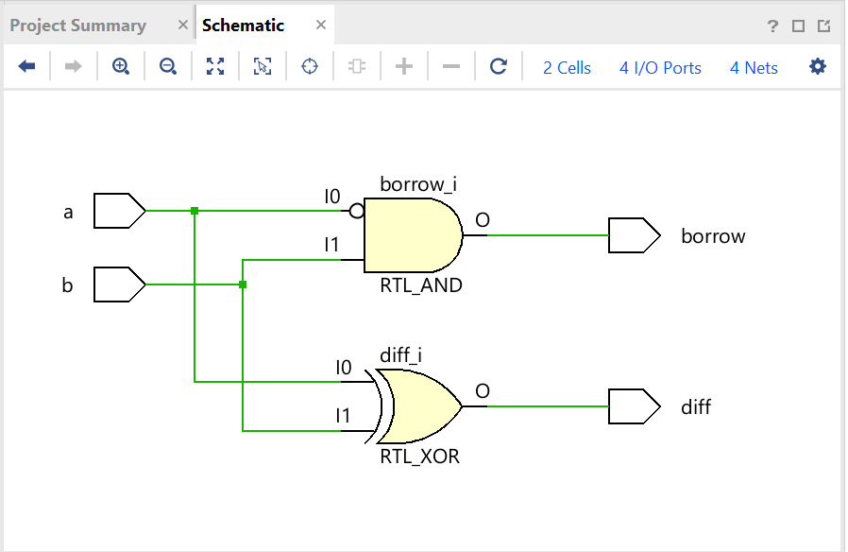
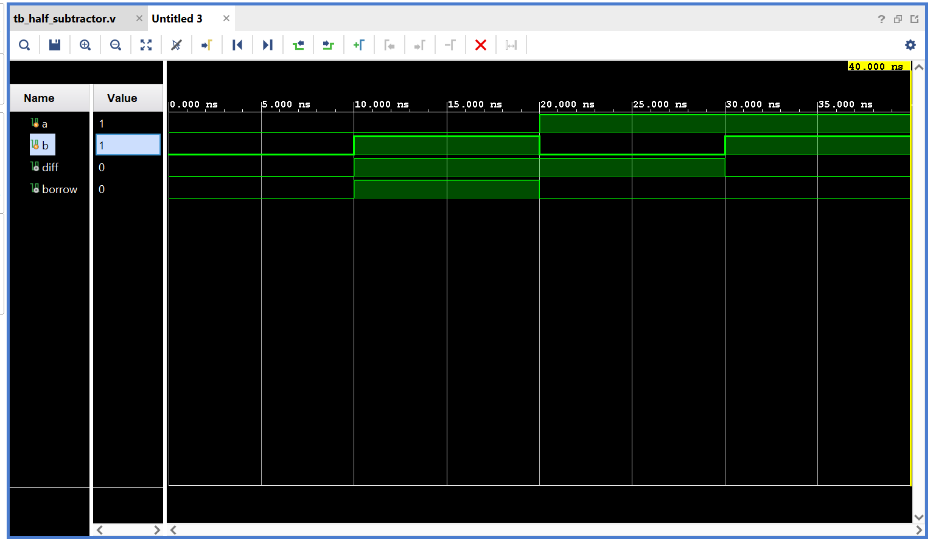

- FULL ADDER:

CODES:

full_adder.v:

`timescale 1ns / 1ps

module half_adder(

input a, b,
output s, c

);

assign s = a ^ b;
assign c = a & b;

endmodule

tb_full_adder.v:

`timescale 1ns / 1ps

module tb_full_adder(

);

reg a, b, c_in;
wire sum, c_out;

full_adder uut(a, b, c_in, sum, c_out);

initial begin

a = 0; b = 0; c_in = 0; //000
#10;

a = 0; b = 0; c_in = 1; //001
#10;

a = 0; b = 1; c_in = 0; //010
#10;

a = 0; b = 1; c_in = 1; //011
#10;

a = 1; b = 0; c_in = 0; //100
#10;

a = 1; b = 0; c_in = 1; //101
#10;

a = 1; b = 1; c_in = 0; //110
#10;

a = 1; b = 1; c_in = 1; //111

$finish;

end
endmodule

OUTPUT:

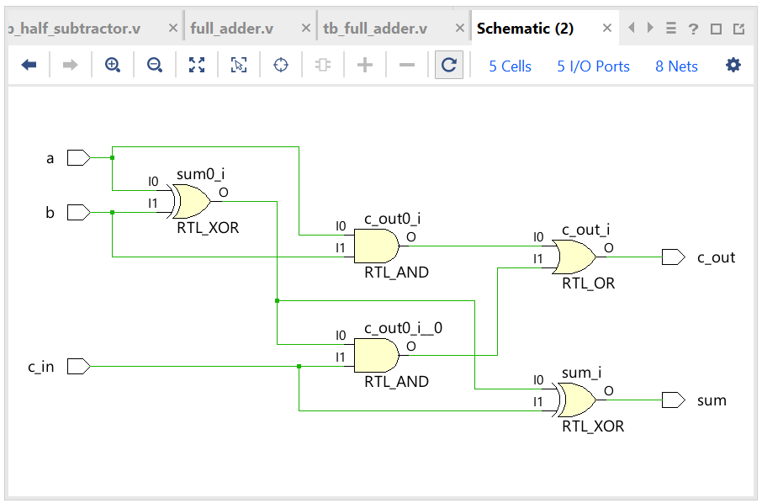
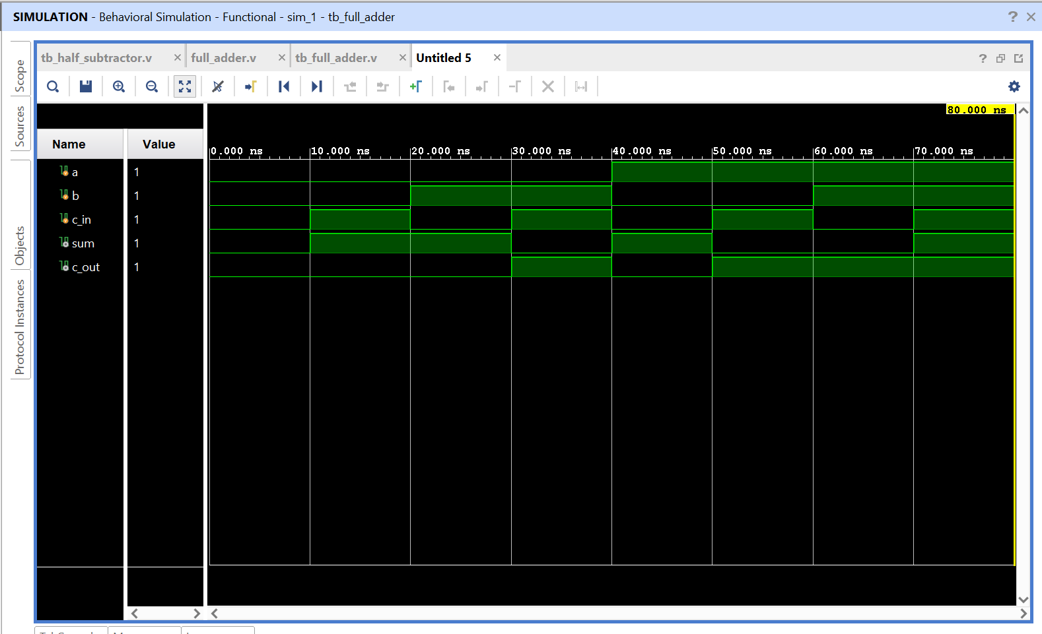

- FULL SUBTRACTOR:

CODES:

full_subtractor.v:

`timescale 1ns / 1ps

module full_subtractor(
input a, b, b_in,
output diff, b_out

);

assign diff = a ^ b ^ b_in;
assign b_out = ((~a)&b)|((~a)&b_in)|(b&b_in);

endmodule

tb_full_subtractor.v:

`timescale 1ns / 1ps

module tb_full_subtractor(

);

reg a, b, b_in;
wire diff, b_out;

full_subtractor uut(a, b, b_in, diff, b_out);

initial begin

a = 0; b = 0; b_in = 0; //000
#10;

a = 0; b = 0; b_in = 1; //001
#10;

a = 0; b = 1; b_in = 0; //010
#10;

a = 0; b = 1; b_in = 1; //011
#10;

a = 1; b = 0; b_in = 0; //100
#10;

a = 1; b = 0; b_in = 1; //101
#10;

a = 1; b = 1; b_in = 0; //110
#10;

a = 1; b = 1; b_in = 1; //111

$finish;

end
endmodule

OUTPUT:

