Exploratory Data Analysis
Business Sales Performance, 2023–2025
A structured report on sales, profitability, and discounting patterns across regions, segments, and product categories.
Dataset: 9,800 orders • Period: Jan 2023 – Dec 2025

1. Executive Summary
This report explores a transaction-level business sales dataset of 9,800 orders placed between January 2023 and December 2025, spanning three product categories, four U.S. regions, and three customer segments. The goal is to surface statistical patterns, correlations, and business-relevant insights through structured exploratory data analysis (EDA).
Across the full period, the business generated $6,384,389 in total sales but only $-53,589 in net profit (an overall margin of -0.8%), driven almost entirely by aggressive discounting. The clearest signal in the data is a strong negative relationship between discount depth and profit margin (r = -0.7388) — discounting is the single biggest lever affecting profitability.

Key Findings at a Glance
- Discount level is strongly negatively correlated with profit margin (r ≈ -0.7388) — the strongest relationship in the dataset.
- 26.5% of all orders were sold at a loss, concentrated in heavily discounted transactions.
- Technology generates the highest sales, while Tables is the least profitable sub-category (-13.2% margin) and Paper the most profitable (21.8% margin).
- West is the top-performing region by total sales.
- November–December (Q4) alone account for 15.5% of annual sales, confirming a clear seasonal pattern.
- 58.5% of all orders included some level of discount.

2. Dataset Overview & Methodology
The dataset simulates a multi-year retail/B2B sales ledger, structured to mirror common real-world sales-tracking datasets used in business analytics. Each row represents one order line item.
Metric | Value
Total records | 9,800
Time period | January 2023 – December 2025
Categories | Furniture, Office Supplies, Technology
Regions | West, East, Central, South
Customer segments | Consumer, Corporate, Home Office
Key numeric fields | Quantity, Discount, Sales, Profit
Missing values | 25 records missing Ship Mode (<0.3%)
Duplicate records | 0
Methodology: data was inspected for structure, missing values, and duplicates; numeric fields were summarized with descriptive statistics; categorical fields were profiled with frequency counts; and relationships between variables were examined using Pearson correlation and grouped aggregations. Visualizations (distributions, trends, heatmaps, and scatter plots) were used throughout to make patterns interpretable.

3. Statistical Summary
The table below summarizes the core numeric variables across all 9,800 orders.
Metric | Value
Average order value | $651
Total sales (all orders) | $6,384,389
Total profit (all orders) | $-53,589
Overall profit margin | -0.8%
Share of orders discounted | 58.5%
Share of orders sold at a loss | 26.5%
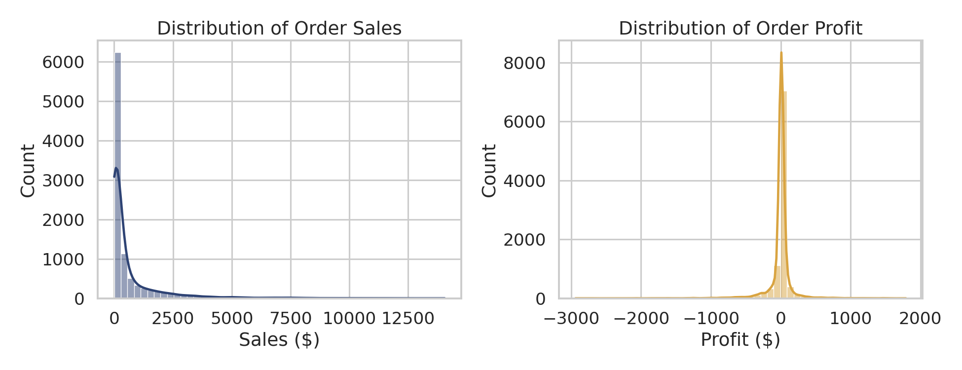
Figure 1. Sales and profit are both right-skewed: most orders are modest in size, with a long tail of large, high-value transactions.

4. Trends Over Time
Aggregating orders by month reveals a clear seasonal cadence, with sales peaking toward the end of each year (Q4), while profit is far more volatile and occasionally dips below zero in heavy-discount months.
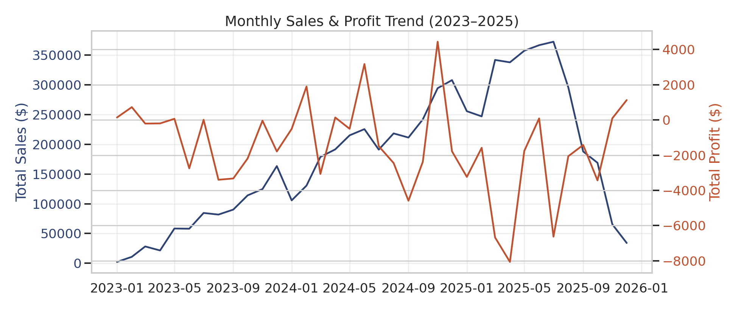
Figure 2. Monthly sales (blue) climb steadily with a Q4 seasonal peak each year, while profit (red) is comparatively flat and volatile — evidence that revenue growth is not translating proportionally into profit growth.

5. Category & Sub-Category Performance
Technology is the leading category by total sales. However, sales volume and profitability do not move together — several high-selling sub-categories are actually loss-making once discounting is factored in.
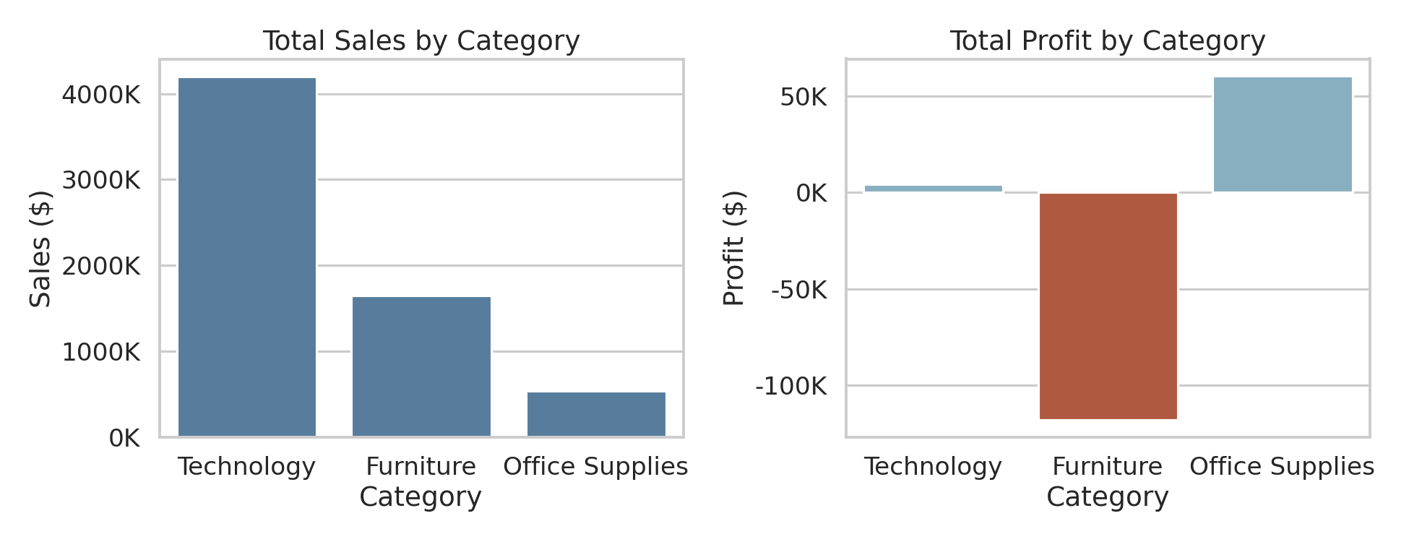
Figure 3. Sales vs. profit by category — Furniture in particular converts strong sales into comparatively weak profit.
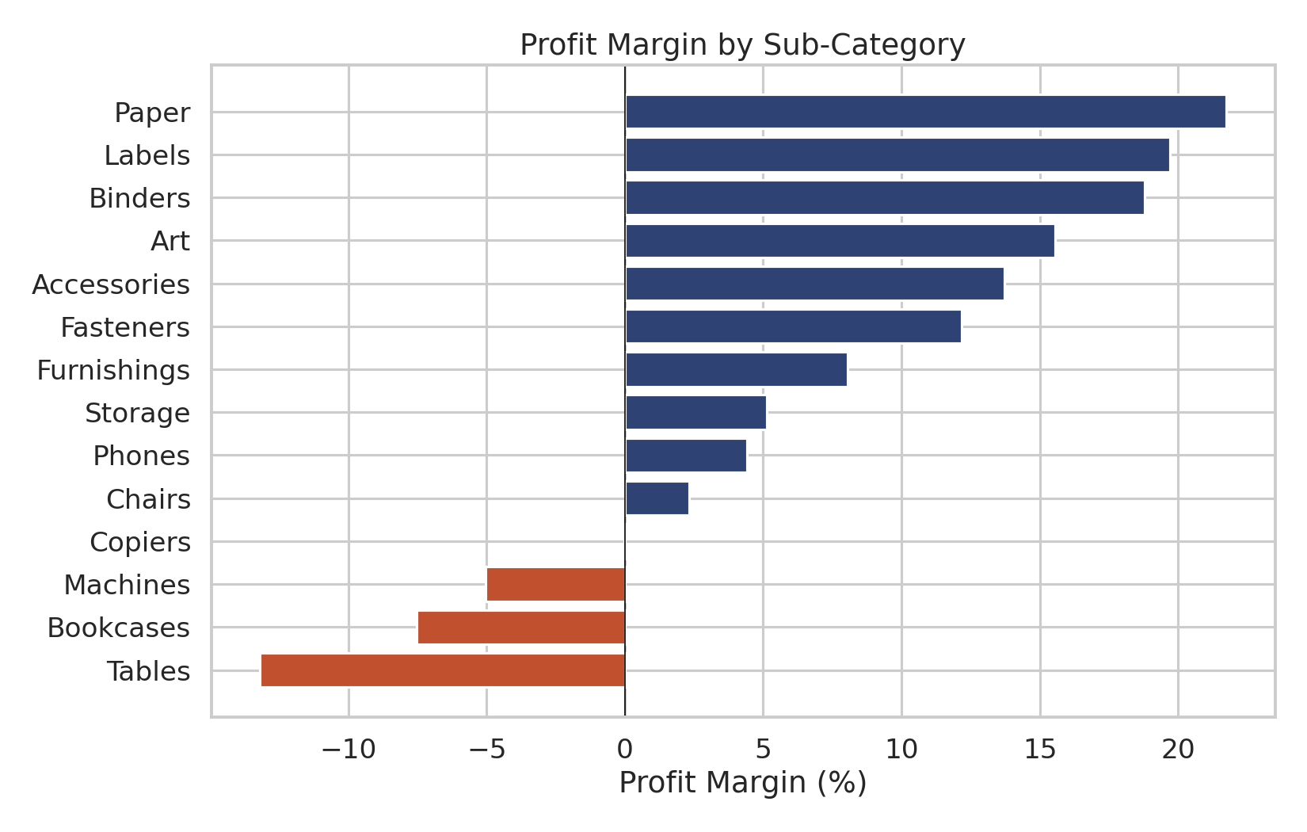
Figure 4. Profit margin by sub-category. Tables operates at a negative margin (-13.2%), while Paper is the most efficient (21.8% margin).

6. Correlation & Key Influencing Factors
A correlation matrix across the core numeric variables (Quantity, Discount, Sales, Profit, and Profit Margin) identifies which factors most strongly influence profitability.
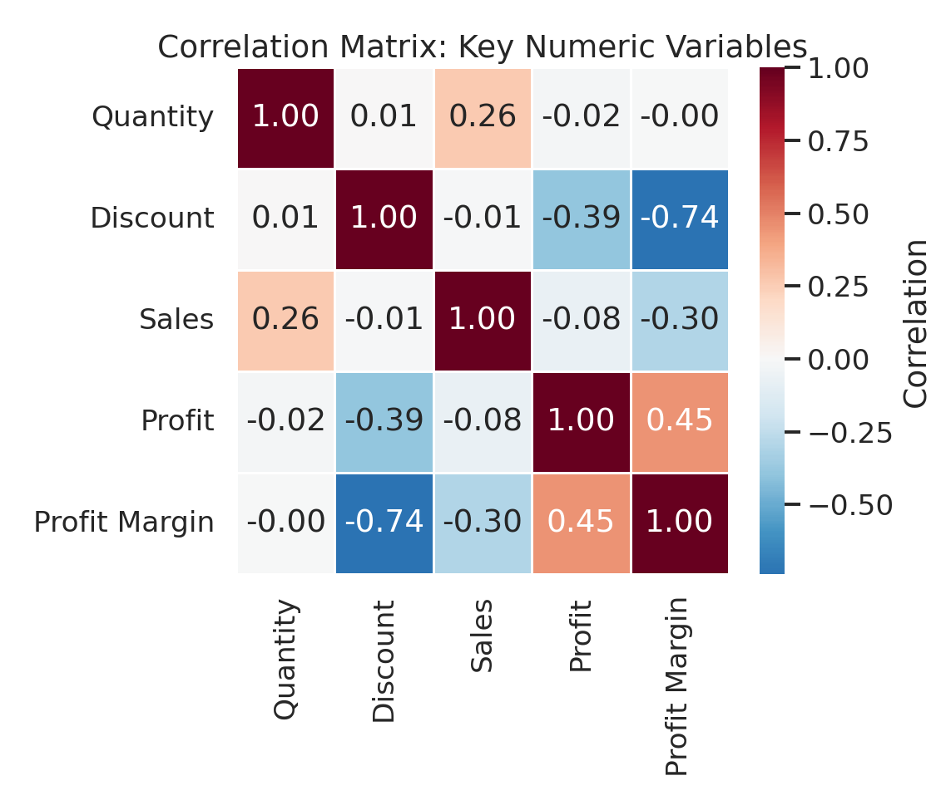
Figure 5. Correlation matrix of key numeric variables.
The standout relationship is between Discount and Profit Margin (r ≈ -0.7388): as discount depth increases, margin erodes sharply and consistently. Sales and Profit show only a weak positive relationship (r ≈ -0.0763), meaning higher-revenue orders are not reliably more profitable — a sign that discounting is being applied disproportionately to larger orders. Quantity correlates modestly with Sales (r ≈ 0.262) but has almost no direct relationship with Profit.
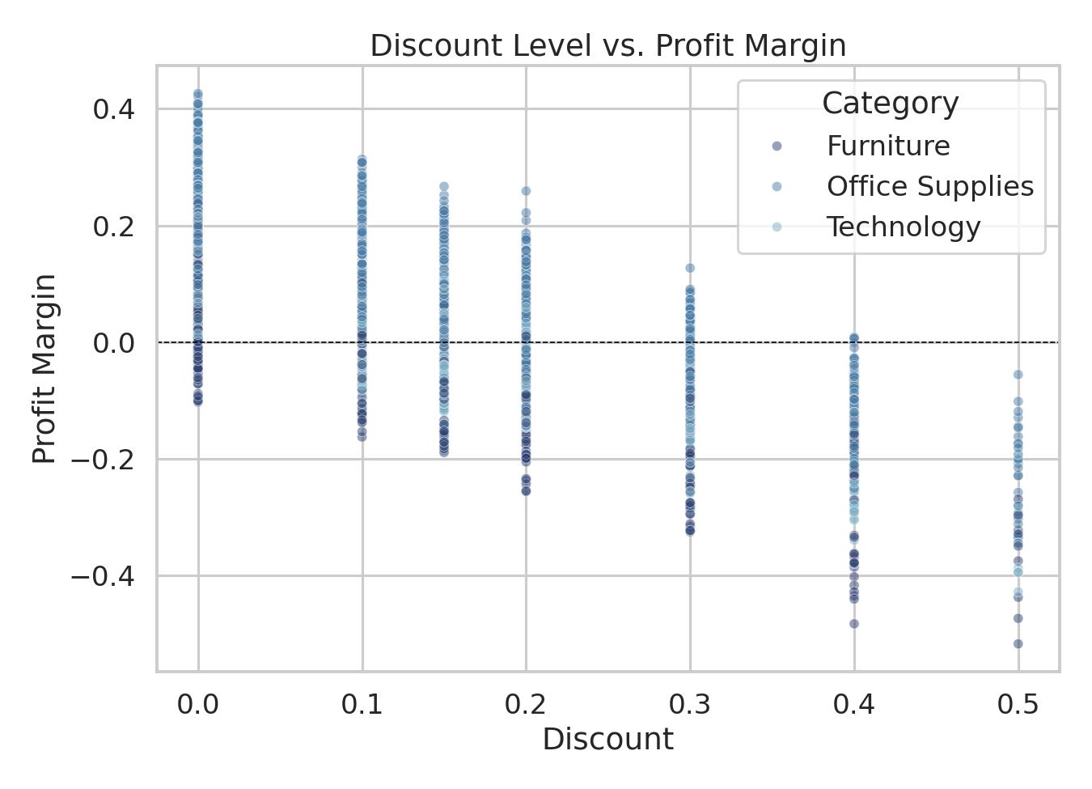
Figure 6. Discount vs. profit margin, colored by category. The downward slope is visible across all three categories — discounting above roughly 20–30% consistently pushes margin negative.

7. Regional & Customer Segment Patterns
West leads all regions in total sales. Breaking sales down jointly by region and customer segment highlights where revenue is concentrated.
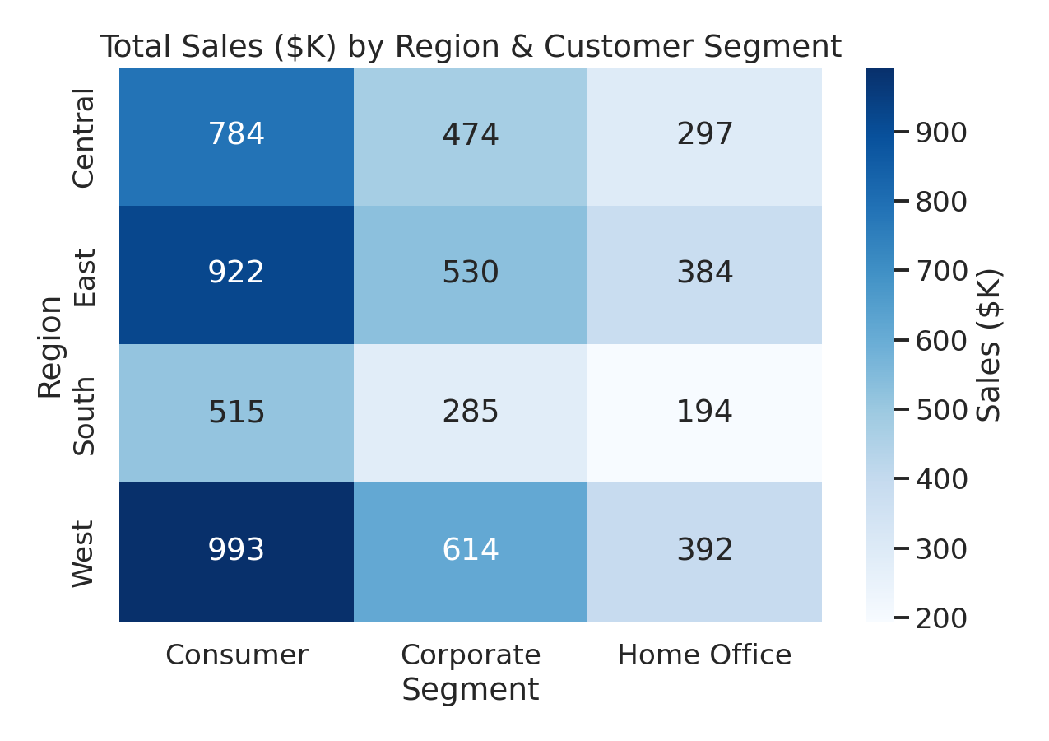
Figure 7. Total sales ($K) by region and customer segment — the Consumer segment in the West region is the single largest combination.
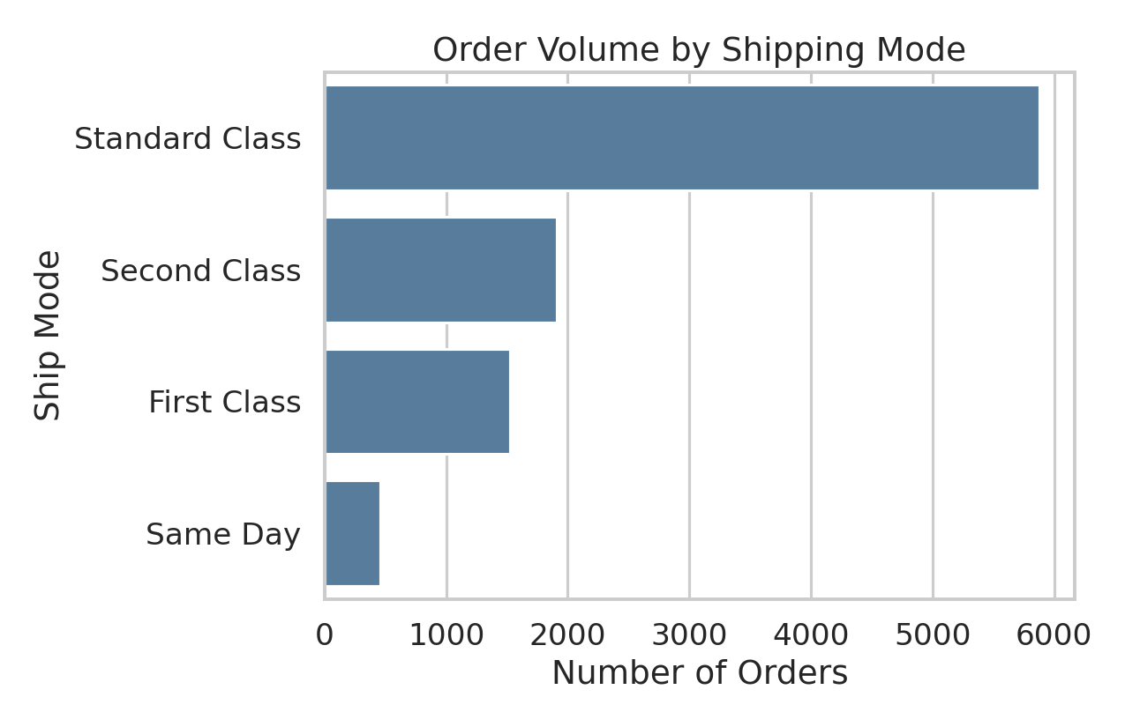
Figure 8. Standard Class shipping dominates order volume, suggesting most customers are not paying for expedited delivery.

8. Business Insights & Recommendations

8.1 Rein in deep discounting
Discounting above roughly 20–30% is the primary driver of loss-making orders (26.5% of all orders). A tiered discount policy — capping standard discretionary discounts and requiring approval beyond a threshold — would directly improve overall margin.

8.2 Re-examine Furniture pricing and discount strategy
Furniture, and Tables specifically, generate meaningful revenue but the weakest margins in the dataset. This category should be prioritized for a pricing and discount-policy review before other categories.

8.3 Lean into Q4 seasonality — profitably
With 15.5% of annual sales concentrated in November–December, inventory and staffing planning should anticipate this surge. Promotions during this window should be structured to protect margin (e.g., bundling rather than blanket discounts).

8.4 Protect high-margin lines
Paper and similar high-margin, high-frequency sub-categories are efficient revenue generators and warrant continued investment in availability and marketing.

8.5 Investigate regional strategy
West outperforms other regions on sales; a follow-up analysis comparing regional discount practices and marketing spend could clarify whether this is a demand effect, a pricing effect, or both.

9. Conclusion
This exploratory analysis shows a business with healthy top-line sales growth and clear seasonal demand, but profitability that is being eroded primarily by discounting practices rather than by weak underlying demand. The strongest, most actionable signal in the data is the discount–margin relationship: tightening discount governance, particularly in low-margin categories like Furniture, represents the most direct lever for improving profitability without sacrificing sales volume.
Suggested next steps include: (1) a controlled test of discount caps in the Furniture category, (2) a cohort analysis of customer segments to see which are most price-sensitive, and (3) a deeper regional analysis to understand what is driving the West region's outperformance.

