SESSION 2025-26
Department: SOET
Program: MCA AI/ml
Course code: ETMMDL274
Course Name: Deep Learning Architectures and Techniques
Semster: 2nd
ASSIGNMENT 03

Submitted to: Submitted by: Dr. Shahid Ahmad Wani Yashvant Giri
Date: 5-4-2026
Roll num:2501940053

*Assignment Title
Text Sentiment Classification Using RNN and LSTM

*Objective
This laboratory assignment focuses on sentiment classification of textual data using deep learning techniques. The main objective is to implement and compare Recurrent Neural Network (RNN) and Long Short-Term Memory (LSTM) models for analyzing sequential text data.
The task demonstrates how deep learning models process natural language and how different architectures affect performance in classification tasks.

*Dataset Description
For this assignment, the IMDB Movie Reviews dataset was used.
- The dataset contains 50,000 movie reviews
- Each review is labeled as positive or negative sentiment
- It is widely used for binary sentiment classification tasks

*Data Preprocessing & Sequence Creation
To prepare the textual data for deep learning models, the following preprocessing steps were performed:
- Tokenization: Text data was converted into sequences of integers using a fixed vocabulary size
- Vocabulary Limitation: Only the top 10,000 most frequent words were considered
- Sequence Conversion: Each review was represented as a sequence of numbers
- Padding: All sequences were padded to a fixed length of 200 to ensure uniform input size
After applying padding, all sequences were converted to a fixed length of 200.
Shorter sequences were padded with zeros, while longer sequences were truncated.
Example of padded sequence:
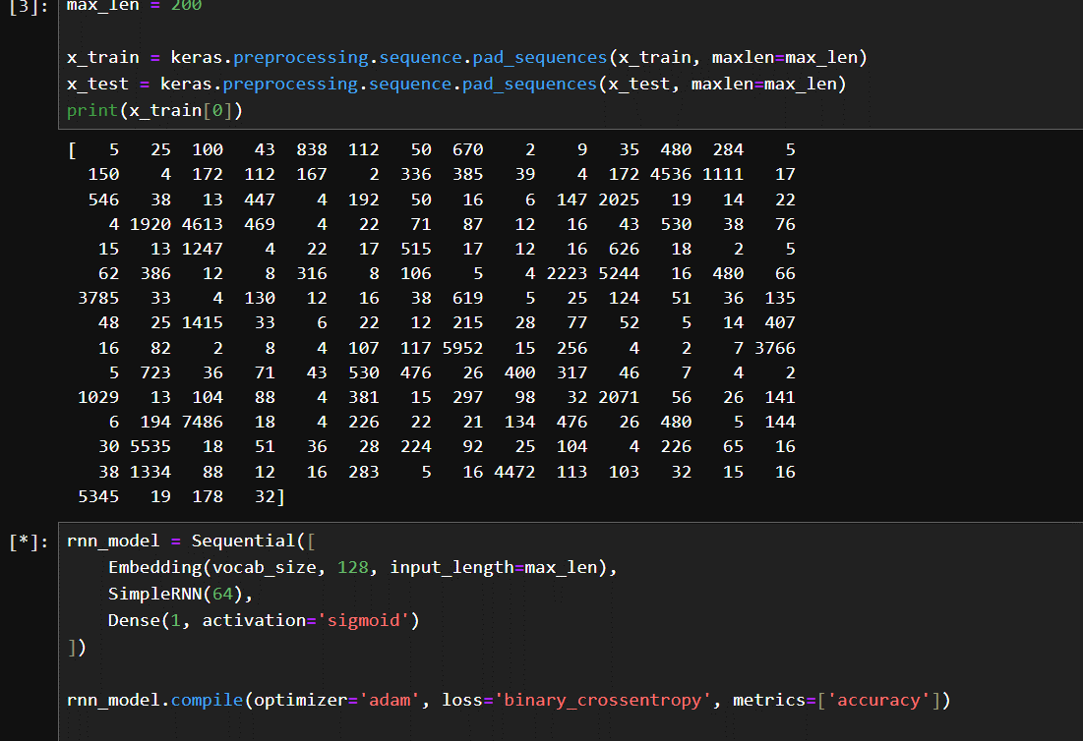
Figure: Example of padded input sequence with fixed length
In this case, the sequence was already long, so truncation was applied instead of padding zeros at the beginning.

*Model Architecture & Implementation

RNN Model
The RNN model was implemented using a Sequential architecture:
- Embedding Layer (128 dimensions)
- SimpleRNN Layer (64 units)
- Dense Output Layer (Sigmoid activation)

LSTM Model
The LSTM model was implemented with the following architecture:
- Embedding Layer (128 dimensions)
- LSTM Layer (64 units)
- Dense Output Layer (Sigmoid activation)

*Training Results and Plots

Both RNN and LSTM models were trained for multiple epochs using the Adam optimizer and binary cross-entropy loss function. The performance of both models was evaluated using training and validation data.

Accuracy Analysis
The accuracy comparison graph shows that the LSTM model consistently achieves higher accuracy than the RNN model across all epochs.
- RNN accuracy increases gradually from around 68% to 93%
- LSTM accuracy improves from around 79% to 96%
This clearly indicates that LSTM performs better in learning sequential patterns.

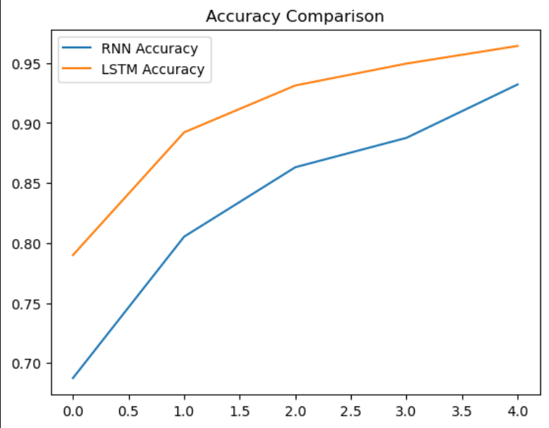

Loss Analysis
The loss comparison graph illustrates the training and validation loss for both models.
- Training loss decreases steadily for both models
- LSTM shows lower loss compared to RNN
- Validation loss slightly increases after some epochs, indicating overfitting
This suggests that while the models learn well, further improvements like regularization can enhance generalization.

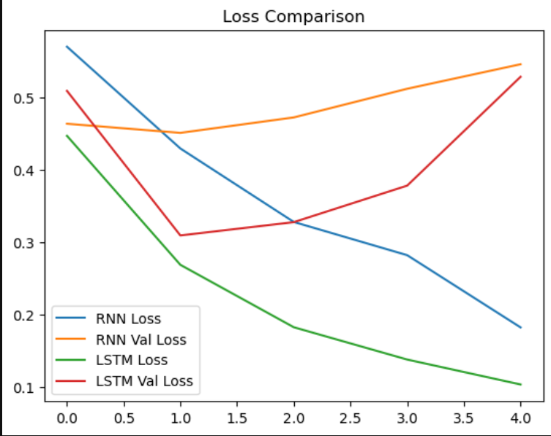

*Evaluation Metrics & Results

The performance of the models was evaluated using standard classification metrics.

RNN Results
- Accuracy: 0.80
- Precision: 0.80
- Recall: 0.80
- F1-score: 0.80

LSTM Results
- Accuracy: 0.85
- Precision: 0.85
- Recall: 0.85
- F1-score: 0.85

Detailed Classification Report
- Class 0 (Negative):
Precision: 0.83
Recall: 0.88
F1-score: 0.86
- Class 1 (Positive):
Precision: 0.87
Recall: 0.83
F1-score: 0.85
- Overall Accuracy: 0.85

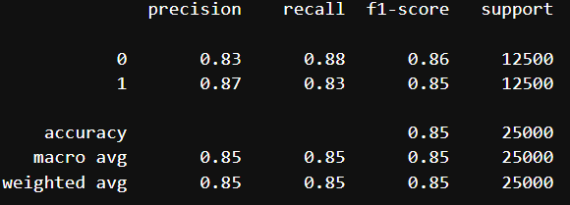
Figure: Classification report showing precision, recall, F1-score and accuracy

The classification report indicates balanced performance across both classes, with an overall accuracy of 85%.

*Result Analysis & Discussion
The LSTM model performs better than the RNN model in sentiment classification tasks.
RNN suffers from the vanishing gradient problem, making it difficult to capture long-term dependencies in text data.
LSTM, on the other hand, uses memory cells and gating mechanisms, which allow it to retain important information over longer sequences.
Additionally, slight overfitting is observed as validation loss increases after certain epochs. This can be improved using techniques such as dropout and early stopping.

*Conclusion
This assignment successfully demonstrates the implementation of deep learning models for sentiment classification.
The comparison shows that LSTM provides better performance than RNN due to its ability to handle long-term dependencies.
Thus, LSTM is more suitable for natural language processing tasks such as sentiment analysis.

