Technical Requirement Document (TRD)
Product: CodeNavigator - Smart Learning Path Generator for Tech Careers

1. System Architecture Overview
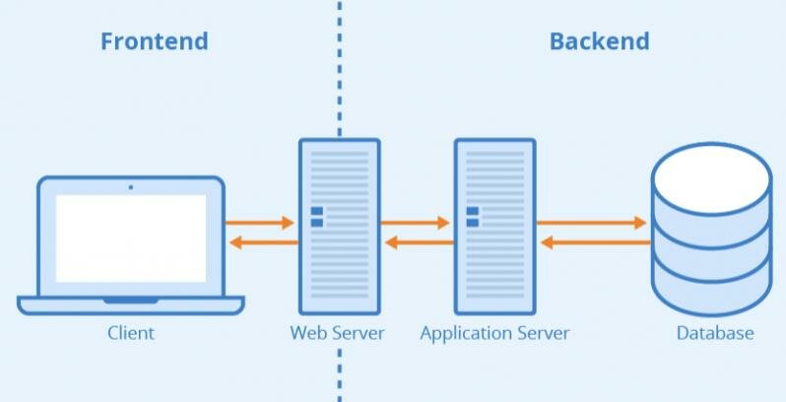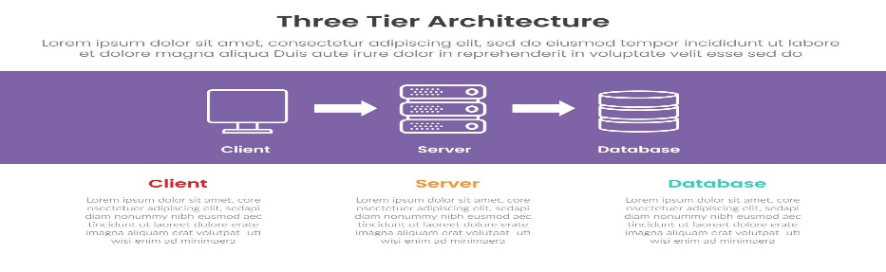
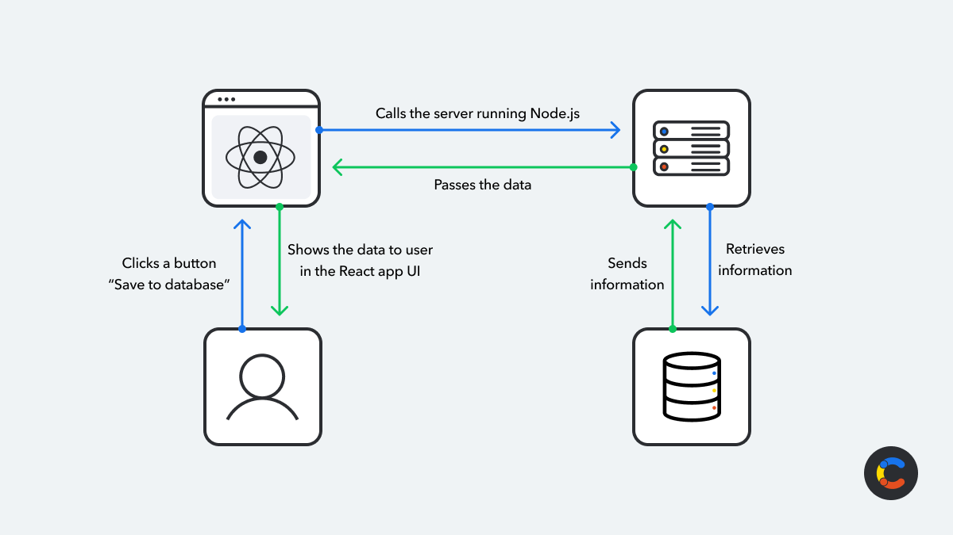

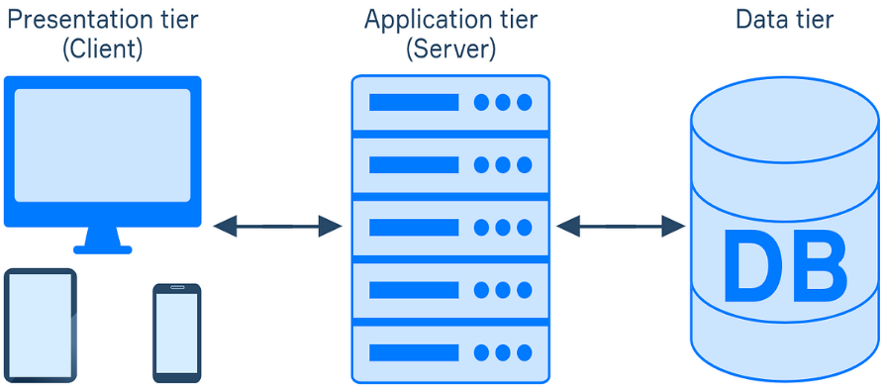
The system follows a three-tier architecture:
1. Frontend (Client)
- Built using React
- Handles UI rendering and user interactions
- Communicates with backend through REST APIs
2. Backend (Server)
- Built using Node.js with Express (or Java Spring Boot if you prefer)
- Handles business logic
- Processes user data
- Generates learning roadmap
3. Database
- Stores users, skills, roadmaps, and progress data
- Recommended: MongoDB
Architecture Flow
User → React Frontend → API Request → Backend Server → Database

2. Frontend Responsibilities
Frontend will focus on UI, user interaction, and API communication.
Key Responsibilities
1. User Interface
Render pages:
- Home Page
- Login / Signup
- Career Selection
- Skill Assessment
- Learning Roadmap
- Dashboard
- Profile

2. State Management
Handle:
- User authentication state
- Selected career path
- Skill progress
- Roadmap data
Possible tools:
- React Context API
or
- Redux (optional)

3. API Communication
Use Axios / Fetch API to communicate with backend.
Example requests:
GET /roadmap
POST /login
PUT /progress

4. UI Components
Reusable components:
Navbar
Sidebar
SkillCard
ProgressBar
RoadmapCard
DashboardWidgets

3. Backend Responsibilities
Backend will handle application logic and data processing.
Main Responsibilities
1. Authentication
Handle:
- User signup
- Login validation
- Token generation

2. Roadmap Generation
Backend generates roadmap based on:
- Career goal
- Known skills
Example logic:
If career = Frontend Developer
Return roadmap:
HTML
CSS
JavaScript
React

3. Skill Gap Analysis
Compare:
User skills vs roadmap skills
Return missing skills.

4. Progress Tracking
Store user progress when they mark skills as completed.

5. API Handling
Provide REST API endpoints for frontend.

4. Database Schema Proposal
Database: MongoDB
Users Collection
Field | Type
_id | ObjectId
name | String
email | String
password | String
careerGoal | String
createdAt | Date

Skills Collection
Field | Type
_id | ObjectId
skillName | String
category | String
resourceLinks | Array

Roadmaps Collection
Field | Type
_id | ObjectId
career | String
stages | Array
skills | Array

Progress Collection
Field | Type
_id | ObjectId
userId | ObjectId
skillId | ObjectId
status | String
updatedAt | Date
Status values:
- completed
- in-progress
- not-started

5. API Structure
Base URL
/api/v1

Authentication APIs
POST /api/v1/auth/signup
Create new user
POST /api/v1/auth/login
Login user
GET /api/v1/auth/profile
Get user profile

Career APIs
GET /api/v1/careers
Get list of available career paths

Roadmap APIs
GET /api/v1/roadmap/:career
Get roadmap for selected career

Skills APIs
GET /api/v1/skills
Get list of skills

Progress APIs
POST /api/v1/progress
Update skill progress
GET /api/v1/progress/:userId
Fetch user progress

6. Authentication Strategy
Authentication will use JWT (JSON Web Token).
Process:
- User logs in
- Backend verifies credentials
- Backend generates JWT token
- Token sent to frontend
- Token stored in localStorage
Example
Authorization: Bearer JWT_TOKEN
Advantages:
- Stateless authentication
- Secure API communication

7. Third-Party Dependencies
Frontend
React Router
Axios
Tailwind CSS or Material UI
Chart.js or Recharts

Backend
Express.js
Mongoose (MongoDB ORM)
JWT
bcrypt (password hashing)

Deployment
Frontend → Vercel
Backend → Render / Railway
Database → MongoDB Atlas

8. Scalability Considerations
To ensure long-term stability, follow these practices:
1. Modular Code Structure
Separate modules:
Auth
Roadmap
Skills
Progress

2. API Versioning
Use versioned APIs
/api/v1
This helps future upgrades.

3. Database Indexing
Add indexes for:
email
userId
This improves query performance.

4. Stateless Backend
Use JWT authentication to allow easy scaling.

5. Error Handling
Implement centralized error handling middleware.
Example responses:
400 Bad Request
401 Unauthorized
500 Server Error

9. Security Considerations
Hash passwords using bcrypt
Sanitize user inputs
Validate API request data
Enable CORS policy

10. Deployment Strategy
Frontend
Deploy on:
Vercel

Backend
Deploy on:
Render / Railway

Database
Use:
MongoDB Atlas

Final Architecture Summary
Frontend
React UI + Dashboard
↓
Backend
Node.js API + Business Logic
↓
Database
MongoDB for user and roadmap data

FOLDER STRUCTURE
frontend/
components/
pages/
services/
context/

backend/
controllers/
routes/
models/
middleware/

