**PROJECT REPORT**

**on**

**Payroll Management System**

**(CSE III Semester Mini project PCS-604)**

**2020-2021**



**Submitted by:**

Mr. YASH BISHT

Roll. No.: 2018872

**Guided by:** CSE-G-III Sem

Dr. Mahesh Manchanda **Session :** 2020- 2021

(Resource Person)

**DEPARTMENT OF COMPUTER SCIENCE AND INFORMATION TECHNOLOGY**

**GRAPHIC ERA HILL UNVERSITY, DEHRADUN**

**ACKNOWLEDGMENT**

I would like to thank my parents for their continuing support and encouragement. I also would like to thank them for providing me with the opportunity to reach this far in my studies.

I would like to particularly thank my Project Guide Dr. Mahesh Manchenda for his patience, support and encouragement throughout the completion of this project and for having faith in me.

At last but not the least I am greatly indebted to all other people who directly or indirectly helped me with this project.

**CERTIFICATE**

### Certified that Mr. ABC (Roll No.- 1223456) has developed mini project on “Library Management System” for the CS VI Semester Mini Project Lab (PCS-604) in Graphic Era Hill University, Dehradun. The project carried out by Students is their own work as best of my knowledge.

Ms Manisha Aeri Mr. Mahesh Manchanda

(Class cordionator) Project Guide

CSE-G-III-Sem Resource Person

(CSE Department) (CSE Department)

GEHU Dehradun GEHU Dehradun

SUBMITED BY:

Yash Bisht

CSE-G-III-Sem

UNIVERSITY ROLL NO.:

2018872

CLASS ROLL NO.:

62

**TABLE OF CONTENTS:**

* **INTRODUCTION**
  + **About project**
* **Lessons learned**
* **Requirement analysis**
* **Technology used**
* **Header files used**
* **Features**
* **Snapshots of program**
* **Details of code**
* **CONCLUSION**
* **Fututre scope**
* **BIBLIOGRAPHY**

**1. INTRODUCTION**

**About project:**

The main concept of our system is manage employee details, Generate salary, extra allowance and deduction on the basis of there experience and job grade. Admin is a responsible for operating whole system. Admin have access to Add new Employee, or delete them. Each employee has a unique username and code to distinguish from other employees. Modifying salary or deleting records is easier with help of unique employee code.

We can set Travel Allowance, Medical Allowance, and Calculate HR and DA. Admin can generate and view Employee wise salary report .

The Payroll management system is a C++ - based solution to manage and maintain employees’ records of an institution. This project on payroll management helps to uphold all records of employees working in an institution. The main aim of the project is to pay the employees perfectly without any delays.

**2. Lessons Learned:**

While implementing the project we learned a lot of things

1. How to gather requirements for the system to implement?

2. Handling issues of data inconsistency and memory allocation.

3. Acquired knowledge on event handling and code optimization

techniques while implementing in code behind

4. Learnt about importance of payslip generator.

5. Some old inbuilt functions of c++ are not valid now.

**3. Requirement analysis:**

The project requires basic knowledge of c++ language. Also, a person must know about payroll system, taxes andallowances. The computer using payroll management system must also have c++ compiler.

**4. TECHNOLOGY**

* C++ Programming Language: C++ is a general purpose, object-oriented programming language widely used in competitive programming and Game Development. C++ is platform dependent and runs on lots of platform like Windows, Linux, Unix, Mac, etc.

**4.1 Header files used:**

* **<iostream>** => for providing functionality of standard input output operations.
* **<stdlib.h>** => This header defines several general purpose functions, including dynamic memory management, random number generation, communication with the environment, integer arithmetics, searching, sorting and converting.
* **<string.h>** => This header file defines several functions to manipulate *C strings* and arrays.
* **<conio.h>** =>The conio.h is a non-standard header file used in C and C++ programming. This file contains console input-output functions.
* **<windows.h> => Windows -specific header file** for the C and C++ programming languages which contains declarations for all of the functions in the Windows API, all the common macros used by Windows programmers, and all the data types used by the various functions and subsystems.
* **<ctype.h> =>** The ctype.h contains inbuilt functions to**handle characters** in C++ respectively.
* **<stdio.h> =>** Input and Output operations can also be performed in C++ using the C Standard Input and Output Library (cstdio, known as stdio.h in the C language). This library uses what are called streams to operate with physical devices such as keyboards, printers, terminals or with any other type of files supported by the system**.**

**5. FEATURES**

* I have added graphics in my project so that the user find it attractive.
* I have tried to use only the basic features of C++ so that program is not hard to understand.
* It is user friendly and helps user to easily run the project without any trouble.
* It helps in calculating salary with all deductions and appreciations included.
* It is specially designed for windows and if user wants to run it on other operating systems, user has to make minimal changes in the program.
* Admin Functionalities
* Add employee
* Generate Salary
* Delete employee records
* Generate Pay Slip
* Get all records.

**6. SNAPSHOT OF PROGRAM**

* First page displays the name, university roll no. and program name. All the displayed letters appear one after the other, by using sleep function in windows.h library.

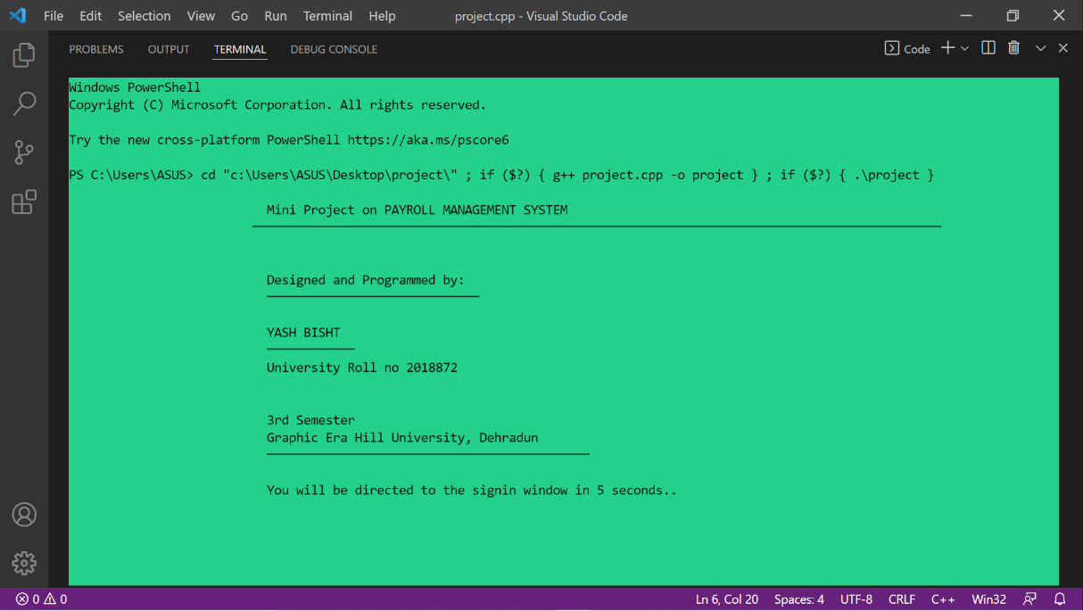

* The signin windows appear as following

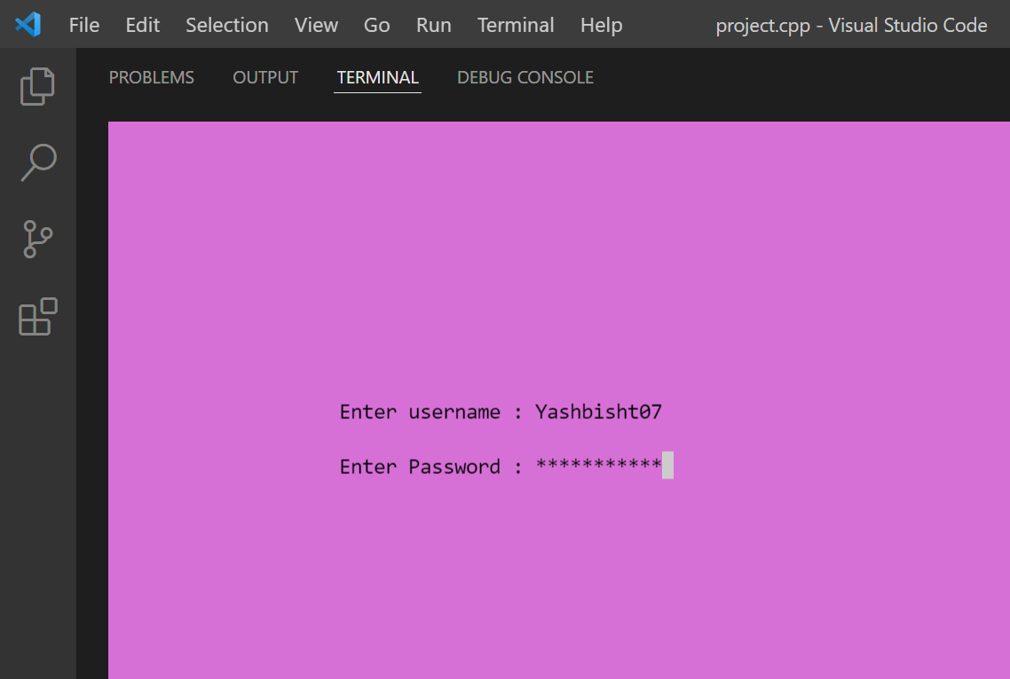

* Wrong password leads to this page. And later back to the login window.

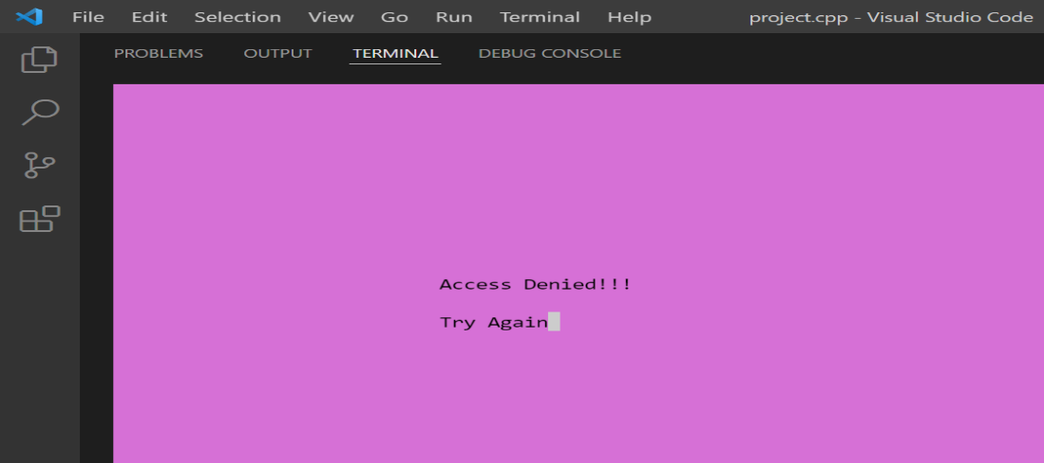

* If the password and username is correct the list at next page is as follows. We can select from the menu using charecters displayed there.

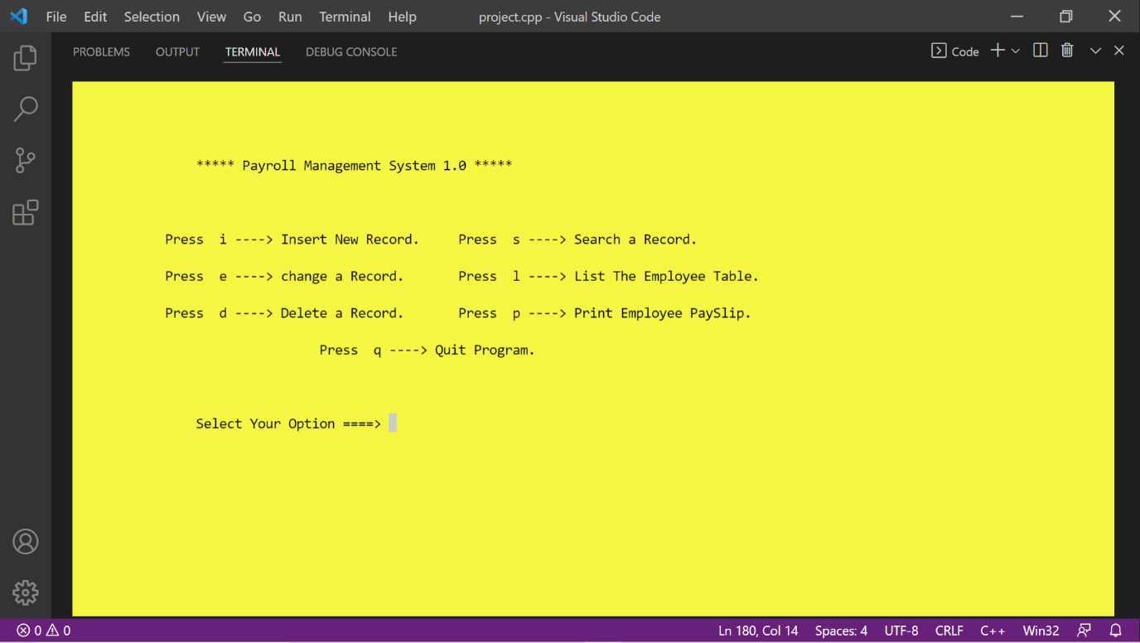

* INSERTION: when a user inputs the character i, they are lead to inserion page as follows:

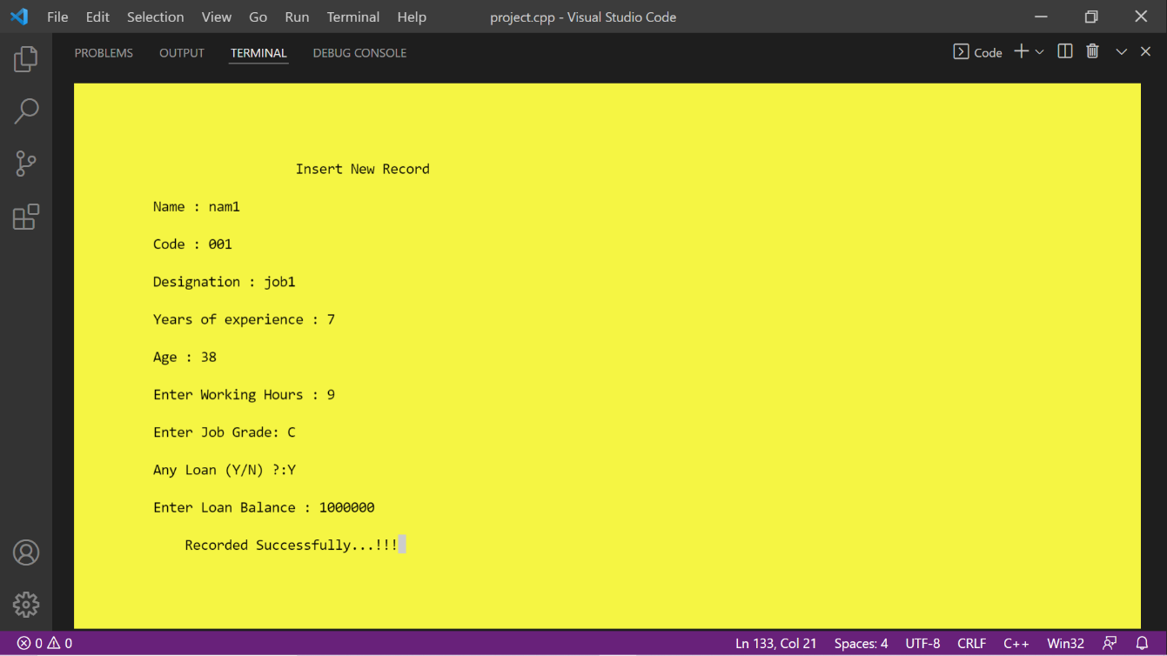

* The list of employees can be viewed using character l. and the display is as follows.

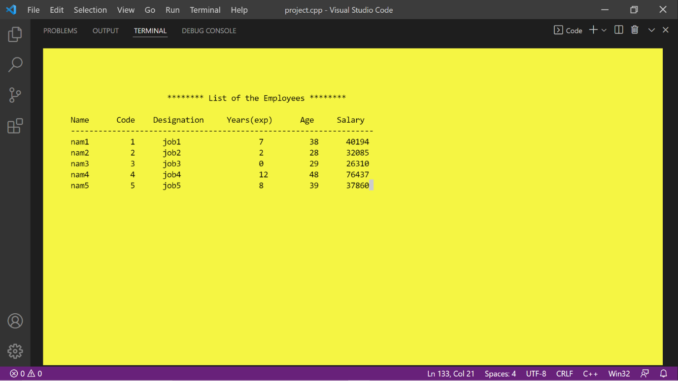

* In case of a huge list and search for a particular employee, unique employee code can help in that operation of searching

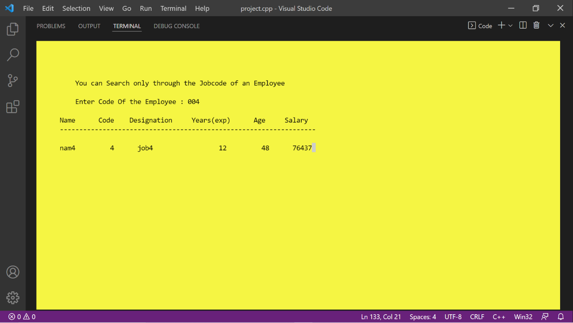

* Altering of any entry is also possible using the character e from the keyboard, altering menu is as follows.

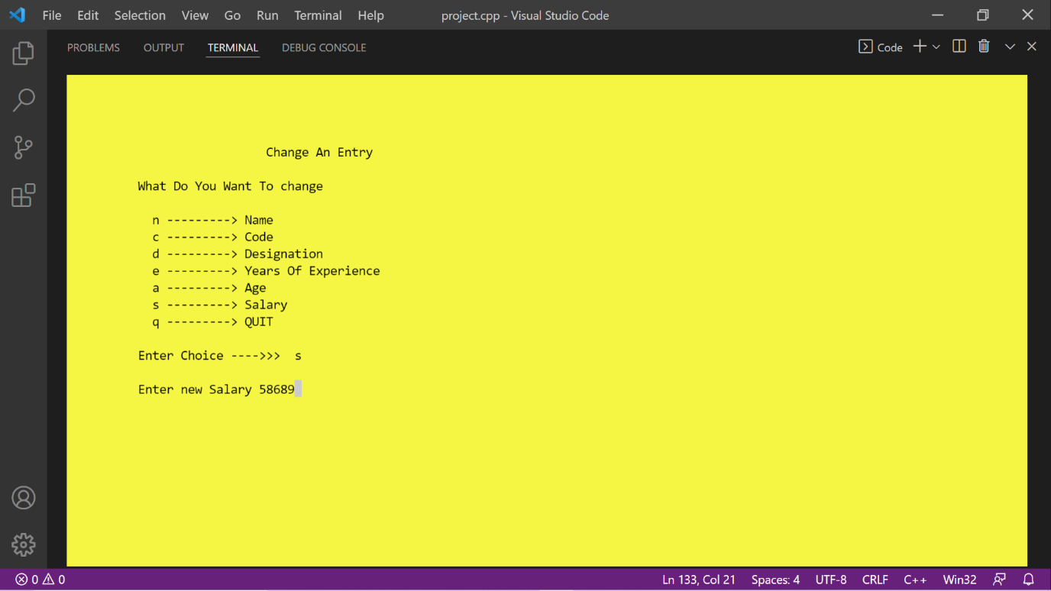

* A record can also be deleted using character d. deletion window is as follows.

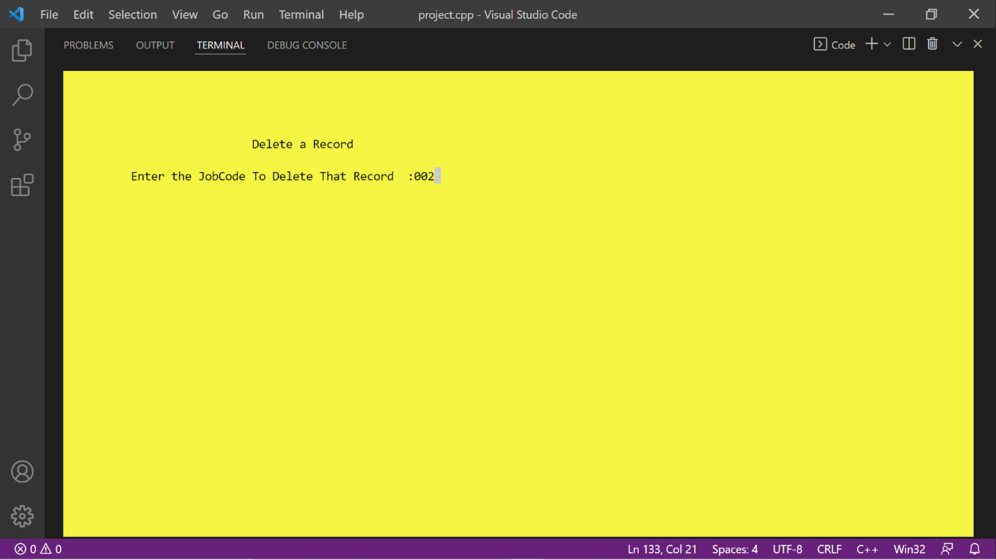

* The payslip of any particular employee can also be generated using character p, the following window appears.

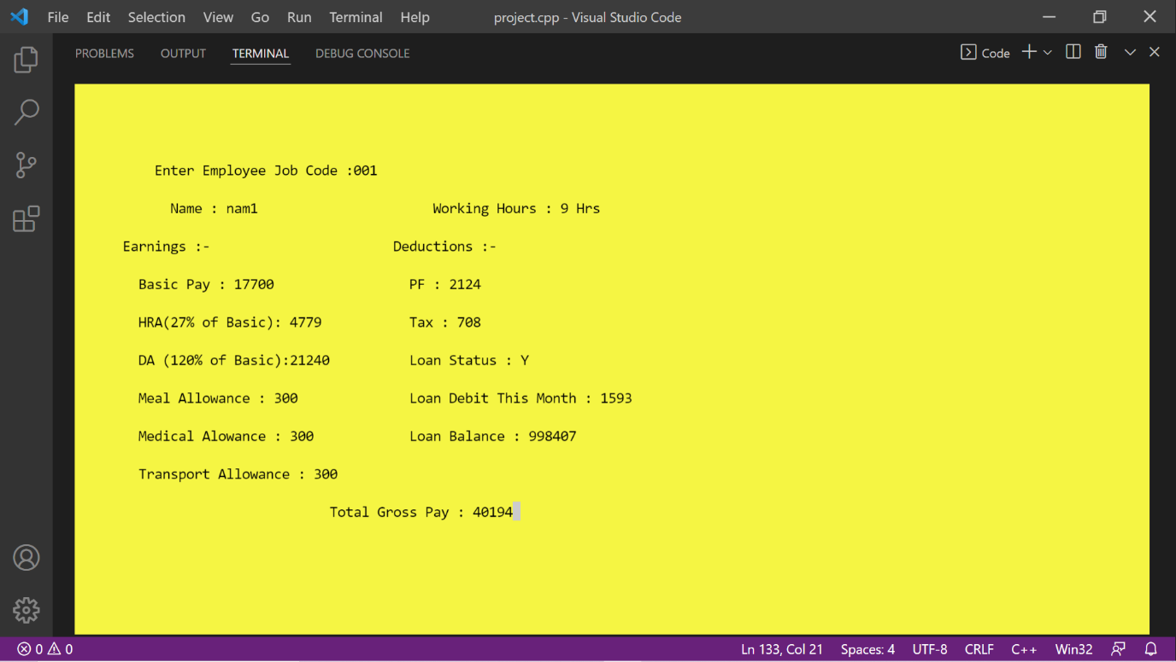

**7 CONCLUSION**

This mini project is my effort to make an interactive C++ program which is appealing to the user. Through this project I want to improve as a coder and learn more features of the C++ programming language.

**7.1 FUTURE SCOPE:**

This project can be further developed to be more interactive having employee login system. Automated salary deduction on the basis of applied and granted leaves by admin. This system can further have additional functions of sorting the list of employees. A function for different departments of institution can also be included.

**8 BIBLIOGRAPHY**

• Google Scholar- "Payroll Management System" by Jhansi Bharathi Madavarapu (govst.edu)

• Projects on github- 1-> GitHub - rmahfuz/Payroll-Management-System: A payroll management system implemented using C++

2-> GitHub - VangaPoornaChand/Payroll-management-System-in-CPP-With-Documentation

• Header files in C/C++ and its uses - GeeksforGeeks

• c++ windows.h library and handles - C++ Forum (cplusplus.com)

• Using gotoxy() in Dev-C++ | The Ultimate Nerd (wordpress.com)

• https://www.youtube.com/watch?v=Iuo9PpGE04Y&list=PLLYz8uHU480j37APNXBdPz7YzAi4XlQUF

• https://www.youtube.com/watch?v=z9bZufPHFLU&list=PLfqMhTWNBTe0b2nM6JHVCnAkhQRGiZMSJ

• How to Make a C++ Login Program Part 1 - YouTube

• File Handling in C++ (tutorialride.com)

• System() Function in C/C++ (tutorialspoint.com)

• Book-> Computer Science with C++- Sumita Arora

• Book-> SC’s Computer Science with C++