Data-Driven Analysis and Recommendations for Launch Week Classes

Submitted by: **Yash Joglekar**  
Company: **Coral Academy**

# 1. Introduction

This report presents a detailed analysis of enrollment data from past Zoom classes, including attendance details and student feedback scores. The objective is to provide actionable insights on optimal class timings and teacher-topic selections for the launch. Coral Academy caters to kids aged 8-13 years, and the dataset captures enrollment and feedback from our beta-testing website.

# 2. Data Overview and Methodology

## Data Overview

The dataset contains the following key columns:  
- Age: Age of the student  
- Teacher Name: Name of the teacher  
- Type: Class type (e.g., trial, regular)  
- Class name: Title of the class  
- Date & Day: When the class was held  
- Start time (in PST) & End time (in PST): Class timings  
- Timezone: Timezone of the enrollment/session  
- Phase Mapping: Phase or stage information  
- Topics: Subjects covered  
- Attended?: Whether the student attended  
- Final score: Feedback score provided by the student  
- Start Hour: Extracted from the start time  
- Attended_Binary: Binary flag for attendance (1 for yes, 0 for no)

## Methodology

1. Data Cleaning & Transformation: Dropped non-essential columns, standardized date/time fields, imputed missing values, and created derived features.  
2. Exploratory Data Analysis (EDA): Performed visualizations (histograms, scatter plots, violin plots, heatmaps) to analyze score distributions, teacher performance, attendance trends, and timezone distributions.  
3. Final Timetable Curation: Combined insights from teacher-topic performance and attendance analysis to generate a recommended launch week timetable.

# 3. Key Findings

## A. Feedback & Score Distribution

The analysis of feedback scores shows a moderate distribution with most scores clustering around 3.0–3.5. Violin plots indicate that days like Wednesday and Sunday have higher median scores with greater variability, suggesting both high engagement and diverse performance on these days.

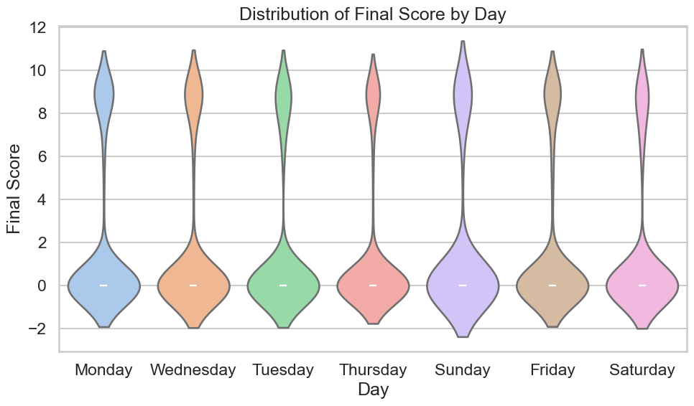

## B. Teacher Performance & Teacher-Topic Analysis

Top-performing teachers such as Mary Daniels, Nicole Pauling, and Melissa Peterson consistently achieve average final scores above 3.0. Teacher-topic analysis highlights that subject like Math, Life Skills, Speaking, and Coding receive the highest ratings.

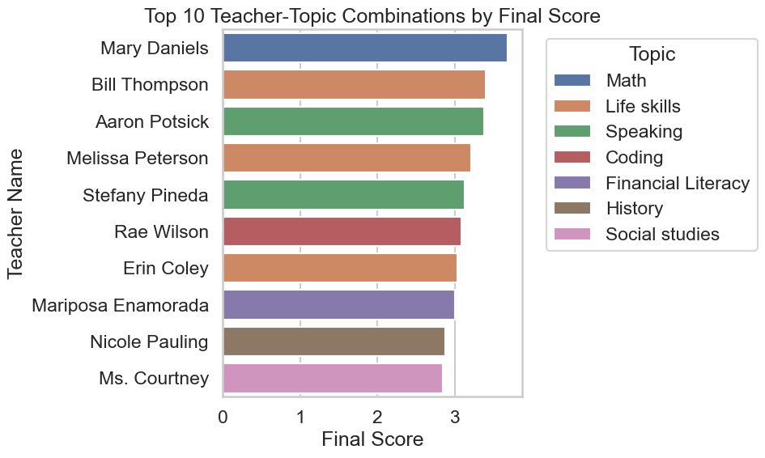

## C. Attendance Analysis

Attendance rates, transformed into a binary indicator, vary by day. Some days show higher attendance rates, and teacher-wise analysis confirms that high-performing teachers also maintain strong attendance.

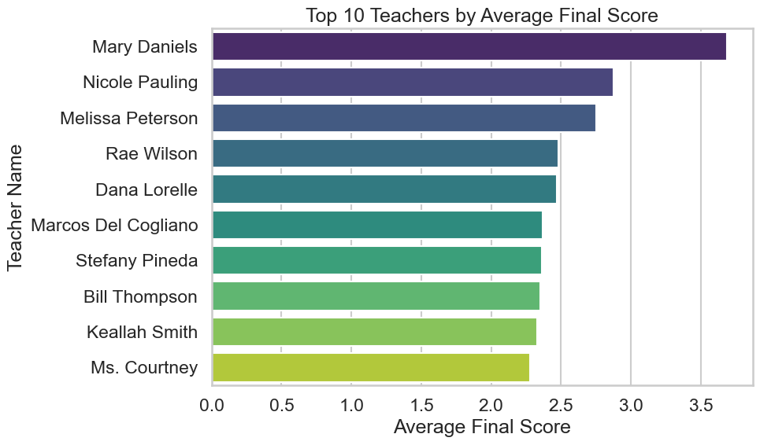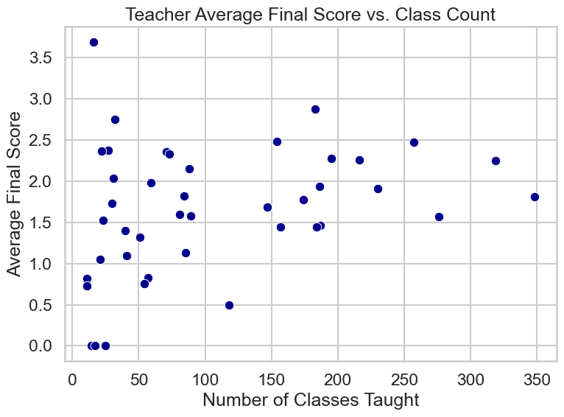

## D. Timezone Distribution

The majority of enrollments are from the EST and PST time zones. There is also participation from other US time zones (MST, CST) and a notable share from international zones (IST, GMT). This indicates that scheduling should primarily target US-friendly hours while considering select sessions for international audiences.

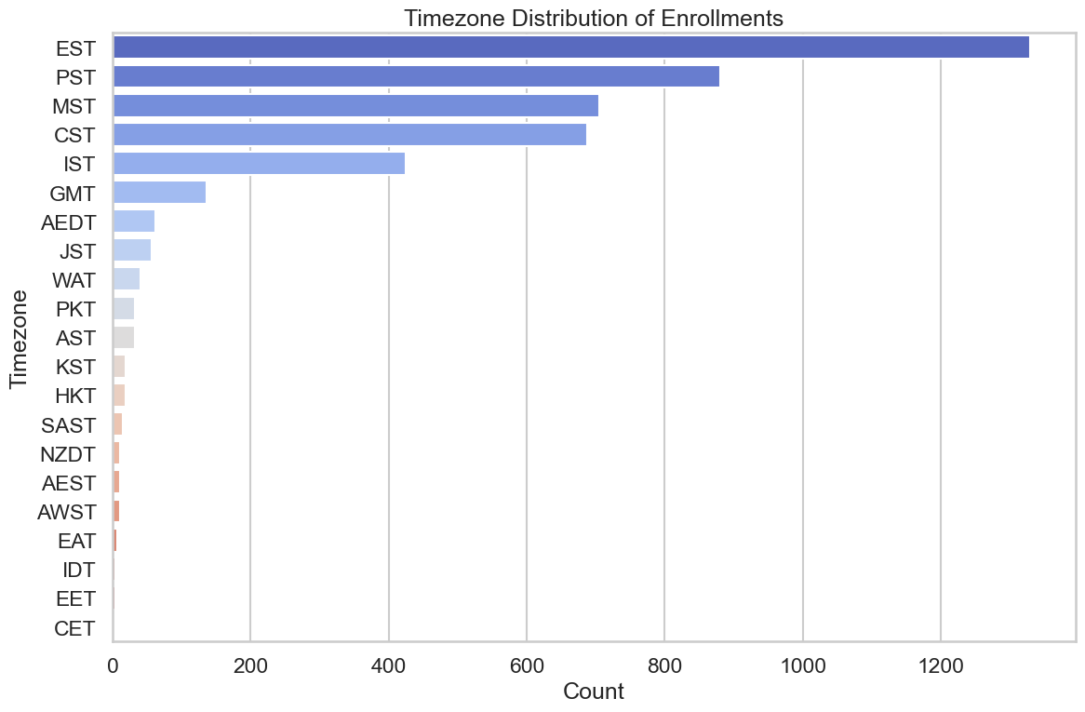

# 4. Recommendations

Based on the analysis, the following recommendations are proposed:

1. **Optimal Class Timings and Time Zones:** 
   * Schedule classes at 11:00 AM and 5:00 PM PST to capture high attendance from EST and PST regions.
2. **Class Curation:**
   * Prioritize top-performing teachers (e.g., Mary Daniels, Nicole Pauling, Melissa Peterson) and popular subjects (Math, Life Skills, Speaking, Coding).
3. **Additional Considerations:**
   * Consider offering a few sessions tailored for international audiences based on IST or GMT.

# 5. Final Recommended Launch Week Timetable

The following table outlines the recommended schedule for launch week:

|  |  |  |  |  |  |
| --- | --- | --- | --- | --- | --- |
| Day | Start Time (PST) | Teacher Name | Topic | Avg Final Score | Comments |
| Monday | 11:00 | Mary Daniels | Math | 3.69 | Highly Recommended |
| Monday | 17:00 | Melissa Peterson | Life skills | 3.05 | Recommended |
| Tuesday | 11:00 | Aaron Potsick | Speaking | 3.38 | Highly Recommended |
| Tuesday | 17:00 | Rae Wilson | Coding | 3.08 | Recommended |
| Wednesday | 11:00 | Stefany Pineda | Speaking | 3.13 | Recommended |
| Wednesday | 17:00 | Bill Thompson | Life skills | 3.40 | Highly Recommended |
| Thursday | 11:00 | Nicole Pauling | History | 2.86 | Recommended |
| Thursday | 17:00 | Ms. Courtney | Social studies | 2.85 | Recommended |
| Friday | 11:00 | Mariposa Enamorada | Financial Literacy | 3.00 | Recommended |
| Friday | 17:00 | Erin Coley | Life skills | 3.04 | Recommended |
| Saturday | 11:00 | Popular Session* | Repeat Popular Class | -- | For Newcomers |
| Saturday | 17:00 | Interactive Q&A* | Open Q&A Session | -- | Community Building |
| Sunday | 11:00 | Recap Session* | Learning Recap | -- | Consolidation |
| Sunday | 17:00 | Guest Panel* | Expert Guest Panel | -- | Closing Discussion |

# 6. Conclusion

The analysis indicates that by focusing on optimal class timings (11:00 AM and 5:00 PM PST), and by prioritizing high-performing teachers and popular topics, Coral Academy can maximize both attendance and student satisfaction during launch week. The recommendations provided here are intended to drive a data-driven approach to scheduling and class curation, ensuring that classes not only sell out quickly but also maintain high engagement levels.