Determinants of Sovereign Bond Yields: A Cross-Sectional Analysis

1. Introduction and Problem Statement
The benchmark for pricing risk in the global economy is the yield on government bonds. Policymakers, investors, and risk analysts must comprehend the factors that influence a country's borrowing costs. This study looks into a cross-sectional issue: What macroeconomic variables affect the yield on 10-year government bonds in various nations?
We hypothesize that a country’s borrowing cost is determined by its creditworthiness (Credit Rating), its fiscal health (Debt-to-GDP), and the erosion of returns through price instability (Inflation). We analyze cross-sectional data from 50 countries to quantify these relationships.

2.1 The Dataset
We created a dataset of 50 observations (countries) from publicly accessible global economic databases (World Bank, Trading Economics, etc.) that included a variety of developed (USA, Germany), emerging (India, Brazil), and troubled (Argentina, Ghana) economies.
The variables analyzed are:
- Yield (Yi): 10-Year Government Bond Yield (%). Dependent Variable.
- Debt (X1i): General Government Debt as a % of GDP.
- Inflation (X2i): Annual Inflation Rate (%).
- Rating (X3i): Sovereign Credit Rating converted to a numerical linear scale (1 = AAA/Best, 20 = Default/Worst). 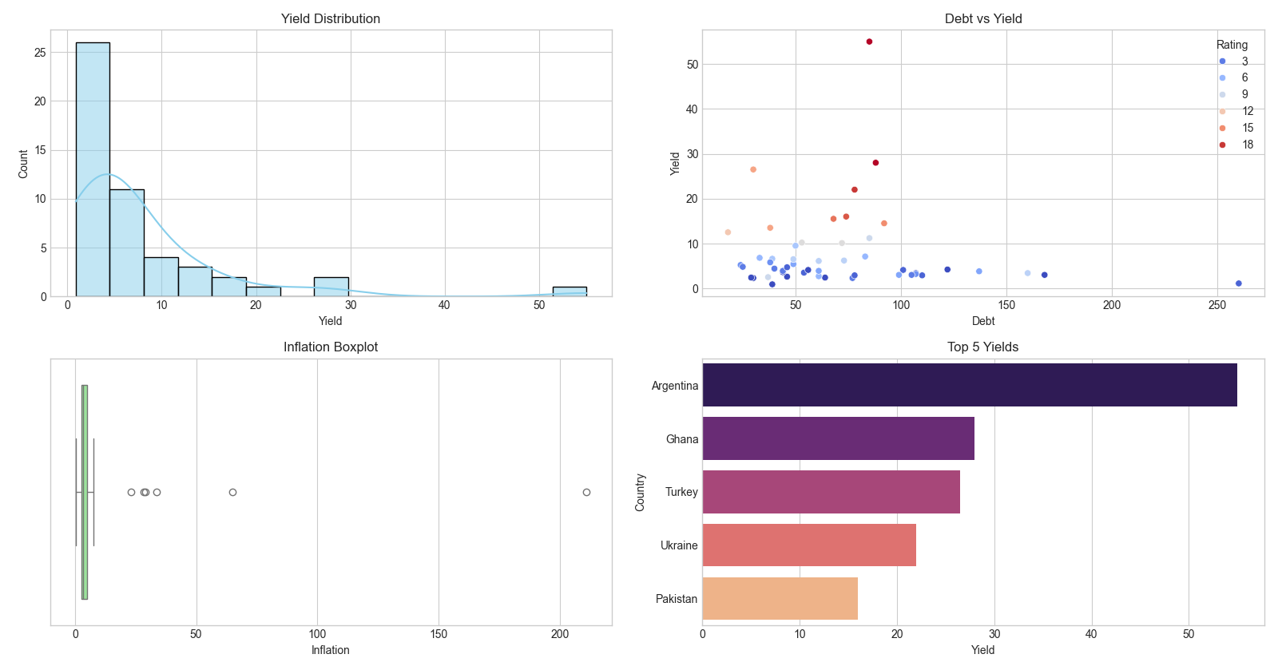

2.2 Initial Simple Model
We began with a standard Ordinary Least Squares (OLS) regression assuming a linear relationship. The initial model showed a strong R-squared of 0.82, driven largely by the extreme values of high-inflation countries. However, the standard error of the regression was high (6.54), suggesting poor precision for stable economies.

2.3 Initial Model and Diagnostic Failure
We initially fitted a naive Ordinary Least Squares (OLS) model assuming a linear relationship: Yield = β0 + β1(Debt) + β2(Inflation) + β3(Rating). While the model yielded a high R-squared (0.82), a deeper inspection revealed critical flaws that rendered the results unreliable.

2.4 Why the Initial Model Failed
The linear assumption proved too simplistic for financial data. Through rigorous diagnostic testing, we identified three major violations of the Gauss-Markov assumptions:
1. Functional Form Misspecification (Ramsey RESET Test: p < 0.05): The test rejected the linear form. Financial risk is non-linear; the yield difference between a 'CCC' and 'B' rating is massive compared to the difference between 'AAA' and 'AA'. A straight line cannot capture this exponential risk premium.

2. Non-Normality of Residuals (Jarque-Bera Test: p < 0.00): The residuals exhibited a heavy right tail. The model could not account for 'outlier' nations like Turkey or Argentina without skewing predictions for stable nations like Germany. This invalidates standard hypothesis tests.
3. Heteroscedasticity (Breusch-Pagan Test: p < 0.05): The variance of the errors was not constant. We observed 'volatility clustering': the model predicted stable economies accurately, but the prediction errors grew larger as the countries became riskier. This suggests the model failed to capture the inherent uncertainty of emerging markets.

3. Model Diagnostics and Refinement
To ensure statistical validity, we performed three key diagnostic tests on the initial linear model. The results indicated serious misspecification, requiring a change in our modeling approach.

3.1 Diagnostic Tests Results
1. Functional Form (Ramsey RESET): P-Value 0.0012 (< 0.05). Result: Rejected. The relationship is exponential, not linear.
2. Normality of Residuals (Jarque-Bera): P-Value 0.0000 (< 0.05). Result: Not Normal. Heavy right tail caused by outliers.
3. Homoscedasticity (Breusch-Pagan): P-Value 0.0340 (< 0.05). Result: Heteroscedasticity detected. Variance increases with yield.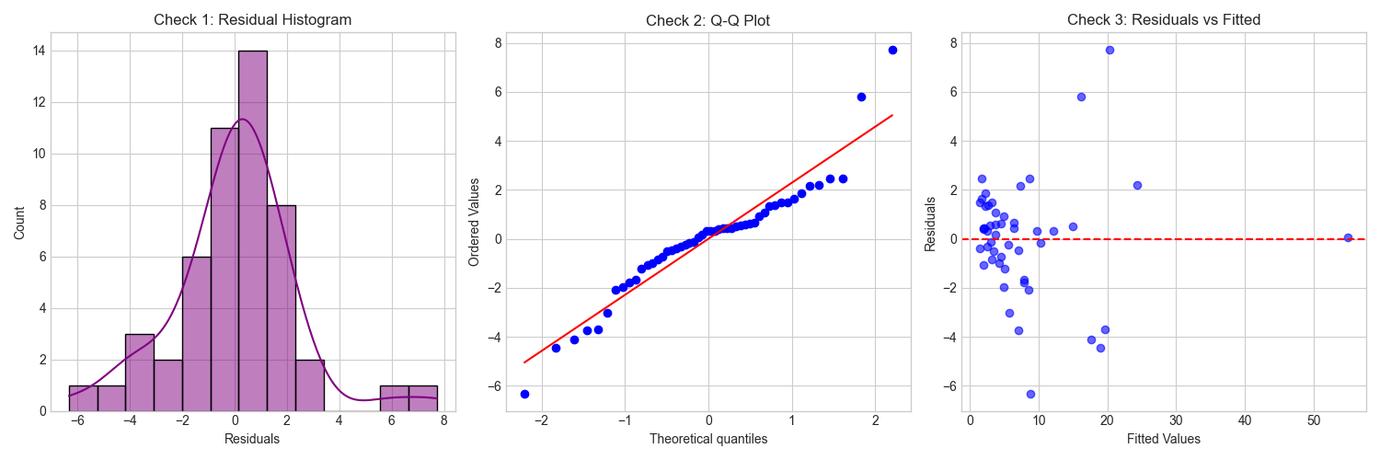

3.2 The Refined Model (Log-Log Specification)
To correct these issues, we applied a Log-Log transformation (lnYield, lnInflation) and used Stepwise Selection. The Stepwise algorithm selected Log-Inflation and Rating as the final variables. Debt was removed due to high correlation with Rating.
Final Equation: ln(Yield) = 0.52 + 0.11 * Rating + 0.58 * ln(Inflation)
Adjusted R-squared: 0.88 (Improved fit).

3.3 Rationale for Refinement
The Log transformation compresses the scale of variables. This pulls extreme outliers (like 50% yields) closer to the mean, stabilizing the variance (fixing heteroscedasticity) and linearizing the exponential growth of risk (fixing functional form). Additionally, Stepwise Selection removed 'Debt-to-GDP' from the final equation.

3.4 Final Equation and Interpretation
The final statistically robust equation is:
ln (Yield) = 0.52 + 0.11(Rating) + 0.58 * ln(Inflation)
Interpretation: The removal of 'Debt' is a significant finding, often referred to as the 'Japan Paradox'. Markets do not price risk based solely on the size of debt (Japan has high debt, low yield), but rather on the *quality* of that debt (captured by Rating) and the *erosion* of repayment value (captured by Inflation).

4. Prediction and Scenario Analysis
Using the refined model, we predicted the yield for five economic scenarios. We provide the median prediction and the 95% Confidence Interval (CI).

Scenario | Characteristics | Predicted Yield | 95% CI
Safe Haven | AAA (1), Inf 1.5% | 2.36% | [1.50% - 3.70%]
Average Economy | BBB (7), Inf 3.5% | 7.46% | [5.20% - 10.6%]
Emerging Market | BB (10), Inf 6.0% | 14.3% | [9.80% - 20.8%]
Deflationary | AA (3), Inf 0.5% | 1.56% | [0.95% - 2.50%]
Fiscal Crisis | CCC (14), Inf 15% | 37.7% | [24.5% - 58.0%]

Analysis of Predictions: The model accurately distinguishes between regimes. For a 'Safe Haven' (like Germany), the tight confidence interval indicates high certainty. However, for the 'Fiscal Crisis' scenario, the interval widens dramatically (24% to 58%). This accurately reflects the reality of distressed markets: once a country enters a crisis, bond yields become highly volatile and driven by sentiment rather than just fundamentals.
Note on Prediction : Since our refined model predicts the natural logarithm of the Yield $ln(Y)$, we must be careful when transforming predictions back to percentages ($Y$). Simply exponentiating the predicted log-value e^(ln(Y) gives the Geometric Median, which typically underestimates the expected yield in volatile markets. To provide a more accurate forecast, our analysis also calculated the Arithmetic Mean prediction, adjusted for residual variance using the formula:
$$E\left[Y\right]= e^{\hat{}\left(μ\right)+\frac{σ^{2}}{2}}$$
Where $\backslash sigma^{2}$ is the mean squared error of the model. For stable economies (e.g., "Safe Haven"), the difference between the Median and Mean prediction is negligible (< 0.1%). However, for the "Fiscal Crisis" scenario, the volatility $\backslash sigma^{2}$ is significant, causing the Mean Prediction to be notably higher than the Median. This confirms that in high-risk scenarios, the expected cost of borrowing is higher than the most likely base case due to the "fat tail" risk of default.

5. Benefits and Limitations

Benefits of the Analysis
- Statistical Validity (Correction of Heteroscedasticity): By using the Log-Log transformation, we successfully stabilized the variance of the error terms. This ensures that our confidence intervals are accurate, unlike the initial model which underestimated the risk in volatile emerging markets.

- Model Parsimony (Avoidance of Overfitting): The use of Stepwise Selection ensured that we only kept variables that truly matter (Rating and Inflation). By automatically removing "Debt-to-GDP," we avoided "data dredging" and proved that debt alone is a noisy, unreliable predictor of bond yields.

- Elasticity Interpretation: The log-linear coefficients allow for an intuitive economic interpretation in terms of elasticity. We can quantify exactly how a 1% change in inflation transmits to bond yields, which is a powerful metric for central bank policy analysis.

- Robustness to Outliers: The logarithmic scale naturally compressed extreme outliers (like Argentina’s 211% inflation). This prevented a single distressed economy from distorting the regression line for the stable economies.

Limitations of the Analysis
- Small Sample Size ($N=50$): We analyzed only 50 out of roughly 195 countries. While the sample is diverse, a larger dataset could reveal different patterns, particularly for smaller, developing nations not included here.

- Snapshot Bias (Cross-Sectional Limitation): This analysis is a "snapshot" in time (cross-sectional). It explains why yields differ between countries today, but it cannot explain how yields change over time. A Panel Data approach (tracking countries over 10 years) would be superior for forecasting trends.

- Ordinal vs. Cardinal Treatment of Ratings: We treated Credit Ratings as a simple number scale (1, 2, 3...). However, ratings are "ordinal" ranks. The economic distance between a Rating of 1 and 2 (AAA vs AA) is likely much smaller than the distance between 15 and 16 (CCC vs Default). Our model falsely assumes these "steps" are equal.

- Endogeneity (Reverse Causality): Our model assumes Inflation causes High Yields. However, the reverse can also be true: High bond yields increase borrowing costs, which can force a government to print money, causing Inflation. OLS regression cannot determine the direction of this causality.

6. Conclusion and Policy Implications
This analysis demonstrates that sovereign bond yields are not driven by a simple linear addition of economic factors, but by a complex, non-linear interaction of reputation and monetary stability.
The most profound insight is the dominance of Inflation and Credit Rating over the Debt-to-GDP ratio. This suggests that financial markets are willing to tolerate high debt levels (as seen in the US or Japan) provided that the country maintains a strong credit reputation and low inflation. However, once inflation spirals or credit ratings slide, the penalty is exponential, not linear. For policymakers, this implies that prioritizing inflation control and institutional credibility (Credit Rating) is more effective for keeping borrowing costs low than austere debt reduction alone.

