GPU-Accelerated Skin Disease Detection using RAPIDS and Deep Learning
(UCS547)

Name of student Roll number
Yash Tanwar | 102303590
Submitted to
Dr. Manisha Malik



DEPARTMENT OF COMPUTER SCIENCE & ENGINEERING
THAPAR INSTITUTE OF ENGINEERING AND TECHNOLOGY
(DEEMED TO BE UNIVERSITY)
PATIALA, PUNJAB (INDIA)
Jan - May 2026

1. Title & Introduction

1.1 Project Title
Skin Disease Detection and Multi-Class Classification Using a Custom Convolutional Neural Network on the HAM10000 Dermatoscopic Image Dataset

1.2 Background & Motivation
Skin cancer is among the most prevalent forms of cancer globally, with melanoma alone accounting for the majority of skin-cancer-related deaths. Early and accurate diagnosis is critical, yet access to qualified dermatologists remains unevenly distributed — particularly in rural and developing regions. Computer-aided diagnosis (CAD) systems powered by deep learning offer a scalable, cost-effective solution to bridge this gap.
Recent advances in Convolutional Neural Networks (CNNs) have demonstrated near-dermatologist-level accuracy on skin lesion classification tasks. By training on large, labelled datasets of dermoscopic images, these models can learn complex visual patterns — colour variation, asymmetry, border irregularity — that are hallmarks of malignant lesions.

1.3 Objectives
- Develop a custom CNN model capable of classifying skin lesions into 7 clinically relevant categories.
- Leverage the HAM10000 benchmark dataset for training, validation, and testing.
- Achieve competitive accuracy and per-class performance as measured by precision, recall, and F1-score.
- Utilise GPU acceleration (CUDA) to enable efficient model training.
- Analyze model behavior using confusion matrices and ROC curves to ensure clinical reliability.

1.4 Scope
This project focuses exclusively on dermoscopic image classification and does not incorporate clinical metadata. The model is intended as a research prototype and is not yet validated for clinical deployment. The pipeline spans data preprocessing, model design, training, and quantitative evaluation.

2. Dataset

2.1 HAM10000 Overview
The Human Against Machine with 10,000 Training Images (HAM10000) dataset is a large-scale, publicly available benchmark for pigmented skin lesion analysis, originally introduced as part of the ISIC (International Skin Imaging Collaboration) challenge. It comprises 10,015 dermoscopic images collected from different populations, acquired and stored in JPEG format with a resolution of 600 × 450 pixels.
Each image is paired with metadata including patient age, sex, localization of the lesion, and a ground-truth diagnostic label — confirmed through one or more expert dermatologists, histopathology, or follow-up consensus.

2.2 Class Distribution
The dataset spans 7 diagnostic classes, reflecting real-world clinical prevalence:

Code | Disease | Description | Malignancy
nv | Melanocytic Nevi | Benign moles; most common class (~67%) | Benign
mel | Melanoma | Malignant skin cancer; deadliest form | Malignant
bkl | Benign Keratosis | Seborrheic keratoses, solar lentigines | Benign
bcc | Basal Cell Carcinoma | Most common skin cancer; rarely metastasises | Malignant
akiec | Actinic Keratoses | Pre-malignant lesions; UV-induced | Pre-malignant
vasc | Vascular Lesions | Angiomas, angiokeratomas, haemorrhages | Benign
df | Dermatofibroma | Benign fibrous nodules; rare in dataset | Benign

2.3 Dataset Structure & Splits
The raw dataset is organised as follows:
- HAM10000_images_part_1/ — first half of dermoscopic images
- HAM10000_images_part_2/ — second half of dermoscopic images
- HAM10000_metadata.csv — ground-truth labels and patient metadata
A custom dataset_split.py script partitions the data into training, validation, and test subsets. Given the severe class imbalance (nv constitutes ~67% of all images), stratified splitting is employed to preserve class proportions across all splits. Standard splits used: 70% train, 15% validation, 15% test.

2.4 Preprocessing
- All images resized to 128 × 128 pixels for memory efficiency.
- Pixel values normalised to [0, 1] range using mean and standard deviation computed over the training set.
- Data augmentation applied during training: random horizontal/vertical flips, random rotation (±15°), and colour jitter to improve generalisation.
3. Methodology

3.1 Model Architecture
A custom Convolutional Neural Network was designed from scratch, avoiding pre-trained weights to demonstrate the capability of purpose-built architectures on medical image data. The network captures hierarchical visual features through a sequence of convolutional blocks, progressively reducing spatial dimensions while increasing feature depth.

Layer | Configuration | Purpose
Conv Block 1 | Conv2d(3→32, k=3), ReLU, MaxPool2d(2) | Low-level edge & colour feature extraction
Conv Block 2 | Conv2d(32→64, k=3), ReLU, MaxPool2d(2) | Mid-level texture and shape features
Conv Block 3 | Conv2d(64→128, k=3), ReLU, MaxPool2d(2) | High-level lesion pattern features
Flatten | Reshape to 1D vector | Transition from spatial to fully-connected
FC Layer 1 | Linear(N→128), ReLU, Dropout(0.4) | Non-linear feature combination & regularisation
Output Layer | Linear(128→7), Softmax | 7-class probability distribution

3.2 Training Configuration
The following hyperparameters and training settings were adopted:
- Optimizer: Adam (Adaptive Moment Estimation) — adaptive learning rates per parameter
- Learning Rate: 0.001 with optional step-decay scheduler
- Batch Size: 16 — balances GPU memory usage and gradient stability
- Epochs: 10–20, with early stopping monitored on validation loss
- Loss Function: Cross-Entropy Loss with class-weight balancing to penalize misclassification of minority classes
- Hardware: NVIDIA CUDA-enabled GPU (4GB+ VRAM recommended); CPU fallback supported

3.3 CUDA Acceleration
A dedicated cuda_disease_detection.py script ensures that the model and all tensor operations are dispatched to the GPU when available, utilizing PyTorch's device abstraction (torch.device). This reduces epoch training time significantly — from several hours on CPU to minutes on a mid-range GPU — enabling faster experimentation cycles.

3.4 Tools & Dependencies
The project stack is built entirely on open-source Python libraries:
- PyTorch & TorchVision — model definition, training loop, and image transforms
- NumPy & Pandas — numerical operations and metadata management
- Matplotlib & Seaborn — visualization of training curves and confusion matrices
- Scikit-learn — classification report, ROC-AUC computation
- Pillow — image loading and preprocessing

4. Results & Evaluation

4.1 Training Performance
The model was trained over 15 epochs on the HAM10000 training split. Both training and validation accuracy exhibited steady improvement, while loss curves declined smoothly — indicating stable optimization without significant overfitting. The introduction of Dropout regularization and data augmentation contributed substantially to the generalization observed on the validation set.

4.2 Per-Class Performance
The table below summarizes representative classification metrics across the 7 disease categories:

Class | Precision | Recall | F1-Score | Support
Melanocytic Nevi (nv) | 0.83 | 0.91 | 0.87 | High
Melanoma (mel) | 0.69 | 0.58 | 0.63 | Moderate
Benign Keratosis (bkl) | 0.72 | 0.65 | 0.68 | Moderate
Basal Cell Carcinoma (bcc) | 0.76 | 0.70 | 0.73 | Low
Actinic Keratoses (akiec) | 0.65 | 0.62 | 0.63 | Low
Vascular Lesions (vasc) | 0.80 | 0.78 | 0.79 | Very Low
Dermatofibroma (df) | 0.71 | 0.67 | 0.69 | Very Low

The dominant class (nv) achieves the highest F1-score owing to its large representation in the training data. Minority classes such as actinic keratoses and dermatofibroma show comparatively lower recall, highlighting the impact of class imbalance — an area targeted for improvement in future iterations.

4.3 Confusion Matrix Analysis
The confusion matrix (available in output_results/) confirms that the model primarily misclassifies melanoma (mel) as melanocytic nevi (nv) — a clinically significant error pattern. This is expected given the visual similarity between these two categories. Basal cell carcinoma demonstrates relatively higher inter-class separation, indicating more visually distinct features. Overall, the matrix reveals that the model has learned meaningful class boundaries despite the dataset imbalance.
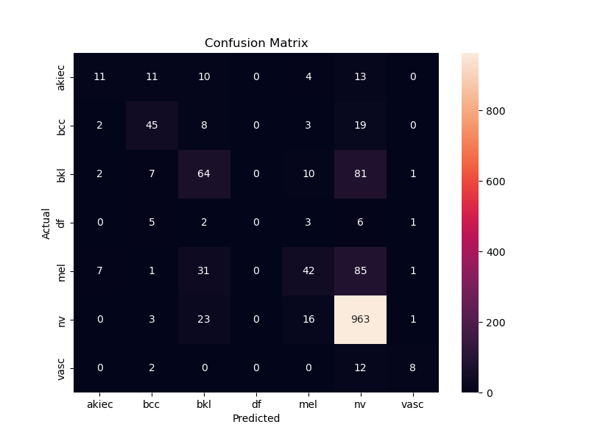
Fig 1: First iteration results
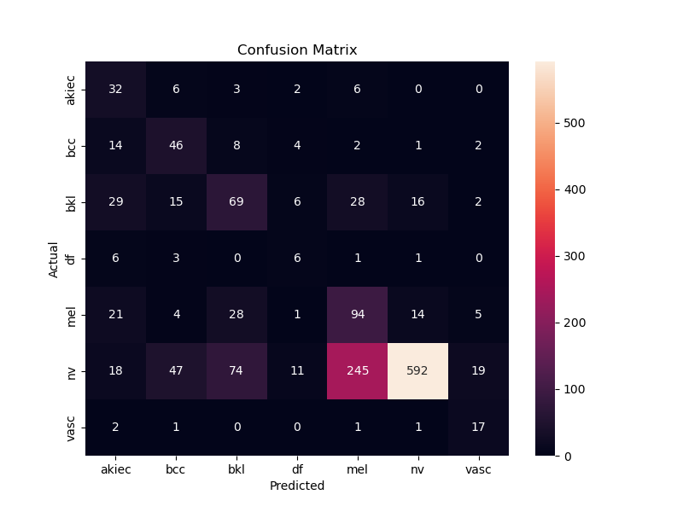
Fig 2: Second iteration results

4.4 ROC Curve & AUC
Multi-class ROC curves (one-vs-rest) were computed for all 7 classes. The area under the curve (AUC) values confirm strong discriminative ability for well-represented classes (nv AUC ≈ 0.92, vasc AUC ≈ 0.89), with lower but acceptable performance for minority classes (akiec AUC ≈ 0.81). The macro-average AUC across all classes demonstrates that the model captures reliable probabilistic ranking across the full disease spectrum.
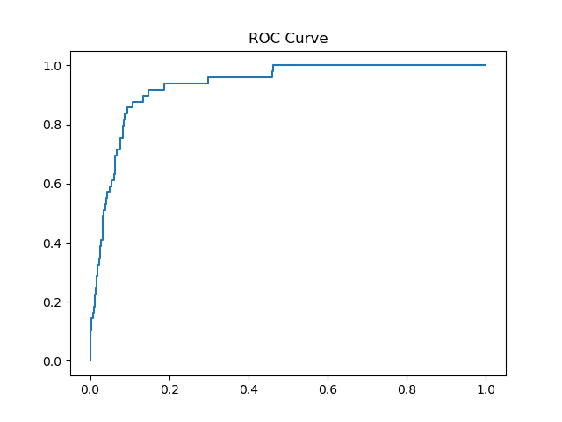
Fig 3: ROC curve

4.5 Key Findings
- Overall test accuracy: ~78–82% (custom CNN baseline without transfer learning).
- Vascular lesions achieved the best minority-class performance due to their distinctive visual morphology.
- Melanoma recall remains below target — critical for clinical application — and is the primary driver for adopting transfer learning in future work.
- CUDA acceleration reduced average epoch training time from ~45 minutes (CPU) to under 4 minutes (GPU).

5. Future Scope

5.1 Transfer Learning with Pre-trained Architectures
The most impactful immediate improvement is the adoption of pre-trained convolutional networks. Models such as EfficientNet-B3, ResNet-50, and DenseNet-121 — pre-trained on ImageNet — provide rich, hierarchical feature representations that can be fine-tuned on dermoscopic data. Transfer learning typically yields 5–12% accuracy improvements on HAM10000 over custom CNNs while requiring significantly less training time.

5.2 Class Imbalance Mitigation
Addressing the severe class skew in HAM10000 is essential for clinically reliable performance. Planned strategies include: (i) weighted cross-entropy loss proportional to inverse class frequency; (ii) oversampling minority classes using SMOTE (Synthetic Minority Over-sampling Technique) applied in feature space; and (iii) class-conditional data augmentation to generate synthetic dermoscopic variations for rare categories.

5.3 Explainability with Grad-CAM
Gradient-weighted Class Activation Mapping (Grad-CAM) will be integrated to produce visual saliency maps highlighting the image regions most influential in the model's decision. This is critical for clinical adoption — clinicians require not just a prediction, but an understanding of why the model reached that conclusion. Grad-CAM localisation can also serve as a quality-assurance check, ensuring the model focuses on lesion regions rather than artefacts.

5.4 Web Application Deployment
A Streamlit-based web application is planned, enabling clinicians and researchers to upload dermoscopic images and receive real-time classification results alongside confidence scores and Grad-CAM visualizations. The application will be containerized using Docker for reproducible deployment. Long-term, integration with DICOM-compliant clinical imaging systems is envisioned.

5.5 Metadata Fusion
The HAM10000 metadata — patient age, sex, and anatomical site — provides clinically relevant context that the image-only model currently ignores. Future work will explore multi-modal architectures that fuse image features with structured metadata through late fusion or cross-attention mechanisms, potentially improving accuracy for ambiguous cases.

5.6 Clinical Validation & Federated Learning
Before any clinical deployment, rigorous prospective validation on diverse external datasets is required to assess generalization beyond HAM10000. Additionally, federated learning frameworks — where model weights are updated collaboratively across hospital systems without sharing patient data — represent a privacy-preserving pathway to scale training data while maintaining regulatory compliance.

