**Nadimpalli Satyanarayana Raju Institute of Technology (Autonomous)**

**Sontyam 531173, Andhra Pradesh**

DEMONSTRATION OF BASIC AWS SERVICES

### Report Summer Internship I

Submitted by

# BATTULA YASWANTH

**(20NU1A0509)**

in partial fulfillment for the award of the degree of

## BACHELOR OF TECHNOLOGY

in

**Department of Computer Science & Engineering**

JUNE-JULY,2022



**Nadimpalli Satyanarayana Raju Institute of Technology (Autonomous)**

**Sontyam 531173, Andhra Pradesh**

DEMONSTRATION OF BASIC AWS SERVICES

### Report Summer Internship I

Carried out at

# BRAINOVISION

in partial fulfillment for the award of the degree of

## BACHELOR OF TECHNOLOGY

in

**Department of Computer Science & Engineering**

JUNE-JULY,2022

## BONAFIDE CERTIFICATE

Certified that this internship report **DEMONSTRATION OF BASIC AWS SERVICES** is the bonafide work of “ **BATTULA YASWANTH ”** who carried out summer internship under our supervision at **BRAINOVISION SOLUTIONS** company.

Signature of the Faculty supervisor Signature of the Industry Supervisor Mr. JANI SHAIK Mr. GANESH NAGU

Assistant. Professor AMAZON WEB SERVICES Dept. of CSE

Signature of the Head of the Department Dr. Srinivas Rayudu

|  |  |  |
| --- | --- | --- |
| **Table of Contents** | | |
| **No.** | **Description** | **Page Number** |
|  | **Name of the Company** | BRAINOVISION |
|  | **Company URL** | https://brainovision.org |
| 1 | Profile of the Company | V |
| 2 | Certificate of Summer Internship I | VI |
| 3 | Learning Outcomes of Summer Internship | 1 |
| 4 | Program Outcomes Addressed (List) | 2 |
| 5 | Learning Outcomes (PO – wise) |  |
| PO #1 | 3 |
| PO #2 | 4 |
| PO #3 | 5 |
| PO #4 | 6 |
| PO #5 | 7 |
| PO #6 | 8 |
| PO #7 | 9 |
| PO #8 | 10 |
| PO #9 | 11 |
| PO #10 | 12 |
| PO #11 | 13 |
| PO #12 | 14 |
| PSO #1 & #2 | 15,16 |
| 6 | Rubrics (Three Reviews & Final Presentation Review) | 17,18 |
| 7 | Feedback  Write your experience with the company | 19 |
| 8 | Photo(s) of your internship experience/Product/Other related | 20 |

# Profile of the company



**Brainovision Solutions India Private Limited** is an organization which deals with the wing of software development and technical education.

It is a place for students and faculty and other companies to find the solution for all their requirements Such as internships, academic projects (Mini & Major projects), online courses, Workshops, and faculty development programs, and to hire a perfect skilled candidate.

# Certificate of Summer Internship I

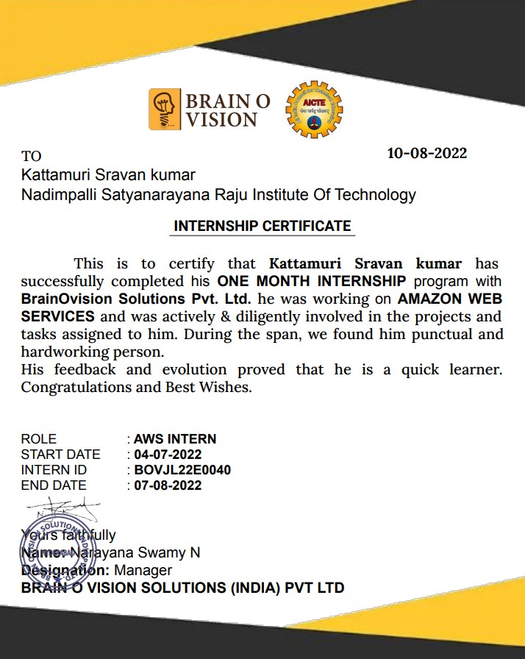



**Acknowledgment**

We would like to take this opportunity to express my deepest gratitude to my project supervisor, Mr. Jani Shaik, N S Raju Institute of Technology (A), Visakhapatnam, who has persistently and determinedly guided me during the whole course of this project. It would have been very difficult to complete this project without his/her enthusiastic support, insight, and advice. We are extremely thankful to Dr. Srinivas Rayudu, professor & Head of CSE Department for providing excellent lab facilities which were helpful in successful completion of my internship program. Our utmost thanks also to all the Trainers of the Company for their support throughout my Summer Internship and Internship Institute Level Coordinator, Mrs. V. Usha Rani, Asst. Prof. of CSE.

We take immense pleasure in thanking Dr. M.A. Khadar Baba, Principal & Dr. J. Raja Murugadoss, Director, N S Raju Institute of Technology (A), Sontyam, Visakhapatnam, for having permitted me to finish the Summer Internship - I. We thank the MANAGEMENT of N S Raju Institute of Technology (A), Sontyam, Visakhapatnam, for providing the various resources to complete the Summer Internship - I successfully. We are thankful to one and all who contributed to my work directly or indirectly.

BATTULA YASWANTH

(20NU1A0509)



# Learning Outcomes of Summer Internship

## As per Curriculum

1. Demonstrate the theoretical learning outcomes
2. Integrate theory and practice during graduation
3. Comprehend the Industry practices in the relevant and allied field of study
4. Develop Communication Skills in terms of Oral, Written, and graphical communications
5. Develop Problem solving skills
6. Develop work habits and teamwork in a multidisciplinary setting for a successful career after graduation

1

# List of Program Outcomes

## As per the Program of Study

PO1: Apply the knowledge of basic sciences and fundamental engineering concepts in solving engineering problems **(Engineering Knowledge)**

PO2: Identify, formulate, review research literature, and analyze complex engineering problems reaching substantiated conclusions using first principles of mathematics, natural sciences, and engineering sciences. **(Problem Analysis)**

PO3: Design solutions for complex engineering problems and design system components or processes that meet the specified needs with appropriate consideration for the public health and safety, and the cultural, societal, and environmental considerations. **(Design/Development of Solutions)**

PO4: Perform investigations, design and conduct experiments, analyse and interpret the results to provide valid conclusions **(Investigation of Complex Problems)**

PO5: Select/develop and apply appropriate techniques and IT tools for the design & analysis of the systems **(Modern Tool Usage)**

PO6: Give reasoning and assess societal, health, legal and cultural issues with competency in professional engineering practices **(The Engineer and Society)**

PO7: Demonstrate professional skills and contextual reasoning to assess environmental/societal issues for sustainable development **(The Environment and Sustainability)**

PO8: Demonstrate Knowledge of professional and ethical practices **(Ethics)**

PO9: Function effectively as an individual, and as a member or leader in diverse teams, and in multi- disciplinary situations **(Individual and Team Work)**

PO10: Communicate effectively among engineering community, being able to comprehend and write effectively reports, presentation and give / receive clears instructions **(Communication)**

PO11: Demonstrate and apply engineering & management principles in their own / team projects in multidisciplinary environment **(Project Finance and Management)**

PO12: Recognize the need for, and have the ability to engage in independent and lifelong learning

**(Life Long Learning)**

PSO1: Able to apply the theoretical knowledge of Computer Science and Engineering and the foundational principles of software development to provide sustainable solutions for the real- world technical challenges in the tech landscape by maintaining professional standards, ethical values, and integrity

PSO2: Able to adopt to technological changes by initiating self-paced learning to meet the industry demands

# (Indicate how the theoretical knowledge of the courses taught helped you to do summer internships)

* The theoretical knowledge that I gained through the summer internship from Brainovision Solutions India Private Limited is an organization that deals with the wing of software development and technical education this is the place for students and faculty and other companies to find solutions for all their requirements
* This internship especially focused on the concepts of AMAZON WEB SERVICES(AWS). Amazon Web Services, Inc. (AWS) is a subsidiary of Amazon that provides on-demand cloud computing platforms and APIs to individuals, companies, and governments, on a metered pay-as-you-go basis.
* These cloud computing web services provide distributed computing processing capacity and software tools via AWS server farms.
* I learned how to launch the web servers and termination of them.
* I have also learned many concepts like cloud computing, EC2 servers, security groups, key pairs, some commands of OS, elastic load balancers, auto-scaling groups, status check, S3, buckets, templates, and many more.
* And also learned many real-time applications, and also developed everything through an AWS account.
* In this seasonal internship, I gone through new knowledge experiences which made us learn many concepts which were used for future enhancement.

# (Indicate the ability of Problem Analysis)

* This summer internship really increased our ability to analyze problems which helped us to develop a highly efficient solution, after doing this internship from brainovision.
* Now we are capable of perfectly analyzing a problem from the very bottom level this analysis enabled us to think perfectly about the problem and finding an optimal solution most of the times, previously most of the time while using a cloud service systems we were stuck at various phases in development but after doing this summer internship from brainovision now we can analyze the problem perfectly beforehand and then later start the development, now we exactly know what we are doing while developing a cloud service.
* now we are able to use cloud service very effectively. Now we can easily analyze a problem from scratch level and we can solve it more efficiently than previous.

**PO #3:**

# (Indicate the ability of Design and Development of Solutions)

In this summer internship, I learned about how to design and development of a solution according to the requirements of the client. The design is the main part of problem solving.

* Using s3 the storage problem is solved
* Using auto scaling groups allows you to automatically adapt the computing power according to the real load of the system
* EC2 allows you to deploy a server within minutes
* Using IAM the maintaining of roles is much easier
* Using VPC the creation of subnets, web servers, and databases are easily secured

**PO #4:**

# (Indicate your experiments being carried out in industry, if any)

* I carried out different experiments like the Launching Of Windows And Linux Instances
* Also I Worked On AWS Virtual Private Cloud, AWS S3(Simple Storage Service), AWS EC2 Instances(Elastic Cloud Compute), AWS ELB(Elastic Load Balancers), AWS IAM(Identity And Access Management), AWS EBS(Elastic Block Storage).
* I went through Introduction To Cloud Computing, Aws Cloud Storage, AWS RDS (Relational Database Services), AWS Web server, AWS ASG (Auto Scaling Group), AWS S3 Buckets, Cloud Front, Access Billing, AWS Auto Scaling Policy, Various Routing Policies, Network
* I also done Application of Load Balancers, Launching, Starting, Stopping, Terminating, Creating An EC2 Instance, Storage Services Provided By AWS Cloud, Healthy Servers Maintenance And Network Protocols And More.

**PO #5:**

# (Indicate the new tools, programming language, equipment learnt during this program, if any)

* During This Summer Internship, I had learnt about Amazon web services on AWS Cloud Console.
* I created An AWS Free Tier Cloud Account in that I learned how to use those services provided by them like elastic cloud computing, IAM service, VPC virtual private cloud elastic load balancer launching windows instance and Linux instance to launch those.
* I had also learned new tools called putty and putty gen for linking terminals.
* Not only for creating VPC I gained a lot of knowledge about networks and DNS, IP addresses, and also about ports, etc. for connecting them safe and securely.

These are the services I learned in the internship

* Elastic compute cloud
* Simple storage service
* Identity access management
* Virtual private cloud

# (Indicate how your Summer Internship is helpful for the Society)

* Increased Enterprise Cloud Migration to AWS
* Expertise in Cloud Computing Is Inevitable for IT Professionals
* AWS Is the Fastest Growing Public Cloud Service
* AWS Is the Most Widely Used Platform in Cloud Adoption
* Free-tier Access and Affordable Pricing
* AWS Skills Demand Is Outstripping Supply
* The Abundance of AWS Learning Resources
* Certification Validates Expertise and Credibility
* AWS Skills Are Well Compensated
* Several Specialty Learning Paths

# (Indicate how the Summer Internship is helpful for the Environment and how it is sustainable)

* AWS enables customers to build sustainability solutions ranging from carbon tracking to energy conservation to waste reduction, using AWS services to ingest, analyze, and manage sustainability data.
* Studies by 451 Research have shown that AWS infrastructure is 3.6 times more energy efficient than the median of U.S. enterprise data centers.
* AWS’ infrastructure is five times more energy efficient than the average in Europe.
* 451 Research also found that AWS can lower customers’ workload carbon footprints by nearly 80% compared to surveyed enterprise data centers.
* For AWS, operating sustainably also means reducing the amount of water used to cool their data centers.
* AWS enables customers to build sustainability solutions ranging from carbon tracking to energy conservation to waste reduction, using AWS services to ingest, analyze, and manage sustainability data.
* AWS enables CropX to determine the status of soil with thousands of sensors, allowing farmers to use less water and fertilizer.
* AWS and Vector are developing an IoT and analytics solution to deliver more affordable, reliable, and cleaner energy.
* PACE cuts CO2 emissions for airlines with their AWS-based onboard application that optimizes flight trajectory from takeoff to touchdown.

# (Indicate the ethical practices followed in your Summer Internship)

* The cloud computing literature reports specific ethical perspectives on focused topics in this domain, but does not explicitly refer to a specific ethical conception or reference point.
* It can be used to analyse the use of cloud technology and the complex multi-stakeholder structure of the industry.
* the ethical issues related to cloud computing, arising from the nature and use of the technology and the way in which the industry is structured, making reference to the existing literature on the topic.
* the ethical issues faced by the cloud computing industry when dealing with this complex multi-stakeholder context.
* The Virtue Ethics-based ethical analysis would need to consider how a virtuous person could make the best possible use of data while becoming the best version of themselves.

# (Indicate your work experience in Summer Internship as an Individual and in a team)

* I need to do lot of work for to complete the tasks given my tutor
* I need to spent more time on gaining more theoretical knowledge
* I always try to watch the video lessons again to gain practical knowledge.
* I face a lot of problems while solving the task
* As I worked with the team members to finish our task, I was offered a joyful learning experience.
* Work is less when working as a team
* I gain more knowledge from working as a team
* Better communication with team members

# (Indicate your improvement in Communication in Oral, Written and Graphical Communication)

* Overcame the fear of answering when I am not sure of an answer.
* Answering even when I don’t know the correct answer
* Learnt new vocabulary
* As I played a team leader I addressed my team, make them understand the scenario and interacted with them towards our project. This helped me to increase my communication skills.
* As I started explaining about the project in college in our weekly assessments, I increased my oral skills
* My confidence had increased a lot during the internship.
* While coming to the written part we had written weekly reports based on the given topic. it has improved my written skills.

# (Indicate your project management in Summer Internship)

* My project is on demonstration of basic AWS services
* Project needs AWS services and any programming code to launch the website
* As a group we did this project some people learned about the s3 service
* Some people have learned front end development for this project
* By using these all we successfully launched a website
* I utilized the time in a very good manner Which help us to complete the project on time.
* I got to experience as an individual and as a team member in managing my work and this will help me and managing things well in real life too.

**PO #12:**

# (Indicate about the self learnt topics or self learnt skills, if any)

* Connecting ec2 instance to a s3 bucket using command line interface.
* Hosting dynamic websites on ec2 instance.
* About computer networks and cidar range ports.

# (Able to apply the theoretical knowledge of Computer Science and Engineering and the foundational principles of software development to provide sustainable solutions for the real-world technical challenges in the tech landscape by maintaining professional standards, ethical values and integrity)

* Importance of Computers in our Life
  + You can understand and analyze the importance of computer by seeing a revolution in online education, offline and online business, online communication and the banking sector. To store, access, manipulate, calculate, and analyze data and information we use software applications only with the help of these computer machines. All our daily life activities are based on online services and products which can only be possible via computers.
* computer programmers spend most of their days doing one of four things:
  + Creating new code from scratch.
  + Building off existing code to create new functionality.
  + Testing someone else’s code before releasing a product.
  + Debugging code to achieve the desired function.

# (Able to adopt to technological changes by initiating self-paced learning to meet the industry demands)

* Flexible and engaging learning culture:
  + On-demand lessons help all students, regardless of where and how they want to study. Self-paced digital learning gives students access to explore critical concepts before an exam. It also gives them the flexibility to find out where they made mistakes in the last exam before moving on to the next one.
* Find the Right Resources for Learning Process:
  + To find the right & worthwhile resources for learning a new technology is as crucial as it can be.
  + You won’t believe but the substandard learning resources will not only make you mediocre or even below-average with the particular technology or skill but can also make you lose your interest in the technology.
  + And as there are an ample amount of learning resources available over the web for each and every technology, you need to be very careful and fastidious to pick out the worthwhile ones among all these.
* Most preferable methods to learn any technology are provided below:
  + Online Courses & Training Programs
  + Recommended Books
  + YouTube Videos
  + Seminars & Conferences



**Internal Quality Assurance Cell (IQAC) Rubrics for Summer Internship**

**20NU1A0509**

**Preamble:** This rubric is specifically designed to assess the performance of the students in Summer Internship

|  |  |  |  |  |  |  |  |
| --- | --- | --- | --- | --- | --- | --- | --- |
|  | Criteria | Unsatisfactory (1) | Developing (2) | Satisfactory (3) | Good (4) | Exemplary (5) | Score |
| A. Objectives &  Outcomes | **Criterion #1**  Ability to understand the need of industry  engagement through internship program | Less awareness on this aspect and no traces of objectives as well as outcomes. | Aware of the significance of the industry engagement to the industry being engaged alone and little bit familiar with objectives and outcomes. | Aware of the significance of the industry engagement and little bit familiar with objectives and outcomes. | Aware of the significance of the industry engagement and completely aware of the objectives and intended learning outcomes of the internship. | Aware of the significance of the industry engagement and completely aware of the objectives and intended learning outcomes of the internship and able to guide others to sensitize them and making efforts on his to companies / SMEs and groom himself initiating life- long learning |  |
| B. Demonstration of theoretical knowledge | **Criterion #2**  Ability to correlate the theory and practice | Unable to correlate and demonstrate the theory and practice | Able to partially connect the theoretical outcomes with the practical applications. However not able to demonstrate to the full extent and cite references with examples | Able to connect the theoretical outcomes with the practical applications. However not able to demonstrate to the full extent and cite references with examples | Able to connect the theoretical outcomes with the practical applications. And able to demonstrate to the full extent and cite references with examples in the appropriate program of study | Able to connect the theoretical outcomes with the practical applications. And able to demonstrate to the full extent and cite references with examples not only in their respective program of study but also in other inter- disciplinary domain suggesting changes for curriculum enrichment |  |
| C. Problem Analysis & Critical Thinking | **Criterion #3**  Ability to identify the source of problems and suggest solutions | Unable to identify the source of  problems and suggest solutions | Able to identify problems’ source with little bit depth and not able to provide solutions | Able to identify the source of problems as well as the source / cause and not able to provide solutions | Able to identify the source of problems as well as the source  / cause and able to provide solutions | Able to identify the source of problems as well as the source / cause and not able to provide solutions by citing appropriate journal papers / articles with research based proven facts |  |

AC 26. 00. 2022 Rubrics for Summer Internship



|  |  |  |  |  |  |  |  |
| --- | --- | --- | --- | --- | --- | --- | --- |
| D. Design and Development of System, Component, Process or  any others in relevant form | **Criterion #4**  Ability to demonstrate the learning outcomes in the form pf product development | Unable to initiate product development on his own | Able to visualize / conceptualize / develop draft version product / system / design / process by taking the support of mentors / peer group and not aware the tools / hardware / software required for the development of the above said items | Able to develop draft version product / system / design / process by taking the minimal support of mentors / peer group and surface awareness / developing stage of identification of the tools / hardware / software required for the development of the above said items | Able to develop product / system / design / process on his own with appropriate use of tools / hardware / software required for the development of the above said items | Able to develop product / system / design / process on his own with appropriate use of tools / hardware / software required for the development of the above said items and develop SOP for the same developed products inking down the scope and limitations of the developed ones and guide others to do so. |  |
| E. Individual and  Teamwork | **Criterion #5**  **Individual and Teamwork in a Multi-disciplinary Setting** | Unable to realize the importance of individual and team work in a multi- disciplinary setting in a real time environment | Able to realize the importance of individual and teamwork in a multi- disciplinary setting and team play is missing | Able to realize the importance of individual and teamwork in a multi- disciplinary setting and shows involvement to certain extent either as an individual or as a team member in contributing  his/her own responsibility to the team | Able to realize the importance of individual and teamwork in a multi-disciplinary setting and extent full support to the team for completing the assigned task either as an individual SME or as a part of team understanding his/her responsibility in a team | Able to realize the importance of individual and teamwork in a multi- disciplinary setting and extent full support to the team for completing the assigned task either as an individual SME or as a part of team understanding his/her responsibility in a team and motivate others and support in case of  uncertainty from his / her part for completing the assigned team task. |  |
| F. Communication  Skills | **Criterion #6**  Able to realize the importance of  communication | Unable to  communicate properly in any of the form (Written, Verbal and  Graphical) | Able to communicate properly verbally with the peer group with the use of appropriate technical language that everyone understands but not with other skills of communication | Able to communicate properly with verbal and written with the peer group with the use of appropriate technical language that everyone understands but not with other skill of communication | Able to communicate properly in all the forms with their peer group with appropriate use of technical language that everyone understands demonstrating professional ethics occasionally | Able to communicate properly in all the forms with their peer group with appropriate use of technical language that everyone understands and support others in doing so |  |
| Signature of the Reviewer with Date / Review No. | | | | **Total Score (Average of the ‘A’, through ‘F’** | |  | |

2

**Your Feedback on Experiential Learning**

# The internship is small and course and is also small.

* **The course was good**

# The tutor teaching is good

* **Classes were not consistent**

# Gained good amount of knowledge

* **Overall, the internship is good**

**Signature of the Student**

**BATTULA YASWANTH**

19

# Photos of your internship experience/Product/Other related

**1.photos related to the project**

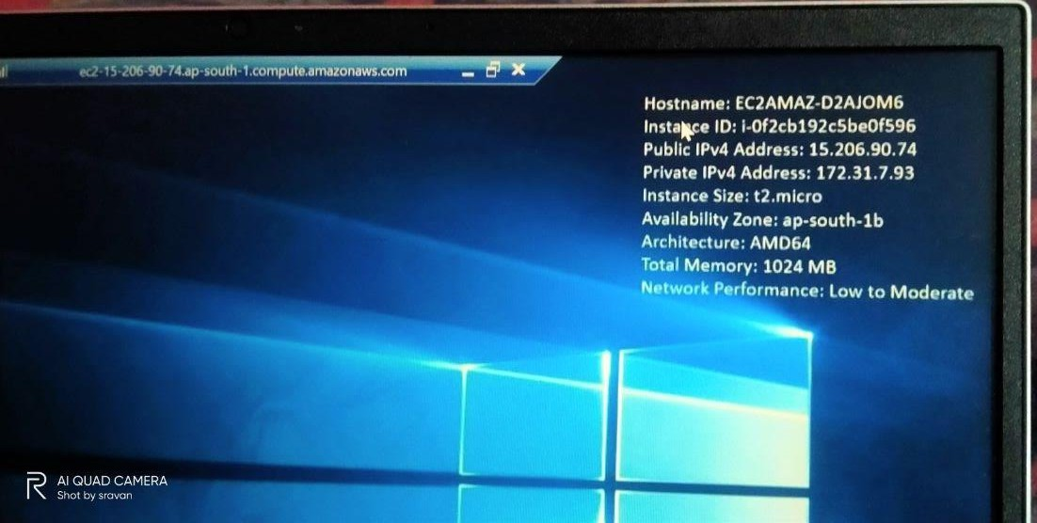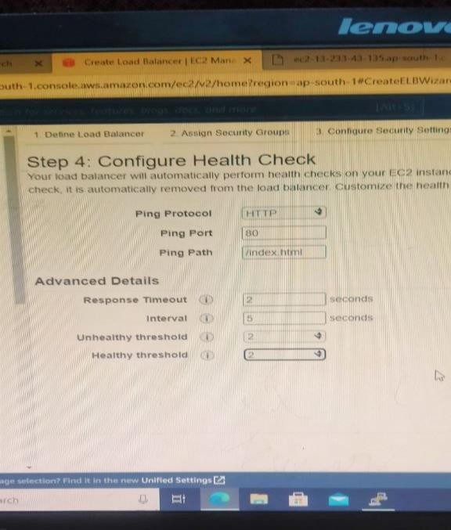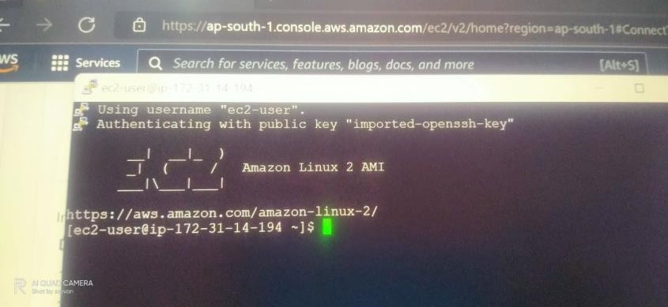

20