### **Q1) Analysis of FDI Equity Inflow Remittance Trends to India for Q3 FY23-24 (October - December 2023)**

**Trends and Analysis:** India's third quarter of FY23-24 saw significant FDI equity inflow remittances, totalling USD 11,549 million, despite global economic uncertainties. The inflows were diversified across sectors, with services, computer software and hardware, trading, and telecommunications being major recipients.

**Key Trends:** The FDI equity inflows showed steady growth of 17.43% compared to the previous quarter, indicating sustained investor confidence. The services sector, particularly IT and telecommunications, remained the primary source of investment. The investment was concentrated in key states with favourable business environments and infrastructure.

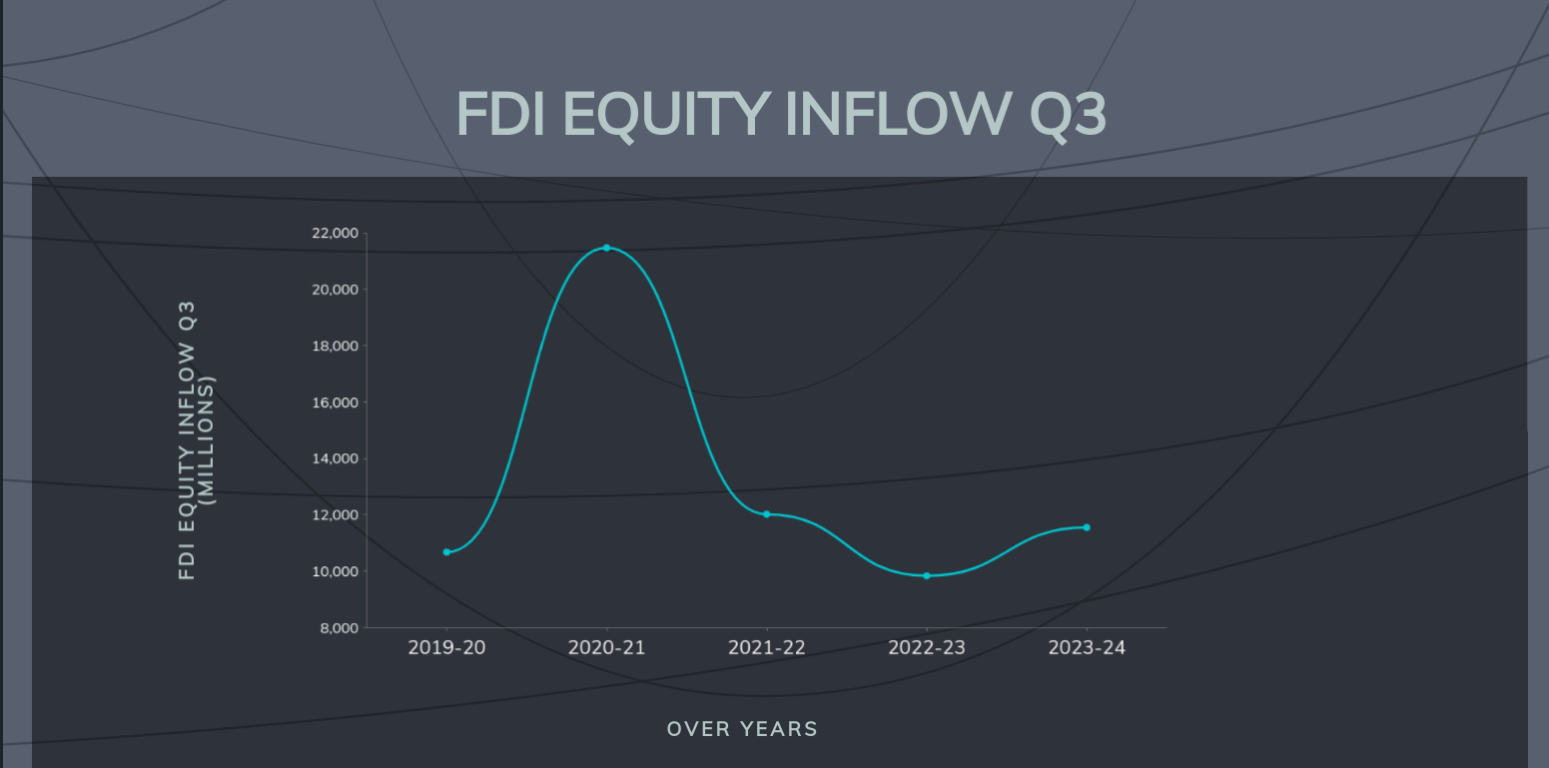

**Top 5 States:** The top five states receiving the highest FDI equity inflows during this period were Maharashtra, Karnataka, Gujarat, Delhi, and Tamil Nadu, totalling USD 4,150 million, USD 3,200 million, USD 1,950 million, USD 1,520 million and USD 730 million respectively.  
Maharashtra remained the leading state, attracting the highest FDI equity inflows due to its robust industrial base and well-developed infrastructure. Karnataka, with its strong IT and biotech sectors, followed closely. Gujarat, known for its industrial corridors and investor-friendly policies, secured the third position, while Delhi and Tamil Nadu rounded out the top five, benefiting from their strategic locations and diverse economic activities.

**Top 10 companies in each state:**

1. **Maharashtra**: Reliance Industries, Tata Consultancy Services, Mahindra & Mahindra, ICICI Bank, Larsen & Toubro, HDFC Bank, Bajaj Auto, Sun Pharmaceutical, Hindustan Unilever, Aditya Birla Group.
2. **Karnataka**: Infosys, Wipro, Flipkart, Biocon, Dell Technologies, Mphasis, Mindtree, Tata Elxsi, Accenture, Bosch.
3. **Gujarat**: Reliance Industries (Jamnagar Refinery), Adani Ports and SEZ, Tata Chemicals, Gujarat State Fertilizers & Chemicals, Zydus Cadila, Suzlon Energy, Adani Power, Torrent Pharmaceuticals, Arvind Mills, Nirma Limited.
4. **Delhi**: Bharti Airtel, Maruti Suzuki, Hero MotoCorp, DLF, Apollo Tyres, IndiGo Airlines, Escorts Group, Max Healthcare, Dabur India, Eicher Motors.
5. **Tamil Nadu**: TVS Motor Company, Ashok Leyland, Titan Company, Hyundai Motor India, India Cements, Amara Raja Batteries, MRF Tyres, Sundar Clayton, Apollo Hospitals, and Chennai Petroleum.

**Methodology:** The analysis used data from DPIIT reports for October-December 2023 and October-December 2022. Data collection involved extracting FDI inflow data, comparing it with previous periods, identifying key sectors and states receiving the highest FDI inflows, and listing the top contributing companies in each state. Visuals were also used to provide a comprehensive understanding of the data.

**Q2) Major Geopolitical and Geo-Economic Events of 2023: A Global Impact Analysis**

## **Introduction**

This analysis examines the significant geopolitical and geo-economic events that impacted international relations, commerce, and global markets in 2023, aiming to understand their long-term impacts.

**1. Continued Repercussions of the Russia-Ukraine War**

**Economic Impact:** The sanctions on Russia and disruptions to Ukrainian shipments led to a surge in global energy prices, reaching a peak of $139 per barrel in March 2023. This led to inflation, with the US experiencing an 8.5% inflation rate, affecting interest rates and economic growth. Ukraine's agricultural export disruptions also exacerbated food insecurity, with wheat prices rising over 30% and exacerbating food insecurity in independent nations.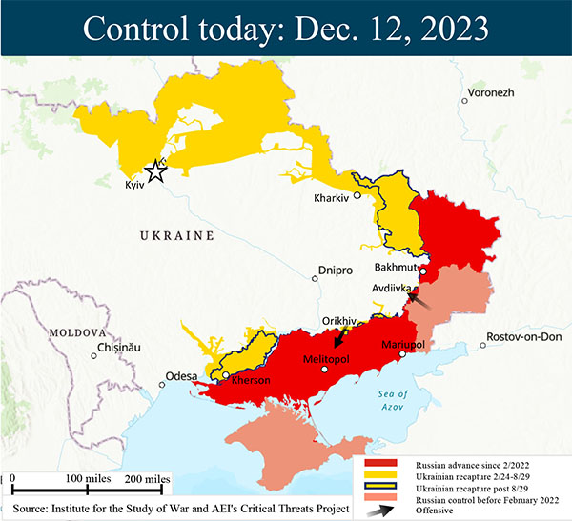

**Geopolitical Impact:** The conflict escalated US-Russian tensions, with unprecedented sanctions isolating Russia from the global economy. NATO member states increased military cooperation and defense spending, while Europe's reliance on Russian energy was highlighted, prompting diversification of energy sources.

**2. India's Rise as the World's Most Populous Nation**

**Economic Impact:** India's growing consumer market, with a projected 1.43 billion population, attracts significant FDI in consumer goods and manufacturing. Its young population offers a demographic dividend, potentially boosting productivity and economic growth.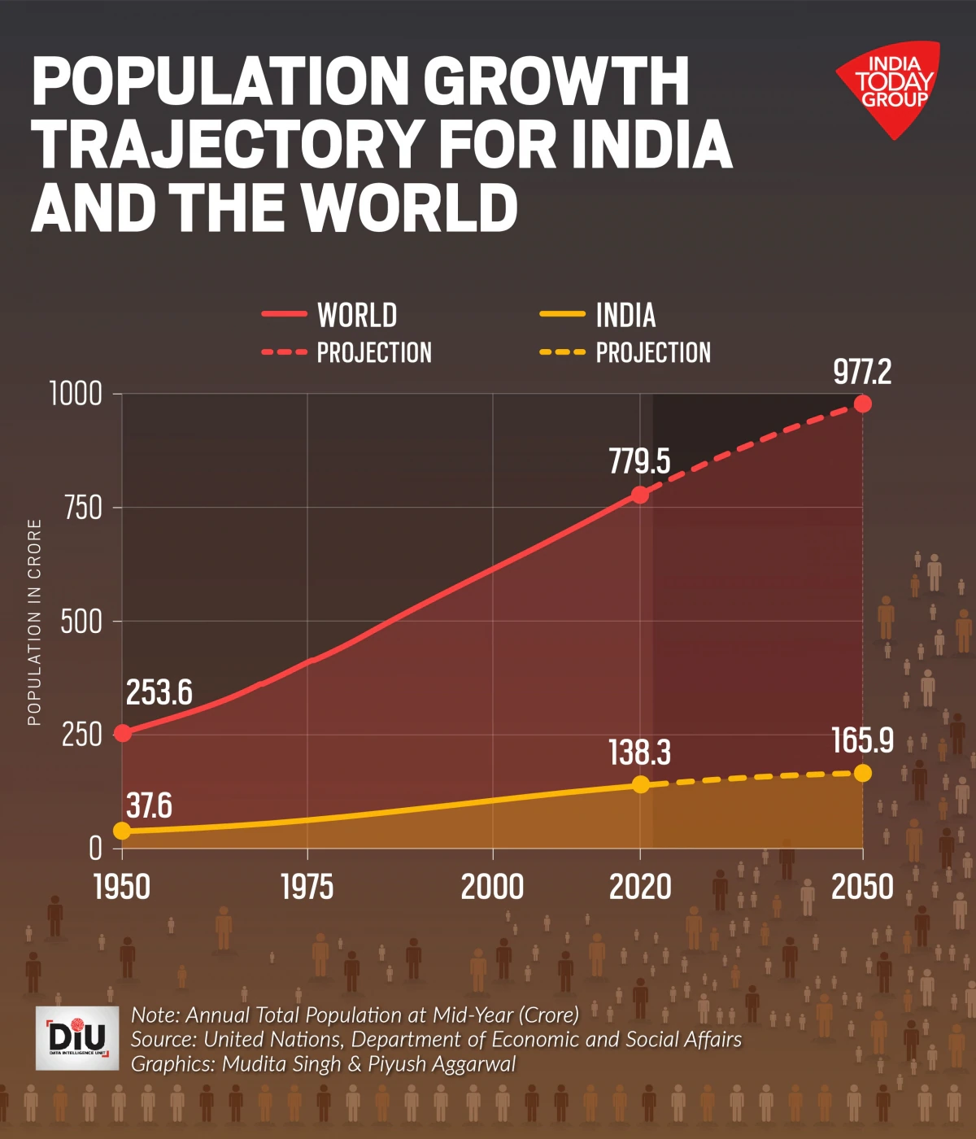

**Geopolitical Impact:** India's growing population is posing a significant threat to global power dynamics, potentially influencing its involvement in global organizations like the G20. India's rise could potentially result in a more multipolar global order, fostering greater regional cooperation in Asia.

**3. Hamas Attack on Israel and Fragile Middle East Peace**

**Impact on Regional Stability:** The attack rekindled Israeli-Palestinian tensions, threatening peace talks and regional instability. It also raised concerns about the sustainability of the Abraham Accords, prompting some Arab signatories to reconsider their relations with Israel.

**Global Energy Security:** The conflict in a major oil-producing region could potentially disrupt energy supplies, potentially affecting global energy security and prices.

**4. Climate Change Concerns: COP28 and Beyond**

**Implications for Geopolitics:** Global cooperation is crucial to tackle climate change, but it also raises tensions over burden-sharing and decarbonization rates.

**Economic Consequences:** Transitioning to a low-carbon economy necessitates substantial investments in renewable energy and sustainable technologies, presenting growth opportunities in green industries and challenging fossil fuel-dependent sectors. Implementing carbon pricing systems could impact global trade patterns and increase costs for carbon-intensive industries.

**The Dispute Over COP28:** The appointment of an oil executive as COP28 president has sparked criticism, highlighting the ongoing struggle to balance environmental sustainability with economic interests.

**5. COVID-19 Pandemic Persisting and China's Economic Challenges**

**Economic Repercussions:** China's strict lockdowns caused global supply chain disruptions, causing shortages across sectors, and reducing global economic growth due to the pandemic-induced volatility and slowdown in China's economy.

**Impact on Geopolitics:** The pandemic underscored the global economy's interdependence and the need for coordinated global health efforts. It also intensified US-China tensions due to the new variant's origins and China's response.

**6. China-Taiwan Tensions: A Flashpoint in the Indo-Pacific**

**Primary Causes:** Taiwanese nationalism and pro-independence sentiment fueled tensions between China and Taiwan, with US involvement and increased arms sales causing China to react with military drills.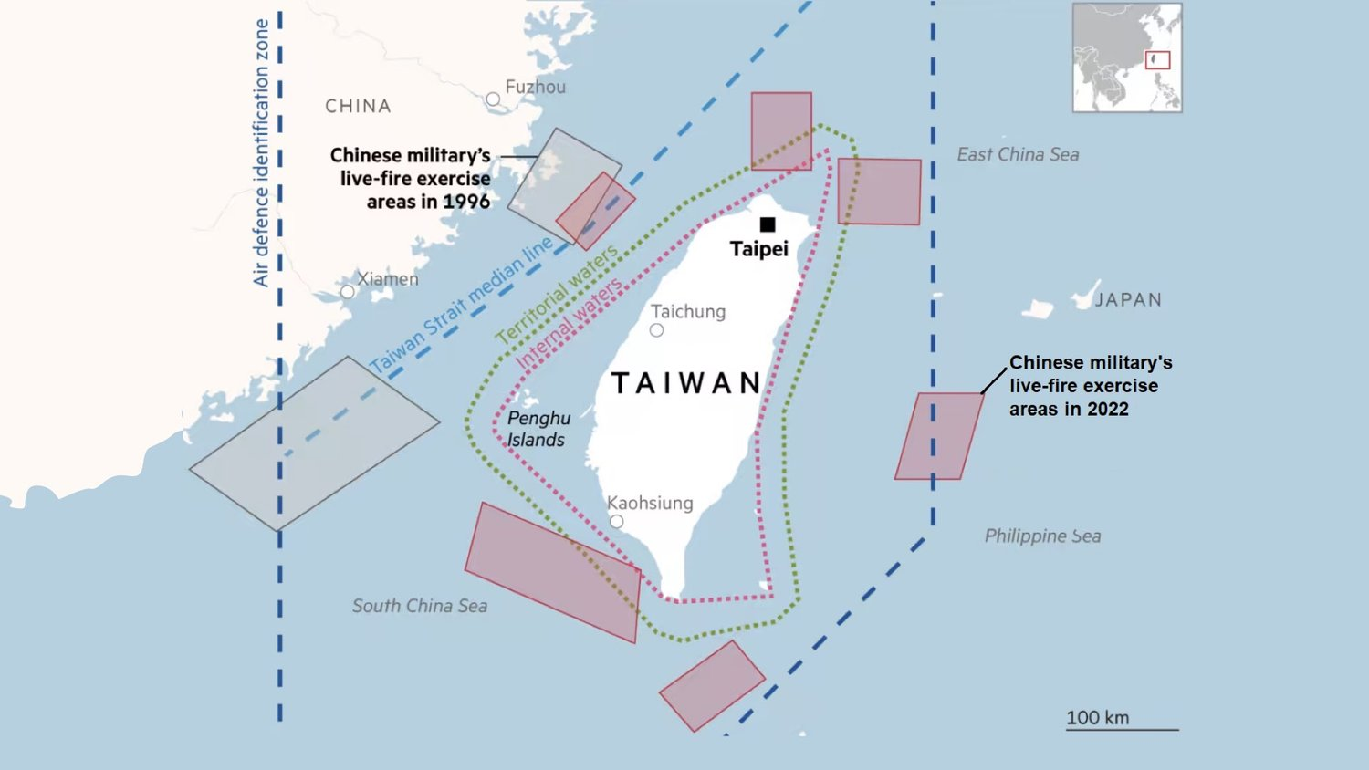

**Escalation in 2023:** Chinese air incursions into Taiwan's ADIZ and simulated amphibious landings increased conflict risk, while Taiwan faced international exclusion from organizations like the WHA due to Chinese pressure.

**Possible Consequences:** Conflict in the Indo-Pacific could severely disrupt the global semiconductor supply chain, potentially leading to regional security issues and increased militarization. Additionally, potential US and allied sanctions on China could disrupt global trade and financial markets.

**Global Reaction:** The international community has called for restraint and constructive dialogue between both parties to de-escalate tensions and prevent potential conflict.

**7. Conclusion**

The significant geopolitical and geo-economic changes in 2023 will have long-term effects on international relations, commerce, and markets. Addressing these challenges requires effective international collaboration, innovation, and a commitment to building a resilient and sustainable future.

**Q3) Methodology for Scraping and Organizing Data from PIB Press Releases**

The project aimed to scrape press release data from the Press Information Bureau (PIB) of India website and organize it into a structured CSV file. The specific details to be extracted included the date of publication, headline, ministry, article content, and URL of each press release.

The methodology involved installing necessary libraries (requests, beautifulsoup4, and csv) for web scraping and data handling, and importing these libraries into the script to facilitate HTTP requests, HTML parsing, and CSV writing. Function definitions included get_article_details(url), generate_urls(start_prid, end_prid), and scrape_pib_data(start_prid, end_prid, output_file).

Key considerations and challenges included the accuracy of the scraper, error handling, data cleaning, and the range of PRIDs. The accuracy of the scraper depends on the consistency of the HTML structure of the PIB website, and any changes in the website's layout could necessitate adjustments in the scraping logic. Error handling was implemented using try-except blocks to handle potential errors during HTTP requests or HTML parsing.

Data cleaning was done using the strip method to remove unnecessary whitespace and concatenating paragraph texts to ensure proper formatting of article content. The range of PRIDs covered a substantial number of press releases, ensuring a comprehensive dataset. Adjusting the range can refine the scope of the scraping task.

In conclusion, the methodology effectively automates the process of scraping and organizing press release data from the PIB website, providing a structured dataset for further analysis or reporting. This provides a better understanding of the content and trends in the press releases issued by the Indian government.