Desi Way
A smart, offline-fast travel assistant app for foreign tourists visiting India

Problem Statement

India attracts millions of foreign tourists every year, but visitors often face challenges such as language barriers, transport confusion, cultural misunderstandings, safety concerns, scams, and lack of emergency guidance. Unlike countries such as Japan, India doesn’t have a unified, tourist-centric mobile application that provides all essential assistance in one place.

Solution Overview

Desi Way (India Visitor Companion) is an Android/Ios application designed to act as a single digital guide for foreign travels in India.
The app focuses on offline usability, safety, cultural guidance, and real-time assistance, making travel in India easier, safer, and more enjoyable.

Key Objectives

- Help foreign tourists overcome language barriers.
- Protect visitors from scams and overcharging.
- Simplify local transport navigation.
- Provides cultural etiquette guidance.
- Enable quick emergency assistance.
- Work reliably in low or no internet conditions.

Features

Core Features (MVP)

Language Bridge
    - Offline phrasebook (English -> Hindi & regional languages)
    - Camera-based text translation (menus, signboards)
    - “Show-to-Local” phrase display
    - Text-to-speech for pronunciation

Scam & Overcharge Protection
    - Common tourist scam alerts
    - Expected price ranges for autos, taxis, food
    - Quick “Am I Overcharged?” checker

Transport Assistant
    - Metro, bus & auto guidance (city-wise)
    - Step-by-step “How to travel” instructions
    - Offline maps and route explanations

Cultural & Etiquette Guide
    - Do’s & Don’ts by region
    - Temple/mosque etiquette
    - Tipping and dress guidance

Emergency & Safety Mode
    - SOS with live location
    - Local emergency numbers
    - Embassy contact storage
    - Medical & police phrase cards

Advanced Features (Future Scope)
- AI-based travel assistant chatbot
- Offline city packs
- Itinerary planner
- Trusted local volunteer help
- Festival & weather alerts

Tech Stack

Layer | Technology
Frontend | Kotlin+Flutter+Jetpack Compose
Backend | Firebase/Supabase
Database | Room (Offline Storage)
Maps | Google Maps/Mapbox
ORC & Translation | Google ML Kit
AI Assistant | LLM API (cached FAQs)

System Architecture (High-Level)

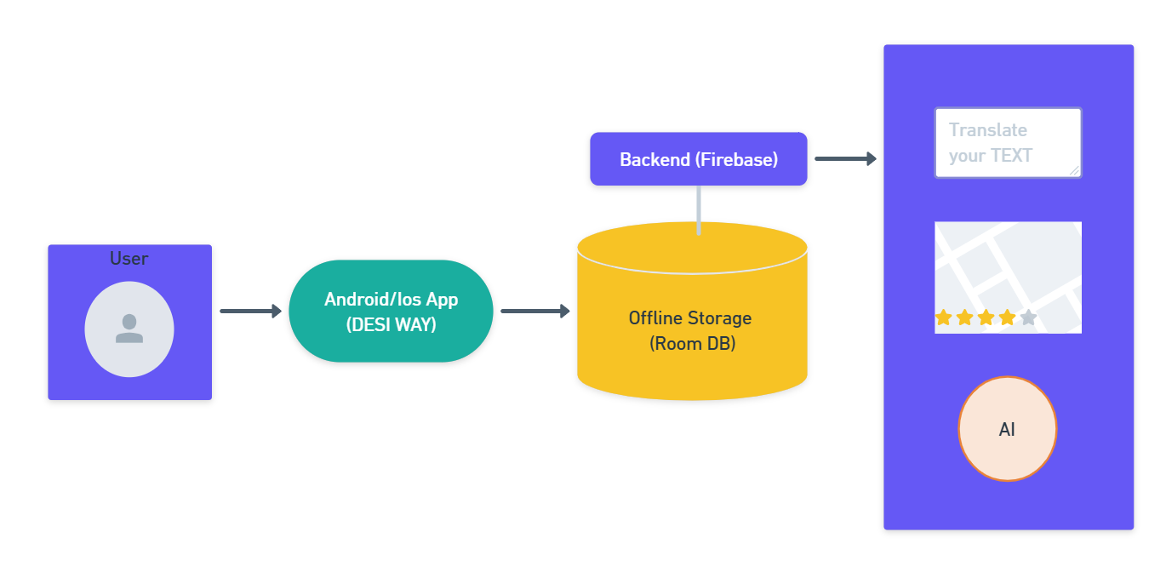

Data Flow Diagram

DFD Level 0 (Context Diagram)

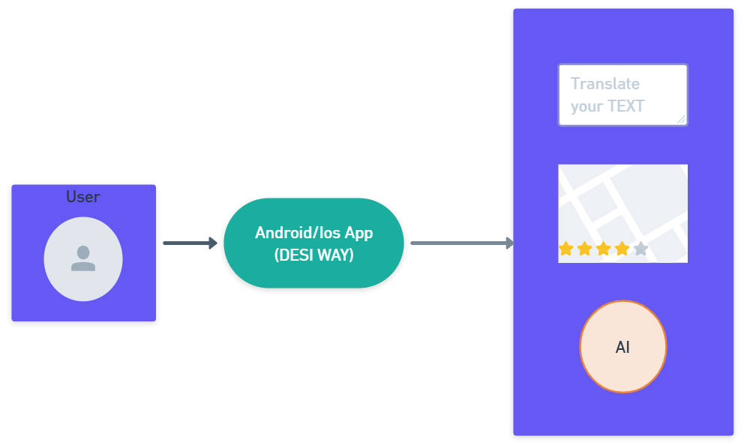

DFD Level 1

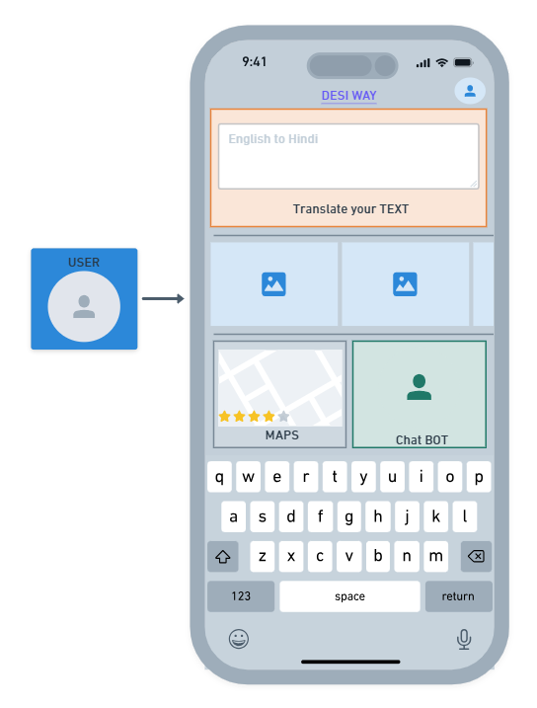

Flowcharts

Overall User Flow

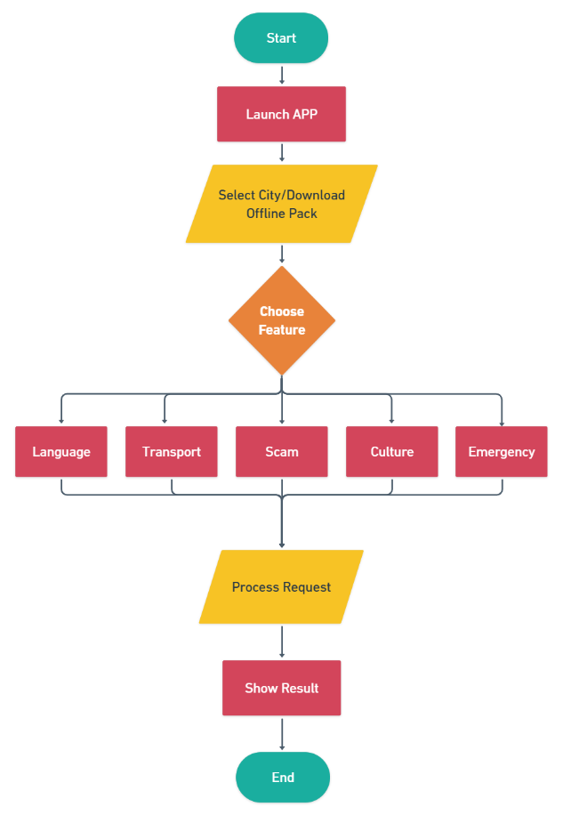

AI Assistant Flowchart

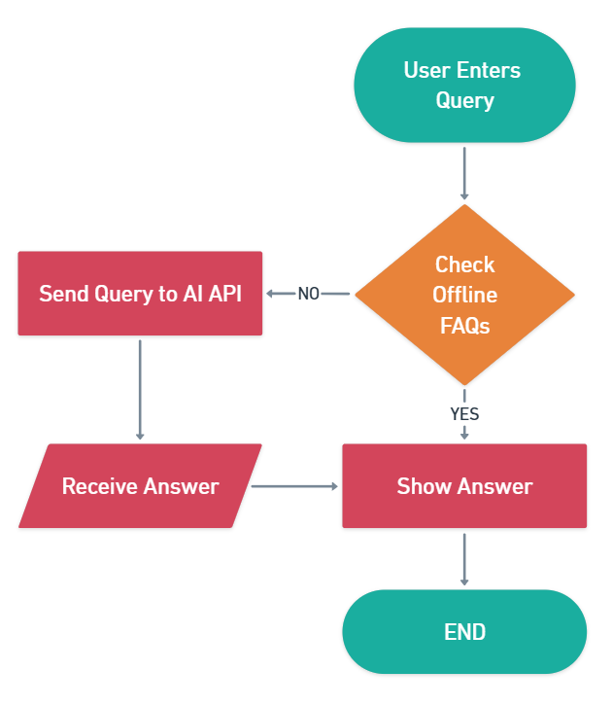

Scam Detection Flow

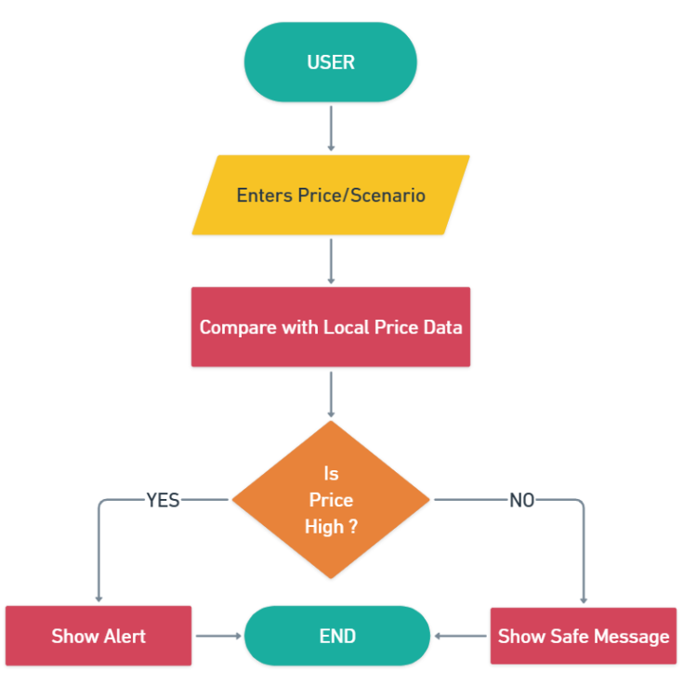

Privacy & Security

- No unnecessary personal data stored
- Location access only during emergency
- Encrypted local storage
- GDPR-Friendly data handling

Future Enhancements

- Voice-based assistant
- Wearable integration
- Tourist police dashboard
- Offline AI models

Conclusion

Desi Way (India Visitor Companion) aims to become the official digital travel partner for foreign tourists in India by providing safety, clarity, and confidence—similar to visitor apps used in Japan.

