Ma'aden Aluminium

Inventory Intelligence — Progress Report
A proof of concept, built on invented data, to show what an automated check of the storeroom can and cannot find.
Last updated 2026-09-10 · every figure in this document was produced by the run of that date

1. The problem, in one page
A storeroom can be full and the plant can still stop for want of a part. Both things are true at the same time, in the same building, and they are the same problem.
One night at Ras Al Khair
02:14 — a bearing fails on the rolling mill and the line stops. 02:40 — the storeroom is 400 metres away and does not have that bearing. It never did. 03:10 — the part is air-freighted at three to five times the normal price. Three days later the mill runs again.
Three aisles away in the same storeroom sit 400 filter cartridges, worth about SAR 300,000, for a machine that was removed in 2019. They are correctly counted and correctly recorded. Not one of them will ever be used.

The money to buy that bearing had already been spent. It was sitting on a shelf, three aisles away, as something else. That is not a warehouse problem and not a counting problem — the records were right. It is a buying decision problem, and it happens because nobody can see across twenty thousand different parts in five storerooms at once.

Why this matters here
Ma'aden Aluminium runs one continuous chain: a bauxite mine at Al Ba'itha, 600 kilometres of rail, then a refinery, a smelter and a rolling mill sharing a single 20 square kilometre site at Ras Al Khair. Every stage runs continuously, so an hour of unplanned stoppage costs far more than the part that caused it. That makes over-stocking feel safe — and it is how a storeroom fills up with the wrong things.
On the invented plant we built for this proof of concept — described in section 3 — the position looks like this:
What | How much
Value of everything on the shelves | SAR 1,458,392,491
Different parts held | 20,140
Storeroom records (a part in a storeroom) | 24,982
Parts not issued once in two years | 7,131 (35.4%)
Value that is dead — see section 3 for what that means | SAR 418,745,836 (28.7%)

Dead means stock for a machine that no longer exists, plus anything beyond three years of real demand. A spare that sits still for years because it protects the smelter is not dead — counting it as dead would overstate the prize about two and a half times.

2. What we set out to prove
Three claims, and deliberately nothing else. Each one has to be provable with a number rather than an opinion.
Claim | How it is measured | Status
We can find the problems hiding in the records | Against a sealed list of faults we planted ourselves | Done — section 5
We can set better stock levels than the ones in use today | By replaying a year of history under both sets of levels | Not yet
A planner can ask a question in plain English and get an answer they can check | Twenty set questions with known correct answers | Not yet

If a piece of work does not serve one of those three, it is not being built. That is a deliberate limit, not an oversight.

3. How we prove it without the client's data
We have not been given Ma'aden's records, and we do not need them yet. Instead we built an invented plant that behaves like a real one, and hid known faults inside it.

Why invented data is better here, not worse
With real records we could show attractive screens, but we could not say how accurate they were — nobody knows the right answer, so nothing can be marked. With invented records we know every fault we planted, so we can say exactly how many were found and how many false alarms were raised. It also means work started immediately rather than waiting on data access.

The words used from here on
- Answer key — the sealed list of faults we hid in the invented data, which the analysis is never allowed to read
- Planted fault — a mistake we put in deliberately, so we know it is there
- False alarm — the system reports a problem where there was none
- Found / missed — of the faults we hid, how many the system reported and how many it walked past
- Storeroom record — one part in one storeroom — the same part in two storerooms is two records

The six record books, and how they join up
Real plants keep this information in three separate systems. Our invented plant keeps the same six record books, joined the same way.
Machines  what exists, how critical | → | Parts  what each part is | → | Storerooms  how many are held | → | Movements  every issue and receipt

Two more feed into it: maintenance jobs record why a part was taken out, and planned shutdown dates tell us about demand that has not happened yet. A job raised weeks before the work is what lets the system see a spike coming instead of being surprised by it.

What happens to the data
Build  invent the plant | → | Check  look for faults | → | Mark  compare to the answer key | → | Show  put it on screen

The checking stage is never allowed to see the answer key. That is enforced automatically: an automatic test reads the checking code and fails if it so much as mentions the answer key by name. Without that, the marks would be worthless and nobody would notice until a Ma'aden engineer asked how they were produced.

Two kinds of fault, kept apart on purpose
This distinction is what makes the marks honest.
 | Planted faults | Faults that emerge on their own
What they are | Typing and record-keeping errors we inserted deliberately | Too much stock, obsolete stock, critical parts running low
Examples | A blank part number; a negative quantity; the same part entered twice | Stock levels set years ago and never revisited; spares for a machine that was scrapped
How they are marked | Found, missed, or a false alarm — exact counts | Against what the invented plant really did

The second kind is never planted. If we inserted them we would only be testing whether the system can find our own insertions, rather than whether it can read a plant.

Learn before, test after
The invented plant has three years of history, from 2023-09-01 to 2026-08-31. Anything that learns from the past is only allowed to see up to 2025-08-31 — two years. It is then marked on the final year, which it has never seen. The cut-off date is set in one place and cannot be skipped by accident.

What it looks like today
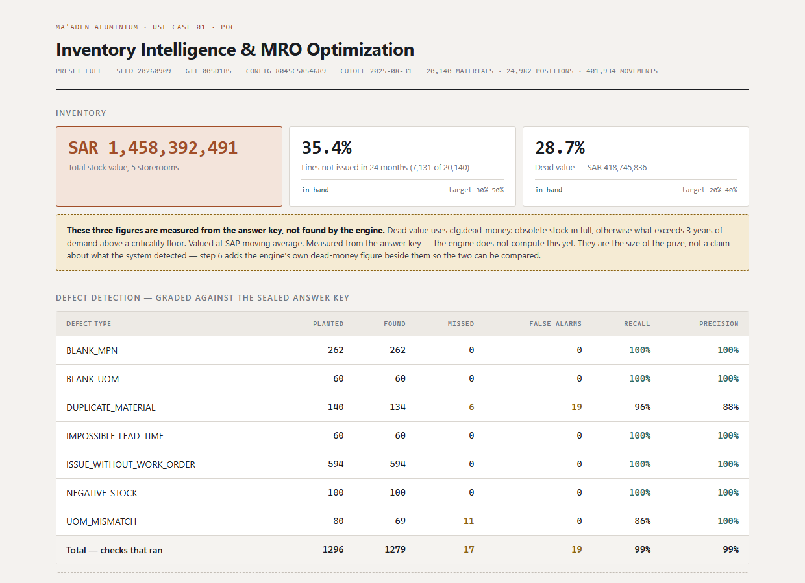
The current screen. Every figure on it was worked out when the analysis ran; nothing is calculated while the page is open, so it cannot disagree with the marks beside it.

4. Progress log
One entry per stage, added as each is finished. Each says what it does, what was measured, and what it still cannot do.

Stage 1 — Building a plant that behaves like a real one (2026-09-10)
An invented plant with 20,140 different parts across 5 storerooms, 401,934 movements of stock over three years, and 150,562 maintenance jobs.
The hard part was not producing data. It was producing data that behaves like a storeroom rather than a supermarket. Published figures for this industry say that between a third and a half of parts do not move in two years, and that a fifth to two fifths of the value is dead. Our invented plant is checked against those figures automatically every time it is built.
What is checked | Measured | Should be | Within range?
Idle >24 months | 35% | 30%-50% | Yes
Dead value share | 29% | 20%-40% | Yes
Shutdown issue-rate multiple | 3.14 | >= 3x baseline | Yes
Issues per work order | 1.97 | >= 1.5 | Yes
Planned wos raised in advance | 100% | = 100% | Yes
Decommissioned assets | 34 | >= 20 | Yes
Consumables with interval >30d | 0 | = 0 | Yes
Unexplained ledger mismatches | 0 | = 0 | Yes
Unplanted negative balances | 0 | = 0 | Yes
Materials in >1 storeroom | 18% | >= 10% | Yes
Family_id absent from source | 100% | = true | Yes

If any of these drifts out of range the build stops. Every later figure is measured against this data, so a plant that quietly stopped resembling a real one would make everything afterwards look excellent and mean nothing.

Eight parts, drawn at random
Part | Made by | SAR each | Criticality | Fitted to
STUB, ANODE STEEL, 855MM, CLASS 2 | Outotec | 482 | B | Rodding station 2
3 OIL HYD ISO VG 220 CLASS | Castrol | 43 | B | Hydraulic power unit 1
BOLT, HEXAGON STAINLESS, M36X100, INCONEL | Unbrako | 26 | C | Mechanical asset MA-008
SENSOR, TEMPERATURE RTD, 345MM, SS304 | Endress+Hauser | 821 | A | Instrument loop IL-013
MODULE, PLC INPUT OUTPUT, TYPE F, CLASS 2 | Siemens | 9,397 | A | Instrument loop IL-005
FILTER, RESPIRATOR CARTRIDGE, TYPE C, CS | Drager | 42 | C | General asset GA-006
PLATE, POT SHELL STEEL, 255MM, GRADE B | Outotec | 3,236 | A | Pot 048, Line 1
LINER, PIPE RUBBER, DN32, DUCTILE IRON | Weir | 538 | A | Slurry pump SL019

Criticality A means the plant stops if it is missing; C means somebody waits. Each part is attached to a machine that could actually hold it — a bearing sits on a pump, never on a potline. A maintenance engineer reading this list is the first test the data has to pass.
What this cannot do yet
- This is invented data. It is built to behave like Ma'aden's, not to be it.
- The published industry figures we check against are ranges from other companies. They are a starting point, and the pilot replaces them with Ma'aden's own numbers.
- Maintenance jobs are grouped by machine and month rather than being modelled job by job. It gives realistic multi-part jobs, but the number of parts on a job is a property of our grouping rather than of the plant.

Stage 2 — Seven checks that read the records (2026-09-10)
Seven separate checks, each looking for one kind of fault. Think of them as seven inspectors walking the storeroom, each with one thing to look for.
What the check looks for | Hidden | Found | Missed | False alarms | Found rate
No manufacturer's part number, so the part cannot be matched to a catalogue or to the same part in another storeroom. | 262 | 262 | 0 | 0 | 100%
No unit. Ten of something means nothing until you know whether it is ten pieces or ten boxes. | 60 | 60 | 0 | 0 | 100%
The same physical part entered twice under different descriptions. | 140 | 134 | 6 | 19 | 96%
A delivery time of nothing, or of ten years. Either way the reorder level built on it is wrong. | 60 | 60 | 0 | 0 | 100%
Stock left the store and no job accounts for it. | 594 | 594 | 0 | 0 | 100%
A quantity below zero. Impossible, so the balance cannot be trusted. | 100 | 100 | 0 | 0 | 100%
A unit that disagrees with every similar part, with the price left on the old unit. | 80 | 69 | 11 | 0 | 86%
Everything together | 1,296 | 1,279 | 17 | 19 | 99%

The checks also raised 100 reports of a different kind: the stock balance not matching the list of movements. Nothing was planted for that, so it is counted separately rather than held against the system. It is the check an auditor recognises on sight — either the arithmetic adds up or the balance cannot be trusted.

Finding the same part entered twice
This is the hardest of the seven, and the one that matters most here. When Ma'aden absorbed the Alcoa and Alba operations in 2025, each came with its own list of parts. The same bearing can now sit under three descriptions in three storerooms, and nobody knows it is the same bearing.
Worse, the usage splits across the entries. Neither looks unusual on its own, so both are re-ordered as though they were separate parts.
The system compares every part against every other one that could plausibly match, using five clues:
- The description, allowing for shorthand — somebody writing BRG where somebody else wrote BEARING.
- The measurements and grades — 6205 and 6310 are different bearings, however similar the words are.
- The manufacturer's part number — the strongest clue there is. Two different numbers mean two different parts; there is no partly the same.
- The manufacturer's name — allowing for SKF, S.K.F. and SKF AB.
- Price, unit and category — weak on its own, useful alongside the rest.
Each clue gives a score, the scores are combined, and anything above an agreed level is reported as a likely pair. A clue with nothing to say — a missing part number, which is exactly what a re-typed record loses — counts as no evidence rather than as evidence against.
How the copy was written differently | Hidden | Found | Found rate
Re-typed with no change | 11 | 11 | 100%
Size moved to the front | 37 | 37 | 100%
Shorthand used (BRG for BEARING) | 48 | 47 | 98%
Spaces removed | 46 | 45 | 98%
Commas removed | 46 | 43 | 94%
Marked -OLD or (DUP) | 22 | 20 | 91%
A character mistyped | 34 | 30 | 88%
Size left off altogether | 18 | 13 | 72%

Reported this way on purpose. A single overall figure would hide that one situation is much harder than the others.

Two faults the checks found in our own invented plant
Both were ours, not the system's, and both would have made the results meaningless if they had gone unnoticed.
- Descriptions repeated by accident. 85 in every 100 parts shared a description with some other part, because we varied them along only one measurement. That produced 82,000 accidental identical pairs against the 140 we planted. The system flagging them was right and our marking was wrong. Parts now carry two characteristics, and a test refuses to let the problem come back.
- Two faults on one record. One check scored 59 out of 60 and the system was innocent: we blanked a unit and then overwrote the same record with a different fault, so the answer key claimed a blank that was no longer there. This is the worst kind of marking error, because it looks like a failure of the thing being tested.
What this cannot do yet
- The unit check finds a part moved to an unusual unit. It cannot find one moved to the usual unit, because that looks exactly like its neighbours. Every miss is of that kind.
- Duplicate detection is weakest when the size was simply left off the re-typed record — there is little left to compare.
- The confidence level for reporting a duplicate pair was chosen using this data. That is normal, but it is not an independent result: on Ma'aden's own records it must be set again from a sample checked by hand.

5. The numbers so far
One table, growing as each stage lands. Everything here was produced by the run named at the top of this document.
Measure | Result
Faults hidden in the records | 1,296
Faults found | 1,279 (99%)
Faults missed | 17
False alarms | 19

Still to come in this table: stock levels compared against today's; dead stock found against dead stock present.

6. What happens next
- Sort every part by how it is used
- Predict what will be needed, method matched to each group
- Set better stock levels, and prove it by replaying a year
- List the dead stock in order of value
- Two screens: the summary, and a page for a single part
- A question box: ask in English, get a checkable answer
Deliberately not being built
A heavier prediction method that would be harder to explain; matching parts by meaning rather than by wording; Arabic descriptions; logins; a live connection to SAP; automatic purchase orders; any screen beyond the two above. Each was considered and set aside so the three claims get proved properly rather than six things getting started.

7. Questions a sceptic would ask
Why invent the data? Why not use ours?
Because invented data can be marked and yours cannot. Nobody knows every fault sitting in Ma'aden's records, so there is nothing to compare an answer against — we could show you a convincing screen and neither of us would know if it were right. Here we hid the faults ourselves, so we can say 1,279 of 1,296 were found with 19 false alarms. It also meant work could start immediately instead of waiting for access.
How do I know the analysis is not just reading the answers?
Because it cannot reach them. The answers are kept apart from the analysis, and an automatic test reads the analysis code and fails the build if it so much as names the answer file. The marking runs afterwards, as a separate step. This is the first thing an auditor would ask, so it is enforced by machine rather than by good intentions.
Is this artificial intelligence?
Mostly no, and that is deliberate. The checks are rules and statistics — the kind of thing an experienced planner would do by hand if they had the time and could hold twenty thousand parts in their head. Artificial intelligence appears in one place only, at the end: turning a typed question into an answer. Even there it does no arithmetic. It asks the system for the figures and reads them back, and every answer shows the numbers underneath. A system that invents a stock figure in front of a planner is finished the first time it happens.
What happens when the real data arrives?
The invented plant plugs into the analysis at the same point real records would. Swapping it is replacing one part, not rebuilding. What will genuinely change is that real records are messier than ours — categories maintained by hand over decades, spellings that drift, codes that mean different things in different plants. The checks are built to say nothing rather than say something wrong when the data is unclear, but that has to be measured on your records, not assumed.
What could go wrong?
Three things, in order of likelihood. The maintenance system may not be reachable, and without it we cannot tell a part that is obsolete from a spare that is quietly protecting the smelter. The savings figure is built on published industry ranges until we can re-measure it on Ma'aden's own records, so it should be treated as an indication of scale rather than a promise. And a system like this only helps if planners use it, which is why the last piece is a plain question box rather than another report.

8. Glossary
Every term used in this document, in one line each.
Term | What it means
Answer key | the sealed list of faults we hid in the invented data, which the analysis is never allowed to read
Criticality | how badly the plant is hurt if the part is missing. A stops production, B slows it, C inconveniences somebody
Dead stock | stock for a machine that no longer exists, plus anything beyond three years of real demand
Duplicate | the same physical part entered twice under different descriptions
False alarm | the system reports a problem where there was none
Found / missed | of the faults we hid, how many the system reported and how many it walked past
Insurance spare | an expensive part held for years against a failure that may never happen. Sitting still is correct behaviour, not waste
Lead time | how long a part takes to arrive once ordered — days for a gasket, eighteen months for a transformer
Movement | a single entry in the stock book — a part issued, or a delivery received
MRO | maintenance, repair and operations: the spare parts and consumables that keep a plant running, as opposed to what it produces
Planted fault | a mistake we put in deliberately, so we know it is there
Reorder level | the quantity at which more should be ordered
Safety stock | the extra held to cover a delivery arriving late or demand arriving early
Service level | how often we intend to have the part when it is asked for. 95% means one request in twenty waits
Shutdown | a planned stoppage for major maintenance. Consumption of certain parts rises sharply, and the date is known in advance
Stockout | a part was needed and was not there
Storeroom record | one part in one storeroom — the same part in two storerooms is two records
Unit of measure | what a quantity counts — pieces, metres, kilograms, boxes
Work order | the maintenance job that explains why a part was taken out of the store

