**ABSTRACT**

In general, the term Temperature is a measure of how hot or cold something is; specifically, a measure of the average kinetic energy of the particles in an object, which is a type of energy associated with motion.

In this Converter Application, a user-friendly interface in android environment for converting temperature from one unit to another unit and to convert Indian rupees to different currencies.

This application can be used as a temperature and Currency converter in offline mode.

The application does conversion of temperature units like Kelvin to Celsius and Celsius to Kelvin, ,Fahrenheit, Newton, Delisle, Rankine, Reaumur, Romer.

Also, this app converts a Rupees to US Dollar, European Euro, Japanese Yen, British pound, Swiss franc , Canadian Dollar, Australian Dollar, South African Rand.

Furthermore, we shall showcase the output using the android studio with the help of java and xml code. After all, will explain the resultant output using the snapshots.

|  |  |  |
| --- | --- | --- |
|  | Acknowledgement | I |
| Abstract | Ii |
| Table of Contents | Iii |
| List of Figures | Iv |
|  |  |
| **Chapter1**  1.1 | **INTRODUCTION**  Problem Statement/ Aim | 1 |
| 1.2 | Scope | 1 |
| 1.3 | Project Description | 1 |
| **Chapter2**  2.1 | **HARDWARE AND SOFTWARE REQUIREMENTS**  Hardware Requirements | 2 |
| 2.2 | Software Requirements | 2 |
| **Chapter3**  3.1 | **DESIGN**  Flowchart | 3 |
| 3.2 | Commands  3.2.1 Files used  3.2.2 Description of a function | 4  4  5 |
| **Chapter4**  4.1 | **IMPLEMENATION**  Code Snippets  4.1.1 Main page  4.1.2 Temperature converter page  4.1.3 Currency converter page | 6 |
| **Chapter5**  5.1 | **RESULT AND DISCUSSION**  Screen Shots | 13 |
| **Chapter 6** | **CONCLUSION AND FUTURE ENHANCEMENTS** | 20 |
|  | **BIBLIOGRAPHY** | 21 |

**LIST OF FIGURES**

3.1Flow Chart

5.1 Splash Screen

5.2 Main Page

5.3 More About

5.4 Toast Message

5.5 Temperature Page

5.6 Temperature Result

5.7 Currency Result

# Chapter 1

**INTRODUCTION**

* 1. **PROBLEM STATEMENT /AIM**

The main aim of this project is to convert Celsius to other temperature and Indian currency to other foreign currencies.

* 1. **SCOPE**

With Technology reaching its peak time in this modern world, everything is being converted to our hands i.e. almost all the manual calculations of system made applications are being converted into mobile apps. This application can be used as a temperature convertor in offline. This application can be used as a currency convertor in offline. The application does conversion of temperature units like Celsius to Kelvin , Fahrenheit Newton , Delisle , Rankine , Reaumur , Romer. Also, this app converts a Rupees to US Dollar, European Euro, Japanese Yen, British pound, Swiss franc , Canadian Dollar, Australian Dollar, South African Rand.

* 1. **PROJECT DESCRIPTION**

This app help us to convert the units from Celsius to other temperature units and currency from Indian rupees to other foreign currencies. This application can be used in offline mode so that it is very useful to the user. This app can be convert Celsius to six other units and also can convert Indian rupees to Eight other currencies.

Chapter 2

**HARDWARE AND SOFTWAREREQUIREMENTS**

* 1. **Hardware Requirements**
* Processor: Intel CORE i5
* Ram: 8GB
* Hard Disk: 1TB
  1. **Software Requirements**
* Android Studio
* Internet
* Java

**Mobile Requirements To Run Application**

* Android OS 4.0 or above
* 512MB RAM
* Screen Size 3.5 inch or above

The Android Emulator has additional requirements beyond the basic system requirements for Android Studio, which are described below:

* + - SDK Tools 26.1.1 or higher;
    - 64-bit processor;
    - Windows: CPU with UG (unrestricted guest) support;
    - Intel Hardware Accelerated Execution Manager (**HAXM**) 6.2.1 or later (HAXM 7.2.0 or later recommended).

Chapter 3

**DESIGN**

* 1. **Flow Chart**

START

Enter value to convert Enter value to convert

unit currency

Select unit to convert Select currency to convert

Show Result

EXIT

* 1. **Command**

In computing, a command is **a directive to a computer program to perform a specific task**. It may be issued via a command-line interface, such as a shell, or as input to a network service as part of a network protocol, or as an event in a graphical user interface triggered by the user selecting an option in a menu.

* + 1. **Files Used**
* AndroidMainfest.xml
* activity_curr2.xml
* activity_main.xml
* activity_temp2.xml
* custom_input.xml
* gradiantmain.xml
* splash_screen_background.xml
* pen.xml
* colors.xml
* strings.xml
* styles.xml
* CurrActivity2.java
* MainActivity.java
* SplashScreen.java
* TempActivity.java
  + 1. **Description of Function**

|  |  |  |
| --- | --- | --- |
| **Sl.No** | **Functions** | **Description** |
| 1. | TextView | A TextView displays text to the user and optionally allows them to edit it.  A TextView is a complete text editor, however the basic class is configured to not allow editing. |
| 2. | EditText | A EditText is an overlay over TextView that configures itself to be editable. It is the predefined subclass of TextView that includes rich editing capabilities. |
| 3. | Button | In Android, Button represents a push button. A Push buttons can be clicked, or pressed by the user to perform an action. |
| 4. | RadioButton | Radio buttons allow the user to select one option from a set. You should use radio buttons for optional sets that are mutually exclusive if you think that the user needs to see all available options side-by-side. If it's not necessary to show all options side-by-side, use a spinner instead. |
| 5. | Widgets | widget is a small gadget or control of the android application placed on home screen. Widgets can be very handy as they allow you to put your favorite applications on your home screen in order to quickly access them. |
| 6. | ImageView | Displays image resources, for example Bitmap or Drawable resources. **ImageView** is also commonly used to apply tints to an image and handle image scaling. |
| 7. | Hint | android: hint is more like a placeholder that sort of explains what type of input the EditText is asking for. i.e. If an EditText is asking for posting a status on social media, the hint like What's on your mind? will be suitable. |
| 8. | Toast | A toast provides simple feedback about an operation in a small popup. It only fills the amount of space required for the message and the current activity remains visible and interactive. Toasts automatically disappear after a timeout. |

Chapter 4

**IMPLEMENTATION**

**4.1 Code Snippets**

**4.1.1 Main Page**

*<?***xml version="1.0" encoding="utf-8"***?>*<**androidx.constraintlayout.widget.ConstraintLayout xmlns:android="http://schemas.android.com/apk/res/android"  
 xmlns:app="http://schemas.android.com/apk/res-auto"  
 xmlns:tools="http://schemas.android.com/tools"  
 android:layout_width="match_parent"  
 android:layout_height="match_parent"  
 android:background="@drawable/gradiantmain"  
 tools:context=".MainActivity"**>  
  
 <**TextView  
 android:id="@+id/textView"  
 android:layout_width="wrap_content"  
 android:layout_height="wrap_content"  
 android:layout_marginStart="69dp"  
 android:layout_marginTop="48dp"  
 android:layout_marginEnd="77dp"  
 android:layout_marginBottom="88dp"  
 android:text="CONVERTER"  
 android:textAlignment="center"  
 android:textColor="#2c3e50"  
 android:textSize="48sp"  
 android:textStyle="bold|italic"  
 app:layout_constraintBottom_toTopOf="@+id/btnTemp"  
 app:layout_constraintEnd_toEndOf="parent"  
 app:layout_constraintStart_toStartOf="parent"  
 app:layout_constraintTop_toTopOf="parent"** />  
  
 <**Button  
 android:id="@+id/btnTemp"  
 android:layout_width="wrap_content"  
 android:layout_height="wrap_content"  
 android:layout_marginTop="88dp"  
 android:text="Temprature"  
 android:textAlignment="center"  
 android:textSize="16sp"  
 android:textStyle="bold"  
 app:backgroundTint="#353030"  
 app:cornerRadius="20sp"  
 app:layout_constraintEnd_toEndOf="@+id/btnCurr"  
 app:layout_constraintHorizontal_bias="0.48"  
 app:layout_constraintStart_toStartOf="@+id/btnCurr"  
 app:layout_constraintTop_toBottomOf="@+id/textView"** />  
  
 <**Button  
 android:id="@+id/btnCurr"  
 android:layout_width="wrap_content"  
 android:layout_height="wrap_content"  
 android:layout_marginStart="120dp"  
 android:layout_marginTop="81dp"  
 android:layout_marginEnd="119dp"  
 android:layout_marginBottom="222dp"  
 android:text="Currency"  
 android:textAlignment="center"  
 android:textSize="16sp"  
 android:textStyle="bold"  
 app:backgroundTint="#3C3636"  
 app:cornerRadius="20sp"  
 app:layout_constraintBottom_toBottomOf="parent"  
 app:layout_constraintEnd_toEndOf="parent"  
 app:layout_constraintHorizontal_bias="0.478"  
 app:layout_constraintStart_toStartOf="parent"  
 app:layout_constraintTop_toBottomOf="@+id/btnTemp"  
 app:layout_constraintVertical_bias="0.0"** />  
  
 <**View  
 android:id="@+id/divider"  
 android:layout_width="419dp"  
 android:layout_height="5dp"  
 android:layout_marginTop="2dp"  
 android:layout_marginBottom="41dp"  
 android:background="@color/white"  
 app:layout_constraintBottom_toTopOf="@+id/textView"  
 app:layout_constraintEnd_toEndOf="parent"  
 app:layout_constraintStart_toStartOf="parent"  
 app:layout_constraintTop_toTopOf="parent"** />  
</**androidx.constraintlayout.widget.ConstraintLayout**>

**4.1.2 Temperature converter page**

*<?***xml version="1.0" encoding="utf-8"***?>*<**androidx.constraintlayout.widget.ConstraintLayout xmlns:android="http://schemas.android.com/apk/res/android"  
 xmlns:app="http://schemas.android.com/apk/res-auto"  
 xmlns:tools="http://schemas.android.com/tools"  
 android:layout_width="match_parent"  
 android:layout_height="match_parent"  
 android:background="@drawable/gradiantcurr"  
 tools:context=".TempActivity2"**>  
  
 <**EditText  
 android:id="@+id/etTemperature"  
 android:layout_width="248dp"  
 android:layout_height="59dp"  
 android:layout_marginStart="98dp"  
 android:layout_marginTop="60dp"  
 android:layout_marginEnd="99dp"  
 android:layout_marginBottom="2dp"  
 android:background="@drawable/custom_input"  
 android:drawableStart="@drawable/pen"  
 android:drawablePadding="12dp"  
 android:ems="10"  
 android:hint="@string/hint"  
 android:inputType="numberDecimal"  
 android:textSize="25sp"  
 android:textStyle="bold"  
 app:layout_constraintBottom_toTopOf="@+id/tvResult"  
 app:layout_constraintEnd_toEndOf="parent"  
 app:layout_constraintStart_toStartOf="parent"  
 app:layout_constraintTop_toTopOf="parent"** />  
  
 <**RadioGroup  
 android:id="@+id/radioGroup"  
 android:layout_width="221dp"  
 android:layout_height="323dp"  
 android:layout_marginStart="30dp"  
 android:layout_marginTop="20dp"  
 android:layout_marginBottom="10dp"  
 app:layout_constraintBottom_toTopOf="@+id/btnConvert"  
 app:layout_constraintStart_toStartOf="parent"  
 app:layout_constraintTop_toBottomOf="@+id/tvResult"**>  
  
 <**RadioButton  
 android:id="@+id/radCtoF"  
 android:layout_width="wrap_content"  
 android:layout_height="38dp"  
 android:text="@string/radCtoF"  
 android:textSize="20sp"  
 android:textStyle="bold"  
 android:theme="@style/RadioButtonStyle"**/>  
  
 <**RadioButton  
 android:id="@+id/radFtoC"  
 android:layout_width="match_parent"  
 android:layout_height="38dp"  
 android:text="@string/radFtoC"  
 android:textSize="20sp"  
 android:textStyle="bold"  
 android:theme="@style/RadioButtonStyle"**/>  
  
 <**RadioButton  
 android:id="@+id/radCtoK"  
 android:layout_width="match_parent"  
 android:layout_height="38dp"  
 android:text="°C to Kelvin"  
 android:textSize="20sp"  
 android:textStyle="bold"  
 android:theme="@style/RadioButtonStyle"** />  
  
 <**RadioButton  
 android:id="@+id/radCtoN"  
 android:layout_width="match_parent"  
 android:layout_height="38dp"  
 android:text="°C to Newton"  
 android:textSize="20sp"  
 android:textStyle="bold"  
 android:theme="@style/RadioButtonStyle"** />  
  
 <**RadioButton  
 android:id="@+id/radCtoD"  
 android:layout_width="wrap_content"  
 android:layout_height="38dp"  
 android:text="°C to Delisle"  
 android:textSize="20sp"  
 android:textStyle="bold"  
 android:theme="@style/RadioButtonStyle"** />  
  
 <**RadioButton  
 android:id="@+id/radCtoR"  
 android:layout_width="match_parent"  
 android:layout_height="38dp"  
 android:text="°C to Rankine"  
 android:textSize="20sp"  
 android:textStyle="bold"  
 android:theme="@style/RadioButtonStyle"** />  
  
 <**RadioButton  
 android:id="@+id/radCtoRe"  
 android:layout_width="match_parent"  
 android:layout_height="38dp"  
 android:text="°C to Reaumur"  
 android:textSize="20sp"  
 android:textStyle="bold"  
 android:theme="@style/RadioButtonStyle"** />  
  
 <**RadioButton  
 android:id="@+id/radCtoRo"  
 android:layout_width="match_parent"  
 android:layout_height="38sp"  
 android:text="°C to Romer"  
 android:textSize="20sp"  
 android:textStyle="bold"  
 android:theme="@style/RadioButtonStyle"** />  
 </**RadioGroup**>  
  
 <**Button  
 android:id="@+id/btnConvert"  
 android:layout_width="wrap_content"  
 android:layout_height="wrap_content"  
 android:layout_marginStart="153dp"  
 android:layout_marginTop="5dp"  
 android:layout_marginEnd="153dp"  
 android:layout_marginBottom="20dp"  
 android:text="@string/btnConvert"  
 android:textSize="16sp"  
 android:textStyle="bold|italic"  
 app:backgroundTint="#43C6AC"  
 app:cornerRadius="40sp"  
 app:layout_constraintBottom_toBottomOf="parent"  
 app:layout_constraintEnd_toEndOf="parent"  
 app:layout_constraintStart_toStartOf="parent"  
 app:layout_constraintTop_toBottomOf="@+id/radioGroup"** />  
  
 <**TextView  
 android:id="@+id/tvResult"  
 android:layout_width="wrap_content"  
 android:layout_height="wrap_content"  
 android:layout_marginStart="172dp"  
 android:layout_marginTop="20dp"  
 android:layout_marginEnd="172dp"  
 android:layout_marginBottom="30dp"  
 android:hint="Result"  
 android:textAlignment="center"  
 android:textColor="#380B9C"  
 android:textSize="24sp"  
 android:textStyle="bold|italic"  
 app:layout_constraintBottom_toTopOf="@+id/radioGroup"  
 app:layout_constraintEnd_toEndOf="parent"  
 app:layout_constraintStart_toStartOf="parent"  
 app:layout_constraintTop_toBottomOf="@+id/etTemperature"** />  
  
</**androidx.constraintlayout.widget.ConstraintLayout**>

**4.1.3 Currency Converter page**

*<?***xml version="1.0" encoding="utf-8"***?>*<**androidx.constraintlayout.widget.ConstraintLayout xmlns:android="http://schemas.android.com/apk/res/android"  
 xmlns:app="http://schemas.android.com/apk/res-auto"  
 xmlns:tools="http://schemas.android.com/tools"  
 android:layout_width="match_parent"  
 android:layout_height="match_parent"  
 android:background="@drawable/gradiantcurr"  
 tools:context=".CurrActivity2"**>  
  
 <**EditText  
 android:id="@+id/edtVal"  
 android:layout_width="270dp"  
 android:layout_height="51dp"  
 android:layout_marginStart="87dp"  
 android:layout_marginTop="40dp"  
 android:layout_marginEnd="87dp"  
 android:background="@drawable/custom_input"  
 android:drawableStart="@drawable/pen"  
 android:drawablePadding="12dp"  
 android:ems="10"  
 android:hint="@string/hint2"  
 android:inputType="numberDecimal"  
 android:textAlignment="viewStart"  
 android:textColorHint="#E3A712"  
 android:textSize="24sp"  
 android:textStyle="bold|italic"  
 app:layout_constraintEnd_toEndOf="parent"  
  
 app:layout_constraintStart_toStartOf="parent"  
 app:layout_constraintTop_toTopOf="parent"** />  
  
 <**TextView  
 android:id="@+id/txtResult"  
 android:layout_width="wrap_content"  
 android:layout_height="wrap_content"  
 android:layout_marginStart="177dp"  
 android:layout_marginTop="25dp"  
 android:layout_marginEnd="177dp"  
 android:text="Result"  
 android:textAlignment="center"  
 android:textColor="#340B8E"  
 android:textSize="24sp"  
 android:textStyle="bold|italic"  
 app:layout_constraintEnd_toEndOf="parent"  
 app:layout_constraintStart_toStartOf="parent"  
 app:layout_constraintTop_toBottomOf="@+id/edtVal"** />  
  
 <**RadioGroup  
 android:id="@+id/radioGroup2"  
 android:layout_width="321dp"  
 android:layout_height="342dp"  
 android:layout_marginStart="48dp"  
 android:layout_marginTop="32dp"  
 android:layout_marginEnd="25dp"  
 android:layout_marginBottom="16dp"  
 app:layout_constraintBottom_toTopOf="@+id/btn"  
 app:layout_constraintEnd_toEndOf="parent"  
 app:layout_constraintStart_toStartOf="parent"  
 app:layout_constraintTop_toBottomOf="@+id/txtResult"**>  
  
 <**RadioButton  
 android:id="@+id/btnUSD"  
 android:layout_width="match_parent"  
 android:layout_height="wrap_content"  
 android:layout_marginBottom="10sp"  
 android:text="US Doller"  
 android:textSize="24sp"  
 android:textStyle="bold"  
 android:theme="@style/RadioButtonStyle"** />  
  
 <**RadioButton  
 android:id="@+id/btnEUR"  
 android:layout_width="match_parent"  
 android:layout_height="wrap_content"  
 android:layout_marginBottom="10sp"  
 android:text="European Euro"  
 android:textSize="24sp"  
 android:textStyle="bold"  
 android:theme="@style/RadioButtonStyle"** />  
  
 <**RadioButton  
 android:id="@+id/btnJPY"  
 android:layout_width="match_parent"  
 android:layout_height="wrap_content"  
 android:layout_marginBottom="10sp"  
 android:text="Japanese Yen"  
 android:textSize="24sp"  
 android:textStyle="bold"  
 android:theme="@style/RadioButtonStyle"** />  
  
 <**RadioButton  
 android:id="@+id/btnGBP"  
 android:layout_width="match_parent"  
 android:layout_height="wrap_content"  
 android:layout_marginBottom="10sp"  
 android:text="British Pound"  
 android:textSize="24sp"  
 android:textStyle="bold"  
 android:theme="@style/RadioButtonStyle"** />  
  
 <**RadioButton  
 android:id="@+id/btnCHF"  
 android:layout_width="match_parent"  
 android:layout_height="wrap_content"  
 android:layout_marginBottom="10sp"  
 android:text="Swiss Franc"  
 android:textSize="24sp"  
 android:textStyle="bold"  
 android:theme="@style/RadioButtonStyle"** />  
  
 <**RadioButton  
 android:id="@+id/btnCAD"  
 android:layout_width="match_parent"  
 android:layout_height="wrap_content"  
 android:layout_marginBottom="10sp"  
 android:text="Canadian Dollar"  
 android:textSize="24sp"  
 android:textStyle="bold"  
 android:theme="@style/RadioButtonStyle"** />  
  
 <**RadioButton  
 android:id="@+id/btnA"  
 android:layout_width="match_parent"  
 android:layout_height="wrap_content"  
 android:layout_marginBottom="10sp"  
 android:text="Australian Dollar"  
 android:textSize="24sp"  
 android:textStyle="bold"  
 android:theme="@style/RadioButtonStyle"** />  
  
 <**RadioButton  
 android:id="@+id/btnZAR"  
 android:layout_width="match_parent"  
 android:layout_height="wrap_content"  
 android:text="South African Rand"  
 android:textSize="24sp"  
 android:textStyle="bold"  
 android:theme="@style/RadioButtonStyle"** />  
 </**RadioGroup**>  
  
 <**Button  
 android:id="@+id/btn"  
 android:layout_width="wrap_content"  
 android:layout_height="wrap_content"  
 android:layout_marginStart="153dp"  
 android:layout_marginTop="10dp"  
 android:layout_marginEnd="153dp"  
 android:layout_marginBottom="20dp"  
 android:text="Convert"  
 android:textSize="16sp"  
 android:textStyle="bold"  
 app:backgroundTint="#43C6AC"  
 app:cornerRadius="40sp"  
 app:layout_constraintBottom_toBottomOf="parent"  
 app:layout_constraintEnd_toEndOf="parent"  
 app:layout_constraintStart_toStartOf="parent"  
 app:layout_constraintTop_toBottomOf="@+id/radioGroup2"** />  
</**androidx.constraintlayout.widget.ConstraintLayout**>

# Chapter 5

**RESULT AND DISCUSSION**

**Screenshots**

**5.1 Splash Screen**

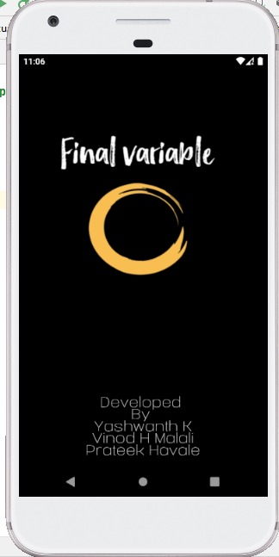

Fig 5.1 **Splash Screen**

**5.2 Main Page**

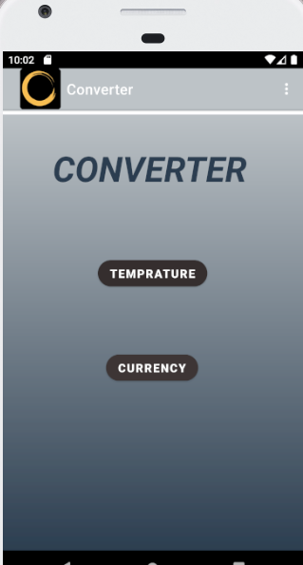

**Fig 5.2 Main Page**

Fig 5.2 Choose the option

**5.3 More About**

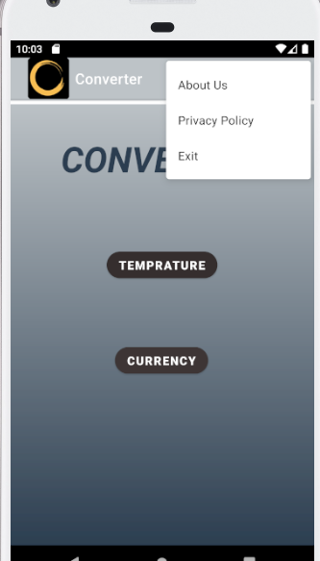

**Fig 5.3 More about**

Fig 5.3 Give more options like privacy policy and about us

**5.4 TEMPERATURE CONVERTER PAGE**

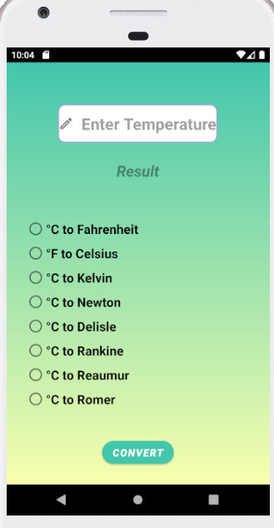

**Fig 5.4 TEMPERATURE PAGE**

Fig 5.4 Consist of options to convert

**5.5 TOAST MESSAGE**

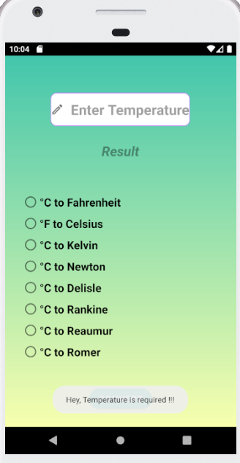

**Fig 5.5.1 TOAST MESSAGE**

Fig 5.5.1 Shows toast message for Temperature

**5.6 TEMPERATURE RESULT**

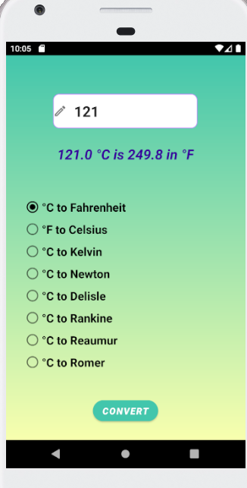

**Fig 5.6 TEMPERATURE RESULT**

Fig 5.6 Shows converted temperature result to the user

**5.7 CURRENCY RESULT**

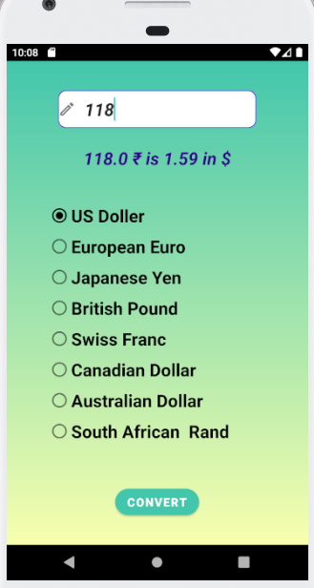

**Fig 5.7 CURRENCY RESULT**

Fig 5.7 Shows the converted Currency result

Chapter 6

**CONCLUSION AND FUTUREENHANCEMENTS**

## 6.1 CONCLUSION

## CONVERTER APP has been developed to implemented to convert units and convert currencies. There are many currencies in this world but in this application we have implemented eight currencies as of now. And also many units but in this application we have implemented six unit converts. The experience of developing an android app is quite challenging, motivating as well as satisfying.

* 1. **FUTURE ENHANCEMENTS**

This project has many future applications, it helps to implement a many other unit converts and currency converts. In future real time currency conversion can be implemented. Add Measurement converter, power converter, volume converter, area converter, time converter and many more for user convenience and user can get all converter at a single application. It can be implement more user convenient application.

**BIBLIOGRAPHY**

**WEBSITE LINKS**

* <https://github.com/topics/android-project>
* <https://youtube.com>