**Tools Required**: IntelliJ IDEA, JAVA8, Spring Boot, H2 DB and Postman.

**Application Work flow**:

This application will pull the data from external API (Rate API) and save the data into H2 DB.

**Application Flow**:

This application has five end points

**First end point**

When hit end point will call Rate API and get the one year data for GBP/USD/HKD currencies and save into H2 DB.

**URL**

http://localhost:8080/data

**Results**

By hitting above url we will get a response like below.

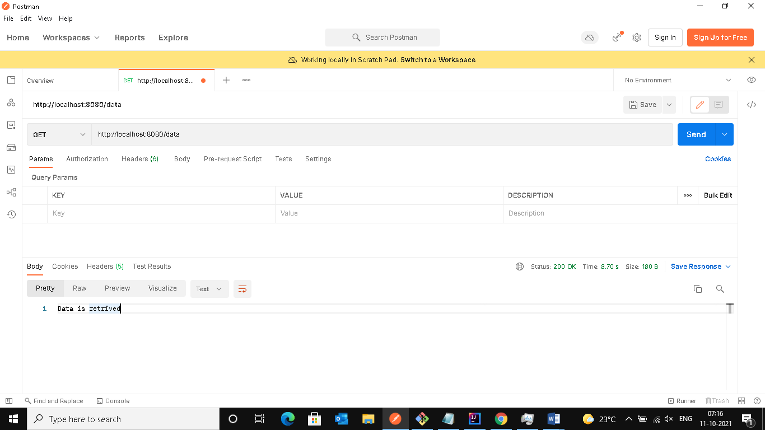

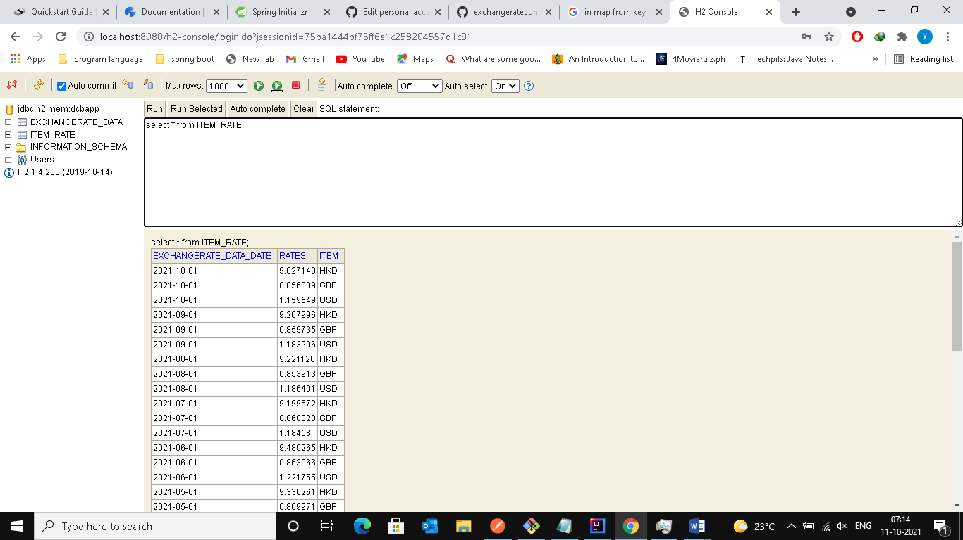

**Second end point**

When hit endpoint we need to pass input date as part of endpoint url, will get data for input date from external API and will save into H2 DB.

**URL**

http://localhost:8080/2021-06-01

**Result**

By hitting above url we will get a response like below.

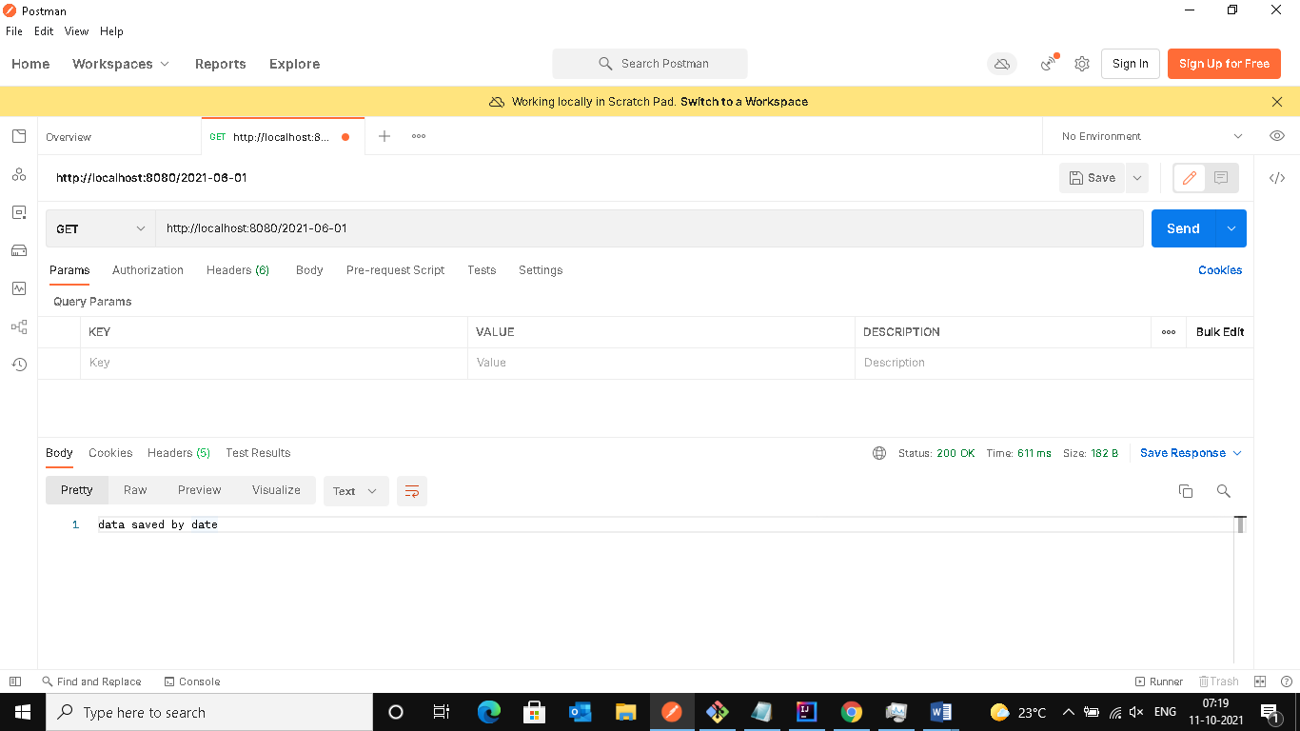

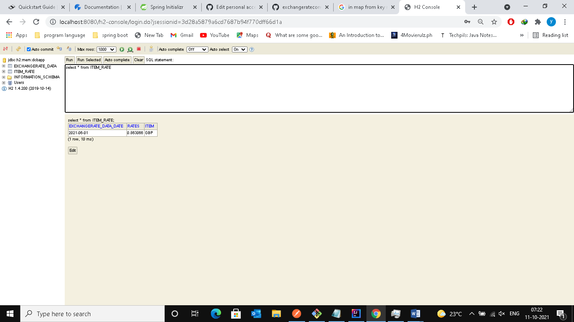

**Third end point**

When hit endpoint will call Rate API and get one year data for all currencies and save into H2 DB.

**URL**

<http://localhost:8080/alldata>

**Results**

By hitting above url we will get a response like below.

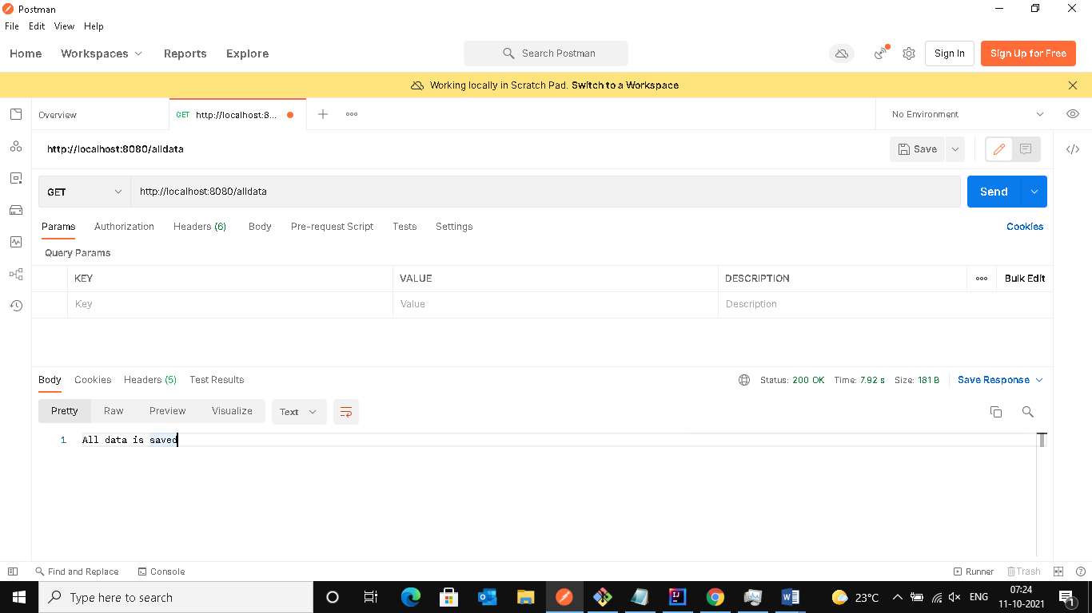

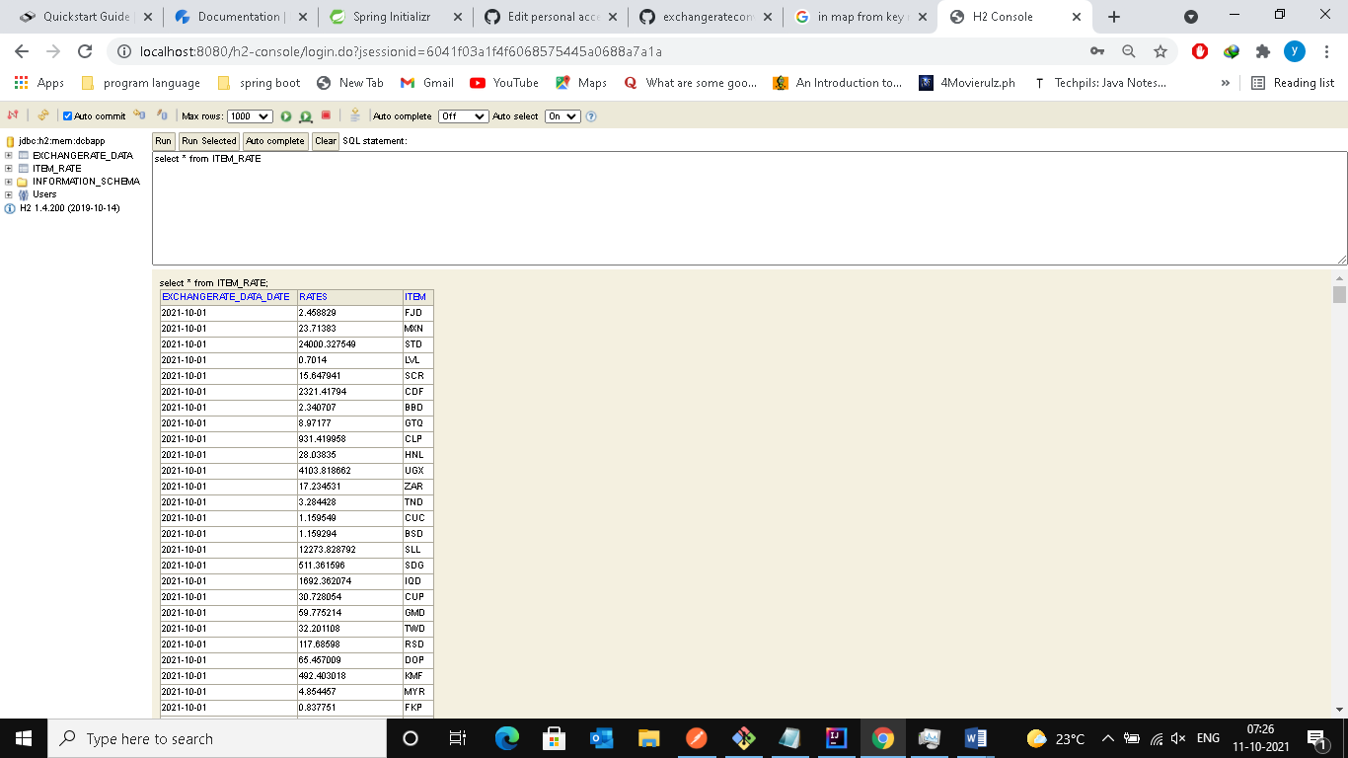

**Fourth end point**

When hit endpoint we need to pass input date as part of endpoint url, Will get data for input date from H2 DB and display to Browser console or Postman.

**URL**

<http://localhost:8080/alldata/2021-05-01>

**Results**

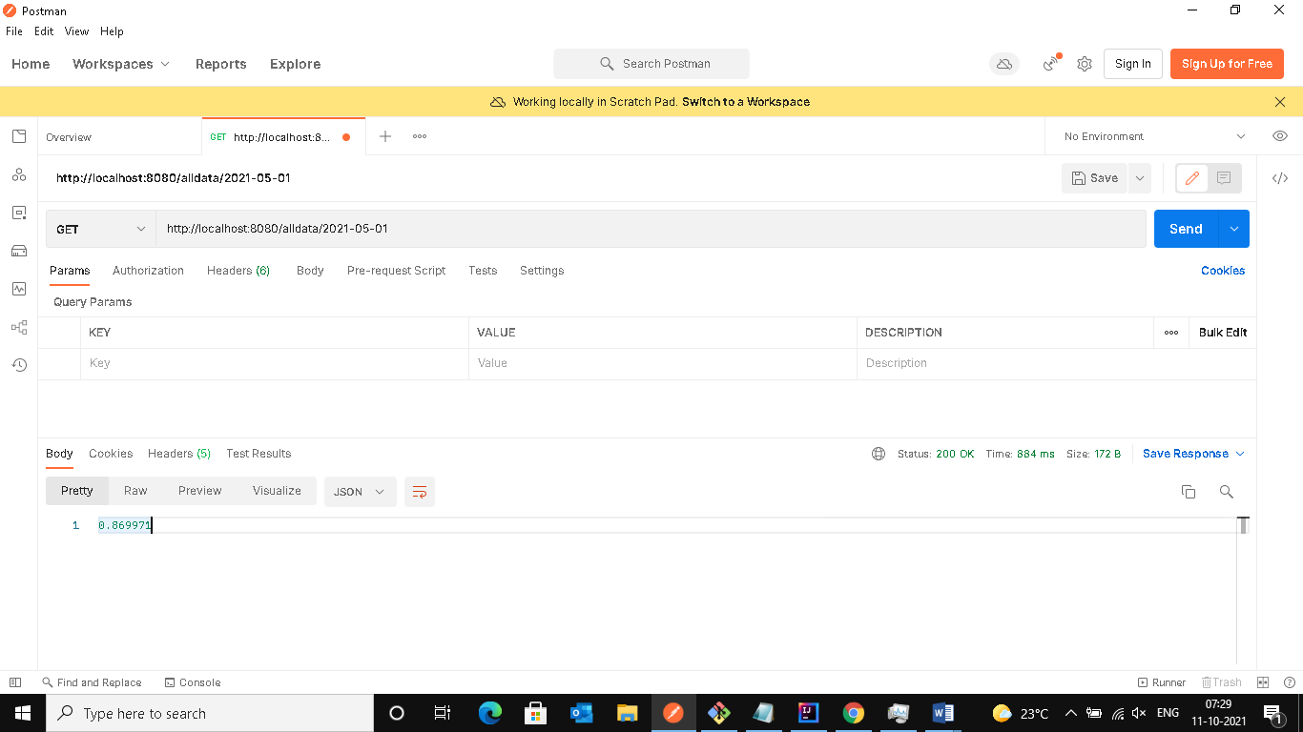

**Fifth end point**

When hit endpoint we need to pass two input dates as part of endpoint url, will get data in between two dates and today date data.

**URL**

<http://localhost:8080/alldata/2021-05-01/2021-08-01>

**Results**

