Name:V V YASWANTH

1)Given 2 numbers(interval) display(space separated) odd numbers between two intervals.

Input Size : N,Q <= 100000

Sample Testcase :

INPUT

1 6

OUTPUT

3 5

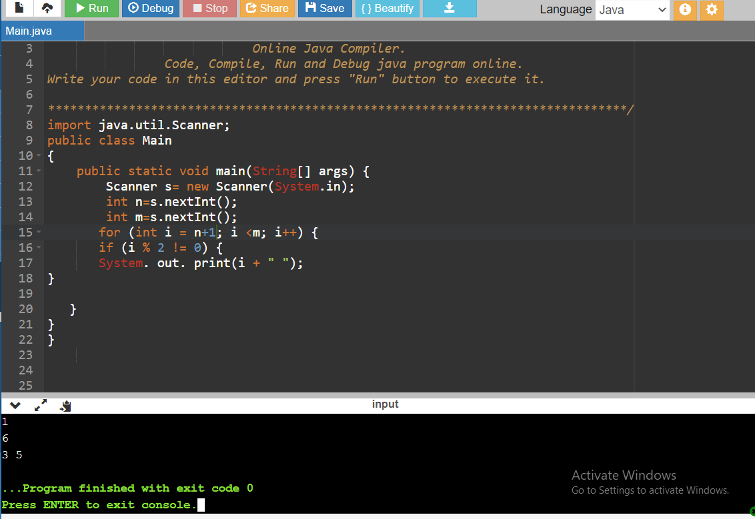

2) Given a number N and an array of N integers, print the median element.

Input Size : 1 <= N <= 1000

Sample Testcase :

INPUT

3

2 1 3

OUTPUT

2

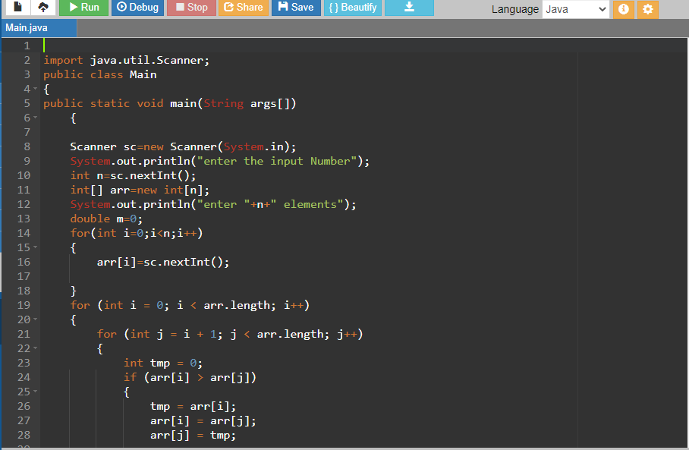

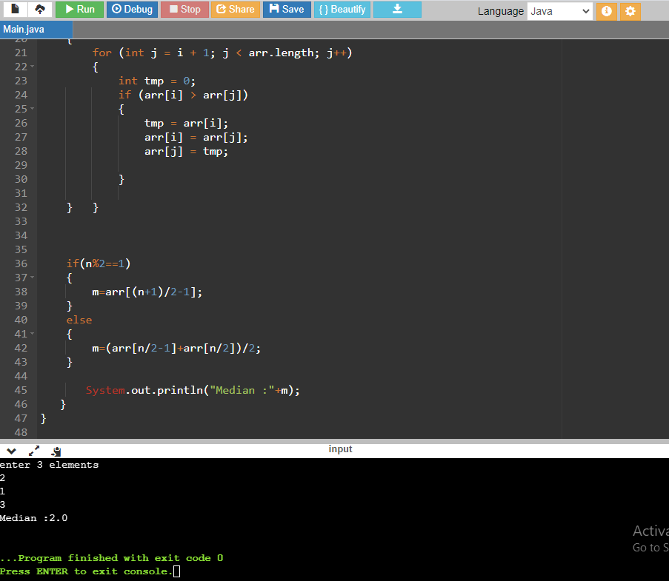

3) Program to print half pyramid using \*

\*

\* \*

\* \* \*

\* \* \* \*

\* \* \* \* \*

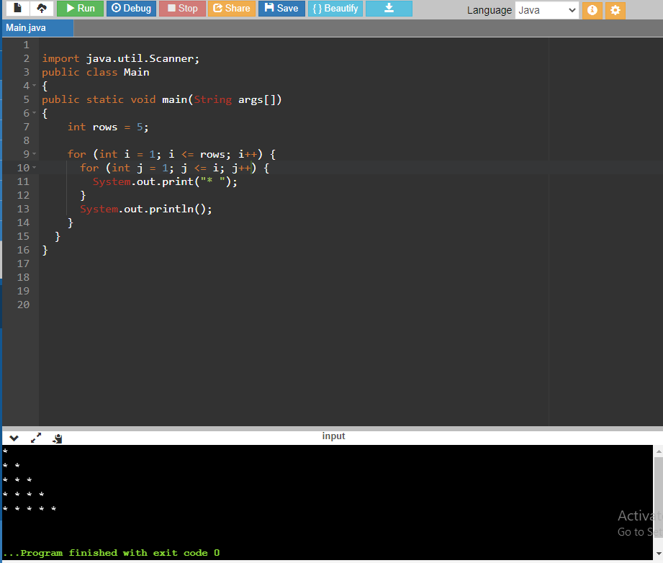

4) Inverted half pyramid using \*

\* \* \* \* \*

\* \* \* \*

\* \* \*

\* \*

\*

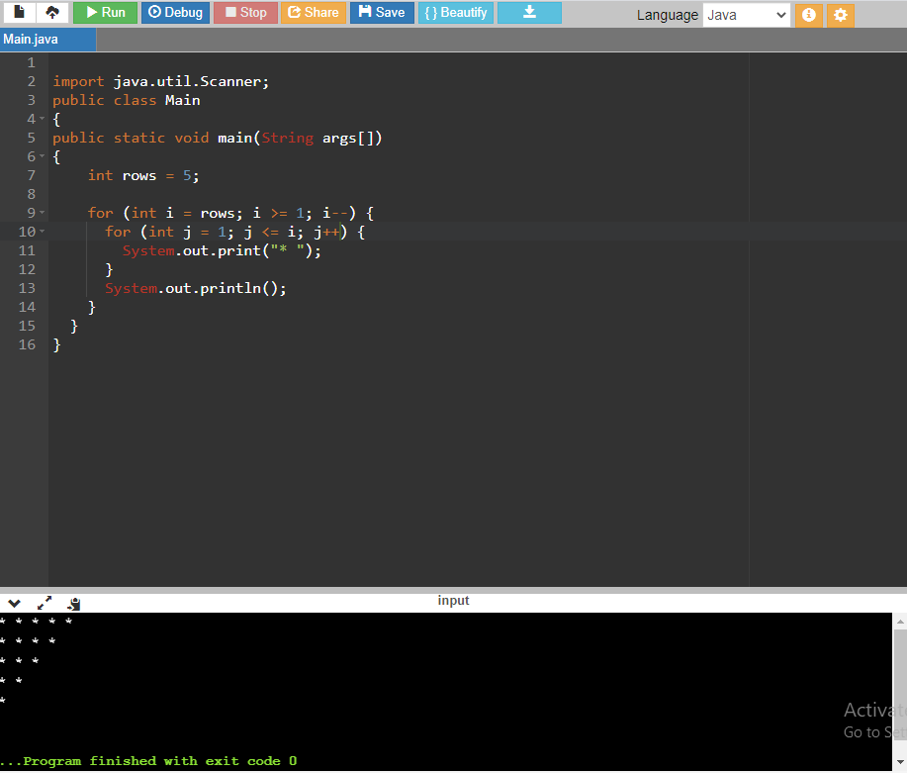

5) Program to print full pyramid using \*

\*

\* \* \*

\* \* \* \* \*

\* \* \* \* \* \* \*

\* \* \* \* \* \* \* \* \*

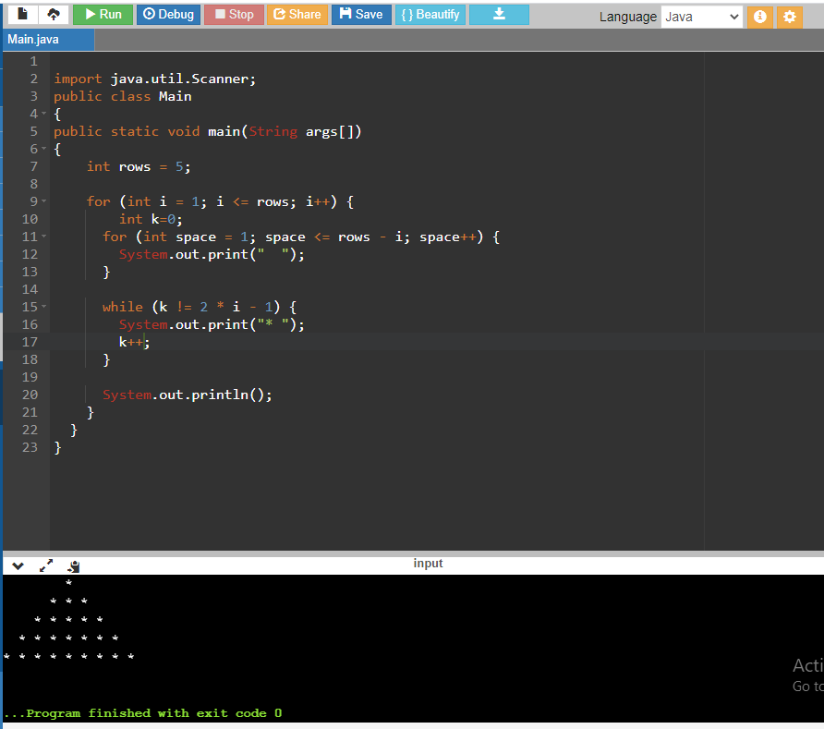

Mcqs…………………………………….

66)D

67)C

68)A

88)Num : 30

90)0