Name:V V YASWANTH

1)Rearrage the elements in a array in a specific manner mentioned in a clue

the clue says cursed are the odd and sorted are the even, the clue translates to sort the even positioned elements of an array starting from the element at index 0 in ascending order

Input

size of the array followed by elements

output

even index array elements are sorted in ascending order

Sample IP

5

3 9 1 44 6

Sample OP

1 9 3 44 6

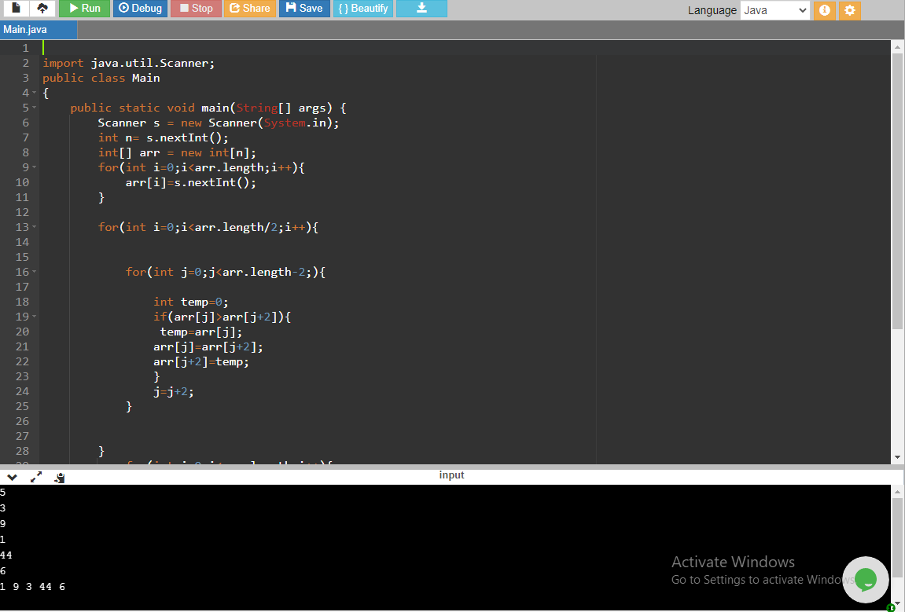

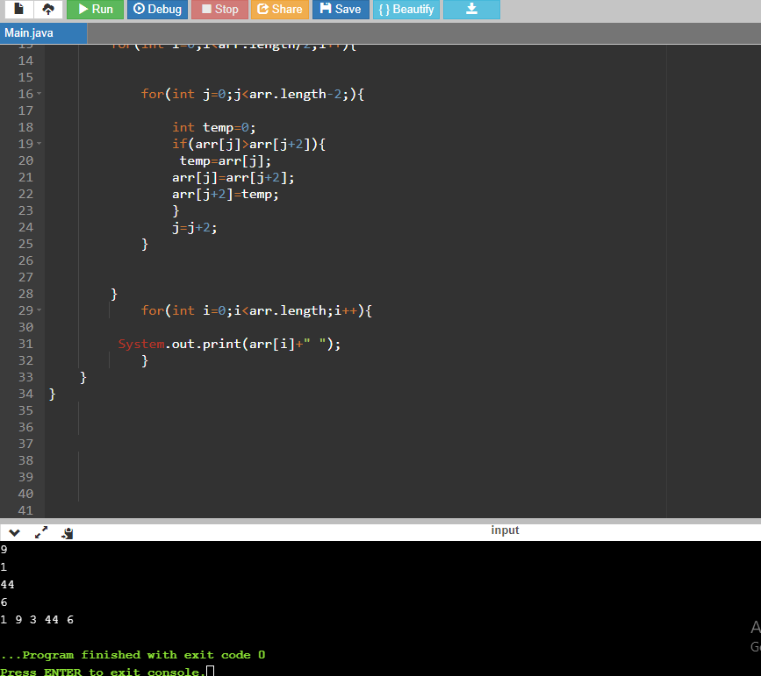

2) Explain the different ways of constructing an ArrayList?

A) By using an **ArrayList.add()** method

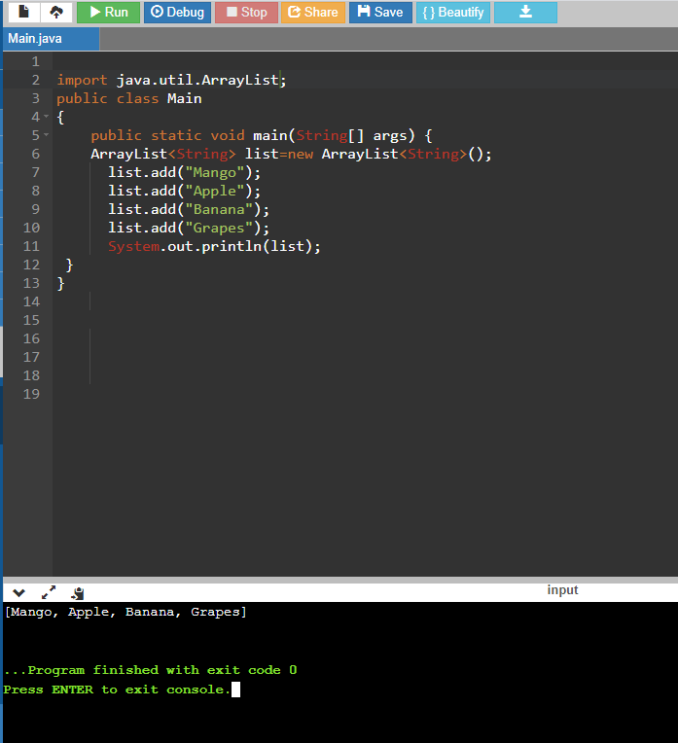

3) How do you increase the current capacity of an ArrayList?

A) By using **ensureCapacity( )** we can increase the capacity of an ArrayList object

4) How do you decrease the current capacity of an ArrayList to the current size?

A**) trimToSize()** method trims the capacity of this ArrayList instance to be the list's current size.

5) How do you find out whether the given ArrayList is empty or not?

A) We can use the size method of the ArrayList class to check if the ArrayList is empty. If the **ArrayList size is equal to 0** then the ArrayList is empty, otherwise not.

6) How do you check whether the given element is present in an ArrayList or not?

A) **ArrayList. contains()** method can be used to check if an element exists in an ArrayList or not.

7) count repeated charcters using recursion in a given string

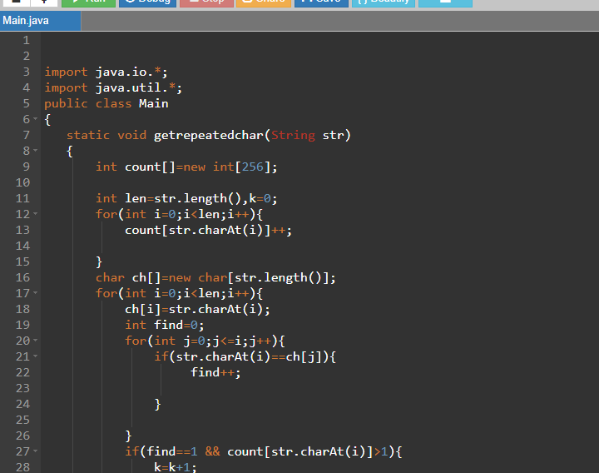

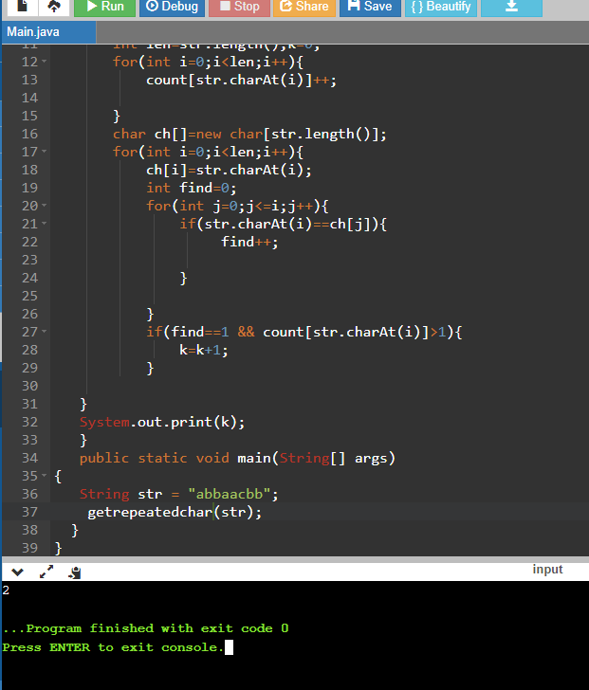

9) Reverse every word in a given sentence

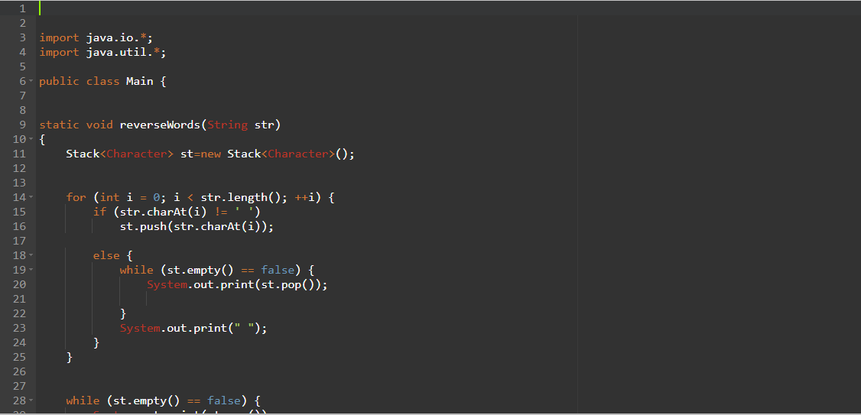

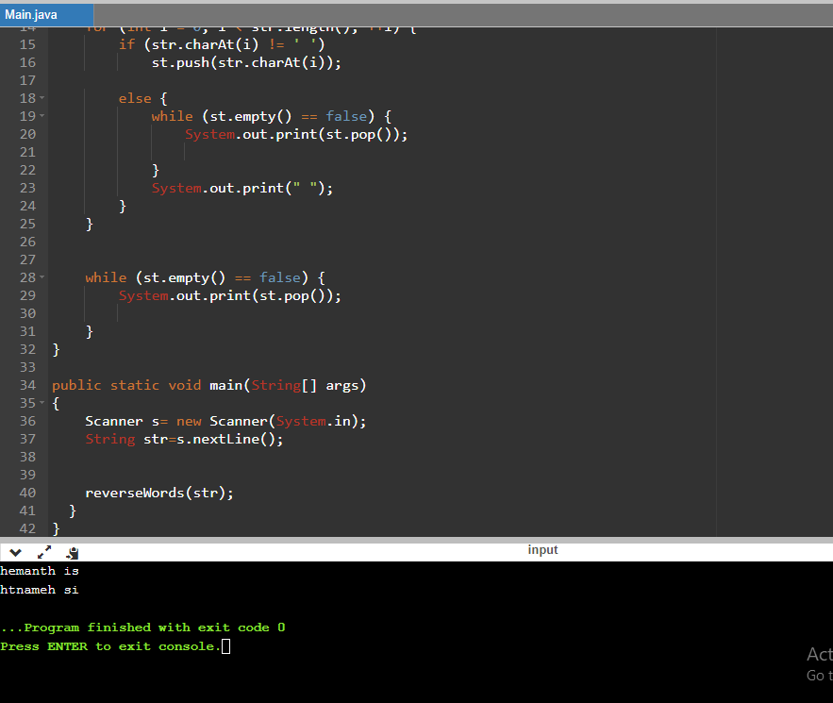

10. find the most repeated character in a sentence using Inheritance

