**Ideation Phase**

**Brainstorm & Idea Prioritization Template**

|  |  |
| --- | --- |
| Date | 21 JUNE 2025 |
| Team ID | LTVIP2025TMID46184 |
| Project Name | ResolveNow: Your Platform for Online Complaints |
| Maximum Marks |  |

**ResolveNow: Your Platform for Online Complaints Template:**

**ResolveNow: Your Platform for Online Complaints** is a web-based application designed to streamline the process of registering and managing complaints. Users can easily file grievances, track their status, and receive timely updates. The platform empowers organizations to handle issues efficiently while ensuring transparency and accountability. With a user-friendly interface and secure backend, ResolveNow improves communication between complainants and service providers.

Reference: <https://www.mural.co/templates/brainstorm-and-idea-prioritization>

**Step-1: Team Gathering, Collaboration and Register the Problem Statement**

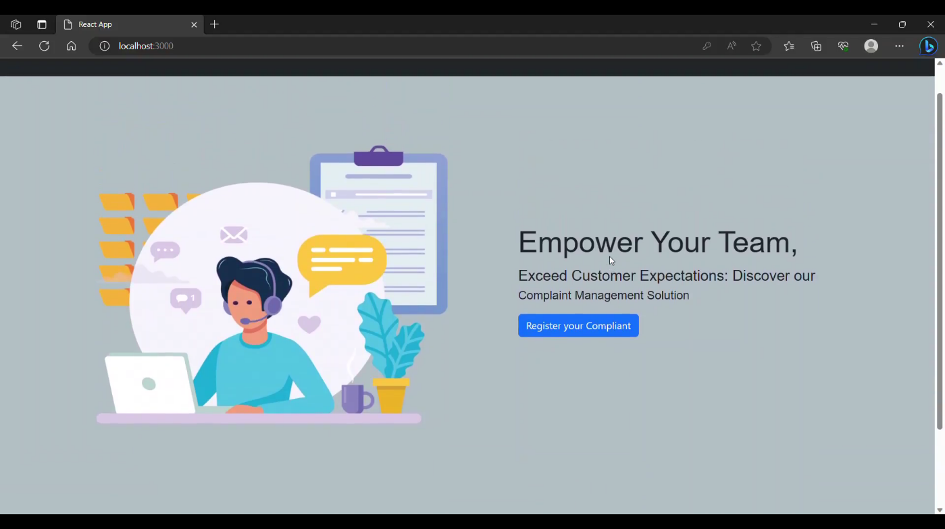

**Step-2: Login and sign in details**

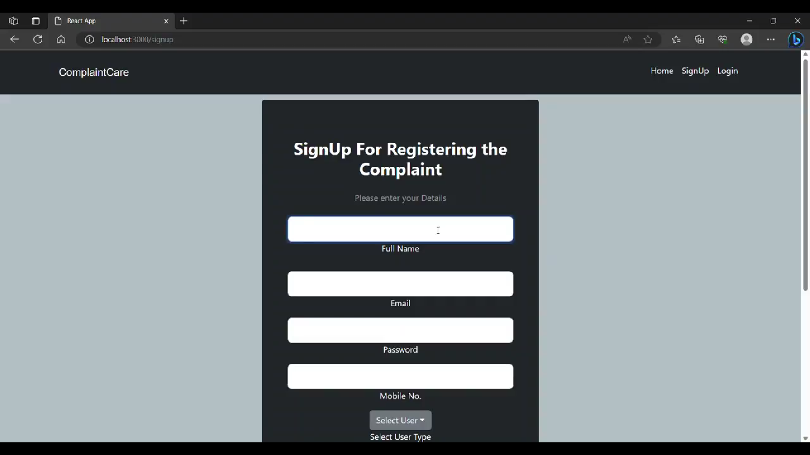

**Step-3: Complaint Registration**

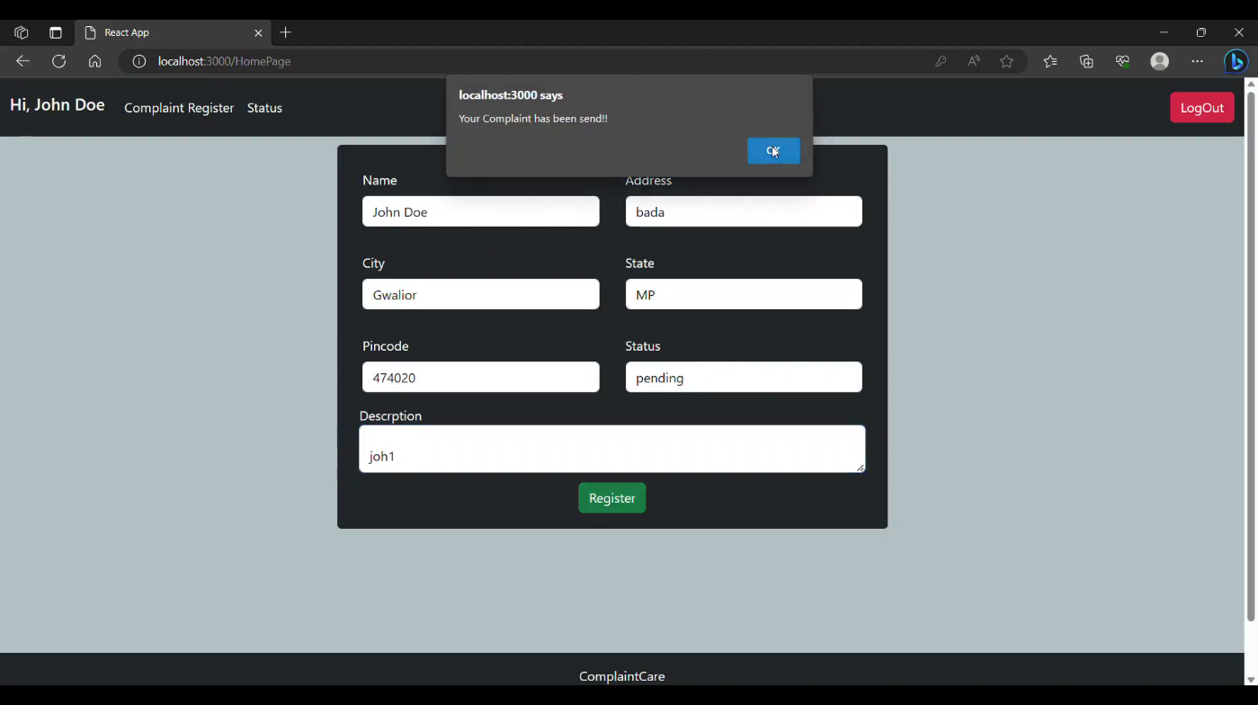

Step-4: Complaint successfully registered

