3.1 Experimental result
The measured DC resistance R_{mean}, effective electrical conductivity σ_{eff}, and the associated standard deviations R_{SD} and σ_{SD} obtained for the three lattice architectures (n = 3 specimens per architecture) are listed in Table 2. The specimen geometry parameters—gauge length L and cross-sectional area A—are included for reference.
Table 2. DC resistance and effective electrical conductivity of sintered Graphene/SiC lattices (n = 3 per architecture).
Lattice Structure | 𝑳 (mm) | 𝑨 (mm²) | R_{mean} (Ω) | R_{SD} (Ω) | σ_{eff} (S/m) | σ_{SD} (S/m)
Grid | 14.06 | 64.402 | 34.983 | 0.532 | 6.240 | 0.095
Scaffold | 14.25 | 66.07 | 21.75 | 0.690 | 9.916 | 0.314
Honeycomb | 14.28 | 63.536 | 20.676 | 0.477 | 10.869 | 0.250
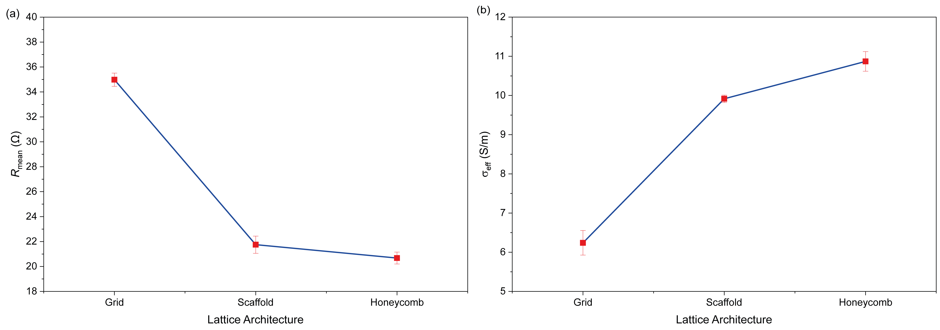
The Grid architecture yielded the highest mean resistance (R_{mean} = 34.983 ± 0.532 Ω) and the lowest effective conductivity (σ_{eff} = 6.240 ± 0.095 S/m). The Scaffold architecture showed intermediate values: R_{mean} = 21.75 ± 0.690 Ω and σ_{eff} = 9.916 ± 0.314 S/m. The Honeycomb architecture exhibited the lowest resistance (R_{mean} = 20.676 ± 0.477 Ω) and the highest effective conductivity (σ_{eff} = 10.869 ± 0.250 S/m). Accordingly, R_{mean} decreases monotonically in the order Grid > Scaffold > Honeycomb, while σ_{eff} increases in the reverse order: Grid < Scaffold < Honeycomb. These trends are illustrated graphically in Fig. 10, which plots R_{mean} (Fig. 10(a)) and σ_{eff} (Fig. 10(b)) as a function of lattice architecture. The error bars represent the standard deviation of three independently printed and sintered specimens.
Fig. 10. Experimentally measured (a) mean DC resistance R_{mean} (Ω) and (b) effective electrical conductivity σ_{eff} (S/m) as a function of lattice architecture (Grid, Honeycomb, Scaffold). Error bars represent standard deviation (n = 3).

