KELT-3b:

**KELT-3b** is a gas giant exoplanet orbiting the F-type main-sequence star KELT-3. It was discovered in 2013 by the KELT telescope in Arizona.

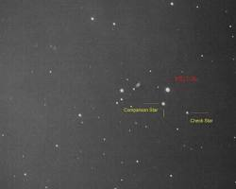

**Key characteristics:**

* **Type:** Gas giant
* **Mass:** Approximately 1.94 times the mass of Jupiter
* **Radius:** About 1.56 times the radius of Jupiter
* **Orbital period:** 2.7 days
* **Temperature:** Very hot, with a surface temperature estimated around 2132 degrees Celsius (3870 degrees Fahrenheit)
* **Orbital radius:** 0.04123 AU from its star (Very close)
* **Discovery method:** Transit
* **Eccentricity:** 0 (The orbit is perfectly circular)
* **Far from Earth:** 686 light-years

**TOI-560c**

**TOI-560c** is a super-Earth exoplanet orbiting the star TOI-560. It was discovered in 2021 using the Transiting Exoplanet Survey Satellite (TESS).

**Key characteristics:**

* **Type:** Super-Earth
* **Mass:** Estimated to be around 2.7 times the mass of Earth
* **Radius:** Estimated to be around 1.5 times the radius of Earth
* **Orbital period:** 18.87 days
* **Temperature:** Likely too hot to be habitable, with an estimated surface temperature of around 400 degrees Celsius (752 degrees Fahrenheit)
* **Eccentricity:** 0.0930 (The orbit is perfectly circular)
* **Surface gravity:** 1.2878 gravity in Earth
* **Discovery method:** Transit Exoplanet Survey Satellite (TESS)
* **Far from Earth:** 103 light-years

**51 Pegasi b**

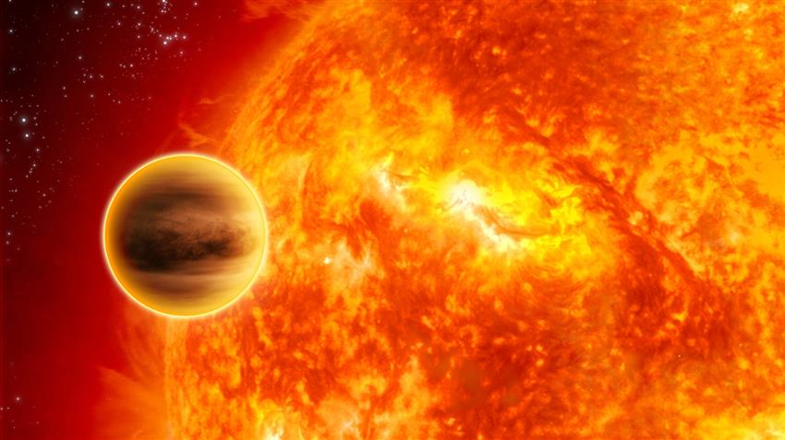

**51 Pegasi b** was the first exoplanet discovered orbiting a main-sequence star similar to our Sun. Also, the first Hot Jupiter ever observed. Its discovery in 1995 marked a significant milestone in the field of exoplanet research, confirming the existence of planets outside our solar system.

**Key characteristics:**

* **Type:** Gas giant
* **Mass:** Approximately 0.46 times the mass of Jupiter
* **Radius:** About 1.5 times the radius of Jupiter
* **Orbital period:** 4.23 days
* **Temperature:** Very hot, with a surface temperature estimated around 1000 degrees Celsius (1832 degrees Fahrenheit)
* **Far from Earth:** 50 light-years

**Significance of its discovery:**

* **Pioneering discovery:** 51 Pegasi b was the first exoplanet discovered around a Sun-like star, revolutionizing our understanding of planetary systems beyond our own.
* **Hot Jupiter class:** Its close orbit and high temperature led to the classification of "hot Jupiter," a category of gas giant exoplanets that orbit their stars at very short distances.
* **Implications for planetary formation:** The discovery of 51 Pegasi b challenged existing theories of planetary formation, as it suggested that gas giants could form closer to their stars than previously thought.
* **Discovery:** 51 Pegasi b's discovery in 1995 by Swiss astronomers Michel Mayor and Didier Queloz surprised the scientific community since models of planetary formation at the time did not predict its existence. The pair later won the Nobel Prize in Physics in 2019 for their achievement.

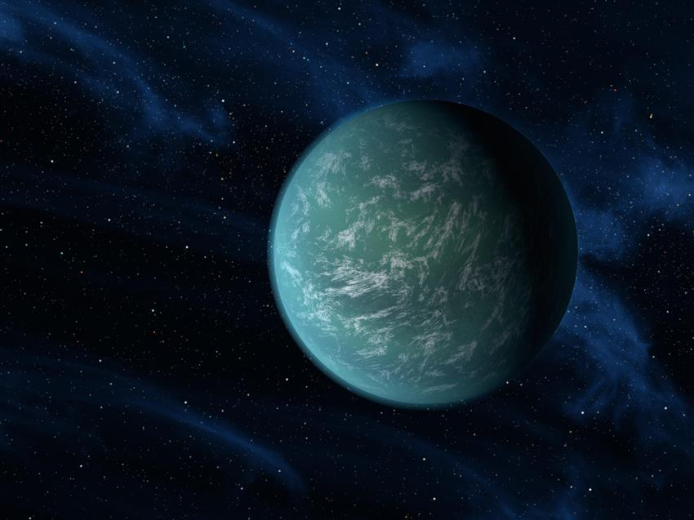**Kepler-22b**

**Kepler-22b** is a super-Earth exoplanet orbiting the Sun-like star Kepler-22. It was discovered in 2011 by NASA's Kepler Space Telescope and is one of the most promising candidates for a potentially habitable planet outside our solar system.

**Key characteristics:**

* **Type:** Super-Earth
* **Mass:** Estimated to be around 2.4 times the mass of Earth
* **Radius:** Estimated to be around 2.4 times the radius of Earth
* **Orbital period:** 289.85 days
* **Temperature:** Estimated to be around 22 degrees Celsius (72 degrees Fahrenheit), potentially within the habitable zone of its star
* **Eccentricity:** 0.034 (its orbit is nearly circular, with a very slight deviation from a perfect circle)
* **Gravity:** 0.9 g
* **Far from Earth:** 600 light-years

**Significance of its discovery:**

* **Potential for habitability:** Kepler-22b's estimated temperature and location within its star's habitable zone make it a promising candidate for supporting liquid water on its surface.
* **First confirmed planet in the habitable zone:** Kepler-22b was the first confirmed exoplanet to be located within the habitable zone of a Sun-like star.
* **Implications for extraterrestrial life:** The discovery of Kepler-22b has fueled speculation about the possibility of extraterrestrial life and the existence of other habitable planets in our galaxy.

Roughly twice the size of Earth, Kepler-22b was discovered in 2011 by NASA's Kepler Space Telescope. The exoplanet was the first to be found in any star's **habitable zone**.

Although scientists are unsure what Kepler-22b looks like, the exoplanet orbits its star at just the right distance – where a planet is most likely to have a climate that would allow any water on its surface to remain liquid.

This area is also called the Goldilocks Zone, since the conditions are not too hot, not too cold, but just right. However, there are no guarantees that this exoplanet, located about 600 light-years away from Earth, hosts alien life, or that humans could live on it.

its location within its star's habitable zone suggests that it could potentially support liquid water, we don't have direct evidence to confirm this.

**Proxima Centauri b**

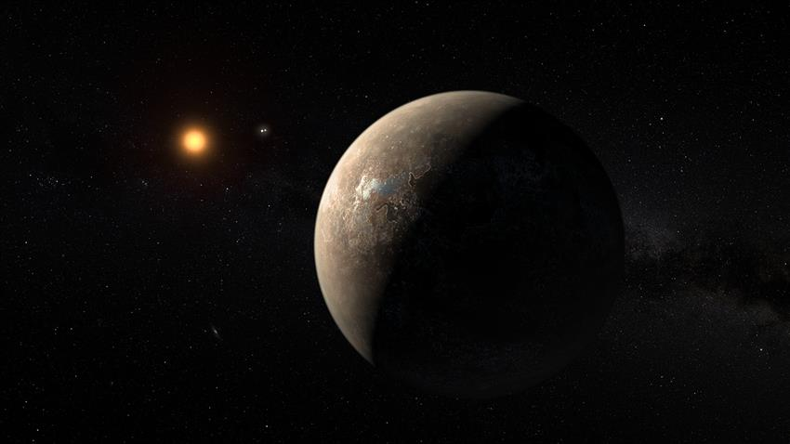

**Proxima Centauri b** is an exoplanet orbiting Proxima Centauri, the nearest star to our Sun. It was discovered in 2016 and is the closest exoplanet to Earth.

**Key characteristics:**

* **Type:** Super-Earth
* **Mass:** Estimated to be around 1.3 times the mass of Earth
* **Radius:** Estimated to be around 1.2 times the radius of Earth
* **Orbital period:** 11.18 days
* **Temperature:** Estimated to be within its star's habitable zone, with a potential for liquid water on its surface.
* **Far from Earth:** 4.2 light-years

**Significance of its discovery:**

* **Closest exoplanet to Earth:** Proxima Centauri b is the nearest known exoplanet to Earth, making it a prime target for future exploration and research.
* **Potential for habitability:** Its location within its star's habitable zone and similar mass to Earth make it a promising candidate for supporting life.
* **Implications for extraterrestrial life:** The discovery of Proxima Centauri b has fueled speculation about the possibility of extraterrestrial life and the existence of other habitable planets in our galaxy.

Proxima Centauri is the closest star to the Sun. This **red dwarf star** is located 4.2 light-years – or 40 trillion kilometers – away from Earth. An exoplanet, Proxima Centauri b, was detected orbiting this star in 2016.

Proxima Centauri b is a rocky planet that is a bit larger than Earth. Like Kepler-22b, it is also located in its star's habitable zone. Scientists find this exoplanet very intriguing, but they will have to continue studying it from afar – even using the fastest space probe ever built, the Parker Solar Probe which could travel at speeds of up to 724,000 km/h, it would take almost 7000 years to reach Proxima Centauri b!

In 2020, scientists confirmed the existence of a second planet in this system: Proxima Centauri c. This super-Earth or mini-Neptune is about 7 times as massive as our planet but orbits its star beyond the habitable zone.

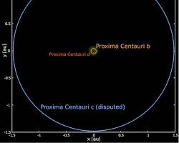**Proxima Centauri d**

**Proxima Centauri d** is a newly discovered exoplanet orbiting Proxima Centauri, the nearest star to our Sun. It was announced in February 2023 and is the third known planet in the Proxima Centauri system.

**Key characteristics:**

* **Type:** Super-Earth
* **Mass:** Estimated to be around 2.5 times the mass of Earth
* **Orbital period:** Approximately 5.12 days
* **Temperature:** Likely too hot to be habitable, with an estimated surface temperature around 234 degrees Celsius (453 degrees Fahrenheit)

**Significance of its discovery:**

* **Additional planet in the Proxima Centauri system:** The discovery of Proxima Centauri d adds to our understanding of the planetary system around Proxima Centauri, which could potentially host multiple habitable planets.
* **Challenges for detection:** Proxima Centauri d is a challenging planet to detect due to its small size and close proximity to its star. Its discovery highlights the advancements in exoplanet detection techniques.