// =======================

// Attached: HW_2A,2B,2C,2D

// =======================

// HW 2A

// =======================

// Youssef Abdelwahab

// CS 1B

// =======================

#include <iostream>

#include <iomanip>

#include <string>

#include <cmath>

using namespace std;

void getScores(double testScores[],int Size,int* sum, float* avg);

void showMenu();

char getChoice();

void displayResult(double testscores[],int Size,char choice,float* avg, int* sum);

int main()

{

const int Size = 5;

double testScores[Size];

int sum = 0;

float avg;

char choice;

getScores(testScores,Size,&sum,&avg);

showMenu();

choice = getChoice();

displayResult(testScores,Size,choice,&avg,&sum);

system("pause>null");

return 0;

}

//========getScores===============================================================================

//================================================================================================

void getScores(double testScores[],int Size,int* sum, float* avg)

{

cout << "Please enter 5 test scores: " << endl;

cout << " " << endl;

for (int i = 0; i < Size; i++)

{

cout << "Please enter test score #" << i + 1 << " ";

cin >> testScores[i];

*sum += testScores[i];

}

*avg = *sum / Size;

}

//=======showMenu=================================================================================

//================================================================================================

void showMenu()

{

cout << " " << endl;

cout << "A.) Calculate the average of the test scores." << endl;

cout << "B.) Display all test scores" << endl;

cout << " " << endl;

}

//=======getChoice================================================================================

//================================================================================================

char getChoice()

{

char choice;

cout << "Enter your choice: ";

cin >> choice;

return choice;

}

//======displayresult=============================================================================

//================================================================================================

void displayResult(double testScores[], int Size, char choice,float* avg, int* sum)

{

if (choice == 'A' || choice == 'a')

{

cout << " " << endl;

cout << fixed << showpoint;

cout << setprecision(2);

cout << "The average is " << *avg;

}

else if (choice == 'B' || choice == 'b')

{

for (int i = 0; i < Size; i++)

{

cout << " " << endl;

cout << testScores[i];

}

}

else

{

cout << " " << endl;

cout << "Invalid entry!";

}

}

// =======================

// Attached: HW_2A,2B,2C,2D

// =======================

// HW 2B

// =======================

// Youssef Abdelwahab

// CS 1B

// =======================

#include <iostream>

#include <iomanip>

#include <string>

#include <cmath>

using namespace std;

const int Rows = 3;

const int Columns = 4;

void getData(int numArray[][Columns]);

void displayArray(int numArray[][Columns]);

int main()

{

int numArray[Rows][Columns];

cout << "Enter integers into the 2-Dimensional array:" << endl;

cout << " " << endl;

getData(numArray);

cout << " " << endl;

cout << "Here is the data in the 2-Dimensional array:" << endl;

cout << " " << endl;

displayArray(numArray);

system("pause>null");

return 0;

}

//========getData==================================================================================

//================================================================================================

void getData(int numArray[][Columns])

{

for (int i = 0; i < Rows; i++)

{

for (int j = 0; j < Columns; j++)

{

cout << "Enter a number: ";

cin >> numArray[i][j];

}

}

}

//=========displayArray=====================================================================================

//==========================================================================================================

void displayArray(int numArray[][Columns])

{

for (int i = 0; i < Rows; i++)

{

for (int j = 0; j < Columns; j++)

{

cout << setw(7)<< numArray[i][j] << '\t';

}

cout << " " << endl;

}

}

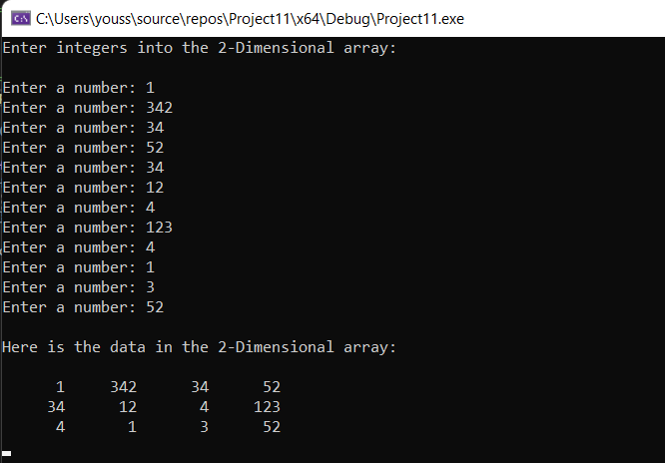

// =======================

// Attached: HW_2A,2B,2C,2D

// =======================

// HW 2C

// =======================

// Youssef Abdelwahab

// CS 1B

// =======================

#include <iostream>

#include <iomanip>

#include <string>

#include <cmath>

#include <fstream>

using namespace std;

const int row = 5;

const int col = 3;

void getanddisplayinfo(char gradeArray[][col]);

void displayinfo(char gradeArray[][col]);

void getgpa(char gradeArray[][col],float gpavalues[row][col]);

void calcgpa(float gpavalues[row][col]);

int main()

{

char gradeArray[row][col];

float gpavalues[row][col];

getanddisplayinfo(gradeArray);

getgpa(gradeArray,gpavalues);

calcgpa(gpavalues);

system("pause>null");

return 0;

}

//================================================================================================

//================================================================================================

void getanddisplayinfo(char gradeArray[][col])

{

ifstream grades("Grades.txt");

cout << "All grades: " << endl;

for (int r = 0; r < row; r++)

{

for (int c = 0; c < col; c++)

{

grades >> gradeArray[r][c];

}

}

cout << " " << endl;

for (int r = 0; r < row; r++)

{

for (int c = 0; c < col; c++)

{

cout << setw(7) << gradeArray[r][c] << "\t";

}

cout << endl;

}

if (!grades.is_open())

cout << "Error opening file";

}

//================================================================================================

//================================================================================================

void getgpa(char gradeArray[][col],float gpavalues[row][col])

{

for (int r = 0; r < row; r++)

{

for (int c = 0; c < col; c++)

{

switch (gradeArray[r][c])

{

case 'A': gpavalues[r][c] = 4;

break;

case 'B': gpavalues[r][c] = 3;

break;

case 'C': gpavalues[r][c] = 2;

break;

case 'D': gpavalues[r][c] = 1;

break;

case 'F': gpavalues[r][c] = 0;

break;

}

}

}

}

//================================================================================================

//================================================================================================

void calcgpa(float gpavalues[][col])

{

float rowTotal = 0;

for (int r = 0; r < row; r++)

{

rowTotal = 0;

for (int c = 0; c < col; c++)

{

rowTotal += gpavalues[r][c];

}

cout << "" << endl;

cout << fixed << showpoint;

cout << setprecision(2);

cout << "Student#" << (r + 1) << " gpa is: "<< rowTotal/3 << endl;

}

}

// =======================

// Attached: HW_2A,2B,2C,2D

// =======================

// HW 2D

// =======================

// Youssef Abdelwahab

// CS 1B

// =======================

#include <iostream>

#include <iomanip>

#include <string>

#include <cmath>

using namespace std;

int seqSearch(const int list[], int size, int number);

int main()

{

const int SIZE = 5;

int idNumbers[SIZE] = { 12345, 54321, 11223, 33211, 44411 };

int number;

int index;

cout << "\nEnter the number to be searched: ";

cin >> number;

index = seqSearch(idNumbers, SIZE, number);

if (index != -1)

cout << number << " is found at index " << index << endl;

else

cout << number << " is not found in the list." << endl;

system("pause>null");

return 0;

}

//=======seqSearch=======================================================================================

//================================================================================================

int seqSearch(const int idNumbers[], int size, int number)

{

int index = 0;

bool found = false;

while (index < size && !found)

{

if (idNumbers[index] == number)

found = true;

else

index++;

}

if (found)

return index;

else

return -1;

}

