OXFORDSHIRE COUNTY COUNCIL
Information Governance Unit
Freedom of Information (FOI) Response System
System Architecture & Technical Specification
AI-assisted intake, drafting, human review, approval, sign-off and dispatch
Compliant with the Freedom of Information Act 2000 and the Environmental Information Regulations 2004
Version 1.0 · June 2026 · Status: Draft for review

Contents

1. Executive summary
This document specifies the system architecture for an AI-assisted Freedom of Information (FOI) response platform for Oxfordshire County Council. The platform receives requests from residents, local businesses and other stakeholders, automatically classifies and routes each request to the owning department, drafts a grounded response from the council’s own records, escalates to a human subject-matter expert wherever information is missing or confidence is low, and moves the response through departmental approval, senior sign-off and final dispatch by the FOI team.
The design keeps a human in the loop for every disclosure decision. Artificial intelligence accelerates intake, classification, retrieval and drafting, but it never releases information on its own. All exemption, redaction and public-interest decisions are made or confirmed by accountable officers, and the whole process is wrapped in a single auditable case record with a statutory-deadline clock running from receipt.
The workflow is summarised in eight stages: (1) intake and registration, (2) AI triage and classification, (3) knowledge retrieval and auto-draft, (4) department human review where information is missing, (5) update of the response, (6) compliance and exemptions gate, (7) final sign-off, and (8) dispatch by the FOI team.
Before live traffic, a Phase 0 bootstrap (Section 4) seeds the system entirely from public data — the council website and the published disclosure-log responses — to build both the grounding knowledge base and the house style the drafting model writes in. Internal systems (SharePoint, EDRMS, case and finance) are integrated in a later phase.

2. Objectives and design principles

2.1 Objectives
- Reduce the time officers spend locating information and drafting routine responses.
- Improve consistency, completeness and tone across FOI responses.
- Meet the statutory deadline of 20 working days from receipt for every request, with controlled use of the permitted public-interest extension.
- Maintain a complete, defensible audit trail for every request and every decision.
- Automatically publish disclosable responses to the council’s disclosure log.

2.2 Design principles
- Human-in-the-loop. AI drafts and suggests; accountable officers decide and authorise every disclosure.
- Grounded, not generative-from-thin-air. Every factual claim in a draft is cited to a source document; the model retrieves rather than invents.
- Compliance by design. Statutory deadlines, exemptions, the public-interest test and data-protection redaction are built into the workflow, not bolted on.
- Auditability. Every action, draft version and decision is logged against a single case record.
- Least privilege. Role-based access and UK data residency throughout.

3. End-to-end workflow diagram
The diagram below shows the full request lifecycle, the decision points where work branches to human review, and the governance and compliance spine that applies across all stages.
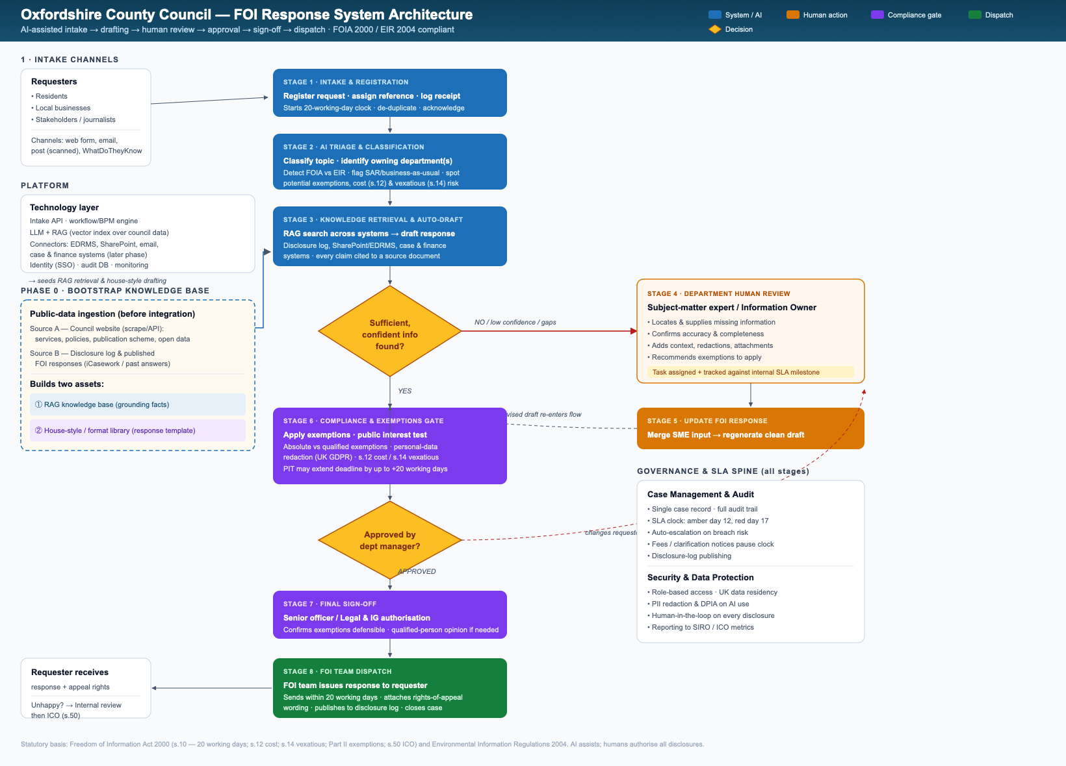
Figure 1 — FOI response system: end-to-end workflow and governance spine.

4. Knowledge base bootstrap (Phase 0)
Before any integration with the council’s SharePoint, EDRMS, email, case or finance systems, the platform is seeded entirely from public data. This Phase 0 step gives the drafting and retrieval services something authoritative to work from on day one, and is the system’s initial training data.

4.1 Two public sources
- Source A — the council website. Service pages, policies, the publication scheme and open-data datasets are ingested to provide factual grounding for the topics FOI requests most often touch.
- Source B — the published FOI responses. The disclosure log and previously published answers are ingested both as factual precedent (many requests repeat) and as the source of the council’s house style.

4.2 Two assets it produces
- A RAG knowledge base. A vector index over the public content so the retrieval service (Stage 3) can find and cite relevant material.
- A house-style / format library. The recurring structure of published responses — acknowledgement, confirm-or-deny, question-by-question answers, exemptions, re-use clause, review and appeal rights — captured as a template the drafting model follows. This is specified in detail in the companion FOI Response Template & House-Style Guide.

4.3 Method and caveats
Efficient ingestion: a polite, rate-limited crawler with a sitemap-driven scope for the website, and, for the disclosure log, a rendering crawler or — preferably — a data feed agreed with the Information Governance Unit, because the log is served through a JavaScript portal (iCasework) that does not expose content to a simple fetch. Only public, already-disclosed information is ingested at this stage; no personal or internal data is involved until later phases.
Refresh: the knowledge base and house-style library are re-crawled on a schedule so newly published responses and updated guidance keep the system current. When internal systems are connected in a later phase, the same template is reused with richer, authoritative grounding.

5. Stage-by-stage specification
STAGE 1 Intake & registration

Trigger: a request arrives from a resident, local business or stakeholder via web form, monitored email inbox, post (scanned/OCR’d) or a re-use platform such as WhatDoTheyKnow.
What happens: the request is captured into the case-management system, assigned a unique reference, time-stamped, de-duplicated against open cases and acknowledged to the requester. Receipt starts the statutory clock.
Compliance: the date of receipt fixes the 20-working-day deadline under section 10 of FOIA. Requests that are actually subject access requests, complaints or business-as-usual enquiries are flagged for re-routing rather than processed as FOI.
Outputs: a registered case record with reference, requester contact details, receipt date and SLA target.
STAGE 2 AI triage & classification

What happens: the AI triage layer reads the request and classifies it — topic, the owning department(s), and whether it falls under FOIA or the Environmental Information Regulations 2004. It detects early risk signals: likely exemptions, requests that may exceed the cost limit (section 12), and potentially vexatious or repeated requests (section 14).
Routing: the case is routed to the correct department queue. Requests spanning multiple departments are split into sub-tasks with a lead owner.
Human oversight: classification is advisory. An FOI officer can override the department, statute or risk flags before drafting proceeds.
STAGE 3 Knowledge retrieval & auto-draft

What happens: a retrieval-augmented generation (RAG) step searches the indexed knowledge base and assembles a draft in the council’s house style. Initially (Phase 0) this is the public bootstrap knowledge base — the disclosure log, published responses and council website; in later phases it expands to internal records (EDRMS/SharePoint, case and finance systems).
Grounding: every factual statement in the draft is linked to the source document it came from, so reviewers can verify it. Where the model cannot find supporting evidence, it explicitly marks the gap rather than guessing.
Decision point: the system assesses whether sufficient, high-confidence information was found.
Outcome | Next step
Sufficient & confident | Proceed to the compliance & exemptions gate (Stage 6) with the AI draft.
Missing / low confidence / gaps | Escalate to department human review (Stage 4).

STAGE 4 Department human review

Owner: the subject-matter expert or designated Information Owner in the relevant department.
This is the stage that handles the case where the system cannot find the relevant information. The expert:
- Locates and supplies the missing information from records the AI could not reach.
- Confirms the accuracy and completeness of what has been gathered.
- Adds context, attachments and any necessary caveats.
- Recommends which exemptions, if any, should be applied and why.
Tracking: the review is issued as a tracked task with its own internal milestone, so the case does not stall and the statutory clock is monitored centrally.
STAGE 5 Update FOI response

What happens: the expert’s input is merged back in and the system regenerates a clean, consolidated draft. The revised response then re-enters the main flow at the compliance and exemptions gate. New material added here is indexed so future similar requests can be answered automatically.
STAGE 6 Compliance & exemptions gate

Before any response can be approved it passes a compliance gate that applies the legal framework:
- Exemptions. Absolute exemptions are applied where they bite. Qualified exemptions trigger a public-interest test (see Section 6).
- Data protection. Personal data is redacted in line with UK GDPR and the Data Protection Act 2018 before release.
- Cost and vexatious checks. If the request exceeds the appropriate cost limit (section 12) a fees notice or refusal is prepared; section 14 is considered for vexatious or repeated requests.
- Deadline management. Where a public-interest test is needed, the deadline may be extended by up to a further 20 working days; the extension and its justification are recorded.
STAGE 7 Final sign-off

Owner: a senior officer, supported by Legal Services / the Information Governance Unit. After the department manager approves the substance of the response, final sign-off confirms that any exemptions are defensible and that, where the law requires a qualified person’s opinion, it has been obtained. If changes are required at either approval point, the case loops back to the department expert.
STAGE 8 FOI team dispatch

Owner: the central FOI team. The approved response is issued to the requester within the statutory deadline, together with the standard wording on the right to an internal review and onward complaint to the Information Commissioner. Disclosable responses are published to the disclosure log and the case is closed with its full audit trail retained.
After dispatch: if the requester is dissatisfied they may request an internal review, which at Oxfordshire is carried out by a member of the Legal Services / Information Governance team with no prior involvement in the request. If still dissatisfied, the requester may complain to the Information Commissioner under section 50 of FOIA.

6. Roles and responsibilities (RACI)
A = Accountable, R = Responsible, C = Consulted, I = Informed.
Stage | Req'er | FOI team | Dept SME | Legal/IG | System/AI
1 Intake & registration | R | A | I | I | R
2 Triage & classification | – | A | C | I | R
3 Retrieval & auto-draft | – | A | C | I | R
4 Department review | – | C | R/A | C | C
5 Update response | – | C | R | C | R
6 Compliance & exemptions | – | R | C | A | R
7 Final sign-off | – | C | C | A | I
8 Dispatch | I | R/A | I | C | R

7. Statutory and compliance mapping
The platform is built around the requirements of the Freedom of Information Act 2000 (FOIA), the Environmental Information Regulations 2004 (EIR), and UK data-protection law. The key provisions and how the system honours them are summarised below.
Provision | Requirement | How the system meets it
FOIA s.10 | Respond promptly and within 20 working days of receipt. | Clock starts at registration; SLA dashboard with amber (day 12) and red (day 17) alerts and auto-escalation.
FOIA s.1 / s.16 | Duty to confirm or deny and to advise & assist. | Standard acknowledgement, clarification prompts and structured response templates.
FOIA Part II | Apply absolute and qualified exemptions correctly. | Compliance gate (Stage 6) records each exemption claimed and its basis.
Public interest test | Weigh public interest for qualified exemptions; permitted extension up to a further 20 working days. | PIT workflow with recorded reasoning; deadline extension logged with justification.
FOIA s.12 / s.14 | Cost limit; vexatious or repeated requests. | AI cost and pattern flags; fees-notice and refusal templates.
FOIA s.45 Code | Internal review on request. | Independent reviewer (no prior involvement) routed via Legal/IG.
FOIA s.50 | Complaint to the Information Commissioner. | Appeal-rights wording attached to every response; ICO metrics reported.
EIR 2004 | Environmental information handled under EIR. | Triage detects EIR cases and applies EIR timescales and exceptions.
UK GDPR / DPA 2018 | Protect personal data; lawful processing of AI. | PII redaction, DPIA on AI use, UK data residency, least-privilege access.

8. Technical architecture

8.1 Logical components
Component | Responsibility
Intake gateway / API | Receives requests from web form, email, post (OCR) and re-use platforms; normalises and validates them.
Workflow / BPM engine | Orchestrates the eight stages, assignments, SLAs, escalations and approval gates.
Case-management store | Single source of truth per request: metadata, versions, decisions, audit trail.
Classification service (LLM) | Topic, department, statute (FOIA/EIR) and risk classification.
Ingestion / crawler service | Phase 0 bootstrap: crawls the council website and disclosure log; builds and refreshes the public knowledge base.
House-style / format library | Stores the response template and worked examples learned from published responses; steers the drafting model.
Retrieval (RAG) service | Vector index and search over the knowledge base (public first, internal records later); assembles grounded context.
Drafting service (LLM) | Generates cited draft responses, in house style, plus refusal/fees notices.
Redaction & DLP service | Detects and removes personal and exempt data prior to release.
Connectors | Secure integrations to EDRMS/SharePoint, email, case and finance systems, and the disclosure log.
Identity & access (SSO) | Authentication, role-based authorisation, least privilege.
Audit & reporting | Immutable event log, SLA dashboards, ICO and SIRO reporting.

8.2 Data flow
- (Phase 0, ahead of live traffic) The ingestion service crawls the council website and disclosure log to build the public knowledge base and house-style library.
- Request is received and registered; an event is written to the audit log and the SLA clock starts.
- The classification service tags the request and the workflow engine routes it to a department queue.
- The retrieval service gathers grounded context and the drafting service produces a cited draft.
- If confidence is high, the draft goes to the compliance gate; otherwise a review task is assigned to the department SME.
- The SME supplies missing information; the draft is regenerated and re-enters the flow.
- Exemptions, redaction and the public-interest test are applied at the compliance gate.
- Department approval, then senior/Legal sign-off, then dispatch by the FOI team and publication to the disclosure log.

8.3 Security and data protection
- UK data residency for all request content, records and model processing.
- Role-based access control with least privilege; full access logging.
- A Data Protection Impact Assessment (DPIA) covering the AI components, reviewed periodically.
- Encryption in transit and at rest; segregation of personal and exempt data.
- Human authorisation required before any information is disclosed — no automated release.
- Retention and disposal aligned to the council’s records-retention schedule.

8.4 Key risks and mitigations
Risk | Impact | Mitigation
AI hallucination / inaccurate draft | Wrong information disclosed | Grounded RAG with source citations; mandatory human review and sign-off.
Accidental disclosure of personal/exempt data | Data breach; ICO action | Automated redaction plus compliance gate plus human authorisation.
Missed statutory deadline | FOIA breach; complaints | SLA clock, amber/red alerts, auto-escalation, central monitoring.
Misrouting to wrong department | Delay | Advisory classification with officer override; multi-department splitting.
Model/connector outage | Process stall | Manual fallback path; queues persist; no single point of release.

9. Phased implementation
Phase | Focus | Scope
Phase 0 | Public-data bootstrap | Ingest the council website and published disclosure-log responses to build the knowledge base and house-style library. No internal-system access; the initial training data.
Phase 1 | Foundations | Intake, registration, case management, SLA clock and audit trail; AI drafting from the Phase 0 knowledge base with officer review.
Phase 2 | Internal integration | Connect EDRMS/SharePoint, email, case and finance systems to widen grounding beyond public data; redaction service.
Phase 3 | Workflow automation | Department routing, review tasks, approval and sign-off gates, disclosure-log publishing.
Phase 4 | Optimisation | Analytics, and a feedback loop that indexes new SME-supplied material and newly published responses for reuse.

Note: AI capabilities are introduced in an assistive, read-only-to-release posture. Human authorisation of every disclosure remains constant across all phases.

10. References
Statutory and guidance sources underpinning the compliance design:
- ICO — Time limits for compliance under FOIA (section 10)
- ICO — The public interest test
- ICO — Timescales (guide to managing an FOI request)
- Oxfordshire County Council — Freedom of information requests
- Oxfordshire County Council — FOI disclosure log (iCasework portal)
Companion document: FOI Response Template & House-Style Guide (the format the drafting model follows).

