Abstention dominates the aggregate under-count on dense scenes for one anchor build and language: signed error direction in object counting with vision-language models
— — —

Abstract
Evaluation reports symmetric magnitudes: 100 and 150 look alike. We treat the signed error direction as a measurable dimension and contribute two findings, plus the apparatus that makes them checkable: an operationalisation of abstention that separates a suppressed abstention from a true zero, and the dual-convention identities that make under-counts readable. For one anchor build under Chinese prompts (§5.7, §8.2), the dominant dense-scene failure in these cells is not underestimation but abstention — a literal "0" — accounting for 82–94% of the total under-count under ground-truth-weighted share (base arm; the same abstention rate under the item-count convention is 53.9–68.2%); answered-zero rate drops 42.7 pp on the BF16 build under English (§8.2). Given an abstention option 1591/1591 calls abstain; forbidding it yields a per-item median of 2.463–9.452× (§5.7, M.1). The gate is the availability of an abstention token, not enumeration demand (M.18). Abstention is a behaviour, not a capability ceiling: gated by legibility, removable by tiling (56.6% → 0.0% on the anchor build) or, at a directional cost, by prompt relaxation (ρ: −82% → +234%). Span of the direction is a property of implementation × training domain × data domain × protocol, not of a paradigm — 2–3.4× across official implementations (DM-Count 20.1–34.3 pp vs P2PNet [1] 10.1 pp, same protocol), 3.5× under a domain swap, and a defective reproduction as an implementation defect (§6.1, K). What replicates under shared calibration is the ordering of these spans, not their magnitudes, and only under the level sets and calibers compared (§7.3).

1. Introduction
Motivation and the evaluation gap. In surveillance and resource scheduling the two error directions are asymmetric: missing objects and double-counting are not equivalent, and most safety and inventory settings prefer over- to under-counting. The error's signed direction has therefore remained implicit. Our first question is: can a counting system's error direction be manipulated systematically, and what sets the range over which it can be moved? (Appendix M.11)
A prior question. Before that, we examined a widely accepted premise: that vision-language models (VLMs) systematically underestimate dense scenes, which prior work treats as a capability problem. Re-classifying every outcome in our corpus (892 result files, ~620k records, four VLM configurations, nine datasets), we find that the dominant component of these "underestimates" is not underestimation but abstention: the model declines to estimate instances it cannot individually ascertain, and expresses that refusal as the literal answer "0". Under a ground-truth-weighted convention on one anchor build, answering 0 accounts for 82–94% of the total under-count (base contract arm, Chinese prompts; over all arms and domains it spans 0–99.4% — 0% on the over arm and 99.4% on ShanghaiTech-A under the under arm (Appendix J.1); the answered-zero rate drops 42.7 pp on the BF16 build under English prompts (Appendix M.39)).
Why separating the two is not a matter of terminology. A model answering a literal 0 on 60% of dense images and underestimating by 20% on the rest reads, conventionally, as mild underestimation — whereas on six images in ten it answers nothing at all. The remedies are opposite: retraining or calibration versus changing the input protocol. Worse, recording a refusal as "predicted 0" makes it masquerade as conservative, which a safety deployment least wants.
The second half of the gap. Selective prediction and abstention-aware classification have well-developed criteria [2], but sit in classification, question answering and reasoning, where abstention is explicitly declared. Counting differs in three ways: abstention is implicit (a literal 0, indistinguishable at the output level from an estimate of zero); costs are asymmetric, so its acceptability is a deployment question; and there is no dependable confidence for a rejection rule. The framework cannot be transplanted directly — abstention must first be operationalised and validated in the counting domain (§3.6, Proposition 1) — and that step exposed the received reading's problem.
Four properties of abstention. ① Measurable, with a lineage-specific channel. Rather than stipulate that pred = 0 means abstention, we give an empirical criterion: a lineage abstaining mainly in language would show an answered-zero-to-refusal ratio approaching 0.
② Gated by per-instance legibility, not by target count, and decoupled from directional bias: on count-controlled grids, arrangement and blur alone drive abstention from 0% to 90%, while on clean synthetic dots the base arm never abstains yet still underestimates by up to 50%, and in microscopy it is 0.0% with a bias of −50.1% (§5.6, §5.7).
③ Switchable from both ends, being a behaviour: tiling (Fig. 1) drops the ShanghaiTech-A [3] abstention rate from 56.6% to 0.0% (2×2: 6.0%, 3×3: 0.55%) without harming direction.
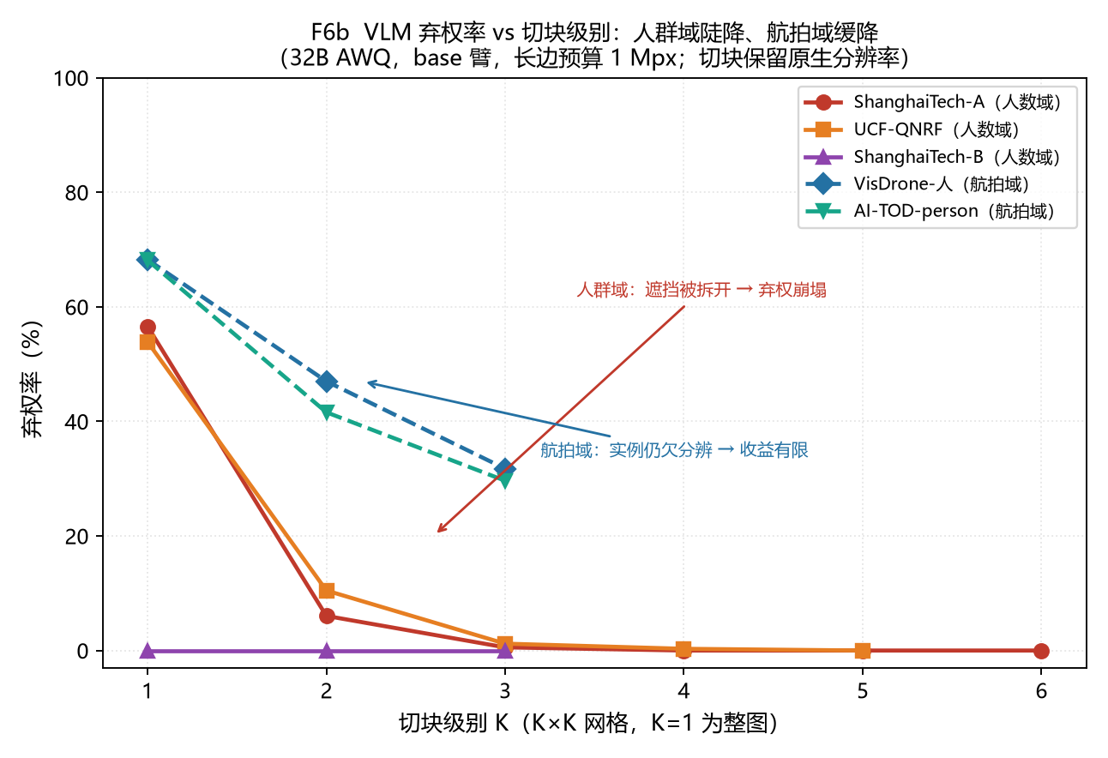
④ Removing abstention costs direction. Prompt relaxation (Fig. 2) also drives abstention to zero but flips ρ from −82% to +234%…+345%, so accuracy and directional controllability cannot both be obtained; tiling is the only mechanism that improves both. (Per-property numbers: Appendix L.)
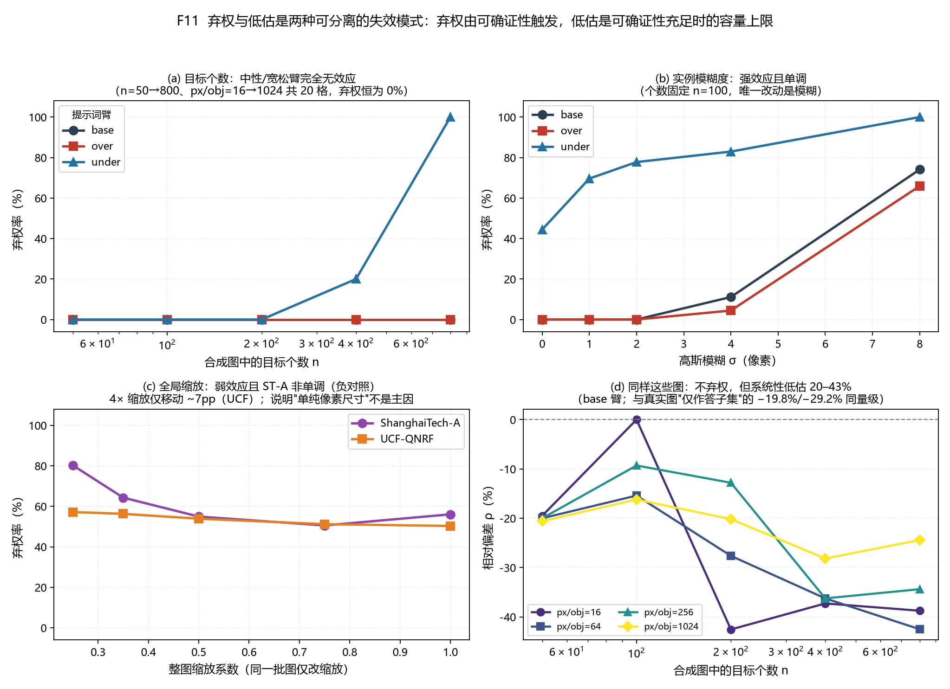
Supporting result: the response spectrum of direction. The signed direction can be moved continuously, but its achievable span is an empirical property of implementation × training domain × data domain × protocol, not of a paradigm. What is established is the ordering, preserved at Spearman 0.981–0.999 when every ladder is re-estimated on a common level count with its extreme level removed (Appendix F.10): the ordering is not a function of the scanning grid, the magnitudes are (median retention 0.51–0.67 under random thinning; F.10). What is not established is a partition: the observed separating split is 1.6 pp, below our own noise floor (2.15–6.46 pp) and below the smallest attainable corrected p of that test, so we report a candidate only, and claim neither two anchor zones nor bimodality (Appendices F.3, M.37, M.17).
Contributions. Two empirical findings, plus the apparatus that makes them checkable: the identities of §3.8 and the appendices, which are arithmetic rather than findings, and whose role is that every headline number is recomputed from the released records, or labelled a transcription or an author-side computation (Appendix F.9). 1. Finding 1 — on dense scenes the aggregate under-count is mostly a suppressed abstention, and the suppression is set by the output contract. Within the cells studied here, literal-zero outputs dominate the pooled under-count (§5.5); for InternVL2.5-8B [4] the answered-zero channel covers only 69.69% of abstentions (§3.6, Proposition 7); and the outlet is a property of the serving configuration rather than of the lineage (the rate is not; Appendix M.47) — given an abstention token 1591/1591 calls abstain, and in a census fixing the stack and varying only the contract, item-level pairing removes the answered zero in 46 of 52 (model × domain) cells (52 of 52 under the three-option contract; M.18.2–M.18.3), while the same grid on seven families — four of them beyond the corpus's own, all unquantised — removes it in 7 of 7 (§5.7, M.19), two of the seven having offered only 9 and 156 zeros to remove (2 of the latter from the dense domains). The frequency claim stays bounded: the corpus is dominated by one lineage (§8.2), the dense-scene headline is build-specific (five deployments of one 32B checkpoint differ by up to 90.3 pp, and on the cross-family grid the share exceeds 50% only at the two precisions of the defining checkpoint; M.19.15) and the aerial-scene one domain-specific (2.7–8.7 pp across the same five; M.18.4, M.18.8).
2. **Finding 2 — per-instance legibility gates whether a model answers, and it is a diagnostic rather than a
repair. We give the proxy, the effect structure under three controlled manipulations, and what it cannot do: it supports selective prediction (the most legible 20% of images reduce MAE by 31–66%, selector AUC 0.753–0.786) but cannot repair direction (ρ attenuating only from −85.0% to −53.4%), and because it requires instance-level boxes it is a diagnostic, not a deployment-time criterion** (§3.3, §7.1).
3. The apparatus: a re-checkable measurement discipline. The dual convention and its divergence
condition (Proposition 2), the anomaly-exclusion rule, span variants against the noise floor (2.15–6.46 pp), and every split point enumerated rather than searched (Appendix F.3). It yields one positive rule where a magnitude law is absent: the span ordering is robust, magnitudes are not, and a magnitude is quoted with the grid density and the calibration caliber that produced it (Propositions 3, 5; §7.3). The spectrum is reported as an ordering, not as a finding.
Where each result binds. The abstention results are measured on seven families across four corpus domains plus a nine-configuration panel on FSC-147 [5], and tested prospectively on an independently sampled panel of six further families in six lineages with no Qwen model (§5.14); the direction results span three families of implementations.

2. Related Work

2.1 Detection-based counting versus density regression
Two families dominate counting: detection-based methods localise instances and count them, while density regression predicts a density map whose integral is the count — the definitional formulation of the field [6]. Comparative work treats them as paradigms with characteristic trade-offs, and magnitude error is the axis on which they are compared; one controlled benchmark organises its probes by complexity [7].

2.2 Thresholds, operating points and cost-sensitive decisions
The detection literature has long studied the operating point, and cost-sensitive decision theory formalises asymmetric losses. That apparatus supplies no measured answer for counting, which is this section's job: the counting error direction as a function of the operating point, with NMS IoU as a second such knob, and with "crossing zero" shown to be not a single event — the zero of the user-side error and that of the total error differ by a factor of about 2.1–2.3 (§4.4, §4.7).

2.3 VLM counting, and abstention in the counting domain
VLM counting is an active area, with benchmarks showing that current models count poorly ([8] and successors). A parallel and largely separate literature studies abstention: selective prediction [9], [10], [11], rejection options, abstention benchmarks for multimodal reasoning ([12], [13]), and abstention knobs in video question answering ([14]); and VLM refusal moves with an image's mere presence in ways instructions do not control [15] — acting on the tendency, not on the channel §5.7 manipulates. The gap is that abstention rates have never been measured on counting tasks, and that none addresses the implicit case: a literal zero that the output level cannot distinguish from a genuine zero. On counting tasks we reproduce rather than claim the legibility gating — it is gated by per-instance legibility, not by object count — and for the dominant lineage it appears as that literal zero (§3.6, §5.6).

2.4 A same-source study: numerosity stimuli under orthogonal manipulation
The numerosity tradition [16] and NumerosityVLM [17] likewise use synthetic stimuli under orthogonal manipulation, but answer a different question:
Table 1. Positioning against the numerosity-stimulus literature of §2.4.
Dimension | NumerosityVLM | This work
Stimuli | Synthetic, orthogonally manipulated | Synthetic and real; pixel budget, blur, contrast, crowding, tiling, prompt
Dependent variable | Accuracy | Signed error direction and abstention
Conclusion | Architecture explains most variance | Direction is governed by implementation × training domain × data domain × protocol

2.5 Sparse counting and the head/person granularity problem
Sparse counting benchmarks (SFCHD [18], FSC-147 [5], CountBench [19], TallyQA [20]) [21] and the head/person literature supply our sparse and external-validity settings. Recent work notes that counting granularity is left implicit, and that most counting datasets lack multi-granularity annotation ([22]; [23]); §3.2 turns this into a first-class variable.

2.6 VLM counting-failure mechanisms: our positioning
Recent work locates counting failure at the reporting stage ([24]; a hierarchy in [25]) and establishes cross-paradigm counting comparison ([26]); we cite that locus rather than claim it. Those works localise the failing stage — one decomposing counting into visual individuation, magnitude awareness and symbolic mapping [27] — whereas our quantity is the composition of what it emits: an answered 0 split into a suppressed abstention recoverable by an output contract and a genuine estimate of zero, with the machinery that separates them on a fixed serving stack in §3.8 and §5.7.

2.7 Evaluation validity: non-determinism and aggregate metrics
Our VLM indicators came from single samples. Repeat sampling shows item-level reproducibility for a hosted API to be only about 15%, while a locally controlled stack agrees at essentially 100% (batch ≤ 2), and aggregates are far more stable (Appendix A).

2.8 Crowded-scene occlusion counting
A dedicated benchmark evaluates VLMs on counting occluded objects (CAPTURe [28]). Its objects remain informative behind the occluder and require inference, so it probes reasoning; our occlusion factor asks instead whether an instance is still ascertainable given a pixel budget. The models do not perform modal completion: when inference is possible they neither infer nor abstain, they simply under-report as usual (−50% vs. −50%). (Appendix M.11)

3. Method

3.1 Counting conventions and metrics
Calibration conventions and their failure modes follow the standard taxonomy of Guo et al. [29].
All three families are evaluated against the same ground truth. Magnitude metrics are MAE, RMSE, normalised MAE and tolerance-based scores; the principal directional quantity is the signed relative deviation
ρ = pred - gtgt (in percent, signed),
Two uncertainty quantities are used here and they are not interchangeable: the across-repeat band of §A.3 governs cross-model and cross-configuration comparisons, whereas a per-cell interval resamples images and is therefore a lower bound (§A.2). The quantity has two sub-conventions that must be labelled separately — the pooled ratio and the per-image ratio mean — whose divergence condition is given by Proposition 2. Correlation coefficients are always written r and annotated as Pearson or Spearman. Abstention is an indicator in its own right, never folded into tolerance-based scoring, and always reported as a triad: the rate, ρ on answered items only, and the abstention share of the total under-count. Density is summarised by OPM, whose applicability boundary is §7.1.

3.2 Target granularity is a first-class, and widely ignored, variable
In counting, "one target" is not naturally determined: in a safety-helmet scene an annotation may define the head or the whole person. Running both conventions on SFCHD shows that changing the convention changes the sign and magnitude of the conclusion (§5.2). Any counting evaluation must therefore declare its target granularity explicitly; part of the spread across published counting numbers is a granularity artefact rather than a modelling difference.

3.3 Per-instance legibility: definition, operationalisation and boundaries
Our central independent variable is per-instance legibility — whether, under the given observation conditions, a target instance is still sufficient to be judged an independent instance. It is not a property of the model but of observation conditions × annotation granularity, and can therefore be computed before inference from images and annotations.
It is a multivariate construct; we do not assume a single sufficient proxy. The three manipulable factors are instance size, blur σ (decoupled from resolution) and overlap (arrangement at fixed size and blur). Their effects are not equal: under controlled frame pairing blur is the strongest single gate, while the per-instance pixel budget is a covariate rather than the gate — informative within a domain, but at fixed scale it co-varies with instances per image, and across the aerial and microscopy domains the two decouple (§5.6, §5.10).
The observable proxy. For each instance i, take a_i, the pixels inside its annotation box not covered by another instance's box; the image-level proxy is the median over instances, p = median_i a_i (Appendix C.1). It is deliberately simple — no model, no inference, no confidence signal — and its usefulness is demonstrated rather than assumed: as a selector it reaches AUC 0.753–0.786, and keeping the most legible 20% of images cuts MAE by 31–66% while attenuating the relative deviation only from −85.0% to −53.4% (§7.1) — an ordering usable before inference, not a repair of the direction.
Boundaries — what this variable is and is not. Legibility is a secondary, stratifying variable in this paper, and its use is bounded accordingly. It supports stratification, ranking and selective prediction; it is not a sufficient statistic, must not be compared across scales directly, and must not be read as "more pixels is always better". Because it is defined on annotation boxes it is not a deployment-time decision rule, and the obvious annotation-free substitute — the same functional form on detector boxes — does not inherit its power (AUC 0.49–0.63; Appendix M.20 records the measurement and why we report it as a boundary rather than a promise). It is also not an attention map or a confidence, and not OPM, whose cross-domain Spearman correlation is only +0.33 (§7.1).

3.4 Datasets and scene characteristics
FSC-147 is the counting-anything benchmark of Ranjan et al. [5]; CountQA [30] and PushupBench [31] are the corresponding VLM-counting benchmarks.
Nine datasets are characterised on two axes — the count axis (OPM) and the legibility axis (Appendix D.3); OPM is used for characterisation only, since §7.1 shows it is not a legibility-consistent gate. What matters for the central claim: VisDrone [32] and AI-TOD [33] have the lowest targets-per-image (17–22) yet abstain as often as ShanghaiTech-A (433 targets per image), 68% vs. 57% (Proposition 6).

3.5 Implementations
Detection: YOLOv12n [34] (tiling follows SAHI [35]) with nine variants plus budget × source-domain combinations, zero-shot COCO [36] person detectors under a tiling protocol for the dense end, and two label conventions; Faster R-CNN [37] and RetinaNet [38] supply a second and third family (fairness parameters in Appendix D.2; Appendix M.11). Vision-language models: Qwen3-VL-32B-Instruct [39] on a self-hosted 4-bit AWQ [40] community requantisation (cyankiwi/Qwen3-VL-32B-Instruct-AWQ-4bit; Appendix M.46) and GPTQ-W4 [41] stacks cross-checked against a BF16 hosted API, with an 8B scale control, a Qwen2.5-VL-7B [42] generation control and InternVL2.5-8B [4] as a second lineage; three directional arms use byte-identical prompts across datasets, plus five prompt families and a seven-level prompt-strength dose, with Chinese corpus prompts (language control: §5.5). Density regression: BL [43], CSRNet [44] and DM-Count [45] trained on SFCHD [18], with public in-domain weights for the dense end.

3.6 Abstention: operationalisation and lineage stratification
Abstention is our leading indicator, so its operationalisation is stated item by item rather than left as "the predicted total is zero". Three points matter here.
(a) Five mutually exclusive classes — normal, answer_zero, refuse, format_drift, api_error — with api_error excluded from the denominator. (b) De-duplication at file level (MD5) and at row level by identity of the experimental condition, not by item. The class criteria, the de-duplication protocol and the per-tile parsing of concatenated raw fields are given in Appendix B.1–B.2.
(c) Is `pred = 0` a sufficient operationalisation? A two-lineage answer (the two lineages for which the ratio is measured). We give an empirical criterion rather than a stipulation: a lineage that abstained mainly in natural language would show a low ratio of answered-zero to textual refusal, approaching 0, and the lower that ratio, the larger the identification error 1/(κ+1) of Proposition 7 — the two statements point the same way. Over the whole corpus (892 result files, ~620k records):
Table 2. Lineage-stratified abstention channel (the table behind §3.6(c) and Proposition 1).
Lineage | Answered zero | Textual refusal | Ratio | Coverage by pred = 0
Qwen3-VL-32B [39] | 31,387 | 57 | 550.6 : 1 | 99.82%
Qwen3-VL-8B | 3,392 | 0 | — (none) | 100%
Qwen2.5-VL-7B | 980 | 0 | — (none) | 100%
InternVL2.5-8B | 14,015 | 6,096 | 2.3 : 1 | 69.69%

For the Qwen family — the source of all our abstention headlines — `pred = 0` covers 99.82% of them (the three configurations: 0.18%, 0% and 0%). For InternVL2.5-8B it covers only about seven tenths, the rest arriving as textual refusals. Cross-lineage comparisons of abstention rate must therefore define the channel per lineage. The incompleteness is lower-bounded, not disclosed: by Proposition 7, a lineage with ratio κ identifies its answered-zero rate only to within at least the missed-refusal share 1/(κ+1) — 0.18% for Qwen3-VL-32B and 30.31% for InternVL2.5-8B — so any answered-zero rate quoted for a partially covered lineage carries that error bar, and the two lineages are never pooled (§3.8, §8.2).
(d) A consequence that corrects the mechanism. What decides whether a refusal is expressed is the output contract, and specifically whether it offers an abstention token — not how much per-instance work the prompt demands. Prompts that require per-instance enumeration ("count every person one by one") or localisation ("locate every person") but expose only a numeric field produced zero explicit refusals and went on answering 0 (Qwen3-VL-32B-AWQ on VisDrone: 258/273 under enum, 263/273 under locate; both builds of that checkpoint reproduce it, Appendix M.18). Adding a single abstention token to the same enumeration prompt converted 268/273 of those items into explicit abstention, whereas relaxing the demand while still exposing only a number ("give your best estimate even if you cannot count precisely") left the answered-zero count unchanged (121 → 121) or slightly higher (232 → 235). The operative gate is therefore the availability of an abstention token, not the enumeration demand. The legibility attribution consequently rests on the direct manipulations of §5.6–5.7, with one boundary that the same census imposes: under an abstention contract the dense domains saturate (89–100% of items the corpus had answered with a number, 100% of those it had answered 0), so the outlet carries no selectivity there and legibility-gating is demonstrable only in the aerial domains, where it is exercised on 36–93% of such items (Appendix M.18).

3.7 Anomalous records, exclusions and data hygiene
Anomalous-record removal, quarantine of unreadable key data, and the person-matched recomputation are preconditions here rather than refinements; the rules and the corpus-wide scan behind them are in Appendix I.

3.8 Formal framework: what is identifiable from outputs
Eight statements are used later. All are either identities of the reporting convention or decidability statements — not empirical findings — so they are stated compactly here; full derivations and scope notes are in Appendix M.21.
Proposition 1 (abstention is not identified by outputs alone). y = 0 is produced both by abstaining and by estimating zero, so identification needs an auxiliary channel. This holds only if the two channels are exhaustive; a genuine zero that is also not verbalised would be a third, and our data do not exclude one. We use κ=\#\y=0\/\#\textual refusals\ and report the measured value — the missed-refusal share 0.18% for Qwen3-VL-32B (κ = 550.6) and 30.31% for InternVL2.5-8B (κ = 2.3) — which is the arithmetic reason §3.6 reports the two lineages separately rather than pooled.
Proposition 2 (the two conventions diverge exactly when the per-image ratio correlates with ground truth). ρ_pooled-ρ=Cov_g(g,r)/ g, and abstention is itself GT-dependent, so the covariance is non-zero in dense domains by construction. Both conventions are therefore always reported — and §5.12 measures what a single convention costs.
Proposition 3 (span is a functional of the admitted level set). Any candidate predictor built from its extremes is a component of the definition (partial correlation exactly ± 1). That is why we withdraw our own candidate and claim availability — decidable from the same quantities, since it holds iff max_ℓ q_ℓ ≥ 1 at the loosest admitted level — but not magnitude: magnitude is not predicted by any quantity we have been able to construct.
Proposition 4 (the aggregate bias decomposes exactly). ρ_total=-(1-w)+w ρ_answered with w=G_N/G, and the abstention share of the under-count has the closed form S=(1-w)/[1-w(1+ρ_answered)], which is a share inside [0,1] only when the net deviation is an under-count; where it is not, the two pp terms of Table 3 are the reported quantities (§8.2). This is a reporting identity of the same form as the answer-propensity / conditional-composition decomposition we use elsewhere [46]; what is in question is where the movement goes on this corpus.
Proposition 5 (span is equivariant, not invariant, under shared affine calibration). span s·span, so the objection that a large span is a calibration artefact requires exhibiting s1.
Proposition 6 (targets-per-image is not a legibility-consistent stratifier). VisDrone and AI-TOD have the fewest targets (17–22) yet abstain as often as ShanghaiTech-A (433), which is what licenses stratifying by legibility rather than by density.
Proposition 7 (under the two-channel assumption the identification error of the answered-zero channel is 1/(κ+1), a lower bound). Conditional on it, that error is a known function of a measured quantity — 0.18% for Qwen3-VL-32B and 30.31% for InternVL2.5-8B — and because a third channel would raise it, these are lower bounds on the identification error, not upper bounds. The assumption is not proven: the quantity is a coverage, not a precision — it bounds how much abstention the channel catches, not how many answered zeros are genuine. Two external true-zero pools now measure a sensitivity: under base three of four builds answer zero on 98–100% of aerial pool S-1, and only one build — gemma-3-12b — has headroom in both pools, so only that build's two-source comparison is licensed (the other three builds' two-source agreement there is largely a saturation product, Appendix M.32(c)), and remains unknown (Appendix M.21) — whereas under `permit` the anchored build abstains on 148 of 150 S-1 items yet still answers zero on 146 of 150 of the second pool (Appendix M.21). Third-channel sensitivity is in Appendix J.5.
Proposition 8 (the dual-convention gap is an identity, not a bound). From Proposition 4 the gap equals -(1-w)(1+ρ_answered), i.e. zero iff w = 1 or ρ_answered=-1, and it survives an unbiased answered subset — so a single-convention report is not merely incomplete but uninterpretable.

3.9 Figures and tables
Figures 1–4 and Tables 1–6 appear where their claim is stated (Appendix D.4).

4. Results I: Detection — the threshold knob and the domain conditionality of its reach
(A cross-paradigm control that supplies the direction knob; the headline finding is in §5.)

4.1 Reachability of the zero crossing, and its domain conditionality
Detection is the only family here in which a single scalar moves the signed direction continuously across zero: on VisDrone the in-domain detector's pooled ρ — person-matched throughout this section — travels from +109.4% to −86.3%, while the same architecture with COCO-pretrained weights, on the same domain, item set and convention, covers only 16.4 / 30.3 / 55.5 pp — the three input sizes 640 / 1024 / 1536 px, i.e. the same ladder giving the in-domain weights 95.9 / 159.3 / 195.7 pp (three levels) — and never crosses (all-detections, same eight-level grid: 63.1–156.0 pp for the zero-shot ladder and 352.8–508.3 pp for the in-domain one; Appendix F.10). (Appendix M.37)

4.2 Refinement by density binning: the bound holds, but it is a per-tile bound
An earlier reading of these results placed the boundary of reachability at a fixed image-level density. Refining by ground-truth density bin, on a fine grid (threshold step 0.005, bootstrap 10,000×), shows the bound is real but belongs to each effective tile rather than to the image: the last reachable bin is reached by tiling, and what fails beyond it is the per-tile instance budget.

4.3 The fine τ ladder: where the boundary lies
The published ladders scan τ at different granularities, so the boundary is located on a common grid (per-level tables in Appendix F.8). The curve separating reachable from unreachable levels is the threshold-cleaning curve of Fig. 3; the fine-grid magnitudes are read with their grid density (§7.3).
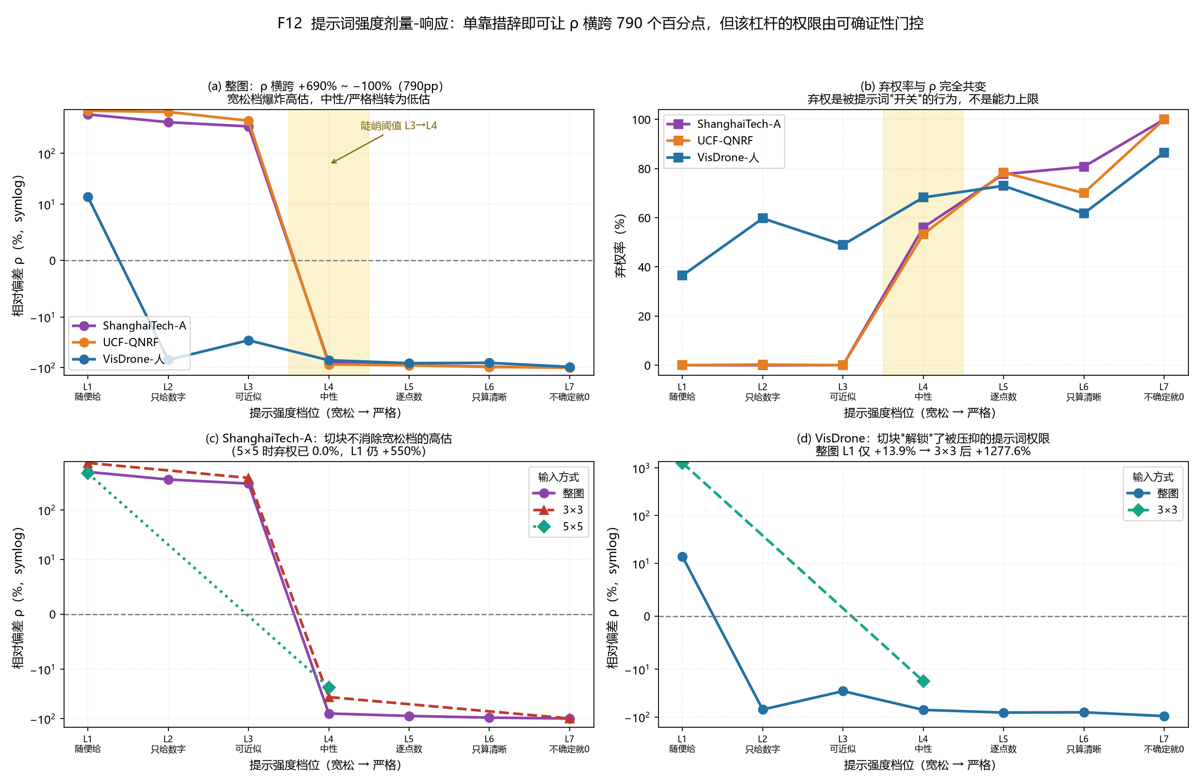
To rule out a coarse-grid artefact we repeat the scan on a fine grid — τ from 0.02 to 0.90 in steps of 0.005 (177 points), with 4,000× bootstrap image resampling for the 95% interval of τ^\; every weight file is matched to a unique result table by an `n_raw` fingerprint (100% match), so configuration attribution does not rest on file naming. Tiling moves UCF from unreachable to reachable (τ^\ 0.121–0.152): protocol and threshold jointly determine reachability. (Appendix M.9)

4.4 A second knob: NMS IoU and input scale
The threshold is not the only quantity bearing on reachability. NMS IoU is a second knob: it moves τ^\ monotonically 0.038 (IoU 0.5) → 0.073 (0.6) → 0.121 (0.7), while inference input scale matters much less — 640 / 1024 / 1280 give 0.117 / 0.121 / 0.131 (Appendix E.2). Controllability is therefore a property of the joint* configuration of threshold, NMS IoU and input protocol, not of one scalar.

4.5 Tile granularity: a third knob, which can turn unreachable into reachable
Extending the ladder to tile-512 and tile-256 across two detector families under the identical protocol (Appendix E.3, M.16) gives two readings: tile granularity can rescue an unreachable configuration — unreachable at tile-1024 becomes reachable at tile-512 — so unreachability is a joint property of domain × protocol; and the two families unseal at different granularities, the pre-FPN architecture needing finer tiling for the same domain.

4.6 The direction of τ^\* under finer tiling is not family-invariant
"Finer tiles raise τ^\" holds for RetinaNet — monotone on UCF-QNRF [47] (0.124 → 0.225 → 0.306) and ShanghaiTech-A (unreachable → 0.124 → 0.237) — and fails* for YOLO (UCF 0.121 → 0.176 → 0.173; ShanghaiTech-A unreachable → 0.260 → 0.183).

4.7 "Crossing zero" must specify which zero
The phrase presumes the zero is unique; it is not. The cascade identity max|δ_U - (δ_T - δ_H)| = 0 holds exactly per image over the 6,033 held-out images — a definitional identity, so any two of the three quantities determine the third (Appendix M.9).

5. Results II: Vision-language models — abstention is the leading failure mode

5.1 Screening and the full SFCHD cross-paradigm comparison
Screening on the sparse end (SFCHD, 12,066 images) across three arms and two stacks establishes the baseline for the rest of the section: on sparse, clearly visible targets, the three-arm prompts move the direction as expected but at small amplitudes, and abstention is negligible.

5.2 Target granularity changes the sign and magnitude of the conclusion
Running both target conventions on SFCHD (head-level versus whole-person) under the three directional arms shows that ρ and the abstention rate are not interchangeable between conventions.

5.3 Sparse-domain three-arm directional induction
On the full sparse set (12,066 items × 3 arms × 2 stacks) the prompts move the direction monotonically and reproducibly, with the under arm producing systematic under-counting and the over arm over-counting. Because abstention is near zero here, this setting isolates directional control from abstention control — a separation that proves useful in §5.7.

5.4 Cross-domain abstention summary
Aggregating over domains, the abstention rate is not ordered by object count: it is highest in the dense-crowd and aerial domains and essentially zero in the clearly-resolved ones, although the latter carry more targets per image (§5.6 identifies the ordering variable). (Appendix M.29)

5.5 Decomposing the under-count: abstention versus answering
By Proposition 4 the total under-count is an abstention term plus a scaled answering term, and the abstention share has the closed form S=(1-w)/[1-w(1+ρ_answered)]; evaluated here it gives 82–94% on the four dense and aerial domains under the base contract arm, Chinese prompts, one anchor build, and the ground-truth-weighted convention (three of twenty (language × build) cells leave the unit interval; M.18.9, M.39, M.46(c)). This is the quantitative core of the paper's central claim (a coverage of the abstention channel, not a precision; Proposition 7): the received description "VLMs underestimate dense scenes" is mostly a description of refusals. (Appendix M.9)
Table 3. Proposition 4's terms on the four headline domains.
Domain (anchor build) | abstention term | answering term | S | abstention rate, item-count convention
ShanghaiTech-A | −76.41 | −4.67 | 94.2% | 56.6%
UCF-QNRF | −81.27 | −5.48 | 93.7% | 53.9%
AI-TOD | −67.17 | −12.99 | 83.8% | 68.1%
VisDrone | −58.39 | −12.71 | 82.1% | 68.2%

(Terms are pp of the pooled relative deviation and sum to it exactly; S is the ground-truth-weighted share and the last column the same rate under the item-count convention. Appendix J.1.)

5.6 Causal attribution of abstention: not count, but legibility
Three controlled manipulations refute the intuitive "too many objects" explanation: the gate is per-instance legibility (§3.3), and count retains only a secondary within-domain role (M.11).

5.7 Abstention and under-counting are two separable failure modes
The title claims the composition of the aggregate under-count, not the absence of under-estimation: the answered-only relative deviation is −19.8% (ShanghaiTech-A), −29.2% (UCF-QNRF), −30.5% (VisDrone) and −39.6% (AI-TOD), each far outside the paper's own 7 pp band (§A.3 — the across-repeat band of ρ, which is neither the 3.92 pp batch bound of Appendix M.21.9 nor a band for zero rates).
Mode A: capacity-driven under-counting. Even with ideal input the model under-counts by up to 50% in relative deviation (not an abstention share; Appendix J.8) — a floor set by the reporting stage, not by perception. Mode B: mode collapse, whose extreme form is answering 0. Triggered by loss of legibility, absent on clean input, switchable on by blur, overlap or a strict prompt. The channel is set by the output contract (Appendix M): on the items that the corpus configuration answered exactly 0, five configurations given an explicit abstention option abstained explicitly in 1591 of 1591 successful calls and never answered 0, while forbidding abstention produced a per-item median of 2.463–9.452× the true count. The zero is therefore neither specific to the quantised local deployment nor a universal family behaviour: the hosted checkpoint matching the corpus configuration answers 0 on 25.8–31.7% of these items, whereas plus, flash and 235b answer 0 on 0–0.4% (all 48 cells: Appendix M, M.11).
The cross-family result: the answered zero is set by the contract, not by the lineage (Appendix M.19). A family's chat template cannot be equalised across vendors — changing it moves an absolute rate by up to 56.6 pp — so no absolute rate is compared across families: every claim below is a within-family paired contrast with the template held constant (Appendix M.19.1, M.19.8). Every configuration above descends from two lineages, so we re-ran the same grid with the identical instrument (same probe, prompts, parser, domains, pools, fixed seed and items, md5 03edb14c98ff) on four further open-weight families — Gemma-3-12B, InternVL3.5-8B, Phi-3.5-Vision-4.2B and LLaVA-OneVision-7B, all unquantised official builds — together with three anchors: seven families. Adding the abstention token removed the answered zero in 7 of 7:
Table 4. The cross-family contract gate. The three rows tagged (anchor) use the community AWQ-4bit requantisation of §3.5.
family (lineage) | base zeros | still 0 under permit | rate | 95% CI (Wilson)
Gemma-3-12B (Google) | 9 | 0 | 0.0% | [0.0%, 29.9%]
InternVL3.5-8B (OpenGVLab) | 156 | 0 | 0.0% | [0.0%, 2.4%]
Phi-3.5-Vision-4.2B (Microsoft) | 197 | 0 | 0.0% | [0.0%, 1.9%]
LLaVA-OneVision-7B (community) | 235 | 5 | 2.1% | [0.9%, 4.9%]
Qwen3-VL-32B-AWQ (anchor) | 685 | 1 | 0.1% | [0.03%, 0.8%]
Qwen2.5-VL-72B-AWQ (anchor) | 214 | 0 | 0.0% | [0.0%, 1.8%]
InternVL2.5-8B-AWQ (anchor) | 230 | 0 | 0.0% | [0.0%, 1.6%]

The two modes decouple completely (Fig. 4). On clean synthetic dots the base arm never abstains yet still under-counts by up to 50%; in microscopy (BBBC005 [48]) abstention is 0.0% while the bias reaches −50.1%. Conversely, on dense crowds abstention is 50–70% while the answered-only bias is only −19.8% / −29.2%.
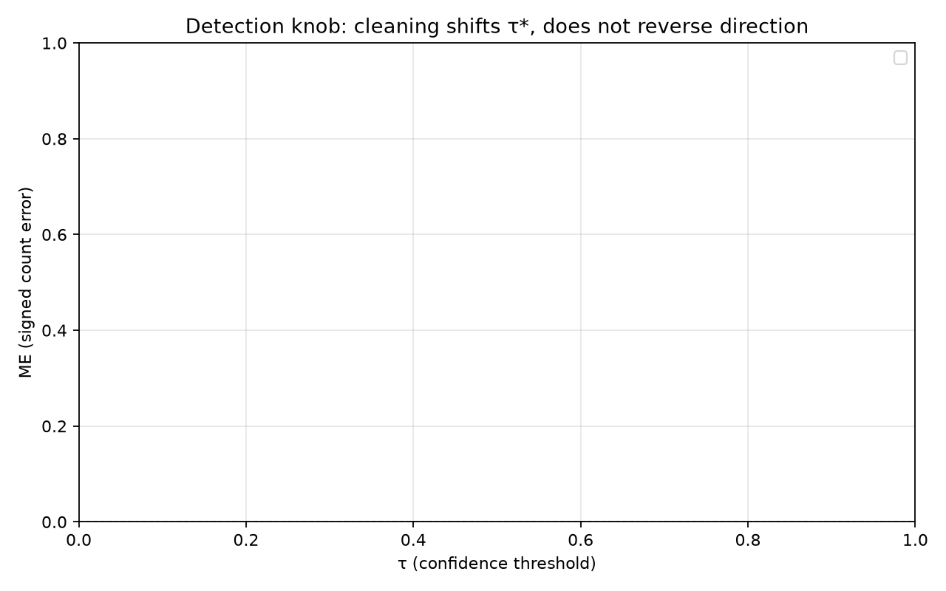
(Appendix M.34)
Legibility is a usable selector, but cannot repair direction. Keeping the most legible 20% reduces MAE by 31–66% while the relative deviation only attenuates from −85.0% to −53.4% — still a systematic under-count of more than half (selector AUC 0.753–0.786). What gates abstention is blur, not resolution: downscaling to 15% of the pixels gives almost no abstention (0.6%) whereas blurring the same image and frames gives 9.1% (+8.6 pp, paired, n = 900). Not lineage-specific: on a controlled disc grid the same gate reproduces in three further lineages, where the permitted contract leaves no zeros (Appendix M.19.10).

5.8 The two routes to removing abstention, and their price
Route A — tiling (raise legibility; preserves accuracy) reduces the ShanghaiTech-A abstention rate from 56.6% to 0.0% while leaving direction intact, and lifts the suppressed directional authority of prompts in the aerial domain (+13.9% whole-image to +160.4% at 3×3). Route B — relaxing the prompt cannot obtain both. (Appendices M.8, M.11)

5.9 Model scale: what is bought is knowing whether to answer
Comparing 8B and 32B of one lineage (a clean 4× contrast), scale does not make answers more accurate: the 8B model's answered-only deviation is more negative (Appendices L.1, M.8, M.11).

5.10 Aerial domain: the legibility extreme
VisDrone and AI-TOD are the legibility extreme, and their bottleneck is instance under-resolution whereas the crowd bottleneck is overlap (Appendix M.29).

5.11 A quantitative consequence of abstention (two more in Appendix M.28)
(a) Counting abstentions as zero inflates "under-estimation", so a dual convention is required. On the same data the pooled relative deviation differs between "abstentions counted as 0" and "answered items only" by 61.3 pp (ShanghaiTech-A), 57.5 pp (UCF) and 40.6 pp (AI-TOD and VisDrone) (Appendix M.8).
Proposition 4 expresses this gap as -(1-w)(1+ρ_answered), so the four reported values are a consistency check on the numbers printed in this paper rather than an independent empirical prediction.

5.12 What a single convention costs: the ranking moves
The two conventions are not bookkeeping alternatives. On the same items of our own census — up to fourteen configurations over the four domains that admit a common item intersection, zero and non-zero pools pooled within a domain, so that no rank difference can come from different denominators (the quantities and the denominator are defined in Appendix M.21) — the convention changes how large a configuration's measured bias appears, and in the dense domains changes the order:
Table 5. What one convention costs.
domain | configurations | common n | Spearman between the two rankings | largest single \ | Δρ\ |  | rank-pair inversions
ShanghaiTech-A | 14 | 144 | 0.604 | 48.2 pp | 17 of 91
UCF-QNRF | 14 | 249 | 0.864 | 36.2 pp | 11 of 91
VisDrone | 8 | 277 | 1.000 | 9.4 pp | 0 of 28
AI-TOD | 8 | 222 | 0.476 | 37.5 pp | 9 of 28

A single configuration's measured bias therefore differs by up to 48.2 pp between the conventions, and in the dense domains 28 of 182 rank pairs invert (Spearman 0.604 and 0.864). The aerial domains split: VisDrone is convention-invariant (ρ = 1.000, no inversion) while AI-TOD is the most sensitive cell of all (0.476). A number quoted under one convention is thus not comparable with a number quoted under the other — the operational reading of Proposition 8, and what the released protocol of §7.9 reports as a matter of course. (Reproduction: `convention_rank.py`; frozen result `convention_rank_result.json`.)
What it does *not* cost: the decision. Three decision forms — a deliverability verdict (deployable iff ≥θ of images fall inside a ±tol band), a service level, and a selection set (the three best configurations per dataset) — over five datasets, ≈800 verdicts and a 3 × 3 grid of θ × tol: one verdict flips, and the selected sets are identical in all five datasets. The convention is therefore a comparability problem, not a decision problem for the three decision forms tested here: across those forms it cannot make a user deploy the wrong model, but it can make the numbers incomparable. The decision-relevant quantity is the abstention mass (§5.11, M.27).

5.13 The same two experiments on a public benchmark (FSC-147)
Everything above uses nine corpora this paper assembled. To check that neither the zero nor the contract effect is a property of those datasets, we ran the same instrument (the same probe, not a re-implementation) on FSC-147 [5] — a public counting benchmark of natural images with a different object vocabulary and density range — on a fixed-seed, GT-stratified sample of 300 test images:
Table 6. The contract gate on FSC-147 (five of the nine configurations in the panel; the full panel is Appendix M.24.1).
configuration | base answers 0 | still 0 under permit | 95% CI
Gemma-3-12B | 248 / 300 | 0 (0.0%) | [0.0%, 1.5%]
InternVL3.5-8B | 273 / 300 | 0 (0.0%) | [0.0%, 1.4%]
Phi-3.5-Vision-4.2B | 255 / 300 | 2 (0.8%) | [0.2%, 2.8%]
LLaVA-OneVision-7B | 187 / 300 | 0 (0.0%) | [0.0%, 2.0%]
Qwen3-VL-32B (BF16) | 277 / 300 | 251 (90.6%) | [86.6%, 93.5%]

Three readings, one of which is a counterexample and is reported as one. (i) The zero is not a property of our corpora: four of five families answer exactly 0 on 62–91% of a public benchmark's images, so the phenomenon is not an artefact of the nine datasets above. (ii) The gate replicates in eight of nine configurations and fails in one. Across the full panel (Appendix M.24.1) permit leaves ≤ 6% of those zeros in eight; the exception is the Qwen3-VL-32B build, keeping 251 of those 277 while the same build on ShanghaiTech-A leaves 0 of 62 (§M.19.8). Its diagnosis is informative: under the three-option channel contract that build leaves 0 zeros — for it the outlet must be enumerated as an option rather than permitted (Appendix M.24.3). The gate is therefore family × domain × wording conditional, not universal, and we state that explicitly rather than as a dense-only caveat. (iii) Here the convention moves magnitudes, not the ρ ordering (ρ by up to 44.0 pp; Spearman 0.983 on the ρ ordering, 1 inversion of 36) — the asymmetry §5.12 reports for the decision forms. Its sensitivity to the input scale is bounded in Appendix M.41. The two rank correlations behind this paragraph rest on the answered subset of the 300 sampled images, which is 17–52 images per configuration (Appendix M.24.2); those two figures carry no interval.

5.14 A prospective test on an independently sampled panel
Every family above was chosen by us. To test whether the two effects survive a panel the paper did not choose, we froze six predictions, their thresholds and the sampling rule before collecting any data (preregistration 75eeca6fa68c9be65c2b569d4237d8df; rule and full frame in Appendix M.31). The rule takes one open-weight family per lineage, excludes every family used above, and yielded six families in six lineages with no Qwen model — five of those lineages appear nowhere in §3–§5. The pools are the census-defined ones, which do not depend on the new models, and the instrument is the frozen probe, byte-identical in prompts and parser to the census probe.
The gate replicates in the dense domains; the ordering rule holds; and the zero rate is a property of the domain rather than of the family. Under permit the answered zero falls to 0.0% in both dense domains for all five families that honour the JSON contract; pooled over four domains four of six families reach ≤2% (0.00%, 0.00%, 0.00%, 0.18%). The two exceptions are diagnostic rather than fatal. Idefics3-8B leaves 7.23%, but its residual sits on sparse aerial items whose ground truth is one to three objects — a missed tiny target, not a refused outlet. deepseek-vl2-tiny leaves 48.28%: it never abstains in the aerial domains and its dense-domain output is 99% unparsable, so its numbers are a format failure and a genuine family × domain outlet failure at once. The contract knob moves the zero rate by at least 10 pp more than the resolution knob in 10 of 12 qualifying cells (83%; exact binomial P(X≥10| n=12, p=1/2)=0.019), while the resolution knob alone never moves it by more than 32.0 pp. Decomposing the 24 cell-level rates gives a variance component of 0.0959 for domain against 0.0037 for family — a factor of 25.8 — with a bootstrap interval that excludes zero — the frozen record value `[0.0831, 0.1002]`, item level, as printed in Appendix M.31.2. That is the population-level statement the earlier corpora could not make.
Two of the six pre-registered predictions failed outright (two further sub-items failed; a prediction counts as failed only when its primary criterion failed), and both bear on scope rather than on the measurement: the convention can change the top-ranked family in two of four domains, and the exemplar arm removes the zero (by 58–93 pp in five of six families) without making the counts accurate — removing the zero is not the same as becoming able to count (full verdicts and per-family numbers: Appendix M.31.2–M.31.4).
On hosted endpoints the abstention is latent rather than absent. Three proprietary deployments, on the same 253 items, never answer zero under a number-only contract (0.0%; Wilson 95% upper bound 1.5% on 0 of 253); permitted to abstain they abstain explicitly on 98–100% of those items (residual 0.00%); and their numbers are no more accurate than the open families' (34–47% median relative error against 59–83%). The failure that open families express as a zero is present in frontier hosted models too; only its expression differs.
What the same correction does to a published number. The convention term is not a rounding detail: on the public benchmark the two conventions differ by a median of 32.9 counts and by up to 45.6, while the spread between its nine configurations under the published convention is 2.6 counts — the convention effect is 12.7 times the between-system spread, and the two conventions reorder the panel (seven of 36 pairs invert, Spearman 0.783 on the MAE ordering). Reporting one convention without the abstention mass therefore publishes an ordering of abstention propensity; the correction needs no re-run, since MAE_A=(1-w) MAE_B+w GT_abstained recovers it from any stored output (Appendix M.35).

6. Results III: Density regression — direction is a function of the input-scale protocol

6.1 Density regression has a scale freedom parameter that must be calibrated per domain
On the dense end, density regression is the most accurate family under a fixed protocol but the least directionally controllable: its predicted totals scale multiplicatively with inference input size, so ρ is a function of the scale protocol rather than of the model alone, and the family carries a scale freedom parameter that must be calibrated per domain. Because a reproduction of CSRNet required us to retire an implementation defect, all density-regression span figures here use the official DM-Count weights on the identical item set and grid: 20.1–34.3 pp, against 10.1 pp for official P2PNet weights [1], and 107–1433 pp for the retired reproduction.

6.2 Three further properties, and their protocols
Three further measurement properties matter here, with protocols in Appendix H: a counting-consistency term on the log ratio between the predicted integral and the ground-truth count reduces the seed-to-seed spread by roughly an order of magnitude and removes most of the systematic positive offset the uncorrected objective leaves behind — a remedy for a training artefact, not a new architecture (H.1); the abstention rate is a stable property only under greedy decoding, since under sampling it co-varies with temperature and sample count, which is why our VLM protocol fixes temperature at 0 (H.2); and the collapse of density-regression output under overlap occurs for both 8B and 32B models at comparable overlap levels, making it a property of the task structure rather than of model capacity (H.3).

7. Discussion

7.1 Legibility, not OPM, is the stratifying variable
The conventional density axis conflates "how many objects are there" with "how hard is each one to ascertain". Across ten domain/dataset points the correlation between abstention rate and object count is only r = +0.33, with no explanatory power, whereas the legibility proxy orders the same points consistently. It is used here as a stratifier, not as the paper's primary claim: the contract result (§5.7) and the convention result (§5.12) hold without it. A downstream user who wants a rule rather than a stratifier should read §7.7 and Appendix M.20 first.

7.2 Same-scale accuracy comparison across the three families
Bringing the three families to a common effective instance scale inverts the usual ranking (full table in Appendix F.1). A single density-regression number is not a comparable quantity unless the weight set is specified. (Appendix M.11)

7.3 The response spectrum of knobs: the ordering, and what is not predicted
What this design can and cannot resolve. Ten unit values on four sides — six knobs map onto four sides, and Appendix F.2 reconciles the three unit sets — resolve to the design's own noise floor, 2.15–6.46 pp, and the separating split (1.6 pp, corrected p ≥0.075) lies below it. For the split as observed (3 vs 7) the nine enumerated split points span only 120 assignments, so the smallest attainable corrected p is 0.075 — no gap whatsoever would be certified by this test; a 5-vs-5 split would need 6.5 pp for 80% power. We therefore do not claim a separable structure and report the 1.6 pp gap for completeness only; what the design supports is the ordering, specifically under the pooled relative deviation (Appendix F.7, M.37).
The ordering is stable under the two obvious deflations, with intervals. Re-estimated on a common level count with each ladder's extreme level removed, it is preserved at Spearman 0.999 / 0.981 / 0.991 over 24 (knob × domain) units, and at 0.983 / 0.987 / 0.983 on a fully recomputable unit set at the same level count (31 units; Appendix M.37). A unit bootstrap puts it at 0.939–0.996 (31 units) and 0.836–0.983 (36 units, k=3), and clustering by knob gives 0.913–0.994 (cluster-level; recomputed from the released package, Appendix F.7); a label-permutation test gives p<5×10^-5; leaving out any single knob (36 units) keeps it at 0.883–0.970; per-unit spans with caliber intervals are plotted in Fig. F.17 (Appendix F.12). It is also exactly preserved under shared affine calibration (Proposition 5: span ↦ s·span) and under no calibration — the M.37 held-out third gives median 0.995, interval 0.984–0.998, above 0.9 in 200 of 200 splits — but not when each unit is re-fitted independently: 0.810 / 0.536 over 8 / 36 units, per-unit family medians 0.41–0.54 (isotonic 0.571 / 0.521). Measured s spans 0.027–2.352, so a compressor must vary its factor across units; no deployment-usable granularity does so while preserving the ordering (per-domain 0.732; Appendix M.37). The claim is scoped to the first two calibers, and the VLM unit's own build-sensitivity is bounded in Appendix M.18.8 (its level moves 90.3 pp across five builds; its contract effect does not). The magnitudes are not caliber-portable: the in-domain detector ladders give 96–196 pp person-matched and 353–508 pp all-detections, so a magnitude is quoted with its caliber (Appendix F.2 reconciles the three unit sets; M.37). No scale-free form of the span — equal-count gridding, endpoint removal, or the three M.37 calibration families — makes cross-knob magnitudes invariant, and the ordering also survives normalising each span by its knob's relative travel (Appendix F.10; M.42–M.45), and the 0.85 criterion set for that objection is not met by the re-normalised ladders (0.629 on log ratios, 0.595 on ranks, 0.580–0.754 over the four subsets; Appendix M.37). On two counting domains this paper has never used it passes on one and is a knife-edge that fails on the other (M.49). Under a common error-and-cost budget the ordering is not preserved and half the units admit no admissible pair at all (Appendix M.45).
What the spectrum supports is an ordering rule, and we state it as one. Availability is decidable: "is pred/gt ≥ 1 at the loosest admitted level?" predicts reachability with zero exceptions across three lineages and nine cells. And the ordering is the surviving quantity, under the level sets compared: rank knobs by this ordering, and quote a magnitude only with the grid density and the calibration caliber that produced it, and only within the level sets compared. Our own candidate for the magnitude (Proposition 3) is a component of the definition and is withdrawn, so a magnitude law remains open — but the ordering rule is what a practitioner needs to choose between knobs, and it is measured, not assumed.

7.4 The high response of the detector threshold is domain-conditional
The detector threshold is the largest-response knob, but its authority is domain-conditional: in the aerial domain the full in-domain ladder moves ρ across the whole span, whereas in dense-crowd domains no lineage reaches `pred/gt ≥ 1` at any threshold and the span collapses close to the noise floor; the same architecture and knob give a 3.5× smaller span under a training-domain swap alone (Appendix M.8).

7.5 Language-side contracts: channel independence, and one excluded branch
Two facts survive (per-arm numbers are labelled by model × domain × contract arm × convention, and each is a pooled relative deviation on the common item intersection; Appendix G.1). `choice` rewrites the value without passing through abstention: it moves the relative deviation across zero while the abstention rate barely moves, and it works in dense domains too. One correction: on the choice arm the 32B model shows a pooled deviation of only +0.9%, but the grid's value 50 sits close to that domain's median GT (50.5) and 46.6% of answers land on it — a property of the grid design, not calibration. (Appendix M.11)

7.6 Three mechanism hypotheses, tested and excluded
All three candidate explanations are excluded (mediator, choice-rewriting, forbid0-conversion), so we treat the forbid0 mechanism as unresolved rather than explained (Appendix G.2); the tests and their per-arm numbers are in Appendix M.30.

7.7 Deployment implications: what a user can and cannot have
The legibility score can be read as a criterion for "is this input still inside the model's nominal operating range?" — a requirement forming independently in the perception literature, where detectors fail silently under blur, noise, compression and resolution change ([49]–[50]). Legibility can decide whether to answer; changing the direction requires changing the protocol, the prompt, or the family. It is an analytical diagnostic, not a reporting or gating rule: it needs annotation boxes, so the adoption recipe for a third party with none is in Appendix M.22. A rule that works was looked for and not found. Three annotation-free signals — cross-scale, cross-phrasing and cross-family agreement — were tested on 45 (family × domain) cells against a bar fixed before the runs (AUC ≥ 0.65 and the error on the most-agreeing 20% at ≤ 0.6× the overall error): 1 of 45 passes, and in the aerial domains the agreement signals are anti-correlated with error, because the other models share the same domain-specific bias. Quality, like abstention (Proposition 1), is therefore not identifiable from outputs alone — it has to come from outside the answers (Appendices M.23, M.14).

7.8 An independent endorsement of enumeration over regression
That enumeration-style counting is more directionally controllable than regression-style counting is not isolated to this paper: work on other tasks independently finds that regress-then-round pipelines lose the property being measured. (Appendix M.26)

7.9 An adoptable protocol, released as running code
The paper's transferable object is a protocol, not a finding: adopt_contract_probe.py runs the three contract arms against any OpenAI-compatible endpoint given only a directory of images — no dependency on our corpora, annotations or detectors, and with prompt texts byte-identical to the census probe — and adopt_report.py prints the channel diagnosis with its Wilson interval, the abstention mass w, and both conventions' deviations with their verdicts. The thresholds are frozen in adopt_criteria.json (residual ≤5% read from the point estimate — several cells rest on 2–25 items, so their upper bounds are wide and they are direction readings, Appendix M.46(a) ⇒ contract-set; >30% ⇒ record a counterexample and retry with the three-option wording; a convention gap below the 7 pp noise floor ⇒ immaterial for that cell). Adoption costs one serving session and yields the two quantities §5.3–§5.13 turn on, which is what makes these comparisons reproducible elsewhere (M.22). In a first independent use it was run, unchanged, on two corpora whose recipe residual had never been reported — including a large unconstrained dense-crowd release (JHU-CROWD++ [51]) — with the criteria fixed before the runs (Appendix M.46).

8. Limitations

8.1 Disclosure of measurement fragility
Seven counts of measurement fragility are itemised with item-level impact in Appendix M.32: Two runner defects and, separately, a dead parse branch recorded as a third instrument finding; Run-to-run non-determinism, characterised below; Graded isolation, with a residue ledger; a census of anomalous predictions; No attention-based criterion; and Per-cell intervals are lower bounds, the across-repeat term exceeding the interval width by roughly a factor of two where levels are few (§A.2). No aggregate above depends on the affected runs (§3.7, §5.1). The two numbers: the aggregate change in ME is within 0.19 counts, and where the corpus contains an independent re-run the aggregate ρ differs by at most 0.81 pp across the six such pairs; Item-level claims are made only on our own stack: local stacks at batch ≤ 2 reproduce exactly, hosted endpoints do not (§A.3). Non-determinism is documented for LLM inference [52], [53] and for evaluation harnesses [54], [55].

8.2 Scope limitations
The optimal input fidelity was not located: whether increasing fidelity beyond the native scale becomes harmful was not measured — a non-monotonicity existing work suggests may exist.
The attribution boundary is behavioural, not anthropomorphic. We read an answered zero as mode collapse — output degenerating onto the mode or a prior integer — not as a human-like refusal, and claim nothing about intent; the operationalisation is stated so that it can be replaced.
The detector lineage is narrow, resting on YOLO with RetinaNet and Faster R-CNN as secondary lineages; a broader sweep would establish whether §4.1's domain conditionality and §4.5's unsealing granularity are family or architecture properties. The exemplar condition is measured on one benchmark, three boxes and six families (§5.14), so it bounds the zero without mapping the few-shot counting family; its 384-px resolution is the release's own short-side constraint, and M.41 varies it (contract arms ≤ 2.0 pp, exemplar abstention 10.7 pp across scales, 11.0 pp in one step). The three hosted endpoints are deployments we cannot pin to a build, so their numbers are dated rather than frozen.
The abstention identification rests on a two-channel assumption. That assumption is testable, and is tested (§5.7). The census holds the serving stack fixed and varies the contract and the build; three residual limits are in Appendix M.33. A true-zero control closes that gap: on 306 crops whose correct answer is zero by the dataset's own annotation, the three-way contract returns no_people on 47–87% of items of the easy stratum, whereas on dense items the census had answered zero the same models return no_people on 0–1% and cannot_judge on 98–100% — the two outlets' sensitivity and specificity on stated pools, which is not the channel's precision. On these pools answering zero is correct behaviour, so the control measures sensitivity and says nothing about the mixed corpus (§3.8; Appendices M.21, M.38, M.40).
The corpus is dominated by one lineage, which bounds every frequency claim. Most of the ~620k records come from the Qwen family, so the abstractions' frequency statements are claims about that family and the configurations measured alongside it, not about vision-language models in general. The contract result is not lineage-bound: on the public benchmark FSC-147 it holds in 8 of 9 configurations (§5.13) — with the Qwen3-VL-32B build as the reported counterexample there. The abstention completeness claim still rests on the Qwen family (κ = 550.6) and the smaller InternVL subset (1/(κ+1) = 30.31%). Every corpus-level rate was measured with Chinese prompts, so we repeated the arms in a byte-frozen English rendering on the same items: the channel result is language-robust (no_people differs by at most 7.2 pp), but the answered-zero rate is not — the anchor lineage answers zero on 60.2% of the dense pool under Chinese and 17.5% under English, a 42.7 pp drop on the BF16 build — a pooled dense-pool figure; the per-domain drops on the same build are 18–22 pp and come from a different item set (Appendix M.39). The shares of §5.5 are therefore scoped to the prompt language and to the one anchor build measured here (the share holds at BF16; the rate does not; eight of nine further families and builds fall short; M.19.15). The true-zero pools differ by 54.7 pp, so p≈1 is not transferable (Appendix M.21.9). Two further limits: the abstention share leaves its unit interval when the net deviation is near zero — three of twenty cells, unmeasured rather than clipped, the two pp terms of Table 3 being the fallback there — and the English prompt lowers the answered-zero rate on the dense domains only, by 15–26 pp on the corpus's own third-party 4-bit build, where two of the twenty cells stay outside the unit interval and every absolute rate on that build carries a ~1.3% item-level stack band (Appendices M.19.16, M.46(c)). The 8-bit rows were served weight-only, not weight-and-activation 8-bit — the host's compute capability is 8.0 and W8A16 needs 8.9, so the loader takes the weight-only path — and they therefore bound the build, not that path (M.46(c)).
Domain composition is not systematic: the nine datasets span a legibility range rather than a stated population, so domain-level statements describe these domains, not a distribution.
The corpus was not pre-registered as a whole. Only the sub-experiments explicitly marked as pre-registered had their criteria written before the data were examined — Appendix G.1 and G.2 list them with each criterion quoted as frozen. The rest are post hoc (including the choice of tiling level, weight set and aggregation convention), which is why both conventions and the weight-set range are reported wherever they diverge. Statistical power for the spectrum is low (four knob sides, ten units), and the candidate claim rests on a permutation test over single split points plus bootstrap intervals, not on a modality test.

9. Conclusions
We set out to make the direction of counting error measurable and found that the dominant dense-scene failure is not directional but abstention; the contributions are therefore two findings, plus the apparatus that makes them checkable. The first is a measurement dimension: signed error direction, reported with the convention under which it is read, because the two conventions differ by tens of percentage points on the same data. The second is a behavioural reading of the answered zero: the channel through which a model declines to answer is set by the output contract rather than by the lineage, so the outlet is a property of the serving configuration (§5.7). The spectrum replicates in its ordering, not its magnitudes, and then only under the level sets and calibers compared: with ten units and a separation of 1.6 pp below the noise floor (corrected p≈0.075), it supports a ranking, and its per-cell intervals are sampling lower bounds (§8.1). The weakest parts are stated as such in §8; the most consequential open question is whether the abstention channel can be given a statistical guarantee rather than a measured rate (§7.7).
Scope, stated where it binds. Every frequency claim above holds for the configurations and builds measured: within the dense domains five deployments of a single 32B checkpoint differ by up to 90.3 pp in their answered-zero rate but only 6–11 pp on the abstention share itself, the quantity the headline is about (Appendix M.18.9; the contrasts behind that boundary are in §8.2).

Declaration of generative AI and AI-assisted technologies in the manuscript preparation process
During the preparation of this work the author(s) used a panel of large language models, accessed through their vendors' application programming interfaces, to simulate peer review of the manuscript and to audit the internal consistency of the reported numbers and cross-references. These tools were not used to generate the text; the author(s) reviewed and edited the content and take(s) full responsibility for the published article.

CRediT author contribution statement
Author contributions are declared by the corresponding author at submission, using the CRediT taxonomy.

Acknowledgements
None.

Data availability
The image corpora are public datasets, cited above. The derived per-image prediction records, analysis scripts and run logs that reproduce every reported number are released or flagged at https://github.com/YBP2005/P3 (CC BY 4.0), with per-file MD5s.

Funding
This research did not receive any specific grant from funding agencies in the public, commercial, or not-for-profit sectors.

References
1. Song, Q., Wang, C., Jiang, Z., et al. Rethinking Counting and Localization in Crowds: A Purely Point-Based Framework. ICCV 2021. https://doi.org/10.1109/ICCV48922.2021.00335.
2. Narasimhan, H., Menon, A., Jitkrittum, W., et al. Plugin Estimators for Selective Classification with Out-of-Distribution Detection. preprint arXiv:2301.12386, 2023.
3. Zhang, Y., Zhou, D., Chen, S., Gao, S., Ma, Y. Single-Image Crowd Counting via Multi-Column Convolutional Neural Network. CVPR 2016. https://doi.org/10.1109/CVPR.2016.70.
4. Chen, Z., Wang, W., Cao, Y., et al. Expanding Performance Boundaries of Open-Source Multimodal Models with Model, Data, and Test-Time Scaling. preprint arXiv:2412.05271, 2024.
5. Ranjan, V., Sharma, U., Nguyen, T., Hoai, M. Learning To Count Everything. CVPR 2021. preprint arXiv:2104.08391.
6. Lempitsky, V., Zisserman, A. Learning To Count Objects in Images. NIPS 2010.
7. Chen, Y.-Y., Guo, L.-Z. TriViewBench: Controlled Complexity Scaling for Multi-View Structural Reasoning in MLLMs. preprint arXiv:2606.26029, 2026.
8. Guo, X., Huang, Z., Shi, Z., et al. Your Vision-Language Model Can't Even Count to 20: Exposing the Failures of VLMs in Compositional Counting (VLMCountBench). preprint arXiv:2510.04401, 2025.
9. Srinivasan, T., Hessel, J., Gupta, T., et al. Selective "Selective Prediction": Reducing Unnecessary Abstention in Vision-Language Reasoning. Findings of ACL 2024. preprint arXiv:2402.15610.
10. Chow, C. K. On optimum recognition error and reject tradeoff. IEEE Trans. Inf. Theory 16 (1970) 41-46. https://doi.org/10.1109/TIT.1970.1054406.
11. Hendrycks, D., Gimpel, K. A Baseline for Detecting Misclassified and Out-of-Distribution Examples in Neural Networks. preprint arXiv:1610.02136, 2016.
12. Madhusudhan, N., Yadav, V., Lacoste, A. Knowing When Not to Answer: Evaluating Abstention in Multimodal Reasoning Systems. preprint arXiv:2604.14799, 2026.
13. Pramono, F., Cai, J., Kulkarni, S. TRAPSBench: Vision-Language Models Encode but Fail to Express Epistemic Restraint. COLM 2026. preprint arXiv:2608.13167.
14. Ortiz, J. Explicit Abstention Knobs for Predictable Reliability in Video Question Answering. preprint arXiv:2601.00138, 2025.
15. Zhang, H., Feng, Y., Liu, H., et al. The Uncontrolled Variable: Vision-Language Refusal Is Conditioned on the Image-Attachment Interface, and Not Robust to Irrelevant Image Properties. preprint arXiv:2609.26174, 2026.
16. Trick, L. M., Pylyshyn, Z. W. Why are small and large numbers enumerated differently? A limited-capacity preattentive stage in vision. Psychol. Rev. 101(1):80–102, 1994. https://doi.org/10.1037/0033-295X.101.1.80.
17. Fu, Y., Li, F., Liu, X., et al. NumerosityVLM: A Cognitively Inspired Benchmark for Interpreting Numerosity Representations in Vision-Language Models. preprint arXiv:2608.15425, 2026.
18. Yu, F.-S., Li, J., Wang, X., et al. Large, Complex, and Realistic Safety Clothing and Helmet Detection: Dataset and Method. preprint arXiv:2306.02098, 2023.
19. Paiss, R., Ephrat, A., Tov, O., et al. Teaching CLIP to Count to Ten. ICCV 2023. https://doi.org/10.1109/ICCV51070.2023.00294.
20. Acharya, M., Kafle, K., Kanan, C. TallyQA: Answering Complex Counting Questions. AAAI 2019. https://doi.org/10.1609/AAAI.V33I01.33018076.
21. Djukic, N., Lukezic, A., Zavrtanik, V., et al. A Low-Shot Object Counting Network With Iterative Prototype Adaptation. ICCV 2023. preprint arXiv:2211.08217.
22. Liu, C., Wu, H., Xie, W. Count Anything at Any Granularity. preprint arXiv:2605.10887, 2026.
23. Huang, Z., Dai, M., Zhang, Y., et al. Point, Segment and Count: A Generalized Framework for Object Counting. CVPR 2024. preprint arXiv:2311.12386.
24. El-Shangiti, A., Nurgazy, A., AlQuabeh, H., et al. The Count Is There, but Misaligned: Understanding and Correcting Counting Failures in VLMs. preprint arXiv:2607.09544, 2026.
25. Anh, D., Irawan, P., Vo, T. Counting to Four is still a Chore for VLMs. preprint arXiv:2604.10039, 2026.
26. Nguyen, G., Huang, Y., Hoai, M. Can Current AI Models Count What We Mean, Not What They See? A Benchmark and Systematic Evaluation (PairTally). preprint arXiv:2509.13939, 2025.
27. Pang, X., Hou, Y., Wang, J., Sachan, M. Unveiling the Visual Counting Bottleneck in Vision-Language Models. ICML 2026. preprint arXiv:2605.30170.
28. Pothiraj, A., Stengel-Eskin, E., Cho, J., et al. CAPTURe: Evaluating Spatial Reasoning in Vision Language Models via Occluded Object Counting. ICCV 2025. preprint arXiv:2504.15485.
29. Guo, C., Pleiss, G., Sun, Y., et al. On Calibration of Modern Neural Networks. ICML 2017. preprint arXiv:1706.04599.
30. Tamarapalli, J., Grover, R., Pande, N., et al. CountQA: How Well Do MLLMs Count in the Wild? preprint arXiv:2508.06585, 2025.
31. Li, S., Chen, J., Sharma, K., et al. PushupBench: Your VLM is not good at counting pushups. preprint arXiv:2604.23407, 2026.
32. Zhu, P., Wen, L., Du, D., et al. Detection and Tracking Meet Drones Challenge. IEEE TPAMI 44(11), 2022. https://doi.org/10.1109/TPAMI.2021.3119563.
33. Wang, J., Yang, W., Guo, H., et al. Tiny Object Detection in Aerial Images. ICPR 2021. https://doi.org/10.1109/ICPR48806.2021.9413340.
34. Tian, Y., Ye, Q., Doermann, D. YOLOv12: Attention-Centric Real-Time Object Detectors. NeurIPS 2025. https://doi.org/10.52202/085713-2627.
35. Akyon, F., Altinuc, S., Temizel, A. Slicing Aided Hyper Inference and Fine-tuning for Small Object Detection. ICIP 2022. preprint arXiv:2202.06934.
36. Lin, T.-Y., Maire, M., Belongie, S., et al. Microsoft COCO: Common Objects in Context. ECCV 2014. https://doi.org/10.1007/978-3-319-10602-1_48.
37. Ren, S., He, K., Girshick, R., Sun, J. Faster R-CNN: Towards Real-Time Object Detection with Region Proposal Networks. IEEE TPAMI 39(6), 2017. https://doi.org/10.1109/TPAMI.2016.2577031.
38. Lin, T.-Y., Goyal, P., Girshick, R., et al. Focal Loss for Dense Object Detection. ICCV 2017. https://doi.org/10.1109/ICCV.2017.324.
39. Bai, S., Cai, Y., Chen, R., et al. Qwen3-VL Technical Report. preprint arXiv:2511.21631, 2025.
40. Lin, J., Tang, J., Tang, H., et al. AWQ: Activation-aware Weight Quantization for LLM Compression and Acceleration. preprint arXiv:2306.00978, 2023.
41. Frantar, E., Ashkboos, S., Hoefler, T., Alistarh, D. GPTQ: Accurate Post-Training Quantization for Generative Pre-trained Transformers. preprint arXiv:2210.17323, 2023.
42. Bai, S., Chen, K., Liu, X., et al. Qwen2.5-VL Technical Report. preprint arXiv:2502.13923, 2025.
43. Ma, Z., Wei, X., Hong, X., et al. Bayesian Loss for Crowd Count Estimation with Point Supervision. ICCV 2019. https://doi.org/10.1109/ICCV.2019.00624.
44. Li, Y., Zhang, X., Chen, D. CSRNet: Dilated Convolutional Neural Networks for Understanding the Highly Congested Scenes. CVPR 2018. https://doi.org/10.1109/CVPR.2018.00120.
45. Wang, B., Liu, H., Samaras, D., Nguyen, H. Distribution Matching for Crowd Counting. NeurIPS 2020. preprint arXiv:2009.13077.
46. Han, H. Off-Target Effects of Response-Style Alignment in a Korean 27B Language Model. preprint arXiv:2609.11291, 2026.
47. Idrees, H., Tayyab, M., Athrey, K., et al. Composition Loss for Counting, Density Map Estimation and Localization in Dense Crowds. ECCV 2018. https://doi.org/10.1007/978-3-030-01216-8_33.
48. Ljosa, V., Sokolnicki, K. L., Carpenter, A. E. Annotated high-throughput microscopy image sets for validation. Nat. Methods, 2012. https://doi.org/10.1038/nmeth.2083.
49. Becker, S., Weiss, S., Hübner, W., et al. Self-Aware Object Detection via Degradation Manifolds. preprint arXiv:2602.18394, 2026.
50. Kumar, D., Darabi, N., Tayebati, S., et al. Beyond Confidence: Adaptive Abstention in Dual-Threshold Conformal Prediction for Autonomous Systems. Proc. 2025 IEEE International Conference on Omni-layer Intelligent Systems. preprint arXiv:2502.07255.
51. Sindagi, V. A., Yasarla, R., Patel, V. M. JHU-CROWD++: Large-Scale Crowd Counting Dataset and A Benchmark Method. IEEE Trans. Pattern Anal. Mach. Intell., 2020. https://doi.org/10.1109/TPAMI.2020.3035969.
52. Yuan, J., Li, H., Ding, X., et al. Understanding and Mitigating Numerical Sources of Nondeterminism in LLM Inference. preprint arXiv:2506.09501, 2025.
53. Fu, T., Martínez, G., Conde, J., et al. Beyond Reproducibility: Token Probabilities Expose Large Language Model Nondeterminism. IEEE Trans. Comput., 2026. preprint arXiv:2601.06118.
54. Fang, Z., Jiang, Z., Chen, H., et al. Dataset-Level Metrics Attenuate Non-Determinism: A Fine-Grained Non-Determinism Evaluation in Diffusion Language Models. preprint arXiv:2604.13413, 2026.
55. Mustahsan, Z., Lim, A., Anand, M., et al. Stochasticity in Agentic Evaluations: Quantifying Inconsistency with Intraclass Correlation. preprint arXiv:2512.06710, 2025.

Supplementary material
Item-level tables, protocols, convention notes and pre-registered criteria moved out of the main text are provided as a separate supplementary file (appendices A–M and Z); where the two disagree, the main text governs.

