Environment and Problem Definition
The environment chosen is that of hospital bed management. This is well suited to reinforcement learning because it is a sequential, high stakes decision making process with uncertainty, delayed consequences and complex trade offs. Which is exactly the conditions that reinforcement learning is designed for.
A core reason is that hospital bed management behaves like a Markov Decision Process (MDP). Decisions need to be made repeatedly as new patients arrive, beds freed up and conditions change.
Hospitals experience continuous fluctuations in patient arrivals, discharges and acuity levels. NHS England (formerly NHS Digital) describes bed management as similar to “tetris or chess”, where each placement affects future possibilities and constraints. Within a hospital there are many wards and patient types. Staff are often overwhelmed with options because the number of possible allocations can be huge.
Patient arrivals, deterioration, length of stay and discharge times are uncertain. And delayed consequences with bed allocation can affect many aspects of a hospitals operation. Future emergency capacity, patient flow later in the day and the risk of bottlenecks being a few of the many consequences.
There are many competing objectives such as reducing patient moves, improving patient experience, reducing length of stay, maintaining ICU buffer capacity and avoiding emergency rejections being good examples of the complexity within hospital operations.
All of these make reinforcement learning a good fit for hospital bed management. For Q learning this will be a simplified setup but adding more complexity to demonstrate the ability of Deep Q-Networks.
The environment will consist of a number of different ward types which need to be matched to different patient types:-
ICU beds free: (0,1,2)
General beds free: (0,1,2,3)
Incoming patient type: (emergency, urgent, elective\planned)
State Transition and Reward Functions
State space S
Use a compact, fully discrete state:
- ICU beds free: $\left\{0 , 1 , 2\right\}$
- General beds free: $\left\{0 , 1 , 2 , 3\right\}$
- Incoming patient type: $\left\{0=\text{emergency},1=\text{urgent},2=\text{elective}\right\}$
So a state is:
$$s=(\text{icu_free},\text{gen_free},\text{ptype})$$
Action space $A$
Use 3 discrete actions:
- 0: Allocate to ICU
- 1: Allocate to general ward
- 2: Delay admission
Transition function $P(s^{'}∣s,a)$
- If action = allocate to ICU (0):
  - If icu_free > 0:
    - icu_free' = icu_free - 1
    - Patient is admitted.
  - Else:
    - Patient is effectively rejected (or treated as “delayed” with penalty).
- If action = allocate to general (1):
  - If gen_free > 0:
    - gen_free' = gen_free - 1
    - Patient is admitted.
  - Else:
    - Patient rejected/delayed.
- If action = delay (2):
  - Beds unchanged.
  - Patient remains in a conceptual queue (you can model this via a “waiting penalty” rather than explicit queue if you want to keep it simple).
Then:
- Discharges: At each step, with some probability, beds become free:
  - For example, each occupied ICU bed has probability $p_{\text{discharge,ICU}}$of being freed; same for general.
  - In a simple model, you can say:
    - With probability $0.3$, icu_free = min(icu_free + 1, 2)
    - With probability $0.4$, gen_free = min(gen_free + 1, 3)
- New patient arrival: Sample next ptype' from a categorical distribution:
  - Emergency: 0.2
  - Urgent: 0.3
  - Elective: 0.5
So the environment step is:
- Apply action to current patient and beds.
- Sample discharges → update icu_free, gen_free.
- Sample next patient type → ptype'.
- Compute reward.
- Return $\left(s^{'} , r , \text{done}\right)$.
Reward function
Tie it directly to clinical/operational logic:
- Base rewards:
  - +5 if patient is admitted to an appropriate bed:
    - Emergency/urgent → ICU or general (you can define “appropriate” more strictly if you like).
    - Elective → general.
- Penalties:
  - −10 if an emergency patient is effectively rejected (no bed and action tries to admit, or you choose “delay”).
  - −3 if misallocated:
    - Emergency/urgent sent to general when ICU is available (or define misallocation as “lower-than-needed acuity”).
  - −1 for each delayed step for any patient (you can track a simple “waiting time” counter or just penalize action 2).
- Optional bonus:
  - +1 if icu_free ≥ 1 at the end of the step (buffer capacity).
Example reward logic per step:
- If ptype = emergency:
  - Action 0 (ICU) and icu_free > 0 → +5
  - Action 1 (general) and gen_free > 0:
    - If icu_free > 0 → -3 (misallocation)
    - Else → +2 (better than nothing)
  - Action 2 (delay) or no bed available → -10
- If ptype = elective:
  - Action 1 (general) and gen_free > 0 → +5
  - Action 0 (ICU) and icu_free > 0 → -3 (wasting ICU)
  - Action 2 → -1 (waiting)
Emergency Rejection Metric
- Emergency rejection is triggered when:
- “if p == 0 ... emergency_rejected = 1”
- This metric is crucial for evaluating patient safety.

ICU Utilisation Metric
- ICU occupancy is recorded as:
- “icu_occupied = 1 if self.icu_free < 2 else 0”
- This provides a per-step utilisation signal.

Q-learning setup
Q-table
- State size: $3×4×3=36$states.
- Action size: 3.
- Q-table shape: $\left(36 , 3\right)$.
Parameters
- Discount factor $γ$: e.g. $0.9$.
- Learning rate $α$: e.g. $0.1$.
- Exploration policy: $ϵ$-greedy:
  - Start with $ϵ=0.2$or $0.3$, decay over episodes.
Q-learning update
For each transition $\left(s , a , r , s^{'}\right)$:
$$Q(s,a)←Q(s,a)+α\left[r+γ\underset{a^{'}}{max⁡}Q(s^{'},a^{'})-Q(s,a)\right]$$
Running Q-learning and measuring performance
Episodes and horizon
- Episode: sequence of decisions over a “day” or “shift”, e.g. 50 steps.
- Run N episodes 1500
Metrics
Per episode, track:
- Total reward.
- Number of admitted patients (by type).
- Number of rejected/delayed emergency patients.
- Average waiting penalty.
Then:
- Plot episode index vs. average return (smoothed).

Q Learning Performance
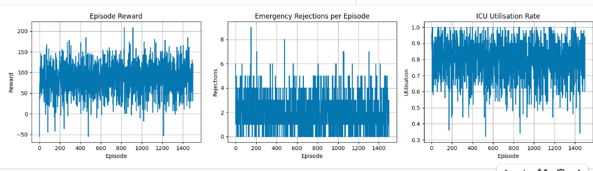

The three graphs shown above give the episode reward, emergency rejections per episode and the ICU (Intensive Care Unit) utilisation. It can be seen on the episode reward that the performance is adequate through shows a lot of variation or noise. At some times going negative which shows that the required positive measures of bed allocation are not being met. Which in a real situation means that patient treatment is delayed. This is further reinforced when looking at the emergency rejections. There are significant peaks which again has a negative impact for patient care because that means patients are not admitted in a timely fashion. Below is a heatmap showing the reward for the different states of free ICU and general beds. This is for the Elective patient type but the maps are similar for all patient types
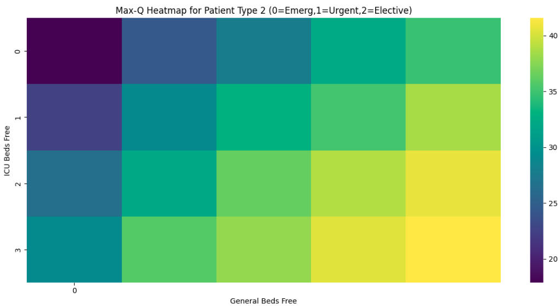

This shows that Q learning is favouring the situation which gives the greatest reward. And this is when the maximum number of ICU and general beds are free. Which means that any new patient being admitted is more likely to have a bed available. Overall this is a very simple situation compared to the realities of a healthcare organisation. Though it shows the way that Q learning can be used and also its limitations. As the number of beds of each type are increased the number states will increase and make Q learning struggle. For comparison the heatmap for Elective patient with ICU beds set to 10 and general to 30.
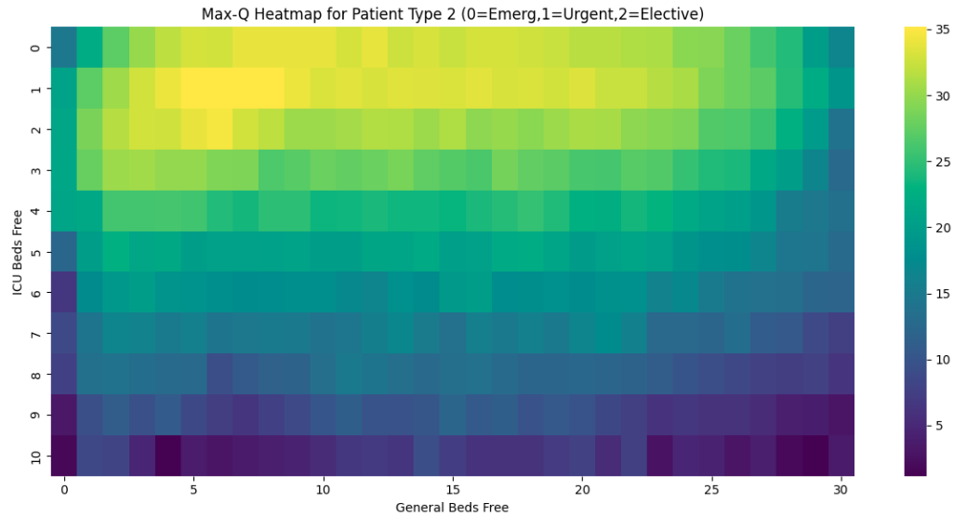

In this situation the heatmap is favouring both ICU and general towards the lower end of the scale.

Parameter and Policy Experiments
So far the learning rate Alpha has been fixed at 0.1 and the discount factor Gamma at 0.9. In order to determine the effect on the reward these were varied. Alpha was set at vales of 0.1, 0.3 and 0.5 with a fixed value for Gamma of 0.9. Plots of reward are shown below:-
Alpha = 0.1 Alpha = 0.3 Alpha = 0.5
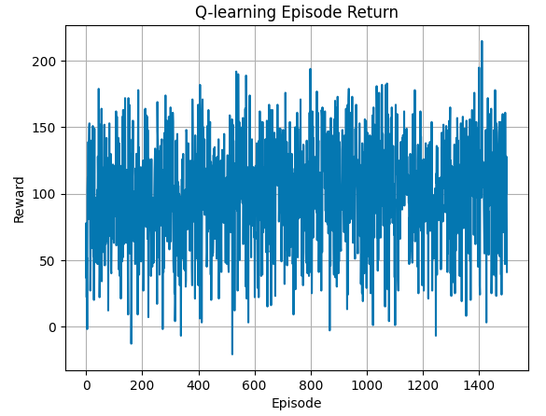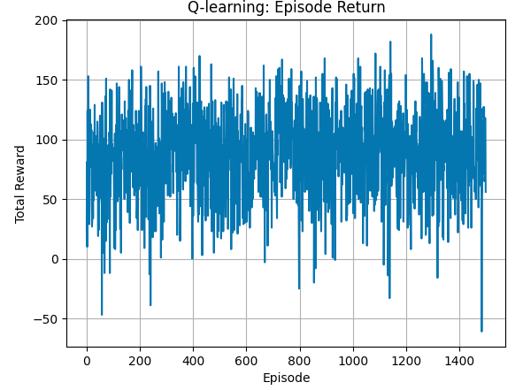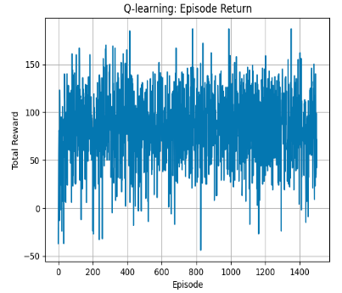
The original value of Alpha = 0.1 gives the best overall results. The values of 0.3 and 0.5 show greater dips into negative reward which would mean that patient are not admitted in a timely fashion which is shown in the penalties as a result.

Next the value of discount factor Gamma was varied between 0.5 qnd 0.9 with Alpha fixed at 0.1 which was shown to be the value that gave the most stable reward values:-
Gamma = 0.5 Gamma = 0.7
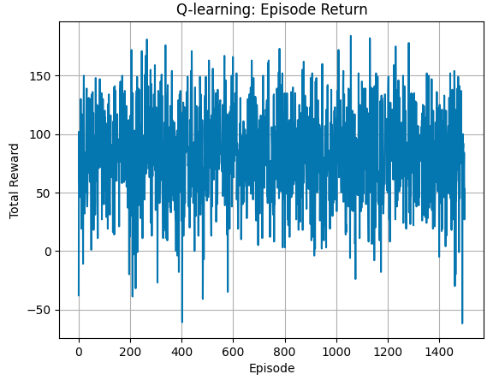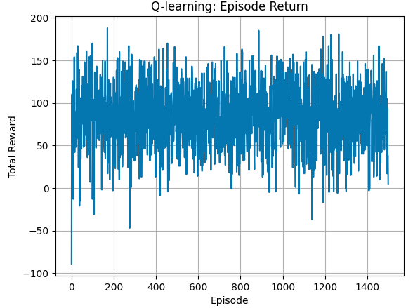

Gamma = 0.9
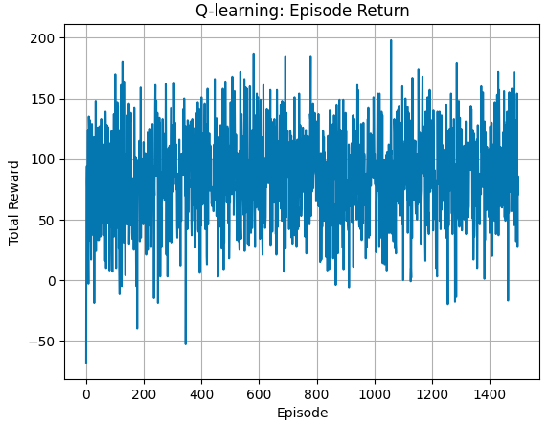

From these results it can be seen that the discount value which indicates how much the model cares about future rewards has less of an affect on the reward value. Whereas the learning rate which shows how much the new information overrides the old has more of an effect. This shows that when the model learns more slowly it is more stable. Which is to be expected from the lower value of Alpha. The higher values of Alpha show more instability.

Deep Q Networks
The environment for the first part of this testing was the same as for the Q learning so that a comparison can be made. After that the DQN environment was increased in complexity to show how DQN can scale to much larger problems compared to Q learning.
The architecture for the DQN environment was chosen based on the parameters chosen for the hospital environment.
The 5 dimensional input vector directly encodes the Markov state which is the number of ICU beds, the number of general beds and the 3 patient types of Emergency, Urgent and Elective. The 3 outputs correspond to the discrete action set of allocate to ICU, allocate to general or delay. And the use of two hidden layers with 64 units was based on standard practice for this level of deep reinforcement learning problem. Using 32 units is generally shown to underfit as opposed to 128 which tends to overfit. The two layer MLP with ReLU is a universal approximator.
The initial tests started by directly comparing the results of the DQN and improvements with the tabular Q learning method. And therefore employed a low complexity model. As expected the DQN showed significant improvement over tabular Q learning as can be seen in the graphs below:-
Tabular Q learning
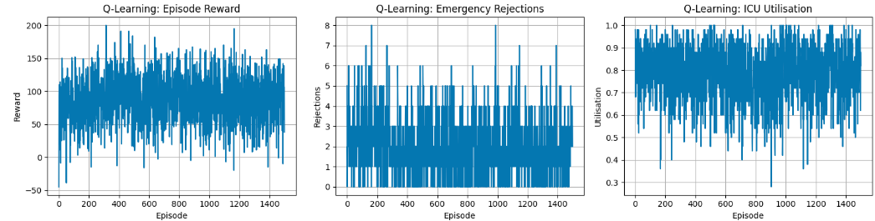

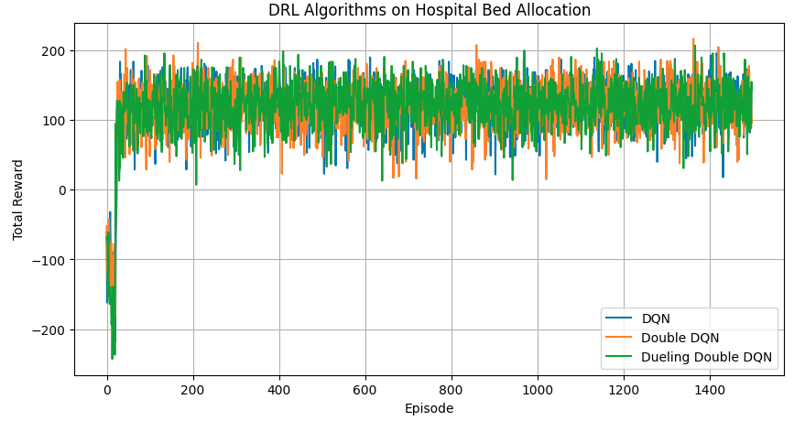
The DQN agents show an increasing level of stability with less noise for each of the improvements. There is an early learning period when the networks are learning and show a lower level of performance compared to tabular Q. Once this period has passed the network outperforms tabular Q.
To be able to clearly demonstrate the advantages of DQN techniques over tabular Q the environment complexity was increased as follows:
State Space
Each state is represented as:
$$s=(\text{ICU free},\text{GEN free},\text{ptype})$$
Where:
- ICU free beds: $0…10$
- General free beds: $0…30$
- Patient type:
  - 0 = Emergency
  - 1 = Urgent
  - 2 = Elective
This yields:
$$N_{\text{states}}=11×31×3=1023$$
Tabular Q-learning can still operate, but the state space is now large enough to justify deep RL.
For deep RL, states are encoded as a 5-dimensional vector:
$$\left[\text{ICU free} , \text{GEN free} , \text{one}\text{‑}\text{hot(}\text{ptype}\text{)}\right]$$
This continuous representation allows neural networks to generalise across capacity levels.
Action Space
Three discrete actions:
- Allocate ICU bed
- Allocate general bed
- Delay admission
Reward Function
The reward structure encodes clinical and operational priorities:
Scenario | Reward
Allocate ICU to emergency/urgent | +5
Allocate ICU to elective | –3
Allocate general to elective | +5
Allocate general to emergency/urgent when ICU available | –3
Allocate general to emergency/urgent when ICU full | +2
Attempt allocation when full | –10
Delay any patient | –1
Delay emergency | –10 additional
This encourages:
- ICU prioritisation for emergencies
- General ward use for electives
- Avoiding unnecessary delays
- Avoiding misuse of ICU beds
Transition Dynamics
- Discharges:
  - ICU: +1 bed with probability 0.3
  - General: +1 bed with probability 0.4
- New patient arrival distribution:
  - Emergency: 0.2
  - Urgent: 0.3
  - Elective: 0.5
Episodes last 50 steps, simulating a short operational window.
This represents a significant increase in the state space from 36 to 1023.

The result graphs of this are shown below:-
Tabular Q with Increased Complexity
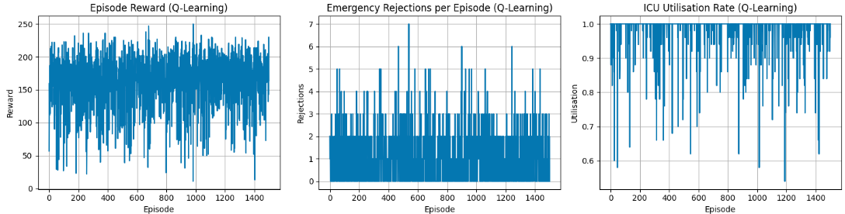

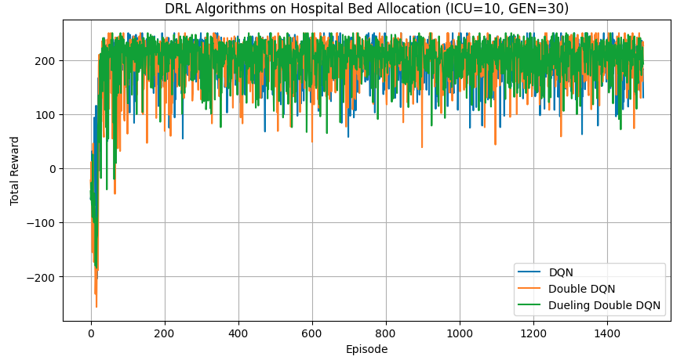

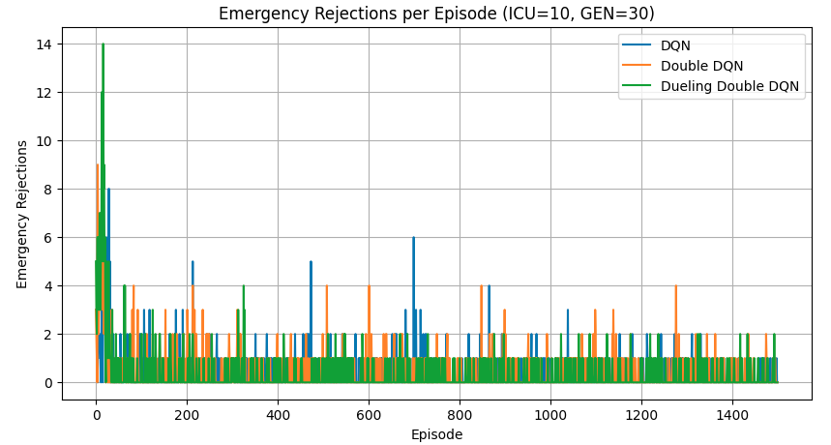

All the DQN methods show a stable noise reduced level of performance the Duelling Double DQN giving the best results.

