1. 快速编译

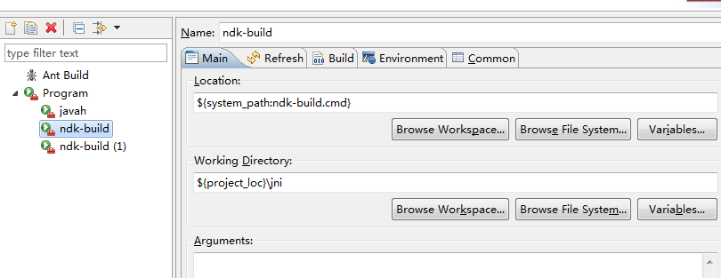

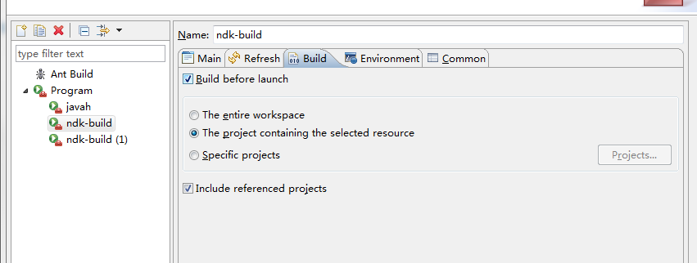

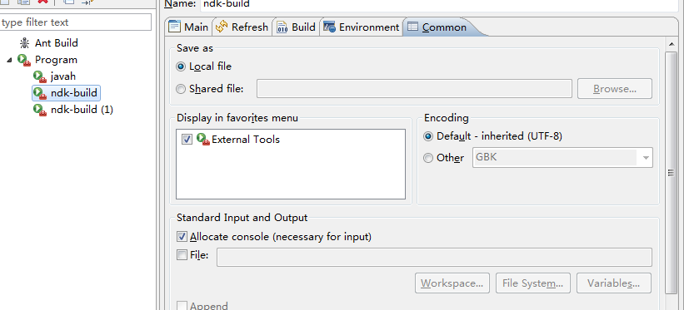

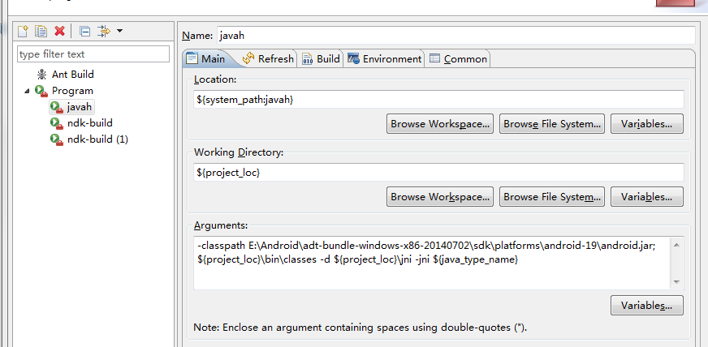

Ndk-build:

${system_path:ndk-build.cmd}

${project_loc}\jni

JavaH:

${system_path:javah}

${project_loc}

-classpath E:\Android\adt-bundle-windows-x86-20140702\sdk\platforms\android-19\android.jar;${project_loc}\bin\classes -d ${project_loc}\jni -jni ${java_type_name}