5-1 (evaluation橫軸是批次記錄步數)

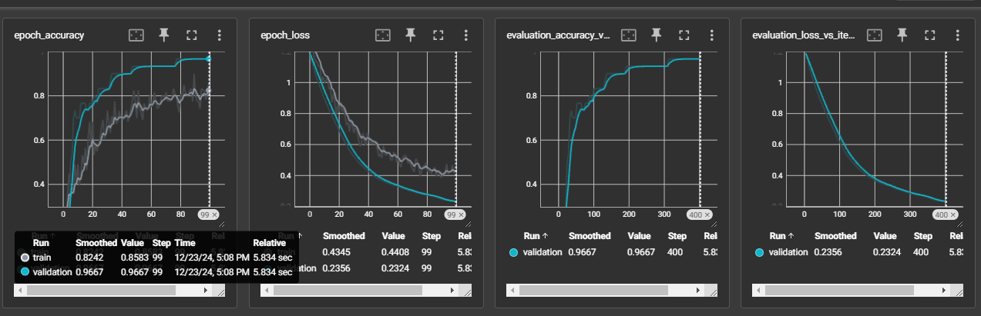

5-2

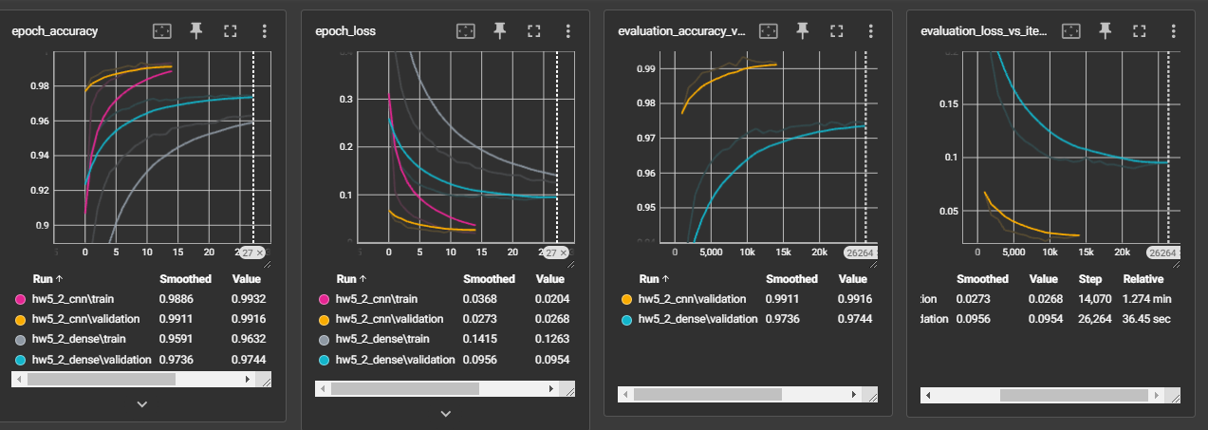

5-3

