The AdventureWork package collects Order and Product data and populates summary table.

The SQL query is equivalent of summary data:

select sh.SalesOrderID

, sh.OrderDate

, p.Name as ProductName

, p.ProductNumber

, pc.Name as ProductCategory

, sd.OrderQty

, sd.UnitPrice

, sd.LineTotal as Total

, st.Name as [Territory (Customer Location)]

from AdventureWorks.Sales.SalesOrderHeader sh

inner join AdventureWorks.Sales.SalesOrderDetail sd on sh.SalesOrderID = sd.SalesOrderID

inner join AdventureWorks.Production.Product p on sd.ProductID = p.ProductID

inner join AdventureWorks.Sales.SalesTerritory st on sh.TerritoryID = st.TerritoryID

left join AdventureWorks.Production.ProductSubcategory psc on p.ProductSubcategoryID = psc.ProductSubcategoryID

left join AdventureWorks.Production.ProductCategory pc on psc.ProductCategoryID = pc.ProductCategoryID

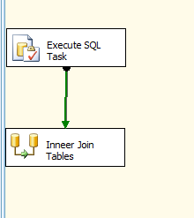

Data Flow task

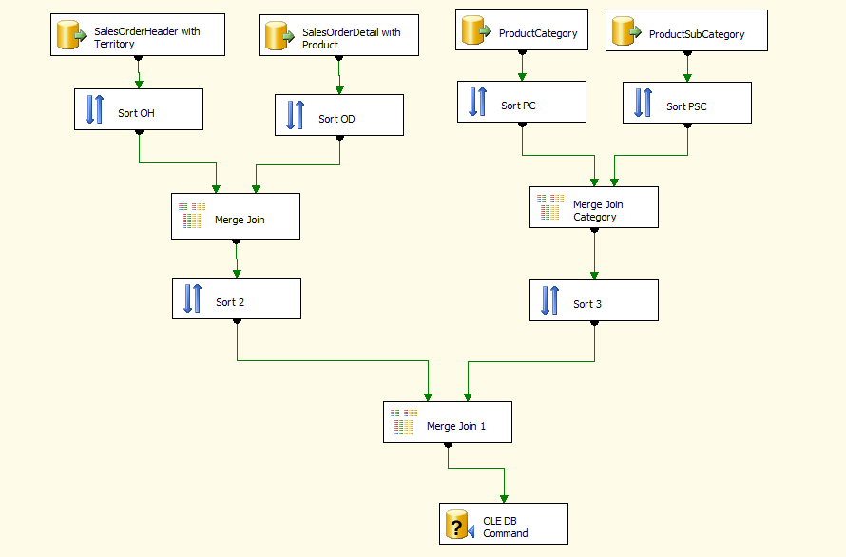



truncate table AdventureWorks2017.dbo. OrderProductTotal

Clean summary table before populating summary data.



Data flow include steps described below:



AdventureWorks.Sales.SalesOrderHeader sh inner join AdventureWorks.Sales.SalesTerritory st on sh.TerritoryID = st.TerritoryID

The OLE DB Source which retrieves joined data from SalesOrderHeader and SalesTerritory tables.

It allows getting [Territory (Customer Location)] data (SalesTerritory .Name)



AdventureWorks.Sales.SalesOrderDetail sd inner join AdventureWorks.Production.Product p on sd.ProductID = p.ProductID

The OLE DB Source which retrieves joined data from SalesOrderDetail and Product tables.

It allows getting all ordered Product data (Product .Name, Product .ProductNumber, Product. ProductSubcategoryID)

 

Blocking transformation type.

Datasets sorted by SalesOrderID field before merge



Semi-blocking transformation type.

AdventureWorks.Sales.SalesOrderHeader sh

inner join AdventureWorks.Sales.SalesOrderDetail sd on sh.SalesOrderID = sd.SalesOrderID

inner join AdventureWorks.Production.Product p on sd.ProductID = p.ProductID

inner join AdventureWorks.Sales.SalesTerritory st on sh.TerritoryID = st.TerritoryID

Merge two datasets SalesOrderHeader and SalesOrderDetail including additional Product and territory information.



The OLE DB Source, ProductCategory table



The OLE DB Source, ProductSubcategory table



Blocking transformation type.

Datasets sorts by ProductCategoryID field before merge.



Semi-blocking transformation type.

AdventureWorks.Production.ProductCategory pc inner join AdventureWorks.Production.ProductSubcategory psc on psc.ProductCategoryID = pc.ProductCategoryID



Blocking transformation type.

Datasets sorts by ProductSubcategoryID field before merge.



Blocking transformation type.

Datasets sorts by ProductSubcategoryID field before merge.



Semi-blocking transformation type.

Merge left join two datasets Product data and ProductCategory data.

left join AdventureWorks.Production.ProductSubcategory psc on Product.ProductSubcategoryID = psc.ProductSubcategoryID



Non-blocking transformation type.

Populates the AdventureWorks2017.dbo. OrderProductTotal table summary table.