The Weather SSIS package copies weather data from the AdventureWorks2017.dbo. Weatherdata to AdventureWorksReporting2017.dbo.Weatherdata table and translates UNIX datetime into DateTime values.

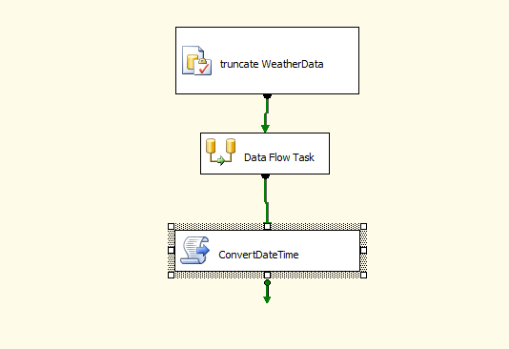

Data Flow task.

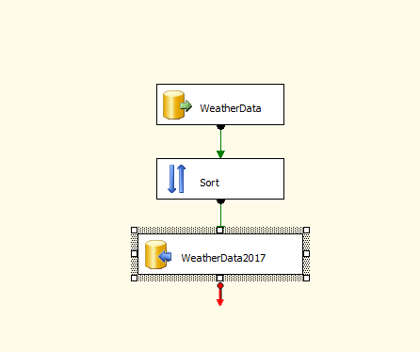

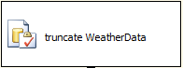

truncate table AdventureWorksReporting2017.dbo. Weatherdata table.

Clean AdventureWorksReporting2017 weatherdata table before populating new data from AdventureWorks2017 database.



Data flow include steps described below:



OLE DB DataSource, AdventureWorks2017 .dbo.WeatherData table



Datasets sorts by name, country fields.



OLE DB Destination, populate AdventureWorksReporting2017.dbo. Weatherdata table.



C# script task. Convert Sunruse/Sunset UNIX datetime into DateTime values.

Script run sql query and updates sunrise_dd, sunset_dd fields using fn_ConvertToDateTime function.

Update AdventureWorksReporting2017.dbo.Weatherdata

set sunrise_dd = ConvertToDateTime(sunrise)

, sunset_dd = ConvertToDateTime(sunset)