## Writeup Template

**Advanced Lane Finding Project**

The goals / steps of this project are the following:

* Compute the camera calibration matrix and distortion coefficients given a set of chessboard images.
* Apply a distortion correction to raw images.
* Use color transforms, gradients, etc., to create a thresholded binary image.
* Apply a perspective transform to rectify binary image ("birds-eye view").
* Detect lane pixels and fit to find the lane boundary.
* Determine the curvature of the lane and vehicle position with respect to center.
* Warp the detected lane boundaries back onto the original image.
* Output visual display of the lane boundaries and numerical estimation of lane curvature and vehicle position.

### Writeup / README

#### 1. Provide a Writeup / README that includes all the rubric points and how you addressed each one. You can submit your writeup as markdown or pdf. [Here](https://github.com/udacity/CarND-Advanced-Lane-Lines/blob/master/writeup_template.md) is a template writeup for this project you can use as a guide and a starting point.

Code File to refer - Advance_Lane_Finding.ipynb

Input Image – test5.jpg

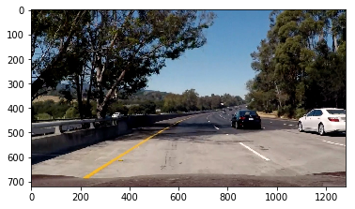

### Camera Calibration

#### 1. Briefly state how you computed the camera matrix and distortion coefficients. Provide an example of a distortion corrected calibration image.

I start by preparing "object points", which will be the (x, y, z) coordinates of the chessboard corners in the world. Here I am assuming the chessboard is fixed on the (x, y) plane at z=0, such that the object points are the same for each calibration image. Thus, `objp` is just a replicated array of coordinates, and `objpoints` will be appended with a copy of it every time I successfully detect all chessboard corners in a test image. `imgpoints` will be appended with the (x, y) pixel position of each of the corners in the image plane with each successful chessboard detection.

I then used the output `objpoints` and `imgpoints` to compute the camera calibration and distortion coefficients using the `cv2.calibrateCamera()` function. I applied this distortion correction to the calibration4.jpg and got following output.

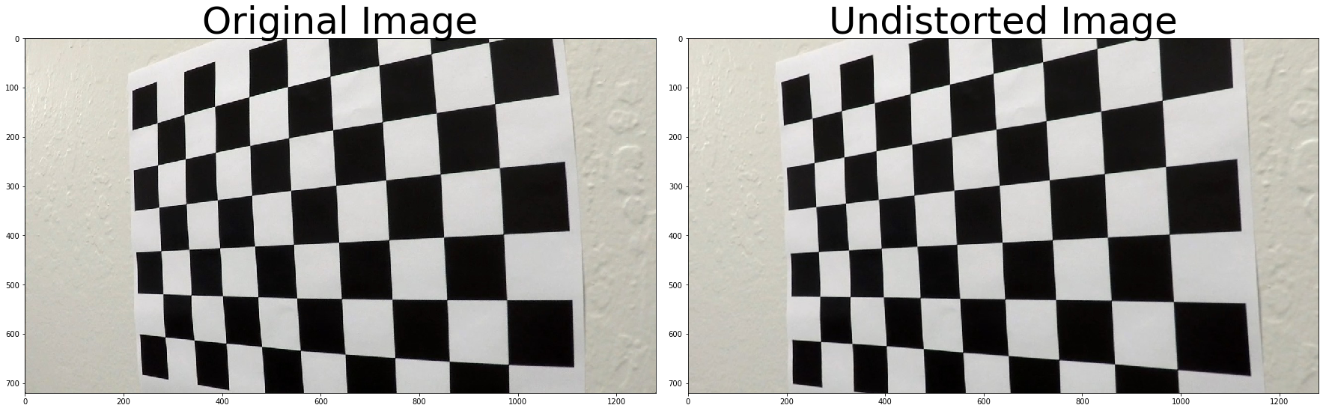

### Pipeline (single images)

#### 1. IMAGE UNDISTORTION

As mention above, using the camera matrix and distortion coefficients calculated in the camera calibration step, I tried undistorts test image (Input Image – test5.jpg) using the cv2.undistort() function and obtained below result:
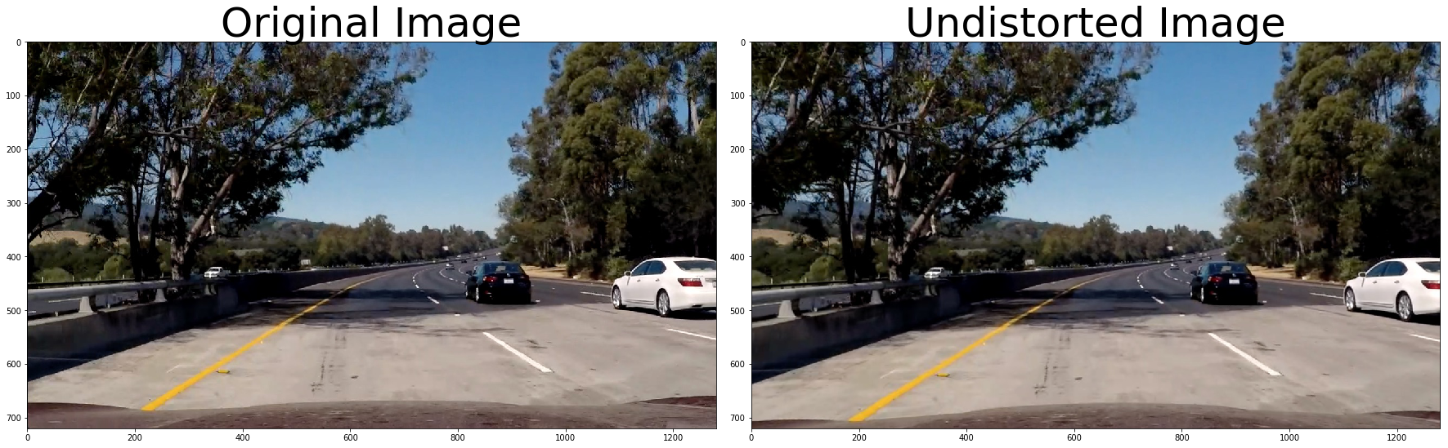

#### COLOR AND GRADIENT THRESHOLDING

I used a combination of RGB-space (R&G threshold) and HLS-space(S threshold) for color thresholding
and
“x-gradient" and “direction of Gradient” thresholds to generate a binary image (thresholding steps is part of color_gradient_Threshold() function).
Following threshold values were considered.
R&G thresh = (150, 255)
s_thresh=(120, 255)
gradx_thresh =(20,100)
dir_thresh=(np.pi/6, np.pi/2))

Then tried creating “Stack each channel” and creating mask from “gradient and colour threshold”
Following o/p were received.
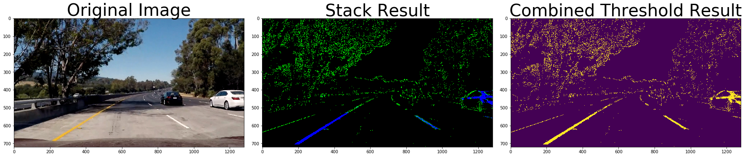

#### 3. PERSPECTIVE TRANSFORM

A perspective transform is useful to transform(warps) the road image taken from front facing camera to a "birds-eye view", as if we were looking down on the road from above.
The transform was implemented in the warpPerspective() function.
cv2.getPerspectiveTransform()calculates the transform matrix based on given source and destination points.
Following source and destination points using a frame with a straight road section:
src -
[ 585. 460. ]
[ 203.33332825 720. ]
[ 1126.66662598 720. ]
[ 695. 460. ]

dst -
[ 320. 0.]
[ 320. 720.]
[ 960. 720.]
[ 960. 0.]
I chose the hardcode the source and destination points in the following manner:

```python
src = np.float32(
[[(img_size[0] / 2) - 55, img_size[1] / 2 + 100],
[((img_size[0] / 6) - 10), img_size[1]],
[(img_size[0] * 5 / 6) + 60, img_size[1]],
[(img_size[0] / 2 + 55), img_size[1] / 2 + 100]])
dst = np.float32(
[[(img_size[0] / 4), 0],
[(img_size[0] / 4), img_size[1]],
[(img_size[0] * 3 / 4), img_size[1]],
[(img_size[0] * 3 / 4), 0]])
```

I verified that my perspective transform was working as expected by drawing the `src` and `dst` points onto a test image and its warped counterpart to verify that the lines appear parallel in the warped image.

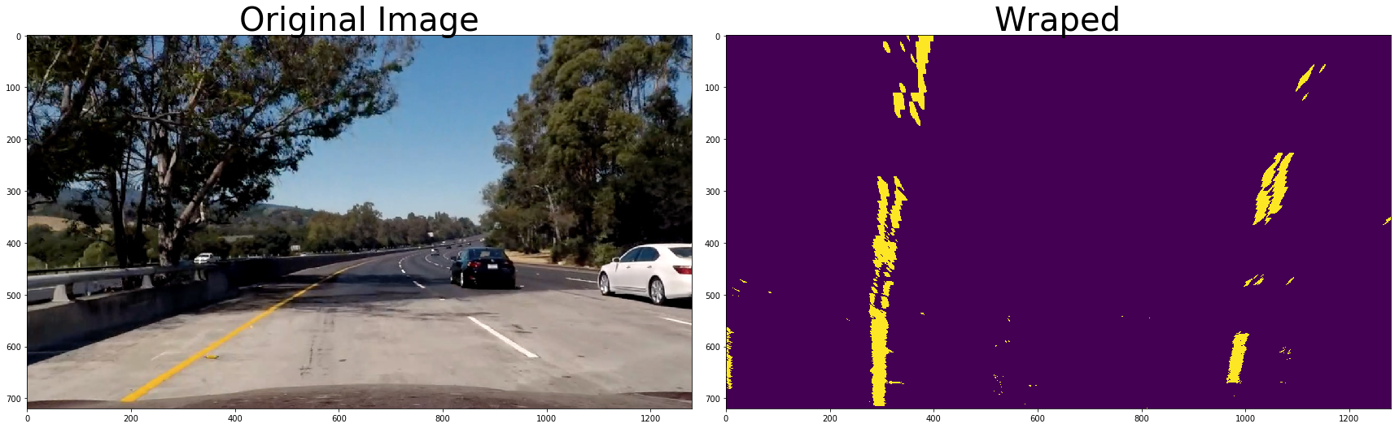

#### 4. LANE PIXEL DETECTION & CURVE FITTING

I detected lane pixels using two methods:
- Step – 1 : using "sliding windows"
- Step – 2 : using “serach for prior”
Find histogram of the lower half of the image is pre-requisite step for "sliding window"
So I calculated the same using find_histogram() and following was the grpah obtained.
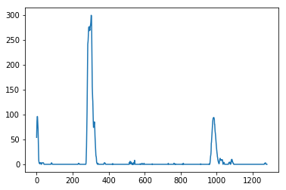

I used the two highest peaks from our histogram as a starting point for determining where the lane lines are, and then use sliding windows moving upward in the image (further along the road) to determine where the lane lines go.
The above logic is implemented using find_lane_pixels().
After lane pixels are detected, a second degree polynomial is fit to the points using the function fit_polynomial(), which internally uses the polyfit() function.
O/P obtained – Some of the rectangles are not coming proper though.

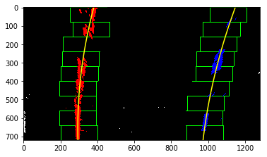

Using search_around_poly() function, If the lanes were already detected the pipeline uses the previous fits to search for lane pixels.
O/P obtained –
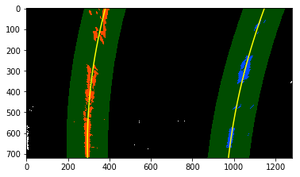

#### 5. COMPUTING RADIUS OF CURVATURE & VEHICLE POSTION

The curvature of the road is calculated in the measure_curvature_real()function using the below equation, so the radius we are reporting is in pixel space, which is not the same as real world space. So we "converts" the pixel values to meters:
Rcurve​=∣2A∣(1+(2Ay+B)2)3/2​
The position of the vehicle is calculated using the get_vehicle_position()function.
The function calculates the center point between left and right lane and returns the distance of the center point from the midpoint of the image.
Final O/P
Radius of curvature: 871.79 m
lane_center 634.321804753
offset from center 0.0300133177347

### Pipeline (video)

For video processing, it is useful to store data from previous frames to facilitate lane finding.
I/P Video – project_video.mp4
O/P Video - project_video_output.mp4'
For this I created two global variables - left_fit1 & right_fit1 which store data of previous frame
to:
- decide whether to use the "sliding window" (fit_polynomial) method
or
- prior search method (search_around_poly)

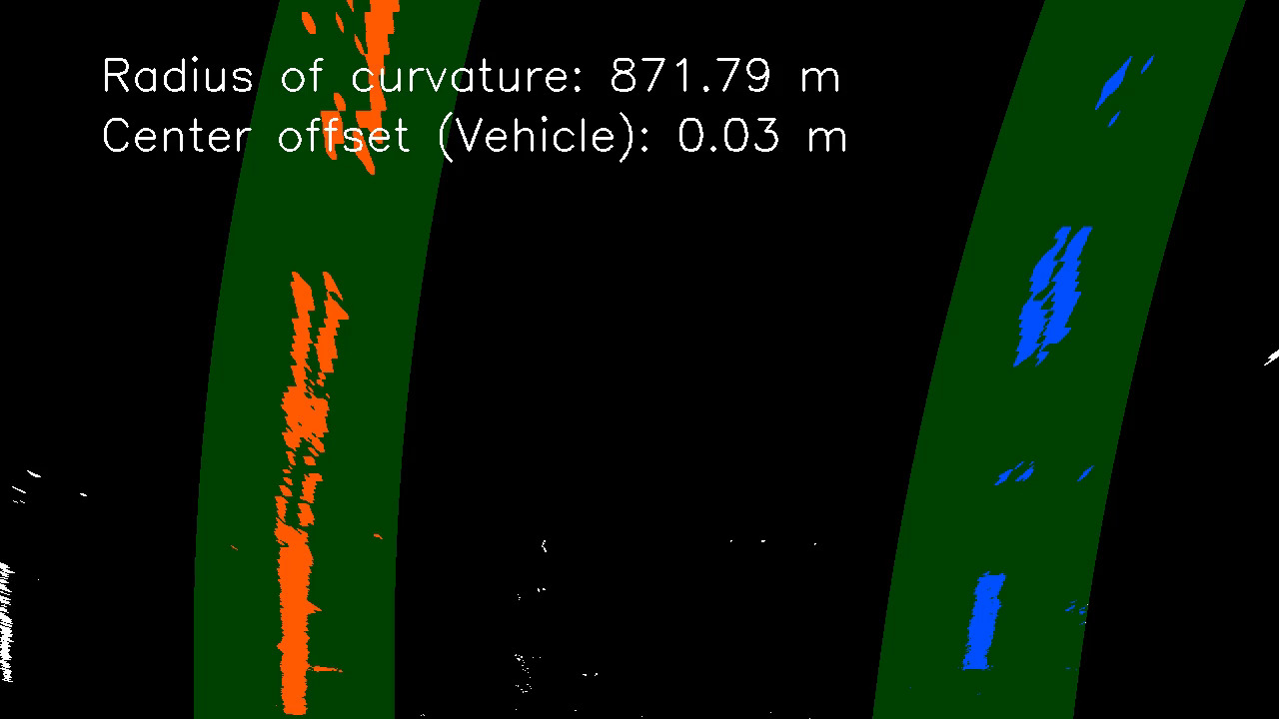

### Discussion

#### Problems / issues you faced in your implementation of this project.

Issues and Challenges

- Though my video frames are getting processed , but when I see the o/p the image is stand sit as if only single frame got processed. Not sure why? Please guide.
- I experimented a lot with gradient and color channnel thresholding to get the proper value..
- Similary in section “LANE PIXEL DETECTION & CURVE FITTING”, earlier the offset value was coming more that 10 and then it droped to negative. Later realized that I was using wrong values of left_fit and right_fit.

Points of failure & Areas of Improvement
Not attempted challenge video. Will try later point of time.
- The method used is fairly simple and works well on straight / slightly curvy roads with good lane visibility but not sure on the cndition with fadded lines and poor visibility due to weather or low light condition.
- Since this pipeline might not work for all the condition (due to cv limitation), checking for other approaches like neual network makes sense at this point.

