Lithic description

12 May, 2022

Text of abstract

Keywords: keyword 1; keyword 2; keyword 3

Highlights: These are the highlights.

# 1 Introduction

Here is a citation (Marwick, 2017)

# 2 Background

# 3 Methods

# 4 Results

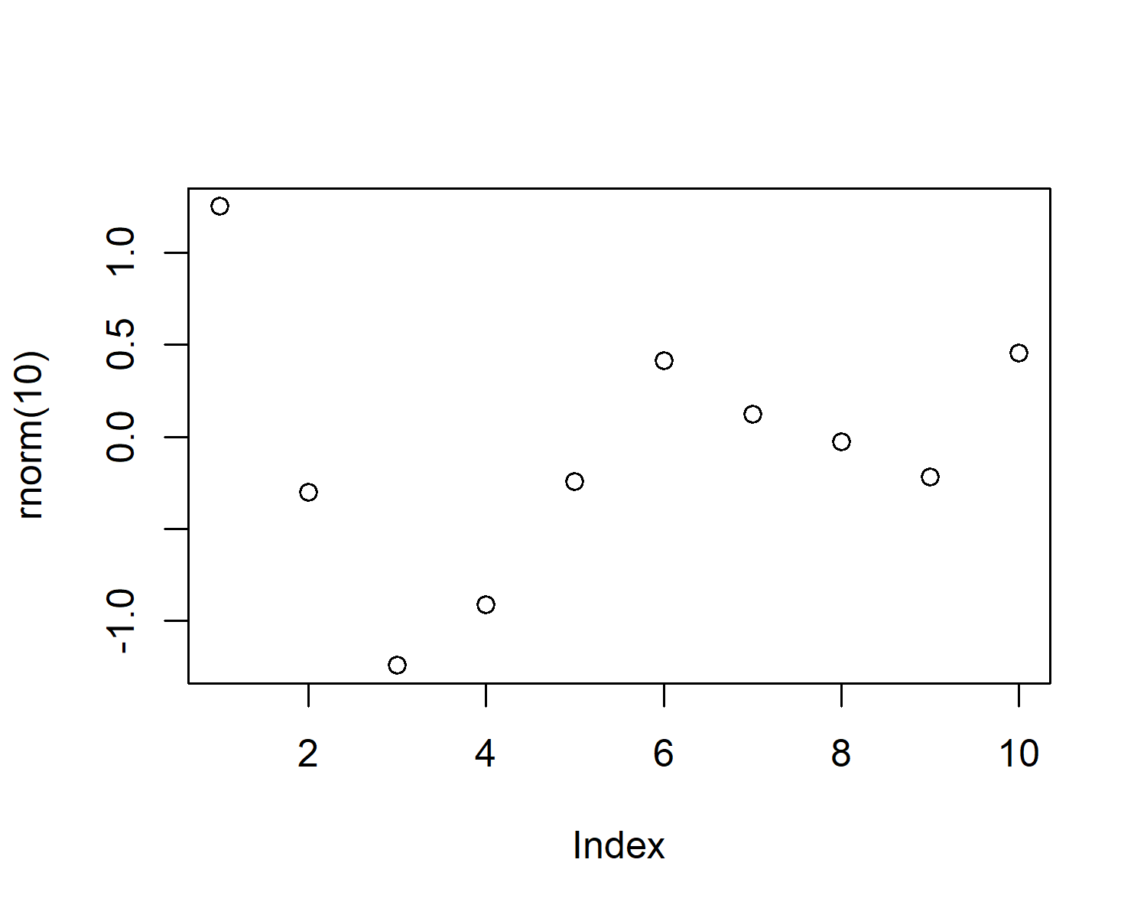

Figure 4.1: A plot of random numbers

Figure 4.1 shows how we can have a caption and cross-reference for a plot

Here is an example of inline code 3.14 in the middle of a sentence.

# 5 Discussion

# 6 Conclusion

# 7 Acknowledgements

# 8 References

Marwick, B., 2017. Computational reproducibility in archaeological research: Basic principles and a case study of their implementation. Journal of Archaeological Method and Theory 24, 424–450. <https://doi.org/10.1007/s10816-015-9272-9>

### 8.0.1 Colophon

This report was generated on 2022-05-12 16:11:42 using the following computational environment and dependencies:

#> - Session info ---------------------------------------------------------------  
#> setting value  
#> version R version 4.1.3 (2022-03-10)  
#> os Windows 10 x64 (build 19043)  
#> system x86_64, mingw32  
#> ui RTerm  
#> language (EN)  
#> collate English_United States.1252  
#> ctype English_United States.1252  
#> tz Europe/London  
#> date 2022-05-12  
#> pandoc 2.17.1.1 @ C:/Program Files/RStudio/bin/quarto/bin/ (via rmarkdown)  
#>   
#> - Packages -------------------------------------------------------------------  
#> package * version date (UTC) lib source  
#> bookdown 0.26 2022-04-15 [1] CRAN (R 4.1.3)  
#> brio 1.1.3 2021-11-30 [1] CRAN (R 4.1.3)  
#> cachem 1.0.6 2021-08-19 [1] CRAN (R 4.1.3)  
#> callr 3.7.0 2021-04-20 [1] CRAN (R 4.1.3)  
#> cli 3.2.0 2022-02-14 [1] CRAN (R 4.1.3)  
#> crayon 1.5.1 2022-03-26 [1] CRAN (R 4.1.3)  
#> desc 1.4.1 2022-03-06 [1] CRAN (R 4.1.3)  
#> devtools 2.4.3 2021-11-30 [1] CRAN (R 4.1.3)  
#> digest 0.6.29 2021-12-01 [1] CRAN (R 4.1.3)  
#> ellipsis 0.3.2 2021-04-29 [1] CRAN (R 4.1.3)  
#> evaluate 0.15 2022-02-18 [1] CRAN (R 4.1.3)  
#> fastmap 1.1.0 2021-01-25 [1] CRAN (R 4.1.3)  
#> fs 1.5.2 2021-12-08 [1] CRAN (R 4.1.3)  
#> glue 1.6.2 2022-02-24 [1] CRAN (R 4.1.3)  
#> highr 0.9 2021-04-16 [1] CRAN (R 4.1.3)  
#> htmltools 0.5.2 2021-08-25 [1] CRAN (R 4.1.3)  
#> knitr 1.39 2022-04-26 [1] CRAN (R 4.1.3)  
#> lifecycle 1.0.1 2021-09-24 [1] CRAN (R 4.1.3)  
#> magrittr 2.0.2 2022-01-26 [1] CRAN (R 4.1.3)  
#> memoise 2.0.1 2021-11-26 [1] CRAN (R 4.1.3)  
#> pkgbuild 1.3.1 2021-12-20 [1] CRAN (R 4.1.3)  
#> pkgload 1.2.4 2021-11-30 [1] CRAN (R 4.1.3)  
#> prettyunits 1.1.1 2020-01-24 [1] CRAN (R 4.1.3)  
#> processx 3.5.3 2022-03-25 [1] CRAN (R 4.1.3)  
#> ps 1.7.0 2022-04-23 [1] CRAN (R 4.1.3)  
#> purrr 0.3.4 2020-04-17 [1] CRAN (R 4.1.3)  
#> R6 2.5.1 2021-08-19 [1] CRAN (R 4.1.3)  
#> remotes 2.4.2 2021-11-30 [1] CRAN (R 4.1.3)  
#> rlang 1.0.2 2022-03-04 [1] CRAN (R 4.1.3)  
#> rmarkdown 2.14 2022-04-25 [1] CRAN (R 4.1.3)  
#> rprojroot 2.0.3 2022-04-02 [1] CRAN (R 4.1.3)  
#> rstudioapi 0.13 2020-11-12 [1] CRAN (R 4.1.3)  
#> sessioninfo 1.2.2 2021-12-06 [1] CRAN (R 4.1.3)  
#> stringi 1.7.6 2021-11-29 [1] CRAN (R 4.1.2)  
#> stringr 1.4.0 2019-02-10 [1] CRAN (R 4.1.3)  
#> testthat 3.1.4 2022-04-26 [1] CRAN (R 4.1.3)  
#> usethis 2.1.5 2021-12-09 [1] CRAN (R 4.1.3)  
#> withr 2.5.0 2022-03-03 [1] CRAN (R 4.1.3)  
#> xfun 0.31 2022-05-10 [1] CRAN (R 4.1.3)  
#> yaml 2.3.5 2022-02-21 [1] CRAN (R 4.1.2)  
#>   
#> [1] C:/Users/Youssef/OneDrive/Documents/R/win-library/4.1  
#> [2] C:/Program Files/R/R-4.1.3/library  
#>   
#> ------------------------------------------------------------------------------

The current Git commit details are:

#> Local: main C:/Users/Youssef/OneDrive/Bureau/Lithic_description  
#> Remote: main @ origin (https://github.com/YDjellal1/Lithic_description.git)  
#> Head: [06b06c4] 2022-05-12: Lithic_descrption_FirstVersion