DHL & FEDEX
API INTERGRATION
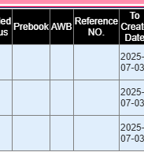
Add one column (AWB)
- For Showing Linked AWB
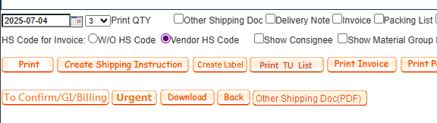
Add a new function (create Label) for DHL/FedEx
- Use for generate AWB via API-DHL/FEDEX

Workflow (Logic)
Main SI Portal
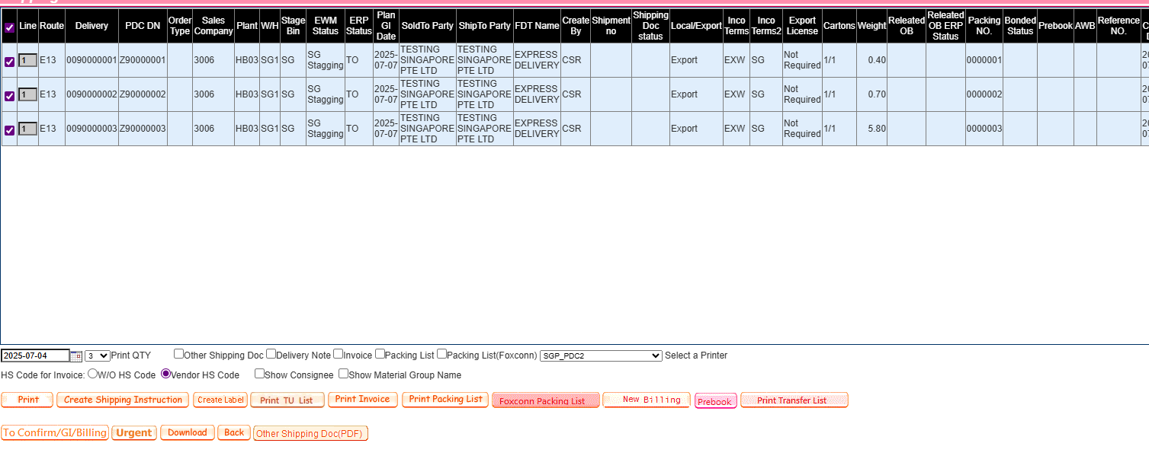
- Select which OB to generate AWB
- Press (Create Label)

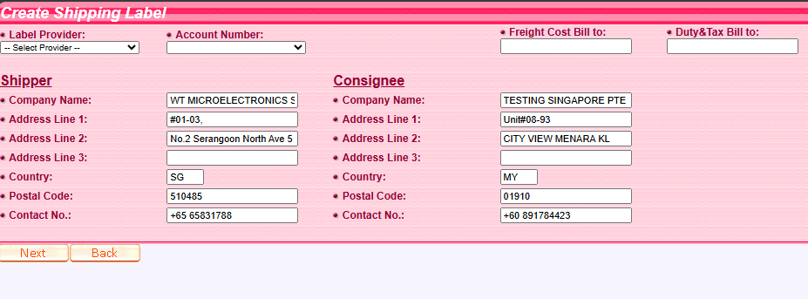

- Label Provider & Account Number:
Mapping and read in/from database
- DHL (eg. WT-3006, EP-3012...)
- FEDEX (eg. WT-3006, EP-3012...)
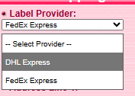
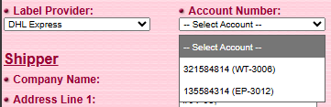
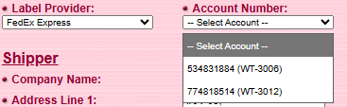

- Bill to A/C:

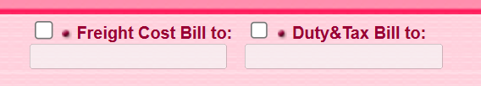
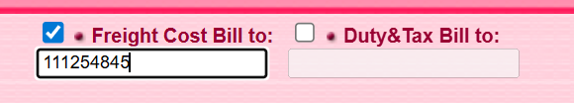

Freight Cost
- If unticked, using our account (same as Account on section 3)
- If ticked,
- freight cost using alternative account
- Duty and tax paid by receiver (blank), alternative account (filled)

- Address get from OB Data.
*The address only get from first OB, ignore differ along other OB.

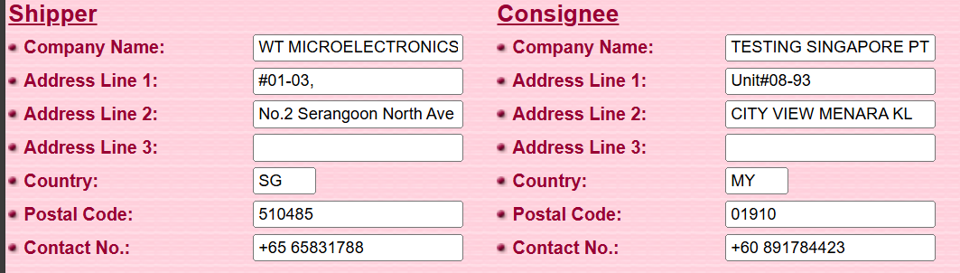

- Verifying
*DHL and FEDEX API have provide verifying function.
Press  Next

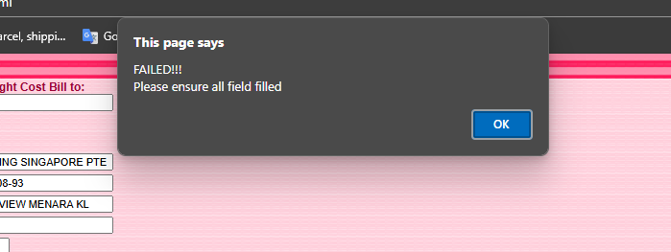

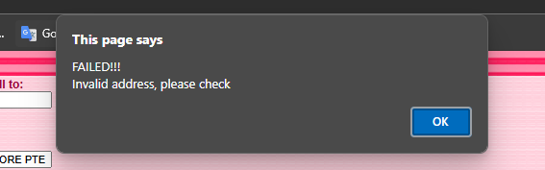

- If error occurred, prompt alert for cause.
- Null input
- Invalid Postal Code (Check via API - address verify)
- Invalid Alternative A/C no.
…. (Refer API Documentation)

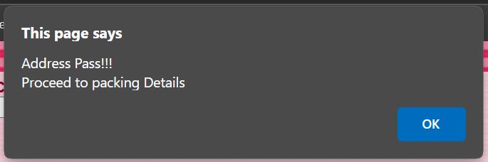

- Content Details
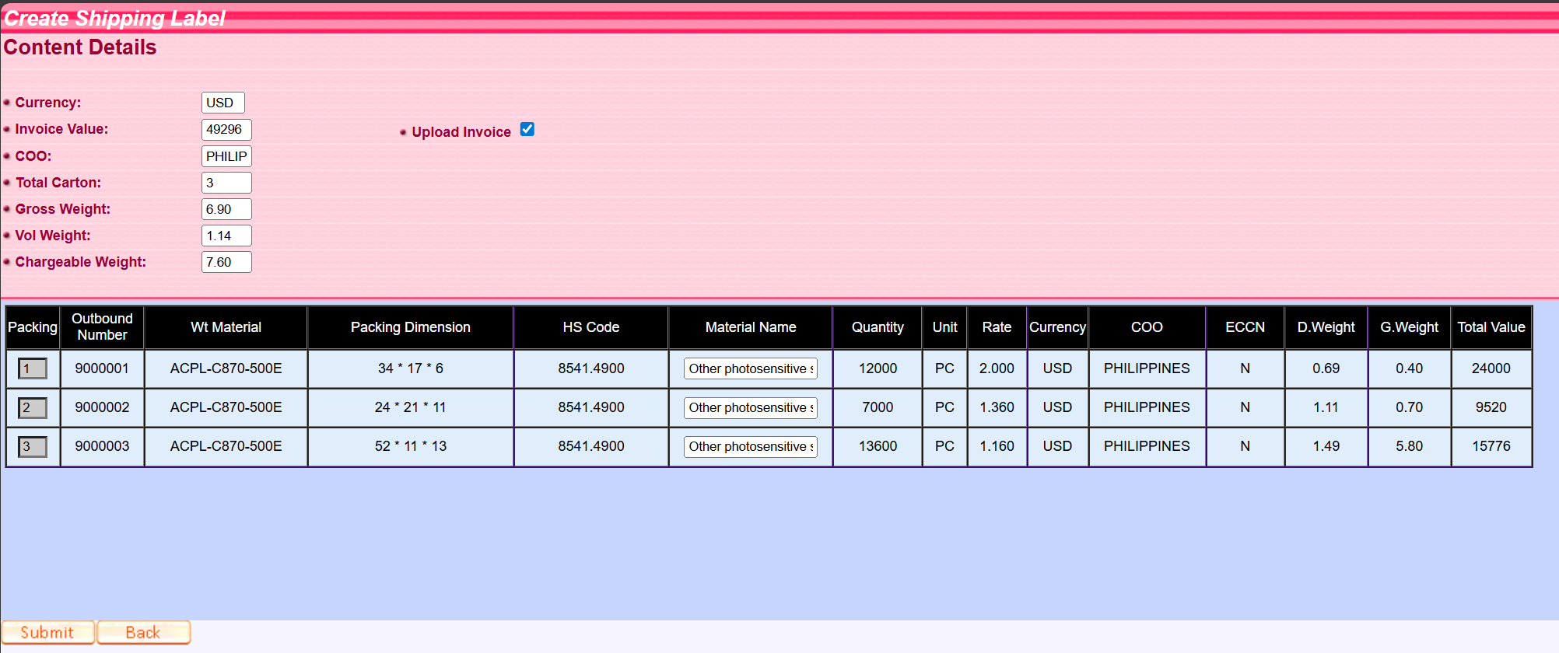
2
1

- (1) Get Invoice Data:
- Value
- Rate
- Part Quantity
- COO (Country of Origin)

- (1) Get Packing Data
- Dimension Weight
- Gross Weight
- Chargeable Weight (Carton Base)

- (2) Upload Document to API
- Tick to upload / Un-tick to nothing

When  submit clicked.
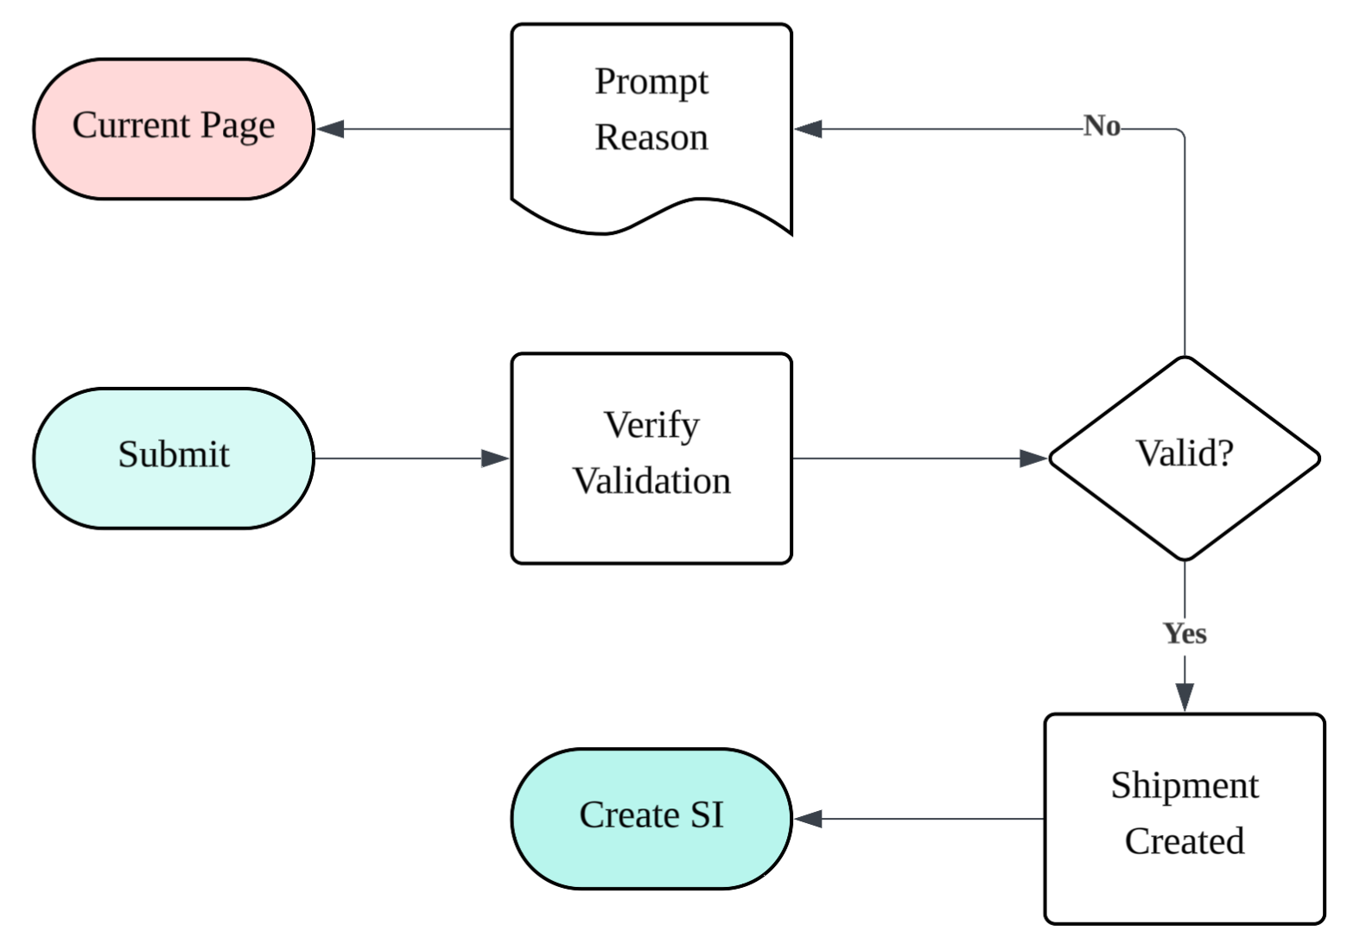
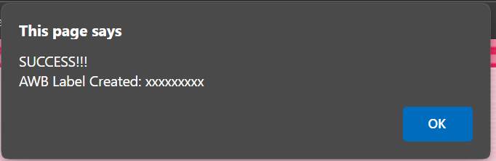
- Create SI
Jump to Create Shipping Instruction interface (Like Normal)
- Pass Generated AWB to Create SI
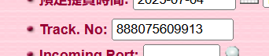
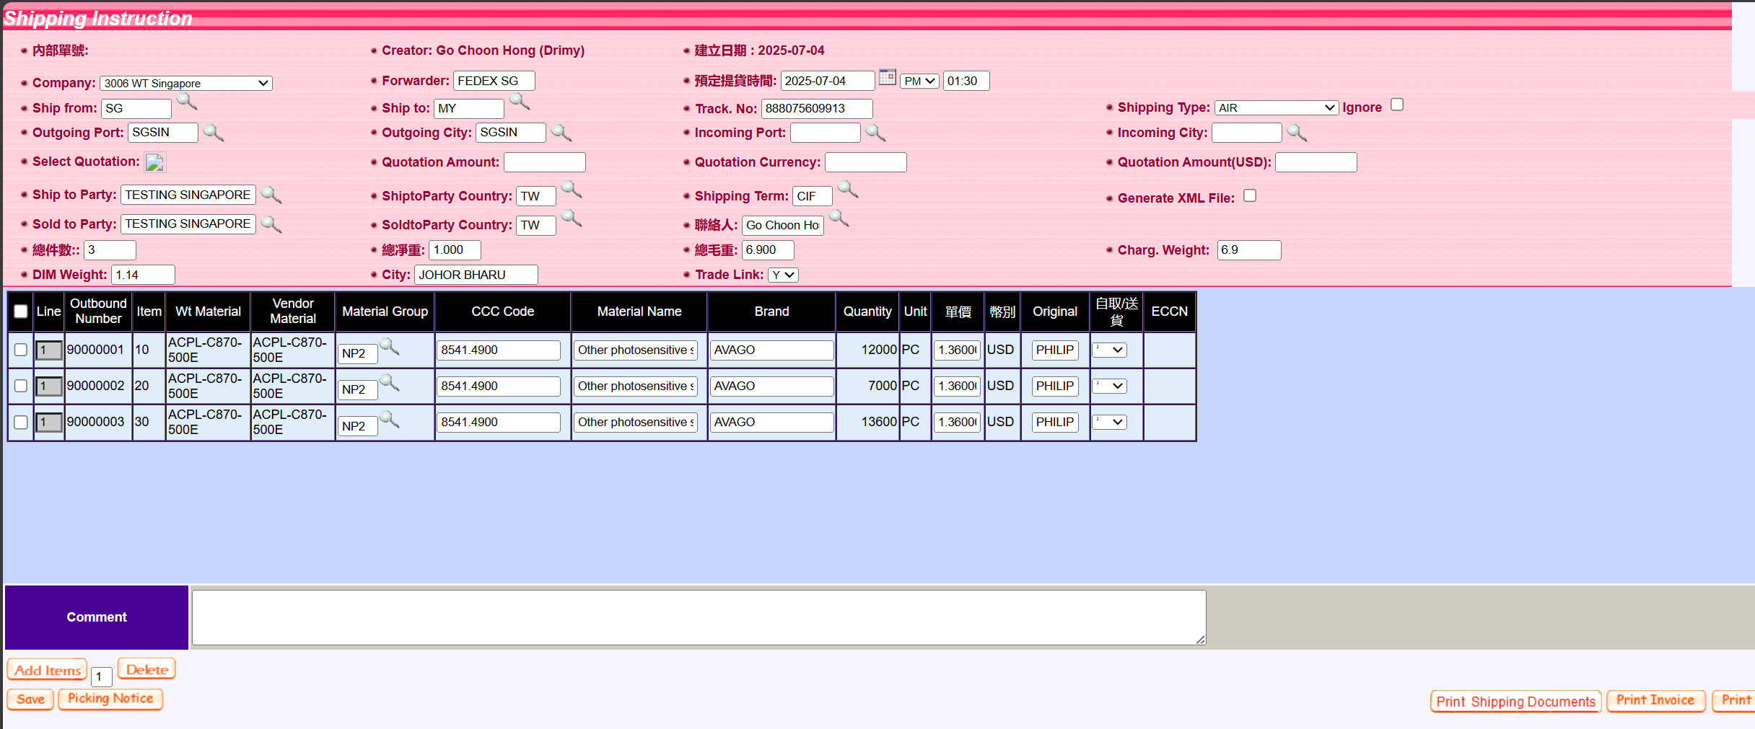
*Create Shipping Instruction Interface
- Click 
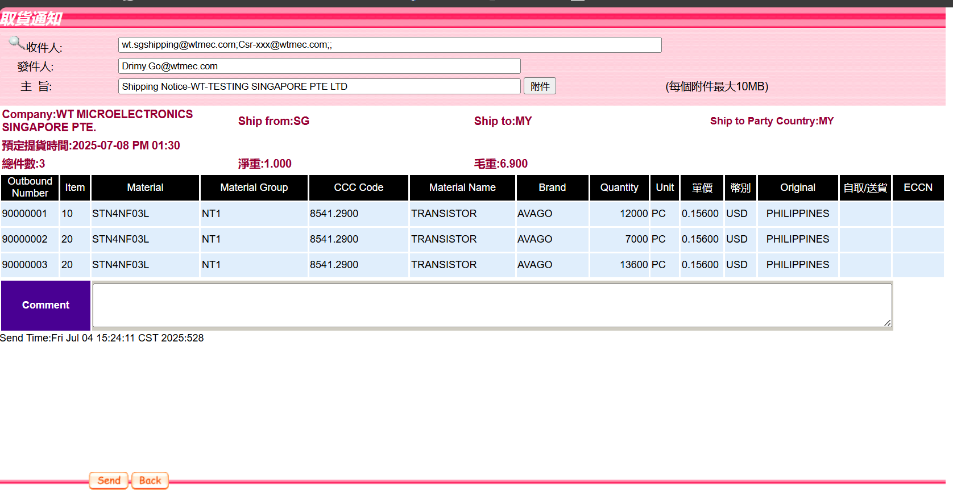
*Email Interface
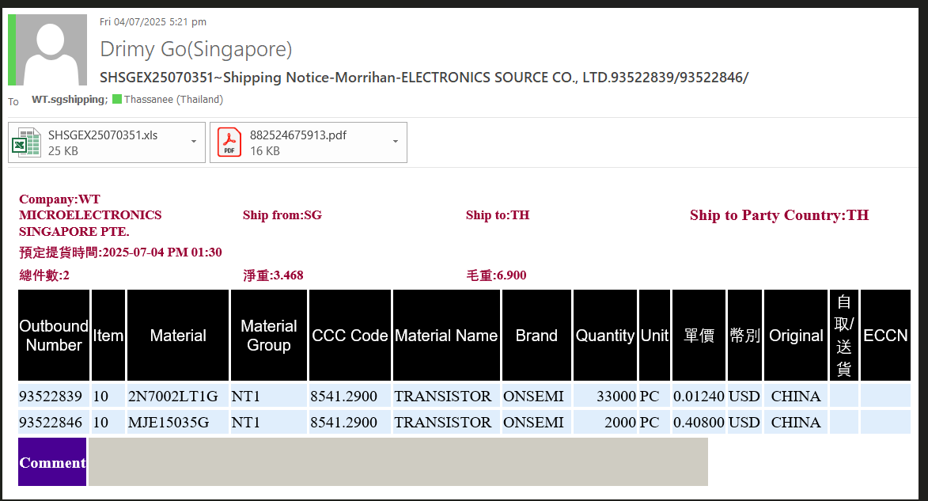
*Email Sent
- Link AWB with Reference No.
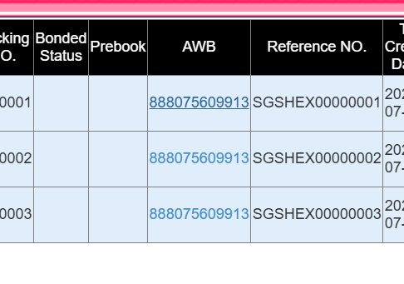
AWB hyperlink clickable, load into generated AWB.
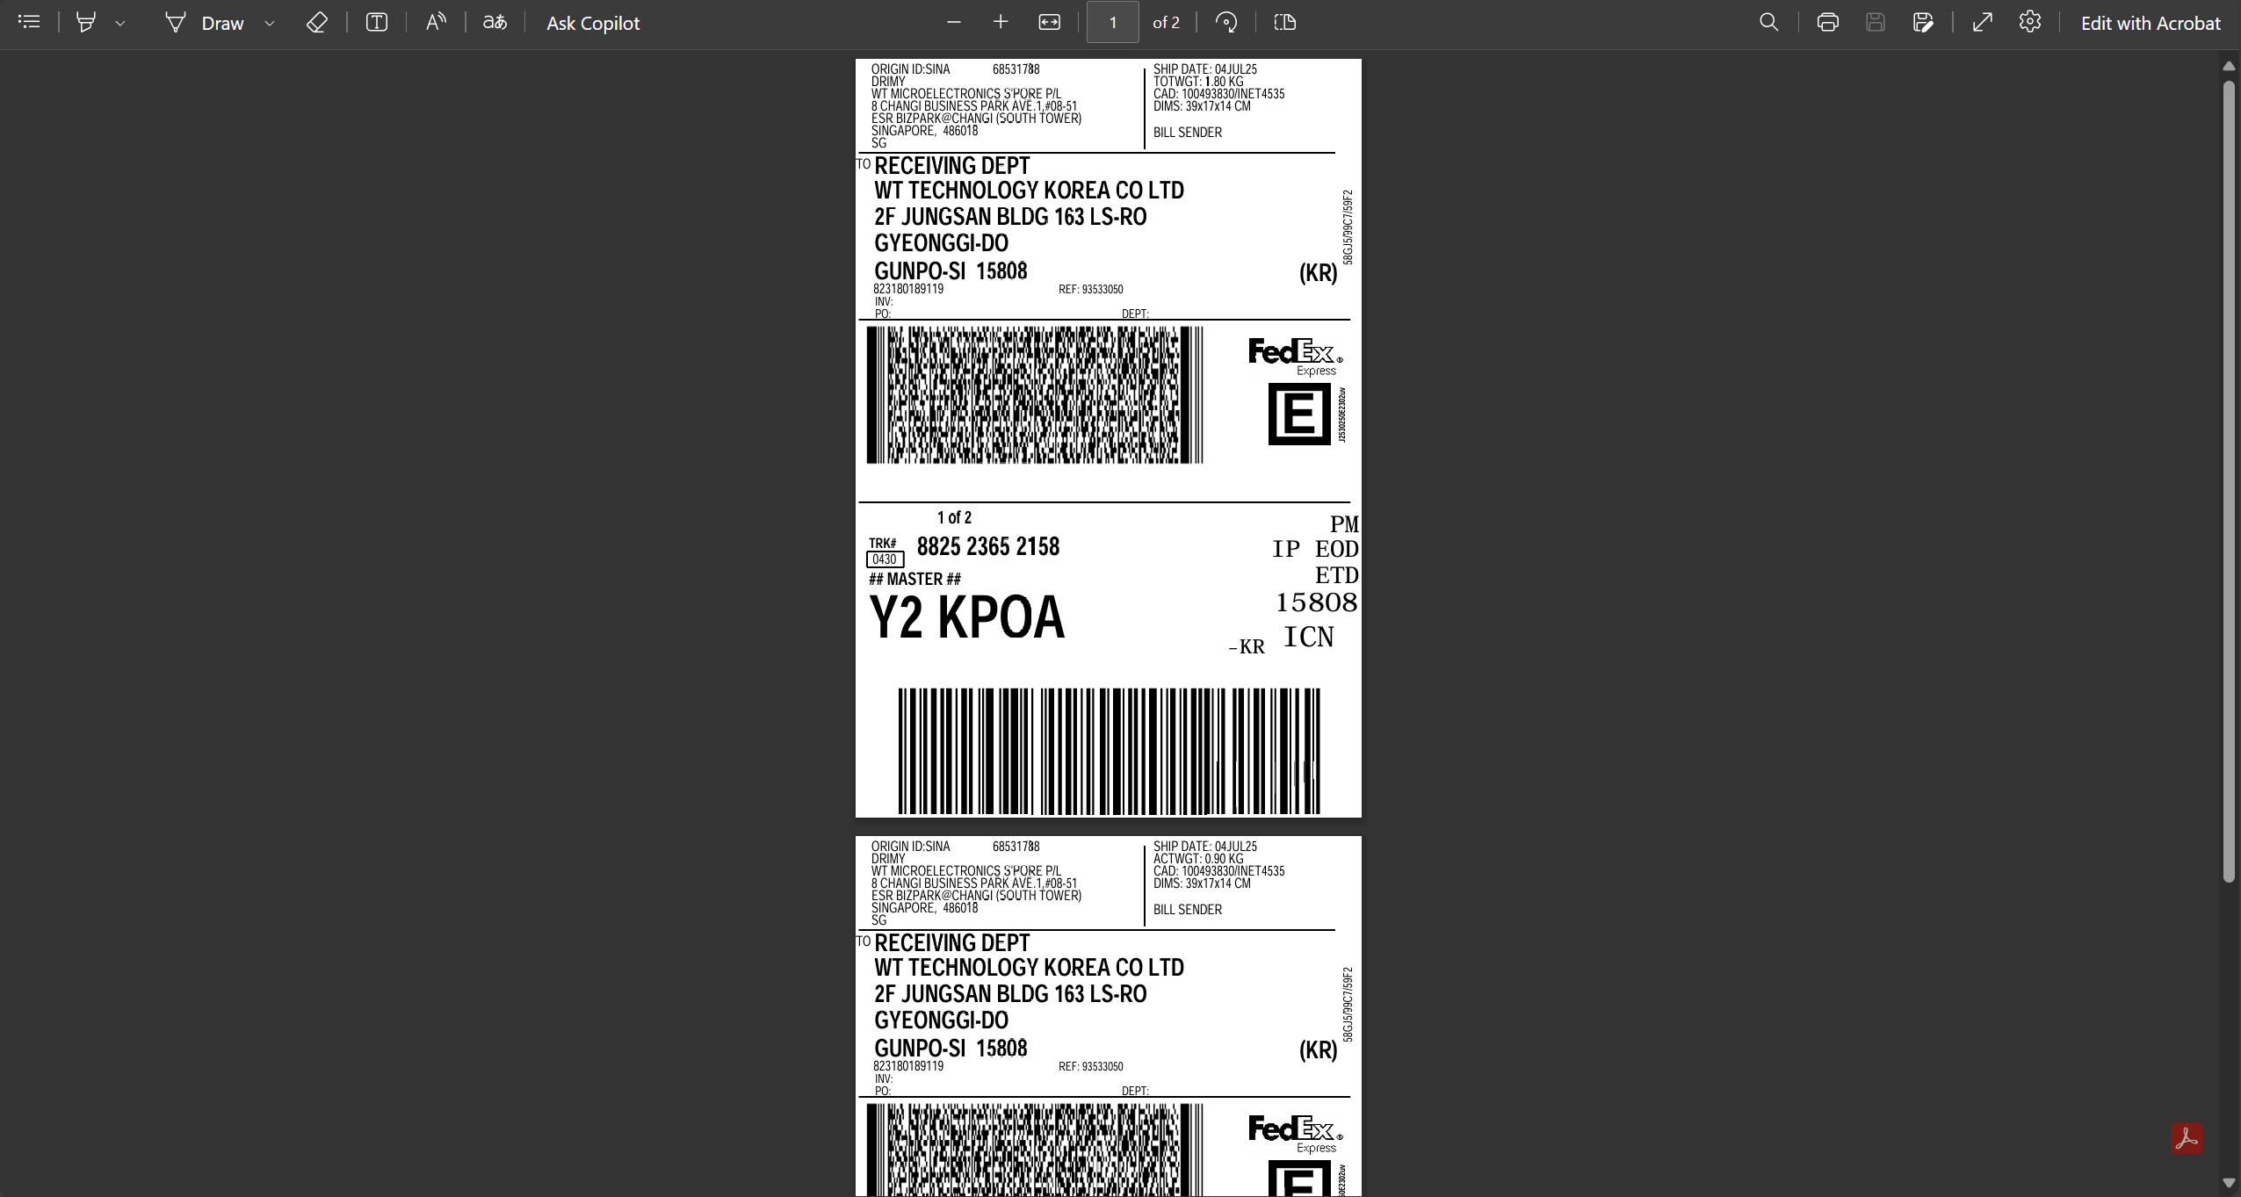

Additional
- CSR able to track via FedEx/DHL API (Refer API Documentation)
- Delete AWB / Shipping Instruction:
*Unlink AWB with Reference Number
*Unlink OB with Reference Number

**Important:
Input field and Data requirement may able to add after research with API Documentation, this only demonstrate.

External Link
FedEx API Documentation:
developer.fedex.com/api/en-us/get-started.html
DHL API Documentation:
DHL Express - MyDHL API

