Standard Operating Procedure

Using the Quality pages
Document reference: SOP-FRS-003 (assigned by the owner)
Draft revision: D0.1 | Prepared: 09 October 2026
Approval: NOT RECORDED | Effective date: NOT ASSIGNED

1. Purpose and scope
Use Quality to record observations, review nonconformances, investigate root causes, follow corrective and preventive actions, and review rejection reports. This procedure covers Findings, NCR, RCA, CAPA and Reject Reports, including navigation, supported actions, relationships and stop conditions.
Finding means a recorded observation. NCR means a nonconformance record. RCA means root-cause analysis. CAPA means corrective and preventive action. Reject Reports contains Issue slips and Daily reject records; these are separate record types with different completion controls.
This editable review draft follows the layout and structure of SOP-FRS-002. It does not assign scientific acceptance limits, initiation criteria, new permissions, deadlines or retention periods. Controlled approval and effectivity for this revision remain to be recorded.

2. Responsibilities and prerequisites
User: sign in with your own account, confirm your identity, open the relevant register and act only within the current permission, scope, state and version. Record facts from the applicable source; do not substitute an assumption for a missing source.
Quality owner: resolve Finding-to-NCR initiation criteria (PD-15). QC / inspection procedure owner: resolve the consequence of inspection FAIL (PD-16). QMS owner: resolve NCR closure authority and workflow (PD-17). Quality-policy owner: resolve general CAPA effectiveness requirements and criteria (PD-18).
Assigned RCA analyst and CAPA action owner: review the linked NCR, existing analysis or actions and available evidence. Labels naming the next owner are workflow guidance and do not grant access or approval authority.
P-04 CAPA closure is restricted to an active Supervisor with the explicit CAPA-close permission and authorized scope, subject to eligible state, current version, reason, reauthentication and electronic signature.
The named owner yazeed is the designated approval and activation authority for the FRS document family under the existing owner instruction. That document authority does not record approval or activation of this file or replace action-specific business controls.

3. Page elements and register meanings
Open the navigation menu and select Quality, then the required register. On a narrow screen, select Open navigation first. Confirm the page title and account menu before reviewing records.
Findings — https://qclevel.top/quality/findings. Create finding opens the draft form. State and Apply filter select Draft, Open, Under review, Closed or VOID. Populated rows show Finding number, Summary, Severity, State, Owner, Created and Source context. Open the finding number to view its details and visible related NCRs.
NCR — https://qclevel.top/quality/ncr. Read Workflow decisions still pending. Filter by State; open the NCR number to review the nonconformance, source finding and visible linked investigations. Rows identify Source finding, RCA and Next step. NCR initiation and closure are not offered while their governing decisions remain unresolved.
RCA — https://qclevel.top/quality/rca. Root-cause analyses are linked to NCRs. Filter by State and follow a linked NCR context where available. Create linked RCA draft is shown when a readable eligible NCR source exists. Draft creation and analysis submission are distinct from approval and NCR closure.
CAPA — https://qclevel.top/quality/capa. Read Policy status, then filter by State. Rows identify CAPA, Action plan, State, Source NCR, Actions, Effectiveness and Next step. Open the CAPA reference to inspect available context and the controlled closure operation where eligible.
Reject Reports — https://qclevel.top/reject-reports. Review summary cards, quantities by report type and recorded unit, analytics and Recent reports. Tabs are All, Issue slips, Daily reject, Awaiting approvals and Completed. Create report opens the form when permitted.
Reject filters include Search, Item code, Item name, Lot, Department, Recorded unit, Include missing unit, Status, From and To. Select Filter after entering the criteria. Dates use YYYY-MM-DD; correct invalid dates or a reversed range before interpreting results.

4. Operating procedure
4.1 Open and orient. Sign in, expand navigation and open the intended Quality page. Confirm the account, register title, filters and visible policy notice. Registers are current read views; reload after an operation to obtain the saved state.
4.2 Create a Finding draft. In Findings select Create finding. Enter Finding number from the approved source, Title and Description. Enter Severity only when an approved value is available. Select Save draft and confirm the saved record reference. A draft does not create an NCR or establish a quality decision.
4.3 Review a Finding. Filter the register, open the finding number and read its description, state, owner context and visible related NCRs. Follow the related NCR link only when present. Where PD-15 is pending, stop initiation and refer the criterion question to the Quality owner; do not assume automatic conversion.
4.4 Review NCR. Open the NCR reference and verify the source Finding, investigation context, state and permitted next step. Follow linked RCA or CAPA records where visible. An inspection FAIL does not itself authorize an NCR initiation consequence. READY_FOR_CLOSURE does not resolve PD-17 or mean CLOSED.
4.5 Create and prepare RCA. From RCA select Create RCA draft for the intended eligible NCR when shown. Confirm the source NCR before creating the separate draft. In the analysis detail enter Method, Analysis and Root cause supported by the investigation evidence; select Save analysis and confirm the retained values.
4.6 Start and submit RCA. In a supported Draft or Returned state select Start analysis. In In progress, review the saved method, analysis and root cause, then select Submit recorded analysis for review. Confirm Submitted. Approval, return and void remain unavailable pending the controlled policy and signature ceremony; submission does not approve RCA or close NCR.
4.7 Review CAPA. Open the linked CAPA and read the action-completion count, verification requirement, recorded effectiveness requirement, source NCR and current next owner. Review evidence in its owning workflow where available. The current page does not offer a general CAPA creation or action-edit form; do not substitute a hidden operation or database update.
4.8 Perform P-04 closure only when authorized. An eligible active Supervisor opens Close CAPA, checks the displayed version, enters Closure reason, reauthenticates and reviews the meaning “I close CAPA [reference], version [version].” Select Close CAPA and confirm the saved outcome and available audit/signature evidence. The exception permits closure despite incomplete actions or unaccepted effectiveness; it does not establish effectiveness or close the source NCR.
4.9 Review Reject Reports. Select the report type or approval tab and apply the needed item, lot, department, unit, status and date filters. Open the report number. Compare quantities only within the same recorded unit and report type; review missing units separately. Use the date-and-unit drilldown when displayed.
4.10 Prepare a rejection report. Select Create report, choose the appropriate Issue slip or Daily reject form, and enter the source date, department, material/product identity, lot, recorded quantities and unit, rejection reason and relevant remarks. Follow the form’s required fields. Use any rejection limit only from the applicable approved source; do not invent a limit.
4.11 Confirm report completion correctly. Issue slips record approval confirmations; Daily reject records need no approval. Confirm the actual report state and saved evidence in the detail page. A displayed confirmation or Completed/Finalized state is not by itself proof of an account-bound electronic signature, scientific acceptance or material release.
4.12 Reconcile after saving. Review the saved reference, values, state, version and available history. Return to the register, reapply relevant filters and refresh. If a response is interrupted or the outcome is unclear, inspect the existing record before retrying to avoid duplicate records or decisions.

5. Counts, states and exceptions
Independent records: Finding, NCR, RCA, CAPA, Issue slip and Daily reject counts measure different populations. Do not add them as one quality completion total or assume a mandatory automatic chain. Relationships apply only where recorded and visible.
Empty view: No records in this view applies to the account, source and filters currently read. Clear filters where appropriate; absence does not prove closure or that other scopes contain no records. Findings uses pagination with 25 records per page when populated; inspect additional pages where shown.
Unavailable source: retry from the register and report the page, time, account role and displayed message to support if persistent. An unavailable related source does not make a relationship absent or its count zero. A record not found may be nonexistent or outside your authorized scope.
Policy stop: PD-15, PD-16, PD-17 and PD-18 remain explicit limits in the current pages. Refer each issue to its named decision owner. Do not treat an administrator label, a visible link or this SOP as authority to bypass a blocked action.
State/version conflict: retain your proposed input, reload and review the saved record before a new attempt. Reassess state, scope and intended action. Do not retry approval using a stale version.
Quantity interpretation: keep exact source quantities and recorded units. Different units and report types are not added or silently converted. A missing reject percentage is not zero; inspect its source and denominator before using it.
Closure and release: CAPA CLOSED does not prove effectiveness. RCA SUBMITTED does not mean APPROVED. NCR closure is a separate controlled decision. Scientific PASS and RELEASED remain separate. Reject reports do not release receiving material.

6. Records and review checks
Operational evidence stays with the individual record: reference, source relationship, recorded values, state/version, actual transition history and applicable signature/audit evidence. Retain applicable investigation and action evidence under the approved process; this SOP defines no new retention period.
Before controlled use, verify representative permitted and denied accounts, populated registers, linked detail pages, draft saves, RCA submission, P-04 closure and rejection-report completion. Include stale submissions, uncertain outcomes and unavailable related sources. Check role-bound signing where required.
Authoring verification on 09 October 2026: authenticated read-only review using yazeed opened all five live registers and observed their empty views, filters and policy messages. Findings and Reject Reports showed their creation links. No business record was created, changed, approved or closed. Populated details and mutation/signature ceremonies were not exercised.
Reviewer: NOT RECORDED. Approver: NOT RECORDED. Document reference: SOP-FRS-003. Effective date: NOT ASSIGNED. Layout and content checks support authoring only; they do not establish operational acceptance.

7. References and revision history
R1: Live site https://qclevel.top — authenticated register observations on 09 October 2026 for /quality/findings, /quality/ncr, /quality/rca, /quality/capa and /reject-reports. Record details and mutation paths were reviewed from source only.
R2: src/pages/quality/findings/index.astro, new.astro and [findingId].astro — register, draft entry and relationships.
R3: src/pages/quality/ncr/index.astro and [ncrId].astro; src/pages/quality/rca/index.astro and [rcaId].astro — policy notices, linked investigation and supported RCA draft/save/start/submit.
R4: src/pages/quality/capa/index.astro and [capaId].astro; src/modules/quality/capa/application/close-capa.ts — current CAPA presentation and controlled P-04 closure.
R5: src/pages/reject-reports/index.astro and new.astro — report types, filters, unit-separated analytics and entry forms. Source candidate: 6d925d74d243bbfd77ab5b784c21cd68303672b6; working tree was clean at inspection. Live deployed SHA was not independently established.
R6: SOP-FRS-001 Document control and sources; SOP-FRS-002 D0.1 Work page — document control context and retained design template. Approval of a draft is not inferred from a cited reference.
D0.1 | 09 October 2026 | Initial review draft covering the five Quality registers, source-supported operations, live empty views, policy stops and evidence boundaries. No application, permission or database change.

Visual operating guide
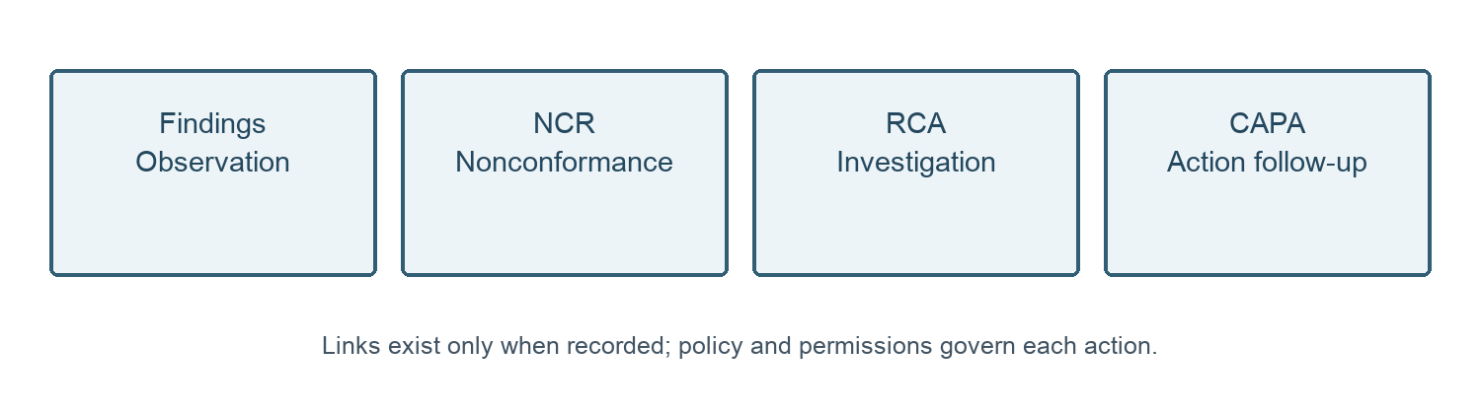
Figure 1. Quality record relationships. This is a navigation guide, not an automatic initiation or closure chain.
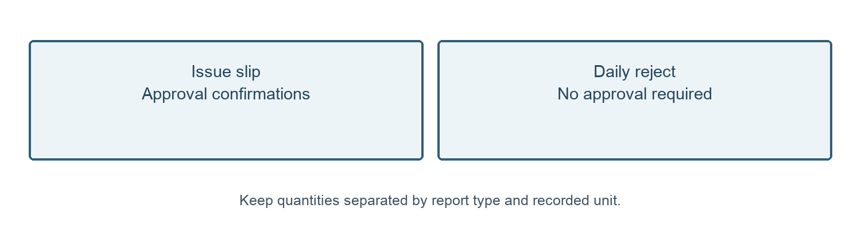
Figure 2. Reject report types. Completion, signature evidence and material release are distinct.

