Standard Operating Procedure

Using Administration pages
Document reference: SOP-FRS-009 (assigned by the owner)
Draft revision: D0.1 | Prepared: 09 October 2026
Approval: NOT RECORDED | Effective date: NOT ASSIGNED

1. Purpose and scope
Use Administration to inspect member accounts and manage authorized account, role, permission and scope changes. This procedure covers Administration (/admin), Users (/admin/users), Roles (/admin/roles), Permissions (/admin/permissions) and Scopes (/admin/scopes) at https://qclevel.top.
A role groups permission grants. A permission identifies an action. A scope defines the records to which an authorized action can apply. Opening a page, holding a role or holding GLOBAL scope does not by itself authorize a change or a QC approval.
This SOP describes current live pages and source-supported conditional controls. It creates no access approval, signature policy or retention rule. SOP-FRS-009 D0.1 is a review draft; approval and effectivity must be recorded before controlled use.

2. Responsibilities and prerequisites
Authorized administrator: confirm the intended member, approved access requirement and exact operation before changing access. Review the resulting account state and grants after the server confirms success. Use your own active account and keep credentials out of SOPs, screenshots and audit notes.
Access owner and responsible manager: establish which duties, roles and record scopes are required. Resolve authority questions through the approved process. A selected checkbox is proposed access, not evidence that access has been approved.
Member: use your assigned account, keep your credentials private and change a temporary password at the required first or next sign-in. Report unexpected access or inability to perform assigned work through the support process.
Creation and profile management require PERM-IDN-MANAGE-USERS. Initial and later role membership need PERM-ADM-ROLE-ASSIGN; scope assignment and removal need PERM-ADM-SCOPE-ASSIGN. Role permission replacement needs PERM-ADM-PERMISSION-ASSIGN on an active role. Creation and role grant replacement use global authorization context in the local source.
Account operations have separate permissions: PERM-IDN-DEACTIVATE for Disable account, PERM-IDN-ACTIVATE for Activate account, PERM-IDN-RESET-PASSWORD for Reset password and PERM-IDN-REVOKE-SESSIONS for Revoke all sessions. Follow the displayed per-action capability and current state; an administrator label alone is insufficient.
Document Control maintains this SOP identity, revision and controlled distribution. The FRS owner direction identifies yazeed as approval and activation authority; it does not record approval or effectivity of this draft. Administration has no electronic-signature ceremony in the inspected controls; an audit event is not an electronic signature.

3. Page elements and register meanings
Administration offers Users with Open users and Create user, Roles with Open roles, Permissions with Open permissions, Scopes with Open scopes, and Audit history with Open audit. The audit link supports traceability and is not another access-editing screen.
Users has Search accounts, Account state and Apply filters. State choices are All states, Active, Inactive and Disabled. The register displays Login identity, Display name, State, Roles and Scopes, with the authorized account count and page position. Select the Login identity link to open the member.
Member details contain Account profile, Account lifecycle, Roles, Scopes and Your authority for this member. Profile facts include Login identity, Email, State, Must change password and Last login. Technical record details is a secondary disclosure. Read the authority panel and each operation-specific note before acting.
Create user contains Login identity, Display name, Email (optional), Temporary password, Initial roles (optional) and Initial scopes (optional). The current role list shows ADMIN, EMPLOYEE, MANAGER, SUPERVISOR and SYSTEM_OWNER. Listing SYSTEM_OWNER as an option does not authorize a second owner; the named-owner restriction still applies.
Roles is a read-only catalog of Name, Role type, Status and Version. Open a role name to inspect Configuration and Canonical grants. An authorized operator can select permission checkboxes and use Replace grants. This replaces the entire permission set for the role; it does not assign that role to a member.
Permissions is a read-only Active permissions table with Permission, Domain and Action. Use the exact PERM code to identify a grant. Grants change through Roles; there is no direct member-permission edit or permission-creation control on this page.
Scopes lists the canonical vocabulary and offers Browse members. OWN means Own records; ASSIGNED means Assigned records; TEAM means Team records; DEPARTMENT means Department records; SITE means Site records; DOMAIN means Domain records; GLOBAL means Whole system.
TEAM, DEPARTMENT, SITE and DOMAIN require a value identifying the approved collection. OWN, ASSIGNED and GLOBAL take no value. Use a real approved identifier; do not invent a team, department, site or domain to obtain access. Scope alone never satisfies permission, state, separation of duties or business checks.

4. Operating procedure
4.1 Confirm identity and purpose. Open https://qclevel.top and sign in if required. Confirm your account and choose Administration from navigation. Identify the access request or operational reason before opening a change control.
4.2 Find the member. Select Open users. Enter Search accounts and choose Account state as needed, then select Apply filters. Read the authorized count and any page controls. Open the exact Login identity; do not select a similarly named account by display name alone.
4.3 Check current authority. Confirm Login identity, State, current roles and current scopes. Read Your authority for this member. View only or Not allowed means stop at inspection. If a grant list is unavailable, do not treat it as empty or prepare a replacement from incomplete information.
4.4 Create an authorized account. Select Create user. Enter the agreed unique Login identity and Display name, optional Email and a temporary password using the approved secure handling process. Do not reuse another member identity or put a password in an access request record.
4.5 Select initial access separately. Choose only approved Initial roles and Initial scopes. Enter collection values only for TEAM, DEPARTMENT, SITE or DOMAIN. Account-creation permission does not grant permission to assign initial roles or scopes. Avoid selecting SYSTEM_OWNER for a new member; it is restricted to the canonical named owner.
4.6 Confirm creation. Review all fields and selections, then select Create user once during authorized operation. Read any field errors. After confirmed success, verify the resulting member identity, ACTIVE state, roles, scopes and the requirement to change the temporary password at first sign-in. Use Cancel to leave without creating.
4.7 Update another member profile when permitted. Open the member and change Display name or Email (optional) in Account profile. Select Save profile once. The current form does not edit Login identity. Confirm the refreshed values; self profile edits through administration are disabled.
4.8 Disable an account when authorized. In Account lifecycle, select Disable account for an ACTIVE member. Review the dialog subject and effect, then confirm Disable account or select Cancel. Confirm the resulting DISABLED state. Disabling revokes every active session and is audited; it is not deletion of the account.
4.9 Activate an account when authorized. For an eligible non-active member, select Activate account. Confirm the correct subject in the dialog, then confirm the operation. Read back ACTIVE state. Activation restores account status; it does not add missing roles or scopes or prove successful sign-in.
4.10 Revoke sessions when authorized. Select Revoke all sessions, inspect the member named in the dialog and confirm. This ends active sessions without changing account state or password. Review the confirmed outcome and relevant audit event. Do not infer a session count from a page that does not display it.
4.11 Reset another member password when permitted. Enter a temporary password in Account lifecycle and select Reset password. Review the member in the confirmation dialog and confirm only the intended reset. A successful reset revokes sessions and requires a password change at next sign-in. Share the temporary credential only through the approved secure channel.
4.12 Respect self and owner protections. Administration blocks self-disable, self-activate, self session revocation, self password reset, self role changes and self scope changes. SYSTEM_OWNER membership and GLOBAL scope of the canonical yazeed owner are Protected. Do not attempt their removal through another interface or a crafted request.
4.13 Assign a role to another member. Read Current roles. If Assign role is available, choose the approved Role and enter Reason (optional) when useful for traceability. Select Assign role once. After the page refreshes, verify the exact role code in Current roles. Already assigned roles need no duplicate grant.
4.14 Remove a role when permitted. Select Remove role on the exact non-protected active membership. Read the member, role and effect in the confirmation dialog. Confirm or Cancel. Verify the role is no longer assigned. Permissions supplied by other roles can remain; removing one role is not proof of total access revocation.
4.15 Inspect role permissions. Open Roles and select the exact role name. Confirm Code, Status and Version, then read Canonical grants. Use Permissions to clarify the exact PERM code and action. The current Roles catalog does not offer role creation, rename or activation controls.
4.16 Replace the role grant set only for an approved change. Review the complete checked set, not just the newly selected checkbox. Select desired permissions and clear only grants approved for removal. Consider all members holding this role. Replace grants writes the complete selected set and can remove every unchecked grant.
4.17 Apply and verify grant replacement. Select Replace grants once. The current control submits directly; do not rely on a second confirmation dialog. After confirmed success and reload, verify the role version and complete resulting grant set. A stale version requires a fresh review; never overwrite unseen changes.
4.18 Open scope administration. From Scopes, read Canonical vocabulary and select Browse members. Find the member and open their Scopes section. Confirm current grants and collection values. The Scopes catalog itself has no stand-alone assignment form.
4.19 Assign one scope when permitted. In Assign scope, choose Scope kind. Enter Scope value for TEAM, DEPARTMENT, SITE or DOMAIN; leave it absent for OWN, ASSIGNED or GLOBAL. Enter Reason (optional) if needed, then select Assign scope once. Verify the exact kind and value after refresh.
4.20 Remove one scope when permitted. Select Remove scope for the specific grant. Review the dialog member and scope, then confirm or Cancel. Verify that grant is gone and unrelated scopes remain. An identical grant assignment is idempotent in the local source; an absent-grant removal is a no-op, not a new access change.
4.21 Use bulk replacement only for an intentional approved reset. If Bulk operations is available, read its warning and review the complete Resulting scope set and collection values. Replace scopes revokes the current set and writes the selected set in one transaction. Prefer incremental Assign scope and Remove scope for a single change.
4.22 Resolve stale data safely. For CONFLICT_STALE_VERSION or a stale message, select Refresh record when shown, or refresh the role detail. Read the current state and version, reassess the intended operation and submit only if still permitted. Role memberships and individual scopes do not carry a version column; do not invent a version check for those controls.
4.23 Resolve other errors. For validation errors, correct the identified fields. For changed authorization, stop the action and route the access issue to the responsible owner. For provider or catalog unavailability, wait for recovery and reread the record. A missing confirmation is not proof that the operation failed.
4.24 Confirm the outcome before retrying. Review the latest member or role state and available audit history after a timeout or interruption. Do not repeat an uncertain create, password reset or complete-set replacement until the result is reconciled. Never expand your own access to resolve a refusal.

5. Counts states and exceptions
On 09 October 2026, authenticated live reading with yazeed showed one authorized ACTIVE member, holding ADMIN and SYSTEM_OWNER and a protected GLOBAL scope. Its detail page showed self-management restrictions. Five active roles were visible at version 1. These are observations of that view at authoring time, not fixed system totals or approved role assignments.
Permissions displayed a read-only canonical catalog. The Admin role detail exposed checked permission grants and Replace grants. Scopes displayed all seven kinds and Browse members. The create-user form was read without entry or submission. No new account or access change was made.
Only the owner account was present in the observed member register. Other-member profile, lifecycle, role and scope controls are described from local source and were not exercised live. Do not treat these conditional instructions as verified production mutation, sign-in or session-revocation evidence.
ACTIVE, INACTIVE and DISABLED are account states. Must change password is a separate flag. Active role status, an account role label, GLOBAL scope, permission catalog membership and controlled approval authority are distinct facts.
Admin-only status does not establish QC review, scientific approval, release or document effectivity authority. Those workflows retain their own permission, scope, state, separation-of-duties and signature requirements. An administration change cannot serve as a retrospective QC approval.
The local role-replacement control has no electronic-signature step. Document any applicable authority requirement through the approved governance process; this SOP does not create a signature bypass or treat an audited checkbox change as a signed approval.

6. Records and review checks
Retain the approved access request or reason, affected member or role identity, intended and resulting access, operator and time, and relevant audit reference through the approved records process. Record only non-secret metadata. This SOP supplies no retention duration or new access-request storage workflow.
Use Open audit from Administration when authorized to inspect the relevant change. Confirm the actor, subject and operation against the resulting record. An audit event records the action; it does not prove that assigned duties, access approval, electronic signature or human acceptance are complete.
Before controlled adoption, verify creation with permitted and denied initial grants, another-member profile and lifecycle actions, protected/self denials, role replacement and stale recovery, scope value validation, incremental versus bulk effects, unknown-outcome recovery and audit consistency in an authorized test environment. Credential changes must be performed by an authorized human operator.
Authoring evidence: live authenticated reading of all five requested pages, create-user form, own-member detail and Admin role detail on 09 October 2026; local source review of conditional operations and guards. Creation, update, disable, activation, session revocation, password reset, role replacement and scope mutations were NOT RUN. Deployed-source parity and human UAT remain NOT VERIFIED.
Reviewer: NOT RECORDED. Approver: NOT RECORDED. Reference: SOP-FRS-009. Draft revision: D0.1. Effective date: NOT ASSIGNED. Document preparation does not register an approval or effective version.

7. References and revision history
R1: https://qclevel.top/admin; https://qclevel.top/admin/users; https://qclevel.top/admin/roles; https://qclevel.top/admin/permissions; https://qclevel.top/admin/scopes — authenticated live observations on 09 October 2026.
R2: SOP-FRS-001 Document control and sources — related review draft. The current SOP-FRS-008 Word file supplies the FRS design and seven-section structure. Referencing a draft does not establish controlled approval or effectivity.
R3: src/pages/admin/index.astro, users/index.astro, users/new.astro, users/[userId].astro, roles/index.astro, roles/[roleId].astro, permissions/index.astro and scopes/index.astro — page labels, conditional controls and recovery behavior.
R4: src/modules/identity/application/create-user.ts; src/modules/administration/application/update-role-permissions.ts, manage-user-role.ts, assign-user-scope.ts and remove-user-scope.ts; src/shared/authorization/types.ts — explicit grants, scope semantics and source guards. Local source HEAD: 6d925d74d243bbfd77ab5b784c21cd68303672b6. Identity with the deployed artifact was not verified.
D0.1 | 09 October 2026 | Initial review draft for Administration, Users, Roles, Permissions and Scopes. SOP-FRS-009 assigned by the owner; current FRS design and structure preserved.

Visual operating guide
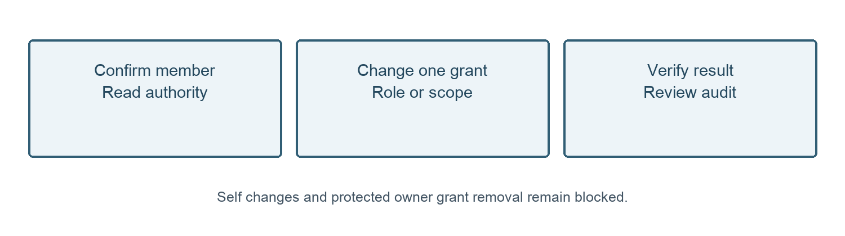
Figure 1. Member access path. Check the exact identity and current authority before each change.
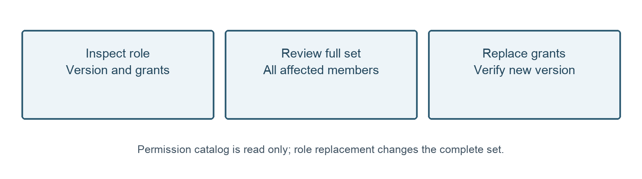
Figure 2. Role permission path. Review the complete selected set before replacement.

