Standard Operating Procedure

Using Workspace Tools
Document reference: SOP-FRS-011 (assigned by the owner)
Draft revision: D0.1 | Prepared: 09 October 2026
Approval: NOT RECORDED | Effective date: NOT ASSIGNED

1. Purpose and scope
Use Workspace Tools to read your notifications, find authorized records, manage your own password and browser session, and consult operating guidance. This procedure covers Notifications (/notifications), Search (/search), Account settings (/account) and Operating guides (/help) at https://qclevel.top.
These four links sit together under WORKSPACE TOOLS in primary navigation. They support work across domains; a notification or search result does not transfer decision authority, and an operating guide does not grant a permission.
SOP-FRS-011 D0.1 describes authenticated live observations and conditional controls confirmed in local source. It is a review draft. Approval is NOT RECORDED and the effective date is NOT ASSIGNED. It defines no new password rule, notification obligation, response time, retention period or QC decision.

2. Responsibilities and prerequisites
Account holder: use your own ACTIVE authenticated account. Confirm the signed-in identity before reading recipient-specific information or changing credentials. Keep passwords out of screenshots, search terms, records and support requests.
Authorized operator: use notifications and search to locate the exact record, then follow the owning domain procedure. Confirm the record state, version, scope, assigned stage and available action before acting. Reading a notification does not complete, approve, close or release its subject.
Supervisor and QCM: resolve operational or quality blockers through the existing review and escalation route. A role card in Operating guides is a starting-point summary; actual decisions still depend on server authorization and any required electronic signature.
Access administrator: resolve missing search or notification access and incorrect account information through the governed member workspace. The account page does not edit login identity, display name, email, roles or scopes. Follow SOP-FRS-009 for controlled account administration.
Named system owner and support functions: handle platform, security, authentication, database and production decisions within their existing authority. The help page routes escalation by function. Do not infer an individual contact, SLA or approval authority from a generic role description.
Document Control and QMS: review this SOP against the current interface, related FRS drafts and applicable controlled sources before approval, effectivity and distribution. The owner-assigned reference SOP-FRS-011 identifies this document; it does not itself approve the content.

3. Page elements and register meanings
Navigation: Open navigation reveals the domain sections and the separate WORKSPACE TOOLS group. Its four links are Notifications, Search, Account settings and Operating guides. Close navigation or Escape returns to the workspace. Ctrl/Cmd+K is the displayed shortcut to Search.
Notifications: All and Unread switch the recipient-scoped view. A populated row contains title, message, created time, severity and Read or Unread status. Its subject link opens the relevant record when a destination is known; an unknown or missing subject stays on Notifications.
Unread rows conditionally offer Mark “[notification title]” as read. This is a separate state-changing control. The register shows up to 50 notifications per page and page controls when more are available. It has no compose, recipient selection, delete, mark-all-read or notification-preference control.
Search: Find authorized records contains Search records, Search, and Clear search after a query. Enter or Search submits the query. Result rows show record type, business reference, description, state and optional context. Next results appears only when another result page exists.
Search accepts a nonblank term of 1–200 characters. The current source supports Tasks, Receiving items, Inspection reports, Laboratory tests, Findings, NCR, RCA, CAPA, Equipment, Documents, Change requests and Reject reports. Results are subject to search permission plus each domain read permission and scope; the interface provides no domain filter or bulk action.
Account settings: Account information displays Login identity, Display name, Email and State. Password and security contains Current password, New password, visibility controls and Change password. Session contains Sign out. There is no confirmation-password field, profile editor, session inventory, per-device revoke control or account-deletion control here.
Operating guides: Print this guide and On this page lead to Start of day by role, Everyday routes, Screen and state guidance, Troubleshooting, Escalation and handoff, and Service interruption. Role cards cover Employee, Supervisor, Manager (QCM), Admin and System owner (named). Links are filtered by page visibility, which remains separate from action authority.
The guide includes receiving, two-stage inspection review and document-version state tables. It states that PASS and RELEASED are separate and APPROVED documents are not automatically EFFECTIVE. The page is a derived operational summary; it does not replace controlled role, permission, state-machine or business-rule sources.

4. Operating procedure
4.1 Open a Workspace Tool. Confirm the signed-in account, open navigation and choose one of the four links under WORKSPACE TOOLS. Use the exact route in section 1 if needed. After a session-expiry redirect, sign in with your own account and return to the intended page.
4.2 Read your notifications. Open Notifications and select All for the full authorized recipient view or Unread for outstanding read items. Read the displayed count, active filter and page. No notifications means no rows in that recipient view; it does not show that no business work is pending.
4.3 Interpret a populated notification. Read its title, message, time, severity and current read state. Follow its link and match the business reference and current state on the subject page. Notifications can reflect an earlier event; the current controlled record remains the decision source.
4.4 Mark an item as read when appropriate. Return to Notifications and select the individual Mark “[notification title]” as read control once. Wait for confirmation or reload, then verify Read in All or its removal from Unread. Marking as read changes notification read state only; continue any business action in the subject workspace.
4.5 Resolve an unconfirmed read-state change. If the notification is missing, no longer belongs to this account, access is denied, or a provider/stale message appears, refresh the register and inspect its current read state before deciding whether to retry. Do not treat an interrupted request as confirmed success.
4.6 Navigate notification pages. Use the displayed page controls when the view exceeds one page. Confirm that All or Unread still reflects your intended view after navigation. Return to the named filter if needed. This SOP does not claim multi-page live behavior was exercised during preparation.
4.7 Handle an unavailable notification source. Read the specific access, invalid-page or service-unavailable message. For an invalid page use Open page 1; for access refusal ask the administrator to review access; for an outage refresh after recovery. Unavailable data is not an empty register or a zero count.
4.8 Open Search. Choose Search under WORKSPACE TOOLS or use Ctrl/Cmd+K. Enter an exact record number, document number, lot, task title or suitable description. Use the minimum relevant non-secret text; search terms appear in the page URL and may remain in browser history.
4.9 Submit the search. Select Search or press Enter. Read “Showing [displayed] of [total] authorized results” and the query. The displayed count is the current page; the total is the authorized matching population. Neither represents every record in the system.
4.10 Open the correct result. Compare record type, business reference, descriptor, state and context before following the result link. On the record page, recheck identity and current state. Search grants no create, edit, review, approval, signature or release authority.
4.11 Continue or reset the search. Select Next results when offered to read the next bounded result page. Use Clear search to return to the starting view. If a result-page link is no longer valid, start the same search again; do not alter the paging token.
4.12 Resolve zero results. Check spelling and the reference, then use a broader non-secret term if appropriate. No matching records found is limited to the authorized query. Ask the responsible domain or access administrator to investigate an expected record; do not infer that an undisclosed record was deleted.
4.13 Resolve invalid or unavailable search. Correct an empty or excessive query to 1–200 characters. If Search is not available for this account, request access review. If Search is temporarily unavailable, retry the same search after service recovery; no result count is established while the source is unavailable.
4.14 Inspect your account. Open Account settings and confirm Login identity, Display name, Email and State. If identity or profile data are wrong, ask an administrator to correct them in the member register under SOP-FRS-009. This page cannot make profile, role or scope changes.
4.15 Prepare a password change only when needed. Read the warning that changing your password ends all active sessions, including this one. Finish or safely preserve any pending work through its normal controlled workflow first. Enter Current password and the intended New password yourself, following the applicable approved security policy.
4.16 Review private password entry. Use Show password only in a private setting when needed, then hide it again. The current form has two password fields and no separate confirmation field. This SOP supplies no invented minimum length, expiry interval, complexity requirement or recovery credential.
4.17 Submit a password change once. Select Change password and wait for the confirmed redirect to sign-in. Sign in again with the new password. The source commits the credential update, active-session revocation and secret-free audit event together; actual production execution was not tested for this SOP.
4.18 Handle password-change failure. Correct a current-password validation error or a required-field error as displayed. For changed security details, reload before another attempt. For denied or missing-account states, stop and contact the administrator. For provider failure or an unconfirmed outcome, do not submit again yet; seek administrator assistance to reconcile the result without sharing either password.
4.19 Sign out when finished. Select Sign out under Session to end this browser session. Confirm the return to sign-in before leaving a shared workstation. Signing out here is distinct from changing the password, which ends all active sessions. Administrator-revoked sessions are rejected on their next request.
4.20 Consult Operating guides. Open the page and choose the needed On this page link. Start with the role card for your work, then use Everyday routes to reach the appropriate register. Page links are navigation aids; authorize the actual operation through the target workspace.
4.21 Read state guidance in context. Match the specific record and state to the table, then inspect its own page for the current next action. The guide is summarized and may omit implementation blockers. In particular, the live two-stage table explicitly describes a signature at final approval; current local policy also requires a stage-one Supervisor signature. Follow the current domain procedure and signature ceremony rather than infer that stage one is unsigned.
4.22 Preserve controlled boundaries. PASS does not release material. A notification that a test or inspection was approved is not a release instruction. APPROVED does not activate a controlled document. The guide’s role descriptions do not enable currently blocked document approval, effectivity or production recovery.
4.23 Use troubleshooting for a refusal. Hidden action controls require authority/state/scope review; Refresh record requires rereading and reassessing the current version. Missing scientific source or criterion requires escalation. A lost request response requires record/history reconciliation before retrying. Do not create a second channel of controlled data to avoid an outage.
4.24 Escalate by function. Employee escalates blocked work to Supervisor; Supervisor escalates critical or recurring quality issues to QCM; QCM escalates cross-domain, compliance or production risk to the named owner; Admin escalates security, authentication, database, migration, backup and outage issues to the named owner. Use the organizational contact register when available; do not invent a contact or deadline.
4.25 Prepare a useful handoff. Retain route, check time, record/request reference, current state, relevant filter, safe error/reference and the next responsible function. Separate confirmed facts from unconfirmed outcomes. Exclude credentials, raw sensitive payloads and unnecessary controlled content.
4.26 Print guidance when required. Select Print this guide to open the browser print workflow. Review the proposed output and date before printing or saving. A printout of the help page remains a derived information copy; it is not an approved SOP, effective WI, record approval or evidence of completed training.
4.27 Respond to service interruption. Stop dependent approval, release or signature work when an outage is shown. Report it to technical support/Admin; production decisions go to the named owner. After recovery, sign in if needed and inspect record/history and notification state before resuming an interrupted operation.

5. Counts states and exceptions
Authenticated observations on 09 October 2026 used the existing yazeed session, displayed as Administrator · System owner. All notifications showed no notifications sent to this account; Unread was inspected separately. These recipient-view observations do not prove that every critical workflow has a configured notification or that a worker delivered events.
The live Search starting view and a query for SOP-FRS-011 were inspected. The query showed 0 of 0 authorized results and No matching records found. This only establishes that response for the account/query/time; the new Word draft is not registered in the application by creating it locally.
Account showed login identity yazeed, display name Yazeed, Email Not provided and State Active. Current password, New password, Change password and Sign out were visible. Neither password entry, password change nor sign-out was executed.
The four WORKSPACE TOOLS links and all six help sections were visible. The guide’s stage-one signature summary is incomplete relative to the current local domain policy; section 4.21 records this limitation. A help link or role card does not establish that the linked action is implemented, permitted or successfully executed.
Current source projects only final APPROVED inspection and laboratory events to their authors through the QC outbox handler. Stage one is silent in that handler. This does not establish a complete event/recipient catalogue, scheduled worker operation, external email/SMS/push delivery, or notification response SLA.
Read and Unread are notification states, not business states. A successful empty result, authorization refusal, invalid query/page and provider outage are separate outcomes. Never use zero-result or read-state counts to claim domain completion or acceptance.

6. Records and review checks
Record only evidence needed for the investigation or controlled process: tool/route, time and timezone, signed-in account reference when appropriate, filters/query context without secrets, subject reference, observed state, action result, safe error/request reference and responsible follow-up function. Apply the existing records process; no new retention period is defined here.
A read notification is no proof of task completion, review, approval, release, receipt acknowledgement under a new policy or human training. A search result is a locator and authorized projection, not a signed controlled record. A printed guide is informational unless separately controlled through the approved document process.
Authoring evidence: live authenticated inspection of Notifications, Search, Account settings and Operating guides, the Workspace Tools navigation, and one non-secret search on 09 October 2026. Local source review supplied conditional notification, search paging, password, session and outbox boundaries. The search may create aggregate product-analytics telemetry; no business decision or credential change was submitted.
Live populated notification rows, mark-as-read, positive search results, multi-page navigation, credential/session mutations, print output, denied personas, provider fault recovery and human UAT were NOT RUN. Local source review is distinct from independent deployed-artifact parity, which is NOT VERIFIED for this SOP.
Before controlled adoption, verify own-recipient versus other-recipient access; read-state success and interrupted outcomes; authorized positive/zero search and paging; safe denied/unavailable views; password-update/session/audit consistency in an authorized test environment; sign-out; help links and printed copy; and reconciliation of guide summaries against effective domain rules.
Reviewer: NOT RECORDED. Approver: NOT RECORDED. Reference: SOP-FRS-011. Draft revision: D0.1. Effective date: NOT ASSIGNED. Preparation of this review draft does not register, approve, activate or operationally adopt it.

7. References and revision history
R1: https://qclevel.top/notifications; https://qclevel.top/search; https://qclevel.top/account; https://qclevel.top/help — authenticated page observations on 09 October 2026; primary navigation confirms the four WORKSPACE TOOLS links.
R2: SOP-FRS-010 D0.1 System pages — design and seven-section template source. SOP-FRS-009 D0.1 Administration pages, SOP-FRS-004 D0.1 Quarantine pages, SOP-FRS-005 D0.1 Laboratory tests, and SOP-FRS-001 Document control and sources — related review drafts. Referencing them does not establish approval or effectivity.
R3: src/pages/notifications.astro, search.astro, account.astro and help/index.astro; src/shared/notifications/{notification-service,notification-destination}.ts; src/shared/search/{search-service,search-result,search-result-destination}.ts — page controls and conditional read boundaries. Local source HEAD: 6d925d74d243bbfd77ab5b784c21cd68303672b6.
R4: src/modules/identity/application/change-password.ts; src/modules/identity/infrastructure/postgres-credential-mutation-commit.ts; src/actions/account.ts; src/shared/outbox/qc-event-handler.ts — credential/session mutation and limited notification projection boundaries. Source evidence does not substitute for exercised deployment behavior.
D0.1 | 09 October 2026 | Initial review draft for the four Workspace Tools pages. SOP-FRS-011 assigned by the owner; FRS header, footer, styles, seven-section structure and visual operating guide preserved.

Visual operating guide
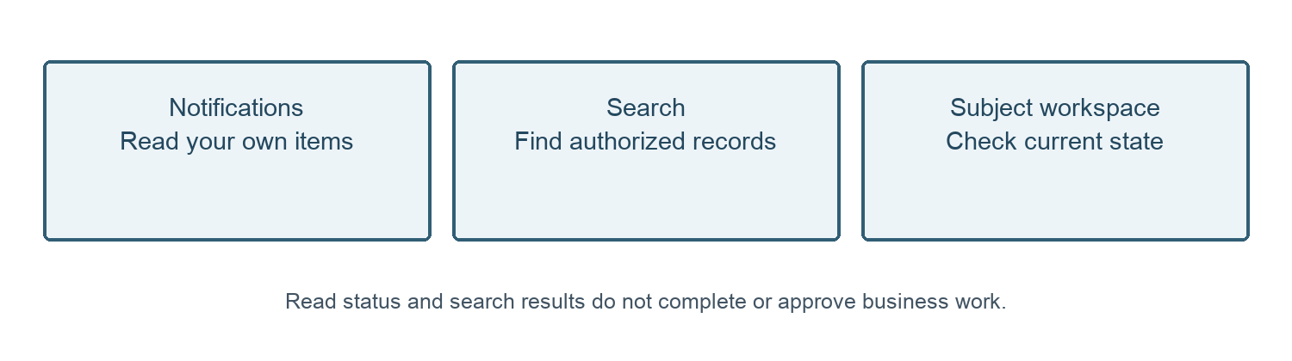
Figure 1. Locate the record. Read notifications and search, then verify current state in the subject workspace.
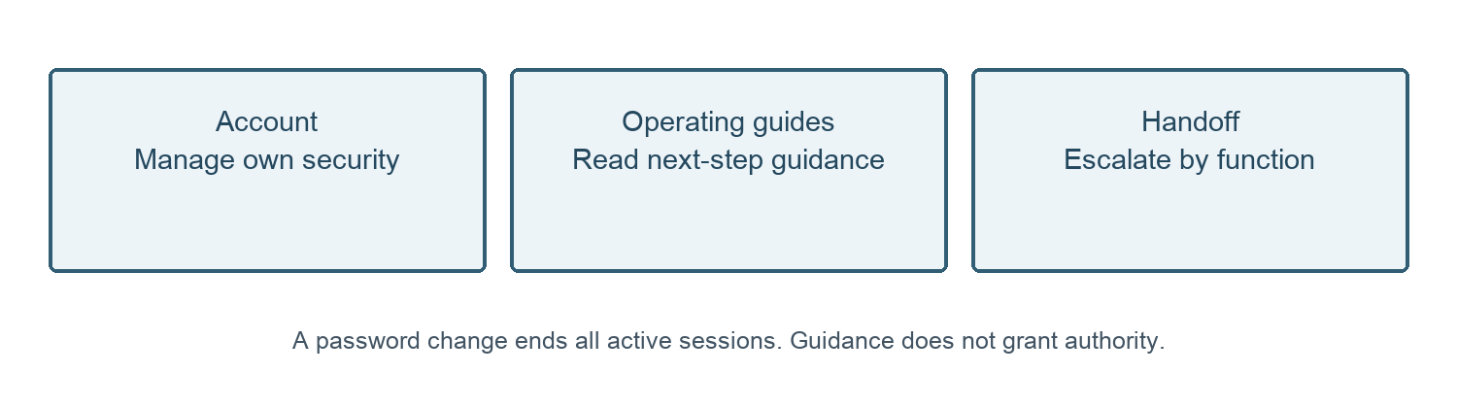
Figure 2. Security and support. Manage your own session and use guidance to prepare a safe handoff.

