1. Purpose, scope and document status

Purpose
Control the identity, source evidence, preparation, review, approval, effectivity, distribution, revision and withdrawal of SOPs, WIs and linked forms used by the QC Operations & Laboratory Management System.

Scope
Applies to company-controlled copies, system operating procedures, scientific method references, templates, attachments and historical usage records. This candidate draws on the existing QC-SOP-001 D0.2 draft; it does not replace its delivery or make it effective.

Document identity
SOP-FRS-001 is the reference assigned by the owner for this procedure. D0.3 is a proposed draft revision, not an approved company-controlled revision. Title: Document control and sources. Prepared: 09 Oct 2026. Approval: NOT RECORDED. Effective date: NOT ASSIGNED. Status: DRAFT FOR REVIEW.

Authority basis
The owner decision documented on 05 Oct 2026 and effective on 04 Oct 2026 requires account-bound signatures for all approvals. The later owner-approved action map QC-GESAP-ACTION-MAP-v1, effective 09 Oct 2026, governs the mapped signature decisions. Its document approval/effectivity rows 13 and 14 remain UNRESOLVED.

Definitions
APPROVED records an authorized approval; EFFECTIVE records separately authorized applicability at the point of use. A received copy, printed approval name, signature image, content hash, successful software test or completed task does not establish either state for this draft. PASS is separate from RELEASED.

Use limitation
Use this document for review and preparation only until its own controlled approval and effectivity are recorded. The steps below describe required controls; they are not evidence that every application transition is available or runtime-verified.

2. Responsibilities and source precedence

Document Control
Maintain the document/source register, exact identities and revisions, received-copy completeness, review dispositions, distribution and withdrawal records. These are proposed operating responsibilities based on SOP-FRS-001 D0.2; formal appointment and effectivity authority remain for QMS to establish.

Author and technical owner
The author prepares the draft and links every technical claim to its source. The QC/method specialist checks technical applicability, units, criteria, equipment requirements and cited editions. Never derive scientific limits or AQL values from a generic example.

QMS and engineering
QMS reviews document authority, separation of duties, retention, changes and effective-use conditions. Engineering checks that system instructions match supported actions, names and version controls. Technical availability does not grant approval authority.

Approver and user
The named system owner yazeed is designated by the owner instruction of 09 Oct 2026 as approval and activation authority for this FRS document family, including documents generated through code. This does not record a signature or effectivity for any individual revision, waive version-bound signing/audit requirements, or implement the currently blocked application transitions. Users verify the effective revision before controlled use.

Newest applicable source
For a conflict, compare the explicit decision/revision and effective dates for the same topic. Apply the newer governing decision and record the older statement as superseded for that scope. A file modification time or a newly written draft does not prove policy effectivity. Preserve unresolved same-date, identity or scope ambiguity for QMS disposition.

Identity and content
Use the governing master list for company report identity, title and approved revision where applicable. Use supplied images for observed form structure and printed content. Preserve exact source spelling and original files. A newer signature map does not silently revise product methods, retention periods or document-effectivity authority.

3. Source intake and draft preparation

3.1 Receive and register
Record the exact document code/title, printed revision/date, source location, supplier/owner reference, received date, page count, missing pages and source classification. Preserve the original bytes and identify any derived image, PDF or transcription separately.

3.2 Verify integrity and completeness
Check readability, page order, attachments and cross-references. Calculate SHA-256 for source and delivered files and record the hash scope. A matching hash proves byte integrity only. Apply file-safety controls only under approved tools/policy; an unperformed malware scan remains NOT VERIFIED.

3.3 Classify the source
Keep received physical company records and their actual evidence separate from verified digital approval/effectivity. The supplied WI set is registered as RECEIVED_CONTROLLED_COPY_NOT_QMS_VERIFIED; digital approval/effectivity is not inferred from the printed Controlled Copy stamp.

3.4 Reconcile conflicts
Capture both conflicting statements, source identifiers, revisions/dates, selected newer authority, the exact scope of replacement and unresolved consequences. Do not silently rename codes, correct printed content, substitute methods or delete the older evidence.

3.5 Prepare the draft
Keep the document identity and candidate revision visible on every page. Include purpose, scope, definitions, responsibilities, prerequisites, ordered steps, records, stop conditions, references and change history. Mark unsupported manual steps and proposed controls clearly. Link scientific claims to exact source pages and editions.

3.6 Bind the source
Record linked files and their hashes against the exact draft revision. In-system document content identity is server-derived; do not submit a browser-created digest as authoritative. Changes to source bytes require renewed source reconciliation and review; retain historical bindings.

4. Review, approval and effectivity

4.1 Submit for review
Confirm the source register and draft are complete enough for review. Use only the supported authorized submission route and current record version. Preserve reviewer comments and decisions against the reviewed revision.

4.2 Review independently
The technical owner checks content and applicability; engineering checks system fidelity; QMS/Document Control check authority and controlled use. Record the disposition of each comment. Review completion is distinct from approval and is not a verified electronic signature merely because an approver name is displayed.

4.3 Resolve prerequisites
The latest owner instruction designates yazeed as the approval and activation authority for the FRS document family. Before actual digital approval, implement and verify the document-specific action/version/signature ceremony and source prerequisites. The current code still rejects approval with POLICY_SOURCE_REQUIRED; do not bypass it using another page or database update.

4.4 Sign when authorized and supported
The signer opens the exact record, checks its state/version, reviews the decision meaning, declares signing intent and reauthenticates through the server. Enforce account identity, subject permission, scope, sequence and separation of duties. The signature binds the pre-transition version and action; each required stage has independent evidence.

4.5 Confirm the committed outcome
The decision, signature, audit and applicable outbox effects must commit atomically. Check the saved record and accessible signature details: signer identity/role, action meaning, time, record and exact signed version, verification status and audit reference. An authentication or persistence failure is not a successful approval.

4.6 Make effective separately
APPROVED does not make a document EFFECTIVE. The named owner yazeed authorizes activation of this FRS family under the latest instruction, with actual date and applicability recorded separately. A supported version-bound controlled process and prerequisites must still be implemented/verified. This SOP assigns no effective date and does not assert that activation occurred.

5. Distribution, change and exception handling

5.1 Distribution and training
After actual effectivity, record the issued revision, location/recipient, issue date and affected personnel training evidence. Verify the Word/PDF and controlled source have matching revision and content. Printed drafts remain marked DRAFT FOR REVIEW. Distribution/training controls are proposed operating controls from D0.2, not a claim of digital tracking.

5.2 Point-of-use verification
Before controlled use, verify identity, effective revision, applicability, source completeness and linked form/method. Stop if any required source is missing or ambiguous. Preserve the version/hash used by each historical inspection or laboratory record rather than replacing it with the current source.

5.3 Change control
Record the change reason, affected clauses, sources and workflows, reviewer dispositions and candidate revision. Signed or historical content must not be overwritten. Current digital revision creation requires an EFFECTIVE predecessor and no open DRAFT/IN_REVIEW/RETURNED version. An APPROVED predecessor alone is insufficient.

5.4 Withdrawal and retention
Once an authorized replacement is effective, withdraw superseded copies from new use while preserving predecessor and historical links. Supersede is currently guarded by an approved effective-date policy; the default denies it. ARCHIVE being named in a state machine does not prove a wired user operation. Retention/disposal periods and authority remain unassigned until the applicable QMS policy is approved.

5.5 Stale version or uncertain write
For a version conflict, preserve the proposed input, refresh the record and reassess the decision before a new submission. If a response is interrupted or the saved result is uncertain, inspect the current record/signature/audit before any retry. Do not treat an uncertain outcome as a failed transaction or create duplicate intent.

5.6 Stop and escalate
Stop approval/effectivity for missing policy, missing scientific evidence, unreadable/incomplete sources, changed file binding, unauthorized actor, failed reauthentication or invalid state/version. Record the document/revision, observed issue and responsible decision owner. Owner exceptions, where governed, must be explicit, justified and audited; this SOP creates no override path.

6. Records, reconciliation and acceptance

Required records
Maintain: document/source register; source-file/hash manifest; completeness and identity conflicts; review-comment dispositions; change history; actual approval/signature and effectivity evidence; distribution/training records; superseded-copy withdrawal and applicable retention/disposition records. Existing draft QC-REC-009 and QC-REC-013 may be reviewed for suitability; citing them does not approve them.

Conflict C-01: stage-one signatures
Older 23 Sep-derived statements treating Supervisor approval as audit-only are superseded by the 05 Oct owner decision, effective 04 Oct. Independent stage-one approval signatures are required within its scope; preserve earlier events as historical events without retrospective signatures.

Conflict C-02: pending map approval
Older narrative saying the whole action map awaits approval is superseded by the 09 Oct map header/activation log: owner-approved and effective 09 Oct, revision QC-GESAP-ACTION-MAP-v1. The map still contains stale open-decision wording in section 4 items 1-2; use the later explicit activation record for its own approval/date, not as completion of QMS or runtime acceptance.

Conflict C-03: document activation
The latest owner instruction of 09 Oct 2026 designates yazeed as approval and activation authority for this FRS document family and supersedes the earlier uncertainty about who holds that authority in this scope. The map rows 13-14 and current application remain unresolved/blocked in implementation. The instruction creates no individual approval signature, effective date or tested runtime transition and does not automatically close other QMS/source/retention decisions.

Conflict C-04: example identity
The user-selected example directory WI-8-2-2-64 contains page images whose printed code appears WI-8-2-2-04. Preserve both observations and request master/source identity reconciliation. The example is used only for layout, not as this SOP identity or as evidence for scientific limits.

Acceptance before controlled use
QMS must establish this SOP identity/revision approval and effectivity, resolve applicable document authority/source/retention decisions, record independent reviewer outcomes and real approval evidence, and verify the actual supported workflow on a bound candidate. Authoring, PDF rendering and content checks do not establish these outcomes.

7. References and revision history

R1 - Primary owner decision
Documents/QC-OWNER-DECISION-ALL-APPROVALS-SIGNATURE-2026-10-05.md: effect and limits, effective date 04 Oct 2026; documented 05 Oct 2026. Basis for account-bound signing, atomicity, stage separation and no retrospective signatures.

R2 - Newer governing map
Documents/QC-GLOBAL-ELECTRONIC-SIGNATURE-ACTION-MAP.md: header, activation log, signer model and rows 13-15; owner-approved/effective 09 Oct 2026, revision QC-GESAP-ACTION-MAP-v1. Rows 13-14 remain unresolved.

R3 - Global functional requirement
Documents/QC-GLOBAL-ELECTRONIC-SIGNATURE-POLICY.md: sections 3-5 and 8-9. Read its pending-map narrative together with R2; R2 resolves its map approval/date only, not all QMS controlled policy conditions.

R4 - Existing procedure
Documents/QC_System_WI_SOP_Pack/References/Authoring_Sources.zip, member SOP/QC-SOP-001.md: D0.2 revised 04 Oct 2026. Basis for source intake, specialists, review, distribution/training, retention proposals and history. QC-SOP-001 D0.2 delivery and archive remain preserved; SOP-FRS-001 is the owner-assigned reference for this new procedure.

R5 - Source intake and example
WIs/COMPANY-WI-SOURCE-MANIFEST.md and .json within the pack; example images WIs/company-controlled-pages/WI-8-2-2-64/. Scanned copies are source material; the example contributes layout only. Source intake records remain distinct from verified QMS approval.

R6 - Implementation corroboration
src/modules/documents/application/approve-version.ts; review-version.ts; supersede-version.ts; domain/document-state.ts; domain/revision-creation.ts. Source review confirms current denial and state/version boundaries; no PostgreSQL/browser/UAT execution was performed for this authoring task.

Revision record
D0.2 | 04 Oct 2026 | Existing pack draft; preserved. D0.3 candidate | 09 Oct 2026 | Expanded source control, applied the newer signature map, recorded scoped conflicts and separated approval/effectivity from technical implementation. Human preparation/review/approval signatures: NOT RECORDED. Effective date: NOT ASSIGNED.

8. Supporting work instructions
Owner-assigned reference numbers; all are DOCX review candidates. The owner authority instruction is reflected in each child; no individual approval or effectivity has been recorded by their generation.
WI-FRS-001 — Source receipt and verification | Documents/QC_System_WI_SOP_Pack/WIs/review-drafts/WI-FRS-001.docx
WI-FRS-002 — Document preparation and revision | Documents/QC_System_WI_SOP_Pack/WIs/review-drafts/WI-FRS-002.docx
WI-FRS-003 — Document review and comment resolution | Documents/QC_System_WI_SOP_Pack/WIs/review-drafts/WI-FRS-003.docx
WI-FRS-004 — Document approval with electronic signature | Documents/QC_System_WI_SOP_Pack/WIs/review-drafts/WI-FRS-004.docx
WI-FRS-005 — Document activation, distribution and withdrawal | Documents/QC_System_WI_SOP_Pack/WIs/review-drafts/WI-FRS-005.docx

Latest owner authority clarification
Owner instruction recorded on 09 Oct 2026: the named system owner, yazeed, is the approval and activation authority for the FRS document family, including documents authored through code. This records the authority designation; generation of a file is not an individual electronic approval or an effective-date event. Account-bound signing, audit traceability and version binding remain required. No application permission or production record is changed by this instruction document.
09 Oct 2026: parent draft reconciled with owner designation and linked to WI-FRS-001–005. Candidate remains D0.3; controlled approval/effectivity not recorded.

Visual operating guide
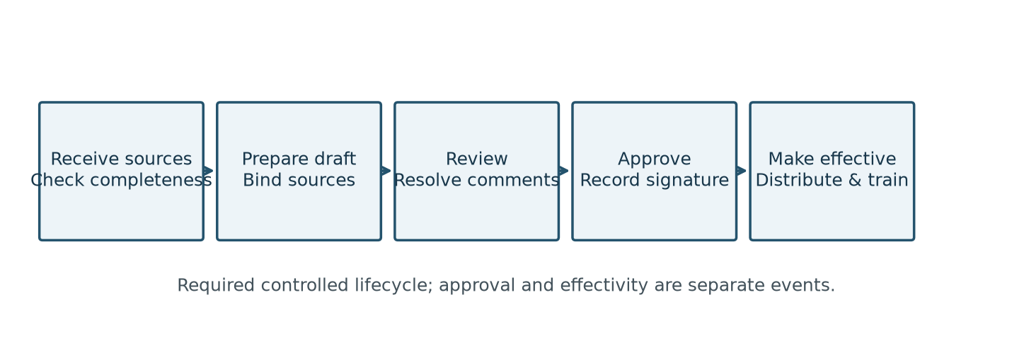
Figure 1. Controlled-document lifecycle. This diagram describes the procedure; it does not assert that blocked application transitions are implemented.
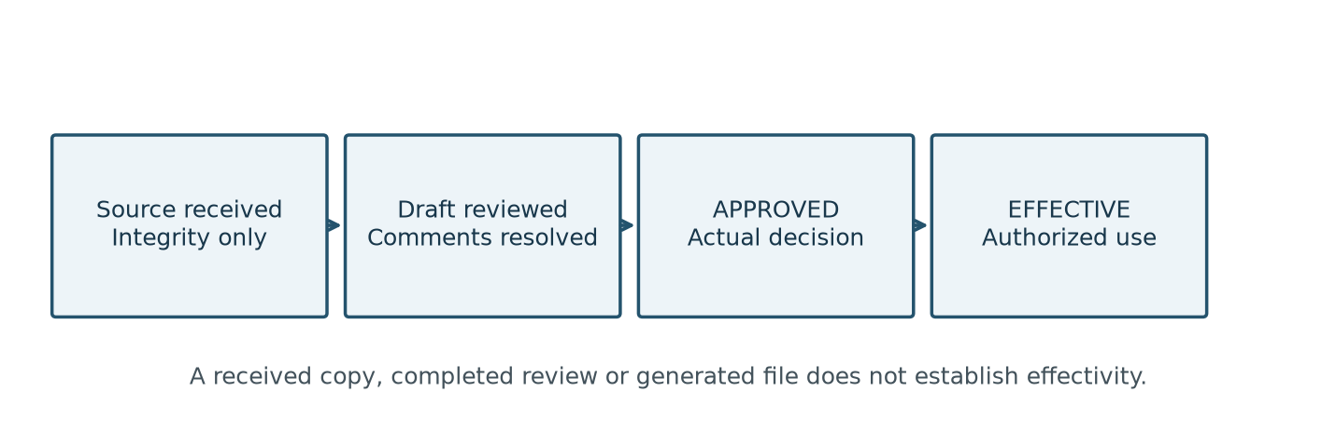
Figure 2. Evidence boundaries. Apply the document-specific source, authority, version and signature prerequisites before each transition.

