Standard Operating Procedure

Using the Work page — My work today
Document reference: SOP-FRS-002 (assigned by the owner)
Draft revision: D0.1 | Prepared: 09 October 2026
Approval: NOT RECORDED | Effective date: NOT ASSIGNED

1. Purpose and scope
Use the Work page (/work) to identify personal outstanding work, understand the next step, and open its source record. The page is a read-only queue; actions are performed in the owning record workspace.
This procedure covers the queue, its four groups, record links, counts, refresh, access restrictions and unresolved sources. It does not establish inspection criteria, approval authority, release permission, response deadlines or a new escalation policy.
This file is an editable review draft. The owner assigned SOP-FRS-002 as its document reference; register entry, revision approval and effectivity remain to be recorded. Source review supports the page description; live browser, database and user acceptance verification were not performed for this document.

2. Responsibilities and prerequisites
User: sign in with your own account, confirm your identity and scope, inspect the assigned records, and perform only permitted actions in their source workspace.
Assigned user or role holder: check the record’s current owner, state and next action before proceeding. The Owner label describes the next-step responsibility; it does not grant permission.
Supervisor or responsible register owner: assess a reported block or assignment issue within existing authority. Support administrator: investigate access or unavailable-register incidents. These are proposed operating responsibilities, not new role grants.
Prerequisites: an authenticated account, access to the relevant source register, and the record-specific prerequisites for the requested action. The queue may be accessible while individual sources or totals are unavailable to the account.

3. Page elements and group meanings
My work today: the page heading. Server snapshot: the time the server generated this view. All windows in UTC: the time basis for classification. Refresh: reload the queue from the server.
Signed in as, Role and Scope: confirm the account, role label and authorized reading scope. If the scope is Not confirmed, do not treat the page as a verified personal workload.
Groups appear in this order: Blocked → Overdue → Due today → Assigned to you. Each record is listed once in its highest-priority matching group; group counts may overlap.
Group | Included work | User interpretation
Blocked | Assigned tasks in ON_HOLD; receiving records created by the user with inspection_result HOLD. | Open the source and inspect the hold; do not bypass it.
Overdue | Open tasks assigned to the account with a due date before today begins in UTC. | Check the task due date and supported next action.
Due today | Open tasks assigned to the account due from today’s UTC midnight to before tomorrow’s. | Review due work using the displayed UTC boundary.
Assigned to you | Outstanding assigned tasks, actionable approvals assigned to the account/role, returned inspection or laboratory records authored by the user, and eligible document reviews. | Read the next step and source state; eligibility remains permission-bound.

4. Operating procedure
4.1 Open Work. Sign in when redirected to the login page. Confirm Signed in as, Role and Scope before using the queue.
4.2 Check freshness. Read Server snapshot and the displayed timezone. Select Refresh at the start of review and after a record action. The page shows a snapshot; it does not claim continuous live updates.
4.3 Review Blocked. Read the state and reason. Open the record to inspect its actual hold condition and available evidence. A held task’s reason is retained in the task audit trail, not in a separate queue reason column. A receiving HOLD remains a release barrier.
4.4 Review Overdue and Due today. Confirm the due date in the task record. Classification uses UTC, not the Riyadh calendar day. For Riyadh (UTC+3), a UTC day starts at 03:00 local time and ends immediately before 03:00 the next day.
4.5 Review Assigned to you. Check each record’s title, reason, age/state, Next, Owner and From. The assignment may name your account or an eligible role you hold; verify the current assignment in the source record.
4.6 Open the record. Select its linked title. Review the source record’s current state, assignment, version and prerequisites. Complete the supported permitted next step there. Do not infer approval or release authority from queue visibility.
4.7 Confirm the saved outcome. Check the source record’s resulting state and available audit or signature evidence where applicable. If the write outcome is uncertain, inspect the saved record before retrying. For a version conflict, retain your proposed input and review the refreshed record.
4.8 Return to Work and select Refresh. Reconcile whether the record moved groups or left the queue. If it remains, inspect the source state and assignment; disappearance alone is not evidence of completion or approval.
4.9 Review How this group is counted. Expand it to inspect Ownership, Scope, Time basis and Included records. Use Source registers links to review the matching register and records beyond the queue preview.
4.10 Review What this queue cannot answer yet. Follow the named source owner or source workspace for the missing information. Do not substitute an unavailable value with zero or completion.

5. Counts, states and exceptions
Counts: never add the four group counts to obtain a total. A task can qualify as assigned, due and blocked simultaneously. Each group displays at most 10 records; its count can exceed the displayed list. Some matches are displayed in a higher-priority group.
No total for your account: one or more contributing sources are not authorized. The group may still show records and source links from authorized sources. Do not report a complete total from this partial view.
Confirmed empty: a zero or empty-state message applies only to the readable sources and snapshot. It does not prove that the wider department has no work, nor that unmodeled sources are complete.
Your work queue is temporarily unavailable: a register read failed, so all groups and counts are withheld. Retry using the provided link. If the issue persists, report the page, snapshot if available, displayed message and account role to support; do not include passwords.
Your work queue is unavailable: the account cannot view the requested queue. No record or count is shown. Ask the authorized administrator to review access under the existing permission process.
Age not recorded: a usable timestamp is absent. Do not invent an age or due date. Check the source record.
Unresolved sources include a separate blocked-reason field, full assignment history in the queue, materialized equipment-eligibility blocks, unassigned work within scope, and reject analytics. Their absence is not a successful check or a zero workload.
A scientific PASS is an inspection result. RELEASED is a separate decision. Work links cannot release receiving items on HOLD.

6. Records and review checks
The authoritative operational evidence remains the source record and its available assignment, state, audit and signature records. The Work page is a navigation snapshot, not an approval record or a controlled release report.
Where an existing incident or escalation process requires a record, capture the source reference, observed state/message, snapshot time and responsible owner. This SOP creates no new retention period or form requirement.
Before controlled use, verify the page with representative authorized accounts, unreadable sources, an empty queue, a provider failure, overlapping groups and more than 10 matches. Confirm source-link navigation and refresh after a permitted action. These checks are NOT RUN for this authoring task.
Reviewer: NOT RECORDED. Approver: NOT RECORDED. Document reference: SOP-FRS-002. Effective date: NOT ASSIGNED.

7. References and revision history
Source candidate: 4e8f4b9ce3c6fd51f893919ab9d4f70a7217670d. Working tree was clean at source inspection.
R1: src/pages/work/index.astro — labels, identity, navigation and unavailable states.
R2: src/modules/dashboard/application/my-work-definitions.ts — membership, ownership, UTC boundaries and unresolved sources.
R3: src/modules/dashboard/application/my-work-queue.ts — precedence, 10-item preview, count withholding, sorting and age labels.
R4: src/modules/dashboard/application/get-my-work.ts — authenticated personal queue entry.
D0.1 | 09 October 2026 | Initial review draft describing the Work page from current source. No application, permission, database or approved document revision changed.

Visual operating guide
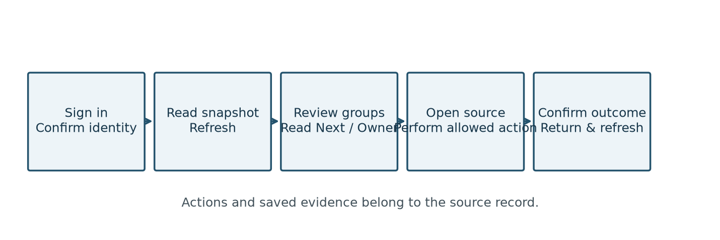
Figure 1. Daily review and source-record action sequence. A refresh does not itself change a record.
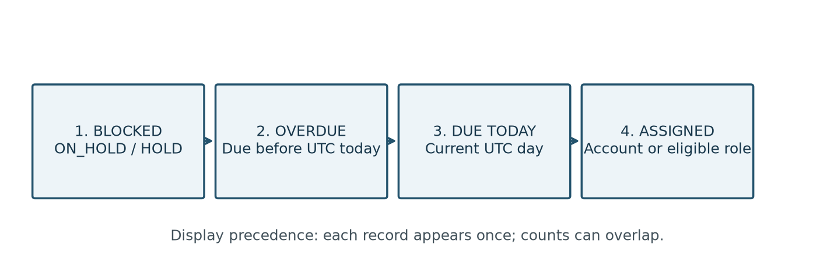
Figure 2. Group precedence. Never add group counts to calculate a total. Preview: up to 10 records per group. UTC midnight corresponds to 03:00 in Riyadh.

