ENDOTRACHEAL TUBE
ISO 5361:2016
WI & Inspection Report Gap Analysis
Evidence-based Quality Control / Medical Device Compliance Review
Field | Controlled review value
Department | Quality Control (QC)
Product | Endotracheal Tube
Primary standard | ISO 5361:2016
Other supplied standards | ISO 16628:2022; BS EN ISO 8836:2014 (scope-screened, not primary for this product)
Inspection report | Inspection & Test Report for Endotracheal Tube - Rev. 4 - Page 1/1
Assessment date | 06 October 2026
Assessment basis | Uploaded standards + uploaded WI file + current inspection-report image

CONTROLLED REVIEW NOTE: The supplied inspection report is evaluated as a blank controlled template. Empty execution fields are not treated as a failed lot record; gaps are raised only where the form/WI/evidence structure cannot demonstrate the requirement.

1. Executive Summary
Primary conclusion. ISO 5361:2016 is the directly applicable supplied standard for a true tracheal/endotracheal tube. The attached WI file does not contain a matching Endotracheal Tube WI. Instead, it contains WI-8-2-2-06-1 Rev.00, “Inspection Procedure for Endobronchial Tube,” dated 05.12.2023. ISO 5361 itself excludes endobronchial/tracheobronchial tubes, while ISO 16628:2022 covers tracheobronchial tubes. Therefore the current Endotracheal Tube inspection report cannot be treated as correctly linked to that Endobronchial WI.
Compliance effect. Because the target WI is missing and the report “According to WI:” field is blank, no ISO requirement is classified as fully Covered at the controlled-document-system level. Several inspection rows partially address ISO characteristics, but many lack numeric limits, test methods, controlled specification references, or fields for actual measured evidence.
Finding | Classification | Priority | Required control
No matching Endotracheal Tube WI in attached WI file | Document Control Gap | P1 / High | Issue/identify the controlled Endotracheal Tube WI and link it to the report master.
Endobronchial WI is a different product/standard scope | Document Control Gap | P1 / High | Do not use WI-8-2-2-06-1 as the ETT WI unless product classification is formally changed and the form set is re-controlled.
Dimensions and bevel criteria are generic | Partial Gap | P1 / High | Add ISO numeric limits or an exact controlled drawing/specification number and revision.
Cuff leak / diameter / collapse / herniation / seal evidence is incomplete | Gap / Evidence Gap | P1 / High | Add the applicable ISO method/acceptance and evidence route; do not force type tests into every lot unless required by the control plan.
Kink-resistance row lacks Annex H method and acceptance | Partial Gap | P1 / High | Define Annex H or validated equivalent evidence and record pass/fail.
Sterility / packaging / biocompatibility / risk controls are not linked | Evidence Gap | P1 / High | Link controlled technical-file, validation, supplier or routine-release evidence rather than using a generic lot row.

2. Documents Reviewed
Document | Title | Extent | Use in review
ISO 5361:2016 | Anaesthetic and respiratory equipment - Tracheal tubes and connectors | 48 PDF pages | Primary applicable supplied standard for Endotracheal/Tracheal Tube.
ISO 16628:2022 | Anaesthetic and respiratory equipment - Tracheobronchial tubes | 20 PDF pages | Not primary for a true Endotracheal Tube; relevant only if product is actually double-lumen tracheobronchial/endobronchial.
BS EN ISO 8836:2014 | Suction catheters for use in the respiratory tract | 40 PDF pages | Not a governing standard for the Endotracheal Tube itself; applicable only to a separate suction-catheter component if that component is in scope.
Wi.pdf | Scanned WI compilation | 18 PDF pages | Contains Semi Auto Biopsy Needle, Ureteric Catheter and Endobronchial Tube WI. No matching Endotracheal Tube WI identified.
Current report image | Inspection & Test Report for Endotracheal Tube | 1 page | Rev. 4 visible; page 1/1; Doc.# and full date are cropped/partially visible.

3. Document Identification
Identification field | Verified result
Product | Endotracheal Tube (inspection-report title)
Target WI | NOT AVAILABLE in the attached WI compilation
Non-matching WI found | WI-8-2-2-06-1 - Inspection Procedure for Endobronchial Tube
Non-matching WI revision / date | Rev. 00 / 05.12.2023
Non-matching WI extent | 11 pages (Wi.pdf pp.8-18)
Primary ISO | ISO 5361:2016
Inspection Report | Inspection & Test Report for Endotracheal Tube
Report Revision | Rev. 4
Report Document No. | Partially visible as “F-823-T…”; full number cannot be verified from the source image
Report Date | Partially visible as “23.04.202…”; full year cannot be verified
Report Page | 1/1
Report WI linkage | “According to WI:” field is blank
Other linked forms for target product | Not verifiable because the target Endotracheal Tube WI was not supplied/found
DOCUMENT CONTROL OBSERVATION: WI-8-2-2-06-1 page 11/11 references “Inspection and test report for Endobronchial tube: F-823-T98.” The current uploaded form is titled “Inspection & Test Report for Endotracheal Tube.” The current form number is cropped, so a numeric form-number mismatch cannot be asserted; the product-title/scope mismatch is nevertheless directly verified.

4. Scope
This assessment covers only the Endotracheal Tube and the uploaded controlled-source evidence. It does not assume that an Endobronchial/Tracheobronchial WI is interchangeable with an Endotracheal Tube WI. Technical-file/type-test requirements are not automatically converted into routine lot tests. Where such requirements can reasonably be controlled through approved specifications, risk management, supplier evidence, validation, qualification, periodic verification or type testing, the gap is classified as an Evidence Gap when the link is absent.

5. Methodology
Step | Method
1 | Screen standard scope before clause comparison.
2 | Extract ISO 5361 requirements and conditional applicability using exact clause/page references.
3 | Identify the WI matching the target product; exclude non-target WI content from technical coverage.
4 | Map each ISO requirement to the current report row without treating similar-but-different characteristics as equivalent.
5 | Classify as Covered, Partial Gap, Gap, Evidence Gap, Document Control Gap or Not Applicable.
6 | Distinguish routine inspection controls from type-test/validation/technical-file evidence.
7 | Assign P1/P2/P3 based on safety/performance/compliance significance and missing acceptance criteria.

6. Standard Applicability and ISO Requirements Review
Standard | Applicability | Scope basis | Control decision
ISO 5361:2016 | Direct | Covers oro-tracheal and naso-tracheal tubes and connectors; specialized tracheal tubes are included. It explicitly excludes endobronchial/tracheobronchial tubes. | Primary standard for the current Endotracheal Tube report.
ISO 16628:2022 | Not direct for true ETT | Covers tracheobronchial tubes used for one-lung isolation; these are double-lumen airway devices. | Use only if the controlled product is actually tracheobronchial/endobronchial.
BS EN ISO 8836:2014 | Not applicable to ETT itself | Covers flexible suction catheters for suctioning the respiratory tract. | Do not import its suction-catheter tests into the ETT report unless a separate suction catheter is being controlled.
The following extraction summarizes the applicable ISO 5361 requirement families. The detailed clause-by-clause linkage appears in Section 7.
Clause | Requirement family | Technical requirement / acceptance | ISO page | Method / evidence route | Applicability
4.1-4.2 | Risk management & safety | Risk-management file, conditional usability/clinical evidence, and validation of alternative type-test methods. | PDF pp.11-12 (ISO pp.5-6) | Technical file / risk-management file | Mandatory + conditional
5.1-5.2 | Size & dimensions | Size designation, ID/OD tolerances, Table 1a tube dimensions and Table 2 connector dimensions. | PDF pp.12-17 (ISO pp.6-11) | Measurement / controlled specification | Mandatory / design-dependent
5.3 | Materials | Biological safety; durable/legible marking; reuse and phthalate controls when applicable. | PDF p.19 (ISO p.13) | Technical file / marking durability | Mandatory + conditional
5.4 | Bevel | 38 +/-10 degrees for tracheal tube bevel (Cole: 45 +/-5); patient end free of sharp edges. | PDF p.19 (ISO p.13) | Angle + visual inspection | Mandatory / tube-type dependent
5.5 | Cuffs | Leak integrity, cuff position, diameter +/-15%, cuffed-tube collapse, herniation, tracheal seal and sharp-edge controls. | PDF pp.19-20 (ISO pp.13-14); Annexes B-D,G | Functional/type tests + dimensional inspection | Conditional - cuffed
5.6 | Inflating system | Inflating tube OD/location/angle, pilot balloon/deflation function, Luer fit, free length and marked-distance accuracy. | PDF p.20 (ISO p.14) | Functional + dimensional inspection | Conditional - cuff system
5.7 | Curvature & surfaces | Magill curvature when applicable, intended-shape retention, smooth internal/external surfaces. | PDF pp.20-21 (ISO pp.14-15) | Measurement + inspection | Mandatory / design-dependent
5.8 | Radiopaque marker | If labelled radiopaque, demonstrate radiographic distinguishability against aluminium comparison standard. | PDF p.22 (ISO p.16) | ASTM F640 Method B | Conditional
5.9 | Kink resistance | Annex H: steel ball passes freely through lumen after specified bending/conditioning. | PDF p.22 (ISO p.16); Annex H pp.45-46 | Annex H | Mandatory
6 | Murphy eye | If present: area >=80%, opposite bevel, compression risk controlled, no sharp edges. | PDF p.23 (ISO p.17) | Measurement / inspection / risk file | Conditional
7 | Sterility & packaging | Sterile designation supported by applicable sterilization requirements and ISO 11607-1 sterile barrier packaging. | PDF pp.23-24 (ISO pp.17-18) | Validation / routine-control evidence | Conditional - sterile
8 | Marking & information | Tube, pack/insert and connector marking requirements, including size/OD, length, glottic mark, batch, sterile/single-use and cuff-performance information. | PDF pp.24-27 (ISO pp.18-21) | Label/IFU inspection | Mandatory + conditional

7. ISO ↔ WI ↔ Inspection Report Unified Gap Matrix
Matrix interpretation: No matching Endotracheal Tube WI is present in the attached WI file. Therefore no row is classified as fully Covered at the controlled-document-system level. “Partial Gap” means the inspection template captures part of the characteristic but lacks complete ISO acceptance/method/evidence. “Evidence Gap” means the requirement can be controlled outside routine lot inspection but no controlled evidence link is shown.

ID | ISO Requirement | ISO Clause | ISO Page | WI Coverage | WI Page | Inspection Report Coverage | Report Row/Page | Status | Priority
ETT-01 | Risk assessment and acceptable risk  Apply an established risk-assessment process; determine risk acceptability under the manufacturer policy; verify through the risk-management file. | 4.1.1-4.1.3 | PDF p.11 (ISO p.5) | NO - target WI not available | N/A | NOT EXPECTED IN THIS REPORT - No risk-file reference or linked evidence on the form. | No dedicated row / p.1 | Evidence Gap | P1 / High
ETT-02 | Usability, clinical evaluation, modelling  Where required by a competent authority, address usability risk, document clinical evaluation, and perform validated biophysical/modelling research where appropriate. | 4.1.4-4.1.6 | PDF pp.11-12 (ISO pp.5-6) | NO - target WI not available | N/A | NOT EXPECTED IN THIS REPORT - No controlled evidence reference. | No dedicated row / p.1 | Evidence Gap | P2 / Medium
ETT-03 | General safety and alternative type tests  Minimize reasonably foreseeable safety hazards in normal and single-fault conditions. Alternative type tests are acceptable only when validated against the standard methods and provide equivalent safety. | 4.2.1-4.2.2 | PDF p.12 (ISO p.6) | NO - target WI not available | N/A | NOT EXPECTED IN THIS REPORT - No linked risk or alternative-method validation evidence. | No dedicated row / p.1 | Evidence Gap | P1 / High
ETT-04 | Size designation  Designate tracheal tube size in accordance with the applicable ISO table. | 5.1 | PDF p.12 (ISO p.6) | NO - target WI not available | N/A | PARTIAL - Header has Received Sizes; rows 9-10 refer to size/specification without the ISO designation control. | Header “Received Sizes”; rows 9-10 / p.1 | Partial Gap | P1 / High
ETT-05 | Basic dimensions and ID tolerance  For applicable Magill-type tubes use Table 1a dimensions; marked ID is the designated size with tolerance +/-0.15 mm for sizes <=6.0 and +/-0.20 mm for sizes >=6.5. | 5.2.1.1-5.2.1.3 | PDF pp.12-13 (ISO pp.6-7) | NO - target WI not available | N/A | PARTIAL - Rows 9-10: As per specification O.D, I.D / According to Size; no numeric limits or controlled specification ID/revision. | Rows 9-10 / p.1 | Partial Gap | P1 / High
ETT-06 | OD tolerance  For Magill-type tubes, marked OD is subject to +/-0.15 mm for sizes <=6.0 and +/-0.20 mm for sizes >=6.5. | 5.2.1.4 | PDF p.12 (ISO p.6) | NO - target WI not available | N/A | PARTIAL - Row 9 references O.D but provides no limit, method, actual value field, or controlled specification revision. | Row 9 / p.1 | Partial Gap | P1 / High
ETT-07 | Connector basic dimensions and size  Connector dimensions shall follow Table 2; when supplied with a tube, connector designated size shall not be less than the tube size. | 5.2.2.1-5.2.2.2 | PDF p.16 (ISO p.10) | NO - target WI not available | N/A | PARTIAL - Rows 4-5 use Good Fitting / According to size and visual defects only. | Rows 4-5 / p.1 | Partial Gap | P1 / High
ETT-08 | Curved/angled connector lumen  Minimum connector ID shall be >=80% of designated size and corresponding cross-sectional area shall not be reduced by >10%. | 5.2.2.3 | PDF p.16 (ISO p.10) | NO - target WI not available | N/A | NO - No numeric lumen or area criterion. | Rows 4-5 (similar only) / p.1 | Gap | P1 / High
ETT-09 | Connector suction port closure  If a suction port is provided, closing it shall not obstruct or narrow the connector lumen. | 5.2.2.4 | PDF p.16 (ISO p.10) | NO - target WI not available | N/A | NO - No suction-port criterion. | No dedicated row / p.1 | Gap | P2 / Medium
ETT-10 | 15 mm machine-end connector  Machine end shall be a male 15 mm conical connector conforming to ISO 5356-1. | 5.2.2.5 | PDF p.16 (ISO p.10) | NO - target WI not available | N/A | PARTIAL - Rows 4-5 only state fitting/appearance; no 15 mm / ISO 5356-1 acceptance. | Rows 4-5 / p.1 | Partial Gap | P1 / High
ETT-11 | Connector patient-end geometry  Patient-end connector dimensions follow Table 2; transition shall allow smooth suction-catheter passage; curved connector angle >45 degrees; opening plane 90 +/-5 degrees. | 5.2.2.6-5.2.2.8 | PDF p.17 (ISO p.11) | NO - target WI not available | N/A | NO - No corresponding numeric or functional criteria. | Rows 4-5 (not numeric) / p.1 | Gap | P1 / High
ETT-12 | Biological safety  Patient respiratory-gas-pathway and mucosal-contacting parts, including cuff and connector, shall satisfy appropriate ISO 10993-1 biological safety evaluation/testing. | 5.3.1 | PDF p.19 (ISO p.13) | NO - target WI not available | N/A | NOT EXPECTED IN THIS REPORT - No linked biocompatibility record, specification, or technical-file reference. | No dedicated row / p.1 | Evidence Gap | P1 / High
ETT-13 | Durability and legibility of tube marking  Tube marking shall remain durable and legible; compliance is by inspection per the referenced ASTM durability approach. | 5.3.2 | PDF p.19 (ISO p.13) | NO - target WI not available | N/A | PARTIAL - Rows 15-18 check Clear Printed / Printed clearly but do not verify durability. | Rows 15-18 / p.1 | Partial Gap | P2 / Medium
ETT-14 | Reuse resistance  If intended and marked for reuse, tube/connector/marking materials shall withstand recommended cleaning/disinfection/sterilization without compromising biological safety. | 5.3.3 | PDF p.19 (ISO p.13) | NO - target WI not available | N/A | NOT EXPECTED IN THIS REPORT - No linked reprocessing validation evidence. | No dedicated row / p.1 | Evidence Gap | P2 / Medium
ETT-15 | Phthalate labelling  If required by a competent authority and phthalates are incorporated in patient-contacting parts, label the device accordingly. | 5.3.4 | PDF p.19 (ISO p.13) | NO - target WI not available | N/A | NOT EXPECTED IN THIS REPORT - No material/label evidence link. | No dedicated row / p.1 | Evidence Gap | P2 / Medium
ETT-16 | Bevel angle  Tracheal tube bevel angle shall be 38 +/-10 degrees (Cole-type: 45 +/-5 degrees). | 5.4.1 | PDF p.19 (ISO p.13) | NO - target WI not available | N/A | PARTIAL - Row 8: comply with drawing/specification; no drawing/specification number/revision or numeric limit. Row 3 only says smooth beveled tip. | Rows 3, 8 / p.1 | Partial Gap | P1 / High
ETT-17 | Patient-end sharp edges  Patient end at the bevel shall be free from sharp edges. | 5.4.3 | PDF p.19 (ISO p.13) | NO - target WI not available | N/A | PARTIAL - Row 3 says Smooth beveled tip but does not state exact sharp-edge acceptance or method. | Row 3 / p.1 | Partial Gap | P1 / High
ETT-18 | Cuff integrity / leakage  If cuffed, cuff shall be integrally attached and leak-free. Inflate to 9.0 kPa (90 cmH2O) or 1.5x cuff diameter, whichever first; seal, immerse entire inflation system, observe >=10 s; no bubbles. | 5.5.1 | PDF p.19 (ISO p.13) | NO - target WI not available | N/A | PARTIAL - Row 20: Leak Test for balloon - Should not be leak; test pressure/diameter, immersion, time and actual observation are not recordable. | Row 20 / p.1 | Partial Gap | P1 / High
ETT-19 | Cuff position / Dimension C  Maximum distance from patient end to machine end of inflatable cuff length shall meet Table 1a. | 5.5.2 | PDF p.19 (ISO p.13) | NO - target WI not available | N/A | NO - No dedicated cuff-position/dimension-C field. | No dedicated row / p.1 | Gap | P1 / High
ETT-20 | Maximum cuff diameter  Maximum cuff diameter shall be within +/-15% of marked value. Annex B determines diameter at 2.0 +/-0.1 kPa after 5 min at 23 +/-2 C, using four diameters at 45-degree intervals and their mean. | 5.5.3 + Annex B | PDF p.19 / Annex B PDF p.32 (ISO pp.13/26) | NO - target WI not available | N/A | NO - Row 13 only says High volume low pressure cuff; no marked value, actual diameter, or +/-15% result. | Row 13 (not diameter) / p.1 | Gap | P1 / High
ETT-21 | Cuffed-tube collapse  When tested by Annex C, a steel ball of 75% of designated size shall pass freely after specified cuff conditioning/test pressure. | 5.5.4 + Annex C | PDF p.19 / Annex C PDF pp.33-35 (ISO pp.13/27-29) | NO - target WI not available | N/A | NO - Row 2 kink resistance is not the Annex C cuff-collapse test and cannot substitute for it. | Row 2 (different test) / p.1 | Gap | P1 / High
ETT-22 | Cuff herniation  After Annex D conditioning and axial-force procedure, no part of inflated cuff shall extend beyond the nearest bevel edge. | 5.5.5 + Annex D | PDF p.20 / Annex D PDF p.36 (ISO pp.14/30) | NO - target WI not available | N/A | NO - No herniation criterion or result field. | No dedicated row / p.1 | Gap | P1 / High
ETT-23 | Tracheal seal  Cuff shall limit leakage/aspiration when tested by Annex G at internal pressure not exceeding 2.7 kPa (27 cmH2O); Annex G reports leak-rate performance. | 5.5.6 + Annex G | PDF p.20 / Annex G PDF pp.42-44 (ISO pp.14/36-38) | NO - target WI not available | N/A | NOT EXPECTED IN THIS REPORT - Row 20 is a bubble leak check and is not the Annex G tracheal-seal performance test; no linked type-test evidence. | Row 20 (different test) / p.1 | Evidence Gap | P1 / High
ETT-24 | Cuff attachment sharp edges  Cuff and tube-to-cuff transition at attachment points shall be free of sharp edges; check through risk-management evidence. | 5.5.7 | PDF p.20 (ISO p.14) | NO - target WI not available | N/A | NO - No dedicated criterion. | Row 13 (general only) / p.1 | Gap | P1 / High
ETT-25 | Inflating tube dimensions and separation  Inflating tube OD <=3.0 mm; separation point on concave aspect if tube is curved; inflation-lumen wall encroachment <=10% of tube ID; dimensions per Table 1a/Figures. | 5.6.1 | PDF p.20 (ISO p.14) | NO - target WI not available | N/A | PARTIAL - Rows 11-12 check kink resistance/gluing/leakage only; no dimensional/location criteria. | Rows 11-12 / p.1 | Partial Gap | P1 / High
ETT-26 | Inflating tube separation angle  Angle between inflating tube and tracheal tube at separation shall not exceed 45 degrees. | 5.6.2 | PDF p.20 (ISO p.14) | NO - target WI not available | N/A | NO - No criterion. | No dedicated row / p.1 | Gap | P1 / High
ETT-27 | Pilot balloon and intentional deflation  Inflation system shall indicate cuff inflation/deflation; intentional deflation shall not be prevented by tube/valve/closure acting as non-return valve. | 5.6.3-5.6.4 | PDF p.20 (ISO p.14) | NO - target WI not available | N/A | PARTIAL - Rows 18-19 address pilot-balloon printing and leakage, not indication/deflation function. | Rows 18-19 / p.1 | Partial Gap | P1 / High
ETT-28 | Inflation connector compatibility  Free end shall accept a male 6% Luer taper fitting compliant with ISO 594-1. | 5.6.5 | PDF p.20 (ISO p.14) | NO - target WI not available | N/A | NO - No connector compatibility criterion. | No dedicated row / p.1 | Gap | P1 / High
ETT-29 | Inflating tube free length S3  S3 shall be >=40 mm unless valve/closure provided; with closure, >=10 mm unless pilot balloon and valve are integral. | 5.6.6-5.6.7 | PDF p.20 (ISO p.14) | NO - target WI not available | N/A | NO - No S3 measurement or specification reference. | No dedicated row / p.1 | Gap | P1 / High
ETT-30 | Marked separation distance accuracy  If separation distance is marked, actual distance shall equal marked value +/-10 mm. | 5.6.8 | PDF p.20 (ISO p.14) | NO - target WI not available | N/A | NO - No marked-vs-actual distance verification. | No dedicated row / p.1 | Gap | P2 / Medium
ETT-31 | Curvature and retention of intended shape  For Magill-type size >=6.5, radius of curvature is 140 +/-20 mm subject to stated exceptions; tube shall maintain intended shape after removal from packaging. | 5.7.2 / 5.7.5 | PDF pp.20-21 (ISO pp.14-15) | NO - target WI not available | N/A | PARTIAL - Rows 2, 7 and 8 mention tube status/form/angle but no radius limit or explicit post-packaging shape test. | Rows 2, 7, 8 / p.1 | Partial Gap | P1 / High
ETT-32 | Smooth internal/external surfaces  Tube shall have smooth outside and inside surfaces; compliance linked to risk-management evaluation. | 5.7.6 | PDF p.21 (ISO p.15) | NO - target WI not available | N/A | PARTIAL - Tip/connector appearance rows do not cover the full inner and outer tube surfaces. | Rows 2-3, 5 (partial) / p.1 | Partial Gap | P2 / Medium
ETT-33 | Radiopaque performance  If labelled radiopaque, marker shall be radiographically distinguishable from the aluminium comparison standard using ASTM F640 Test Method B. | 5.8 | PDF p.22 (ISO p.16) | NO - target WI not available | N/A | PARTIAL - Row 15 only checks X-Ray Line Marking is clear/straight; visual presence is not radiopacity performance. | Row 15 / p.1 | Partial Gap | P1 / High
ETT-34 | Kink resistance  When tested by Annex H, a steel ball of minimum diameter 75% of designated ID shall pass freely after the specified bend/conditioning. | 5.9 + Annex H | PDF p.22 / Annex H PDF pp.45-46 (ISO pp.16/39-40) | NO - target WI not available | N/A | PARTIAL - Row 2 states Kink resistance / Thermo sensitive tube but provides no Annex H method, conditioning, ball size, radius or pass result. | Row 2 / p.1 | Partial Gap | P1 / High
ETT-35 | Murphy eye size and location  If Murphy eye present: area >=80% of cross-sectional area derived from minimum allowed ID; located opposite the bevel. | 6.1-6.2 | PDF p.23 (ISO p.17) | NO - target WI not available | N/A | PARTIAL - Row 14 only says Smooth edged Murphy eye; no area or location acceptance. | Row 14 / p.1 | Partial Gap | P1 / High
ETT-36 | Murphy eye collapse risk and edges  Murphy-eye design shall not make patient end unduly prone to kinking/collapse, and the eye shall be free from sharp edges; risk-management evidence required for compression risk. | 6.3-6.4 | PDF p.23 (ISO p.17) | NO - target WI not available | N/A | PARTIAL - Row 14 covers smooth edge generally but not compression/kink risk evidence. | Row 14 / p.1 | Partial Gap | P1 / High
ETT-37 | Sterility assurance  If supplied/marked sterile, satisfy EN 556-1:2001 4.1 and applicable ISO 11135 / ISO 11137-1 sterilization requirements. | 7.1 | PDF p.23 (ISO p.17) | NO - target WI not available | N/A | NOT EXPECTED IN THIS REPORT - Row 23 only selects Sterile or Bulk; no sterilization validation/batch-release evidence link. | Row 23 / p.1 | Evidence Gap | P1 / High
ETT-38 | Sterile barrier packaging  Sterile tube/connector shall be individually packed with effective microbial/particulate barrier per ISO 11607-1, allow aseptic extraction, and reveal opening / prevent unnoticed reclosure. | 7.2 | PDF p.24 (ISO p.18) | NO - target WI not available | N/A | PARTIAL - Row 1 checks Good without any damage; this does not demonstrate sterile-barrier conformity or packaging validation. | Rows 1, 23 / p.1 | Evidence Gap | P1 / High
ETT-39 | Symbols / manufacturer information conventions  Where required by competent authority, marking and supplied information shall comply with EN 1041 and appropriate ISO 7000 / ISO 15223 symbols. | 8.1 | PDF p.24 (ISO p.18) | NO - target WI not available | N/A | NO - No symbols checklist or linked label specification. | No dedicated row / p.1 | Gap | P3 / Low
ETT-40 | Marking on the tube  Tube marking includes manufacturer/supplier identity, designated ID and OD in the required format/region, single-use wording when applicable, length marks, and Oral/Nasal/Oral-Nasal identification. | 8.2.1 | PDF pp.24-25 (ISO pp.18-19) | NO - target WI not available | N/A | PARTIAL - Rows 7, 15-17 and 22 cover selected formation/printing/logo checks, but not the full required marking set or positioning/format. | Rows 7, 15-17, 22 / p.1 | Partial Gap | P2 / Medium
ETT-41 | Glottic depth mark  Uncuffed tubes shall have a glottic depth mark with specified visibility; if provided on cuffed tubes it shall meet the same rule; position from tip is disclosed on package/insert. | 8.2.2 | PDF p.25 (ISO p.19) | NO - target WI not available | N/A | PARTIAL - Row 17: With depth Guide mark; no visibility position, distance, or package disclosure. | Row 17 / p.1 | Partial Gap | P2 / Medium
ETT-42 | Marking contrast  Marking materials shall contrast with tube colour. | 8.2.3 | PDF p.25 (ISO p.19) | NO - target WI not available | N/A | NO - No contrast criterion. | No dedicated row / p.1 | Gap | P2 / Medium
ETT-43 | Individual pack / insert marking  Pack/insert shall include applicable content description, Oral/Nasal designation, ID, OD, manufacturer/supplier, batch, sterile status, single-use statement, cuff diameter and other conditional information. | 8.3.1 | PDF pp.25-26 (ISO pp.19-20) | NO - target WI not available | N/A | PARTIAL - Report checks logo and sterile/bulk status only; no complete controlled pack-marking checklist. | Rows 22-23 (partial) / p.1 | Partial Gap | P2 / Medium
ETT-44 | Pack/insert dimensional disclosures  Disclose applicable glottic-depth distance(s) and, for cuffed sizes <=6.0, nominal distance from tip to machine end of inflated cuff. | 8.3.2 | PDF p.26 (ISO p.20) | NO - target WI not available | N/A | NO - No corresponding field. | No dedicated row / p.1 | Gap | P2 / Medium
ETT-45 | Insert instructions and cuff performance information  Insert shall include preparation instructions and, for cuffed tubes, Annex G cuff-performance information including test pressure and leakage-rate distribution for intended trachea diameters; date/revision if required by authority. | 8.3.3 | PDF pp.26-27 (ISO pp.20-21) | NO - target WI not available | N/A | NOT EXPECTED IN THIS REPORT - No linked IFU/insert review or type-test evidence reference. | No dedicated row / p.1 | Evidence Gap | P2 / Medium
ETT-46 | Connector size marking  Tracheal tube connector shall be clearly marked with designated tube size. | 8.4 | PDF p.27 (ISO p.21) | NO - target WI not available | N/A | NO - Rows 4-5 address fitting/appearance, not connector marking. | Rows 4-5 (not marking) / p.1 | Gap | P2 / Medium

8. Critical Findings
Rank | Priority | Finding | Compliance impact
1 | P1 | No controlled Endotracheal Tube WI | The supplied WI compilation contains an Endobronchial Tube WI, not an Endotracheal Tube WI. The current report therefore has no verified governing WI.
2 | P1 | Product/standard scope mismatch | ISO 5361 applies to tracheal/endotracheal tubes and explicitly excludes endobronchial/tracheobronchial tubes. ISO 16628 covers tracheobronchial tubes. The document set must not merge these scopes.
3 | P1 | Dimensional acceptance is not controlled | Rows 9-10 use “As per specification” / “According to Size” without the specification/drawing number and revision or the ISO numeric tolerances.
4 | P1 | Cuff performance is not adequately recordable | The report has generic balloon leak rows but no ISO 5361 cuff leak conditions, cuff-position limit, cuff diameter +/-15%, Annex C collapse, Annex D herniation, or Annex G seal evidence route.
5 | P1 | Kink resistance is underspecified | Row 2 names kink resistance but does not define Annex H method, conditioning, bending radius, 75% steel-ball criterion or pass evidence.
6 | P1 | Connector and inflation-system requirements are incomplete | 15 mm ISO 5356-1 conformity, connector geometry, inflating-tube dimensions/angle, Luer compatibility, S3 length and intentional deflation are not fully controlled.
7 | P1 | Technical-file evidence is not linked | Biocompatibility, risk management, sterility, sterile-barrier packaging and type-test evidence are not linked from the WI/report system.
8 | P2 | Marking/IFU coverage is fragmentary | The report checks selected printing but not the complete ISO 5361 tube, package, insert and connector marking requirements.

9. Document Control Findings
ID | Finding | Evidence | Class | Priority | Required control
DC-01 | No matching Endotracheal Tube WI | Wi.pdf pp.8-18 is WI-8-2-2-06-1, titled Inspection Procedure for Endobronchial Tube; target product WI not present. | Document Control Gap | P1 / High | Issue/identify the controlled Endotracheal Tube WI and formally link it to the report.
DC-02 | Wrong product scope in linked WI set | Endobronchial WI is scoped to endobronchial tube manufacturing; ISO 5361 excludes endobronchial/tracheobronchial tubes. | Document Control Gap | P1 / High | Separate the Endotracheal and Endobronchial document families unless controlled product classification proves otherwise.
DC-03 | Report WI field blank | “According to WI:” on current report template is blank. | Document Control Gap | P1 / High | Preprint/control WI number and revision in the form master.
DC-04 | Referenced form family differs by title | Endobronchial WI p.11/11 references F-823-T98 “Inspection and test report for Endobronchial tube”; current form is Endotracheal Tube. | Document Control Gap | P1 / High | Confirm current controlled form number and correct the WI/form master linkage.
DC-05 | Current report Doc.# not fully verifiable | Source photo crops the document number as “F-823-T…”. | Evidence Gap | P2 / Medium | Verify against the controlled master before release; do not infer the number from the photo.
DC-06 | Uncontrolled “as per specification” references | Rows 8-10 do not identify drawing/specification number or revision. | Document Control Gap | P1 / High | Add exact document ID/revision or print the ISO numeric acceptance directly.
DC-07 | Conditional requirements lack structured N/A logic | One form combines cuffed/uncuffed, oral/nasal/reinforced, Murphy-eye, radiopaque and sterile/bulk configurations. | Document Control Gap | P2 / Medium | Add applicability fields and N/A rationale so only relevant requirements are executed.

10. Recommended Actions
ID | Requirement / Area | Current State | Required Action | Priority
A-01 | Controlled WI / report linkage | No matching Endotracheal Tube WI; report WI field blank. | Create or identify the controlled Endotracheal Tube WI. Add WI number/revision to the form master and remove reliance on the Endobronchial WI for this product. | P1 / High
A-02 | Dimensional specification | Rows 9-10 are generic. | Add designated size, actual ID/OD fields, applicable tolerances from ISO 5361 5.2.1, minimum length/Table 1a reference, and exact drawing/specification ID/revision where used. | P1 / High
A-03 | Connector controls | Rows 4-5 only assess general fit/appearance. | Add 15 mm male ISO 5356-1 conformity, applicable Table 2 dimensions, connector ID/geometry and actual results or a controlled approved connector specification reference. | P1 / High
A-04 | Bevel control | Rows 3/8 lack numeric criterion. | Add 38 +/-10 degree acceptance for standard tracheal tube bevel (or controlled applicable tube-type value), actual angle result, and explicit “free from sharp edges” check. | P1 / High
A-05 | Cuff leak test | Row 20 says only “Should not be leak”. | For cuffed tubes, define/record the ISO 5361 5.5.1 condition: 9.0 kPa or 1.5x cuff diameter (whichever first), sealed system, water immersion, >=10 s observation, and no bubbles. | P1 / High
A-06 | Cuff geometry / type tests | Cuff position, diameter, collapse, herniation and seal not adequately evidenced. | Add routine dimensional checks where designated by the control plan; link Annex C/D/G tests to controlled qualification/type-test/periodic evidence unless the approved control plan requires lot testing. Record marked cuff diameter and Annex B result where applicable. | P1 / High
A-07 | Inflation system | Rows 11-12/18-19 are qualitative. | Add inflating-tube OD, separation angle/location, deflation function, Luer compatibility and applicable S3 lengths, or exact controlled specification references with actual result fields. | P1 / High
A-08 | Kink resistance | Row 2 lacks method/acceptance. | Add Annex H or validated-equivalent reference, size-dependent bend radius, conditioning, 75% steel-ball criterion and pass/fail evidence. Do not treat “thermo sensitive” as the kink-resistance acceptance criterion. | P1 / High
A-09 | Murphy eye | Row 14 only checks smooth edge. | When Murphy eye is present, add >=80% area, opposite-bevel location, smooth edge and controlled compression/kink-risk evidence. Provide N/A when absent. | P1 / High
A-10 | Radiopacity | Row 15 is only a visual line check. | If product is labelled radiopaque, link radiopacity performance evidence to ASTM F640 Method B / ISO 5361 5.8. Keep visual line presence as a separate routine inspection if required. | P1 / High
A-11 | Technical-file evidence links | Risk, biocompatibility, sterility and packaging are not linked. | Add controlled references to risk-management file, biological evaluation, sterilization validation/routine release, ISO 11607 packaging validation, and approved supplier/CoA evidence as applicable. | P1 / High
A-12 | Marking / IFU checklist | Rows 15-18/22-23 cover selected items only. | Create a controlled label/IFU checklist covering tube, pack/insert and connector marking from ISO 5361 Clause 8, with configuration-based N/A logic. | P2 / Medium
A-13 | Report evidence architecture | No fields for actual measurements or controlled source revision in several rows. | Add columns/fields for method/source document ID & revision, nominal/limit, actual result, unit, pass/fail, N/A rationale and inspector/date where the value is measured. | P1 / High

11. Priority Action Plan
Sequence | Action | Deliverable | Target timing
P1-1 | Freeze document linkage | Confirm controlled product classification and stop using Endobronchial WI as the Endotracheal WI. | Before next controlled revision/release
P1-2 | Issue/identify ETT WI | Create/approve a matching Endotracheal Tube WI and link report number/revision. | Immediate
P1-3 | Close direct inspection criteria | Dimensions, connector, bevel, cuff leak, inflation system, kink resistance, Murphy eye, radiopacity. | Next WI/report revision
P1-4 | Close evidence routes | Risk, biocompatibility, cuff type tests, sterility and packaging validation/routine evidence. | Before compliance closure
P1-5 | Reconcile controlled form number | Verify the full Endotracheal report Doc.# against the controlled master and WI reference. | Before form approval/use
P2-1 | Complete marking/IFU controls | Implement Clause 8 checklist and configuration-based N/A logic. | Next document-control cycle

12. Final Conclusion
The current Endotracheal Tube document set is not ready to be considered fully controlled against ISO 5361:2016 because the governing Endotracheal Tube WI is not present and the current inspection report is not linked to a verified WI. The attached Endobronchial WI belongs to a different ISO scope and must not be used as a substitute without a formal product-classification change and controlled document revision. The inspection report does contain useful routine characteristics, but major P1 requirements remain only partially defined or lack documented evidence routes. The corrective strategy should combine measurable routine-inspection criteria with controlled references to technical-file, qualification, supplier, validation and type-test evidence where ISO does not require every test on every production lot.

13. Source Traceability
Source | Traceability used
ISO 5361:2016 | Scope: PDF p.7 (ISO p.1); risk/safety: pp.11-12 (ISO pp.5-6); dimensions/connectors: pp.12-17 (ISO pp.6-11); materials/bevel/cuffs: pp.19-20 (ISO pp.13-14); curvature/radiopacity/kink: pp.20-22 (ISO pp.14-16); Murphy/sterility/marking: pp.23-27 (ISO pp.17-21); Annex B: p.32; Annex C: pp.33-35; Annex D: p.36; Annex G: pp.42-44; Annex H: pp.45-46.
ISO 16628:2022 | Scope: PDF p.7 (ISO p.1). Used only to establish that tracheobronchial tubes are a different product-standard scope.
BS EN ISO 8836:2014 | Scope: PDF p.12 (ISO p.1). Used only to establish that the standard is for suction catheters.
Wi.pdf | Wi.pdf pp.8-18: WI-8-2-2-06-1 Rev.00, Inspection Procedure for Endobronchial Tube. Page 11/11 references Endobronchial report F-823-T98. No Endotracheal Tube WI identified in the 18-page compilation.
Inspection Report image | Inspection & Test Report for Endotracheal Tube, Rev.4, page 1/1. Rows 1-23 mapped in Appendix A. Doc.# and full date are cropped in the source image.

Appendix A - Current Inspection Report Row Map
Row | Description | Current requirement text
1 | Packing Condition | Good without any damage
2 | Tube Status | Kink resistance / Termo sensitive tube
3 | Tip Forming status | Smooth beveled tip
4 | Fitting with Connector | Good Fitting / According to size
5 | Connector Status | No flashing, black spot / smooth edge
6 | Type | Cuffed / Uncuffed
7 | Tube formation | Oral / Nasal / Oral nasal / Reinforced
8 | Angle formation | comply with drawing / specification
9 | Tube Dimension | As per specification O,D , I,D
10 | Tube Length | According to Size
11 | Inflation tube Status | Kink Resistance tube
12 | Inflation tube Gluing | Strong Gluing, no leakage
13 | Cuff Status | High volume low pressure cuff
14 | Murphy Eye status | Smooth edged Murphy eye
15 | X-Ray Line Marking | Clear Printed Straight
16 | Graduation Scale | Clear Printed
17 | Guide Mark | With dept Guide mark
18 | Printing in pilot balloon | Printed clearly
19 | Leak Test for Pilot balloon | Should not be leak
20 | Leak Test for balloon | Should not be leak
21 | Reinforced spring status | Good smooth fitting, circle shape
22 | Logo | Mais Logo
23 | Sterility Condition | Sterile Or Bulk

Appendix B - Source Snapshots
B.1 Current Inspection Report - Endotracheal Tube (source photo)
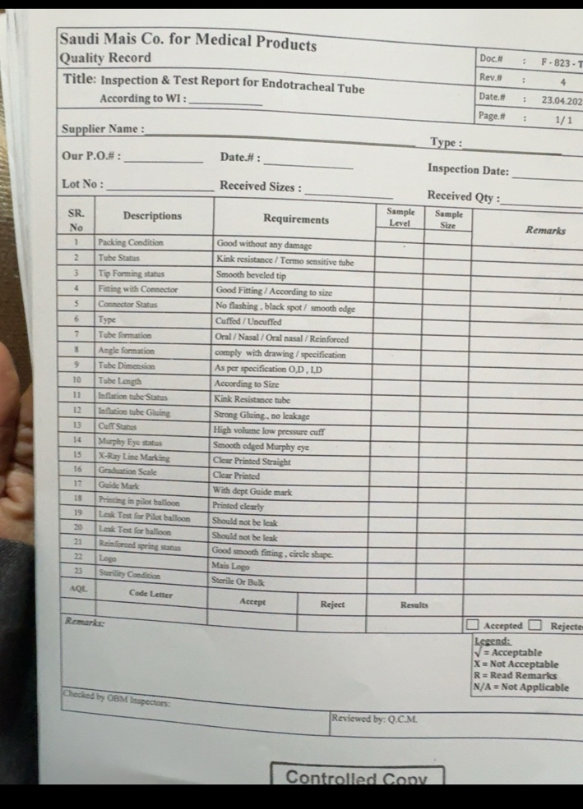
Rev. 4 and page 1/1 are visible. The form number and full date are cropped in the supplied image.

B.2 Non-matching WI - WI-8-2-2-06-1, page 1/11
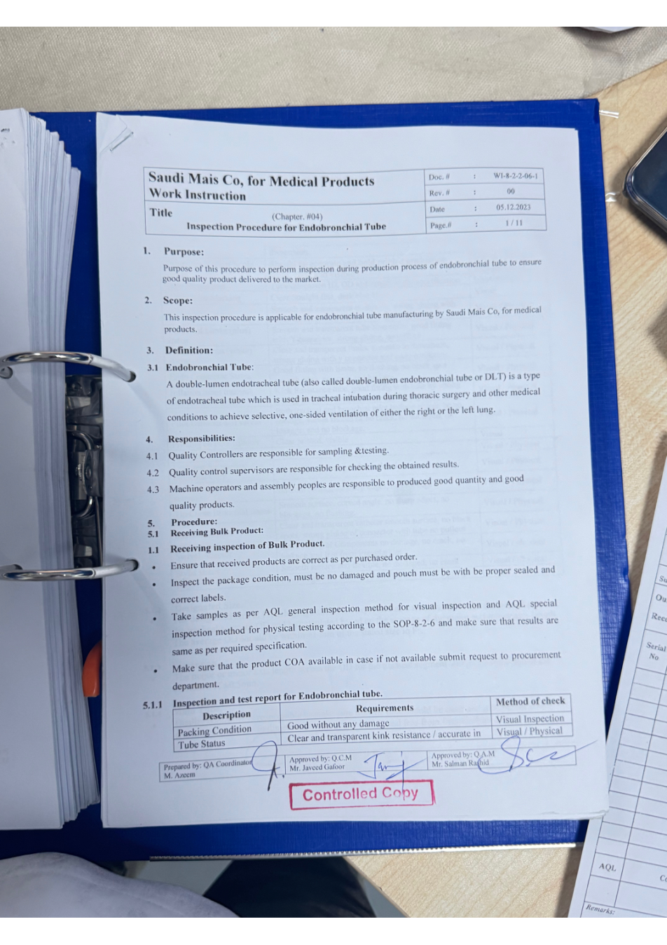
Title and scope identify this WI as Endobronchial Tube, not Endotracheal Tube.

B.3 Non-matching WI - WI-8-2-2-06-1, page 11/11
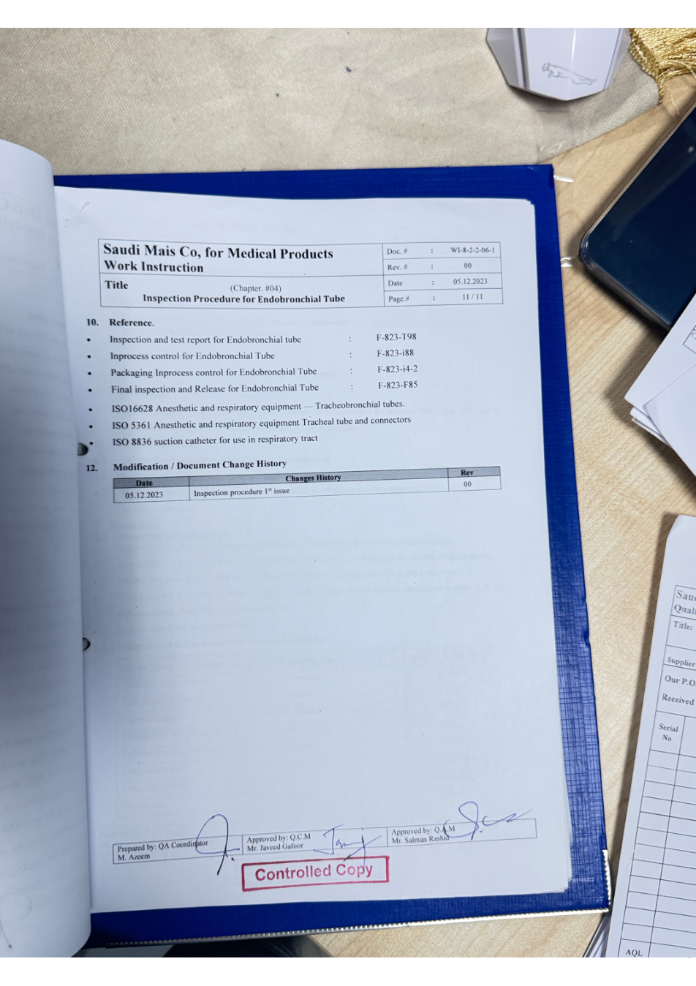
Reference list includes “Inspection and test report for Endobronchial tube: F-823-T98” and ISO 16628 / ISO 5361 / ISO 8836.

