PROCESS AUTOMATION / PROPOSAL FOR MANAGEMENT APPROVAL
Conditional Rejection
Approval Workflow
A targeted enhancement to the existing FOCUS Rejection Request process, using product-level historical reject data to initiate the required approval workflow automatically.
CURRENT REJECT  10.00%  100 rejected / 1,000 produced | HISTORICAL REFERENCE  5.44%  Illustrative product baseline | DIFFERENCE  +4.56 pp  Approval condition is met

THE REQUEST
Once a submitted reject record exceeds the product-specific, approved reject-rate trigger, FOCUS should automatically create and route a Workflow Approval Request to the authorized approvers. No additional review or escalation stage is requested.

SCOPE OF THIS PROPOSAL
Reuse the existing FOCUS authorization sequence. Add an approved, product-level threshold calculation and automatic workflow initiation only when that threshold is exceeded.
Prepared from the supplied four-page procedure and five original system screenshots. All screenshots are reproduced without alteration. Figures, thresholds and future behavior are identified as examples or proposed requirements.
01 / EXECUTIVE BRIEF
Management decision at a glance

The process does not need a separate escalation module. It needs a controlled decision rule that calls the existing approval workflow only when the submitted reject percentage exceeds the approved product-specific limit.
CURRENT PROCESS — EVIDENCED  A user opens a FOCUS Rejection Request, enters the item and rejected quantity, saves the record, and the existing authorization process can notify approvers. An approved request is shown in the information sidebar. | PROPOSED ENHANCEMENT — NOT YET EVIDENCED  Capture or retrieve total production quantity and Lot; compare reject % with an approved, version-controlled baseline from historical data; automatically initiate and link the relevant approval route if the condition is met.

Illustrative approval trigger
PRODUCT / LOT | CALCULATION | REFERENCE | RESULT
BU-340-1000 Mask / 20181107 | 100 rejected ÷ 1,000 produced = 10.00% | 5.44% historical reference | 10.00% > 5.44% → initiate workflow approval

IMPORTANT MANAGEMENT CONTROL
A historical average is not automatically an approved quality limit. The 5.44% figure is used here only because it was supplied in the example. QC and the authorized business owner must confirm the actual trigger rule before release.

Out of scope for automatic action
• The rule does not automatically approve a Rejection Request, authorize stock disposal, open an NCR/CAPA, or create a Destruction Request.
• Under-threshold records follow the currently approved normal handling route; no new approval step is implied by the rule.
02 / SCREENSHOT EVIDENCE • STEP 1
Open the existing Rejection Request screen

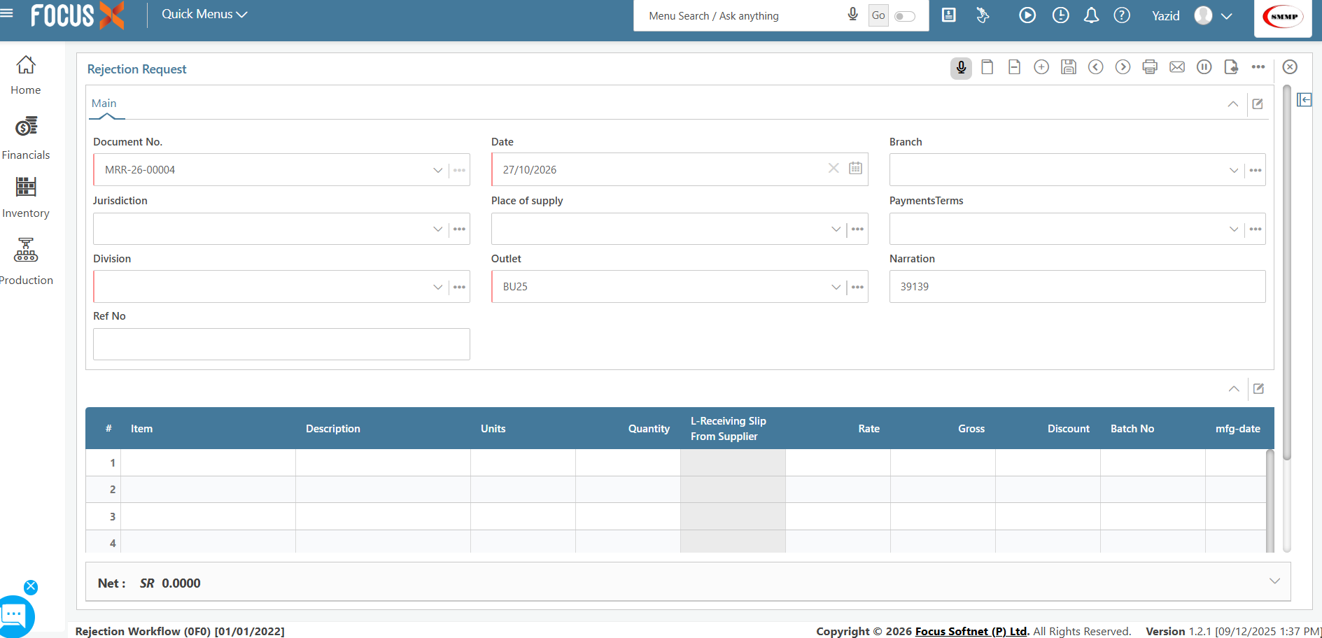
FIGURE 01 | Original FOCUS Request screen. Total production quantity and Lot are not visible in the captured area (supplied file, p. 1).
02 / SCREENSHOT EVIDENCE • STEP 2
Enter the required details and save

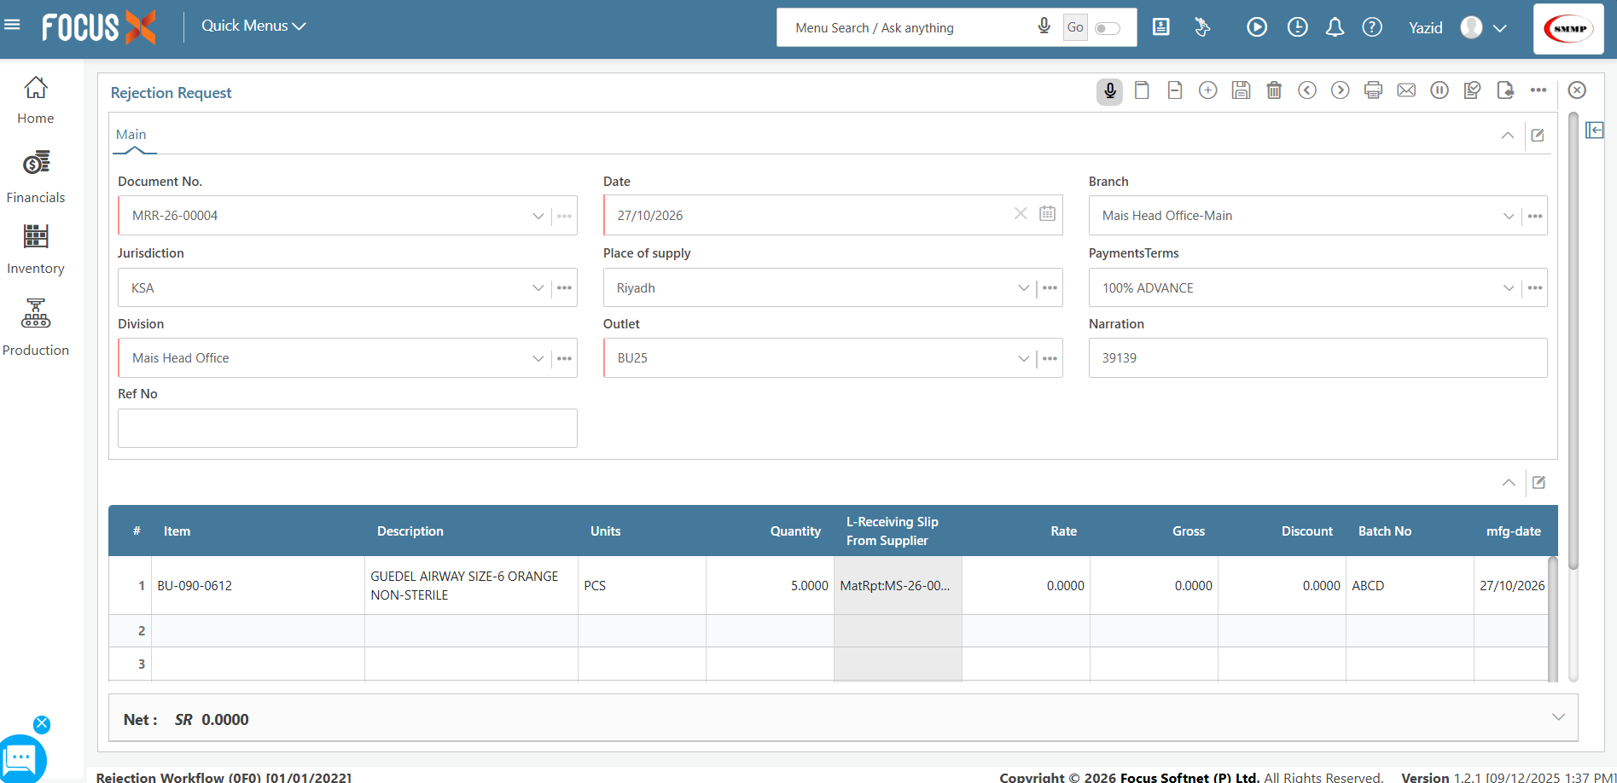
FIGURE 02 | Original FOCUS entry: BU-090-0612 (Guedel Airway Size-6 Orange Non-Sterile), 5 PCS. This is not the illustrated BU-340-1000 mask case (supplied file, p. 2).
02 / SCREENSHOT EVIDENCE • STEP 3
The existing approval notification

The original procedure states that an above-limit request should move to Pending, and the system should notify the department authorized to approve the rejection. The screenshot shows an authorization notification, but not a live percentage comparison.

FIGURE 03 | Original authorization alert: “Rejection Request(s) Require Approval (1)” and a voucher requiring authorization. Source: supplied Word document, page 3.
Approval sequence
01 | 02 | 03
REQUEST IS CREATED | FIRST AUTHORIZED APPROVER | NEXT AUTHORIZED APPROVER
A valid submitted record crosses the approved trigger and opens a linked Pending approval request. | The configured approver receives a notification and can approve or reject the request. | If approved, the request moves to the next configured approval level until all required approvals are complete.

CONTROL
The approvers and their order must come from the company’s existing authorized Approval Matrix. The screenshots do not establish the complete role hierarchy or the order of each sign-off.

02 / SCREENSHOT EVIDENCE • STEP 4
Final approval and the next controlled request

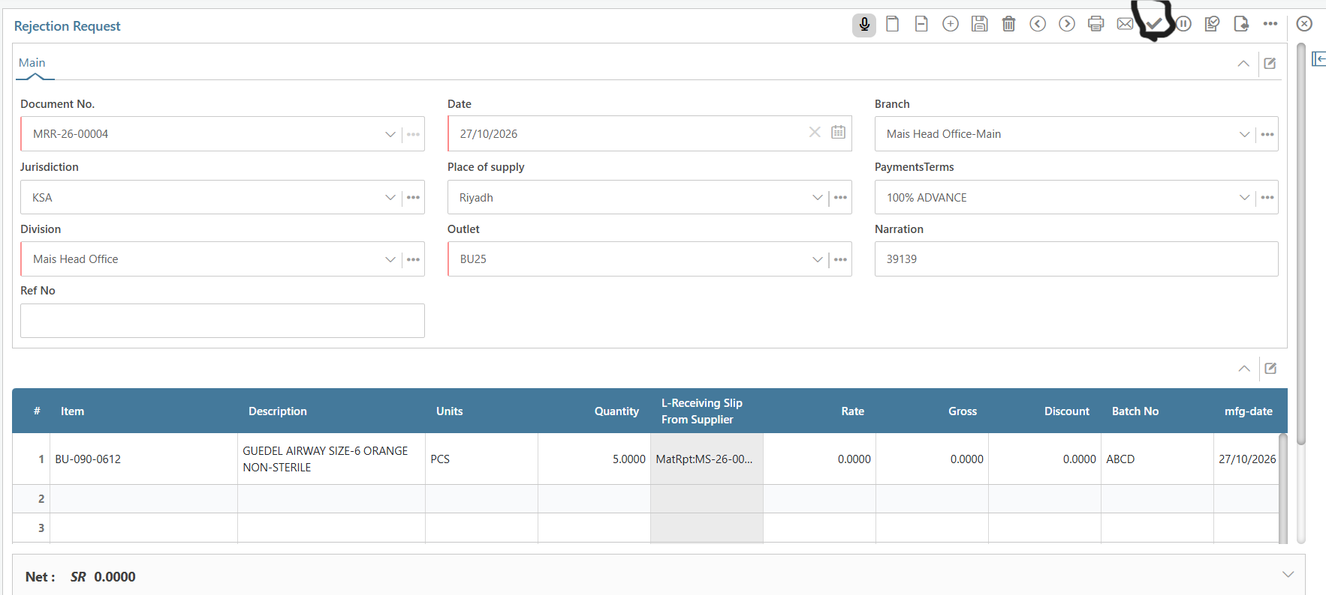 | APPROVED STATUS  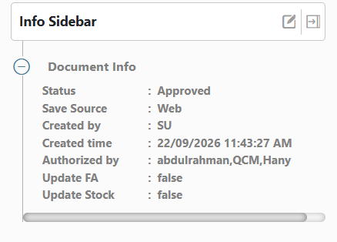  The sidebar displays Approved and an Authorized by field. This is evidence of status and captured approver names, not evidence of automatic threshold checking.
FIGURES 04–05 | Original completed Rejection Request and its status sidebar, reproduced from page 4 of the supplied file.
DOWNSTREAM ACTION: DESTRUCTION REQUEST
The submitted procedure states that, after the Rejection Request is fully approved, the authorized department may create a Destruction Request using a separate workflow. The new percentage-triggered approval rule must not bypass or automatically complete that downstream approval.

03 / FUTURE-STATE WORKFLOW
The proposed automatic approval rule

On submission, the system evaluates the product-specific reject percentage. Only an approved threshold breach initiates the configured Workflow Approval Request. Approval remains a human authorization decision.
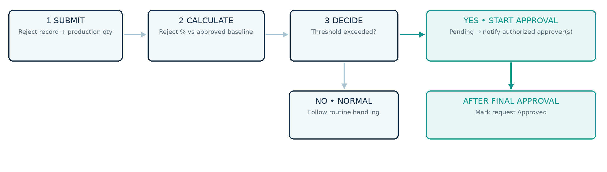
FIGURE 06 | Proposed workflow logic (new illustration, not a screenshot of current FOCUS functionality).
REJECT QUANTITY  100  units | PRODUCTION QUANTITY  1,000  units | REJECT RATE  10.00%  above illustrative 5.44% reference

04 / FUNCTIONAL REQUIREMENTS
Implementation rules and controls

REQUIREMENT | EXPECTED BEHAVIOR
Reference data | Import and validate 2025-onward reject history by product. Calculate a quantity-weighted historical rate where the data supports it; approve the trigger separately.
Mandatory source fields | Product Code, Lot, Rejected Qty, Total Production Qty, date, source document/record ID, and relevant rejection category or line where needed.
Decision point | Evaluate on a valid Submit action, not an unfinished Draft Save. Reject % = Rejected Qty / Total Production Qty × 100.
Threshold condition | Above the approved product threshold → initiate the configured Workflow Approval. At or below → continue existing normal handling.
Record-level protection | One approval request per qualifying source version. Re-evaluate any approved material change and invalidate/renew approval where policy requires.
Exceptions | Missing/zero denominator, unknown product, no approved threshold, or inconsistent quantity: do not silently calculate or auto-route; flag for correction/configuration.
Approvers & traceability | Use existing authorized Approval Matrix. Record notification, approver, decision, timestamp, source ID, rate and threshold/version in an audit trail.
Stock and destruction | No automatic disposition or stock movement from rate calculation. Destruction Request is separate and follows its own authorized workflow.

Design note: if a Lot is recorded across several production entries, the cumulative Lot-level quantities should be considered under an approved aggregation rule to avoid bypassing the trigger by splitting records.
05 / RECOMMENDED NEXT STEPS
Management decisions and controlled rollout

DECISIONS REQUIRED  Approve the principle of conditional approval triggering; nominate the owner for historical thresholds; confirm which authorized roles and sequence apply; confirm the record that supplies Total Production Qty and Lot; and agree how Destruction Requests link back to approved rejections. | RECOMMENDED DELIVERY  First map the FOCUS fields and historical data; then confirm approved baseline rules; implement the trigger and Approval Matrix connection via supported system mechanisms; finally conduct a controlled pilot using real historical scenarios before production release.

Proposed acceptance checkpoints
• The same source item, Lot, rejected quantity and production quantity produce one reproducible reject percentage.
• A record at 10.00% against an approved 5.44% trigger creates exactly one linked Pending Workflow Approval Request.
• A record within its threshold is not routed through the special approval trigger.
• Each assigned approval step issues a notification and advances according to the approved Approval Matrix.
• Approved appears only after all mandatory approvals; a Destruction Request remains a separate authorized workflow.
RECOMMENDED MANAGEMENT APPROVAL
Approve the workflow concept and authorize a detailed FOCUS data/integration assessment. Do not treat the 5.44% reference, the example approver sequence, or the technical integration route as final until they are formally confirmed.

Document basis: the attached “First open the screen of Rejection.docx” (four pages, five screenshots) and the supplied reject-rate example. Screenshots reflect visible FOCUS behavior only; all new conditional logic in this proposal is a future-state requirement.

