Standard Operating Procedure

Using the Quarantine pages
Document status: APPROVED | Revision: D0.1 | Approved by: yazeed (System Owner) | Approval date: 2026-10-09 | Effective date: NOT ASSIGNED. Approval basis: explicit owner instruction in this chat. This file approval does not create a verified in-application electronic signature, assign an effective date or establish operational acceptance.
Document reference: SOP-FRS-004
Revision: D0.1 | Prepared: 09 October 2026
Approval: APPROVED by yazeed | Approval date: 09 October 2026
Effective date: NOT ASSIGNED

1. Purpose and scope
Use Quarantine to register received materials, follow inspection work, review inspection reports and manage controlled inspection templates. This procedure covers Quarantine dashboard, Receiving items, Inspection reports and Quarantine administration, including the linked entry, execution and review screens.
Keep three facts separate: receiving workflow state, scientific inspection result and Release System State. PASS is not RELEASED. An approved inspection report does not authorize material use or automatically release a receiving item.
This approved procedure follows the existing FRS SOP design and seven-section structure. It defines no new acceptance limits, AQL values, sampling plans, permissions, deadlines or retention periods. Owner approval is recorded on 09 October 2026; effectivity must be assigned before controlled use.

2. Responsibilities and prerequisites
Receiving user: enter the delivery identity and exact source quantity with its separate unit. Confirm supplier, document, item, lot and dates. Use your own active account and act only within the permission and scope granted for the record.
Inspector: confirm the receiving context, approved item-to-report mapping and controlled template revision. Record observations, measurements and remarks against the captured template; verify saved values and linked evidence before submission.
Supervisor: conduct the first inspection review stage with the required inspection permission, current version and account-bound electronic signature. QCM / Manager: conduct final approval with the final-approval and signing permissions. The named owner yazeed is subject to the explicit owner rules in each use case; an Administrator label alone grants neither stage.
Quarantine release authority: Supervisor, Manager or named yazeed with the explicit release permission, authorized scope and eligible record. Release checks separation from the inspection executor. Do not infer release authority from being able to open the page.
Template authority: Supervisor, Manager or named yazeed under P-06 with the explicit template permission. Authorized Employee draft creation does not grant review, approval, stop, void or supersede authority. Document Control and the QC technical owner resolve source identity, revision, effectivity, item mapping and scientific criteria.
The named owner yazeed is the designated approval and activation authority for the FRS document family under the existing owner instruction. Approval of this revision is recorded on 09 October 2026; the business controls described here remain binding.

3. Page elements and register meanings
Open navigation and select Quarantine, then the required page. Confirm the account and page title. On a narrow screen use Open navigation. A readable page or visible button is not proof that a controlled action is authorized.
Quarantine dashboard — https://qclevel.top/quarantine. Review Items needing follow-up, Receiving workflow and the Server snapshot time and scope. Cards are Received today, Pending, Ready for inspection, Under inspection, Receiving HOLD, Inspection HOLD, PASS / not released and Released. Open a card’s receiving-record link to inspect its actual filtered population.
Receiving items — https://qclevel.top/quarantine/receiving. Create receiving item opens the entry form. Filters include Search, Item code, Lot, Supplier, Purchase order, Workflow state, Inspection status, Quarantine status, Inspection result, Release state, receiving and expiry date ranges, Ownership and Received on. Select Apply filters. Open a receiving reference to inspect its details, linked inspections, history and available actions.
Inspection reports — https://qclevel.top/quarantine/inspections. Filter by Workflow state, Inspection result and Ownership, then Apply filters. Reports originate from receiving items. Workflow states include Draft, Submitted, Under review, Pending QCM approval, Returned, Approved, Rejected and VOID. Scientific results PASS, FAIL and HOLD are a separate filter.
Quarantine administration — https://qclevel.top/quarantine/admin. Search the Inspection Report catalogue by exact Doc. Code or official title. Review source status and revision before creating a template. The template register provides lifecycle availability and links to version details; Create template selects a controlled master identity and Description.
Receiving detail shows Receiving state, Inspection result and Release System State separately. Inspection detail retains receiving and template snapshots and may show evidence, equipment and AQL context. Review and Execute are separate workspaces. Current template changes do not rewrite the captured context of an existing inspection.

4. Operating procedure
4.1 Review the dashboard. Confirm the snapshot time and authorized scope. Select the relevant attention item or metric link. Confirm the filters in Receiving items before interpreting the count. Received today uses the server-defined UTC day; a displayed local timestamp does not redefine that window.
4.2 Register receiving. In Receiving items select Create receiving item. Enter Receiving number from the approved source, Supplier, Document number, Item code, Lot / batch, Description, Quantity, Quantity unit and Receiving date. Enter Purchase order and Expiry date when applicable. Preserve source digits and units; do not combine the unit with the numeric quantity. Select Create receiving item and verify the saved reference and Pending state.
4.3 Review or correct receiving. Open the receiving reference and compare saved delivery data with the source. Use Start correction / the available correction form only in Pending, Ready for inspection or HOLD with edit authority. Enter corrected values and a factual Correction reason, then Apply correction. Verify the retained quantity unit, dates, current version and history. Identity correction after inspection begins requires the disposition process.
4.4 Apply HOLD or cancellation only when permitted. Enter HOLD reason and select Place on HOLD; verify the receiving state and recorded reason. For an eligible Pending item, the page offers Void this receiving item with Void reason; this is the receiving cancellation operation, distinct from inspection or template VOID. If the action is refused or uncertain, inspect the saved record and history before retrying. This SOP establishes no automatic HOLD-release or cancellation bypass.
4.5 Confirm readiness for inspection. A new receiving item starts Pending. Creation of an inspection requires Ready for inspection or Under inspection. The current detail page does not offer a Pending-to-Ready action; if the item remains Pending, refer it to the Quarantine owner through the authorized process. Do not change its state directly in the database. Where shown and authorized, Start inspection is a receiving transition and is separate from creating the inspection report.
4.6 Create the linked inspection. From the eligible receiving detail review Create an inspection. A unique approved mapped report is selected automatically; when several approved reports are mapped, choose the one required by the approved source. Confirm exact report code, title and revision. Enter Inspection number from the approved source, then Create inspection. Confirm the new Draft and its receiving link. Do not retype or replace the prefilled item, lot, supplier or quantity.
4.7 Resolve template blockers before execution. Stop when no controlled mapping exists, only a master-list identity exists without an approved digital template, approved templates are unavailable, or another report is already in progress. Reload for an unavailable source; refer missing mapping/content to Document Control and the QC technical owner. A selectable title does not resolve source conflict or effectivity.
4.8 Record controlled context. In inspection detail review the captured receiving identity and template revision. Where available, enter the approved AQL, sample size, acceptance/rejection numbers, source reference and applicable sampling facts, select Sampling result from that source, then Record sampling. No sampling values are calculated here. Select Equipment and Link current calibration evidence; the server captures its current calibration and certificate context. Confirm the saved evidence links. Do not claim a calibration or source approval that is not recorded.
4.9 Execute and save. Select Open execution to open Execute inspection. Enter required observations, exact decimal measurements, table rows and remarks using the controls defined by the captured form. Preserve declared units and point types. Select Save digital form / Save results as displayed and verify the saved values by reopening the record. For a controlled digital form, general remarks are saved with form values; the legacy point workspace explicitly states that general execution notes are not saved. Use saved point remarks in that workspace.
4.10 Submit recorded work. Save the complete draft first, then review the persisted values, required points, source context and active evidence. Select Submit saved form for review / Submit for review as displayed. Submission validates the saved form; it does not save unsaved edits. At least one active evidence link is required by the submission path. Confirm Submitted. Do not type a final PASS/FAIL/HOLD to bypass the server’s scientific-source validation.
4.11 Review and sign stage one. The authorized reviewer opens Review inspection and selects Begin review from Submitted. Review the snapshot, observations, evidence and official result. In Under review, the eligible Supervisor reauthenticates and selects Sign stage approval — send to QCM. Verify Pending QCM approval and the matching stage signature. Missing official scientific result or approved source blocks approval; stop and refer the source issue to the technical owner.
4.12 Perform final approval. The eligible QCM / final authority continues in the report’s review workspace and reviews the same report and current version, reauthenticates and selects QCM final approval — approve and lock. Verify Approved and the final signature/audit evidence. The current inspection detail does not offer Open review in Pending QCM approval; if navigation cannot reach the authorized review workspace, stop and ask support to resolve access. Each stage requires its own signature. Final approval moves the related receiving item to Inspection complete; it does not set RELEASED. A receiving item on HOLD is not silently restored by approval.
4.13 Return or reject. When permitted, enter a specific Return reason and select Return for correction. The executor uses Resume for correction where available, corrects and saves the draft, and resubmits through the review stages. If the returned digital form has no Resume control, stop and refer the unavailable action to support; do not create a substitute report to bypass it. Reject inspection / Reject at QCM stage require the displayed reason and current authority. Rejected is a workflow decision, not a substitute for scientific FAIL; previous observations and history are preserved.
4.14 Release separately. Open the receiving detail and verify official PASS, Release pending, current version and release authority independent of the inspection executor. Select Release item only when available and authorized; inspect the resulting receiving state and Release System State RELEASED and history. Inspection complete alone is insufficient. The page does not offer an Inspection-complete-to-Release-pending control. The current release form has no signing ceremony; this SOP does not establish that the broader required release-signature policy is implemented.
4.15 Create or import template drafts. In Quarantine administration search the exact master identity, confirm official title/revision and source status, enter Description, then Create template. Import source drafts, when authorized, records DRAFT transcriptions and conflicts; it does not approve content or create an item mapping. When the catalogue is unavailable, reload and resolve the source dependency before creating or importing templates.
4.16 Manage template lifecycle. Open the version detail and inspect the source and digital preview. Review applies from Draft; approval applies from Draft or Under review only with matched content, source binding and the authorized signature. Approved content is changed through Create DRAFT revision, not in-place editing. Stop applies from Approved; Supersede from Approved or Stopped; VOID applies only in the permitted states. Stop, VOID and Supersede require a reason, password confirmation and signature. Verify the saved version/state and audit history. This lifecycle does not rewrite existing inspection snapshots.

5. Counts, states and exceptions
Counts are independent. Dashboard cards may overlap: Receiving HOLD and Inspection HOLD describe different facts, and PASS / not released combines result and release state. Do not add cards, report counts and template counts as one completion total. An empty filtered or scoped view is not proof that no records exist elsewhere.
Unavailable is not empty. On 09 October 2026 the live administration page showed “Catalogue is temporarily unavailable. Reload before creating a template.” No template versions were visible in the authorized scope. The catalogue message is a dependency failure; it does not establish an empty or approved catalogue. Report the page, time and message to support if reload does not resolve it.
Source or policy stop: unresolved identity/revision conflict, missing mapping, unapproved or ineffective source, missing required evidence or an undetermined final result prevents the affected controlled action. Use the approved master source for identity and revision and the applicable controlled form for content. Do not guess criteria, AQL, acceptance limits or authority.
Stale version or changed access: retain proposed input, review the latest record and reassess state, scope and intended action. Do not automatically repeat a decision against a newer version. For an interrupted response, inspect saved values and history before deciding whether a retry is needed.
Distinguish Draft from Submitted, stage-one approval from final Approved, and Inspection complete from Release pending and RELEASED. Template Approved does not independently prove the effectivity of every linked source. A printed copy, button label or confirmation is not signature evidence without its matching account/action/version record.
Use personal credentials only in the system’s own authentication/signature fields. Do not place passwords in remarks, attachments, screenshots or this SOP. Do not use another person’s account to complete a stage.

6. Records and review checks
Receiving records retain delivery identity, exact quantity/unit, dates, state/version, inspection links and transition history. Inspection records retain receiving/template snapshots, observations, form values, point remarks, required evidence and applicable audit/signature records. Template records retain source binding, revision, lifecycle and historical usage context.
Before controlled use, check representative populated receiving and inspection records, permitted and denied accounts, approved effective mapped templates, exact saved data, required evidence, both signing stages and separate release. Include HOLD, returned work, missing-source, stale-version and uncertain-outcome cases. Do not infer operational acceptance from document formatting.
Authoring verification on 09 October 2026: authenticated read-only browser review using yazeed opened all four requested live pages and the receiving entry form. Receiving and inspection registers were empty; administration showed catalogue unavailability and no visible template versions. No receiving item, inspection, template or business decision was created or changed. Populated details, signing and release were reviewed from local source only, not exercised live.
Reviewer: NOT RECORDED. Approver: yazeed (System Owner). Reference: SOP-FRS-004. Revision: D0.1. Approval date: 09 October 2026. Approval basis: explicit owner instruction in this chat. Effective date: NOT ASSIGNED. This file approval does not create a verified in-application electronic signature, assign an effective date or establish operational acceptance.

7. References and revision history
R1: https://qclevel.top/quarantine; /quarantine/receiving; /quarantine/inspections; /quarantine/admin — authenticated live observations on 09 October 2026. Receiving entry form was read without submission. Live deployed SHA was not independently established.
R2: SOP-FRS-001 Document control and sources; SOP-FRS-002 D0.1 Work page; SOP-FRS-003 D0.1 Quality pages — FRS document context, retained design and related workflow references. Citing a draft does not record its approval.
R3: src/pages/quarantine/index.astro; receiving/index.astro, new.astro and [receivingId].astro; inspections/index.astro and [inspectionId] detail/execute/review pages; admin/index.astro and [templateId].astro — page controls and supported operations.
R4: src/modules/quarantine/receiving/application/create-inspection-from-receiving.ts and release-receiving.ts; inspection/application/submit-inspection.ts; templates/application/lifecycle.ts — receiving origin, submission, release and template controls. Local source candidate: 6d925d74d243bbfd77ab5b784c21cd68303672b6; live deployment parity was not established.
R5: .agents/mind/01-mind-latest.md and src/modules/approvals/application/signature-policy-registry.ts — recorded account-bound approval requirement and implemented action-policy context. The separately named signature-policy documents were not present in the rebuilt Documents tree at authoring; obtain the current controlled policy from its owner before controlled execution.
D0.1 | 09 October 2026 | Initial review draft for Quarantine dashboard, Receiving items, Inspection reports and Quarantine administration. Includes live empty/unavailable observations, source-supported operations and distinct inspection/release states.

Visual operating guide
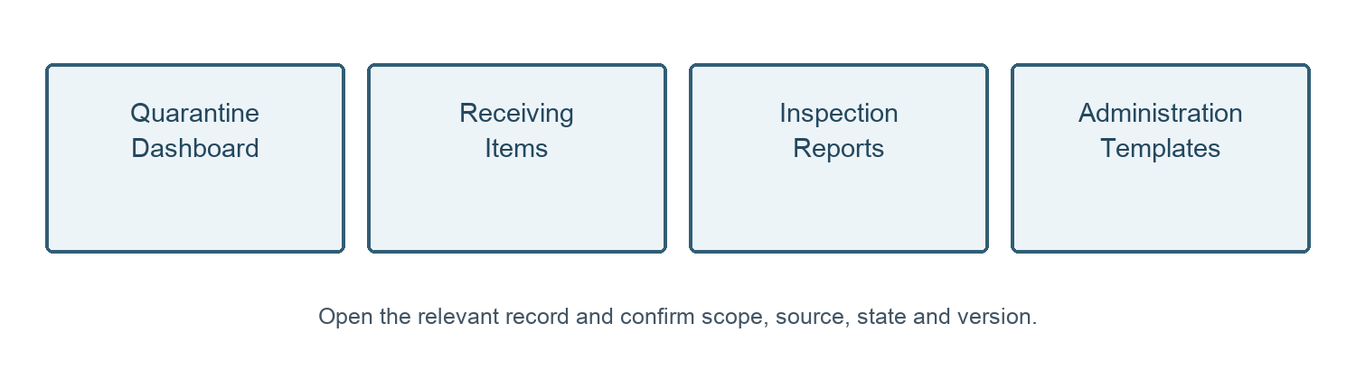
Figure 1. Quarantine page guide. Administration controls templates; it is not a receiving workflow stage.
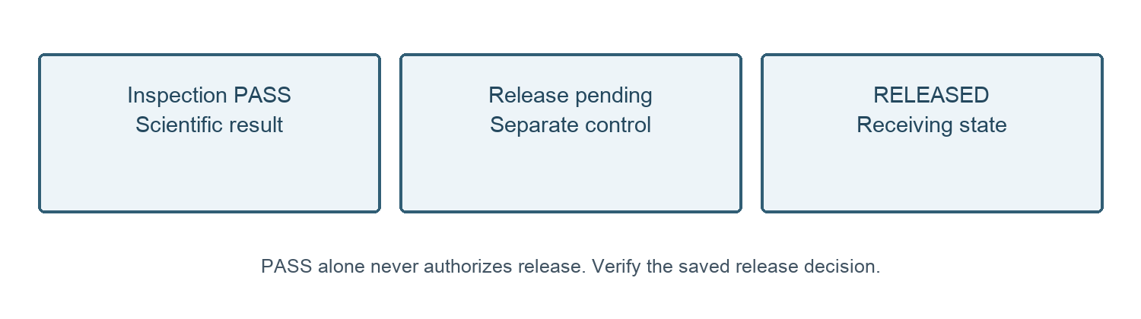
Figure 2. Inspection result and material release are distinct controlled facts; the diagram does not perform a transition.
09 October 2026 — Owner approval recorded for SOP-FRS-004 D0.1 by yazeed through the explicit instruction in this chat. Status changed to APPROVED; file moved to SOPs/approved. Existing revision identifier retained. Effective date: NOT ASSIGNED. This file approval does not create a verified in-application electronic signature, assign an effective date or establish operational acceptance.

