Standard Operating Procedure

Using Laboratory tests
Document status: APPROVED | Revision: D0.1 | Approved by: yazeed (System Owner) | Approval date: 2026-10-09 | Effective date: NOT ASSIGNED. Approval basis: explicit owner instruction in this chat. This file approval does not create a verified in-application electronic signature, assign an effective date or establish operational acceptance.
Document reference: SOP-FRS-005
Revision: D0.1 | Prepared: 09 October 2026
Approval: APPROVED by yazeed | Approval date: 09 October 2026
Effective date: NOT ASSIGNED

1. Purpose and scope
Use Laboratory tests to locate controlled tests, create an eligible draft, record observations and equipment context, and follow review and the two approval stages. This procedure covers https://qclevel.top/laboratory/tests and its linked creation, record, execution and review workspaces.
The linked Laboratory report templates page records separate transcriptions of Subatmospheric Pressure Air Leakage and Pressure Decay source reports. These drafts do not approve a controlled laboratory test. Keep workflow state, official scientific result and material release separate.
This SOP establishes no test method, acceptance threshold, unit, sample size, retest rule or retention period. Use the applicable approved effective method and controlled source. Record approval and effectivity of this document before controlled use.

2. Responsibilities and prerequisites
Laboratory executor: use your own active account within its granted scope and permissions. Verify the controlled template, method reference, source revision and sample identity; enter exact observations and confirm saved data before submission.
Supervisor: perform the first approval stage with laboratory approval and signing permissions, current state/version and fresh account reauthentication. QCM / Manager: perform final approval with final approval and signing permissions. The named owner yazeed acts only under the explicit owner rule for the action. An Administrator label alone is insufficient.
QC technical owner and method owner: supply approved scientific criteria, calculations, sampling instructions and source identity. Document Control: confirm controlled version and effectivity. Equipment custodian: resolve unavailable, overdue or ineligible equipment and calibration evidence.
The designated FRS document approval and activation authority is yazeed under the existing owner instruction. This designation does not record approval or activation of D0.1 and does not remove laboratory workflow controls.

3. Page elements and register meanings
Open navigation, select Laboratory then Laboratory tests, and confirm the account and page title. Create laboratory test opens the controlled entry form. Enter Subatmospheric Air Leakage or Pressure Decay report draft opens the separate transcription workspace.
The register filters are Search, Workflow state and Ownership. Ownership offers All records and Only mine. Sort by offers Recently updated, Test number and Workflow state; Direction offers Descending and Ascending. Select Apply filters after choosing the required combination.
Workflow state offers Draft, Submitted, Under review, Pending QCM approval, Returned, Approved, Rejected and VOID. These labels describe workflow and do not replace the official scientific result. A VOID filter does not prove that a VOID operation is available.
The count states the visible tests, total in the authorized scope and current page. Read it together with the filters. No laboratory tests yet is the empty register state. Empty within one scope or filter is not a system-wide absence claim.
Test details show test number, workflow state, official result, version and controlled Method, Template version and Source. Next workspace provides Open execution workspace or Open review workspace when available; links to related receiving and audit context are read context, not authorization to change another record.

4. Operating procedure
4.1 Locate work. Apply the required search, state, ownership and sort filters. Open the exact test number and confirm method, source, current version and next owner. Use the available page navigation when more than one page is shown.
4.2 Confirm creation prerequisites. Select Create laboratory test. Select Approved template from the controlled list in your scope and enter Approved laboratory test number from the approved source. The system assigns controlled source and version automatically. Do not substitute an unrelated template or invent a test number.
4.3 Save the draft. Select Save draft only when an eligible controlled template is available. Verify the saved test reference, Draft state and captured method/source/version. If the page states that no approved templates are available, stop and refer template approval/source availability to the technical owner and Document Control.
4.4 Open execution. Select Open execution workspace from the test detail. Confirm Raw observations, Samples in this record, parameter labels, declared types, units and Frozen context. A new draft currently starts with no samples; the execution page edits existing sample rows and does not provide a sample/run creation control. If the required samples or runs are absent, stop and refer the missing setup to the laboratory owner and support.
4.5 Enter observations. Record each value against the correct sample and parameter. Preserve exact decimal digits and declared units. Enter text as text and Boolean observations using the displayed true/false choice. Record relevant remarks in the corresponding parameter field. Do not turn a text value into a number or infer a unit or acceptance limit.
4.6 Preview bulk entry when required. The execution page accepts tabular observations with the exact five-column header Sample, Parameter, Value, Unit, Remarks. Use existing sample identifiers and displayed parameter codes; leave Unit blank for a unitless parameter. Select Preview observations, resolve invalid rows and inspect the resulting fields. Preview is not a saved test or a scientific decision.
4.7 Save observations. Select Save observations, then reopen or refresh the saved record and compare values and remarks with the source. Confirm that the current version changed as expected. Save before submission; unsaved fields must not be assumed to be included in the submitted record.
4.8 Record equipment use. Where existing runs are available, select the required run and equipment in Equipment used for a run and select Record equipment use. Confirm the saved equipment/calibration snapshot. Equipment must be eligible and calibration current; an overdue calibration, failed/inactive equipment or maintenance condition blocks use. Do not replace certificate or source facts with an informal remark.
4.9 Submit saved work. Review all required saved measurements, sample identity, controlled source and applicable equipment context. Select Submit for review when available and verify Submitted. The submission path validates completeness, equipment eligibility and controlled execution source. Missing scientific authority/source is a stop condition, not permission to supply a result manually.
4.10 Review the submission. Open Open review workspace. Compare Observed results vs approved criteria and Read-only submission context, including measurements, samples, linked documents and equipment snapshots. Follow the saved state. The local review page does not expose a Begin review control for Submitted records; if the record cannot progress to Under review through an authorized available action, stop and refer the missing workflow control to support.
4.11 Sign the Supervisor stage. In Under review, the eligible Supervisor reviews the persisted context and official result, enters their own password in Reauthentication password (stage approval signature), then selects Supervisor approval — send to QCM. Verify Pending QCM approval and matching stage signature/audit evidence. This stage is not final Approved.
4.12 Sign final approval. In Pending QCM approval, the eligible final authority reviews the current record and source context, enters their own password in Reauthentication password (final approval signature), then selects QCM final approval — approve and lock. Verify Approved and the final signature tied to this account, action and version. Approved does not release a material item.
4.13 Return for correction. When permitted, enter Return reason and select Return for correction at the Supervisor stage, or QCM return reason and Return at QCM stage. Verify Returned and the saved reason. Resume is defined in the application workflow but the current page provides no Resume control and returned execution is read-only. Refer unavailable correction navigation to support; do not create a replacement test to erase the history.
4.14 Handle reject, VOID, reopen and retest requests. The current review page does not offer Reject, VOID or Reopen controls. Reject remains blocked by unresolved decision authority; VOID is not implemented. The Retest page states that authority, count, sequence and original-result handling require approved policy. Stop and refer the requested disposition to the policy owner; preserve the original measurements, result and signatures.
4.15 Enter a separate source-report draft. From Laboratory tests select the report draft link, choose Subatmospheric Pressure Air Leakage Test Report or Pressure Decay Test Report, and transcribe record identity, document number/revision/date, sample/product/lot, conditions, remarks and source-recorded names. Copy each of the 12 displayed sample rows exactly, including units and decimal precision. The 12-row form is not an approved sampling rule.
4.16 Save and check the transcription. Select the source-recorded overall result only when present on the source, then Save draft and inspect the saved draft when returned. Names in Tested by, Reviewed by QC/E and Approved by QA/E are transcribed text, not account-bound signatures. A copied PASS/FAIL, saved draft or printed copy does not approve a laboratory test or release material.

5. Counts, states and exceptions
On 09 October 2026 the authenticated Laboratory tests register displayed 0 of 0 tests in the authorized scope. The creation form displayed no approved templates and stated that a new test cannot be started. This is the observed authoring state; verify the current page before operating.
Unavailable, denied and empty are distinct. For temporary unavailability, reload and report the page/time/message if unresolved. For denied access, refer the action to the authorized owner. Do not interpret either outcome as zero records or as permission to bypass a controlled source.
Keep official result separate from workflow approval and derived/comparison outcomes. Reviewer decision or Not recorded in a criteria row is not PASS; a badge does not establish a complete approved method. The production scientific evaluator remains blocked without a controlled scientific source.
For stale version or changed access, retain intended input, inspect the latest saved record and reassess authority/state before a new action. For an interrupted or uncertain response, inspect the record and audit/signature history before retrying. Never automatically repeat an old approval against a newer version.
Use credentials only in the system authentication/signature fields. Never copy passwords into reports, remarks, screenshots or this SOP. Each approval stage uses its own authorized account-bound signature.

6. Records and review checks
Keep the controlled test identity, method/source/template snapshot, sample identities, exact raw observations, remarks, equipment/calibration usage, workflow version/history and matching approval signatures. Preserve original-result lineage for any authorized later retest; this SOP defines no new retention period.
Before controlled execution, verify a populated record with approved effective sources, existing sample/run setup, permitted and denied users, saved exact observations, equipment eligibility, submission, both approval stages and correction handling. Check source-missing, stale-version and uncertain-response cases. Document formatting is not operational acceptance.
Authoring verification on 09 October 2026: live authenticated read-only browser inspection using yazeed covered the Laboratory tests register, Create laboratory test and the linked report transcription form. No test, source-report draft or business decision was saved. Populated execution/review steps were checked from local source only; live signing, scientific evaluation and full lifecycle were NOT RUN. Live deployed SHA parity was not established.
Reviewer: NOT RECORDED. Approver: yazeed (System Owner). Reference: SOP-FRS-005. Revision: D0.1. Approval date: 09 October 2026. Approval basis: explicit owner instruction in this chat. Effective date: NOT ASSIGNED. This file approval does not create a verified in-application electronic signature, assign an effective date or establish operational acceptance.

7. References and revision history
R1: https://qclevel.top/laboratory/tests; /laboratory/tests/new; /laboratory/report-templates — authenticated observations on 09 October 2026, without submission.
R2: SOP-FRS-001 Document control and sources; SOP-FRS-002 Work page; SOP-FRS-003 Quality pages; SOP-FRS-004 Quarantine pages — related FRS procedures. Citation does not record approval or effectivity.
R3: src/pages/laboratory/tests/index.astro, new.astro, [labTestId]/index.astro, execute.astro, review.astro and retests/new.astro; src/pages/laboratory/report-templates.astro — controls and navigation.
R4: src/modules/laboratory/application/create-lab-test.ts, save-measurements.ts, submit-lab-test.ts, approve-lab-test.ts, final-approve-lab-test.ts and reject-lab-test.ts; infrastructure/postgres-controlled-sources.ts — source binding and action guards. Local source HEAD: 6d925d74d243bbfd77ab5b784c21cd68303672b6. Live deployment parity not established.
D0.1 | 09 October 2026 | Initial review draft for Laboratory tests and its linked source-report transcription workspace. Reference SOP-FRS-005 confirmed by the owner; preserves SOP-FRS-004.

Visual operating guide
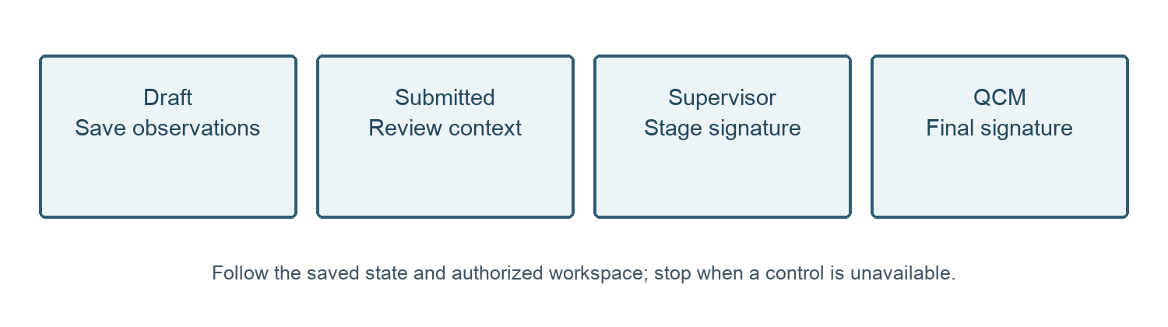
Figure 1. Laboratory workflow guide. Each approval stage requires its own authorized signature.
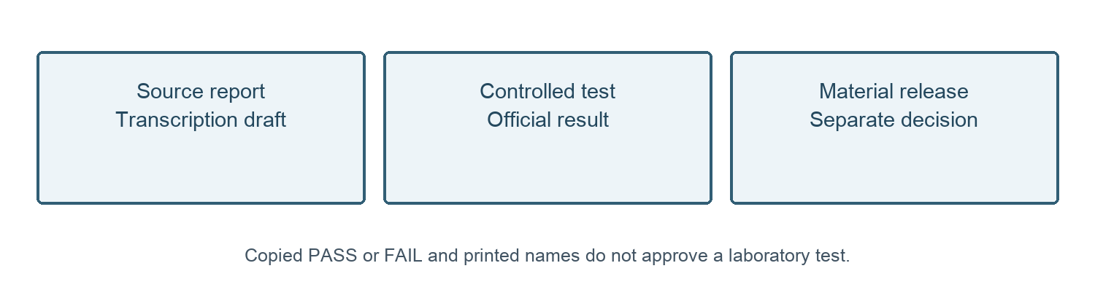
Figure 2. Report transcription, controlled test approval and material release are separate records.
09 October 2026 — Owner approval recorded for SOP-FRS-005 D0.1 by yazeed through the explicit instruction in this chat. Status changed to APPROVED; file moved to SOPs/approved. Existing revision identifier retained. Effective date: NOT ASSIGNED. This file approval does not create a verified in-application electronic signature, assign an effective date or establish operational acceptance.

