Standard Operating Procedure

Using Assets pages
Document status: APPROVED | Revision: D0.1 | Approved by: yazeed (System Owner) | Approval date: 2026-10-09 | Effective date: NOT ASSIGNED. Approval basis: explicit owner instruction in this chat. This file approval does not create a verified in-application electronic signature, assign an effective date or establish operational acceptance.
Document reference: SOP-FRS-006
Revision: D0.1 | Prepared: 09 October 2026
Approval: APPROVED by yazeed | Approval date: 09 October 2026
Effective date: NOT ASSIGNED

1. Purpose and scope
Use Assets to identify equipment, preserve calibration records and follow maintenance work. This procedure covers the Assets overview and the Equipment, Calibration records and Maintenance registers, creation forms and linked record details at https://qclevel.top.
Keep equipment operational state, calibration state and maintenance work state separate. A calibration approval or maintenance completion does not activate equipment, establish a current calibration, approve a laboratory result or release material.
This SOP provides system operating instructions. It establishes no calibration method, tolerance, interval, maintenance frequency, technical acceptance criterion or retention period. Obtain these from the applicable approved source. Record approval and effectivity of this document before controlled use.

2. Responsibilities and prerequisites
Equipment custodian: confirm the approved equipment number, physical identity, location and source requirements. Use your own active account within its granted scope. Confirm the saved equipment, calibration and maintenance links before relying on them.
Calibration executor and reviewer: transcribe the approved source and certificate accurately, confirm the linked equipment and source dates, and act only within the authorized workflow. An Administrator or System owner label alone does not establish permission for a specific action.
Maintenance owner: record the correct equipment, planned work, performer and provider; verify the equipment impact when starting work and the persisted work history when completing it. QC technical owner: supply applicable requirements and resolve equipment eligibility. Policy owner: resolve activation, current-calibration selection and approval/signature rules.
Document Control: control document identity, revision, approval and effectivity. The existing FRS owner instruction designates yazeed as document approval and activation authority; approval of this procedure is recorded on 09 October 2026; activation and asset controls remain separate.
Before entry, have the approved identity source, applicable certificate/work order and source-provided dates. Do not invent numbers, intervals or exemptions. Equipment must exist in your authorized scope before a calibration or maintenance record can be linked.

3. Page elements and register meanings
Open navigation and select Assets. The overview links Equipment register, Calibration records and Maintenance and displays the number of records returned in the account scope. Read the scope label with each number. Counts measure records, not the number of eligible instruments, approved certificates or completed work items.
Equipment provides Add equipment, Search, Operational state and Apply filters. Operational state offers All states, Draft, Active, Out of service, Under maintenance and Decommissioned. Open the equipment identity to inspect its version, manufacturer, model, serial number, location and requirement flags.
Equipment details contain Calibration history, Maintenance history and Status history. Record calibration and Record maintenance open linked creation forms; View all records opens the corresponding register for that equipment. These links provide context and do not grant a mutation permission.
Calibration records provides Add calibration record, Search, State and Apply filters. States are Draft, Scheduled, Submitted, Approved, Current, Due, Overdue, Completed, Failed, Superseded and VOID. Record details include equipment, date, due date, provider, certificate, result/source note, eligibility and Immutable history.
Maintenance provides Add maintenance record, Search, State and Apply filters. States are Draft, Planned, In progress, Completed, Cancelled and VOID. Details include Maintenance summary, Execution timeline, Available actions and Immutable history. Not supplied, Not specified, Not scheduled and Open or not recorded preserve missing-source distinctions.
Available actions depends on state and permission; the server checks permission, scope and version again. A state in a filter does not prove that a transition button exists or that its policy is approved.

4. Operating procedure
4.1 Locate the asset. Open Assets, select the required register, enter Search and choose the state, then select Apply filters. If a filter produces no matches, clear it and recheck the account scope before concluding that the record is absent. Open the exact equipment or record number.
4.2 Create equipment. Select Add equipment. Enter Equipment number from the approved source and Name. Transcribe Manufacturer, Model, Serial number and Location when supplied. Select Calibration required and Maintenance required only according to the approved source; do not use an unchecked box as evidence of an exemption.
4.3 Save and check equipment. Select Create draft during authorized operation. Confirm the saved equipment number, name, Draft state and source fields. Equipment details currently provide read and history links but no edit or state-transition form. Activation remains policy-blocked in the local application. Refer required corrections or activation to the custodian and policy owner; a saved draft is not usable equipment.
4.4 Create calibration. From the equipment detail select Record calibration, or select Add calibration record in Calibration records. Enter Calibration number from the approved source and select the exact Equipment. Compare equipment number, name and physical serial identity before continuing. If no equipment is available, use Create the equipment first and return after its draft is confirmed.
4.5 Transcribe calibration evidence. Enter Calibration date and Due date (source-provided) exactly as supported by the approved source. Leave a missing due date unassigned; do not calculate an interval. Enter Provider, Certificate number and Result / source note as supplied. The current form has no certificate-file upload control; a certificate number or note alone is not the certificate itself.
4.6 Save calibration. Select Create draft and verify the saved calibration number, linked equipment, dates, provider, certificate number and result note. Retain the source certificate under the approved document process. A draft, a source note saying PASS or a recent date does not establish Approved or Current.
4.7 Schedule and submit calibration when permitted. In a Draft detail, select Schedule calibration if required by the authorized plan and confirm Scheduled. Select Submit calibration from Draft or Scheduled after checking the saved evidence; confirm Submitted and the new Immutable history entry. Schedule changes workflow state; it does not supply a missing date or schedule an external service.
4.8 Review calibration approval. The local Submitted detail can show Approve calibration to an account with the required permission. Approval checks include state, current version, scope and separation of author and approver. The current asset action form/use case does not implement account reauthentication or an electronic-signature ceremony for calibration approval. Do not treat that unsigned action as a signed approval; refer controlled approval requiring a signature to the policy owner and support until the applicable ceremony is implemented and verified.
4.9 Record completion or failure when authorized. From Approved or Current, the local page can provide Record calibration completion and Record calibration failure. Confirm the resulting Completed or Failed state and history. The action form changes status and does not provide new certificate, result or technical acceptance fields. Do not infer a technical result from selecting a status.
4.10 Confirm current-calibration selection and use eligibility. Approved and Completed are separate from Current. MAKE_CURRENT is denied by unresolved policy and has no current page control. Do not manually change a current-calibration pointer or claim that the latest certificate is automatically current. Refer selection to the policy owner and confirm equipment eligibility from current source records before use.
4.11 Create maintenance. From the equipment detail select Record maintenance, or select Add maintenance record. Enter Maintenance number from the approved source and select Equipment. Transcribe Type, Scheduled date, Description, Performed by and Provider. Type is a text field; use the source terminology. Performed by is recorded text, not an account-bound signature.
4.12 Save and plan maintenance. Select Create draft and verify the linked equipment, description, type, performer, provider and planned date. In Draft, select Plan maintenance when authorized and confirm Planned. The transition does not create an external appointment or provide a missing scheduled date.
4.13 Start maintenance. In Planned, select Start maintenance only when work actually starts under the approved work instruction. Confirm In progress, Started and the equipment Status history. The local transaction changes eligible Active or Out of service equipment to Under maintenance; equipment in another state causes refusal. Do not use the equipment while it is under maintenance.
4.14 Complete maintenance. In In progress, select Complete maintenance when authorized and work is complete. Confirm Completed, the completion time, recorded downtime and Immutable history. The current transition form does not offer a technical Result input. Missing result remains Not supplied; completion does not certify a repair result, calibration or return to service.
4.15 Cancel planned maintenance. In Planned, enter Reason and select Cancel maintenance when authorized. Confirm Cancelled and the retained history. The current page does not expose cancellation from Draft or In progress. Maintenance VOID is policy-denied; a VOID filter does not authorize that action.
4.16 Return to use. After maintenance completion, review the equipment state and current calibration. Completion leaves return to service as a separate controlled decision; the equipment detail currently has no return-to-service control. Refer it to the authorized custodian/support workflow. Resume laboratory or inspection use only after eligibility is positively confirmed.
4.17 Check the saved record after every action. Confirm the exact record, state, version, timestamps and history. Follow the current page and authorized controls. If the response is uncertain, inspect the record and audit history before deciding whether to retry; do not assume success from a button selection.

5. Counts, states and exceptions
On 09 October 2026 the authenticated Assets overview displayed Equipment register 0, Calibration records 0 and Maintenance 0 for All sites (global). All three registers displayed their empty state, and both linked creation forms reported no equipment in scope. These are observed authoring conditions; recheck current records before operation.
Empty, denied and unavailable are separate outcomes. An unavailable source does not establish zero records. If a related history cannot load, do not infer that it contains no events from the available equipment identity. Refresh and report the page, time and safe message if unresolved.
For laboratory/inspection use, the local eligibility check requires Active equipment with its matching Current calibration and no passed source due date. Under maintenance, Out of service, inactive/decommissioned equipment, missing/non-current calibration and expired calibration block eligibility. No approved bypass is defined here. A requirement checkbox does not establish an exception to the current check.
If a due date is absent, preserve the missing-source status and refer the applicable date or interval decision to the technical owner. Do not convert it to a default annual period or unrestricted use. Eligibility is checked again at point of use; the displayed reading does not reserve the equipment.
For changed state, stale version or changed access, inspect the latest saved record before acting again. Preserve intended input without replaying an old decision automatically. Escalate unavailable activation, current selection, correction or signature controls instead of deleting and recreating history.
Calibration VOID, MARK_DUE, MARK_OVERDUE and SUPERSEDE exist in the domain vocabulary but are not available through the current action rail. Maintenance VOID remains denied. Historical filter states may remain readable; do not infer a scheduler or executable action from a displayed label.

6. Records and review checks
Preserve equipment identity and requirement sources, calibration/certificate references and source dates, maintenance work references, performed-by information, state/version history, equipment impact and related audit evidence. Historical laboratory equipment snapshots retain their original captured context when the asset master changes.
Before controlled adoption, verify populated equipment, calibration and maintenance records with the relevant authorized and denied accounts. Check saved fields, exact linkage, history, duplicate/uncertain submission, stale-version rejection, maintenance impact and eligibility. Verify any required electronic signatures separately; formatting and source inspection do not establish operational acceptance.
Authoring verification on 09 October 2026: live authenticated read-only browser inspection using the existing yazeed session covered Assets, all three registers and all three creation forms. No equipment, calibration or maintenance record was saved and no state, approval or signature was executed. Populated detail/actions were inspected in local source only; deployed-source parity and complete runtime/UAT acceptance are NOT VERIFIED.
Reviewer: NOT RECORDED. Approver: yazeed (System Owner). Reference: SOP-FRS-006. Revision: D0.1. Approval date: 09 October 2026. Approval basis: explicit owner instruction in this chat. Effective date: NOT ASSIGNED. This file approval does not create a verified in-application electronic signature, assign an effective date or establish operational acceptance.

7. References and revision history
R1: https://qclevel.top/assets; https://qclevel.top/assets/equipment; https://qclevel.top/assets/calibrations; https://qclevel.top/assets/maintenance and their linked creation forms — authenticated read-only observations on 09 October 2026.
R2: SOP-FRS-001 Document control and sources; SOP-FRS-002 Work page; SOP-FRS-004 Quarantine pages; SOP-FRS-005 Laboratory tests — related owner-approved SOPs. Citation does not establish effectivity.
R3: src/pages/assets/index.astro; equipment/index.astro, new.astro and [equipmentId].astro; calibrations/index.astro, new.astro and [calibrationId].astro; maintenance/index.astro, new.astro and [maintenanceId].astro; src/ui/components/workflow/AssetActionRail.astro — fields, labels, links and current controls.
R4: src/modules/assets/equipment/application/update-equipment.ts and get-equipment-eligibility.ts; calibration/application/transition-calibration.ts; maintenance/application/transition-maintenance.ts; the related domain state machines and maintenance/infrastructure/postgres-repository.ts — source guards and equipment impact. Local source HEAD: 6d925d74d243bbfd77ab5b784c21cd68303672b6. Live deployed-source parity not established.
D0.1 | 09 October 2026 | Initial review draft for Assets, Equipment, Calibration records and Maintenance. Document reference SOP-FRS-006 assigned by the owner; retains the existing FRS document design and seven-section structure.

Visual operating guide
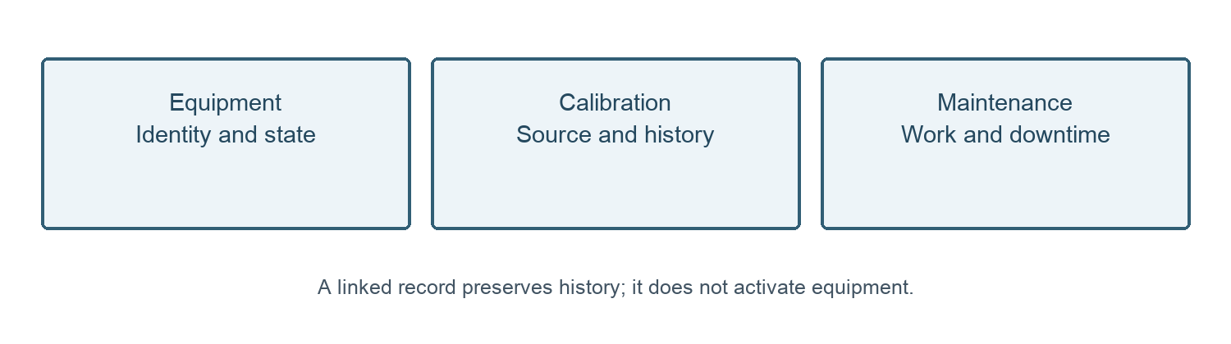
Figure 1. Assets workspaces preserve separate equipment, calibration and maintenance records.
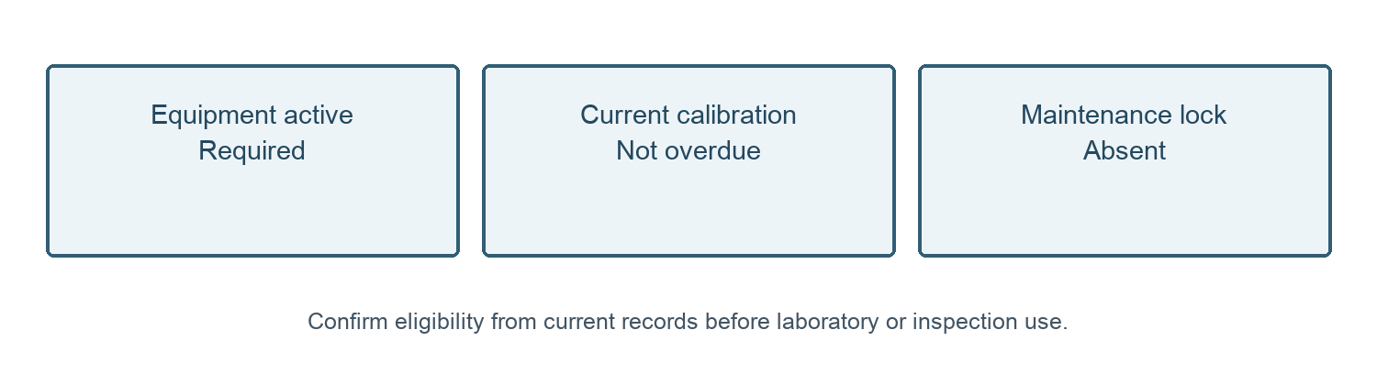
Figure 2. Equipment eligibility requires current source checks; completion alone is insufficient.
09 October 2026 — Owner approval recorded for SOP-FRS-006 D0.1 by yazeed through the explicit instruction in this chat. Status changed to APPROVED; file moved to SOPs/approved. Existing revision identifier retained. Effective date: NOT ASSIGNED. This file approval does not create a verified in-application electronic signature, assign an effective date or establish operational acceptance.

