Standard Operating Procedure

Using Governance pages
Document status: APPROVED | Revision: D0.1 | Approved by: yazeed (System Owner) | Approval date: 2026-10-09 | Effective date: NOT ASSIGNED. Approval basis: explicit owner instruction in this chat. This file approval does not create a verified in-application electronic signature, assign an effective date or establish operational acceptance.
Document reference: SOP-FRS-007
Revision: D0.1 | Prepared: 09 October 2026
Approval: APPROVED by yazeed | Approval date: 09 October 2026
Effective date: NOT ASSIGNED

1. Purpose and scope
Use Governance to review approval work assigned to your account or role and to record, review and follow proposed changes to controlled document versions. This procedure covers My approval queue (/approvals) and Change requests (/change-requests), the creation form, linked details, review and application controls at https://qclevel.top.
Keep the approval decision, application of a change and document effectivity separate. APPROVED authorizes a change; APPLIED records its successful application. Neither state approves or makes the target document effective, establishes a scientific result or means RELEASED.
This procedure supplies operating instructions for the current pages. It creates no new approval authority, technical criteria, retention period or exception. This Word file is owner-approved on 09 October 2026; record its effectivity before controlled use.

2. Responsibilities and prerequisites
Requester: use your own active account, identify the correct controlled document version, provide the source change number and reason, and compare the existing and proposed values before saving. Creation requires PERM-CHG-CREATE and access to the selected document version.
Assigned reviewer or approver: confirm assignment, subject, version, state, evidence and permitted decision before acting. Review permission and an Administrator or System owner label alone do not establish decision authority. The server also checks domain and approval permissions, scope, separation of duties and current version.
Change operator and Documents owner: verify the approved request and current target before application. Application requires PERM-CHG-APPLY plus the target draft-edit permissions and conditions; the Documents domain owns the actual target update. Do not use change approval to rewrite a frozen controlled version.
QMS signature-policy owner: resolve blocked action-specific signature policy. Document Control: control source identity, revision, review, approval and effectivity. The existing FRS owner direction identifies yazeed as document approval and activation authority; approval of this procedure is recorded on 09 October 2026; application controls remain binding.
Prerequisites: an authenticated active account, authorized record scope, a source-supported change number and rationale, and an available controlled document version. For a signed approval, have your own current password and review the displayed signing meaning. Never share passwords or record them in comments, evidence or this SOP.

3. Page elements and register meanings
Open navigation and expand Governance. My approval queue opens the page headed My approvals. The count represents approval work items returned for your account or eligible role and permitted for review. It is not the total system backlog, the number of approved changes or proof that all decisions are available.
When populated, My approvals lists Subject, Workflow, Submitted by, Version, State and Decision status. Open the Subject link for detail review. Decision available after detail review indicates a candidate decision, not an approval already granted. Decision blocked: signature policy unresolved requires policy-owner resolution before reauthentication.
Approval detail provides Controlled subject snapshot, Review context, workflow state, current subject version, next action and owner, handoff context and an audit link. Controlled decision lists only supported and authorized choices: Approve, Return for correction or Reject. Reason / comments is required for Return and Reject. Signed decisions display a signing meaning and Re-enter your password to sign this decision.
Change requests provides New change request, Target type, State and Filter. State options include Draft, Submitted, Under review, Returned, Approved, Rejected, Applying, Applied, Application failed and Cancelled. Filters display recorded states; their presence does not establish a transition button or permission.
New change request contains Request context, Controlled target and Proposed change. The only supported creation target is Controlled document version. Change field offers Revision reference and Change summary. Target identity, current values, version and snapshot are resolved by the system; do not supply invented technical identifiers or hashes.
Change detail shows Control context, Captured target snapshot, Proposed changes and Audit history, with Open review for eligible Submitted or Under review records. Approved document-version requests can expose Apply approved metadata change and Apply approved change. Application attempts, when present, record results and safe error codes separately from the approval decision.

4. Operating procedure
4.1 Confirm account and route. Open https://qclevel.top, sign in when required and confirm your account. Open navigation, expand Governance and choose My approval queue or Change requests. Use the selected record and its current state to determine the next permitted action.
4.2 Review your queue. Read the count and policy message on My approvals. Open the exact Subject when an item is listed. Compare workflow, requester, version, assignment and Decision status. A role-assigned item still requires all decision checks; do not assume ownership or approval authority from visibility.
4.3 Inspect the approval context. Read Controlled subject snapshot and Review context, then confirm the owning record and available evidence using the displayed links. Confirm the current subject version and intended decision. A captured snapshot is review context, not a reservation of the record or proof that its source has stayed unchanged.
4.4 Handle a blocked decision. If Decision unavailable or Review only appears, read the stated policy, authority or state reason. Return to My approvals or consult the named owner. Do not enter a password, borrow another account or change record identifiers to bypass the refusal.
4.5 Make an authorized change-request decision. When offered, select Approve, Return for correction or Reject in Controlled decision. For Return or Reject, enter a specific reason explaining the correction needed or basis for refusal. These two workflow refusals currently do not require an electronic signature; any password control visible because another choice requires signing does not make the refusal a signed approval.
4.6 Sign change authorization. For Approve on a CHANGE_REQUEST, review the displayed meaning Authorize change request followed by its controlled identifier. Re-enter your own password in the signing field, then select Submit controlled decision only when you intend to authorize that exact version. The server verifies reauthentication and signature permission and binds the decision to the account, action, subject version and snapshot.
4.7 Confirm decision persistence. After the response returns to My approvals, inspect the related change request and available audit/signature evidence. Confirm APPROVED, RETURNED or REJECTED as appropriate. Queue disappearance alone does not prove success, and a successful signature check alone does not establish a saved decision or applied change.
4.8 Locate a change request. Open Change requests, enter Target type when needed, choose State and select Filter. Open the exact change number in the populated register. Clear or reset filters and recheck authorized scope before treating a missing row as absence.
4.9 Start a draft. Select New change request. Enter Change number from the approved source and a clear Reason. The page distinguishes this source change number from automatically assigned reference numbers; do not assume it supplies the source change number for you.
4.10 Select the controlled target. Choose Controlled document version and compare document number, title, revision and state. Read the displayed current values when available. If no versions are listed, stop creation and ask Document Control to resolve the available source or authorized scope. The Word SOP files on disk are not automatically registered application versions.
4.11 Describe one proposed field change. Select Revision reference or Change summary and enter Proposed value. Compare it with the current value. The current form creates one textual metadata change; it does not replace source files, change a content hash, approve a method, modify permissions or activate a document.
4.12 Save and verify the draft. Select Create draft during authorized operation. Confirm the saved change number, DRAFT state, reason, target version, captured snapshot and Current/Proposed values. Cancel or Back to register leaves the creation form; this navigation is not the CANCELLED business transition.
4.13 Respect the current submission gap. The local detail page names Submit change request as the next action for DRAFT, but provides no Submit button or form. It also provides no draft edit, Resume or Cancel transition control. Refer these steps to the change-process owner and support for an authorized supported route; do not use developer tools or direct database updates. Creation alone does not submit a request or establish an approval assignment.
4.14 Start review when available. For a Submitted request, select Open review. Compare the reason and proposed values again. Select Start review only when offered and permitted; confirm UNDER_REVIEW and the new history event. This starts review and is not approval. Return, Reject and Approve are unavailable through this direct review route; use the controlled assigned approval workflow.
4.15 Follow returned or rejected requests. A RETURNED request needs the source-supported correction and a permitted resumption route; the current detail page exposes neither edit nor Resume. A REJECTED request has no outgoing transition in the current state machine. Keep its reason and history; consult the process owner rather than recreating records to hide a refusal.
4.16 Apply an approved metadata change. Open the APPROVED document-version request and review Apply approved metadata change. Confirm the target is still an editable DRAFT and still matches the captured version, content hash, document identity, state and old value. Select Apply approved change only within your authority. Approved or effective controlled versions remain frozen and cannot be rewritten through this action.
4.17 Confirm the application outcome. Reopen the request and target. Confirm APPLIED, the successful Application attempt and the updated revision reference or change summary on the target. The request history alone is insufficient to validate the target value. Keep the target document review, approval and effectivity process separate.
4.18 Recover from an uncertain result. If the page reports an unconfirmed result, stale version, changed authorization or failed application, inspect the latest record and its history before retrying. Reload the current approval before retrying when that recovery link is offered. Reassess the decision against the refreshed version; do not automatically repeat an old signature or application attempt.

5. Counts, states and exceptions
On 09 October 2026, an authenticated read using yazeed displayed 0 assigned approval work items, No assigned approval work and Some decisions now require a signature. Change requests displayed No change requests found, and its creation form had no controlled document versions available in authorized scope. These are authoring observations; recheck current records before operation.
Empty, excluded and unavailable are distinct. An empty personal approval queue does not prove that every request is complete. Requests outside authorized scope are excluded. Approval queue is unavailable means the queue and count could not be loaded; do not substitute zero or infer that no approval is waiting.
The current change-request signature registry resolves APPROVE as REQUIRED and RETURN/REJECT as NOT_REQUIRED. Unresolved generic subjects, including controlled document approval, remain blocked before password reauthentication. Do not extend the change-request rule to another subject or treat an unsigned refusal as a formal approval.
The documented domain sequence is DRAFT to SUBMITTED to UNDER_REVIEW, then APPROVED, RETURNED or REJECTED. RETURNED can resume to DRAFT through a supported authorized route. APPROVED can proceed through APPLYING to APPLIED or APPLICATION_FAILED. The present page controls cover only part of this sequence; filter states and domain transitions are not evidence of a complete browser workflow.
APPLICATION_FAILED and recorded failed attempts require inspection by the owning domain and change operator. There is no current detail-page retry or reset control for APPLICATION_FAILED. Some stale/state refusals record a failed attempt while the request remains APPROVED; inspect both state and attempts rather than inferring the state from an error message.
For a missing version, unavailable assignment, blocked policy or frozen target, preserve the controlled history and refer the stated dependency to its owner. Do not change access, invent a target, delete a rejected request or label a failed application APPLIED. No bypass is authorized by this SOP.

6. Records and review checks
Preserve the source change number and rationale, controlled target identity and captured version, existing and proposed values, request state/version history, review decisions, reasons, matching signature evidence where required, application attempts and resulting target value. Use available source-record and Audit links; this SOP establishes no additional retention period.
Before controlled adoption, verify populated records with relevant authorized and denied accounts: target selection and exact values, creation, a supported submission/assignment path, Start review, return/rejection reasons, account-bound approval, stale/version refusal, and successful or failed target application. Check separation of duties and signature persistence separately from the page layout.
Authoring evidence on 09 October 2026: live authenticated read-only inspection of My approvals, Change requests and New change request. No request was created, submitted, reviewed, approved, rejected or applied; no password reauthentication or signature was executed. Populated details and action guards were inspected in local source only. Deployed-source parity and complete runtime/UAT acceptance remain NOT VERIFIED.
Reviewer: NOT RECORDED. Approver: yazeed (System Owner). Reference: SOP-FRS-007. Revision: D0.1. Approval date: 09 October 2026. Approval basis: explicit owner instruction in this chat. Effective date: NOT ASSIGNED. This file approval does not create a verified in-application electronic signature, assign an effective date or establish operational acceptance.

7. References and revision history
R1: https://qclevel.top/approvals; https://qclevel.top/change-requests; https://qclevel.top/change-requests/new — authenticated read-only page observations on 09 October 2026.
R2: SOP-FRS-001 Document control and sources; SOP-FRS-002 Work page — related owner-approved SOPs. Citation does not establish effectivity.
R3: src/pages/approvals/index.astro and [approvalId].astro; src/pages/change-requests/index.astro, new.astro, [changeRequestId]/index.astro and review.astro — labels, filters, fields and current controls.
R4: src/modules/approvals/application/signature-policy-registry.ts, decision-capabilities.ts, authorization.ts and decide-approval.ts; src/modules/change-requests/application/transition-change-request.ts, apply-approved-change-request.ts and authorization.ts; domain/change-request.ts — source policy boundaries and transitions. Local source HEAD: 6d925d74d243bbfd77ab5b784c21cd68303672b6. Referenced historical policy filenames are not treated as available controlled sources in the rebuilt document tree.
D0.1 | 09 October 2026 | Initial review draft for Governance My approval queue and Change requests. SOP-FRS-007 assigned by the owner; preserves the current FRS design and seven-section structure.

Visual operating guide
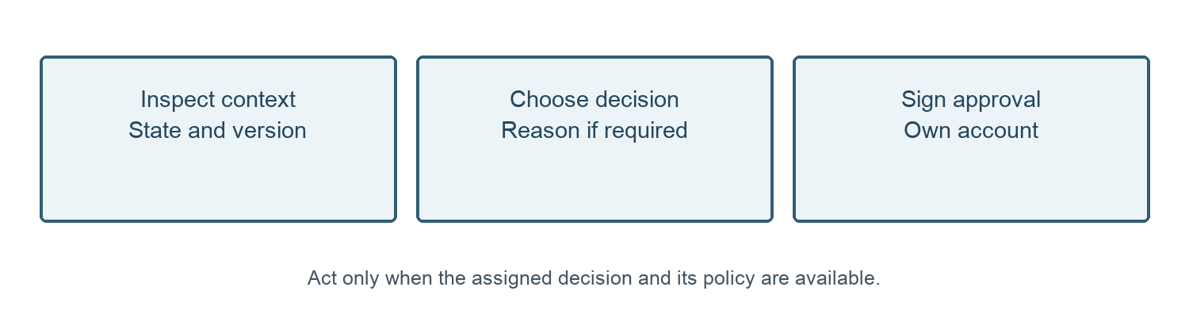
Figure 1. Assigned approval review and account-bound change authorization. Return and Reject require a reason and currently remain unsigned.
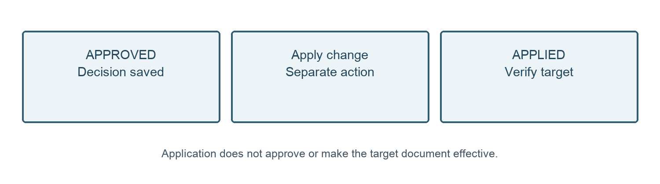
Figure 2. Approval and application are separate. A frozen or changed target prevents application; verify the saved target value.
09 October 2026 — Owner approval recorded for SOP-FRS-007 D0.1 by yazeed through the explicit instruction in this chat. Status changed to APPROVED; file moved to SOPs/approved. Existing revision identifier retained. Effective date: NOT ASSIGNED. This file approval does not create a verified in-application electronic signature, assign an effective date or establish operational acceptance.

