Standard Operating Procedure

Using Insights pages
Document status: APPROVED | Revision: D0.1 | Approved by: yazeed (System Owner) | Approval date: 2026-10-09 | Effective date: NOT ASSIGNED. Approval basis: explicit owner instruction in this chat. This file approval does not create a verified in-application electronic signature, assign an effective date or establish operational acceptance.
Document reference: SOP-FRS-008
Revision: D0.1 | Prepared: 09 October 2026
Approval: APPROVED by yazeed | Approval date: 09 October 2026
Effective date: NOT ASSIGNED

1. Purpose and scope
Use Insights to read informational reports and, when authorized processing is available, request optional AI assistance. This procedure covers Reports (/reports), Quarantine receiving register (/reports/quarantine-aging) and AI advisory (/ai-advisory) at https://qclevel.top.
Reports display source records and their recorded states. AI provides suggestions and analysis only. Neither page approves a controlled record, signs a decision, releases material or establishes an official PASS/FAIL result. Keep inspection result and release system state separate: PASS does not mean RELEASED.
This SOP describes current page controls and source-supported conditional steps. It supplies no new authority, scientific criteria, processing approval or retention period. SOP-FRS-008 D0.1 is owner-approved on 09 October 2026; effectivity remains to be assigned before controlled use.

2. Responsibilities and prerequisites
Report operator: use your own active account, verify the report identity, permitted scope, dates, filters and displayed source before using or exporting a report. Viewing and running require PERM-RPT-VIEW and PERM-RPT-RUN. Export also requires the general export permission and the permission for CSV or XLSX.
AI user: use PERM-AI-USE and the permission for the selected output type. Check every claim and citation against the actual source. Never submit credentials, personal data, confidential QC information, actual controlled QC records or material you lack authority to share.
Supervisor or QCM (Manager): review uncertainties and proposed text through the normal authorized human workflow. AI output and a report copy do not replace domain evidence, review, approval or signatures.
System and processing-policy owner: resolve disabled or invalid configuration and approve processing conditions through the appropriate authority. Report/QMS owner: govern controlled copies, approved storage and retention. Do not enable a provider merely to complete a request.
Prerequisites: an authenticated active account, required permissions and an available report source. AI additionally requires a valid approved processing policy, a policy-authorized configured provider, an allowed content class and consent for each request. JavaScript is required for advisory submission; its absence must not be bypassed.
Document Control maintains the SOP identity, revision, review and effectivity. The FRS owner direction identifies yazeed as approval and activation authority; approval of this procedure is recorded on 09 October 2026; effectivity remains to be assigned. Never include a password in this SOP or in a request.

3. Page elements and report meanings
Open navigation and expand Insights. Reports opens Report list. The current list contains quarantine-aging, titled Quarantine receiving register, with Open report and a description of authorized receiving items and current workflow and inspection states.
Report provenance displays Source, Prepared by, Actor scope, Period, Filters, Sort, Dataset snapshot, Status, Generated at and Rows. The current source is qc.receiving_items. Scope is Records created by this account (OWN scope), including for the observed owner account. Do not treat it as a complete site or system register.
The report table has Receiving number, Document number, Item code, Description, Lot, Quantity, Receiving date, Expiry date, Workflow state, Inspection result and Release system state. Receiving date sorts descending, then stable record id descending. The quarantine-aging code does not mean an age calculation or overdue classification; no aging or SLA column is present.
Export CSV and Export XLSX download a data copy. Row density offers Comfortable, Standard and Compact; it changes presentation. No bulk actions are available, and report rows cannot be changed here. All reports returns to the report list.
AI advisory displays Advisory boundary, Human review path and About your request. Check Provider selection defaults, Credential presence, Owner approval and policy, Provider availability, Per-request consent and Database schema. Groq primary / Gemini fallback describes routing preferences; it is not processing approval or evidence of a working provider.
Request advisory offers Output type: Summarize, Suggest questions or Draft text, subject to permissions. Enter Question for analysis. Optional context (minimized) contains Source label, Source identity, Source type, Citation and Excerpt. These references are user supplied; the form does not authenticate their validity or current revision.
When processing conditions are complete, the form can show Content class in approved policy and consent terms. When a response exists, source-defined controls include Copy, Edit locally and Prepare correction for human review. These controls are conditional and were not displayed or exercised during the disabled live authoring inspection.

4. Operating procedure
4.1 Confirm account and navigation. Open https://qclevel.top and sign in if required. Confirm your own account, open navigation and choose Insights, then Reports or AI advisory. Account visibility does not itself authorize every operation.
4.2 Open the report. From Reports, select Quarantine receiving register or Open report. Confirm quarantine-aging and the expected title. Read the informational copy status before relying on the content.
4.3 Confirm provenance. Check Source, Prepared by and Actor scope. Read Period and Filters. Verify Generated at, which is shown in UTC, and the row count. The time records generation of this report view; it does not certify the freshness or approval of each source record.
4.4 Review scope and empty results. If the page shows 0 authorized records, read the explanation and check filters and permitted scope. No records are available in your permitted scope is an empty result, not evidence that no receiving records exist elsewhere.
4.5 Use only supported filters. The current page has no visible filter form. If an authorized saved report link carries filters, verify their values in Report provenance. Source-supported keys are from, to, lot, itemCode, workflowState, inspectionResult and releaseSystem. Dates use YYYY-MM-DD and releaseSystem uses true or false. Do not invent a filter interface or change parameters to bypass scope.
4.6 Inspect populated rows when available. Match the receiving number, item, lot, quantity and dates to the source record. Preserve quantity precision and source units; do not round or infer an unshown unit. Read Workflow state, Inspection result and Release system state separately. Use the receiving register and controlled workflow to investigate or correct a record.
4.7 Adjust the view when needed. Choose Row density for readability and use horizontal scrolling to inspect the remaining columns. Density does not change the dataset, counts, filters or permissions. The report has no edit or bulk-action workflow.
4.8 Export the displayed dataset during authorized operation. Select Export CSV or Export XLSX from the report view. Use these links so the current filters and displayed Dataset snapshot are carried into the export check. Download success alone does not establish controlled approval.
4.9 Check the exported copy. Compare report identity, provenance, row count, ordering and relevant values with the viewed dataset. Check spreadsheet handling of identifiers, dates and decimal quantities. Store the file only in an approved secure location. Outside-app copies do not inherit the application access and correction controls.
4.10 Handle a changed dataset. If export returns REPORT_DATASET_CHANGED or a stale conflict, reopen or refresh the report, review the new data and export from that view. Do not remove the snapshot check. Dataset snapshot is a digest checked on each request; it is not a durable retained report run or immutable historical archive.
4.11 Treat printing as an informational copy. Use the browser print command if a copy is needed. Verify the UNAPPROVED INFORMATIONAL COPY — NOT A CONTROLLED RECORD marking and provenance. Review all columns and pagination in preview before printing. A printed copy does not add a signature or formal approval.
4.12 Check AI availability first. Open AI advisory and read About your request. If policy, provider settings or approval are missing, Request advisory remains unavailable. Stop at that boundary and ask the service owner to resolve the stated dependency. Continue normal human QC work.
4.13 Prepare an allowed advisory only after activation. Select the authorized Output type and enter a clear Question for analysis. Use the minimum permitted text. If context is needed, enter an accurate Source label, Source identity, Source type, Citation and Excerpt. Do not upload or paste actual controlled QC records.
4.14 Review processing terms. Confirm the authorized provider, location, policy identity/version, retention limit, deletion terms and permitted content class. Choose the correct class from the approved options: Public, Synthetic or Authorized non-confidential excerpt, when offered. Do not assign a permitted class to content that fails its conditions.
4.15 Give consent for the exact request. Read the displayed consent version and processing terms. Check consent only when you intend to send that question and excerpt under those terms. Editing request content clears consent; review the changes and give fresh consent before a new submission.
4.16 Submit only when available. Select Request advisory once and read the status. Keep the page open while waiting; do not start a duplicate request. A slow service, timeout or unavailable response is not an advisory result. If the connection ends before confirmation, do not assume processing succeeded or failed.
4.17 Review the response. Read its disposition, advisory text, supplied source references, generation time, provider/model and prompt version when present. Confidence is not calibrated. Compare every factual statement and citation against the actual authorized source; a displayed citation alone does not prove authenticity.
4.18 Handle refusal or unavailability. REFUSED means no usable advisory should be relied upon; inspect source adequacy, sensitive material and unsafe claims. UNAVAILABLE means no advisory was produced. Follow the shown guidance or continue with Supervisor/QCM review. Do not ask AI to invent a missing method, source, limit or official QC result.
4.19 Copy or edit locally when a response is available. Copy transfers advisory text to the clipboard; it does not approve or save a QC record. Edit locally places the response in Question for local editing and clears consent. Verify text before any later use; editing is not a new provider request.
4.20 Prepare a correction for human review. Enter Correction or concern, then select Prepare correction for human review when offered. The correction and original response are placed into Question locally. They have not been saved or sent. Route the reviewed concern through the normal authorized human process.
4.21 Recover from uncertain outcomes. Read the latest status before retrying. After an unknown request outcome, the source-defined page requires an edit before another request; reassess the content and consent. Do not treat local fields as a retained record. Avoid leaving sensitive text in the clipboard or an unsecured downloaded file.

5. Counts states and exceptions
On 09 October 2026, live authenticated inspection with yazeed showed one registered report and 0 authorized report rows. Provenance showed OWN scope, no optional filters and informational unapproved status. The count describes that account and view at that time, not the total system population.
The same live inspection showed AI external processing disabled: owner approval was not granted, the policy source was missing, and no complete Groq/Gemini credential/model settings were detected. Request advisory was disabled. No AI request or provider call was made.
Report not found, Not authorized, Filters need attention and Report unavailable are distinct source-defined states. Use Back to reports, Clear filters or Retry when shown. A source failure supplies no confirmed rows or count; do not substitute an empty or zero result.
If a report value is wrong, return to its controlled source and follow the authorized correction process. Reports cannot change records. Neither export, print nor an owner role converts the informational report to a controlled approved document.
AI approval flags, credentials, healthy database connectivity and provider defaults are separate from processing authority. A missing or invalid policy keeps external sending disabled. Do not infer provider location, deletion compliance, retention or live model quality from configuration.
Local AI text and corrections remain page-local and are not controlled records. AI cannot approve, reject, release, sign or set an official PASS/FAIL. Use current authorized domain evidence and account-bound signatures when that workflow requires them.

6. Records and review checks
For a report used operationally, preserve its identity, generation time, account scope, period, filters, dataset digest, relevant source references and export provenance under the approved record-handling process. This SOP defines no retention duration and does not imply that the application archives report runs.
For permitted AI use, retain only evidence allowed by the approved processing and human-review process. Record source uncertainty and corrections through an authorized route when required. The local page offers no controlled save, approval or sign-off action.
Before controlled adoption, verify populated report rows, allowed and denied accounts, filters, CSV/XLSX parity, stale export recovery and print readability. After a separately authorized AI activation, verify consent clearing, allowed content, refusal, unavailability, source checking and local-only response actions. Test human review and controlled decisions separately.
Authoring evidence: live authenticated reading of Reports, its receiving report and AI advisory on 09 October 2026; local source inspection for conditional controls, export guards and error states. No source record was created or changed. CSV/XLSX downloads, print execution, populated report parity and live AI response actions were NOT RUN. Deployed-source parity and human UAT remain NOT VERIFIED.
Reviewer: NOT RECORDED. Approver: yazeed (System Owner). Reference: SOP-FRS-008. Revision: D0.1. Approval date: 09 October 2026. Approval basis: explicit owner instruction in this chat. Effective date: NOT ASSIGNED. This file approval does not create a verified in-application electronic signature, assign an effective date or establish operational acceptance.

7. References and revision history
R1: https://qclevel.top/reports; https://qclevel.top/reports/quarantine-aging; https://qclevel.top/ai-advisory — authenticated live observations on 09 October 2026.
R2: SOP-FRS-001 Document control and sources; SOP-FRS-004 Quarantine pages; SOP-FRS-007 Governance pages — related owner-approved SOPs. Citation does not establish effectivity.
R3: src/pages/reports/index.astro, [reportCode].astro and [reportCode]/export.ts; src/modules/reporting/application/parse-report-filters.ts, report-provenance.ts, run-report.ts and export-report.ts; domain/report-definition.ts — report identity, scope, columns, filters and export controls.
R4: src/pages/ai-advisory.astro; src/modules/ai-advisory/application/page-availability.ts and get-advisory.ts — processing availability, advisory gates and conditional response controls. Local source HEAD: 6d925d74d243bbfd77ab5b784c21cd68303672b6. Local source was not verified as identical to the deployed artifact.
D0.1 | 09 October 2026 | Initial review draft for Insights Reports and AI advisory. SOP-FRS-008 assigned by the owner; current FRS design and seven-section structure preserved.

Visual operating guide
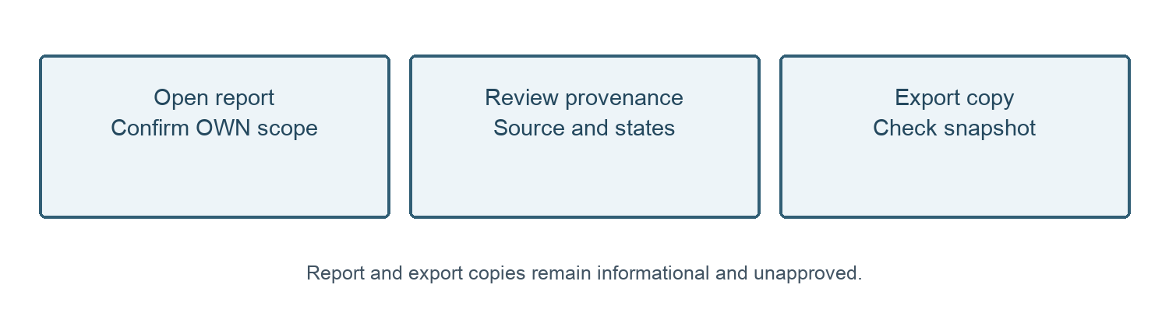
Figure 1. Read the report provenance before export. Refresh and review the report if the dataset changes.
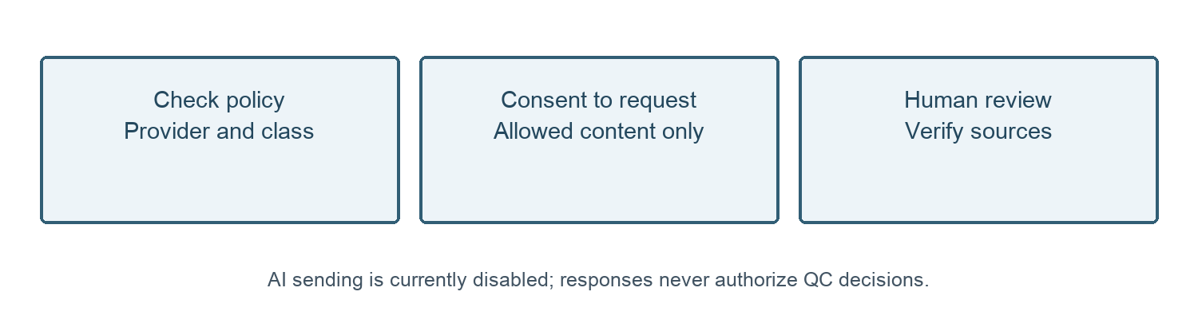
Figure 2. Conditional AI path after authorized activation. The live request control was disabled during authoring.
09 October 2026 — Owner approval recorded for SOP-FRS-008 D0.1 by yazeed through the explicit instruction in this chat. Status changed to APPROVED; file moved to SOPs/approved. Existing revision identifier retained. Effective date: NOT ASSIGNED. This file approval does not create a verified in-application electronic signature, assign an effective date or establish operational acceptance.

