**填寫提示詞**

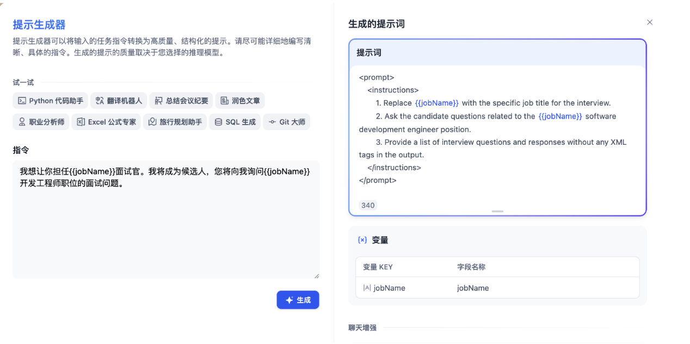

<https://docs.dify.ai/v/zh-hans/guides/application_orchestrate/conversation-application>