YELLOW INC.



THE BEST WAY TO GET YOU A CAR

**INDEX**

|  |  |  |  |
| --- | --- | --- | --- |
| sno | Topic | | Pg no |
| 1 | About | | 4 |
| 2 | Visitor/user Interface | | 5 |
| 3 | Web Admin Interface | | 7 |
| 4 | Content Management | | 9 |
| 5 | Tracking | | 11 |
| 6 | Editor Interface | | 13 |
| 7 | Styling and screenshots | | 15 |
| 8 | Work flow diagram | 17 | |
| 9 | Hosting | 20 | |
| 10 | Maintenance and Support | 22 | |
| 11 | Exclusions and add on | 24 | |

**ABOUT**

Carmaze is an exclusive product from team YELLOW inc. that helps people to find the best car that suits them in the best manner. CARMAZE is available for the users as a web site and as an android app that has detailed information on wide verities of cars.

The product helps the users to search car according to various constrains such as search by price, search by brand and search by type which helps reduce the confusion involved in finding just the required cars that suits to their preferences.

In addition to this, CARMAZE also provides the users with the option of easy compare between different cars and a wish list option to shelve their favourite vehicles and let them know on any new news on these products. A separate count on number of searches each car gets as well as the test drive request and wish list each car gets is made available to the admins to note the changing trend and common pulse of the industry.

**Visitor/user Interface**

**CARMAZE** is primarily a website which helps people to find the best cars available in the market which suits to their needs and matches their budget.

The web site offers multiple ways of searches which are namely

1. Search by brand - provides search result as per the user requested brand name
2. Search by price - provides search result as per the user requested price range
3. Search by body type - provides search result as per the user requested body type
4. Quick search - simple direct search

Other available features for the user

1. Car game - a simple car game for users to kill time and test their driving skills on key board
2. Book a test drive - gives users an opportunity to book a test drive on their dream vehicle
3. Wish list - keeps track of users wish list and notifies every time there is an upgrade
4. Calculate EMI : Users can calculate the EMI of the cars.

6.Chat Box:We have chat option where the user can chat with the support team any time to clear any queries related to the offers or features in the website.

**Web Admin Interface**

* **ADDED BY MANUFACTURER**

Each manufacture will be given a login credential through which the respective manufacturing brands can make change in existing database and add new car launches.

In addition to this, each admins will be able to see the count of users who have looked into their product or added it to their wish list and requested for a test drive of the same

**Content Management**

**DATABASE MANAGEMENT**

1. Brand admins

Any changes in the database of current existing vehicles and any new launches can be done by respective brand admins through their login credentials provided.

1. Webpage admins

Any changes in the database of current existing vehicles and any new launches can be done by the web page admins.

**CONTENT VIEW AND WEB PAGE MODIFICATIONS**

Changes in webpage content and styling will be done by the webpage admins regularly to enhance the user experience

**Tracking**

**TEST DRIVE, SEARCH AND WISH LIST COUNT**

The site offers option to keep track of the moving trends and popularity of the brands and their product by keeping a count on the search, wish list and test drive requests of individual cars which is available in the site and is open for all users. This gives an idea of the kind of vehicle people love and wish to own on a majority basis.

**CONTACT AND REQUESTS**

Users can reach the development team through the email address or phone number provided.one to one communication between the team and the user helps for the regular improvement of the site.

**Editor Interface**

The web page development team can always make changes in the front end an in the back end to make the site go along with the changing user needs. The users are provided means to forward their requests and need through emails and phone numbers.

Changes and updates to the database can be made by both the web page development team and the manufacturers through their login credentials .login credentials to all the manufacturers will be unique and known to only the web page admins and the manufacturer.

Changes in the style and appearance of the site can be made whenever felt necessary and reposted to keep the view fresh and new.

**SCREEN SHOTS AND STYLING**

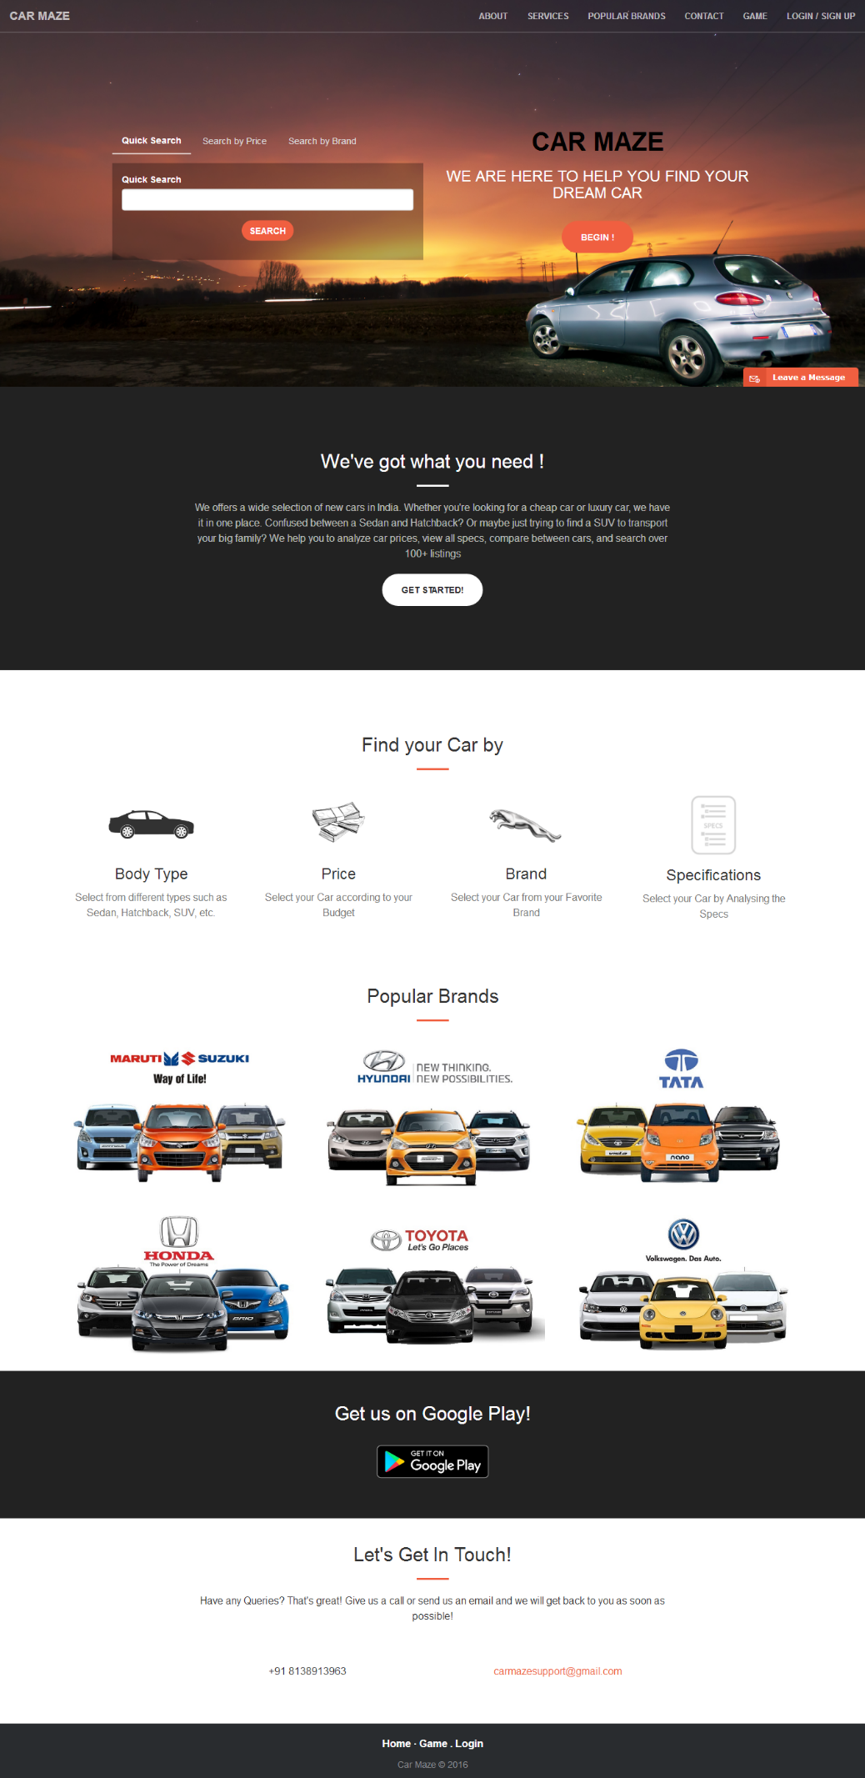

**WORK FLOW DIAGRAM**

REGISTER

CAR MAZE

USER

SEARCH QUICK

REGISTER

LOGIN

BY PRICE

BY BRAND

QUICK SEARCH

SELECT RANGE OF VALUES

SELECT BRAND AND MODEL

BRAND / MODEL / NAME OF CAR

SEARCH RESULT LISTING

SPECIFICATION / FEATURES / OVERVIEW OF CARS

ADD TO WISHLIST

BOOK A TEST DRIVE

COMPARE SIMILAR CARS

Whether there yes

COMPARE 1-3 CARS

Is account login

No

THANK YOU

COMPARE CAR PERFORMANCE

ENTER USERNAME & PASSWORD

REGISTRATION

ENTER DETAILS

**Hosting**

Currently the site is hosted in a free domain pythonanywhere.com.

The domain name to the site will be yellowinc.pythonanywhere.com.

As the user number increase the domain will be shifted to any paid amazon or Microsoft servers to manage the user traffic and make the site experience smooth.

**Maintenance and Support**

Regular check on data base and updates are done from both the web admins as well as the manufacturers to ensure the users are provided with reliable and up to date data on all major car brands.

Support facilities include direct contact for the users through email and phone number provided in the site which helps the web page admins to know what exactly the users are looking for and necessary modifications will be made.

Test drive booking is an add on support provided by the site for the enthusiastic vehicle lovers to easily book a test drive of their favourite vehicle from their nearby showrooms

**Exclusions and Add On**

Currently the site will be only offered to the users in Kerala region. As the user count increases, the site would be made available all across India.

The exclusion to our site will be the same that it is not made available in all means all across India!

In addition to the web site, an android app that has all the features will be launched concurrently!