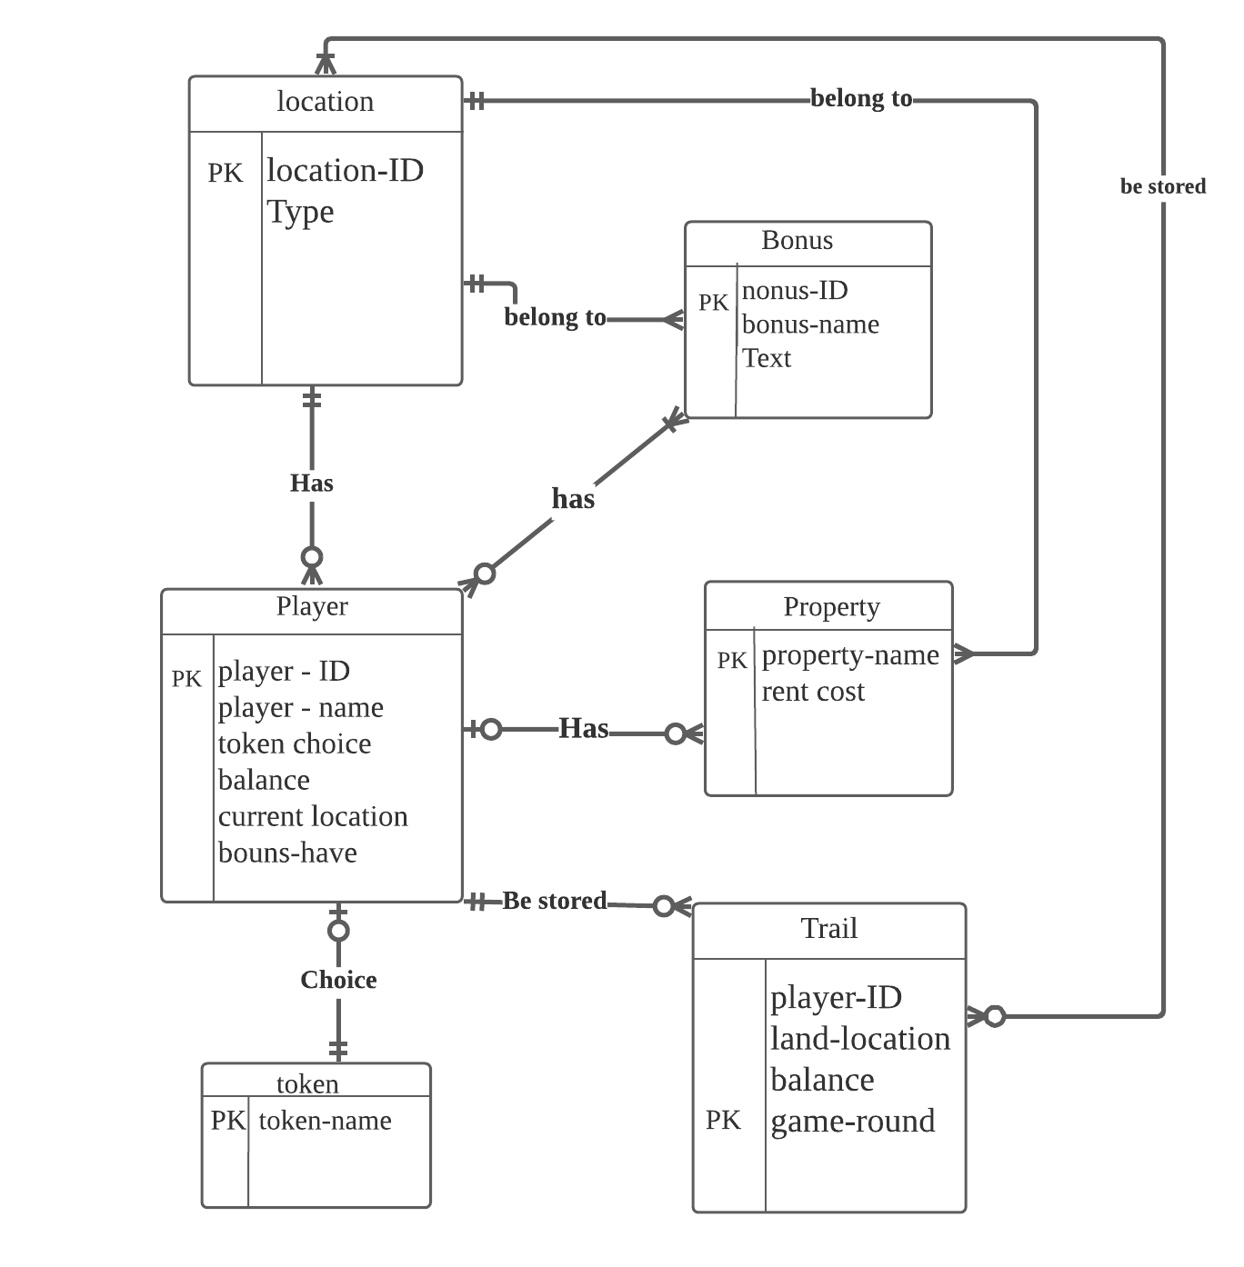Part1-ER diagram

**Short report about ER dragram design choices**

Let me briefly explain my ideas and methods for designing this ER diagram. Part1 covers the knowledge content of lab1 and lab2. First,l read the requirements of data manipulation and data defifinition. Mark some important points, such as entities, the attributes contained in the entity, and the relationship between those entities. After careful comparison and screening, I got 6 entities, namely (player, token, bonus, property, location, trail). ccording to the information given in Part1, I can know the attributes contained in each entity and select the appropriate primary key. The next part is to judge the relationship, this part is extremely important.

1. The player can get bonus. Bonus can be earned many times. But if the player has not reached a specific location of bonus, so the bonus can be zero. The player has won the bonus at least once. Because the starting point as the player's must pass is also a bonus.
2. Players can purchase properties. Players can purchase many properties. But if the player is unlucky or poor and has not purchased the property, the property can be 0. The property may be purchased, which belong to only one player。Or it may be in an unpurchased state.
3. The player must choose a token as his own game character. The token can only belong to one player. Or when there are less than 6 players in the game, some of them are not selected.
4. bonus is part of the location. The location records multiple bouns. Bonus can only correspond to one location.
5. Property is part of the location. The location records multiple property. Property can only correspond to one location.
6. player records the current location. Each step of the player has a location. The location can be reached by multiple players, or none of the players can reach this location.
7. Players have their own audit Trail to record. One Trail belongs to a player. The player has a lot of game records, or it may not start the game so that there is no record.
8. Trail needs to record the player's location landed on. Trail records the location landed on of each player in each round of the game. Trail records location landed on at least once, that is the start point. Location can be recorded by many Trails. Or a location never be recorded in the game.

This is my idea and method to solve Part1, and my understand of my designed ER diagram.